Nandni Ahir
MODUAL 1

  - write a simple “Hello World” program in two different programming languages of your choice. Compare the structure and syntax.

C language

#include<stdio.h>
Main(){
Printf(“Hello World”);
}

Output:
Hello World

C++ language

#include<iostream>
using namespace std;
int main(){
cout << “Hello World” << endl;
return 0;
}

Output:
Hello World

  - Research and Create a diagram of how data is transmitted from a client to a server over the internet.

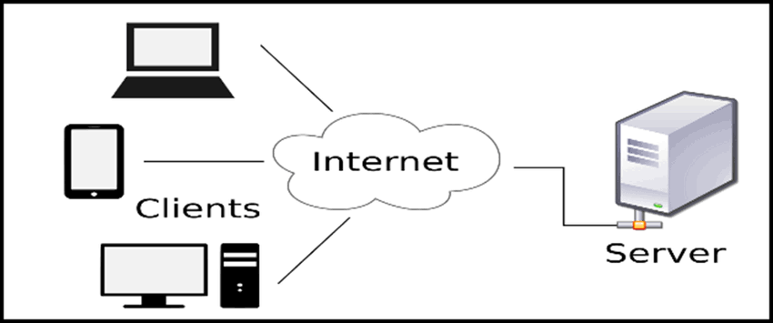

  - Design a simple http client-server communication in any language.

A simple HTTP client-server communication can be designed using Python's built-in http.server and http.client modules.
Server-Side (Python)
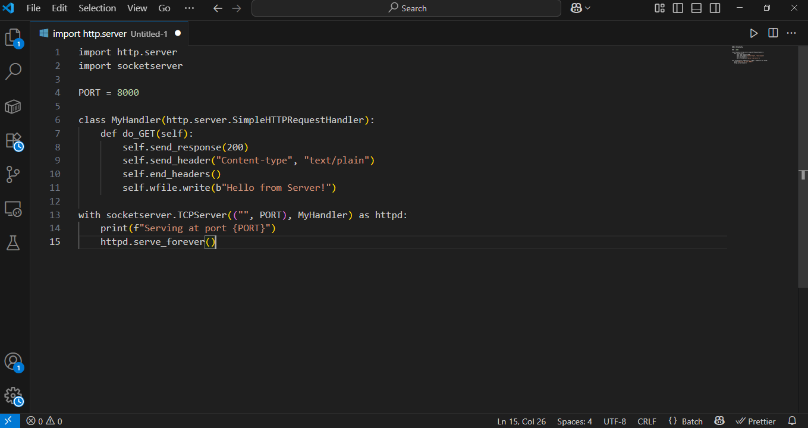

Client-Side (Python)
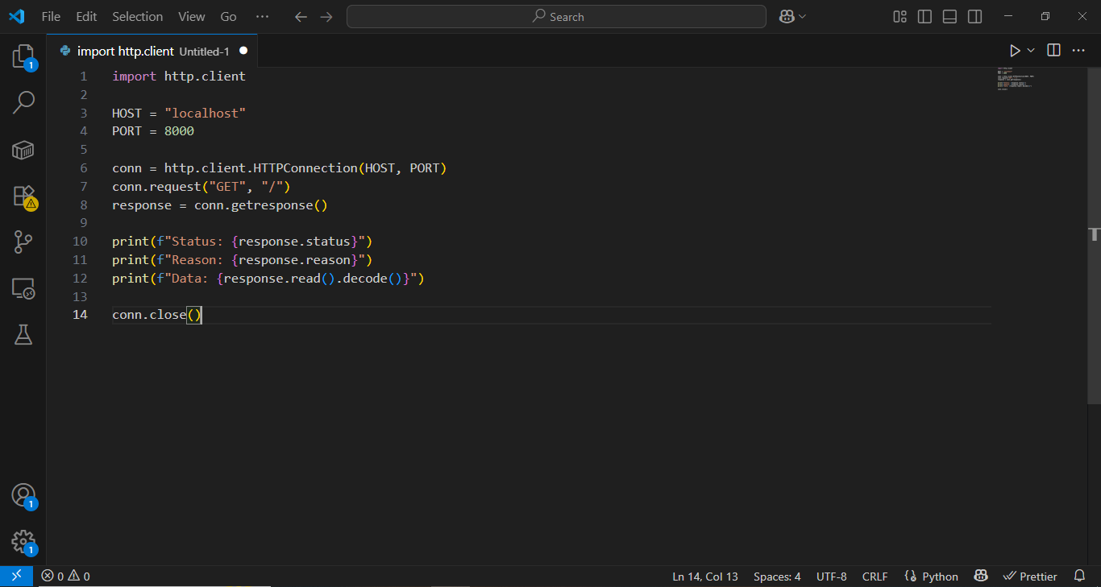

  - Simulate HTTP and FTP requests using command line tools (e.g.curl).

  - Design a basic three-tier software architecture diagram for a web application.
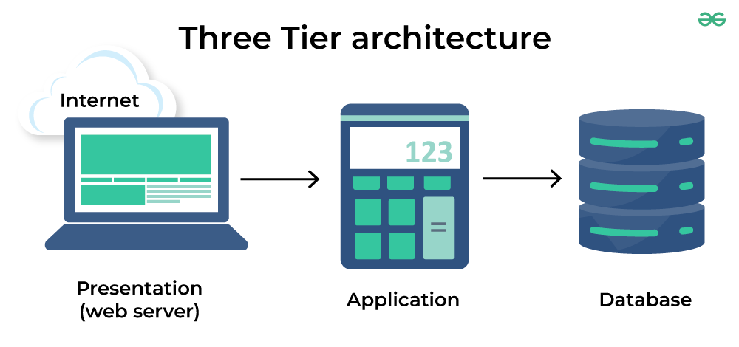

  - Create a case study on the functionality of the presentation, business logic, and data access layers of a given software system.

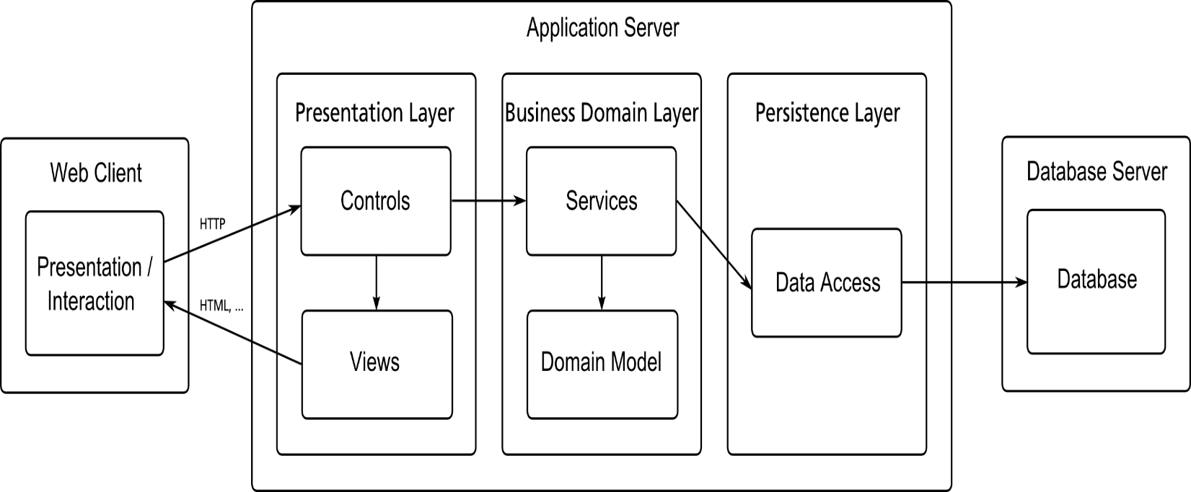

13.1. Explore different types of software environments (development, testing, production). Set up a basic environment in a virtual machine.

  - Write and upload your first source file to Github.

  - Create a Github repository and document how to commit and push code changes.

  - Create a student account on Github and collaborate on a small project with a classmate.

  - Create a list of software you use regularly and classify them into the following categories: system, application, and utility software.

System software:
- Operating system (OS)
- Device drivers
- Firmware
- Boot loaders

Application software:
- Web browsers
- Office suites
- Communication software
- Multimedia and graphics software
- Project management software

Utility software:
- Antivirus/Antimalwae
- File compression tools
- Disk management tools
- Backup software
- System monitors

  - Follow a GIT tutorial to practice cloning, branching, and merging repositories.

  - Write a report on the various type of application software and how they improve productivity.

Application software comprises diverse programs that enhance user productivity by automating tasks, improving communication, enabling data management, and fostering collaboration.

Types of Application Software and Their Productivity Impact are

Productivity Software:
- Examples: Word processors (e.g., Microsoft Word), spreadsheets (e.g., Excel), and presentation software (e.g., PowerPoint).
- Productivity Impact: Automates repetitive tasks like data entry and calculations, creates polished documents and reports quickly, and simplifies complex data analysis, saving time and reducing errors.

Graphics and Design Software:
- Examples: Adobe Photoshop, AutoCAD, and CorelDraw.
- Productivity Impact: Empowers users to produce high-quality visual assets, aiding in marketing, design, and communication with greater speed and precision.

Communication and Collaboration Software:
- Examples: Slack, Microsoft Teams, and Google Drive.
- Productivity Impact: Facilitates real-time collaboration, document sharing, and communication regardless of location, breaking down traditional communication barriers and speeding up project completion.

Web Browsers:
- Examples: Google Chrome, Safari, and Firefox.
- Productivity Impact: Provides quick access to a vast array of information and online services, essential for many tasks, research, and keeping up with digital advancements.

  - Create a flowchart representing the software development life cycle(SDLC).

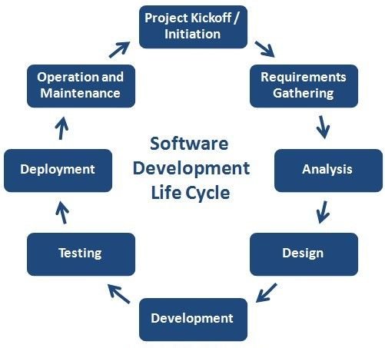

  - Write a requirement specification for a simple library management system.

A simple library management system requires functional specifications like adding/removing books, searching books by title/author/ISBN, tracking book check-outs and returns, and generating reports on available and borrowed books.

Non-functional requirements include user-friendliness, fast database access, high availability (24/7), and a robust, secure system that can handle unique book identifiers and member data.

  - Perform a functional analysis for an online shopping system.

For the Customer (User)
- User Registration & Profile
- Product Browsing & Search
- Shopping Cart Management
- Checkout & Payment
- Order Management

For the Administrator
- User Management
- Product Management
- Inventory Management
- Order Management

Cross-Functional & System-Wide Functions
- Content Management System (CMS)
- Promotions & Discounts
- Security & Authentication
- System Integrations

  - Design a basic system architecture for a food delivery app.

A basic food delivery app architecture includes customer and courier apps, a restaurant app/dashboard, and a central backend with a delivery engine.
Core Components
- Customer App
- Restaurant App/Dashboard
- Courier App
- Admin Panel
- API Gateway
- User & Restaurant Services
- Order Management System
- Payment Gateway
- Delivery Engine
- Database
- Notification Service

Key Processes
- Order Placement
- Order Fulfillment
- Delivery Assignment
- Real-time Tracking
- Completion & Payment

  - Develop test cases for a simple calculator program.

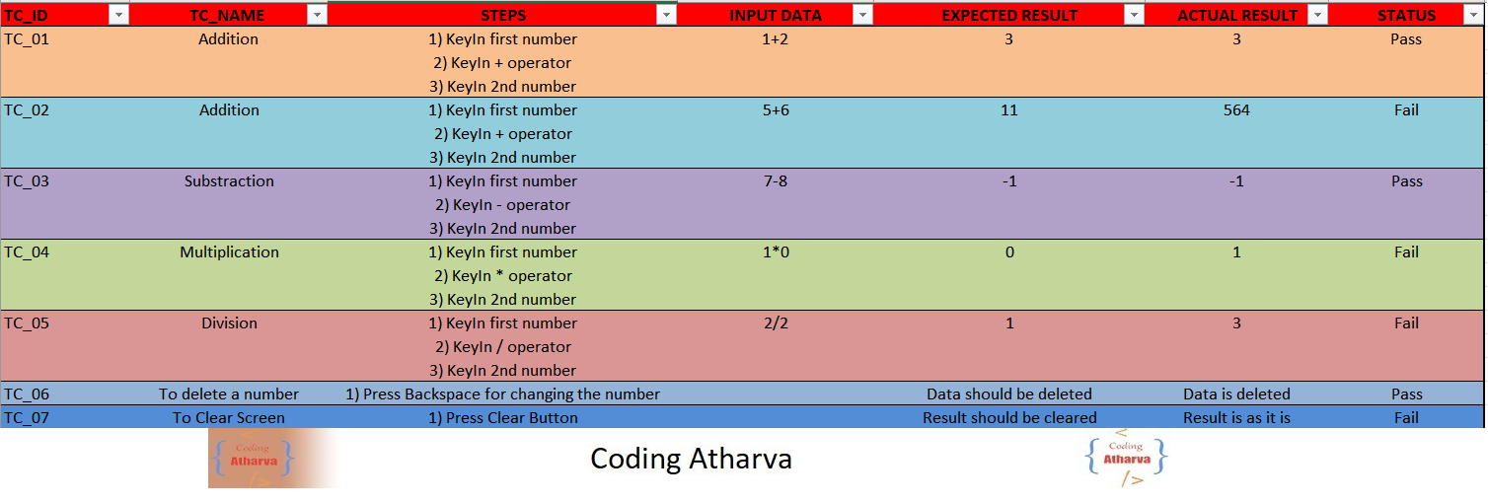
  - Document a real-world case where a software application required critical maintenance.

A notable real-world case of critical software maintenance is the 2021 Facebook Outage, which occurred during a routine maintenance procedure. A software bug in an automated audit tool allowed a faulty command to be deployed, crippling Facebook's network infrastructure and taking all of its services offline for nearly six hours.

  - Create a DFD for a hospital management system.

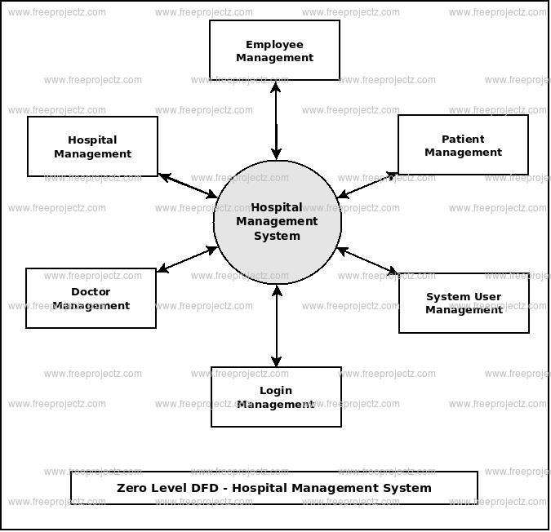

  - Build a simple desktop calculator application using a GUI library.

  - Draw a flowchart representing the logic of a basic online registration system.

