homepage:
only historical data for now on hero section
increase the icons or replace them with stronger icons- the challenge section
replace the decision gap section heading with- floodguard approach
make the flow chart to look something like this 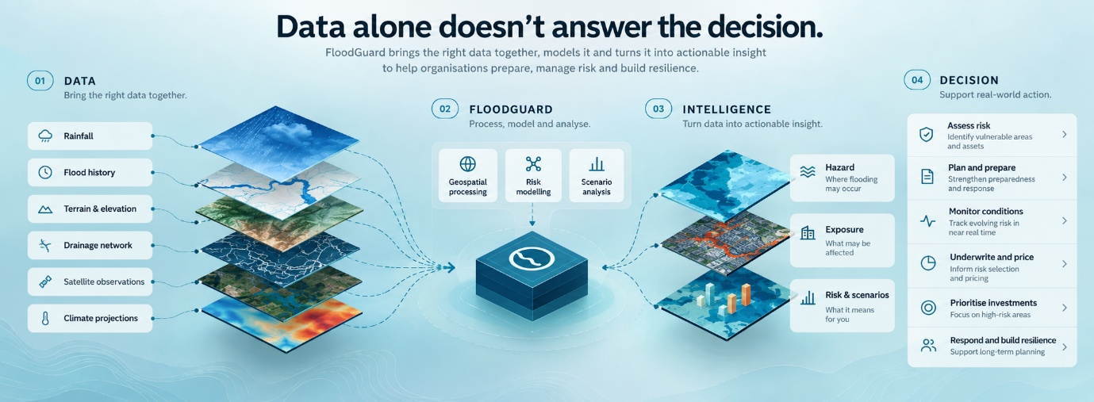
remove floodguard approach section completely

move the platform section from the homepage to platform page completely with more description.
Remove the whole platforms ection in homepage
Move the products overview section from products page to here in homepage products section- give explore more button for every product and make it navigate to that particular product.
Keep sectors as it is, remove solutions section, why floodguard secion should be removed, rename keep exploring section and make sure it has the highlights of what we post on insights page
For book a demo section – make sure all the pages have same CTA which is the one in products page. I pasted it below.
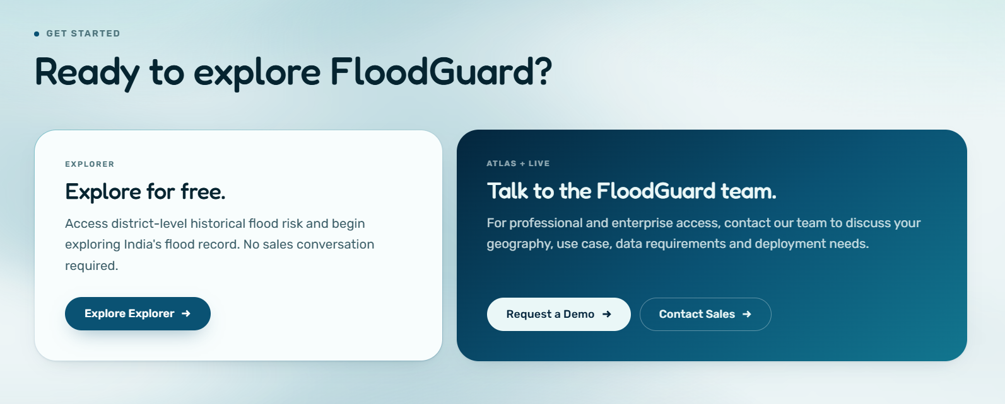
Products page:
Replace the hero section of product with this part- remove the existing view or atleast make it interesting
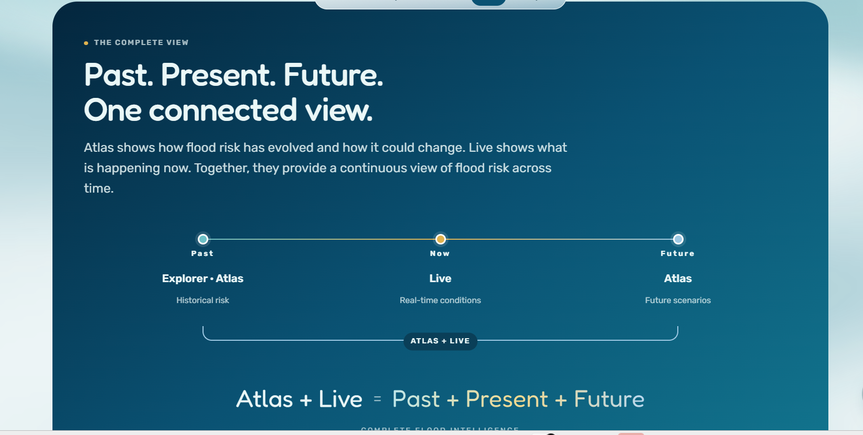
Remove overview section. For explorer section- the format should look like how you did for atlas. Live is good, but look at the alignment.
Remove the complete overview section as it is pushed to the hero section
Compare the platform section should be short, don’t list too many capabilities to confuse the user. Make it short and brief.
Not sure where to start section- remove completely
Keep get started as same.
Remove back to home button at the end.

Solutions page:
I don’t like the map in the hero section- replace it with something else which shows that our applications are many.
Keep the overview of solutions like how its been made for product overview. With an image and some description.
Then split each solution into each page. That means for 5 solutions- 5 pages. The wont be anything in the solutions page except the overview.
For insurance and reinsurance related solution- work on the content- which use case we are targeting should be projected there
For every solution there is misalignment of image and content as shown in the picture
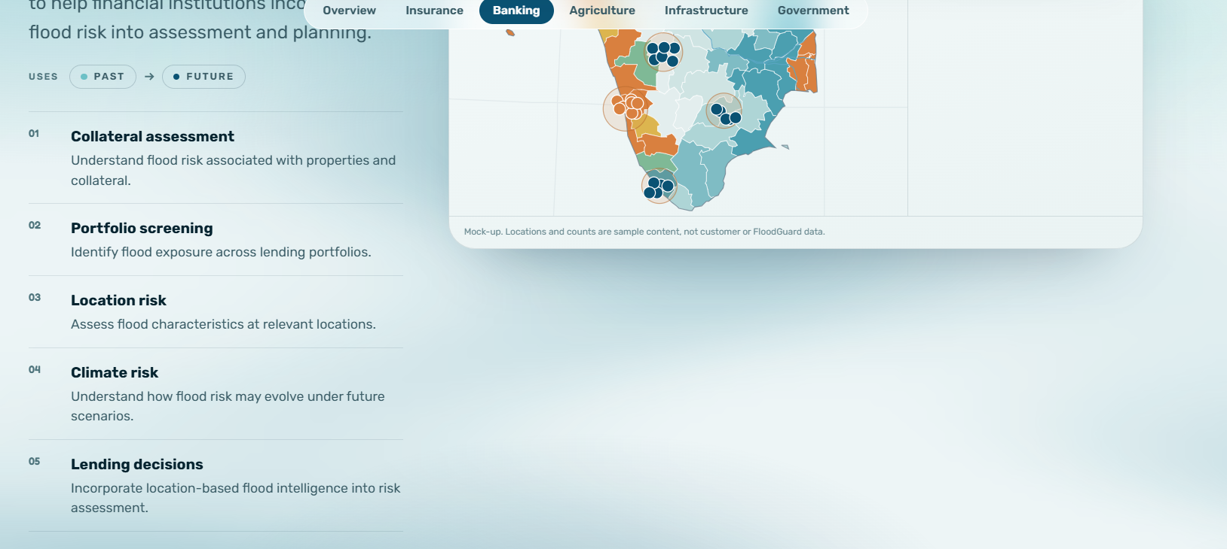
I want u to work on this misalignment for each solution . under each solution page, I want a get started CTA. Keep it as it is on all the pages of floodguard website

Platform page- separate page for platform from that section, with more description, change the content if necessary and make it mre engaging and trustworthy

For insights, I will write 4-5 blogs and each blog should appear next to each other- don’t make it flow like flashcards- not like the existing one.

About us section should have that we are thub, wehub, bowercapital backed project.
Include the profile of Dhanya Bulla and brief about her- and make her as founder- add her linkedin profile. Repeat the same for other people. Second should ber varun Ramavath- multistack developer, Rishanth Patkar- ML&AI analyst and research, and don’t mention any more names. But mention that we are a diverse team with experts from gis, ai, devops. Make this page more trustworthy for the people.

For all the pages- I need the menu bar to be remained same. In the menu bar- products, solutions should have a drop down. Platform, insights and about us will remain the same. Remove home or back to the home button on all the pages. User can navigate to homepage when they click on floodgaurd name or logo. Create a contact us page- with our contact details and address. Address is cohort coworking- Hyderabad(get details from maps), number is +91 9030762494, Mail id: dhanyabulla@floodguard.in
And the user flow should move from: home, products, solutions and everywhere they should move to explore the explorer dashboard. Make it clear thorugh buttons and navigation on all the pages.

