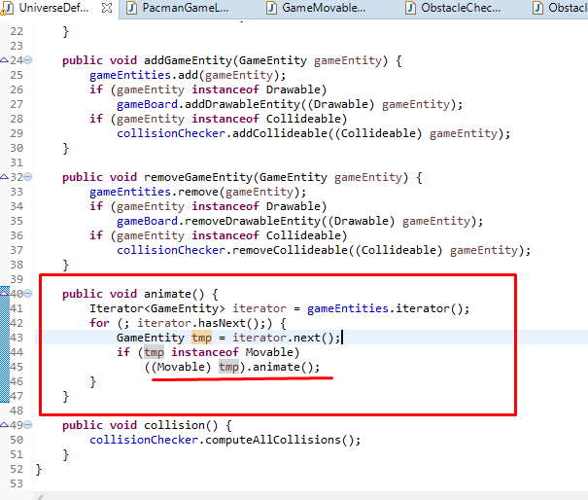

In class UniverseDefault, we can see that the function animate() call to another function animate() in [base](eclipse-javadoc:%E2%98%82=Pacman/%3Cbase).[Movable](eclipse-javadoc:%E2%98%82=Pacman/%3Cbase%7BMovable.java%E2%98%83Movable) to finish its job.