MERN STACK HACKATHON — PROJECT REPORT
FARMER
MARKETPLACE
Connecting farmers and customers with MongoDB, Express.js, React and Node.js
Subject | Full Stack Web Development (MERN Stack)
Problem Statement | Problem Statement 31 — Farmer Marketplace
Core Stack | MongoDB, Express.js, React.js and Node.js (MERN)
Suggested Technologies | REST API, JWT authentication, Mongoose, Axios
Hackathon / Project Designation | MERN Stack Hackathon — Full-Stack Web Application Prototype
Team Members | P . Niklesh  K . Vinay kumar  G . Ravi teja  A.Gouri shankar

1. Abstract
Farmers who grow food often depend on commission agents, wholesalers and local markets to reach their buyers. Each intermediary adds a margin, so the farmer receives only part of the final price, and the customer has little information about origin, availability or a fair price. This project addresses Problem Statement 31: Farmer Marketplace, which asks for a MERN-based web application that connects farmers and customers directly and manages product, quantity, price, farmer and location data in MongoDB.
The proposed system is a full-stack prototype built with MongoDB, Express.js, React.js and Node.js. Every product record stores its name, category, available quantity, unit price, the farmer who listed it and the location from which it is supplied. Farmers can add, view, update and delete their own listings. Customers can browse, search and filter listings by category and location, add items to a cart and place orders. An administrator can manage users and remove unsuitable listings.
The backend is a REST API written with Node.js and Express.js. Passwords are stored as bcrypt hashes, a JSON Web Token (JWT) is issued at login, and role-based access control middleware decides whether a farmer, a customer or an administrator may perform each operation. The React frontend calls this API and updates the screen without reloading the page. When an order is placed, the server checks the stock and reduces the quantity with an atomic database update, so that two customers cannot buy the same kilograms of produce.
The prototype is a demonstration system without real payments, delivery logistics or production hosting. The expected outcome is a working marketplace in which every main operation named in the problem statement (adding, viewing, updating and managing records) is available through the user interface and the API, and in which project information and results are displayed clearly. All numerical results in this report are illustrative worked examples, not measurements from a production deployment.
Keywords: MERN stack, MongoDB, Express.js, React.js, Node.js, REST API, CRUD, JWT, role-based access control, farmer marketplace.
Table 1: Project Summary
Item | Summary
Problem | Build a MERN-based marketplace that connects farmers and customers (Problem 31)
Data managed | Product, quantity, price, farmer and location, stored in MongoDB (users, products and orders collections)
Operations | Create, read, update and delete products; search by category and location; place and track orders
Access control | JWT authentication; three roles: farmer, customer and administrator
Technologies | MongoDB with Mongoose, Express.js, React.js, Node.js, Axios, bcrypt, jsonwebtoken
Outputs | Product listings, search results, cart and order summary, order status, farmer dashboard
Table 2: Organisation of the Report
Pages | Content
2 – 4 | Abstract, introduction, existing and proposed approach
5 – 7 | Problem statement, objectives, scope and limitations
8 – 10 | Major features, functional and non-functional requirements, system workflow
11 – 14 | Database design, REST API design, authentication and methodology, complexity analysis
15 – 16 | Technologies used and system implementation
17 – 20 | Sample results, testing, performance analysis, conclusion, future scope and references

2. Introduction

2.1 Background of Agricultural Marketing
Most farm produce travels from the field to the customer through several hands: a commission agent or trader at the local market, a wholesaler, a retailer and finally the customer. Every stage adds handling cost and profit margin. Because the farmer is at the start of the chain, the farmer has the least information about the final price and the least influence on it. A direct marketplace shortens the chain by letting the farmer publish what is available and letting the customer order it without a series of middlemen.

2.2 Farmers and Customers on One Platform
Farmers and customers need different things from the same data. A farmer needs to publish what is available (product, quantity, price and location) and to keep it up to date as stock is sold. A customer needs to find what is available near them, see the price before ordering and be sure that the quantity shown is really in stock. A marketplace therefore has to serve two kinds of users with different permissions over one shared set of records.

2.3 Problems Caused by Intermediaries and Poor Information
When listings are shared by phone calls, messaging groups or word of mouth, availability is quickly out of date and prices are not comparable. Farmers lose margin to intermediaries, small farmers find it hard to reach customers outside their own area, and fresh produce that cannot be sold in time is wasted. Customers, on the other hand, cannot easily tell who grew the produce or where it is stored, and no record is kept of what was ordered and when.

2.4 Importance of a Digital Marketplace
A digital marketplace gives every product a single, visible record with a quantity, a price, a farmer and a location. Customers can compare listings and search by category or place; farmers can change a price or a quantity in seconds; and every order is stored, so both sides can check what was agreed. For a small farmer, such a platform replaces the need for a shop or a stall with a profile and a product list.

2.5 Motivation for the Proposed System
Commercial marketplaces are large systems whose internal workings are hidden. For a project it is more valuable to build a small but complete application in which every layer can be seen, tested and explained: the database design, the REST API, the authentication rules and the user interface. The proposed Farmer Marketplace does exactly this. It is small enough to be understood end to end, yet it contains the main parts of a real web application: registration, login, role-based access, CRUD operations, search and a transactional order flow.

2.6 Role of the MERN Stack
The MERN stack combines four JavaScript technologies. MongoDB stores data as flexible JSON-like documents. Express.js and Node.js provide the server and the REST API. React.js builds the user interface from reusable components. Because all four use JavaScript and JSON, a product record keeps the same shape from the database through the API to the screen, and a team can work on every layer in one language.

3. Existing Approach and Proposed Approach

3.1 Traditional and Basic Selling Methods
The usual ways in which farmers sell produce are the local market or mandi, sale to a commission agent or trader, personal phone calls and general-purpose messaging or social media groups. These methods are familiar and need no technical skill, which is why they remain the default for most small farmers.

3.2 Limitations of Basic Methods
- Many intermediaries: each trader in the chain takes a margin, reducing the farmer’s share of the price.
- No price transparency: prices are agreed in person and cannot easily be compared across sellers or places.
- Outdated availability: quantities change as stock is sold, but messages and calls are not updated automatically.
- No order record: there is no shared history of what was ordered, at what price and when.
- No access control: in an open group anyone can post or change information, and nothing identifies the farmer.

3.3 Need for a Dedicated Marketplace
Because the same information (product, quantity, price, farmer and location) is needed by every user, it should be stored once, in a database, and shown to each user according to their role. This calls for a web application with an authenticated user model, a clear set of operations on the records and a search that lets customers find what they need. Problem 31 asks for exactly this combination, built with the MERN stack.

3.4 Proposed Farmer Marketplace
In the proposed system a farmer logs in and adds products with quantity, price and location. The records are stored in MongoDB through the Express.js API. A customer browses and filters the listings in the React interface, adds items to a cart and places an order. The server verifies the user’s token and role, checks the stock, reduces the quantity and stores the order. The farmer sees the orders for their own products and updates their status, and the customer can follow the progress.

3.5 High-Level Workflow
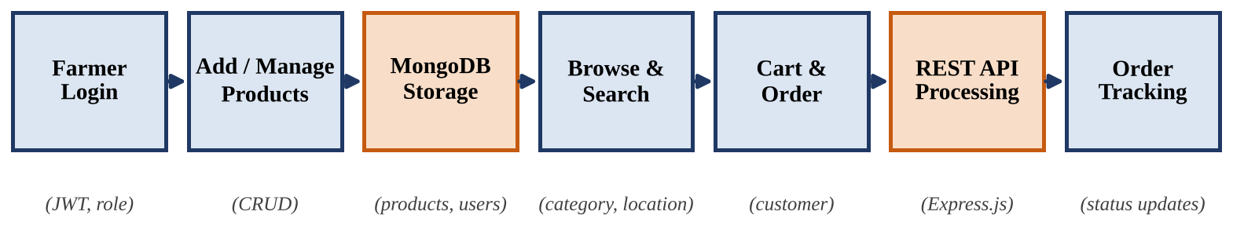
Figure 1: High-Level Farmer Marketplace Workflow
A farmer logs in and manages products, which are stored in MongoDB. Customers browse and search the stored listings, place orders through the REST API, and track the order status. Authentication and role checks are applied by the API to every protected request.

4. Problem Statement

4.1 Official Problem Statement
Problem 31 — Farmer Marketplace (Build a MERN-based farmer marketplace that connects farmers and customers). “The system should manage product, quantity, price, farmer and location using MongoDB. React should provide the user interface, while Node.js and Express.js should handle the backend APIs. The system should support the main operations required for the project, including adding, viewing, updating, and managing relevant records.”

4.2 Problem Definition
The task is to design and build a web application on which farmers can publish their produce and customers can find and order it. The application must keep product, quantity, price, farmer and location data in MongoDB, expose it through a REST API built with Node.js and Express.js, and present it through a React interface. The operations of adding, viewing, updating and managing records must work, and the permissions of each kind of user must be enforced.

4.3 Input, Processing and Output
Table 3: Problem 31 — Input, Processing, Access Control and Output
Stage | Description
Input | User registration and login details; for each product its name, category, quantity, unit price, location and farmer; search filters (category, location, keyword); cart items; order status updates.
Processing | Validate the input; authenticate the user; check the role and ownership; create, read, update or delete records in MongoDB; search and filter products; check and reduce stock when an order is placed.
Access control | A JWT identifies the user and the role. Farmers manage only their own products, customers place and view their own orders, and administrators manage users and any listing.
Output | Product listings and details, search results, cart and order summary, order status, farmer dashboard with stock and orders, and clear error messages.

4.4 Marketplace Requirements
- Every product must store its name, quantity, price, farmer and location.
- Only an authenticated farmer may add a product, and only the owner may change or delete it.
- Customers must be able to search and filter products without being able to change them.
- An order must never reduce the stock below zero.
- Invalid input must be rejected with a clear message and must not change stored data.

4.5 Need for Validation and Consistency
A marketplace is only useful if the data on the screen is correct. If a farmer could enter a negative price, if a customer could order more than is in stock, or if one farmer could change another farmer’s listing, the data would quickly become unreliable. The system therefore validates every input, checks ownership on every change and updates stock in a single atomic database operation. These rules are simple to state and test, but they are what turns a set of forms into a dependable application.

5. Objectives
The project has ten objectives. Each one corresponds to a feature, a technical component or a result presented later in the report.
Table 4: Project Objectives
No. | Objective | How the project addresses it
1 | Demonstrate MERN Stack development. | Build the application with MongoDB, Express.js, React.js and Node.js so that every layer of a modern web application is shown working together.
2 | Implement CRUD operations using MongoDB. | Create, read, update and delete products, users and orders through Mongoose models, with validation of every field.
3 | Build REST APIs using Node.js and Express.js. | Expose resources through URLs and HTTP methods, return JSON and use correct status codes for success and failure.
4 | Develop the frontend using React.js. | Build reusable components for login, product listing, farmer dashboard, cart and orders, which call the API and update without page reload.
5 | Implement authentication and role-based access. | Use bcrypt-hashed passwords, JWT login tokens and middleware that allows only the proper role to reach each route.
6 | Display project information and results clearly. | Show product tables, order summaries and statuses in readable form, and present sample results in tables and simple charts.
7 | Manage product, quantity, price, farmer and location. | Store these five data items for every listing and keep quantity correct when orders are placed or stock is updated.
8 | Connect farmers and customers directly. | Let a farmer publish a listing and a customer order from it without a separate trader in between.
9 | Protect data and reject invalid input. | Validate request bodies, enforce ownership of listings and never reduce stock below zero.
10 | Support easy discovery of produce. | Let customers search and filter by category, location, price and keyword, supported by database indexes.
Objectives 1 and 4 are treated in Chapters 14 and 15, objectives 2, 3 and 7 in Chapters 10 and 11, and objectives 5 and 9 in Chapter 12. Objectives 6 and 8 are demonstrated through the sample results of Chapters 16 and 17, and objective 10 is supported by the indexing analysis of Chapter 13 and the search test cases of Chapter 17.

6. Scope and Limitations

6.1 Scope
The project covers the following activities, all of which fall directly within Problem Statement 31:
- User accounts: registration and login for farmers, customers and one administrator.
- Role-based access: each route is open only to the roles that need it.
- Product management: farmers add, view, update and delete their own products.
- Quantity and price management: quantity and unit price are stored and kept current.
- Location handling: each product carries a location, which customers can filter on.
- Search and filter: products can be found by category, location, price range and keyword.
- Cart and orders: customers place orders, and stock is reduced automatically.
- Order tracking: farmers update the order status and customers follow it.
- Dashboard and display: a React interface shows listings, orders and summaries.

6.2 Limitations
- Prototype, not production system: the application is built for demonstration and is not hardened for large-scale public use.
- No real payment: an order records the amount, but online payment is not processed.
- No delivery logistics: pick-up or delivery arrangements are outside the system.
- Location as text: location is a city or district name, not GPS coordinates.
- Single database server: the prototype uses one MongoDB instance without replication.
- Product images: images are referenced by URL and are not uploaded to the server.
- Illustrative results: the numbers in Chapters 16 and 17 are worked examples, not field measurements.

6.3 Out of Scope
Payment gateways, delivery tracking, mobile applications, SMS or e-mail notifications, regional-language interfaces and automatic price prediction are not part of the problem statement and are not implemented.

6.4 Assumptions
- Farmers enter accurate quantities and prices for their own products.
- Users have an internet connection and a modern web browser.
- All prices are in one currency (Indian rupees) and quantities are in kilograms unless a unit is stated.

7. Major Features
The prototype provides ten major features. The table below lists each feature together with the component that implements it.
Table 5: Major Features of the Farmer Marketplace
Feature | Description | Component / Technology
User registration and login | Create an account with name, e-mail, password and role; log in and receive a JWT. | Auth Module (bcrypt, jsonwebtoken)
Role-based access | Farmer, customer and administrator routes are protected by middleware. | Auth and Role Middleware
Add product | A farmer lists a product with name, category, quantity, price and location. | Product Controller (POST)
View products | Anyone can browse the listings and open a product page with farmer and location. | Product Controller (GET), React list
Search and filter | Filter by category, location, price range and keyword. | MongoDB queries and indexes
Update product | A farmer changes the price or quantity of an own listing. | Product Controller (PUT)
Delete product | A farmer removes an own listing; an administrator may remove any listing. | Product Controller (DELETE)
Cart and order placement | A customer selects items; stock is checked and reduced; the order is saved. | Order Controller, React cart
Order management | A farmer sees orders for own products and updates their status; the customer tracks them. | Order Module
Admin management | An administrator lists users, deactivates accounts and removes unsuitable listings. | Admin Module
These features are deliberately limited to what Problem Statement 31 requires. They form a closed loop: farmers publish and update listings, customers find them and place orders, and the order records and updated stock flow back to both sides.

8. Functional Requirements
Table 6: Functional Requirements
ID | Requirement | Description
8.1 Input Requirements
FR-I1 | Registration details | The user supplies name, e-mail, password and role (farmer or customer).
FR-I2 | Login credentials | The user supplies e-mail and password to obtain a token.
FR-I3 | Product details | Name, category, quantity ≥ 0, unit price > 0 and location are required.
FR-I4 | Search filters | The customer may give category, location, price range and keyword.
FR-I5 | Cart items | Each cart item has a product ID and a positive quantity.
FR-I6 | Order status update | The farmer selects a new status for an order of an own product.
8.2 Processing Requirements
FR-P1 | Authenticate | Verify the password hash and issue a signed JWT with a limited lifetime.
FR-P2 | Authorise | Check the role in the token against the roles allowed for the route.
FR-P3 | Validate input | Reject missing, malformed or out-of-range values with a 400 response.
FR-P4 | Store records | Create, update and delete users, products and orders in MongoDB.
FR-P5 | Query products | Apply filters, sorting and pagination to the product collection.
FR-P6 | Place order | Check stock, reduce quantities atomically, compute the total and save the order.
FR-P7 | Check ownership | A farmer may change or delete only products whose farmer ID is their own.
8.3 Output Requirements
FR-O1 | Product list | Show name, price, quantity, farmer and location for each product.
FR-O2 | Product details | Show the full record of one product, including the farmer and location.
FR-O3 | Cart and order summary | Show items, quantities, prices and the total of the order.
FR-O4 | Order status | Show the current status of each order to the customer and the farmer.
FR-O5 | Farmer dashboard | Show own listings, remaining stock and incoming orders.
FR-O6 | Error messages | Show a clear message when a request is rejected.
Requirements are numbered so that they can be traced to test cases in Chapter 17. Inputs that violate the stated ranges (for example a negative price) are rejected with an error message and do not change the stored data.

9. Non-Functional Requirements and System Workflow
Table 7: Non-Functional Requirements
Attribute | Requirement
Performance | Common queries use indexes and are paginated, so listing pages load quickly for the demonstration data.
Usability | Plain labels; every rejected action shows a reason. The React interface updates without page reload and adapts to small screens.
Security | Passwords are hashed, tokens are signed and expire, and every protected route checks the role.
Reliability | Invalid input is rejected without changing data; stock never becomes negative.
Scalability | The API is stateless, so more server instances can be added; the data can later move to a replicated cluster.
Maintainability | Routes, controllers, models and middleware are separate modules, so a rule can change without touching the rest.

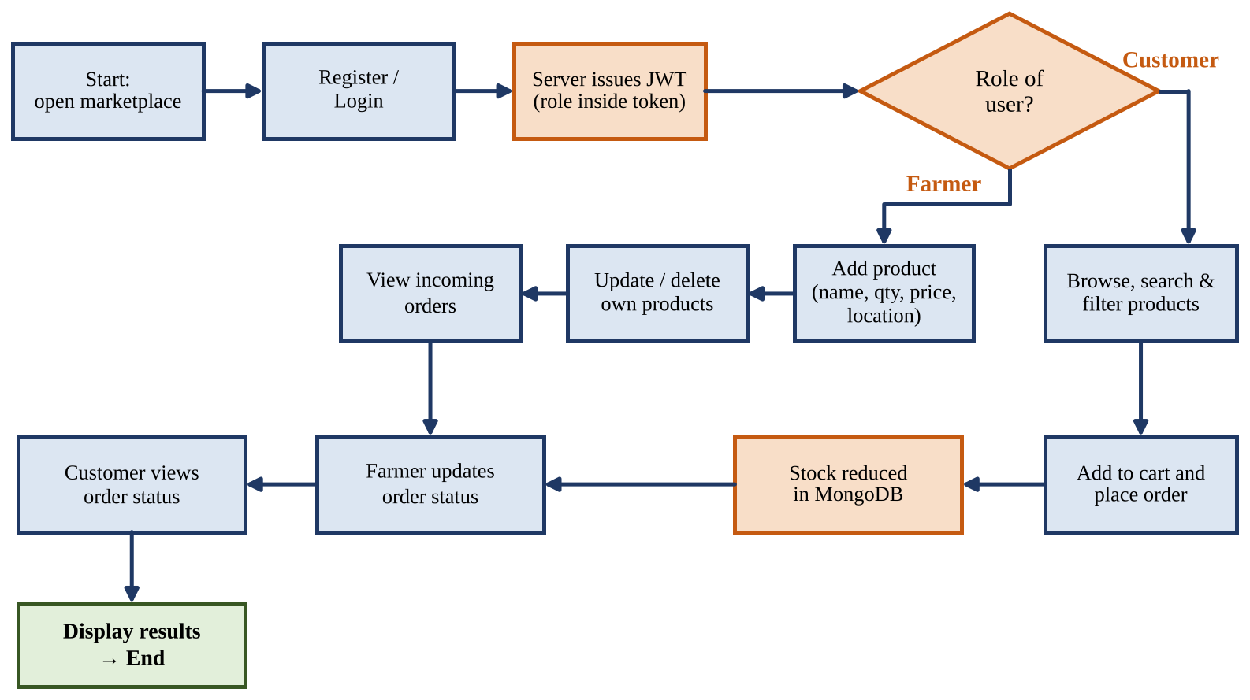
Figure 2: Detailed System Workflow
Table 8: Explanation of the Workflow Stages
No. | Stage | Explanation
1 | Start | The user opens the marketplace in the browser.
2 | Register / Login | The user creates an account or logs in with e-mail and password.
3 | Server Issues JWT | The server verifies the password and returns a signed token that contains the role.
4 | Role Check | Each later request is routed according to the role in the token.
5 | Add Product | A farmer adds a listing with name, quantity, price and location.
6 | Update / Delete Product | A farmer changes or removes a listing that they own.
7 | Browse, Search, Filter | A customer finds listings by category, location, price or keyword.
8 | Add to Cart and Order | The customer selects quantities and places the order.
9 | Stock Reduced | Stock is reduced atomically; the order is saved.
10 | Update Order Status | The farmer marks the order as confirmed, shipped or delivered.
11 | View Status and End | The customer follows the order progress; the session ends at logout.

10. Database Design (MongoDB)

10.1 Concept and Suitability
MongoDB is a document database. Instead of rows in tables it stores documents, which are JSON-like objects, in collections [1]. Product listings suit this model well: a product is read and written as a whole, different categories may need different extra fields, and the record maps directly to the JSON used by the API and React. Mongoose adds a schema on top of MongoDB, so that required fields, types and ranges are checked before a document is stored [5].

10.2 Collections and Relationships
The system uses three collections, shown in Figure 3. The users collection holds accounts and roles. The products collection holds one document per listing and refers to its farmer by ID, so one farmer owns many products. The orders collection refers to the customer and embeds the ordered items with the unit price at the time of purchase, so that a later price change does not alter an old order.
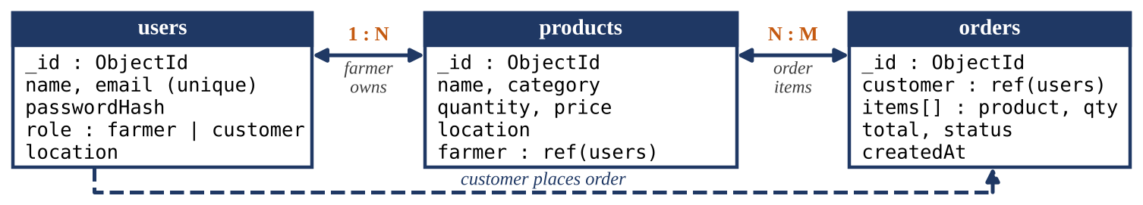
Figure 3: Collections and Relationships of the Marketplace Database

10.3 Design Steps
- Identify the entities: user, product and order.
- Choose references or embedding: the farmer is referenced from a product; order items are embedded in the order.
- Define required fields, types and ranges (quantity ≥ 0, price > 0, role in a fixed list).
- Add indexes for frequent queries: unique e-mail, category, location and farmer.
- Add automatic timestamps (createdAt, updatedAt) to every document.

10.4 Mongoose Schema
const productSchema = new mongoose.Schema({
name: { type: String, required: true, trim: true },
category: { type: String, required: true },
quantity: { type: Number, required: true, min: 0 }, // in kg
price: { type: Number, required: true, min: 0.01 }, // Rs. per kg
location: { type: String, required: true },
farmer: { type: mongoose.Schema.Types.ObjectId, ref: "User", required: true }
}, { timestamps: true });
productSchema.index({ category: 1, location: 1 }); // speeds up filtering

10.5 Small Example
Three sample product documents are shown below (shortened to the main fields; ID values are written as P1 to P3 for readability). A customer filter of category = Fruits and location = Chittoor returns only P3.
Table 9: Sample Product Documents (Sample Values)
ID | Name | Category | Qty (kg) | Price (Rs./kg) | Location | Farmer
P1 | Tomatoes | Vegetables | 120 | 30 | Guntur | Ramesh
P2 | Basmati rice | Grains | 200 | 70 | Warangal | Lakshmi
P3 | Mangoes | Fruits | 60 | 90 | Chittoor | Suresh
Each document stores all five data items required by the problem statement. The same documents are used in the sample results of Chapters 16 and 17.

11. REST API Design (Node.js and Express.js)

11.1 Concept
REST is an architectural style in which the server exposes resources at URLs and the client acts on them with the standard HTTP methods: GET to read, POST to create, PUT to update and DELETE to remove [8]. Each request carries everything the server needs, including the token, so the server keeps no session state. Responses are JSON, and the status code (200, 201, 400, 401, 403, 404, 409) tells the client what happened.

11.2 Why Express.js Is Useful Here
Express.js runs on Node.js and lets each route be declared with a method, a path and a chain of middleware functions [2], [3]. Authentication, role checks and validation are written once as middleware and placed in front of the controllers that need them.

11.3 API Endpoints
Table 10: REST API Endpoints
Method | Endpoint | Access | Purpose
POST | /api/auth/register | Public | Create a new account
POST | /api/auth/login | Public | Check credentials and return a JWT
GET | /api/products | Public | List products; filters: category, location, q, page
GET | /api/products/:id | Public | Show one product
POST | /api/products | Farmer | Add a product
PUT | /api/products/:id | Farmer (owner) | Update price or quantity
DELETE | /api/products/:id | Farmer (owner), Admin | Remove a product
POST | /api/orders | Customer | Place an order
GET | /api/orders/my | Customer | List own orders
GET | /api/orders/farmer | Farmer | List orders containing own products
PUT | /api/orders/:id/status | Farmer | Update the order status
GET | /api/admin/users | Admin | List all users

11.4 Sample Controller
// POST /api/products (farmer only)
exports.createProduct = async (req, res) => {
const { name, category, quantity, price, location } = req.body;
const product = await Product.create({
name, category, quantity, price, location,
farmer: req.user.id // taken from the verified JWT, never from the body
});
res.status(201).json(product); // 201 Created
};

11.5 Example Request Sequence
A customer filters the listing with GET /api/products?category=Fruits&location=Chittoor. Express matches the route, the controller builds the filter { category: "Fruits", location: "Chittoor" }, Mongoose runs find() with the compound index, and the matching documents are returned as JSON, which React shows as product cards.
GET /api/products?category=Fruits&location=Chittoor
200 OK
[ { "_id": "P3", "name": "Mangoes", "quantity": 60, "price": 90,
"location": "Chittoor", "farmer": "Suresh" } ]

12. Authentication and Request Methodology
Every protected request passes through the same sequence of checks before it reaches the database. Authentication answers “who is this user?”, authorisation answers “may this role do this?”, validation answers “is the input acceptable?” and the controller finally applies the business rules, such as ownership and stock. Keeping the order fixed makes the behaviour of the system predictable and easy to test.

12.1 Processing Steps
- The user registers; the password is hashed with bcrypt before it is stored [7].
- The user logs in; the server compares the hash and issues a signed JWT with the user ID and role [6].
- React keeps the token and sends it in the Authorization: Bearer header of every request.
- The authentication middleware verifies the signature and the expiry time of the token.
- The role middleware checks that the role is allowed for the route.
- The validator checks the request body and rejects missing or out-of-range values.
- The controller applies the ownership and stock rules.
- Mongoose reads or writes the documents in MongoDB.
- The server returns a JSON response with a suitable status code.
- React updates its state and re-renders the screen, or shows the error message.

12.2 Methodology Flowchart
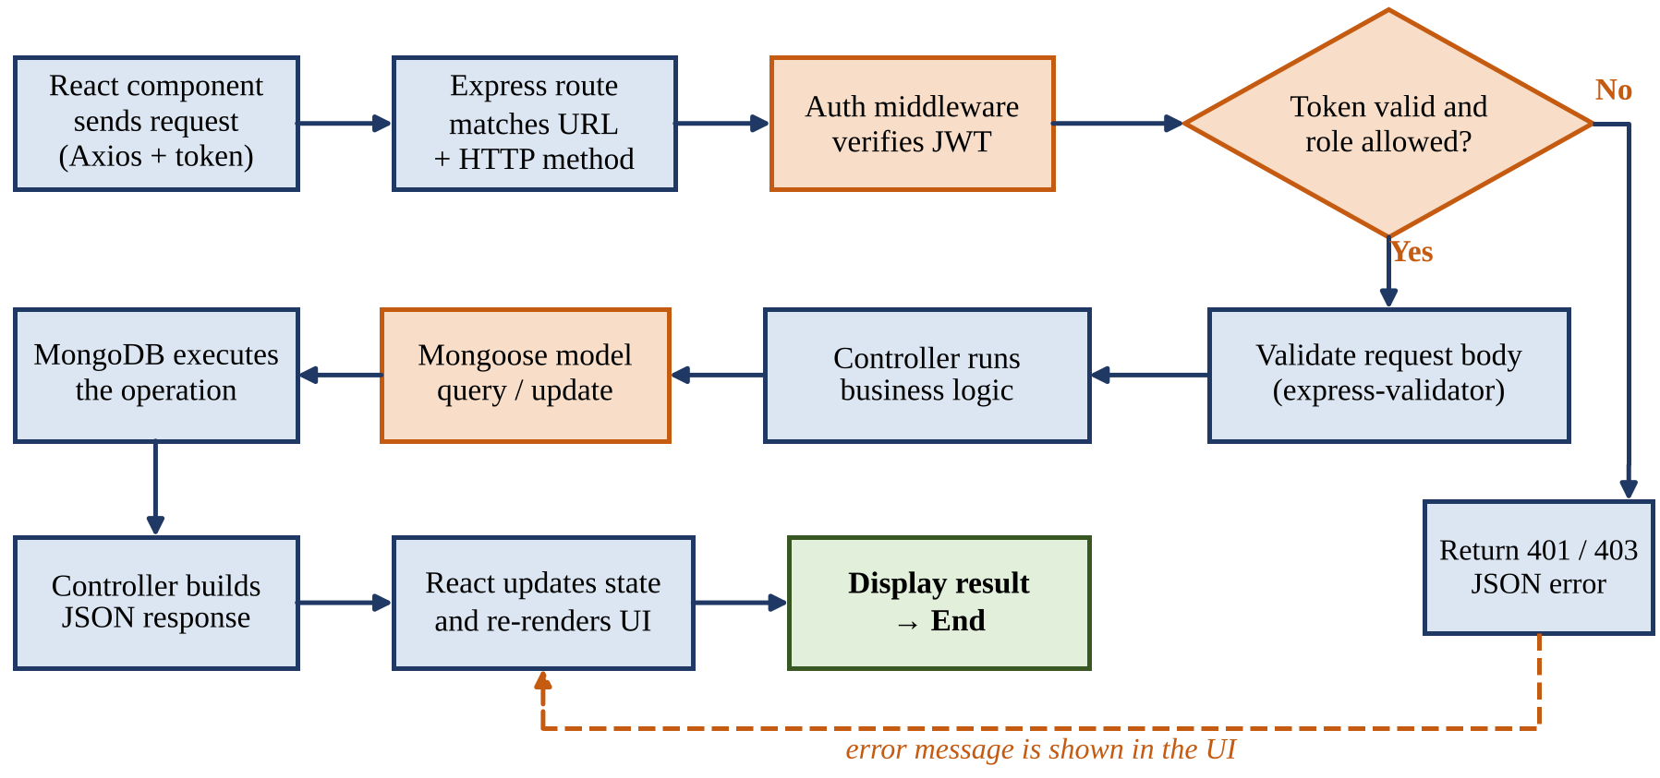
Figure 4: Methodology Flowchart of a Protected API Request
const authorize = (...roles) => (req, res, next) => {
const token = (req.headers.authorization || "").split(" ")[1];
if (!token) return res.status(401).json({ message: "Login required" });
try { req.user = jwt.verify(token, process.env.JWT_SECRET); }
catch { return res.status(401).json({ message: "Invalid or expired token" }); }
if (roles.length && !roles.includes(req.user.role))
return res.status(403).json({ message: "Access denied" });
next();
};
router.post("/", authorize("farmer"), createProduct); // route-level rule
Because the rule is written where the route is declared, the permissions of the whole API can be read from the route files, and a rule can be changed without editing any controller.

13. Complexity Analysis
Let n be the number of products, k the number of products that match a search, u the number of users, o the number of orders and m the number of items in one order. MongoDB indexes are B-tree structures, so an indexed lookup costs O(log n) [1].

13.1 Time Complexity
Table 11: Time Complexity of the Main Operations
Operation | Complexity | Explanation
Insert a product | O(log n) | One entry is added to each index
Find a product by _id | O(log n) | Lookup in the _id index
Search with index (category, location) | O(log n + k) | Index seek, then k matching documents are returned
Search without index | O(n) | Every document of the collection is examined
Update or delete by _id | O(log n) | Locate by index, then change the document and its index entries
Login (bcrypt check) | O(1) | Constant for a fixed cost factor; deliberately slow
JWT verification | O(1) | One signature check per request
Place an order of m items | O(m log n) | Each item is located and its stock decremented

For a search the cost is O(log n + k) with an index and O(n) without one, so indexing matters most as the number of products grows. A page of results of fixed size p costs O(log n + p), and placing an order of m items costs O(m log n), where m is usually a small number.

13.2 Space Complexity
Table 12: Space Complexity of the Data Structures
Structure | Space | Explanation
users collection | O(u) | One document per user
products collection | O(n) | One document per listing
orders collection | O(o · m) | One document per order with m embedded items
Indexes | O(n) | Each index adds one entry per product
Overall | O(u + n + o · m) | Excluding the constant-size server process

13.3 Remarks on Correctness and Consistency
- Index choice: the compound index (category, location) supports queries on category and on category with location, but not on location alone, so a separate location index is added for that case.
- Overselling is prevented: each stock decrement is one conditional atomic update (quantity ≥ requested). Single-document updates in MongoDB are atomic, so two customers cannot both take the last kilograms. For a multi-item order the prototype restores earlier decrements if a later item fails; production use would add transactions on a replica set.
- Pagination: skip and limit are simple but slow down as the skip value grows; for very large collections, range-based paging on an indexed field would be preferred (Chapter 18).

14. Technologies Used
The technologies follow Problem Statement 31: MongoDB for data, Node.js and Express.js for the backend APIs and React.js for the user interface [1]–[5]. Supporting libraries handle security, validation and communication. Figure 5 shows how they are arranged in three layers, which keeps the browser, the server logic and the stored data clearly separated.
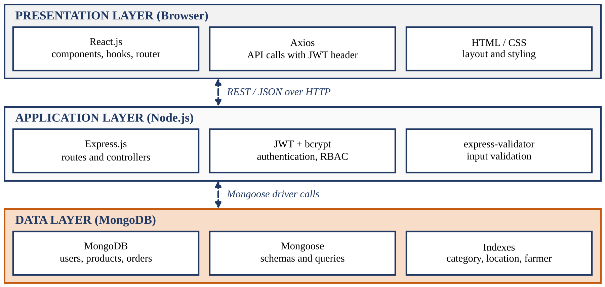
Figure 5: Technology Stack of the Farmer Marketplace
Table 13: Technologies and Their Purpose
Technology | Layer | Purpose in this project
MongoDB | Database | Stores users, products and orders as documents and supports indexed queries.
Mongoose | Data access | Defines schemas, validates fields and provides query methods.
Node.js | Backend | JavaScript runtime that executes the server.
Express.js | Backend | Routing, middleware and controllers of the REST API.
JWT, bcrypt | Security | Signed login tokens and salted password hashing.
express-validator | Backend | Checks and cleans request bodies before they reach the controllers.
React.js | Frontend | Component-based user interface with state and hooks.
React Router | Frontend | Page navigation without reloading the browser.
Axios | Frontend | Sends API requests and attaches the token to each one.
HTML, CSS | Frontend | Page structure, layout and responsive styling.

15. System Implementation
The prototype follows a modular architecture. The React application sends JSON requests to the Express.js server, which passes them through the authentication, role and validation middleware to the route controllers. The controllers use Mongoose models to read and write MongoDB. Keeping routes, controllers, models and middleware in separate modules means that each part can be tested and changed on its own.
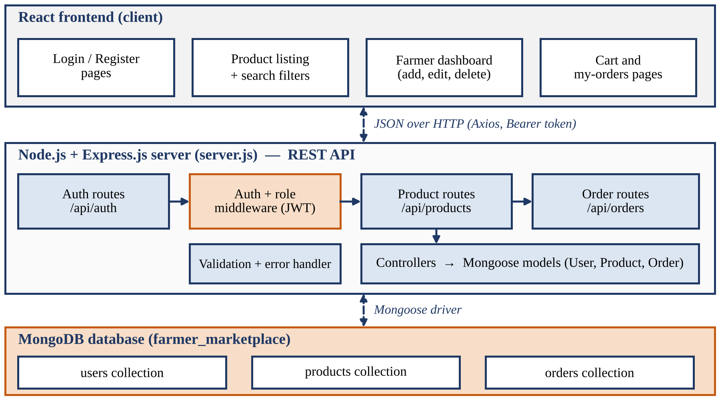
Figure 6: Architecture of the Farmer Marketplace
Table 14: Implementation Modules
Module | Responsibility
Auth module | Registers users, hashes passwords, checks logins and issues JWTs.
Auth and role middleware | Verifies the token and allows only the permitted roles through a route.
Product module | Create, read, update and delete products; search, filter and pagination.
Order module | Checks and reduces stock, stores orders, updates and reports order status.
Admin module | Lists users, deactivates accounts and removes unsuitable listings.
Validation and error handler | Rejects bad input and returns a uniform JSON error.
React pages and components | Login, product list, product page, farmer dashboard, cart and my-orders.
API service (Axios) | One place that sends requests and attaches the Bearer token.

Representative core of the order module (simplified):
router.post("/", authorize("customer"), async (req, res) => {
const done = [];
for (const it of req.body.items) { // it = { productId, qty }
const ok = await Product.findOneAndUpdate(
{ _id: it.productId, quantity: { $gte: it.qty } }, // enough stock?
{ $inc: { quantity: -it.qty } }); // atomic decrement
if (!ok) { await restoreStock(done);
return res.status(409).json({ message: "Insufficient stock" }); }
done.push(it);
}
... // save the order with a price snapshot and return 201
});

16. Results
Sample / Demonstration Results. The values below are illustrative worked examples obtained by applying the order and update rules of Chapters 11 and 12 to the sample products of Table 9 (quantities in kg, prices in Rs. per kg). They are not measurements from real experiments or a real deployment.

Table 15: Sample Operations in Four Scenarios
Req. | User | API call | Checks | Result | Stock after P1 / P2 / P3
Scenario 1: Valid single-item order. Initial stock P1 = 120, P2 = 200, P3 = 60
R1 | Customer C1 | POST /api/orders  P1 × 20 kg | Token valid; role = customer; 20 ≤ 120 | 201 Created; total Rs. 600 | 100 / 200 / 60
Scenario 2: Order with two items. Initial stock P1 = 120, P2 = 200, P3 = 60
R2 | Customer C2 | POST /api/orders  P2 × 50, P3 × 15 | Stock sufficient for both items | 201 Created; total Rs. 4,850 | 120 / 150 / 45
Scenario 3: Insufficient stock. Initial stock P1 = 120, P2 = 200, P3 = 60
R3 | Customer C3 | POST /api/orders  P3 × 80 kg | 80 > 60 available | 409 Conflict; nothing stored | 120 / 200 / 60
Scenario 4: Farmer updates. Initial stock P1 = 120, P2 = 200, P3 = 60
R4 | Farmer F1 (Ramesh) | PUT /api/products/P1  quantity = 180 | Token valid; role = farmer; owner of P1 | 200 OK; P1 updated | 180 / 200 / 60
R5 | Farmer F2 (Lakshmi) | PUT /api/products/P1  price = 35 | Not the owner of P1 | 403 Forbidden; no change | 180 / 200 / 60
Reading the table. In Scenario 1 the order total is 20 × 30 = Rs. 600. In Scenario 2 the two items give 50 × 70 + 15 × 90 = 3,500 + 1,350 = Rs. 4,850. In Scenario 3 the request exceeds the stock of P3, so the conditional update fails and the stock stays at 60. In Scenario 4 the second request is refused because Lakshmi does not own P1, although her token is a valid farmer token.
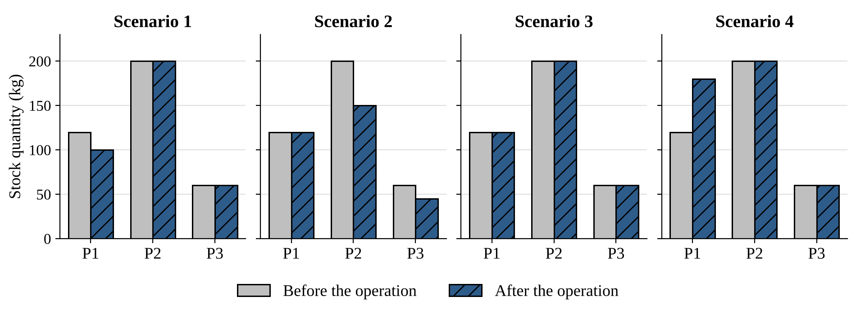
Figure 7: Stock Quantity per Product Before and After the Operations (Sample Values)

17. Testing and Performance Analysis
Each test case below describes an input condition, the result expected from the rules of the design and the simulated result of applying those rules. The cases cover registration, login, access control, validation, search and ordering, and map to the requirements of Chapter 8. They are illustrative and were not produced by an automated test run.
Table 16: Test Cases and Simulated Results
No. | Test case | Input condition | Expected result | Simulated result | Status
1 | Register new user | Valid name, new e-mail, password, role = customer | 201; password stored as hash | 201; hash stored | Pass
2 | Register duplicate e-mail | E-mail already in users | 409 error | 409 “Email already registered” | Pass
3 | Login with valid data | Correct e-mail and password | 200 with JWT | 200; token contains role | Pass
4 | Login with wrong password | Correct e-mail, wrong password | 401 error | 401; no token | Pass
5 | Call protected route without token | POST /api/products, no header | 401 error | 401 “Login required” | Pass
6 | Customer adds a product | Valid token, role = customer | 403 error | 403 “Access denied” | Pass
7 | Farmer adds valid product | All five fields valid | 201; stored in MongoDB | 201; product returned | Pass
8 | Negative price | price = −5 | 400 validation error | 400; nothing stored | Pass
9 | Search by category and location | Fruits, Chittoor | Only matching products | P3 only | Pass
10 | Order above stock | P3 × 80 with stock 60 | 409; stock unchanged | 409; stock = 60 | Pass

17.1 Performance Analysis (Sample Values)
The metrics below are defined for evaluating the prototype. Numerical values are worked examples from the stated sample inputs.
- Documents examined: how many documents MongoDB reads to answer a search; lower is better.
- Response time: time from sending a request to receiving the JSON response.
- Stock consistency: whether the stored quantity always equals the opening stock minus the confirmed orders.
- Success rate: share of valid requests that return a 2xx response.
Table 17: Indexed Search versus Collection Scan (Documents Examined, Sample Values)
Case | Products (n) | Matches (k) | Collection scan | Compound index
1 | 100 | 4 | 100 | ≈ 4
2 | 1,000 | 38 | 1,000 | ≈ 38
3 | 10,000 | 420 | 10,000 | ≈ 420
4 | 50,000 | 2,100 | 50,000 | ≈ 2,100
In case 4 a collection scan examines all 50,000 documents, whereas the index leads directly to the 2,100 matching ones, about 24 times fewer. The saving grows with n while the number of matches stays small. These values follow from the stated sample counts and are not benchmark measurements.

18. Conclusion and Future Scope

18.1 Conclusion
This project addressed Problem Statement 31 by designing a MERN-based farmer marketplace that connects farmers and customers. Product, quantity, price, farmer and location are stored in MongoDB; a REST API written with Node.js and Express.js exposes the operations; and a React interface lets farmers add, update and manage listings and lets customers search, order and track them. Authentication with JWT and role-based access control keep each user within their permissions.
The design is easy to follow: a request is authenticated, authorised and validated, then handled by a controller that reads or writes MongoDB through Mongoose. Ownership checks and an atomic stock update keep the data reliable, and indexes keep common searches efficient as the number of products grows. The sample results show correct behaviour for ordinary orders, insufficient stock and unauthorised changes.
The prototype is a demonstration and not a production service: it has no real payments, no delivery handling and no replicated database. Even so, it shows the full path from the database to the screen in one language and meets each objective listed in Chapter 5.

18.2 Future Scope
The following extensions are realistic next steps.
Table 18: Possible Future Extensions
No. | Extension | Possible contribution
1 | Online payment gateway | Accept UPI or card payments and record them against orders.
2 | Real-time notifications | Inform farmers of new orders and customers of status changes by push, SMS or e-mail.
3 | Map-based location search | Store coordinates and find produce within a chosen distance.
4 | Image upload | Let farmers upload product photos to cloud storage.
5 | Ratings and reviews | Let customers rate farmers and products after delivery.
6 | Delivery integration | Connect with local delivery partners and show tracking.
7 | Price guidance | Suggest fair prices from recent market data.
8 | Regional languages | Offer the interface in local languages for farmers.
9 | Mobile application | Provide a React Native app on the same API.
10 | Cloud deployment | Deploy with containers, a replicated database and automated tests.

19. References
The MERN stack concepts in this report follow the standard documentation listed below: the database, server and interface technologies are cited as [1]–[5], authentication as [6]–[7] and the REST style as [8].
[1] MongoDB, Inc., “MongoDB Manual.” [Online]. Available: https://www.mongodb.com/docs/manual/
[2] OpenJS Foundation, “Node.js Documentation.” [Online]. Available: https://nodejs.org/docs/latest/api/
[3] Express contributors, “Express — Node.js web application framework.” [Online]. Available: https://expressjs.com/
[4] Meta Platforms, Inc., “React Documentation.” [Online]. Available: https://react.dev/
[5] Mongoose contributors, “Mongoose Documentation.” [Online]. Available: https://mongoosejs.com/docs/
[6] M. Jones, J. Bradley, and N. Sakimura, “JSON Web Token (JWT),” RFC 7519, Internet Engineering Task Force, May 2015. [Online]. Available: https://www.rfc-editor.org/rfc/rfc7519
[7] N. Provos and D. Mazières, “A future-adaptable password scheme,” in Proc. USENIX Annual Technical Conference, FREENIX Track, 1999, pp. 81–91.
[8] R. T. Fielding, “Architectural styles and the design of network-based software architectures,” Ph.D. dissertation, Univ. of California, Irvine, 2000.
[9] MERN Stack Hackathon, “Problem Statement 31: Farmer Marketplace,” problem statement document provided by the organisers. [Details of the issuing document to be added by the team.]

