MAC237 – Computer Security
Lab (70 points)
Web Application Penetration Testing
Access Control using Burp Suite
Student: Gokan Bektas
Instructor: Dr. Doyel Pal
LaGuardia Community College (CUNY)
Environment: Kali Linux + Burp Suite Community Edition • PortSwigger Web Security Academy

Overview
This lab covers seven Access Control vulnerabilities on PortSwigger's Web Security Academy (Apprentice level). Access control (authorization) is the server-side check of whether a logged-in user is allowed to do what they're asking. When those checks are missing or can be bypassed, a normal user can reach admin features or another user's data. Each task is a separate deliberately-vulnerable lab tied to my own PortSwigger account, so all testing was authorized and legal.
Two problem types appear: vertical privilege escalation (a low-privilege user gains admin powers — Tasks 1–4) and horizontal privilege escalation / IDOR (one user reaches another user's data — Tasks 5–7).

Setup
1. Launched Burp Suite Community Edition in Kali Linux → Temporary project → Use Burp defaults → Start Burp.
2. Opened Burp's built-in browser (Proxy → Open browser) so all traffic routes through Burp.
3. Logged in to portswigger.net so solved labs record to my account.
4. Used Repeater (Ctrl+R to send a request there) to modify and resend requests for the exploitation steps.

Task 1 — Unprotected admin functionality (10 pts)
Lab: https://portswigger.net/web-security/access-control/lab-unprotected-admin-functionality
The vulnerability
The admin panel has no authorization check — anyone who knows the URL can use it. The path is disclosed in the site's robots.txt file.
Solution steps
1. Browsed to /robots.txt — the Disallow: line revealed /administrator-panel.
2. Navigated to /administrator-panel — it loaded with no login required.
3. Deleted user carlos to solve the lab.
Why it matters
Security through obscurity is not access control. Admin routes need a real server-side authorization check, not just a hidden URL.
Screenshots
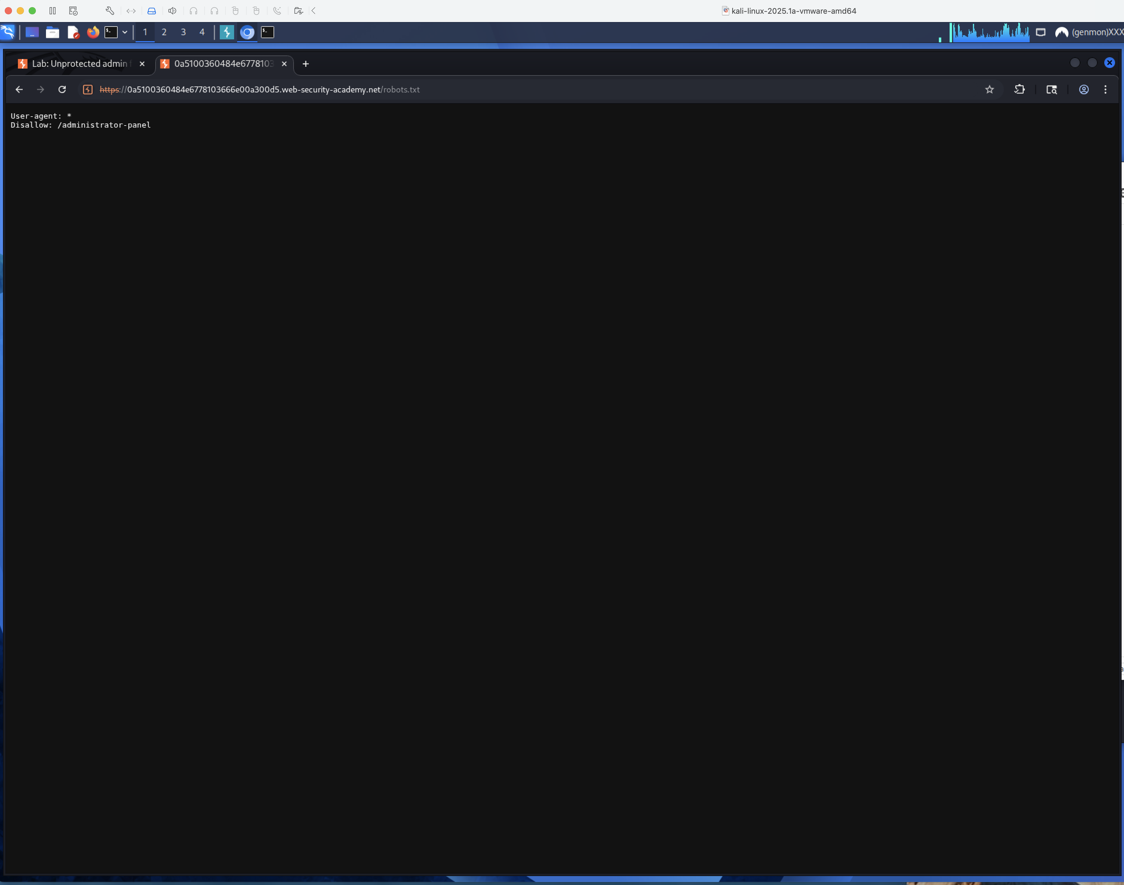
Screenshot 1a — BurpSuite / working screen: robots.txt disclosing the admin panel path
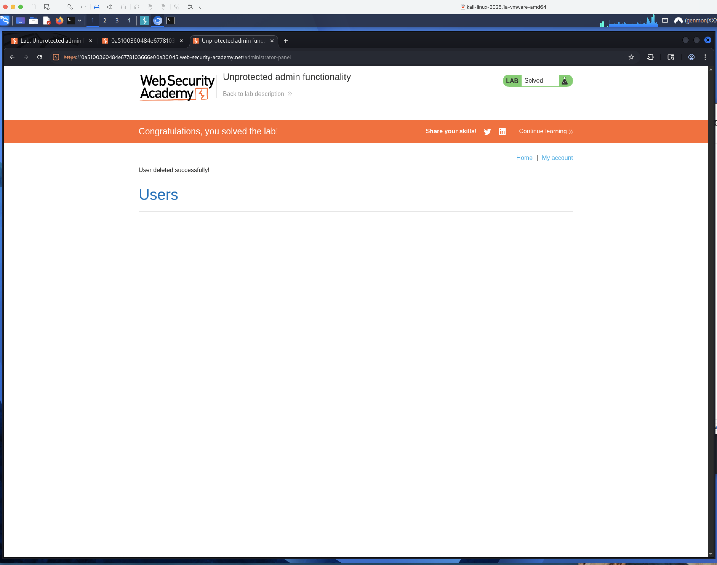
Screenshot 1b — PortSwigger: PortSwigger lab solved

Task 2 — Unprotected admin functionality with unpredictable URL (10 pts)
Lab: https://portswigger.net/web-security/access-control/lab-unprotected-admin-functionality-with-unpredictable-url
The vulnerability
The admin URL is randomized, but the home page's JavaScript references it to decide whether to show an admin link — leaking the secret path to the client.
Solution steps
1. Viewed the home page source and found the admin path inside a <script> block: /admin-12cgtl.
2. Browsed to that path — the admin panel loaded.
3. Deleted user carlos to solve the lab.
Why it matters
Anything the client/JavaScript can see is not secret. Hiding an admin link in client-side code does not protect the endpoint it points to.
Screenshots
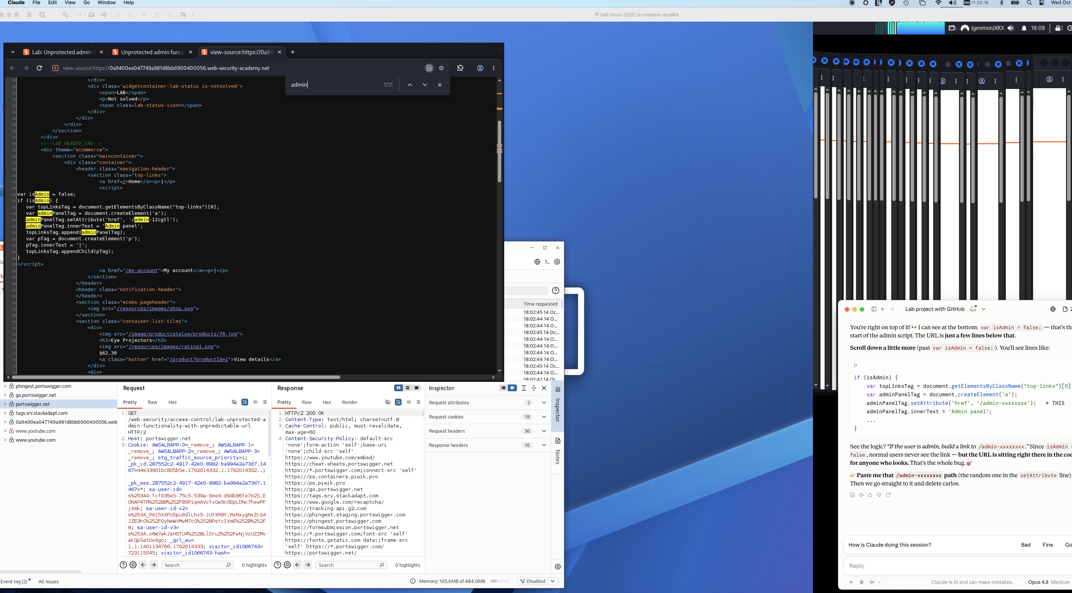
Screenshot 2a — BurpSuite / working screen: Admin URL (/admin-12cgtl) found in the page source JavaScript
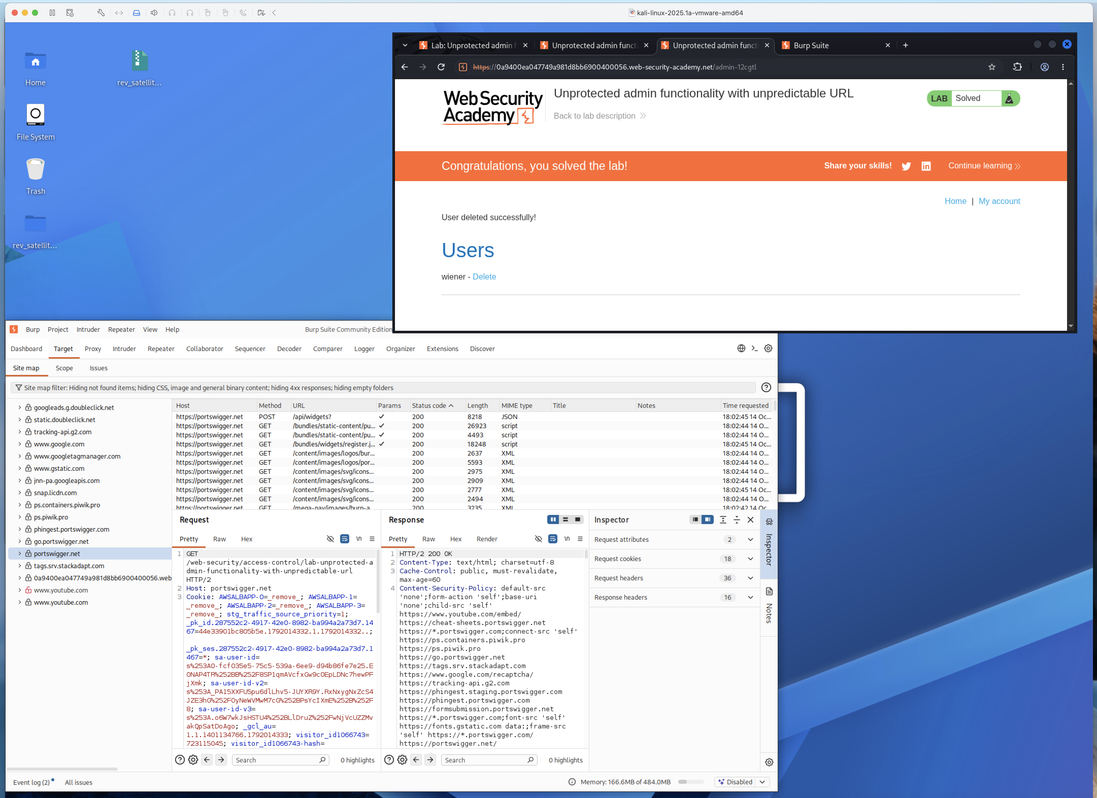
Screenshot 2b — PortSwigger: PortSwigger lab solved

Task 3 — User role controlled by request parameter (10 pts)
Lab: https://portswigger.net/web-security/access-control/lab-user-role-controlled-by-request-parameter
The vulnerability
The app decides admin status from a client-side Admin cookie. Because the value lives on the client, it can simply be changed to true.
Solution steps
1. Logged in as wiener:peter; /admin returned 401 Access denied.
2. Sent the GET /admin request to Repeater and saw Cookie: Admin=false.
3. Changed it to Admin=true and sent — response became 200 OK with the admin panel.
4. Changed the path to /admin/delete?username=carlos (keeping Admin=true) and sent — 302, carlos deleted.
Why it matters
Never trust the client to state its own role. Roles must be stored and checked server-side, not carried in a cookie the user controls.
Screenshots
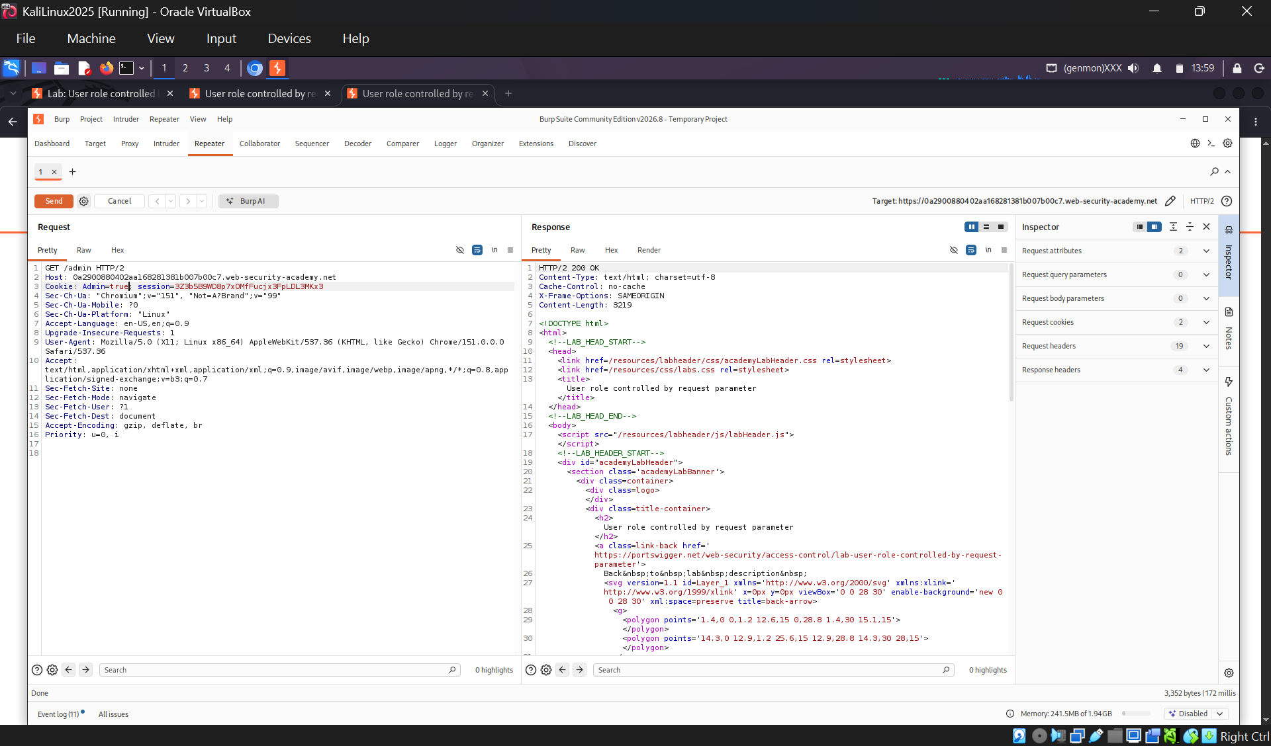
Screenshot 3a — BurpSuite / working screen: Repeater: Admin=true cookie returns 200 OK (admin panel)
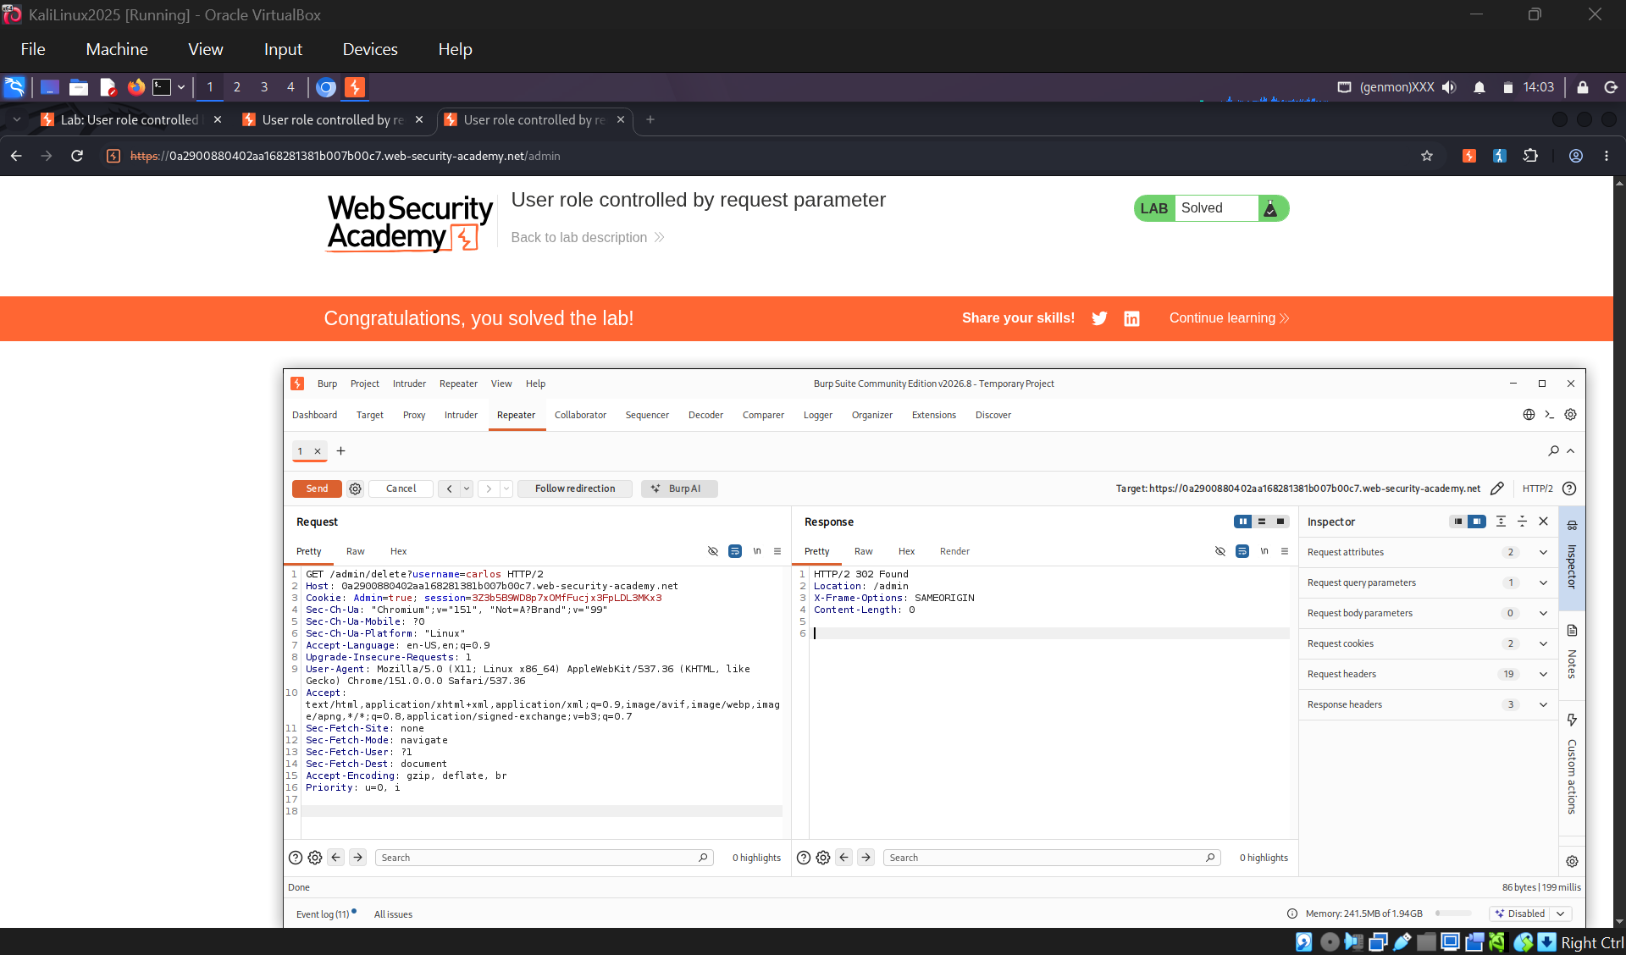
Screenshot 3b — PortSwigger: Repeater delete request (302) and lab solved

Task 4 — User role can be modified in user profile (10 pts)
Lab: https://portswigger.net/web-security/access-control/lab-user-role-can-be-modified-in-user-profile
The vulnerability
The change-email endpoint accepts a JSON body and honors a roleid field it should never trust from the client (mass assignment).
Solution steps
1. Logged in as wiener:peter, submitted an email change, and sent POST /my-account/change-email to Repeater.
2. Response included "roleid":1.
3. Added "roleid":2 to the JSON body and resent — response showed "roleid":2.
4. Browsed to /admin (now allowed) and deleted carlos.
Why it matters
Mass assignment: the server must only accept fields a user is allowed to change (email) and ignore privileged fields like roleid even if submitted.
Screenshots
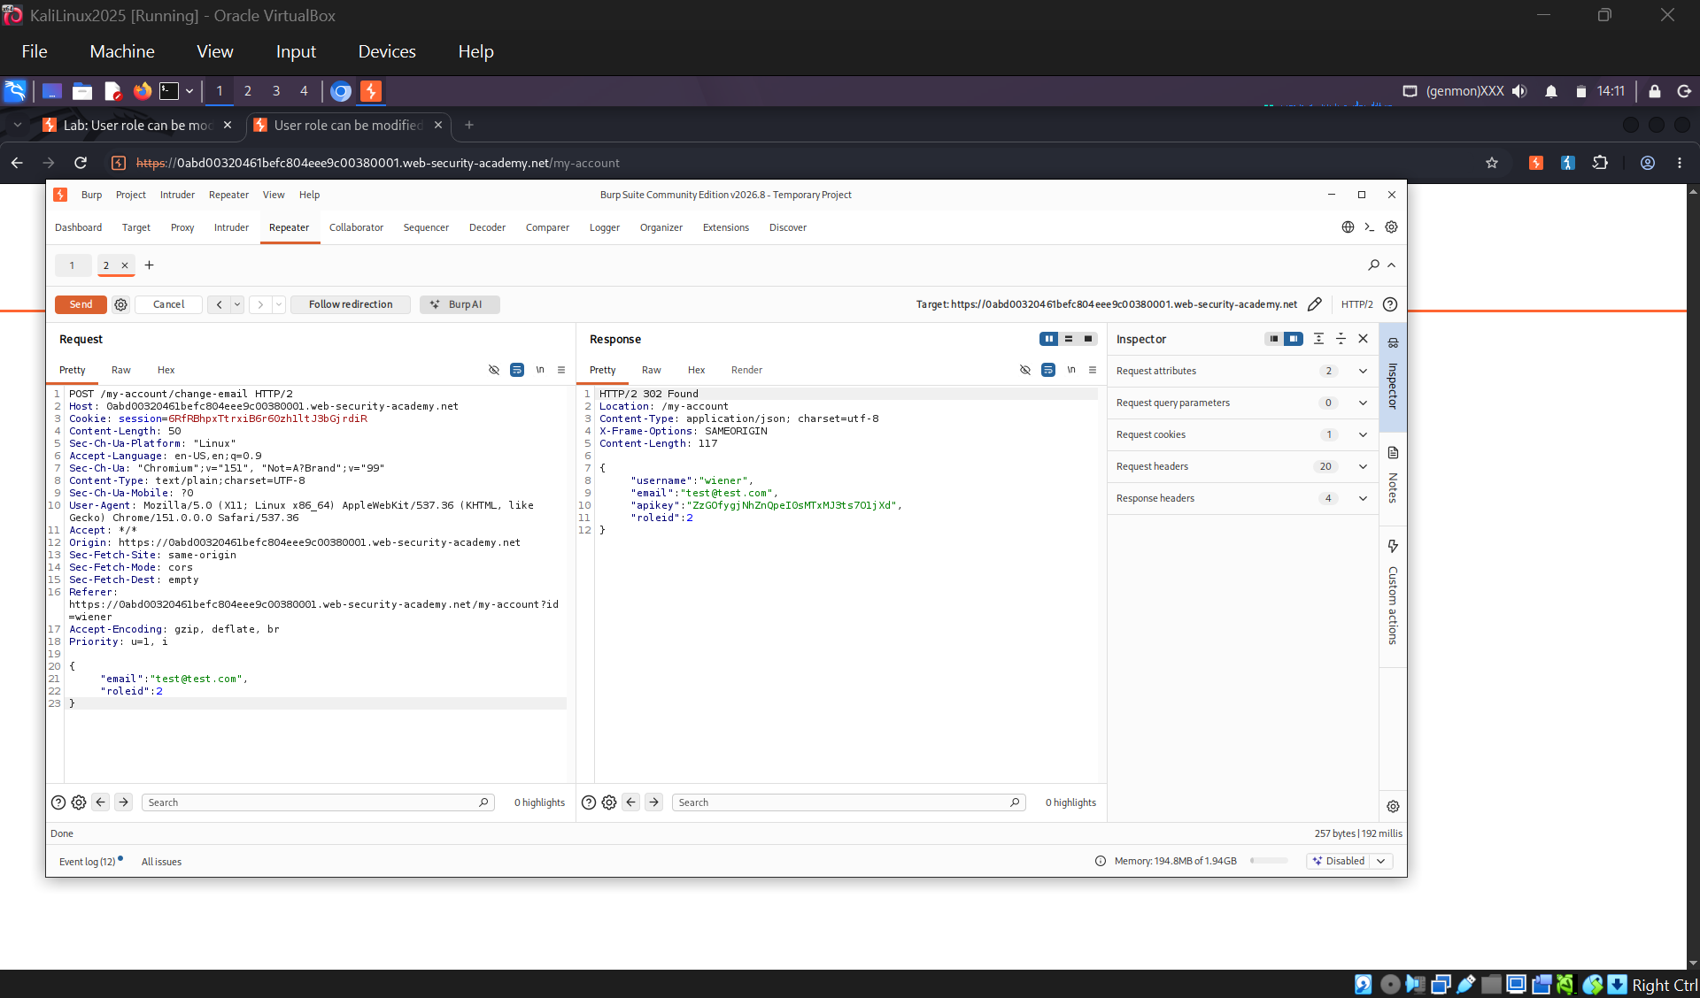
Screenshot 4a — BurpSuite / working screen: Repeater: injected "roleid":2 accepted by the server
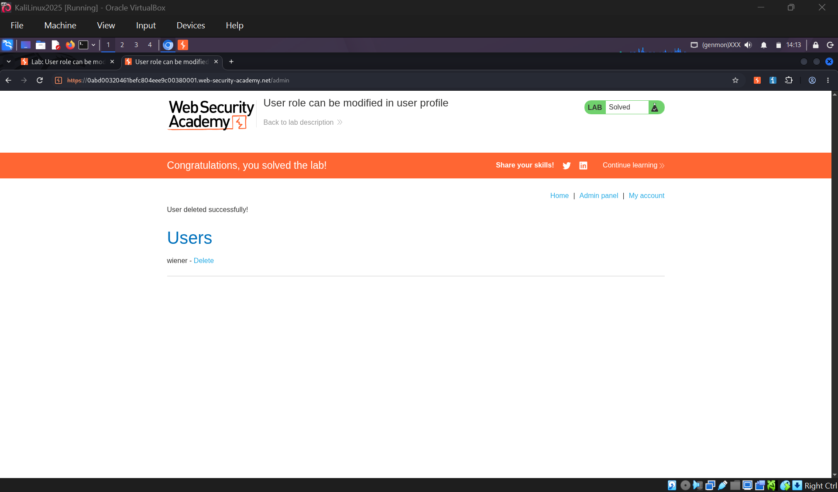
Screenshot 4b — PortSwigger: PortSwigger lab solved

Task 5 — User ID controlled by request parameter (10 pts)
Lab: https://portswigger.net/web-security/access-control/lab-user-id-controlled-by-request-parameter
The vulnerability
The account page returns whichever user is named in the id parameter, with no check that it belongs to the session (horizontal escalation / IDOR).
Solution steps
1. Logged in as wiener:peter; account page was /my-account?id=wiener.
2. Changed id=wiener to id=carlos — the page returned carlos's account and API key.
3. Submitted carlos's API key to solve the lab.
Why it matters
Every object lookup must be scoped to the logged-in user. 'My account' should come from the session, not from a user-supplied id.
Screenshots
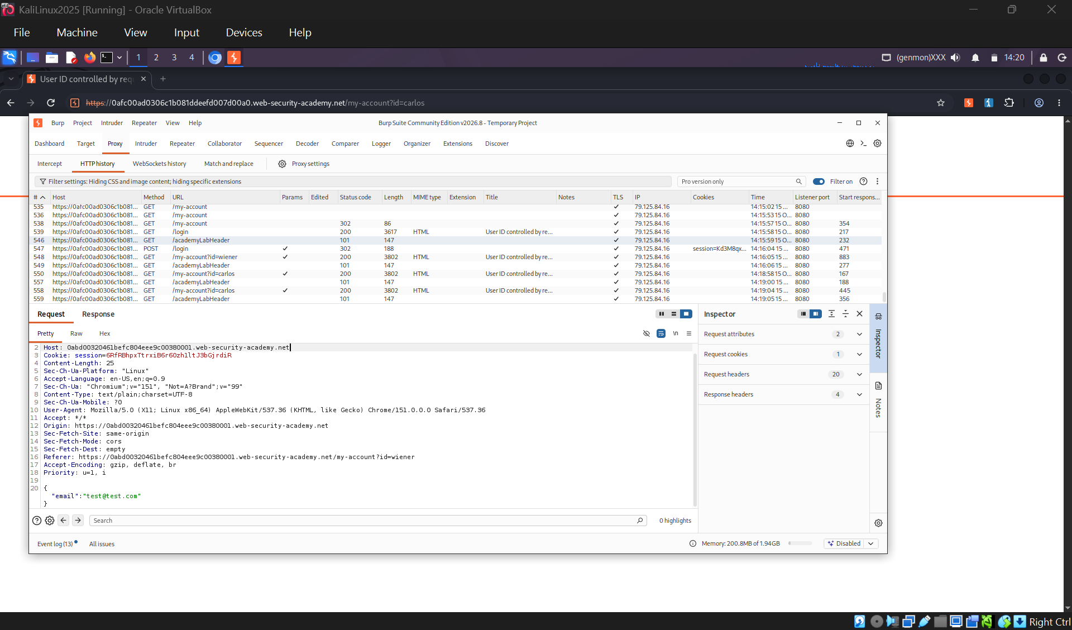
Screenshot 5a — BurpSuite / working screen: Burp HTTP history: id=wiener swapped to id=carlos
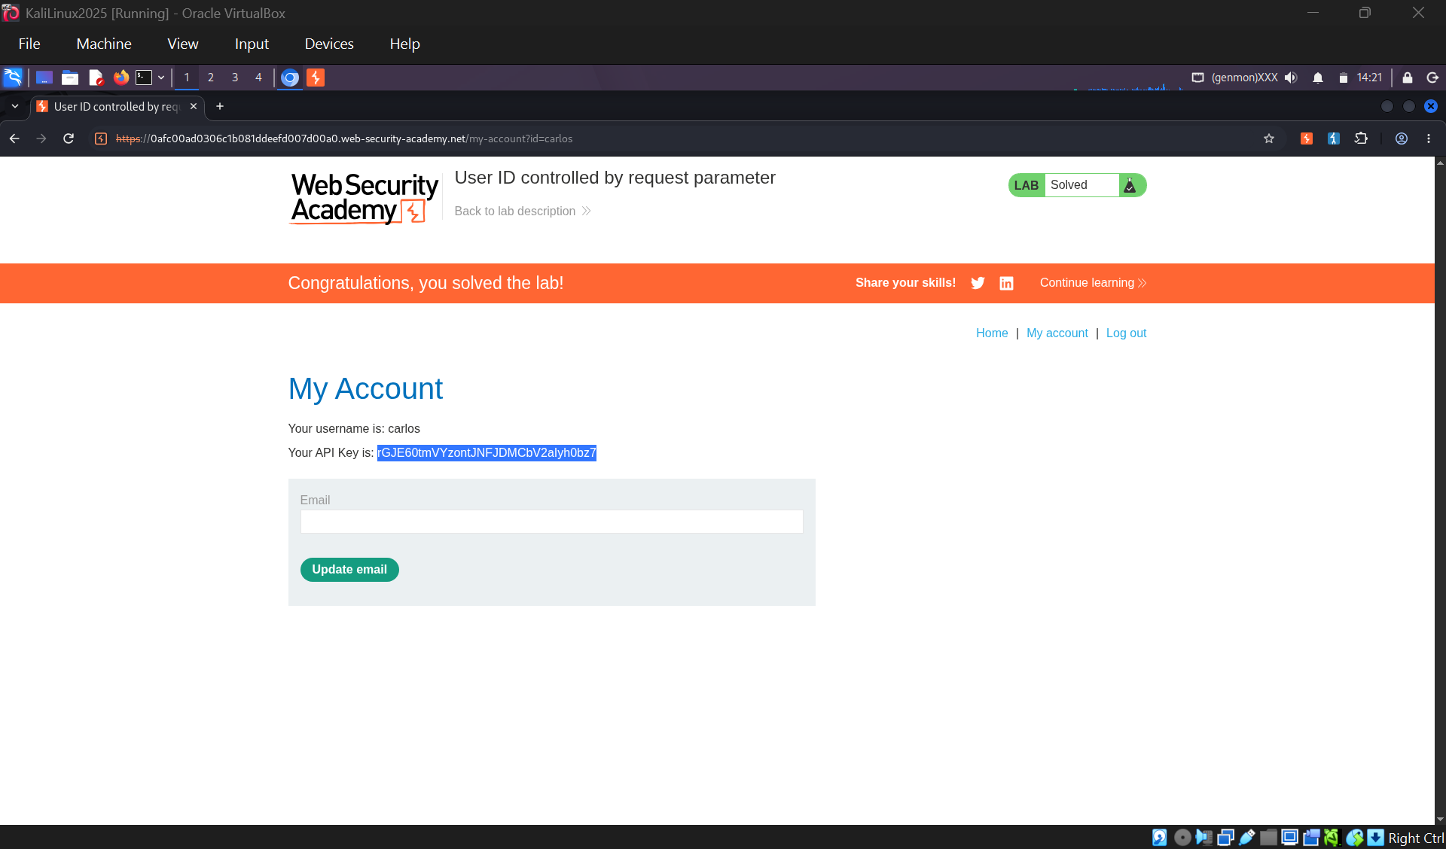
Screenshot 5b — PortSwigger: PortSwigger lab solved

Task 6 — User ID controlled by request parameter with password disclosure (10 pts)
Lab: https://portswigger.net/web-security/access-control/lab-user-id-controlled-by-request-parameter-with-password-disclosure
The vulnerability
Same id-swap flaw as Task 5, but worse: the account page pre-fills the user's password into a masked input, so the plaintext sits in the value attribute of the HTML.
Solution steps
1. Logged in as wiener:peter and changed id=wiener to id=administrator.
2. Viewed the page source — the admin's password was in the password input's value="..." attribute.
3. Logged out, logged in as administrator with that password, and deleted carlos.
Why it matters
Object-level authorization is broken AND a secret (password) is returned to the client. Never send credentials back in any response.
Screenshots
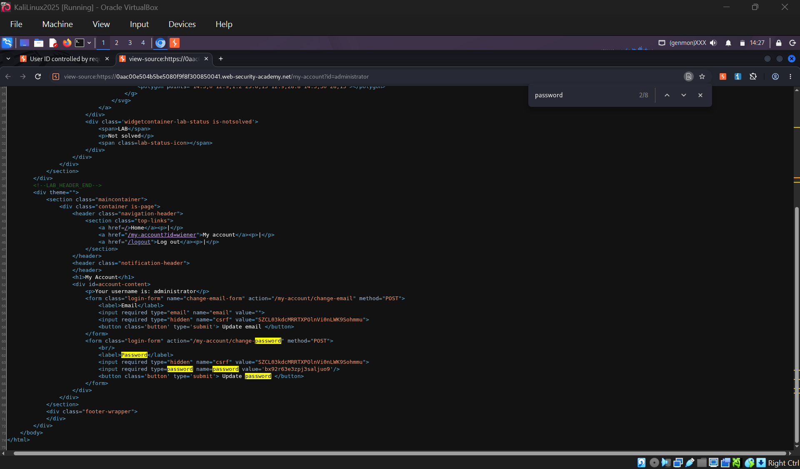
Screenshot 6a — BurpSuite / working screen: Admin password exposed in the HTML value attribute (view source)
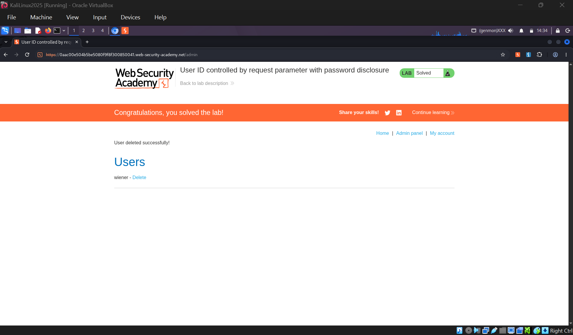
Screenshot 6b — PortSwigger: PortSwigger lab solved

Task 7 — Insecure direct object references / IDOR (10 pts)
Lab: https://portswigger.net/web-security/access-control/lab-insecure-direct-object-references
The vulnerability
Live-chat transcripts are stored as text files named with an incrementing number and served with no ownership check.
Solution steps
1. Opened Live chat, sent a message, and viewed the transcript — served at /download-transcript/2.txt.
2. Changed the filename to 1.txt — retrieved another user's transcript containing carlos's password.
3. Logged in as carlos with that password to solve the lab.
Why it matters
Predictable identifiers (sequential filenames) plus no authorization check = IDOR. Serve files only after confirming the requester owns the resource.
Screenshots
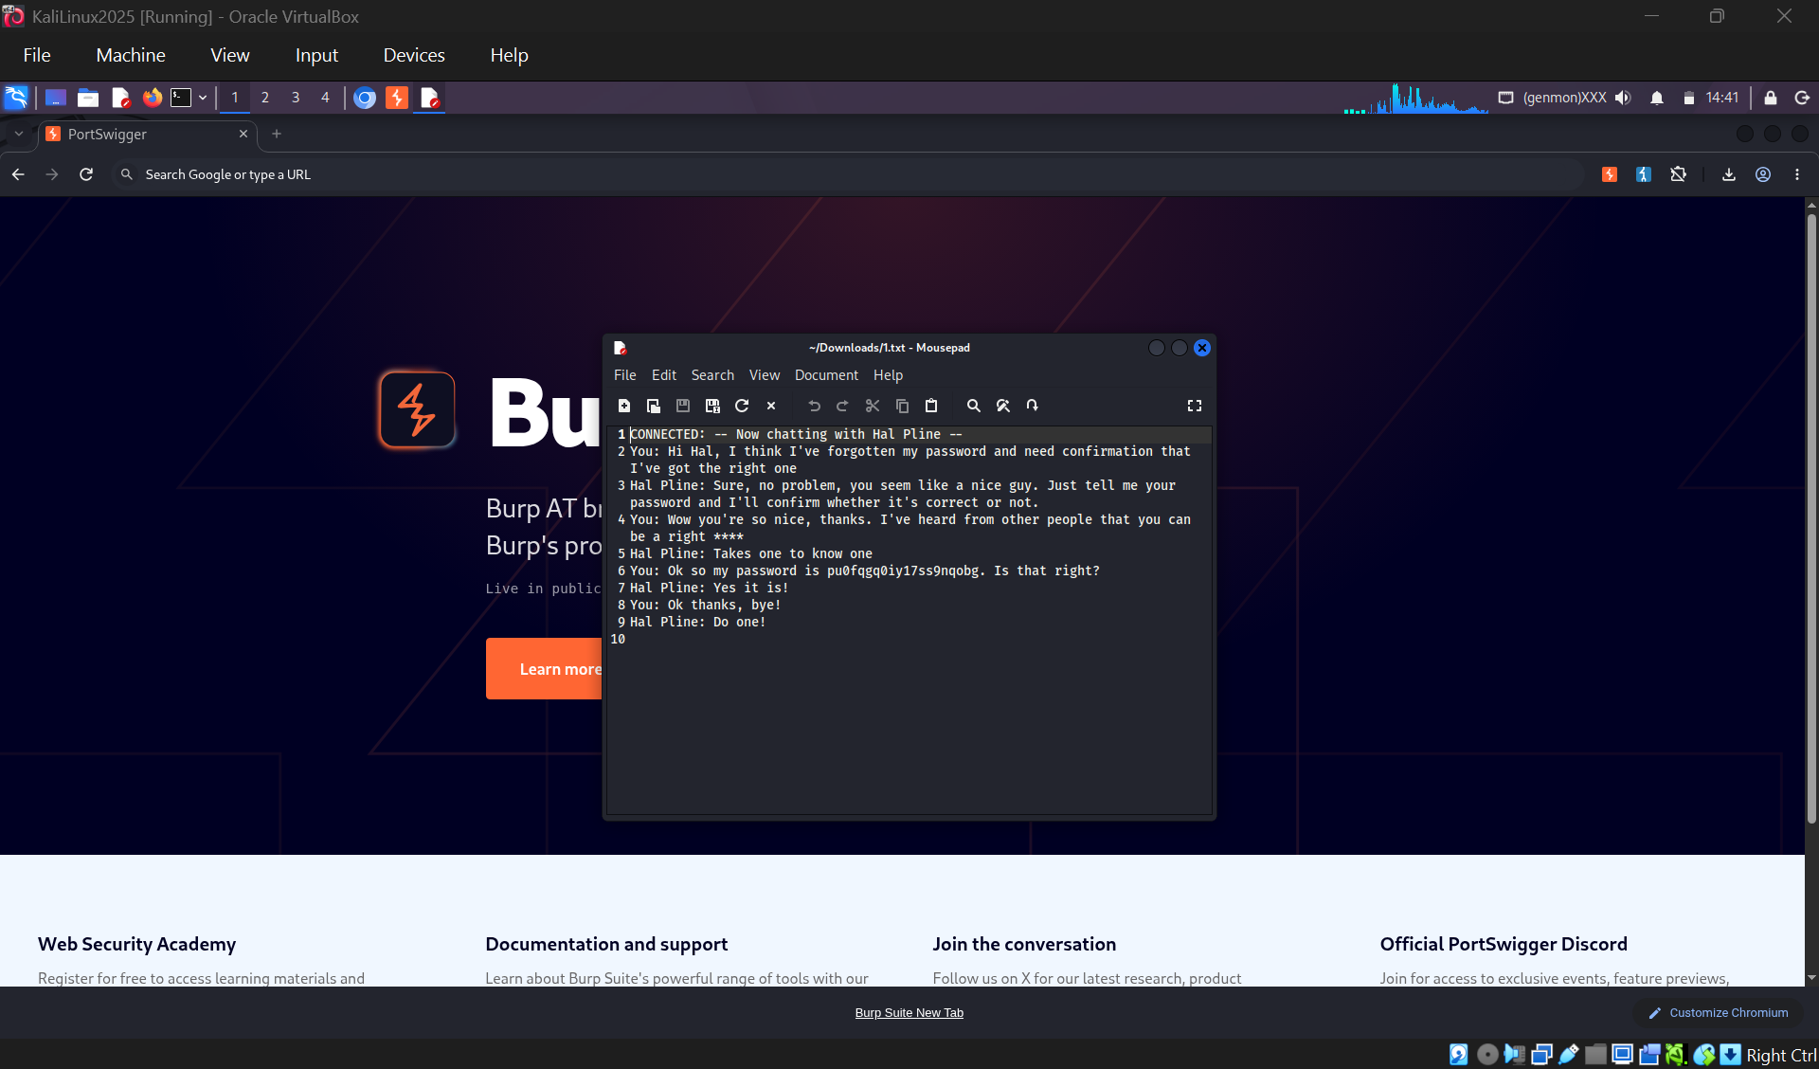
Screenshot 7a — BurpSuite / working screen: Stolen transcript (1.txt) revealing carlos's password
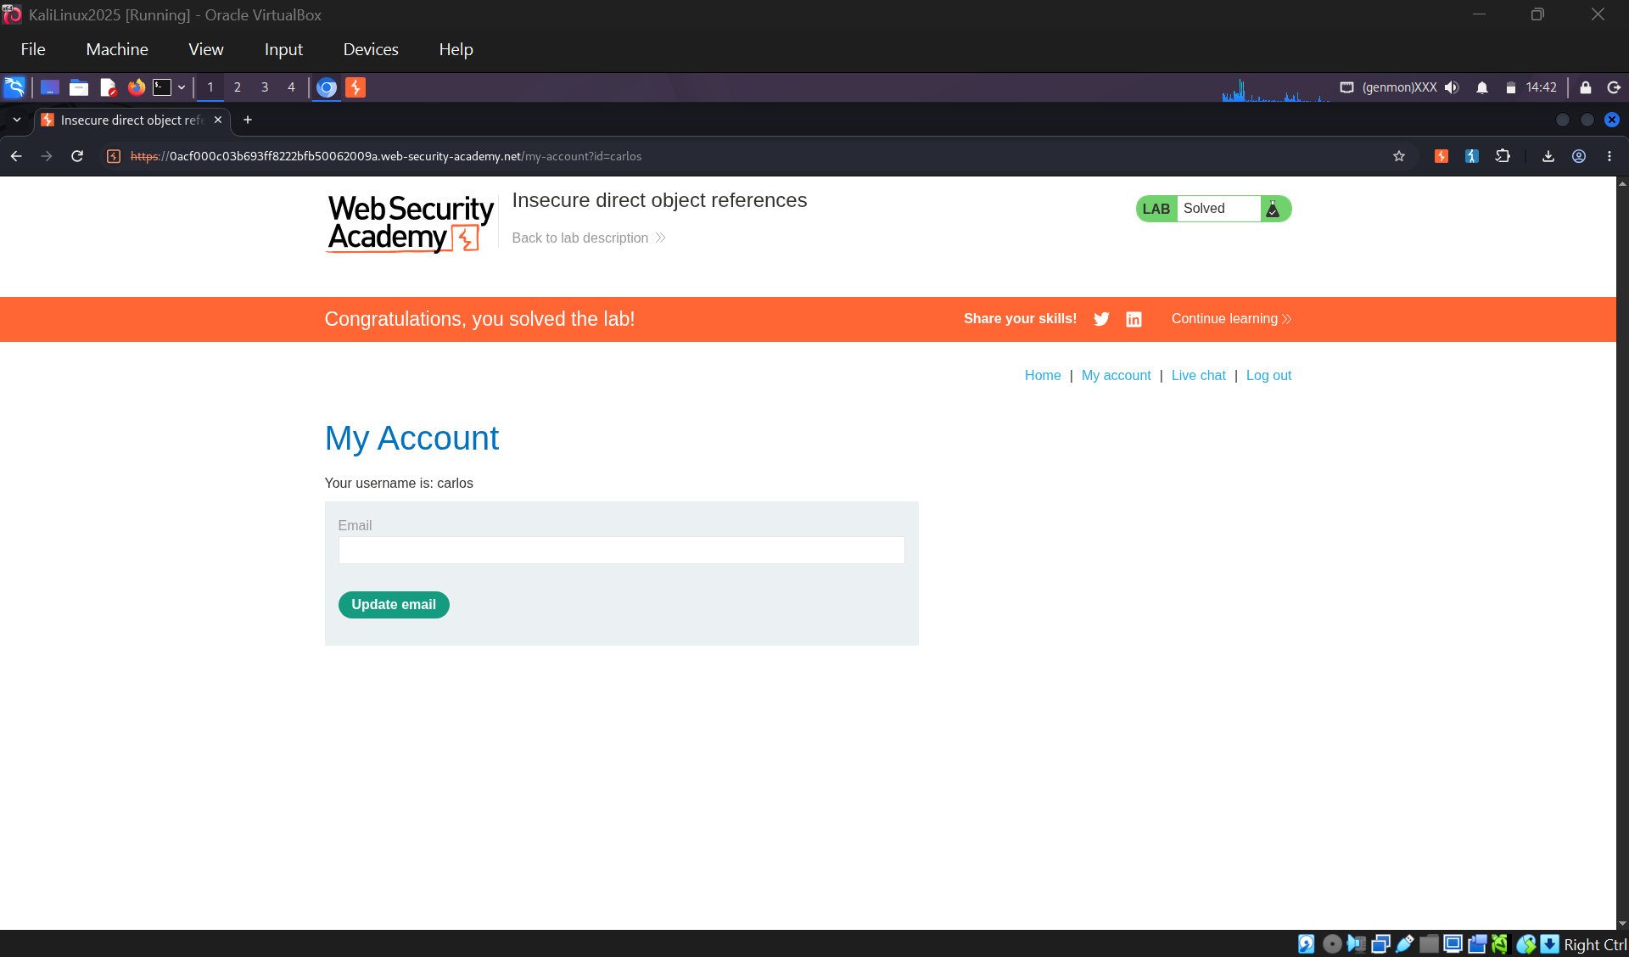
Screenshot 7b — PortSwigger: PortSwigger lab solved

Completion Evidence
All seven Access Control labs were solved and recorded on my PortSwigger account, as shown in the Access Control labs list below (each assigned lab marked “Solved”).
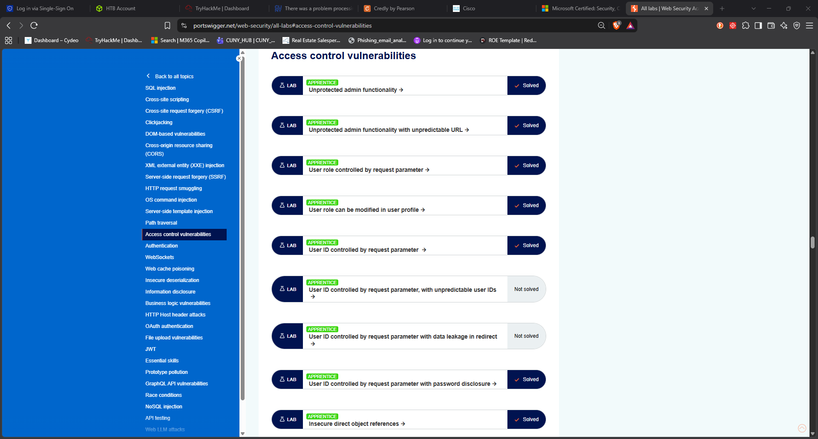
Screenshot 8 — PortSwigger Access Control labs list: all 7 assigned labs marked Solved

Summary of techniques
- Task 1 — robots.txt disclosure → unprotected admin route
- Task 2 — admin URL leaked in client-side JavaScript
- Task 3 — forged Admin=true cookie in Burp Repeater
- Task 4 — mass assignment: injected roleid:2
- Task 5 — IDOR: swapped id parameter to steal an API key
- Task 6 — IDOR plus password disclosed in HTML source
- Task 7 — IDOR on a sequential file download to steal a password

Submission checklist
- All 7 labs solved and recorded on my PortSwigger account.
- Two screenshots per task (working/Burp + solved page) included above.
- Solved-labs list screenshot added.
- Saved as .docx (and/or PDF) and submitted on Brightspace.

