

Tribhuvan University

Faculty of Humanities and Social Sciences

Web-based Ecommerce system
SneakerHead
A project report

Submitted to

Department of Computer Application
Asian College of Higher Studies

In partial fulfillment of the requirements for the Bachelors in Computer Application

Submitted by
Bishesh Chabegu Limbu [22061024]

Under the supervision of
Mr. Rajesh Maharjan

ABSTRACT
The SneakerHead aims to break down the barriers that are associated with traditional sneaker shopping experiences through the use of modern technology. In today's fast-evolving world, providing an uninterrupted and personalized shopping platform matters in the quest for enhanced customer satisfaction and more sales. This abstract is a summary of the key traits and objectives of our project.
The primary aim of the project is to design a user-friendly web platform through which users can browse, search, and filter sneakers based on size, brand, type, and price. Additionally, users can create profiles, place products in wish lists, view their orders, and leave ratings and reviews for the products they purchased. The platform offers a centralized catalog of sneakers with high-definition images, detailed descriptions, and live availability, allowing users to make informed buys based on their preference and needs.
The SneakerHead project represents a major leap in revolutionizing the shopping experience of sneakers and improving customer engagement. With correct implementation and transition, the platform has the capacity to change the way sneaker enthusiasts buy and interact with brand names, ultimately leading to higher customer loyalty and satisfaction.

Key words: Online platform, E-commerce, Sneakers, Shopping Experience

I am obliged to a number of people who helped me to organize this project and thankful for their
kind opinions, suggestions, and appropriate guidelines. I have received endless support and
guidance in finalizing my project so I would like to take this opportunity to thank them all.
First and foremost, I would like to express my special thanks of gratitude to my supervisor Mr.
Pankaj Dhakal, who gave me the honor to do this wonderful project on the topic (E-commerce
Furniture Website using PHP), which has helped me a lot in sharpening my knowledge. I am also
thankful for his continuous feedback and encouragement throughout the project. Without his grace,
this project could not have become accomplished. Moreover, I came to know many new things
while doing the project so, deeply thankful to him.
Secondly, I m overwhelmed with all the support and guidance that I got from my parents and‟
friends. They have assisted me from time to time in making this project satisfactorily complete by
giving innovative ideas. So, I would like to thank them for helping me in making the project
wonderful and unique.
At last but not least, I m thankful to all who have been always encouraging and helping me to cope‟
with the challenges that I faced during the completion of the project.
I am obliged to a number of people who helped me to organize this project and thankful for their
kind opinions, suggestions, and appropriate guidelines. I have received endless support and
guidance in finalizing my project so I would like to take this opportunity to thank them all.
First and foremost, I would like to express my special thanks of gratitude to my supervisor Mr.
Pankaj Dhakal, who gave me the honor to do this wonderful project on the topic (E-commerce
Furniture Website using PHP), which has helped me a lot in sharpening my knowledge. I am also
thankful for his continuous feedback and encouragement throughout the project. Without his grace,
this project could not have become accomplished. Moreover, I came to know many new things
while doing the project so, deeply thankful to him.
Secondly, I m overwhelmed with all the support and guidance that I got from my parents and‟
friends. They have assisted me from time to time in making this project satisfactorily complete by
giving innovative ideas. So, I would like to thank them for helping me in making the project
wonderful and unique.
At last but not least, I m thankful to all who have been always encouraging and helping me to cope‟
with the challenges that I faced during the completion of the project.
I am obliged to a number of people who helped me to organize this project and thankful for their
kind opinions, suggestions, and appropriate guidelines. I have received endless support and
guidance in finalizing my project so I would like to take this opportunity to thank them all.
First and foremost, I would like to express my special thanks of gratitude to my supervisor Mr.
Pankaj Dhakal, who gave me the honor to do this wonderful project on the topic (E-commerce
Furniture Website using PHP), which has helped me a lot in sharpening my knowledge. I am also
thankful for his continuous feedback and encouragement throughout the project. Without his grace,
this project could not have become accomplished. Moreover, I came to know many new things
while doing the project so, deeply thankful to him.
Secondly, I m overwhelmed with all the support and guidance that I got from my parents and‟
friends. They have assisted me from time to time in making this project satisfactorily complete by
giving innovative ideas. So, I would like to thank them for helping me in making the project
wonderful and unique.
At last but not least, I m thankful to all who have been always encouraging and helping me to cope‟
with the challenges that I faced during the completion of the project.

ACKNOWLEDGEMENT
I am truly grateful to a number of people who assisted me in designing and implementing this project, and I value their thoughtful comments, suggestions, and guidance throughout. I have received unlimited support, and I would like to take this chance to cordially thank everyone concerned.
First and foremost, I would like to extend my special thanks and gratitude to my supervisor, Mr Rajesh Maharjan, for giving me the chance to create this incredible project titled "Sneaker Head – E-commerce Sneaker Website", which has greatly enhanced my technical knowledge and hands-on experience. I am especially thankful for her continuous feedback, meaningful comments, and encouragement, which helped me a lot in the completion of this project. Without her support and guidance, this project would never have been possible.
Then, I am deeply obliged to friends for their continuous support, encouragement, and creative ideas throughout the project. Their encouragement helped me to cross various obstacles and complete the project with confidence.
Finally, I would also like to thank everyone who directly or indirectly made this project possible. They supported and encouraged me, and their efforts kept me focused and determined during the development process.

Bishesh chabegu Limbu

Table of Contents

ABSTRACT II
ACKNOWLEDGEMENT III
Tables of Figures VI
Chapter 1: Introduction 1
1.1 Introduction 1
1.2 Problem Statement 1
1.3 Project Objectives 2
1.4 Scope and Limitations 2
1.5 Development Methodology 3
1.5.1 Phases of the Waterfall Model: 3
1.6 Report Organization 4
Chapter 2: Background Study and Literature Review 5
2.1 Background Study 5
2.2 Literature Review 5
Chapter 3: System Analysis And design 7
3.1 System Analysis 7
3.2 Requirement Analysis 8
3.3 Feasibility Analysis 9
3.4 System Modeling 10
3.4.1 Data modeling with (ER) diagram 10
3.4.2 Process modeling with context diagram 11
3.2 System Design 13
3.2.1 Architecture Design 13
3.2.2 Database Schema Design 14
3.3 Interface Design 15
3.4 Algorithm : 16
3.3.1 How Content Based Algorithm Will Work in Web-based Ecommerce Ecommerce System (SneakerHead): 16
Chapter 4: Implementation and Testing 18
4.1 Implementation 18
4.1.2 Tools used (CASE tools, programming languages, database platforms) 18
4.2 Testing 19
4.2.1 Unit Testing 19
➢ Product Addition (Admin Module) 19
Chapter 5 Conclusion and Future Recommendations 23
5.1 Conclusion: 23
5.2 Lession Learnt 23
5.3 Future Recommendations 23
References 23
Appendix 25

TABLE OF FIGURES
Figure 1.1 Waterfall Model 3
Figure 3.2 UseCase Diagram of Sneakerhead 9
Figure 3.4 Fig ER diagram of SneakerHead 11
Figure 3.5 Fig Level 0 DFD of SneakerHead 12
Figure 3.6 Fig Level 1 DFD of SneakerHead 13
Figure 3.7 Fig Architectural Diagram of web based ecommerce system 14
Figure 3.8 Fig schema design of SneakerHead 14
Figure 3.9 Fig Dashboard,Landing page 15
Figure 3.10 Login Page 15

CHAPTER 1: INTRODUCTION

Introduction
SneakerHead a personalized e-commerce platform for sneakers based on a content-based filtering algorithm that recommends products according to users’ preferences. Users can browse and search for sneakers, and filter them by size, brand, and price. They can also manage their profiles, track orders, save products to a wish list. Admins handle product listings, manage orders, and user management [1].
In recent years, the global sneaker industry has witnessed significant growth, driven by fashion trends, brand loyalty, and online consumer behavior. However, many sneaker enthusiasts still struggle with the fragmented and generic experiences offered by mainstream e-commerce platforms, which often prioritize volume over personalization. SneakerHead addresses this gap by providing a dedicated, user-centric web platform focused exclusively on sneakers. The system is designed to streamline the online shopping process through features such as search, personalized recommendations using content-based filtering, and real-time product availability. By tailoring the platform specifically for sneaker shoppers, SneakerHead enhances user satisfaction, supports informed purchasing decisions, and offers a more intuitive and enjoyable online shopping experience. This project aims not only to deliver a functional prototype but to explore how targeted design and user profiling can redefine niche e-commerce platforms in Nepal and beyond.
The website follows a business-to-consumer (B2C) model, meaning selling goods or services directly to individual consumers (e.g., a customer buys a pair of shoes from an online retailer). Since it is a small business, this website has moderate quantity of products, and the delivery service is currently not introduced. The website offers various shopping categories, including sections for Men and Women etc. Any product is available for purchase within the offered price range. Users can easily add products to the cart, and the cart is designed to be simple and intuitive [2].

1.2 Problem Statement
Many e-commerce sites sell various other products and services, but not all of them are focused on just selling sneakers. There are many difficulties to navigate several large e-commerce websites and find the specific type of sneaker a user looking for. And sometimes customer have to hunt through other products such as apparel and accessories that don’t directly relate to the product that you’re looking for. This means people experience a low-quality shopping experience.
To address these issues SneakerHead is the specific website only for sneakers. In addition to this a user-focused and easy to use shopping experience is planned: a sophisticated filtering, search and recommendation feature and the recommendations would be made on a per-user basis.

1.3 Project Objectives
The main objective of this project is to create a personalized sneaker e-commerce web-based platform that enhances the shopping experience for users.
- To implement a content-based filtering recommendation system to suggest sneakers based on user preferences and browsing history.
- To implement advanced filtering and search based on sneaker attributes: size, brand, color, material, and price.
- To build an admin dashboard that enables product management, order monitoring, user account handling.
- To Implement a personalized content-based filtering system to recommend sneakers based on user preferences and browsing history.

1.4 Scope and Limitations
The scope of our project:
- Sneaker browsing and shopping experience for users.
- Personalized recommendations based on user preferences and behavior.
- Users can filter sneakers by size, brand, color, and price for product discovery.
- Admins can easily manage product listings, orders, and user management.
- Users can save products to a wish-list.

The limitations of our project are:
- The platform operates only online and requires internet access.
- No in-person transactions; all payments are made through the integrated payment gateway.
- No automatic notifications for new products or promotions, users must manually check for updates.
- The platform only supports sneakers, and does not include other types of products at this time.
- There is a single administrator account responsible for managing the system.

1.5 Development Methodology
The Waterfall Model is chosen for web-based E commerce system because it provides a structured and sequential approach to software development. This model ensures each phase is completed before proceeding to the next, making it suitable for well-defined project requirements like web-based project management system.
Process has been illustrated below on figure showing top-down development
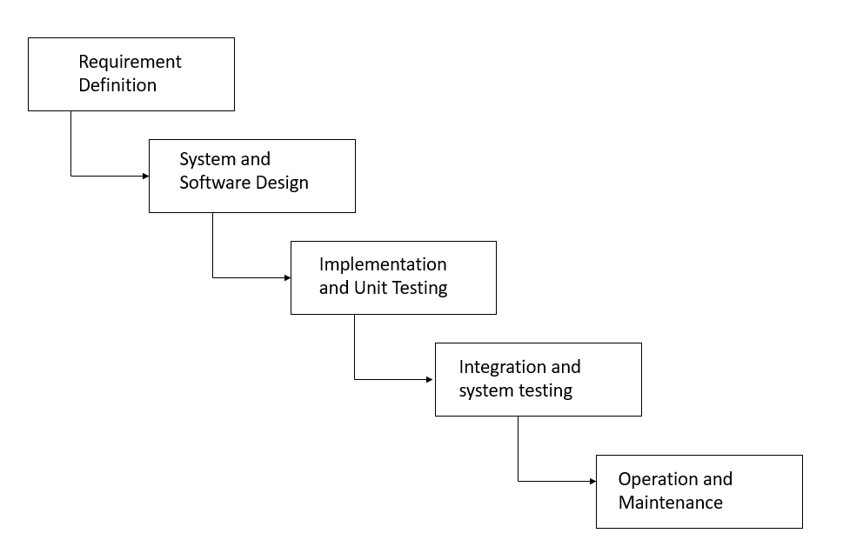

Figure 1.1 Waterfall Model

1.5.1 Phases of the Waterfall Model:
- Requirement Analysis: Gathering project needs, including user roles, features, and system specifications.
- System Design: Designing the system architecture, database, and UI/UX elements.
- Implementation: Coding the frontend and backend based on the design specifications.
- Testing: Conducting unit testing, integration testing, and user acceptance testing.
- Deployment: Deploying web-based project management system on a cloud-based server.
- Maintenance: Continuous monitoring, bug fixes, and future feature updates.

1.6 Report Organization
This report consists of five chapters and each chapter deals with different related topics.
Chapter One: This chapter includes the system and the problems, given an overview about the study. It includes introduction, problem of statement, objectives, and development methodology.
Chapter Two: This chapter covers the literature review which is the previous related work that has been done before. It also includes the description of the website where we have taken the reference.
Chapter Three: This chapter explains the selected methodology that we are going in this project. This chapter shows the design of the system. It includes architectural design, DFD, ER- Diagram, Database Schema etc.
Chapter Four: This chapter discusses the implementation and testing. It includes the overall description of the modules that we have implemented into our application. We have shown the test cases.
Chapter Five: This chapter discusses the conclusion, recommendation and future works to improve this study.

CHAPTER 2: BACKGROUND STUDY AND LITERATURE REVIEW

2.1 Background Study
An online shopping platform for customized sneakers revolutionizes the process of purchasing sneakers, making it convenient, efficient, and accessible. The system typically entails an online platform where customers are able to browse through a predetermined list of sneakers, view sizes available, colors, brands, and prices, and purchase products at their own convenience [3].
The background study of such a system encompasses numerous elements, from the technological infrastructure to user interface, security, and optimization of the user experience. Understanding the needs and expectations of SNEAKERHEAD is extremely critical in developing an easy-to-use and efficient platform. Other factors such as secure payment gateways, mobile friendliness, stock management, and safeguarding customers' data are also of crucial significance.
Further, through the examination of contemporary e-commerce sites on sneakers, a conclusion regarding the sites' weaknesses and strengths and incorporating recent advanced features such as customization, wish list, and real-time updates of stock instantaneously aid in the development of a dynamic and competitive e-commerce website. Overall, extensive study background is reason for the preparation and adoption of an effective e-commerce system of sneakers that increases customers' satisfaction and facilitates shopping.
Online sneaker shopping is the method through which users browse and purchase sneakers on an online platform, allowing them to see many options, compare prices, and make purchases without physically going to stores. It provides greater flexibility, greater choices, and in most instances, special offers for customers [4].
This platform is an intelligent shopping solution which provides consumers with an easy and personalized way of buying sneakers over the internet. It transcends the limitations of buying conventionally by offering features based on consumer interests like filtering by brand, size, price, and style, and product recommendations with the help of content-based algorithms to enhance the shopping experience.

2.2 Literature Review
The Electronic Commerce, or E-commerce, industry is one of the most enlightened sectors of the economy. The industry is growing very rapidly, so data collection and estimation are particularly difficult. Therefore, one has to rely largely on research by both government and private-organization.
According to the U.S. Survey Department, manufacturing sector is the largest supplier to e-commerce sales which has 47.4% of their total shipments, followed by vendors which is having 28.6% of their total sales. These two sectors make the business-to-business group Electronic commerce is generally considered to be the sales feature of e-business. It also consists of the exchange of data to facilitate the financing and payment aspects of business transactions. This is an active and resourceful way of communicating within an organization and one of the most operative and useful ways of leading business [5].
E-commerce today gained so much popularity because its essential technologies are worked out at huge steps. We are even offered to feel the product to better understand its shape, size and quality. In these benefits why to go out somewhere else when all you have to do is make an order, choose the delivery method, put up your feet and wait till the order is supplied right to your door-step [6].
According to Monsuwe there are five external factors to understand consumer's intention to purchase in the internet which is the consumer personality, situational factors, product characteristics, previous online shopping experiences and the trust in online shopping. Consumer's trait includes their demographic factors such as age, income, gender and educational level will lead them to have the intention to shop online. For age factor, consumers that are aged under 25 has more potential to shop in online because of their interest in using new technologies to search for product information and compare and evaluate alternatives. For educational level, higher educated consumers are more likely to use the internet for their shopping medium because they are more computer literate. Product characteristic is also another factor that will influence the consumer's intention to purchase in the internet. Product characteristic can be tangible or intangible; standardized or customized. In an online context, lower tangibility of a product is caused by the lack of physical contact and assistance in the shopping process; consumer's intention to shop on the internet will be low when there is a need to seek advice from a salesperson regarding the considered product. Products such as car, computers, perfume, perfume or lotion has the lower potential to be purchased by the consumer because it requires more personal knowledge and experience [7].

CHAPTER 3: SYSTEM ANALYSIS AND DESIGN

3.1 System Analysis
System analysis is the process of collecting and interpreting facts, identifying the problems, and decomposition of a system into its components. It is done to study a system and its parts to identify the objectives and challenges

3.2 Requirement Analysis
Requirement analysis is the process of precisely identifying, defining, and documenting the various requirements that are required for the development of the project and the product. This process involves gathering and analyzing information from variety of sources, including stakeholders, customers, industry, experts and other related parties. Requirement analysis helps in clearly understanding the needs of the customer, defining the scope of the project, and assessing the timeless and resources required to complete it.
There are mainly two types of requirement analysis including:
- Functional Requirement
- Non-Functional Requirement

- Functional requirement: The requirement that has been used in the project as the functional requirements generally includes the function such as inputs, the processing and the final output. The functional requirements in the project are mentioned below.
- User Module
- User can register and login the system.
- Users can look at their cart detail.
- User can get cart detail after updating each products.
- User can logout from the system after completion of transaction
- Admin Module
- Admin can login the system.
- Admin can add and delete products.
- Admin can see the registered users.
- Admin has the privilege to delete the user
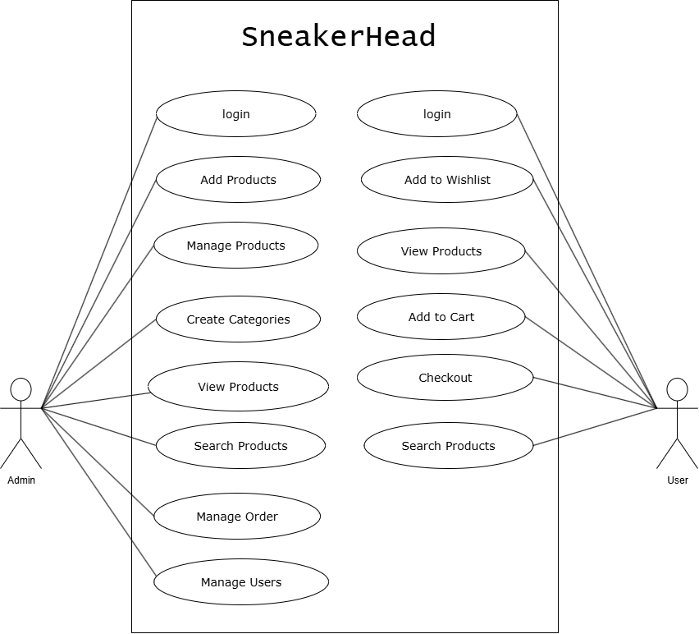

Figure 3.1 UseCase Diagram of Sneakerhead

ii. Non -Functional Requirement The non-functional requirement specifies how the system works. The non-functional requirements included in the project are:
1. System uses different database for storing the attribute for each entity.
2. User can see the transaction detail after performing transaction.

3.3 Feasibility Analysis
i. Technical Feasibility:
- The UI of our project is very simple.
- User will require internet browser and internet to use it
- It will run on many existing web browsers with the latest versions and even in the smart phones.
Recommended Software
- VS Code
- MySQL
- WP Local

- Operational Feasibility
These include the reliability, maintainability, usability, support-ability. The system is operationally feasible as it is reliable for all type of user i.e whether or not the user has the knowledge of computer or not. The system is supported for a small to large-scale organization. It is simple and easy to use due to simple user interface and its operational feasible.

iii. Economic Feasibility
Before the development of a system, the system should be studied whether or not it is within the budget estimated by the organization. The project that we are developing is within the cost estimation of the organization. The project cost is less and no more burdens are needed. The system development does not have any requirement of expensive hardware and software. The platform are open sources and the resources required for the project are also open source. Hence the project is said to be economically feasibility.

iv. Schedule Feasibility
The system is scheduling feasible as it does not require more time for the development phase. The data collection takes more time to collect the data about various products and their quality. After data is collected, the other development phase can be within a month. Gantt charts. It is a useful way of showing what work is scheduled to be done on a specific day. It can also help you view the start and end dates of a project in one simple chart. In my project, I used PowerPoint for developing the Gantt chart which is shown.

3.4 System Modeling

3.4.1 Data modeling with (ER) diagram
An Entity-Relationship (ER) diagram is a graphical representation used in database design to illustrate the logical structure and relationships among entities within a system. It comprises entities, which represent distinct objects or concepts, and relationships, depicting the associations between these entities. Each entity is defined by attributes, describing its characteristics, while relationships specify how entities are connected. In our case, we have identified User, admin, doctor and schedule register as four entities.
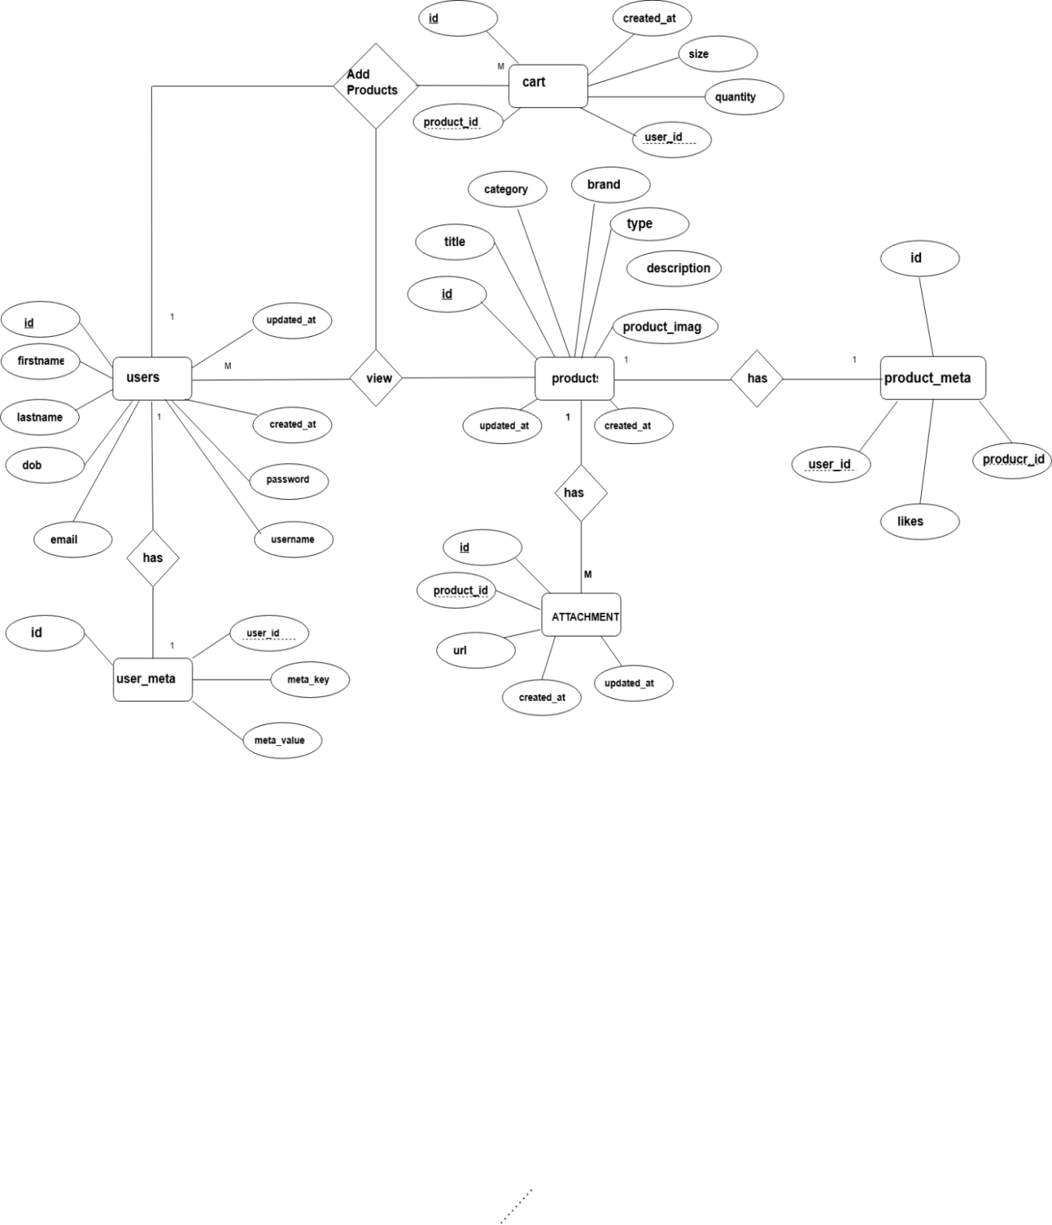
Figure 3.3 Fig ER diagram of SneakerHead

In above figure his ER diagram represents an e-commerce system with four main entities: admin, users, products, and attachment. Each entity has an id as its primary key. An admin can create many products, while users can buy multiple products, forming a many-to-many relationship. Each product has details like title, brand, and description, and can have multiple attachments (e.g., images or files). Attachments are linked to products via the product_id foreign key. Timestamps track creation and updates throughout.

3.4.2 Process modeling with context diagram
- Level 0 DFD
The illustration presents the main process in a single node to introduce the project context. This context explains how the project works in just one look.
The user feeds the input into the system and then receives the output from it

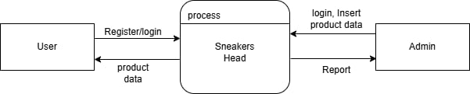

Figure 3.4 Fig Level 0 DFD of SneakerHead

In above figure This Level 0 DFD for Sneakers Head illustrates the system's interaction with two external entities: User and Admin. Users can register or log in and receive product data from the system. Admins log in and insert product data into the system, and in return, receive system-generated reports. The main process, Sneakers Head, handles all data exchanges, including authentication, product management, and report generation.

- Level 1 DFD
A Level 1 Data Flow Diagram (DFD) provides a more detailed breakdown of the main process shown in the Level 0 DFD. It decomposes the single high-level process into sub-processes, shows data stores, and illustrates how data flows between sub-processes, data stores, and external entities. In short Level 1 DFD shows internal processes, data stores, and data flow for a system's main function

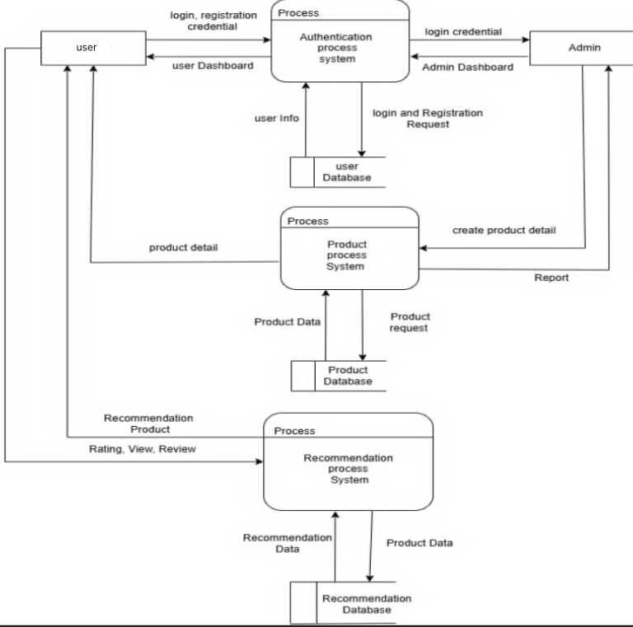

Figure 3.5 Fig Level 1 DFD of SneakerHead

This data flow diagram shows how students and admins interact with a product system. Students log in or register through the Authentication Process System, which uses the User Database. Admins also log in and can create product details, which are managed by the Product Process System and stored in the Product Database. Students request and view products, and their feedback (ratings, reviews) is processed by the Recommendation Process System, which uses the Recommendation Database to suggest products. Admins receive reports, while students get personalized recommendations.

3.2 System Design

3.2.1 Architecture Design
The system design of our SneakerHead E-commerce Platform involves several components and considerations to ensure a seamless user experience and efficient functionality.
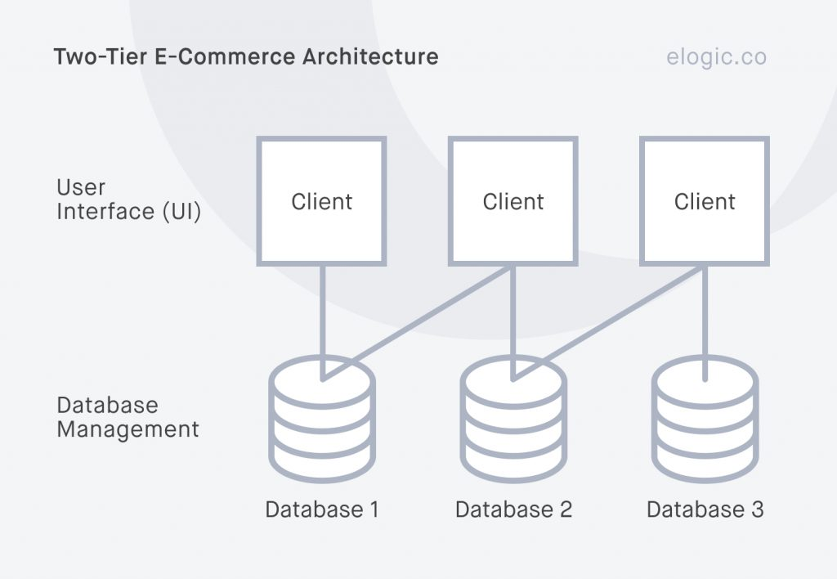

Figure 3.6 Fig Architectural Diagram of web-based ecommerce system

The flowchart shows the user flow for the SneakerHead e-commerce platform. Users can either register or log in. After login, the system checks if the user is an admin or a regular user. Admins can manage products, categories, and users. Regular users can browse products, add items to the cart or wishlist, rate/review products, and proceed to checkout. The flow ensures role-based access and actions for each user type.

3.2.2 Database Schema Design
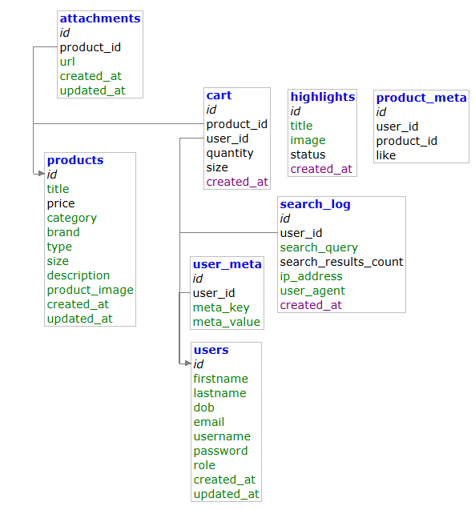

Figure 3.7 Fig schema design of SneakerHead

3.3 Interface Design
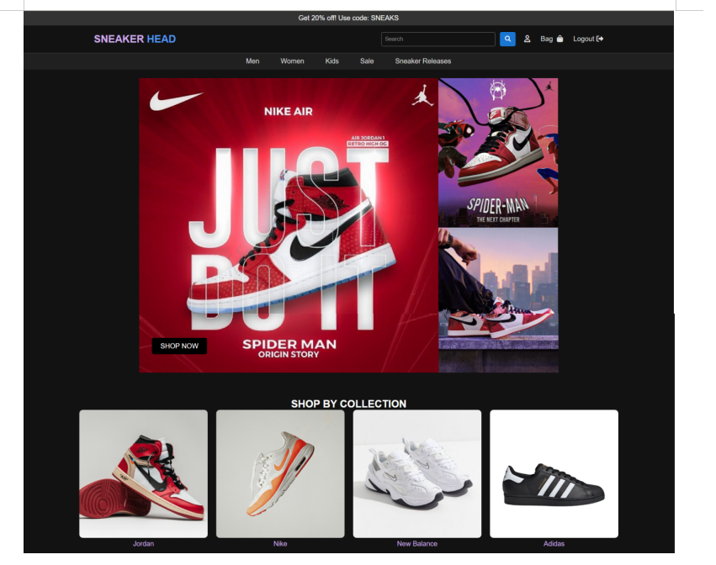
Figure 3.8 Fig Dashboard, Landing page

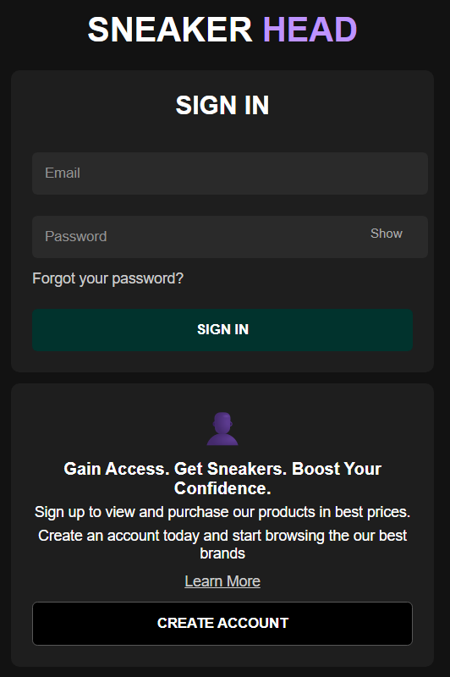

Figure 3.9 Login Page
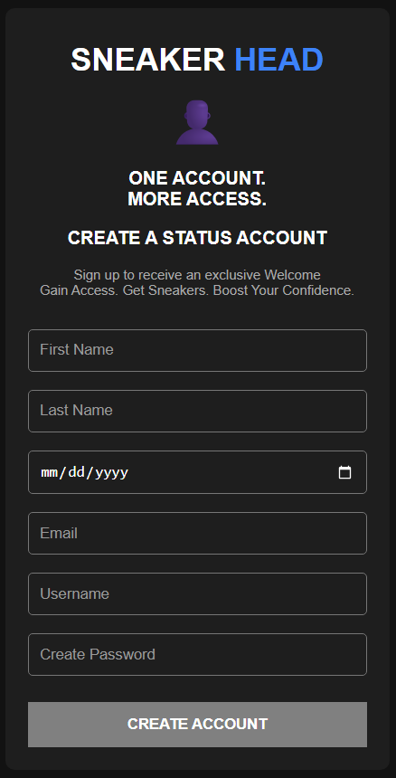
Figure 3.11 Registration Page

3.4 Algorithm:
Content-based filtering is a recommendation method that suggests Sneakers to users based on the attributes and characteristics of the products they have previously shown interest in. This approach utilizes the features of shoes and sneakers (such as brand, type, material, color, style, etc.) to recommend items that match a user’s preferences. Unlike collaborative filtering, which relies on user behavior, content-based filtering focuses on the individual user’s past interactions and product attributes to generate personalized recommendations.

3.3.1 How Content Based Algorithm Will Work in Web-based Ecommerce Ecommerce System (SneakerHead):

1. Data Gathering
You collect and prepare necessary data:
All sneakers: get_all_project_details()
User liked products: get_fav_data_by_user_id($user_id)
User cart items: getCartDetails($user_id)
User preferences:
_brand_preferences_category_preferences
_type_preferences

2. Data Normalization
You clean and structure the data:
Split comma-separated attributes (brand, type, category) into arrays.
Index all products by their ID for fast access.
Extract valid product IDs from the likes and cart arrays.

3. Define Preferences
You structure the preferences like this:
php
CopyEdit
$preferences = [
"type" => $type_meta,
"brand" => $brand_meta,
"category" => $category_meta
];

4. Similarity Calculation
You define two similarity functions:
calculateSimilarity: Checks overlap in attributes between two products.
preferenceSimilarity: Checks overlap between a product and the user's preferences.

5. Recommendation Scoring
For each sneaker not already liked or in the cart, you calculate:
finalScore = 0.4 * likeScore + 0.3 * cartScore + 0.3 * preferenceScore
This gives a weighted score based on:
Similarity to liked items
Similarity to cart itemsMatch with stated preferences
6. Ranking & Filtering
- You sort products in descending order by their final score.
- You ignore items with a score of 0 (no relevance).
7. Display Recommendations
If recommendations are available:
- You fetch each recommended product's full details withgetProductDetailsByProduct_id($product_id).
- You then display them in styled HTML cards with:
- Image
- Title
- Brand
- Price

CHAPTER 4: IMPLEMENTATION AND TESTING

4.1 Implementation

4.1.2 Tools used (CASE tools, programming languages, database platforms)
The SneakerHead E-commerce System is developed to allow users to browse, search, and purchase sneakers, while administrators manage product listings and availability. To develop the system, we first build the front-end, followed by the back-end integrated with a PHP and Adminer database.
Table 1 Tools and Technology
Tools And Technology | Purpose
HTML, CSS & JavaScript | For Frontend Development
Core PHP | For Backend Development
MySQL | Database
Adminer | Database management
Git and GitHub | For version controlling
Draw.io &Figma | For ER diagrams and website design

4.2 Testing
In this project, various testing activities were performed to ensure the functionality, reliability, and correctness of the Sneaker Head e-commerce platform. Unit testing was conducted for key features such as user authentication (login, registration, logout), product management (adding, viewing, and filtering sneakers), and cart operations (adding to cart, removing items, and checkout process). Special attention was given to testing the recommendation system, ensuring that it correctly suggests products based on user preferences and activity. Both user and admin modules were tested to validate their respective operations, including secure access, data validation, and error handling. The goal of these tests was to identify bugs early, improve user experience, and maintain data consistency across the application.

4.2.1 Unit Testing
- Authentication Testing
ID | Description | Expected Output | Status
1 | Valid Login | Redirect to homepage/dashboard | Pass
2 | Invalid login - wrong password | Error: Invalid credentials | Pass
3 | Empty login fields | Error: Fields cannot be empty | Pass
4 | Register with existing email | Error: Email already registered | Pass
5 | Logout functionality | Redirect to login page, session destroyed | Pass

Product Addition (Admin Module)
ID | Description | Expected Output | Status
1 | Add new valid product | Success: Product added | Pass
2 | Add product with missing fields | Error: All fields required | Pass
3 | Add duplicate product | Warning/Error: Product already exists | Pass
4 | Add product with invalid price | Error:Invalid Price | Pass
- Product Display and Filtering
ID | Description | Input | Expected Output | Status
1 | View all sneakers | Click "all" | List of the products displayed | Pass
2 | Filter the brand | Select brand: Nike | Only Nike sneakers shown | Pass
3 | Filter by price range | Min: 2000, Max: 5000 | Sneakers within range shown | Pass
4 | View single product page | Click on product card | Redirect to product detail with correct info | Pass

- Recommendation System

ID | Description | Input | Expected Output | Status
1 | Recommendations based on liked products | User liked 2 Nike sneakers | Suggested similar Nike sneakers | Pass
2 | Recommendations with no history | New user | Message: "Like products to get recommendations" | Pass

- Cart Functionality
ID | Description | Input | Expected Output | Status
1 | Add product to cart | Click "Add to Cart" | Item appears in cart | Pass
2 | Add same product twice | Add same item again | Quantity increases or shows already added | Pass
3 | Remove product from cart | Click "Remove" | Item removed from cart | pass
4 | Checkout with empty cart | Click "Checkout" | Error: Cart is empty | pass
4.2.2 System Testing
- Functional Testing

ID | Test Area | Description | Expected Output | Status
1 | User Registration & Login | Test user sign-up, login, and logout with valid/invalid data | User is registered, logged in/out securely and correctly | Pass
2 | Product Browsing | Test viewing all products and individual product detail pages | Products load correctly, with full details displayed | Pass
3 | Cart Management | Test adding/removing products to/from cart | Cart updates in real-time with accurate info | pass
4 | Add/Edit/Delete Products | Admin adds, updates, deletes product details from dashboard | Product list reflects accurate changes | pass
5 | View User Activity | Admin views users' orders or interactions (if applicable) | User activity logs are correctly displayed to admin | pass
6 | Content-Based Algorithm | Based on likes, cart, and preferences, test relevant recommendations | Recommended products are similar and personalized | pass
7 | Responsiveness & Navigation | Test site layout on various devices and screen sizes | Site is responsive, all buttons and links work as expected | pass
8 | Filter/Search Functionality | Check product filters by brand, category, price range | Filters return correct product results | pass
9 | Unauthorized Access | Test restricted access to admin/user panels without login | Redirected to login page or access denied | pass
10 | Data Validation | Submit invalid data in forms (e.g. blank fields, wrong formats) | System throws appropriate error messages | pass
11 | Page Load Time | Measure how fast product, login, and cart pages load | Pages load within acceptable time (1–3 seconds) | pass

CHAPTER 5: CONCLUSION AND FUTURE RECOMMENDATIONS

5.1 Conclusion:
Sneaker Head is a web-based e-commerce platform designed to streamline sneaker shopping for users. The system supports essential CRUD operations such as adding, editing, viewing, and deleting products, managing customer profiles, and processing orders. Users can browse, search, and filter sneakers by brand, size, color, and price. Additionally, the platform offers personalized recommendations using a content-based filtering algorithm based on users’ browsing history, likes, and preferences. While the system demonstrates the core features of an online sneaker store, further development is needed to make it fully functional and scalable for real-world use. These improvements are outlined in the Future Work section.

5.2 Lession Learnt
Working on this project allowed me to gain a lot of knowledge. Using PHP and MySQL, I acquired hands-on experience in developing web-based applications. Preparing for presentations taught me how to properly document and communicate project details, which also helped boost my confidence. Overall, this project significantly contributed to the development of my technical and soft skills. I have developed SneakerHead, an e-commerce platform with two main modules: User and Admin. Users can perform essential CRUD operations such as updating their profile, adding products to their cart or wishlist, and viewing detailed sneaker information. Administrators can manage the product listings, view customer interactions, and handle orders. The system also features a content-based recommendation engine that suggests sneakers based on user preferences, browsing history, and activity.

5.3 Future Recommendations
- Enable User Reviews and Ratings
- Responsive Design for Mobile Devices
- Wishlist and Notification System
- Add Social Login Options

References

[1] | B. J. J. Jeffrey F. Rayport, "Introduction to e-Commerce," August 2003.
[2] | S. Krishnamurthy, "E-Commerce Management: Text and Cases," july 2002.
[3] | N. A. b. Mohd, "A Review of Usability and Security Evaluation Model of Ecommerce Website," 2019.
[4] | B. Pilawski, "E-COMMERCE: BARRIERS AND LIMITATIONS".
[5] | C. L. Goi, "A Review of Existing Web site Models for E-Commerce," 2001.
[6] | Bora Ly, "A preliminary study of ecommerce adoption in developing countries," 05 December 2010.
[7] | G. J. U. &. P. Marquis, "Factors Affecting E-Commerce Web Site Effectiveness," 01 feb 2016.

Appendix
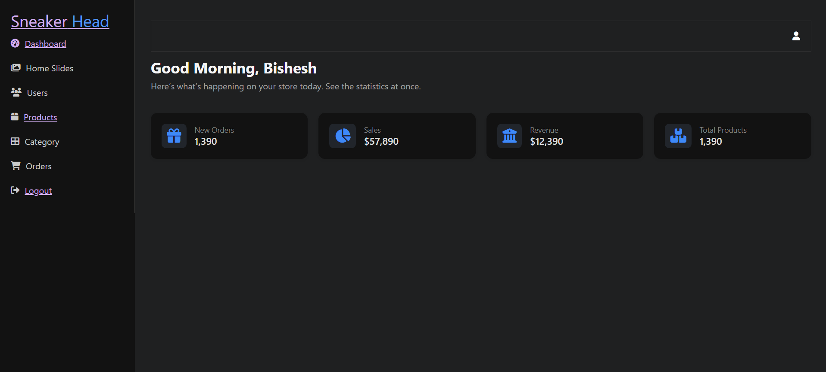
Figure : Admin Panel
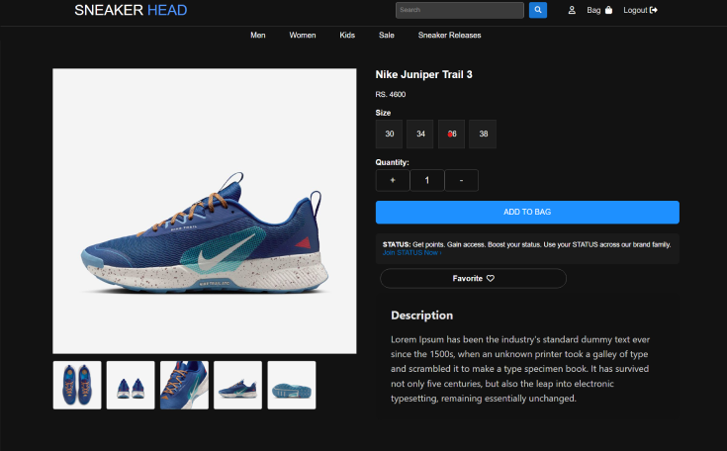
Figure : single product panel

