

CENG241

OBJECT ORİENTED

PROGRAMMİNG

Vehicle Gallery System

Team Members:

Ömer Altıntaş 202111209

Hasan Emre Usta 202111301

Gökay Çetinakdoğan 202111050

Program Language:C++

Main Programs Name: Vehicle Gallery System

IDE: Qt Creator

TABLE OF CONTENTS

1.INTRODUCTION

1.1 Purpose

1.2 Scope

2.DESIGN

2.1 Approach

2.2 System

2.3 System Design

1. Introduction :

Vehicle gallery system is a software that providing businesses to add, delete and update cars and motorcycles to the system.

1.1 Purpose :

With this software, vehicle gallery businesses will be able to track the vehicles coming to their stores more easily.

With the simple appearance of the system, they can easily add, delete, or update their information about the cars and motorcycles they have.

In addition, they can calculate the cost of these vehicles according to the kilometers they travel.

1.2 Scope:

This software includes features that accelerate and facilitate the operations of the business that will use it.

2. DESING :

2.1 Approach :

This software is at a level that meets the services of a vehicle gallery. It makes it easier to keep track of vehicle information.

2.2System :

When the program starts, the login screen opens.

The login screen of the program is as in the figure.

metin, ekran görüntüsü, ekran, görüntüleme, yazılım içeren bir resim

Açıklama otomatik olarak oluşturuldu

Figure 1. Login Page

If the username or password is entered incorrectly on the login screen, the following error screen will be shown.

The error screen of the program is as in the figure.

metin, ekran görüntüsü, yazılım, ekran, görüntüleme içeren bir resim

Açıklama otomatik olarak oluşturuldu

Figure 2. Login Eror Page

When you enter Name: admin and Password: admin on the login screen, the following window opens.

The entrance screen of the program is as in the figure

metin, ekran görüntüsü, yazılım, bilgisayar simgesi içeren bir resim

Açıklama otomatik olarak oluşturuldu

Figure 3. Login login Successful Page

After entering the username and password correctly, the vehicle selection screen appears. Here we choose which type of vehicle we want to process. The vehicle selection screen is as follows.

metin, ekran görüntüsü, yazı tipi, tasarım içeren bir resim

Açıklama otomatik olarak oluşturuldu

Figure 4. Vehicle Selection Page

When we click on the car button, the car registration screen appears.

Here, we first enter the car's information into the relevant fields, including brand, model, year, gear and engine. And when we select the gear, fuel type and color information and click on the add button, our car will be added to the list.

metin, ekran görüntüsü, ekran, görüntüleme, yazılım içeren bir resim

Açıklama otomatik olarak oluşturuldu

Figure 5. Car Registration Screen 1

Here we can choose the gear that belongs to the car among the gear options.

metin, ekran görüntüsü, ekran, görüntüleme, yazılım içeren bir resim

Açıklama otomatik olarak oluşturuldu

Figure 6. Car Registration Screen 2

Here we can choose the fuel type for the car among the fuel type options.

metin, ekran görüntüsü, ekran, görüntüleme, yazılım içeren bir resim

Açıklama otomatik olarak oluşturuldu

Figure 7. Car Registration Screen 3

Here we can choose the one that belongs to the car among the color options.

metin, ekran görüntüsü, yazılım, diyagram içeren bir resim

Açıklama otomatik olarak oluşturuldu

Figure 8. Car Registration Screen 4

After entering the information of the vehicles we want into the required fields and clicking the add button, the vehicles will be added to the list.

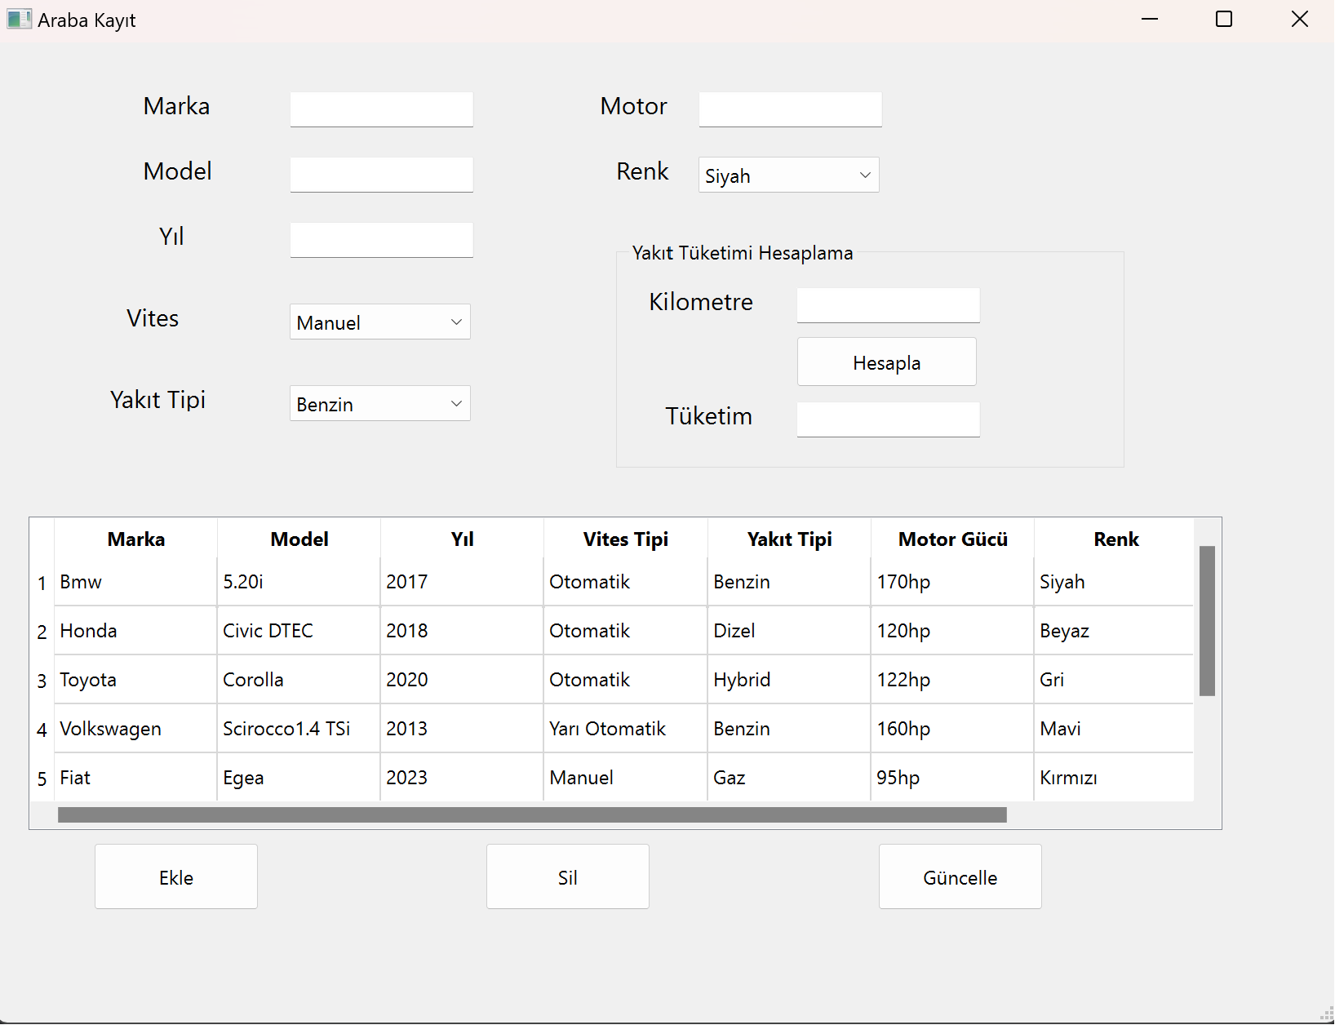

Figure 9. Car Registration Screen 5

If the vehicle information is to be updated, click on the desired line, change the information in the field above and click on the update button.

metin, ekran görüntüsü, ekran, görüntüleme, yazılım içeren bir resim

Açıklama otomatik olarak oluşturuldu

Figure 10. Car Registration Screen 6

After clicking the update button, the following image appears.

metin, ekran görüntüsü, diyagram, sayı, numara içeren bir resim

Açıklama otomatik olarak oluşturuldu

Figure 11. Car Registration Screen 7

If we want to delete a vehicle, we select the row with the vehicle and click the delete button.

metin, ekran görüntüsü, ekran, görüntüleme, yazılım içeren bir resim

Açıklama otomatik olarak oluşturuldu

Figure 12. Car Registration Screen 8

After clicking the delete button, the vehicle is deleted from the list.

metin, ekran görüntüsü, diyagram, ekran, görüntüleme içeren bir resim

Açıklama otomatik olarak oluşturuldu

Figure 13. Car Registration Screen 9

When we enter the kilometers traveled by the vehicle in the fuel consumption field and click on the calculate button, it shows us how much fuel we spent in TL.

metin, ekran görüntüsü, ekran, görüntüleme, yazı tipi içeren bir resim

Açıklama otomatik olarak oluşturuldu

Figure 14. Car Registration Screen 10

When we finish our operations here, we return to the main menu by clicking the cross button on the top right.

If we are going to perform operations for the motorcycle from here, we click on the this button.

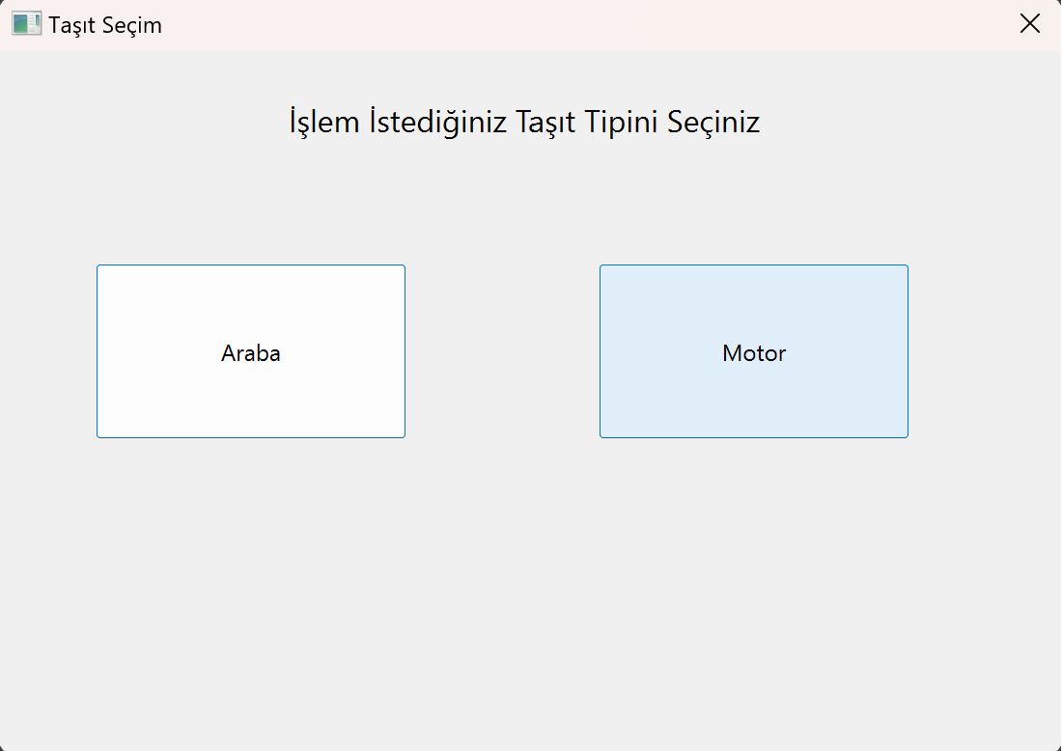

Figure 15. Vehicle Selection Page 2

This following window opens for motorcycle operations

Here we can do the same for motorcycles as we did for cars. Add, delete and update operations work the same way.

metin, ekran görüntüsü, ekran, görüntüleme, yazılım içeren bir resim

Açıklama otomatik olarak oluşturuldu

Figure 16. Motorcycle Registration Screen 1

metin, ekran görüntüsü, sayı, numara, ekran, görüntüleme içeren bir resim

Açıklama otomatik olarak oluşturuldu

Figure 17. Motorcycle Registration Screen 2

In the fuel consumption calculation section, it makes a different calculation than for cars and finds the fuel consumed in TL for the motorcycle.

metin, ekran görüntüsü, yazı tipi, ekran, görüntüleme içeren bir resim

Açıklama otomatik olarak oluşturuldu

Figure 18. Motorcycle Registration Screen 3

When we are done with our operations here, we can close our program by pressing the cross buttons on the top right.

2.3 System Design:

In the system, the vehicle class is the parent of the car and bike classes. There is an inheritance relationship between them. This system has data encapsulation. In the main system, the user is guided by 2 operations. and there are many options within these two options. The class diagram representation of the software is as follows:

metin, ekran görüntüsü, diyagram, dikdörtgen içeren bir resim

Açıklama otomatik olarak oluşturuldu

Figure 19. Class Diagram

3. Conclusion:

This project was created to facilitate the transactions of businesses in the vehicle sales sector according to their needs. It is a system that has been created with C++ object-oriented software language.It is an application that has been tried to be exemplified by using the topics (functions, class ,constructors, destructors, etc.) we see in CENG241 course contentIt can be developed according to needs and can be setting an example for the users in the field.