Sample Course Name

Sample Course Module Name

Author: Asst. Prof. Dr. Uğur CORUH

## Algorithms And Programming

### Week-2 (Git)

#### Spring Semester, 2022-2023

Download [DOC](week-2.en.md_doc.pdf), [SLIDE](week-2.en.md_slide.pdf), [PPTX](week-2.en.md_slide.pptx)

### Git

* How to use Git?

## **How to use Git?**

### Git

* **Here is a basic overview of how Git works** 1.Create a “repository” (project) with a git hosting tool (like Bitbucket) 2.Copy (or clone) the repository to your local machine 3.Add a file to your local repo and “commit” (save) the changes 4.”Push” your changes to your main branch 5.Make a change to your file with a git hosting tool and commit 6.”Pull” the changes to your local machine 7.Create a “branch” (version), make a change, commit the change 8.Open a “pull request” (propose changes to the main branch) 9.”Merge” your branch to the main branch

### Git

* **Sample git notation** A simple modeled version of the git shown in this image.

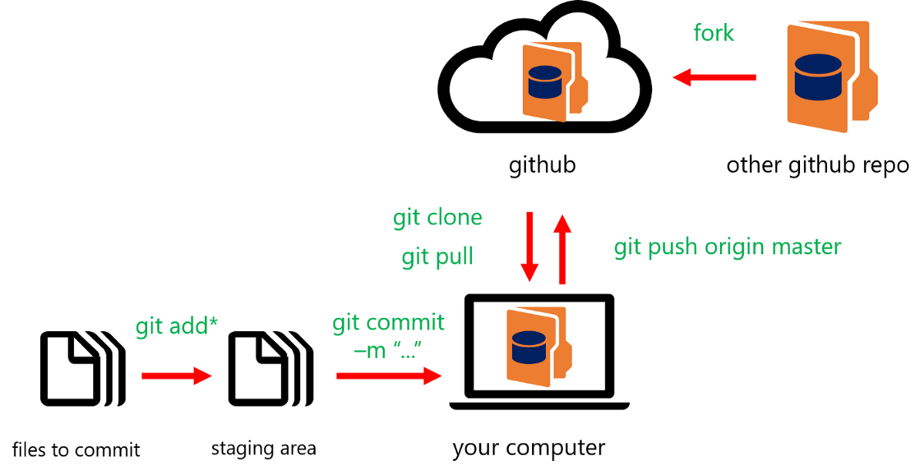

bg right:50% h:300px

### Git

* **Simple “git init” notation**

The git init command creates a new Git repository. It can be used to convert an existing, unversioned project to a Git repository or initialize a new, empty repository.

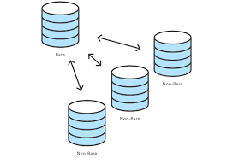

bg right:50% center h:300px

### Git

* **How to use “git add”** Here you see using a git add from the command line.

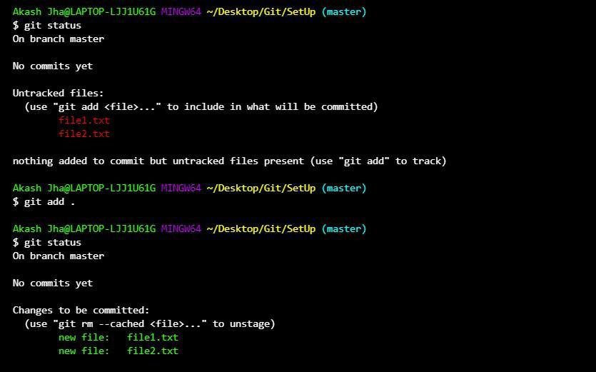

bg left:60% h:350px

### Git

* **How to use “git commit”** Here you see using a git commit from the command line.

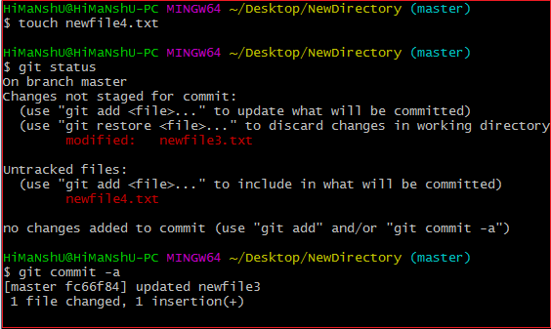

bg left:60% h:350px

**TODO** DO MORE LEARN

## References

* https://www.atlassian.com/git/tutorials/learn-git-with-bitbucket-cloud
* https://www.atlassian.com/git/tutorials/setting-up-a-repository/git-init
* https://www.atlassian.com/git/tutorials/learn-git-with-bitbucket-cloud
* https://medium.com/swlh/an-introduction-to-git-and-github-22ecb4cb1256
* https://git-scm.com/

$End−Of−Week−2−Module$