**GTU Department of Computer Engineering**

**CSE 222/505 - Spring 2021**

**Homework #1 Report**

**Gökbey Gazi Keskin**

**1901042631**

1. **INTRODUCTION**
   1. **Problem Definition**

The Furniture Company Automation system has users such as Administrator, Branch Employee and Brand Customer. Administrators can access all branches and all employees and manage the company by doing queries for product needs in branches, adding/deleting branches, employees, products and creating new products. Branch Employees can only access the branch which he/she works at and its products. Branch employee can manage and organize the branch by selling products, adding new customer subscriptions, doing inquiries for product needs, informing Administrators about product needs, and listing a customer’s previous orders. Customers can login to the system with e-mail and password, search and list products and branches, buy products online, list their previous orders.

* 1. **System Requirements**

**ADMINISTRATOR**

Requires a name, surname, and ID.



All admin methods except the inherited ones are static because all admins can access every single data of the company.

Admins can:

add/remove branches,





add/remove employees to/from branches.





query a branch for needed products, (Returns a container of needed products)



create/add new products for/to branches.





**BRANCH EMPLOYEE**

Requires a name, surname, and ID



Branch employees can:

inquire a product for needs,



inform admins about needing a product. Usually used after inquiry method,



make sales in the store, (face-to-face)



create subscription for a new customer in his/her branch. (face-to-face),



add an existing customer to this branch,



access to previous orders of a customer.

**BRAND CUSTOMER**

Requires a name, surname, e-mail, phone number and password. ID is automatically created by the system.



Brand customers can:

login to the system,



list products of a branch,



search for products with product ID or name,





buy products online,



access his/her previous orders.



1. **USE CASE AND CLASS DIAGRAMS**

**2.1 Use Case Diagram**

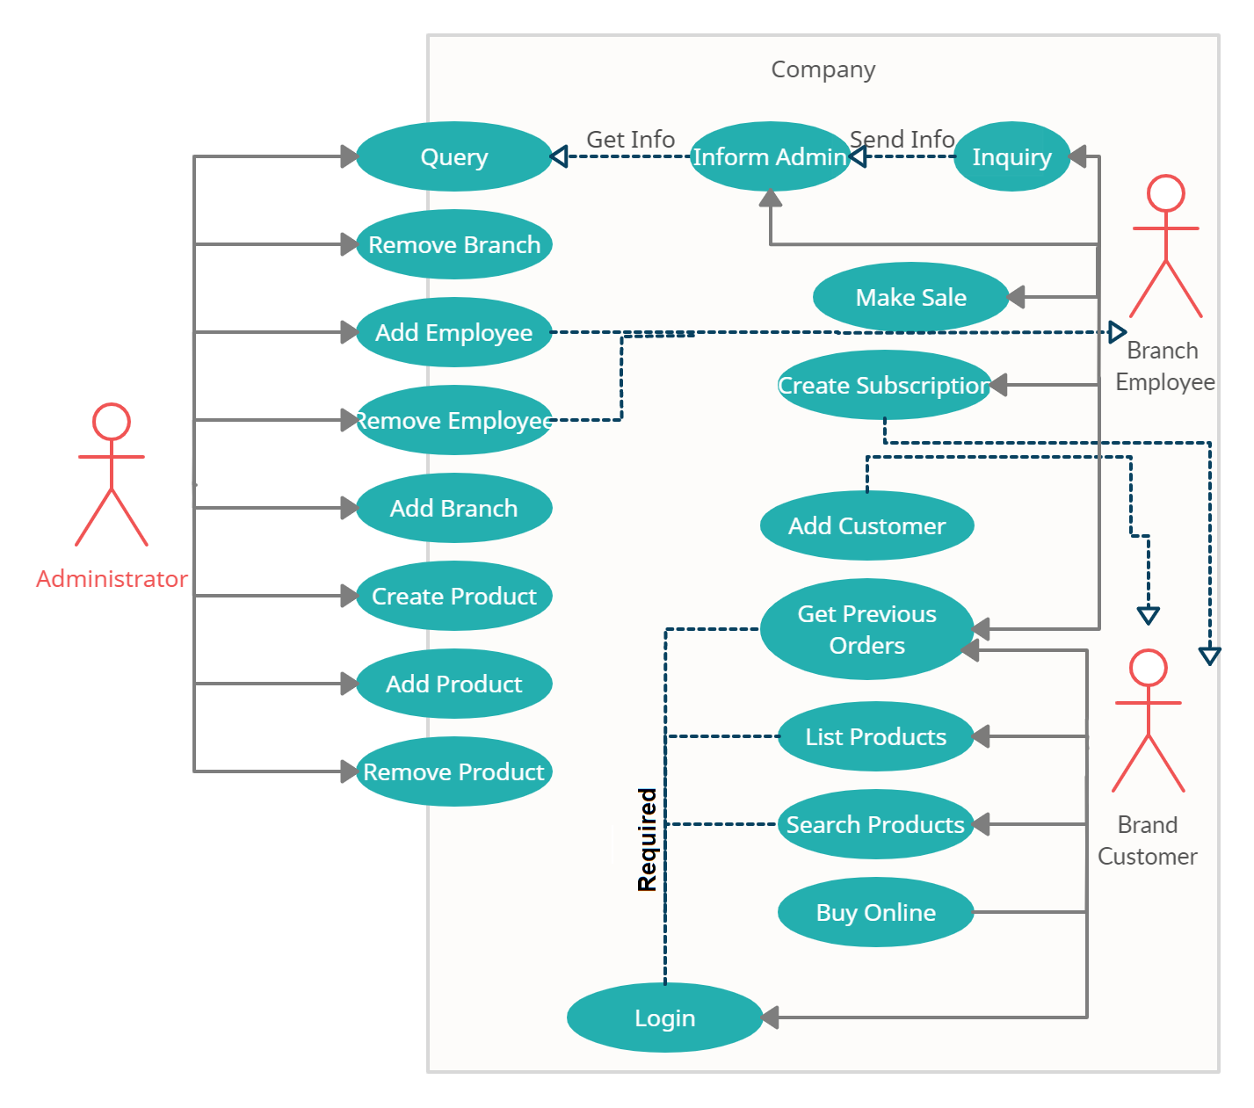

**2.2 Class Diagram**

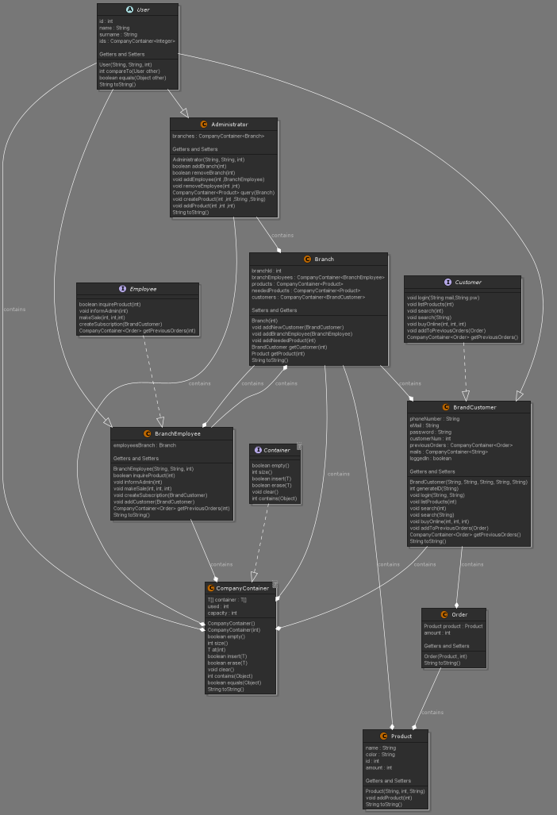

1. **Problem Solution Approach**

Problem is identified in Section 1.1. First, I had to implement a simple container class for containing company’s data with a much cleaner code. So, I implemented CompanyContainer and used it through the whole process. Then I implemented the abstract User Class with name, surname, and ID for holding datas of all the users of the systems and extended it with BranchEmployee, BrandCustomer and Administrator classes. I also created Branch (which has product, employee, and customer containers), Product and Order classes for representing everything clearly. All the methods of the Administrator class are static because all admins can access all data of the company and manipulate (doesn’t matter which admin). But employees can only access and manipulate the data of their branches. Customers has to login before using the system and can access all branches but can’t manipulate them (except for buying products). Employees and Administrators can choose their unique ID but Customers gets an automatically assigned ID. Lastly, I created a user interface to test the project (Driver Class). Next section will consist of Test Cases and Outputs of this interface.

1. **Test Cases and Outputs**

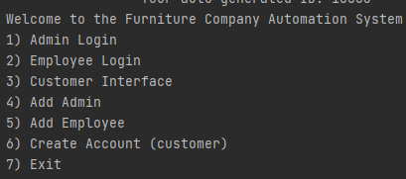

**CREATE ADMIN**

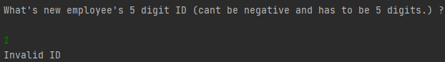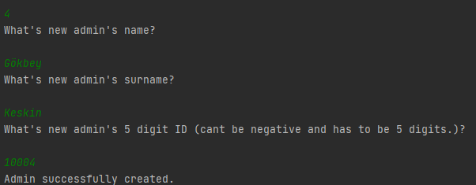

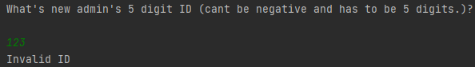

**ADMIN LOGIN**

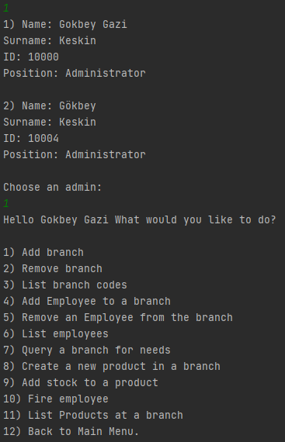

**ADMIN**

** Add Branch Remove Branch**





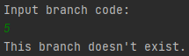

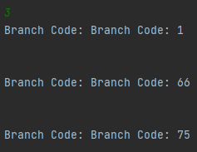

** List Branches**

**List Employees**

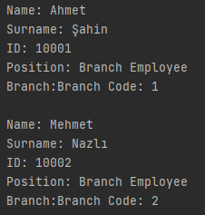



**Add Employee to Branch**

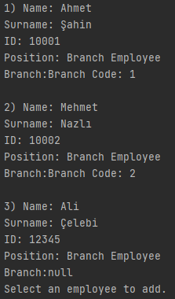

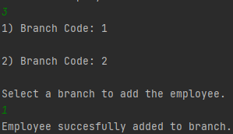

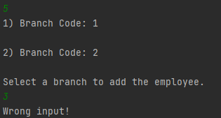

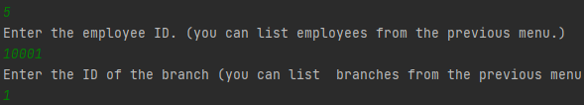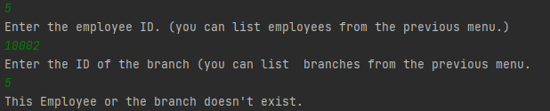**Remove an Employee from a Branch**

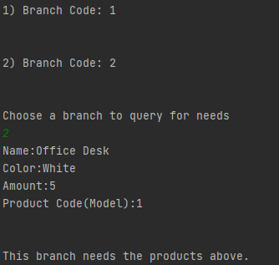**Query a Branch for needs**

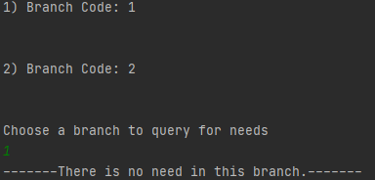

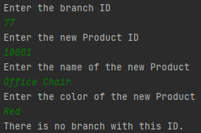 **Create a New Product in a Branch**

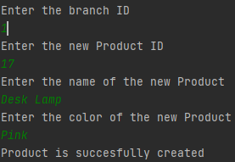

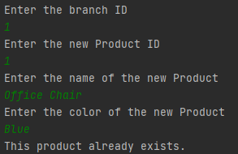

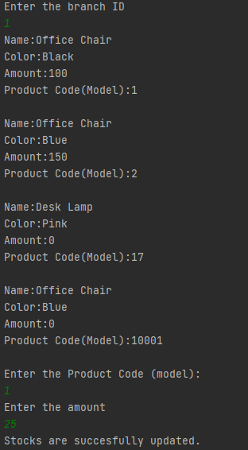**Add Stock to a product**

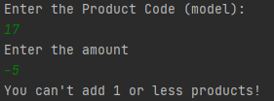

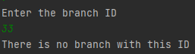

**Fire Employee**

 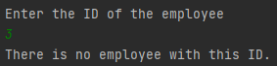

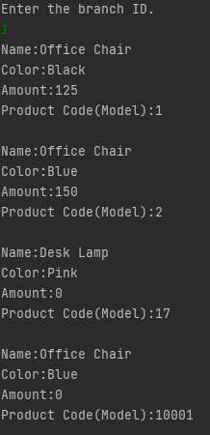**List Products at a Branch**

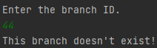



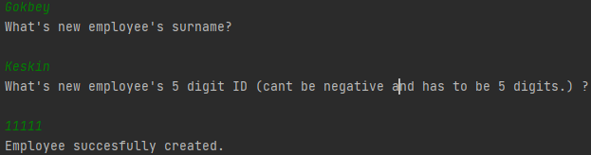**Create Employee**

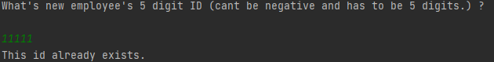

**Employee Login**

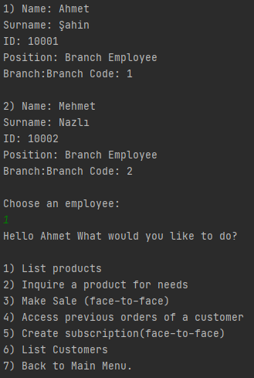

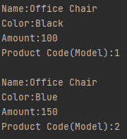**List Products**

**Inquire a product for needs**

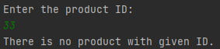

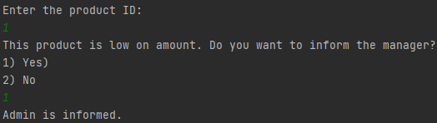

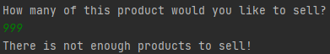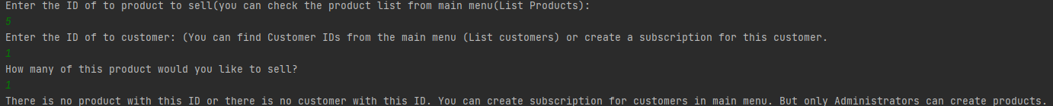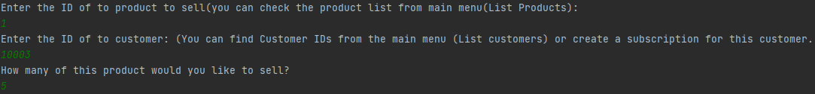**Make Sale**

**Access Previous Orders of a Customer**



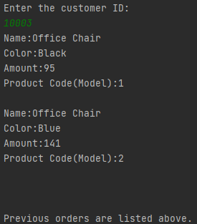

**Create Subscription**

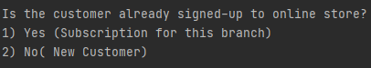

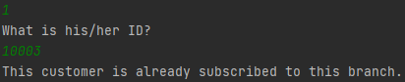

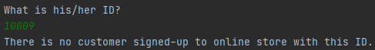



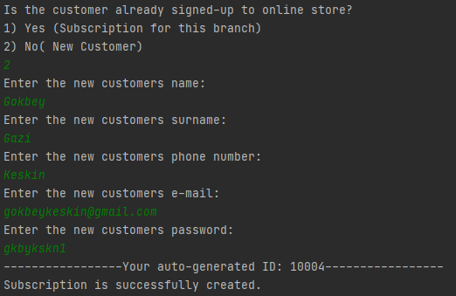

**List Customers**

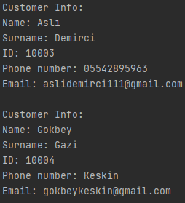

**Create Customer**

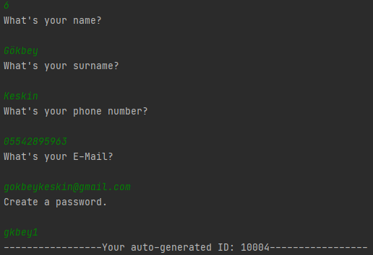

**Customer Interface**

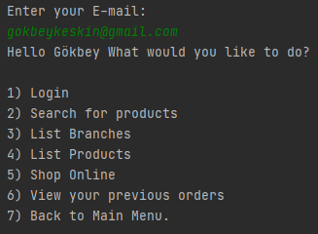

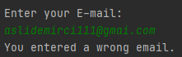

**Login**

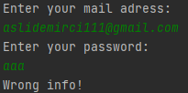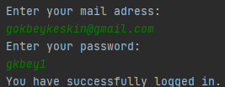



**Every single customer method gives the same warning when the customer is not logged in:**



**Search**

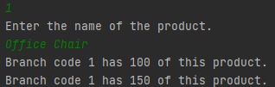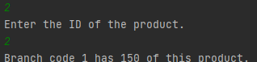

**List Branches**



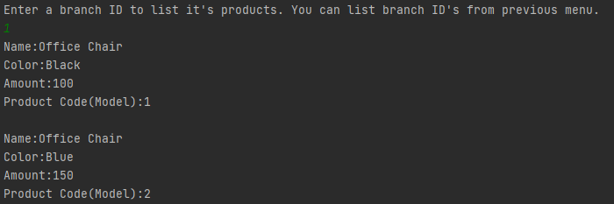**List Products**

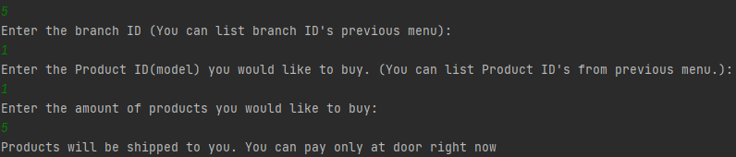**Shop Online**

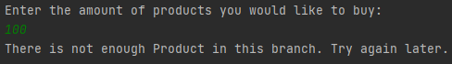



**View your Previous Orders**



