**Console Based Application**

**GRN:12010664**

**Name of the Student: Vedant Gokhale**

**Roll No.: 37**

**Class: AI**

**Division: A**

**Batch: B2**

**Code**

import java.sql.Connection;  
import java.sql.DriverManager;  
import java.sql.Statement;  
  
public class Conn {  
 Connection c;  
 Statement s;  
 public Conn(){  
 try{  
 Class.*forName*("com.mysql.jdbc.Driver");  
 c = DriverManager.*getConnection*("jdbc:mysql://localhost:3306/Employee","root","");  
 s = c.createStatement();  
 }catch(Exception e){  
 System.*out*.println(e);  
 }  
 }  
}

import java.sql.SQLException;  
  
public class AddEmployee {  
 int id;  
 String name;  
 String city;  
 int number;  
  
 AddEmployee(int id,String name,String city, int number) throws SQLException {  
 setCity(city);  
 setId(id);  
 setNumber(number);  
 setName(name);  
  
 Conn c2 = new Conn();  
 String query = "insert into Employee values('" + getId() + "','" + getName() + "','" + getCity() + "','" + getNumber() + "')";  
 c2.s.executeUpdate(query);  
 System.*out*.println("New Employee Added");  
  
 }  
  
 public String getName() {  
 return name;  
 }  
  
 public int getId() {  
 return id;  
 }  
  
 public int getNumber() {  
 return number;  
 }  
  
 public String getCity() {  
 return city;  
 }  
  
 public void setName(String name) {  
 this.name = name;  
 }  
  
 public void setCity(String city) {  
 this.city = city;  
 }  
  
 public void setId(int id) {  
 this.id = id;  
 }  
  
 public void setNumber(int number) {  
 this.number = number;  
 }  
}

import java.sql.SQLException;  
  
public class RemoveEmployee {  
 RemoveEmployee(int id) throws SQLException {  
 Conn c2 = new Conn();  
 String query = "DELETE FROM Employee where ID = " + id + "";  
 c2.s.executeUpdate(query);  
 System.*out*.println("Employee Record Deleted");  
 }  
}

package LAB13;  
  
import java.sql.SQLException;  
  
public class UpdateEmployee {  
 UpdateEmployee(int id,String name,String city, int number) throws SQLException {  
 Conn c2 = new Conn();  
 String query = "UPDATE Employee SET Name = '"+name+"', City = '"+city+"', PhoneNumber = '"+number+"' WHERE ID = '"+id+"';";  
 c2.s.executeUpdate(query);  
 System.*out*.println("Employee Record Updated");  
 }  
}

package LAB13;  
  
import java.sql.ResultSet;  
  
public class ViewEmployee {  
 ViewEmployee() {  
 try {  
 Conn c1 = new Conn();  
 ResultSet rs = c1.s.executeQuery("SELECT * FROM Employee");  
 int i = 1;  
 while (rs.next()) {  
 System.*out*.println("Employee Number " + i);  
 System.*out*.print("ID: " + rs.getInt(1));  
 System.*out*.println();  
 System.*out*.print("Name: " + rs.getString(2));  
 System.*out*.println();  
 System.*out*.print("Pune: " + rs.getString(3));  
 System.*out*.println();  
 System.*out*.print("Contact Number: " + rs.getInt(4));  
 System.*out*.println();  
 System.*out*.println();  
 i++;  
 }  
 } catch (Exception e) {  
 System.*out*.println(e);  
 }  
  
 }  
}

package LAB13;  
  
import java.sql.SQLException;  
import java.util.Scanner;  
  
public class CRUDEmployee {  
 public static void main(String[] args) throws SQLException {  
 Scanner input = new Scanner(System.*in*);  
 int n;  
 int id;  
 String name;  
 String city;  
 int contact;  
 do {  
 System.*out*.println("1. Add Employee ");  
 System.*out*.println("2. Delete Employee ");  
 System.*out*.println("3. Update Employee ");  
 System.*out*.println("4. View Employee ");  
 System.*out*.println("5. Exit ");  
 n = input.nextInt();  
 if (n == 1) {  
 System.*out*.print("Enter employee ID: ");  
 id = input.nextInt();  
 System.*out*.print("Enter employee Name: ");  
 name = input.next();  
 System.*out*.print("Enter employee City: ");  
 city = input.next();  
 System.*out*.print("Enter employee Contact: ");  
 contact = input.nextInt();  
 AddEmployee a = new AddEmployee(id, name, city, contact);  
 } else if (n == 2) {  
 System.*out*.print("Enter ID of Employee: ");  
 id = input.nextInt();  
 RemoveEmployee r = new RemoveEmployee(id);  
 } else if (n == 3) {  
 System.*out*.print("Enter employee ID: ");  
 id = input.nextInt();  
 System.*out*.print("Enter employee Name: ");  
 name = input.next();  
 System.*out*.print("Enter employee City: ");  
 city = input.next();  
 System.*out*.print("Enter employee Contact: ");  
 contact = input.nextInt();  
 UpdateEmployee u = new UpdateEmployee(id, name, city, contact);  
 } else if (n == 4) {  
 System.*out*.println("Employee Details");  
 ViewEmployee v = new ViewEmployee();  
 } else {  
 n = 5;  
 }  
 } while (n != 5);  
 }  
}

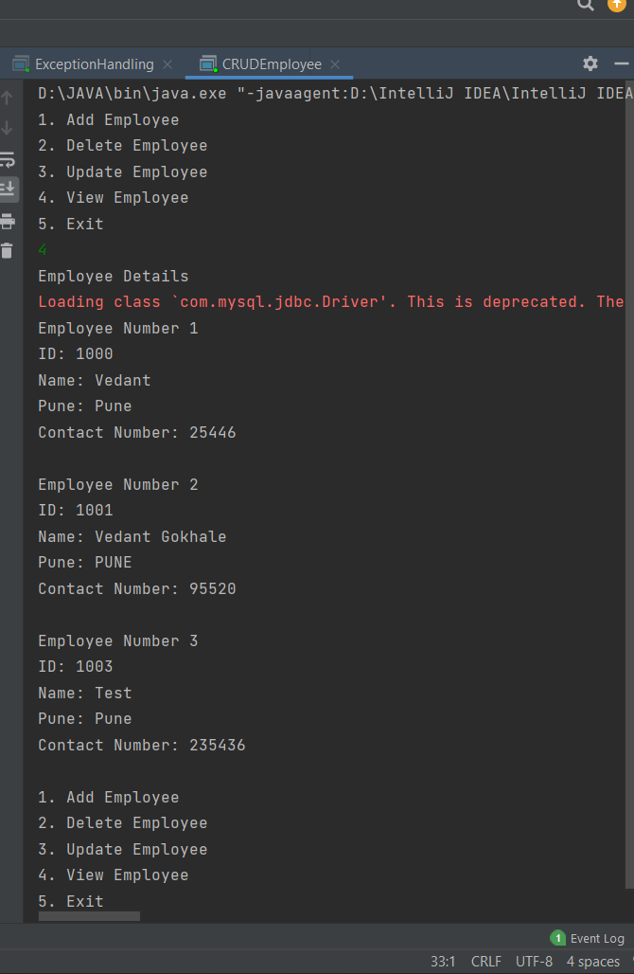

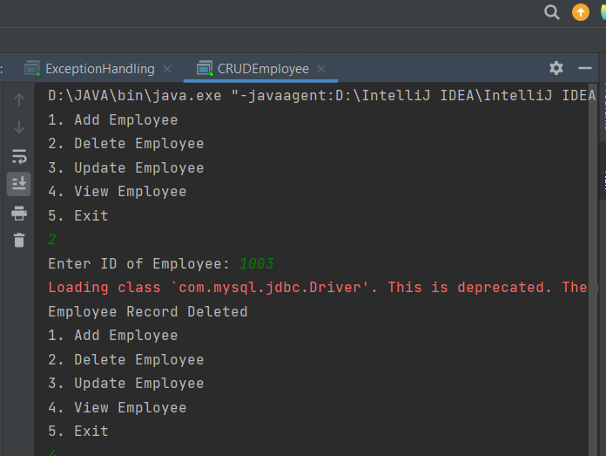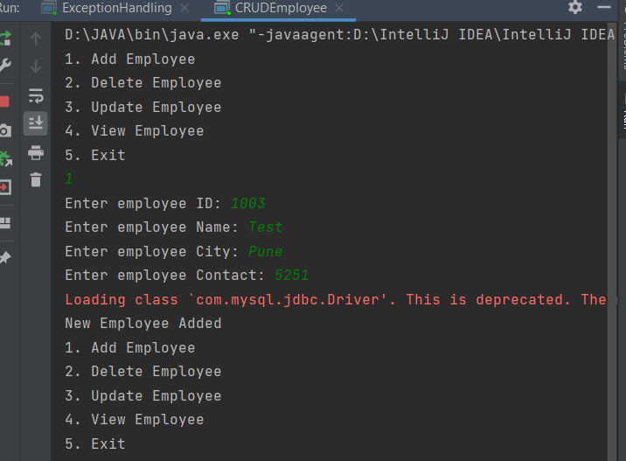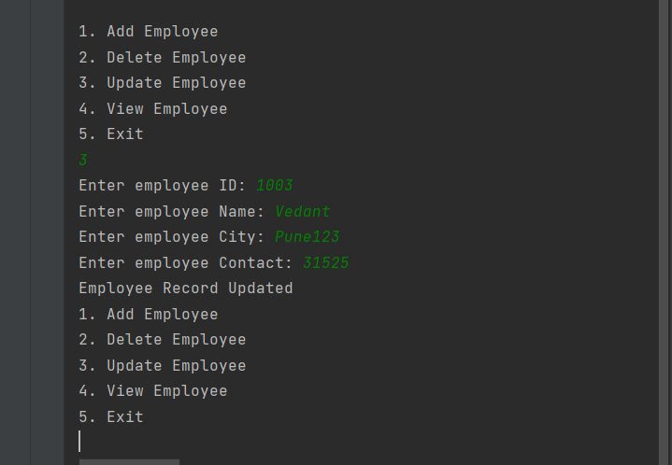

**GUI BASED**

**CODE**

package LAB14;  
  
import java.sql.Connection;  
import java.sql.DriverManager;  
import java.sql.Statement;  
  
public class Conn {  
 Connection c;  
 Statement s;  
 public Conn(){  
 try{  
 Class.*forName*("com.mysql.jdbc.Driver");  
 c = DriverManager.*getConnection*("jdbc:mysql://localhost:3306/Employee","root","");  
 s = c.createStatement();  
 }catch(Exception e){  
 System.*out*.println(e);  
 }  
 }  
}

package LAB14;  
  
import javax.swing.*;  
import javax.swing.table.DefaultTableModel;  
import java.awt.*;  
import java.awt.event.ActionEvent;  
import java.awt.event.ActionListener;  
import java.sql.ResultSet;  
import java.util.ArrayList;  
  
public class DeleteEmployee extends JFrame implements ActionListener {  
 JButton back,remove;  
 JLabel tableTitle,id;  
 JTextField idTF;  
 JTable employeeDetails;  
 public void actionPerformed(ActionEvent ae){  
 if (ae.getSource() == remove) {  
 try {  
 Conn c1 = new Conn();  
 String id = idTF.getText();  
 String query = "DELETE FROM employee where ID = " + id + "";  
 c1.s.executeUpdate(query);  
 JOptionPane.*showMessageDialog*(null, " Employee Record Deleted");  
 System.*out*.println("Employee Removed");  
 } catch (Exception e) {  
 System.*out*.println(e);  
 }  
 }else if(ae.getSource()==back){  
 new Index().setVisible(true);  
 setVisible(false);  
 }  
 }  
  
 DeleteEmployee(){  
 setTitle("EMPLOYEE MANAGEMENT SYSTEM");  
 Conn c1 = new Conn();  
 setLayout(null);  
  
  
 back = new JButton("Back");  
 back.setBackground(Color.*BLACK*);  
 back.setForeground(Color.*WHITE*);  
 back.setBounds(20, 10, 100, 40);  
 add(back);  
 back.addActionListener(this);  
  
 tableTitle = new JLabel("Delete From Record");  
 tableTitle.setFont(new Font("Osward", Font.*BOLD*, 30));  
 tableTitle.setBounds(500, 40, 600, 40);  
 add(tableTitle);  
  
 id = new JLabel("Enter ID");  
 id.setFont(new Font("Osward", Font.*BOLD*, 20));  
 id.setBounds(50, 120, 600, 40);  
 add(id);  
  
 idTF = new JTextField(15);  
 idTF.setBounds(250, 125, 230, 30);  
 idTF.setFont(new Font("Arial", Font.*BOLD*, 14));  
 add(idTF);  
  
 remove = new JButton("Remove");  
 remove.setBackground(Color.*BLACK*);  
 remove.setForeground(Color.*WHITE*);  
 remove.setBounds(500, 125, 100, 30);  
 add(remove);  
  
 remove.addActionListener(this);  
  
  
 String[][] data = {{"1000", "Vedant", "Pune", "12312"}  
 };  
 String[] column = {"ID", "Name", "City", "ContactNumber"};  
  
  
 employeeDetails = new JTable(data, column);  
 employeeDetails.setBounds(50, 200, 1400, 550);  
 employeeDetails.setBackground(Color.*darkGray*);  
 employeeDetails.setGridColor(Color.*white*);  
 employeeDetails.setForeground(Color.*white*);  
 employeeDetails.setRowHeight(40);  
  
 DefaultTableModel model = new DefaultTableModel();  
 model.setColumnIdentifiers(column);  
 employeeDetails.setModel(model);  
  
  
 ArrayList<String> names = new ArrayList<>();  
 ArrayList<Integer> id = new ArrayList<>();  
 ArrayList<Integer> number = new ArrayList<>();  
 ArrayList<String> city = new ArrayList<>();  
  
  
 int count = 0;  
 try {  
  
 ResultSet rs = c1.s.executeQuery("SELECT * FROM employee" );  
 String name = null;  
 while (rs.next()) {  
 names.add(rs.getString(2));  
 id.add(rs.getInt(1));  
 city.add(rs.getString(3));  
 number.add(rs.getInt(4));  
 count++;  
 }  
 } catch (Exception e) {  
 System.*out*.println(e);  
 }  
  
 for (int i = 0; i < count; i++) {  
 String[] rowData = { String.*valueOf*(id.get(i)),names.get(i), city.get(i), String.*valueOf*(number.get(i)) };  
 model.addRow(rowData);  
 }  
  
 add(employeeDetails);  
  
 getContentPane().setBackground(Color.*WHITE*);  
  
 setSize(1510, 840);  
 setLocation(10, 10);  
 setVisible(true);  
 }  
  
  
}

package LAB14;  
  
import javax.swing.*;  
import java.awt.*;  
import java.awt.event.ActionEvent;  
import java.awt.event.ActionListener;  
  
public class Index extends JFrame implements ActionListener {  
 JButton add,remove,update,view;  
 JLabel l1;  
 public void actionPerformed(ActionEvent ae){  
 try{  
 if(ae.getSource()==add){  
 new AddEmployee().setVisible(true);  
 setVisible(false);  
 }else if (ae.getSource()==remove){  
 new DeleteEmployee().setVisible(true);  
 setVisible(false);  
 }else if(ae.getSource()==view){  
 new ViewEmployee().setVisible(true);  
 setVisible(false);  
 }else if(ae.getSource()==update){  
 new UpdateEmployee().setVisible(true);  
 setVisible(false);  
 }  
 }catch (Exception e){  
 System.*out*.println(e);  
 }  
 }  
 Index(){  
 setTitle("EMPLOYEE MANAGEMENT SYSTEM");  
 setLayout(null);  
 l1 = new JLabel("Manage Employees");  
 l1.setFont(new Font("Osward",Font.*BOLD*,22));  
 l1.setBounds(260,40,450,40);  
 add(l1);  
  
 add = new JButton("Add Employee");  
 add.setBackground(Color.*BLACK*);  
 add.setForeground(Color.*WHITE*);  
 add.setBounds(150,120,150,80);  
 add(add);  
  
 remove = new JButton("Remove Employee");  
 remove.setBackground(Color.*BLACK*);  
 remove.setForeground(Color.*WHITE*);  
 remove.setBounds(450,120,150,80);  
 add(remove);  
  
 update = new JButton("Update Employee");  
 update.setBackground(Color.*BLACK*);  
 update.setForeground(Color.*WHITE*);  
 update.setBounds(150,280,150,80);  
 add(update);  
  
 view = new JButton("View Employee List");  
 view.setBackground(Color.*BLACK*);  
 view.setForeground(Color.*WHITE*);  
 view.setBounds(450,280,150,80);  
 add(view);  
  
 add.addActionListener(this);  
 remove.addActionListener(this);  
 update.addActionListener(this);  
 view.addActionListener(this);  
  
  
 getContentPane().setBackground(Color.*WHITE*);  
  
 setSize(800, 480);  
 setLocation(450, 200);  
 setVisible(true);  
 }  
  
 public static void main(String[] args) {  
 Index i = new Index();  
 }  
}

package LAB14;  
  
import javax.swing.*;  
import java.awt.*;  
import java.awt.event.ActionEvent;  
import java.awt.event.ActionListener;  
  
public class UpdateEmployee extends JFrame implements ActionListener {  
 JLabel WindowTitle, employeeName, employeeID, employeeCity, employeeContact;  
 JButton updateEmployee, back;  
 JTextField employeeNameTF, employeeIDTF, employeeCityTF, employeeContactTF;  
 public void actionPerformed(ActionEvent ae){  
 if (ae.getSource() == updateEmployee) {  
 try {  
 String name = employeeNameTF.getText();  
 int id = Integer.*parseInt*(employeeIDTF.getText());  
 int number = Integer.*parseInt*(employeeContactTF.getText());  
 String city = employeeCityTF.getText();  
  
 Conn c2 = new Conn();  
 String query = "UPDATE employee SET Name = '" + name + "',City = '" + city + "',PhoneNumber = '" + number + "'WHERE ID = '"+id+"';";  
 c2.s.executeUpdate(query);  
 JOptionPane.*showMessageDialog*(null, "Record Updated");  
 System.*out*.println("Record Updated");  
  
 } catch (Exception e) {  
 System.*out*.println(e);  
 }  
 }else if(ae.getSource()==back){  
 new Index().setVisible(true);  
 setVisible(false);  
 }  
 }  
 UpdateEmployee(){  
 setTitle("EMPLOYEE MANAGEMENT SYSTEM");  
 setLayout(null);  
 WindowTitle = new JLabel("Update Employee - Fill Details");  
 WindowTitle.setFont(new Font("Osward", Font.*BOLD*, 30));  
 WindowTitle.setBounds(450, 40, 600, 40);  
 add(WindowTitle);  
  
 back = new JButton("Back");  
 back.setBackground(Color.*BLACK*);  
 back.setForeground(Color.*WHITE*);  
 back.setBounds(20, 10, 100, 40);  
 add(back);  
 back.addActionListener(this);  
  
 employeeID = new JLabel("Enter ID");  
 employeeID.setFont(new Font("Raleway", Font.*BOLD*, 20));  
 employeeID.setBounds(50, 120, 450, 40);  
 add(employeeID);  
  
 employeeIDTF = new JTextField(15);  
 employeeIDTF.setBounds(300, 120, 230, 40);  
 employeeIDTF.setFont(new Font("Arial", Font.*BOLD*, 14));  
 add(employeeIDTF);  
  
 employeeName = new JLabel("Enter Name");  
 employeeName.setFont(new Font("Raleway", Font.*BOLD*, 20));  
 employeeName.setBounds(50, 180, 450, 40);  
 add(employeeName);  
  
 employeeNameTF = new JTextField(15);  
 employeeNameTF.setBounds(300, 180, 230, 40);  
 employeeNameTF.setFont(new Font("Arial", Font.*BOLD*, 14));  
 add(employeeNameTF);  
  
  
  
 employeeCity = new JLabel("Enter City");  
 employeeCity.setFont(new Font("Raleway", Font.*BOLD*, 20));  
 employeeCity.setBounds(50, 240, 450, 40);  
 add(employeeCity);  
  
 employeeCityTF = new JTextField(15);  
 employeeCityTF.setBounds(300, 240, 230, 40);  
 employeeCityTF.setFont(new Font("Arial", Font.*BOLD*, 14));  
 add(employeeCityTF);  
  
 employeeContact = new JLabel("Enter Contact Number");  
 employeeContact.setFont(new Font("Raleway", Font.*BOLD*, 20));  
 employeeContact.setBounds(50, 300, 450, 40);  
 add(employeeContact);  
  
 employeeContactTF = new JTextField(15);  
 employeeContactTF.setBounds(300, 300, 230, 40);  
 employeeContactTF.setFont(new Font("Arial", Font.*BOLD*, 14));  
 add(employeeContactTF);  
  
 updateEmployee = new JButton("Update Details");  
 updateEmployee.setBackground(Color.*BLACK*);  
 updateEmployee.setForeground(Color.*WHITE*);  
 updateEmployee.setBounds(140, 400, 250, 45);  
 add(updateEmployee);  
  
 updateEmployee.addActionListener(this);  
 getContentPane().setBackground(Color.*WHITE*);  
  
 setSize(1510, 840);  
 setLocation(10, 10);  
 setVisible(true);  
 }  
  
  
}

package LAB14;  
  
import javax.swing.*;  
import javax.swing.table.DefaultTableModel;  
import java.awt.*;  
import java.awt.event.ActionEvent;  
import java.awt.event.ActionListener;  
import java.sql.ResultSet;  
import java.util.ArrayList;  
  
public class ViewEmployee extends JFrame implements ActionListener {  
  
  
 JButton back;  
 JTable employeeDetails;  
 JLabel tableTitle;  
  
 public void actionPerformed(ActionEvent ae){  
 if(ae.getSource()==back){  
 new Index().setVisible(true);  
 setVisible(false);  
 }  
 }  
 ViewEmployee(){  
 setTitle("EMPLOYEE MANAGEMENT SYSTEM");  
 setLayout(null);  
  
  
 back = new JButton("Back");  
 back.setBackground(Color.*BLACK*);  
 back.setForeground(Color.*WHITE*);  
 back.setBounds(20, 10, 100, 40);  
 add(back);  
 back.addActionListener(this);  
  
 tableTitle = new JLabel("Employee Details");  
 tableTitle.setFont(new Font("Osward", Font.*BOLD*, 30));  
 tableTitle.setBounds(580, 40, 600, 40);  
 add(tableTitle);  
  
  
 String[][] data = {{"1000", "Vedant", "Pune", "12312"}  
 };  
 String[] column = {"ID", "Name", "City", "ContactNumber"};  
  
  
 employeeDetails = new JTable(data, column);  
 employeeDetails.setBounds(50, 100, 1400, 600);  
 employeeDetails.setBackground(Color.*darkGray*);  
 employeeDetails.setGridColor(Color.*white*);  
 employeeDetails.setForeground(Color.*white*);  
 employeeDetails.setRowHeight(40);  
  
 DefaultTableModel model = new DefaultTableModel();  
 model.setColumnIdentifiers(column);  
 employeeDetails.setModel(model);  
  
  
 ArrayList<String> names = new ArrayList<>();  
 ArrayList<Integer> id = new ArrayList<>();  
 ArrayList<Integer> number = new ArrayList<>();  
 ArrayList<String> city = new ArrayList<>();  
  
  
 int count = 0;  
 try {  
 Conn c1 = new Conn();  
 ResultSet rs = c1.s.executeQuery("SELECT * FROM employee" );  
 String name = null;  
 while (rs.next()) {  
 names.add(rs.getString(2));  
 id.add(rs.getInt(1));  
 city.add(rs.getString(3));  
 number.add(rs.getInt(4));  
 count++;  
 }  
 } catch (Exception e) {  
 System.*out*.println(e);  
 }  
  
 for (int i = 0; i < count; i++) {  
 String[] rowData = { String.*valueOf*(id.get(i)),names.get(i), city.get(i), String.*valueOf*(number.get(i)) };  
 model.addRow(rowData);  
 }  
  
 add(employeeDetails);  
  
 getContentPane().setBackground(Color.*WHITE*);  
  
 setSize(1510, 840);  
 setLocation(10, 10);  
 setVisible(true);  
 }  
  
  
}

package LAB14;  
  
import javax.swing.*;  
import java.awt.*;  
import java.awt.event.ActionEvent;  
import java.awt.event.ActionListener;  
  
public class AddEmployee extends JFrame implements ActionListener {  
 JLabel WindowTitle, employeeName, employeeID, employeeCity, employeeContact;  
 JButton addEmployee, back;  
 JTextField employeeNameTF, employeeIDTF, employeeCityTF, employeeContactTF;  
 public void actionPerformed(ActionEvent ae){  
 if (ae.getSource() == addEmployee) {  
 try {  
 String name = employeeNameTF.getText();  
 int id = Integer.*parseInt*(employeeIDTF.getText());  
 int number = Integer.*parseInt*(employeeContactTF.getText());  
 String city = employeeCityTF.getText();  
  
 Conn c2 = new Conn();  
 String query = "insert into employee values('" + id + "','" + name + "','" + city + "','" + number + "')";  
 c2.s.executeUpdate(query);  
 JOptionPane.*showMessageDialog*(null, "New Employee Added");  
 System.*out*.println("New Employee Added");  
  
 } catch (Exception e) {  
 System.*out*.println(e);  
 }  
 }else if(ae.getSource()==back){  
 new Index().setVisible(true);  
 setVisible(false);  
 }  
 }  
  
 AddEmployee(){  
 setTitle("EMPLOYEE MANAGEMENT SYSTEM");  
 setLayout(null);  
 WindowTitle = new JLabel("ADD Employee - Fill Details");  
 WindowTitle.setFont(new Font("Osward", Font.*BOLD*, 30));  
 WindowTitle.setBounds(450, 40, 600, 40);  
 add(WindowTitle);  
  
 back = new JButton("Back");  
 back.setBackground(Color.*BLACK*);  
 back.setForeground(Color.*WHITE*);  
 back.setBounds(20, 10, 100, 40);  
 add(back);  
 back.addActionListener(this);  
  
 employeeID = new JLabel("Enter ID");  
 employeeID.setFont(new Font("Raleway", Font.*BOLD*, 20));  
 employeeID.setBounds(50, 120, 450, 40);  
 add(employeeID);  
  
 employeeIDTF = new JTextField(15);  
 employeeIDTF.setBounds(300, 120, 230, 40);  
 employeeIDTF.setFont(new Font("Arial", Font.*BOLD*, 14));  
 add(employeeIDTF);  
  
 employeeName = new JLabel("Enter Name");  
 employeeName.setFont(new Font("Raleway", Font.*BOLD*, 20));  
 employeeName.setBounds(50, 180, 450, 40);  
 add(employeeName);  
  
 employeeNameTF = new JTextField(15);  
 employeeNameTF.setBounds(300, 180, 230, 40);  
 employeeNameTF.setFont(new Font("Arial", Font.*BOLD*, 14));  
 add(employeeNameTF);  
  
  
  
 employeeCity = new JLabel("Enter City");  
 employeeCity.setFont(new Font("Raleway", Font.*BOLD*, 20));  
 employeeCity.setBounds(50, 240, 450, 40);  
 add(employeeCity);  
  
 employeeCityTF = new JTextField(15);  
 employeeCityTF.setBounds(300, 240, 230, 40);  
 employeeCityTF.setFont(new Font("Arial", Font.*BOLD*, 14));  
 add(employeeCityTF);  
  
 employeeContact = new JLabel("Enter Contact Number");  
 employeeContact.setFont(new Font("Raleway", Font.*BOLD*, 20));  
 employeeContact.setBounds(50, 300, 450, 40);  
 add(employeeContact);  
  
 employeeContactTF = new JTextField(15);  
 employeeContactTF.setBounds(300, 300, 230, 40);  
 employeeContactTF.setFont(new Font("Arial", Font.*BOLD*, 14));  
 add(employeeContactTF);  
  
 addEmployee = new JButton("ADD Employee");  
 addEmployee.setBackground(Color.*BLACK*);  
 addEmployee.setForeground(Color.*WHITE*);  
 addEmployee.setBounds(140, 400, 250, 45);  
 add(addEmployee);  
  
 addEmployee.addActionListener(this);  
 getContentPane().setBackground(Color.*WHITE*);  
  
 setSize(1510, 840);  
 setLocation(10, 10);  
 setVisible(true);  
 }  
  
  
}

