How to show Products from Addons such as Catagory

How to show Products from Addons such as Catagory
Watch on youtube http://youtu.be/o_YJ02Ial_4
or read the next text:
Your site must look like this
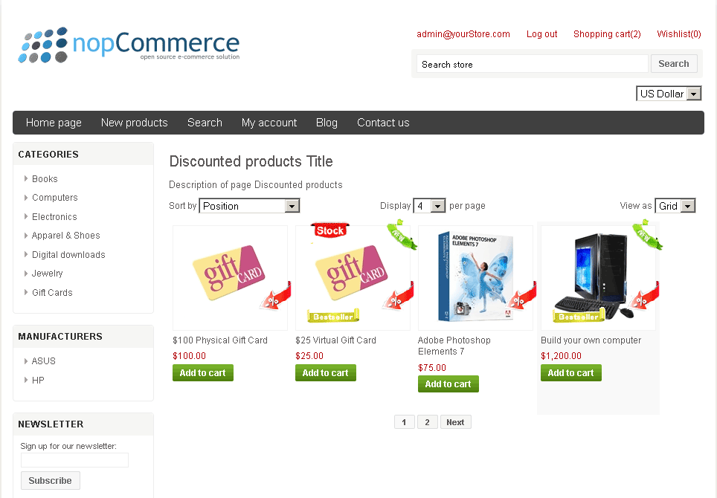
1. Install NopProductAddon.
2. Create NopProductAddon Addon. Put TypeAddon and CssClass. Verify Start date and End date . You can create several Addons with same TypeAddon and CssClass.
Look on this image
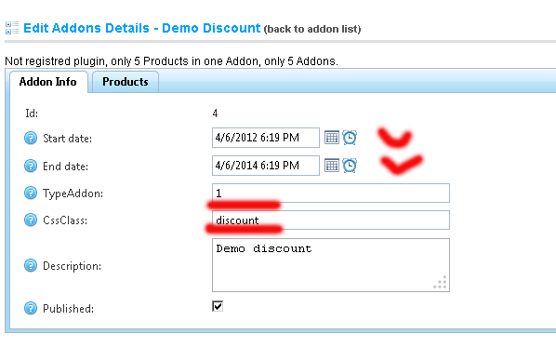
3. Write this code in cshtml file (example in Home\Index.cshtml)
<a href="@Url.Action("Content_Addon", "ProductAddon",
new {typeaddon=your TypeAddon,cssclass = "your CssClass",
title="Pages Title",
description="Description of page" })"
class="t-button">Name of Link</a>
example
<a href="@Url.Action("Content_Addon", "ProductAddon",
new {typeaddon=1,cssclass = "discount",
title="Discounted products Title",
description="Description of page Discounted products" })"
class="t-button">Discounted products</a>
Look on this image
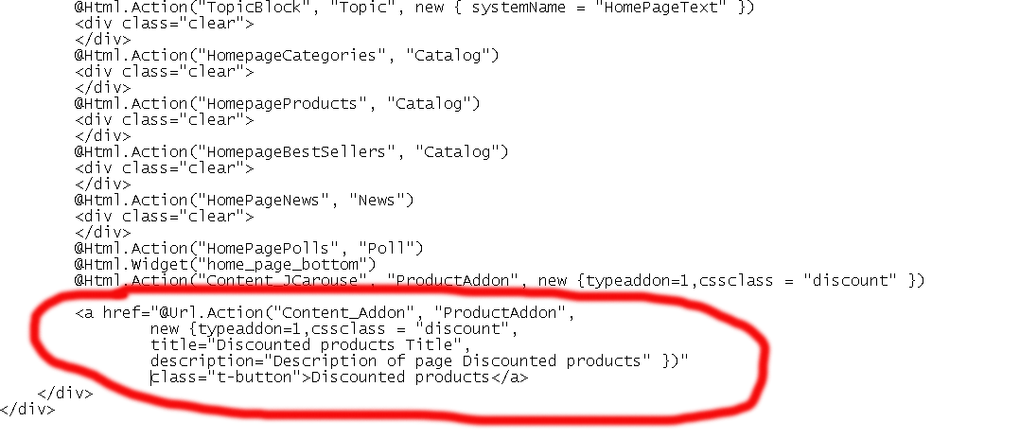
4. Refresh Home page (your page)
Your site must look like this
5. You can change source *.cshtml file.
ProductAddonTemplate.ProductsInGridOrLines.cshtml
ProductAddonTemplate.ProductsInGridOrLines.Mobile.cshtml

