Integrate with SevenSpikes.JCarousel.
How to integrate NopProductAddon with SevenSpikes.JCarousel plugin.
Watch on youtube http://youtu.be/l-CjTztQx60
or read the next text:
Your site must look like this
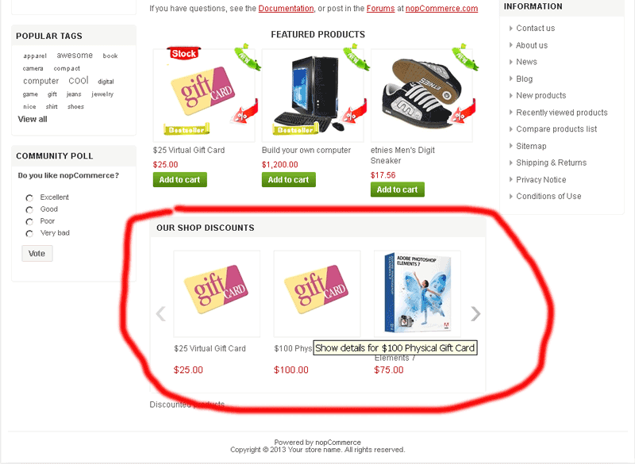
1. Install SevenSpikes.JCarousel plugin and install NopProductAddon.
2. Create JCarousel with Data source type Custom Data Source.
Look on this image
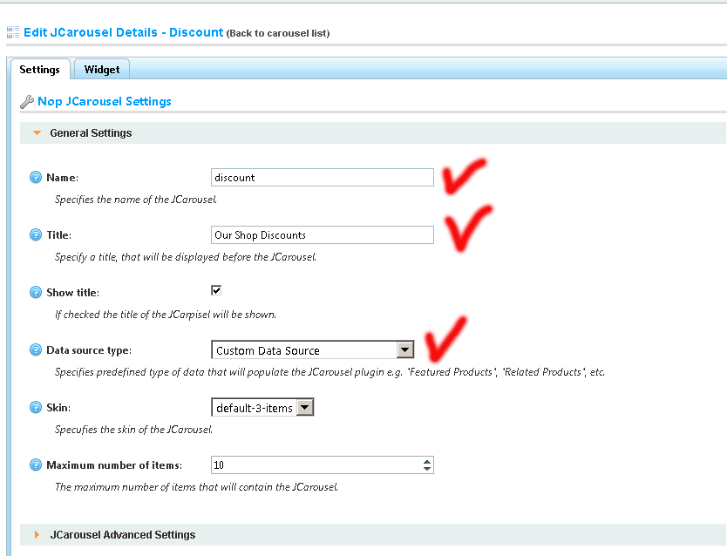
3. Create NopProductAddon Addon. Put TypeAddon and CssClass. Verify Start date and End date . You can create several Addons with same TypeAddon and CssClass.
Look on this image
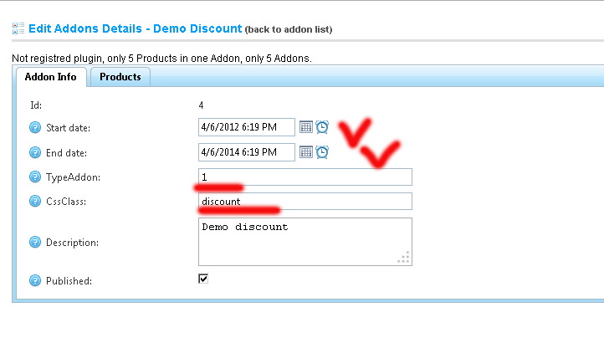
4. Write this code in cshtml file (example in Home\Index.cshtml)

@Html.Action("Content_JCarouse", "ProductAddon", new {typeaddon=your TypeAddon,cssclass = "your CssClass" })
example
@Html.Action("Content_JCarouse", "ProductAddon", new {typeaddon=1,cssclass = "discount" })
Look on this image
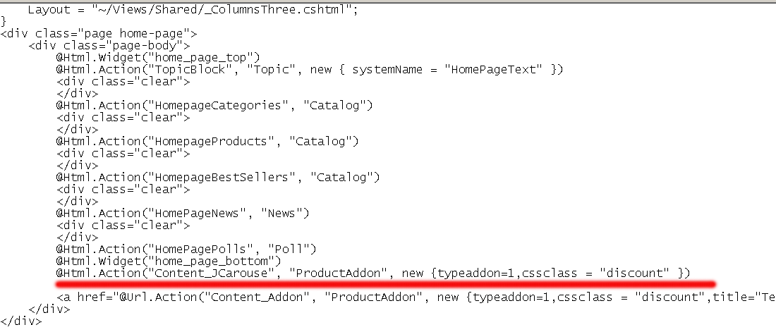
5. Refresh Home page (your page)
Your site must look like this

