http://www.foxnetsoft.com
Showoff how to install and configure the Nop ProductAddon plugin in your store.

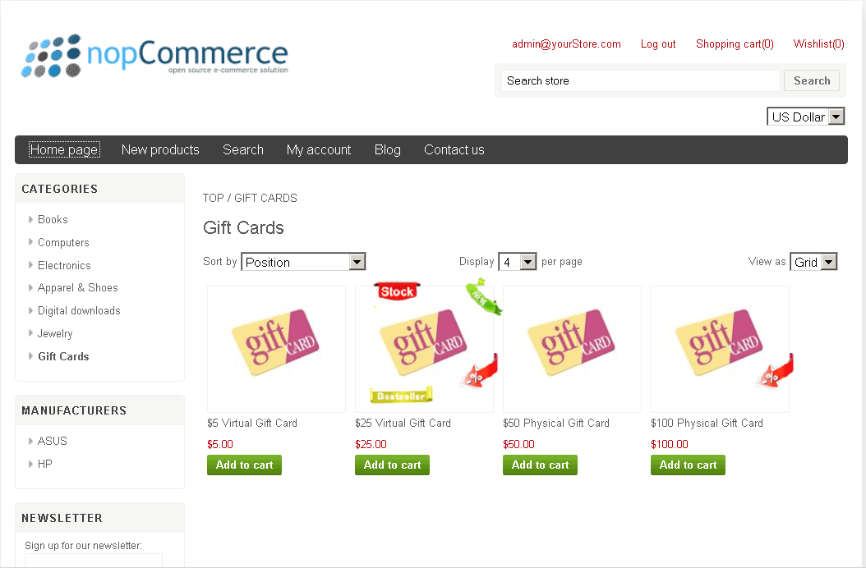

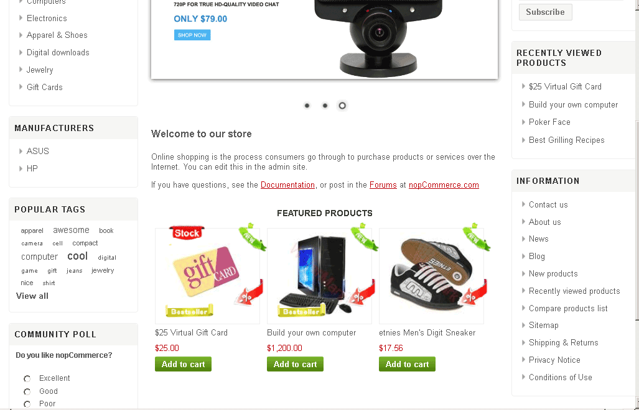
Watch on youtube. http://youtu.be/tmULzIGJID0
or read the next text:

Install plugin
Copy plugin to Plugin folder. In Admin Area select menu Configuration/Plugin. Press the button Reload list of plugins.
Find FoxNetSoft.Plugin.Misc.ProductAddon and press the button Install
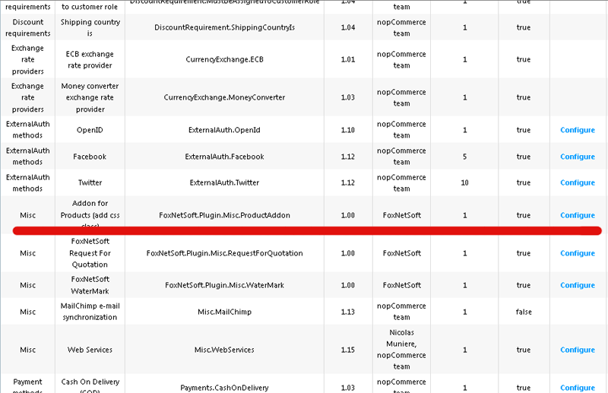
.
Configure plugin
In Admin Area select menu Configuration/Plugin.
Find FoxNetSoft.Plugin.Misc.ProductAddon and press the button Configure.
You can create sample data and set a serial number.
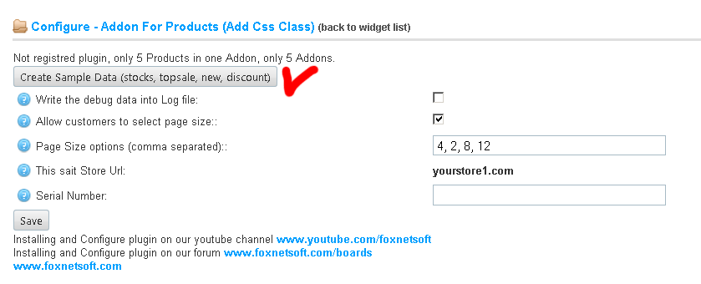

How to use
In Admin Area select in main menu Plugin/FoxNetSoft/ProductAddon.
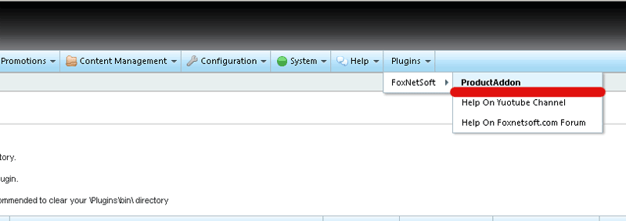
You can create, edit, delete addons, add products.
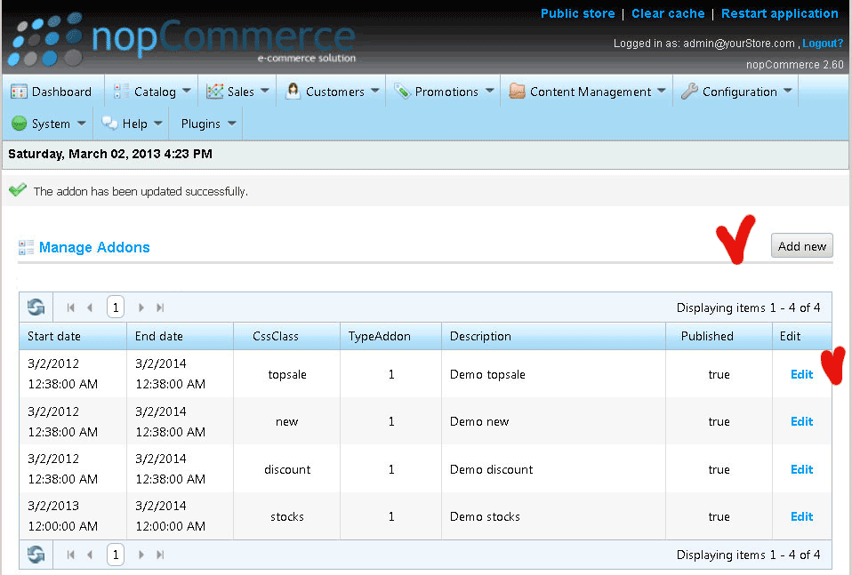
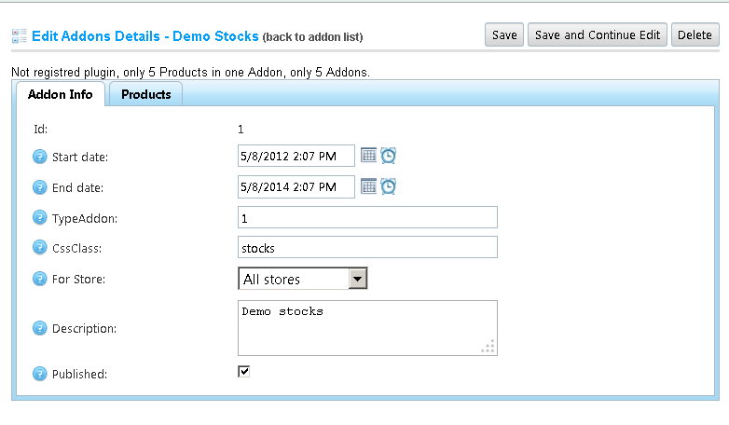

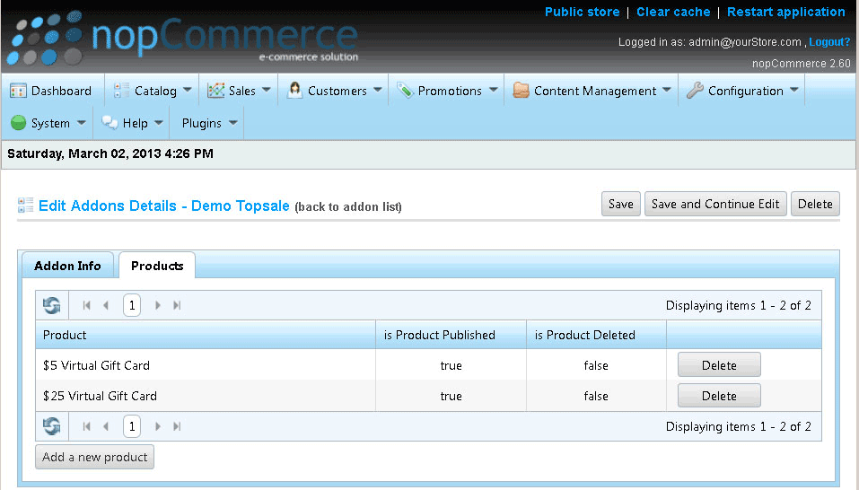

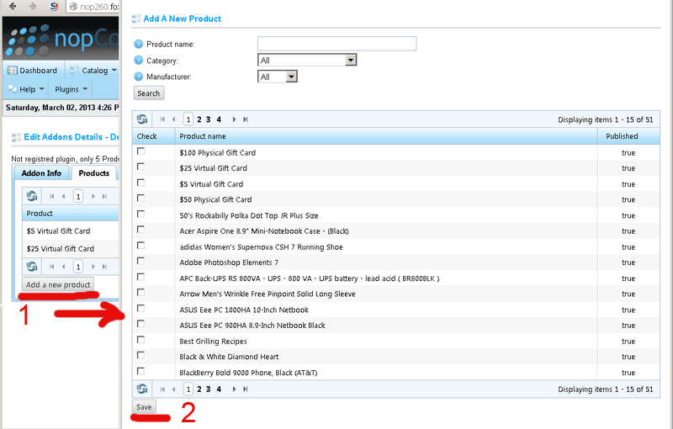
Your sait must look

How to change JavaScript code
Edit Widget_content_after.cshtml in plugin's folder.
How to change css class
Edit styles.cssl in plugin's folder or we recommend write css-clases in themas style.

