name – Nikhil kumar singhvi

roll no – 22

topic – aws Codestar

**AWS CodeStar -**

**AWS CodeStar** is a tool that makes it easy to develop, build, and deploy applications on AWS. It provides everything you need to set up a complete DevOps pipeline, helping teams to work faster and more efficiently.

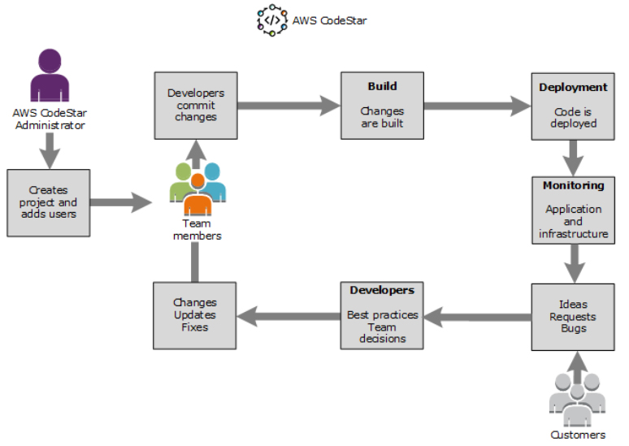

**Key Points:**

**1. Quick Start with Templates**: CodeStar offers ready-made templates for popular programming languages like Java, Python, Node.js, and more, so you can start new projects quickly.

**2. All-in-One DevOps Tools**: It integrates with AWS services like CodeCommit (version control), CodeBuild (build automation), CodeDeploy (deployment), and CodePipeline (CI/CD) to automate the software development process.

**3. Easy Collaboration**: You can easily add team members, set permissions, and track work using tools like AWS IAM and JIRA, all in one place.

**4. Central Dashboard**: Provides a dashboard to see the status of your code, builds, and deployments, helping you monitor progress and catch issues early.

**Benefits:**

- **Faster Development**: Automates repetitive tasks, allowing you to focus on coding.

**- Simple Setup**: Reduces the complexity of managing multiple tools.

**- Better Teamwork**: Makes it easy for teams to work together and manage projects.

In short, AWS CodeStar is a simple, integrated solution for quickly and efficiently managing software development on AWS.