Name: Shivani Laxcar

Roll No. : 31

Subject: Cloud Computing

Assignment Topic: Amazon Web Services System Manager

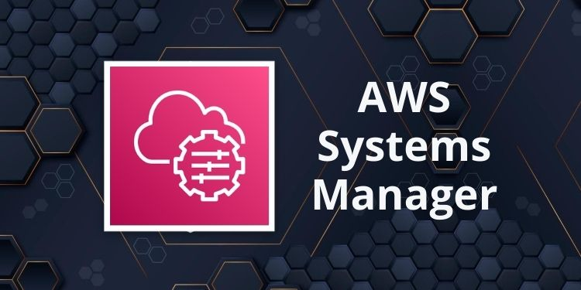

What is AWS Systems Manager?

AWS Systems Manager is a cloud-based service that offers a unified interface to manage AWS resources across multiple AWS services. It simplifies complex tasks by providing features like automation, operational data visualization, patch management, configuration control, and inventory tracking. By using Systems Manager, organizations can easily handle both their AWS infrastructure and on-premises servers, enhancing their overall operational efficiency.

AWS Systems Manager allows for the automation of routine management tasks, such as patching, backup, and configuration management. It integrates with other AWS services, providing a centralized dashboard to monitor and resolve operational issues. Whether managing a single EC2 instance or an entire fleet of resources, Systems Manager helps streamline the process.

How Does AWS Systems Manager Work?

AWS Systems Manager operates by leveraging a set of core services and tools:

*1. Systems Manager Agent (SSM Agent):* This is a small software component installed on the managed instances (e.g., EC2, on-premises servers). It communicates with Systems Manager to execute commands, manage configurations, and collect system information. The SSM Agent can be installed manually or automatically using AWS features like AWS Elastic Beanstalk or Amazon EC2 User Data.

*2. Parameter Store:* Parameter Store is a secure, scalable repository for configuration data management. It stores and retrieves parameters such as database connection strings, secrets, and license codes in plain text or encrypted formats, making configuration management seamless and secure.

*3. Automation:* Systems Manager provides an automation tool that allows users to automate common maintenance and deployment tasks. Automation workflows can be created to manage large-scale deployments, apply patches, or create backups without manual intervention. This improves operational efficiency and reduces the potential for human error.

*4. OpsCenter:* OpsCenter provides a central location where operational issues (OpsItems) across your infrastructure are tracked, investigated, and resolved. This tool allows administrators to analyze operational data, detect trends, and resolve issues faster with a holistic view of their environments.

*5. Run Command:* Run Command allows users to remotely and securely execute scripts or commands on managed instances, eliminating the need for SSH or remote desktop access. This is useful for tasks like installing software, applying updates, or configuring services.

*6. Patch Manager:* AWS Systems Manager Patch Manager automates the process of patching operating systems and applications on managed instances. It ensures systems are up-to-date and compliant with security and governance standards without manual effort.

*7. Inventory:* Systems Manager Inventory enables organizations to collect metadata about their instances and the software installed on them. This data can then be queried to generate reports, track compliance, or provide insights into the state of the infrastructure.

*8. State Manager:* State Manager allows administrators to define and maintain the desired state of their infrastructure. By specifying configuration policies and applying them automatically, it ensures consistency across instances and environments.

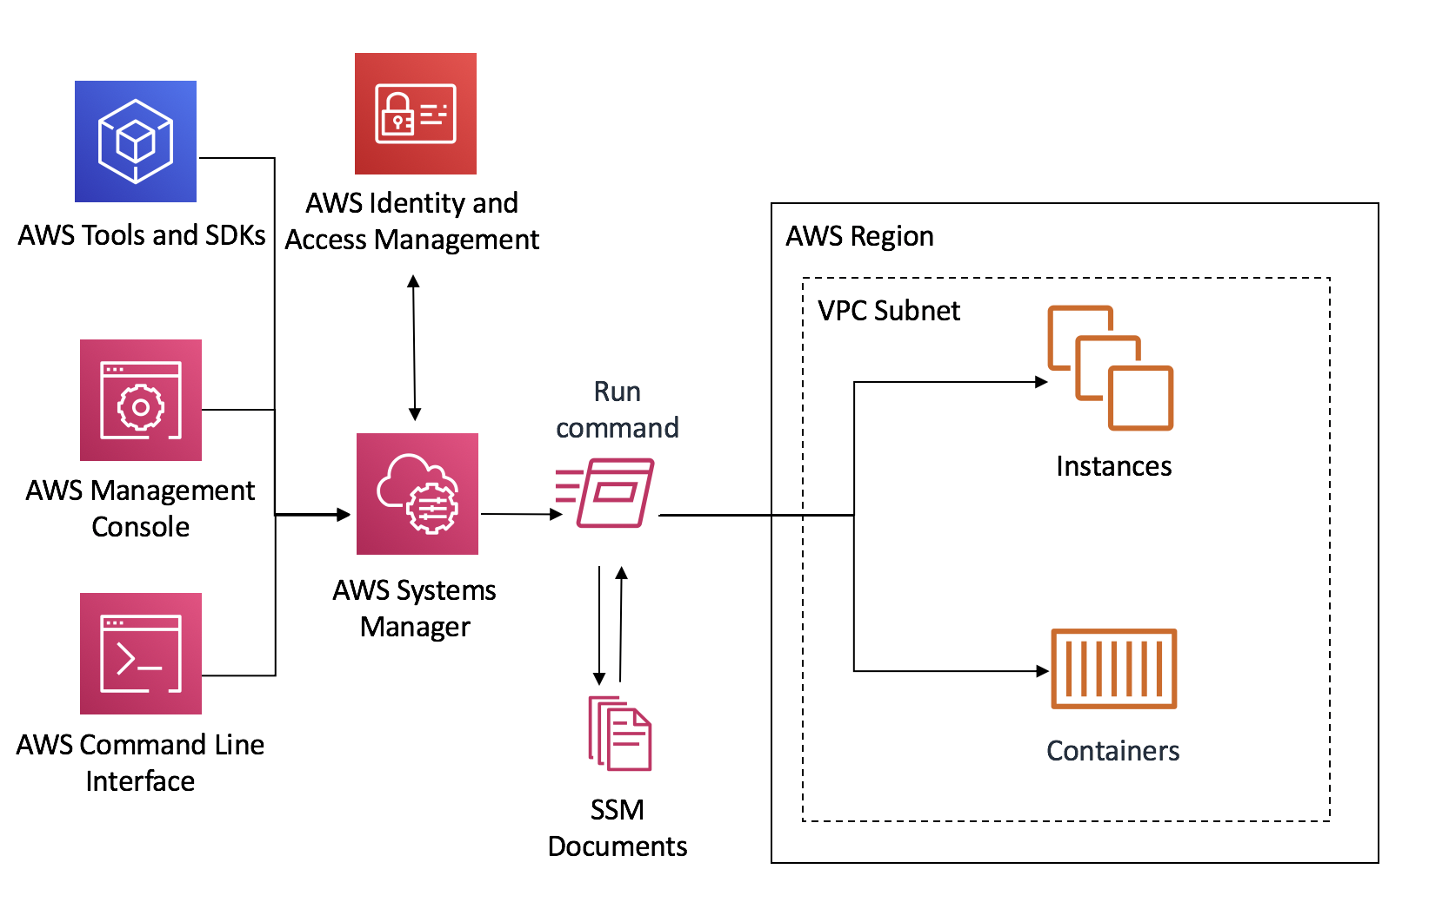

Uses of AWS Systems Manager

1. ***Centralized Management***: Systems Manager provides a centralized view of AWS and on-premises resources. It simplifies the management of large-scale infrastructures by consolidating operations, monitoring, and management tasks into a single platform.

2. ***Improved Security and Compliance***: With Patch Manager and Parameter Store, organizations can maintain updated systems while securely managing sensitive configuration data. This ensures compliance with organizational security policies and industry regulations.

3. ***Cost Optimization***: By providing detailed operational insights and real-time monitoring, Systems Manager helps organizations optimize their resource usage, reduce costs, and identify inefficiencies in their AWS environment.

4. ***Multi-Region and Multi-Account Management***: AWS Systems Manager simplifies the management of multi-region and multi-account setups, providing visibility and control over the entire infrastructure.

5. ***Operational Insights***: OpsCenter and Inventory allow administrators to collect valuable operational data, analyze performance, and troubleshoot issues in real time, improving system reliability and performance.