**AWS CODE DEPLOY**

**What is AWS CodeDeploy?**

AWS CodeDeploy is a fully managed service that automates the process of deploying applications across various environments such as Amazon EC2 instances, on-premise servers, Lambda functions, or even containers. It helps ensure that application updates happen smoothly and efficiently, with minimal downtime.

**Use of AWS CodeDeploy**

1. **Automating Deployments**: AWS CodeDeploy helps automate the deployment process, which reduces the risk of human error and saves time when pushing updates to your application.
2. **Handling Multiple Environments**: It allows you to deploy code to different environments (e.g., development, testing, and production) with the same set of scripts and instructions.
3. **Supports Different Platforms**: You can use it to deploy applications to EC2 instances, on-premise servers, Lambda functions, and containers (such as those running on ECS or Kubernetes).
4. **Version Control**: It enables you to maintain multiple versions of your applications, ensuring you can roll back to a previous version in case of issues during deployment.
5. **Integration**: It works seamlessly with other AWS services like AWS CodePipeline, AWS Lambda, and Amazon ECS to provide a continuous delivery pipeline.

**Advantages of AWS CodeDeploy**

1. **Automation**: Deploying updates automatically reduces manual tasks and errors.
2. **Rollback Support**: CodeDeploy provides automated rollbacks, so if something goes wrong, you can revert to a previous version with minimal disruption.
3. **Custom Deployment Strategies**: It supports different deployment methods like **blue/green deployments** and **rolling updates** to minimize downtime.
4. **Scalability**: CodeDeploy is designed to work with any size deployment, from one server to thousands, making it ideal for large-scale operations.
5. **Monitoring**: AWS CodeDeploy integrates with Amazon CloudWatch and AWS CloudTrail for logging, monitoring, and auditing purposes.

**Disadvantages of AWS CodeDeploy**

1. **Complex Setup for New Users**: Setting up CodeDeploy can be challenging for beginners who are unfamiliar with AWS services and infrastructure.
2. **Limited to AWS Ecosystem**: While it does support on-premise deployments, AWS CodeDeploy works best with AWS services, which might not be suitable for organizations using multiple cloud providers.
3. **Cost Considerations**: For large-scale deployments or extensive use of AWS services, costs can add up, especially if you have many EC2 instances or Lambda functions.
4. **Limited Customization**: While it offers some deployment strategies, more complex deployment needs may require additional configuration outside of CodeDeploy.

**AWS CodeDeploy Architecture**

Here’s a basic diagram of AWS CodeDeploy’s architecture:

* **Source**: Your application code stored in an S3 bucket or GitHub repository.
* **Deployment Group**: A set of instances (EC2, on-premise servers, Lambda functions) where the code will be deployed.
* **Deployment Configuration**: Specifies how many instances to deploy at a time (all at once, half at a time, etc.).
* **Application Revision**: The version of the application you’re deploying.
* **Hooks**: Scripts that run before, during, or after the deployment process to customize it (for example, to stop services or check health statuses).

For a visual representation, you can refer to diagrams in the official AWS documentation.

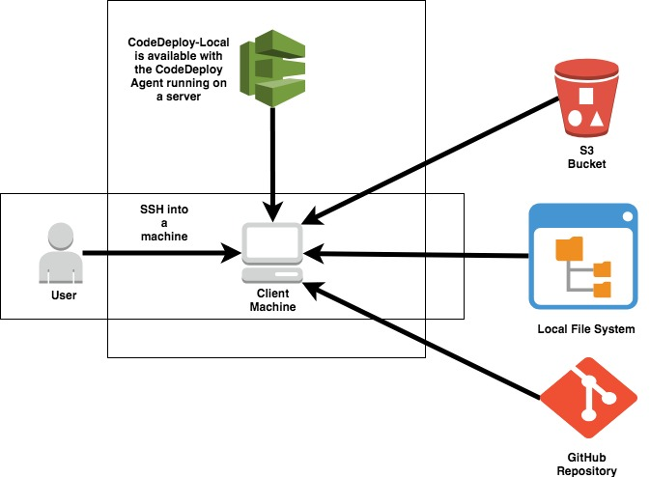

**More Information and Diagrams**

You can find more detailed documentation and diagrams on AWS CodeDeploy here:

* [**AWS CodeDeploy Documentation**](https://docs.aws.amazon.com/codedeploy/latest/userguide/welcome.html) – This includes in-depth descriptions, setup instructions, and architecture diagrams.