***THE MICROSOFT AZURE***

The Microsoft Azure Data Box cloud solution lets you send terabytes of data into and out of Azure in a quick, inexpensive, and reliable way. The secure data transfer is accelerated by shipping you a proprietary Data Box storage device. Each storage device has a maximum usable storage capacity of 80 TB and is transported to your datacenter through a regional carrier. The device has a rugged casing to protect and secure data during the transit.

You can order the Data Box device via the Azure portal to import or export data from Azure. Once the device is received, you can quickly set it up using the local web UI. Depending on whether you will import or export data, copy the data from your servers to the device or from the device to your servers, and ship the device back to Azure. If importing data to Azure, in the Azure datacenter, your data is automatically uploaded from the device to Azure. The entire process is tracked end-to-end by the Data Box service in the Azure portal.

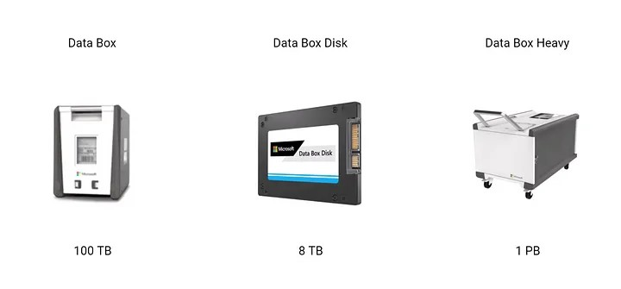

**Why Use Azure Data Box**

1. **Large Data Transfers**: For transferring terabytes to petabytes of data, especially when network transfer speeds are not sufficient or practical.
2. **Bandwidth Limitations**: When you have limited internet bandwidth, transferring large amounts of data over the network can be slow and expensive. Azure Data Box provides a physical solution to this problem.
3. **Cost Efficiency**: In some cases, the cost of shipping a Data Box and loading it with data can be less than the cost of transferring large amounts of data over the internet, particularly for very large datasets.
4. **Data Security**: Azure Data Box includes built-in encryption to ensure that your data is secure during transit. This is crucial for protecting sensitive information.
5. **Speed and Convenience**: By using Azure Data Box, you can significantly speed up the data migration process compared to traditional network transfer methods.

**How to Use Azure Data Box**

1. **Request a Data Box**:
   * **Azure Portal**: Navigate to the Azure portal, go to the Data Box service, and create a new Data Box order. You’ll choose the type of Data Box that suits your needs (e.g., Data Box Disk, Data Box Heavy).
   * **Other Methods**: You can also use Azure CLI or Azure PowerShell to request a Data Box.
2. **Receive and Prepare the Device**:
   * **Delivery**: Azure will ship the Data Box to your location.
   * **Setup**: Once you receive the device, connect it to your local network and power it up.
3. **Transfer Data**:
   * **Data Copy**: Use the provided Data Box tools to copy your data to the device. This typically involves using software like Azure Data Box Import/Export tool to manage the data transfer.
   * **Data Validation**: Validate that your data has been correctly copied to the Data Box.
4. **Return the Device**:
   * **Ship Back**: After the data transfer is complete, return the Data Box to Azure using the provided shipping labels and instructions.
5. **Data Import**:
   * **Azure Upload**: Once the Data Box arrives at the Azure data center, the data is uploaded to your Azure storage account. You can then access it using Azure services.

**Where to Use Azure Data Box**

1. **Data Migration**: When migrating large amounts of data from on-premises environments to Azure. This is common during cloud adoption or data center decommissioning projects.
2. **Data Backup and Recovery**: For creating backups of large datasets and restoring them into Azure storage. This can be part of a disaster recovery plan.
3. **Data Transfer to Azure Data Lake**: For transferring large volumes of data into Azure Data Lake Storage for big data and analytics purposes.
4. **Content Delivery**: When moving large content libraries, such as media files, into Azure for use in content delivery networks or other cloud-based applications.
5. **Compliance and Regulations**: In scenarios where data compliance regulations prevent sending large amounts of data over the internet, using physical transport via Data Box might be necessary.

**When to Use Azure Data Box**

1. **Large Data Volumes**: When dealing with large volumes of data (hundreds of terabytes or more) that would be inefficient or impractical to transfer over the internet.
2. **Slow or Unreliable Network**: If you have limited or unreliable internet bandwidth that would result in slow data transfer speeds, Azure Data Box offers a faster alternative.
3. **Data Transfer Projects with Strict Deadlines**: When you need to transfer data quickly and meet tight deadlines, Azure Data Box can expedite the process compared to network transfers.
4. **High Costs of Network Transfer**: When the cost of transferring large data volumes over the internet would be prohibitively expensive compared to using a physical device.
5. **Security Concerns**: When data security during transit is a concern and you prefer a physical solution that includes encryption and controlled handling.