**Bhumika upadhyay**

**Topic - AZURE COMMUNICATION SERVIES**

**Roll no - 5**

**Introduction**

* **What is Azure Communication Services?**
  + Overview of ACS as a cloud-based platform for adding communication capabilities to applications.
  + Integration with Microsoft’s cloud ecosystem.
* **Key Features and Capabilities**

Azure Communication Services offers a range of powerful features to build engaging and robust communication experiences:

* Voice: Enable high-quality voice calls, including one-on-one and group conferencing, with features like call transfer, hold, and mute.
* Video: Offer real-time video streaming, screen sharing, and multi-party video conferencing for collaborative experiences.
* Chat: Build real-time chat applications with features like group chat, message history, and typing indicators for seamless communication.
* SMS: Send and receive SMS messages for notifications, two-way communication, and authentication.
* User Management: Manage user identities, groups, and permissions for secure and efficient communication.
* Analytics and Monitoring: Gain insights into communication usage, performance, and quality with built-in analytics and monitoring tools.
* Azure Communication Services supports various communication formats:
* Voice and Video Calling
* SMS
* Email
* Advanced Messaging for WhatsApp
* Scenarios for Azure Communication Services include:
* **Business to Consumer (B2C)**
* Employees and services engage external customers using voice, video, and text chat in browser and native apps. Your organization can send and receive SMS messages, or operate an interactive voice response system (IVR) using Call Automation and a phone number you acquire through Azure. You can Integrate with Microsoft Teams to connect consumers to Teams meetings hosted by employees. This integration is ideal for remote healthcare, banking, and product support scenarios where employees might already be familiar with Teams.
* **Consumer to Consumer (C2C)**
* Build engaging consumer-to-consumer interaction with voice, video, and rich text chat. You can build custom user interfaces on Azure Communication Services SDKs. You can also deploy complete application samples and an open-source UI toolkit to help you get started quickly.

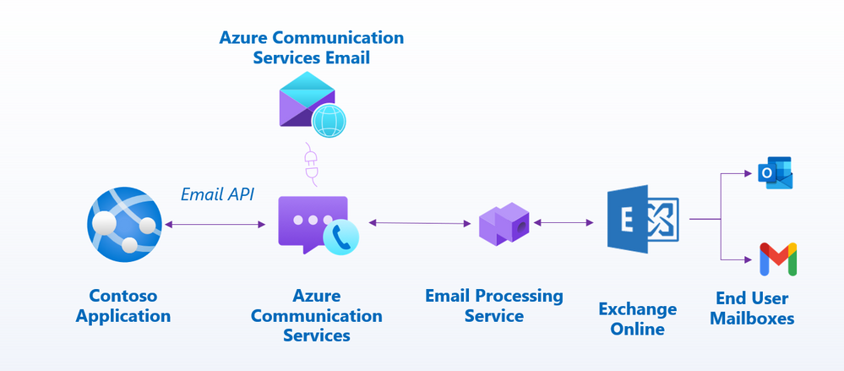

1. The Contoso Application sends an email through the Email API.
2. The Email API sends the email to the Azure Communication Services.
3. The Azure Communication Services processes the email and sends it to the Email Processing Service.
4. The Email Processing Service sends the email to the Exchange Online service.
5. Exchange Online sends the email to the recipient's mailbox, whether it's an Outlook account or a Gmail account.