# 

# Azure Database for MySQL

Innovate with a scalable, open-source MySQL database

**What is Microsoft Azure Database for MySQL?**

Microsoft Azure Database for MySQL is a *managed database service provided by Microsoft as part of its Azure cloud platform.* This service enables users to host MySQL databases on the Azure cloud, *offering a fully managed environment* that includes features like automated backups, scaling, security, and monitoring.

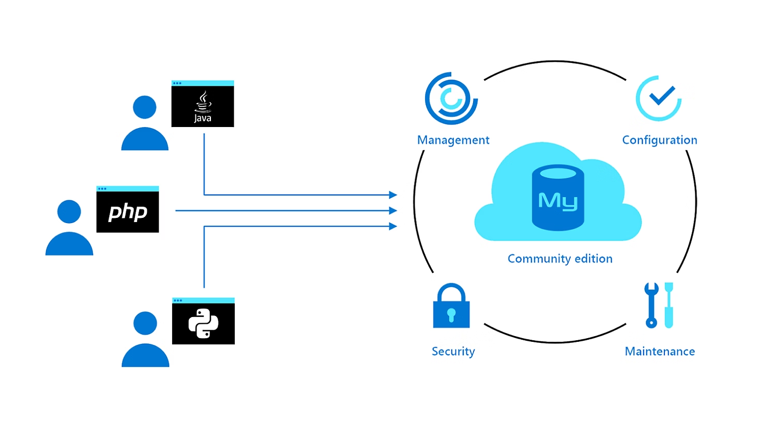

### **Build and Save with a Cost-Effective MySQL Database on Azure**

**Easily Build or Migrate**:

* Microsoft Azure Database for MySQL allows for easy building or migrating of workloads. Users can set up, manage, and automate the maintenance of their MySQL database servers, including routine updates, backups, and security measures.

**Cost Savings**:

* The service offers significant cost savings, with an estimated 48% lower total cost of ownership compared to on-premises or other cloud services. Users can save even more with burstable instances or by utilising stop-start capabilities, which charge only for storage when the database is stopped.

**Latest MySQL Community Edition**:

* Azure supports the latest MySQL Community Edition, providing compatibility with a wide range of tools, drivers, and programming languages. This ensures flexibility and ease of integration for developers and businesses.

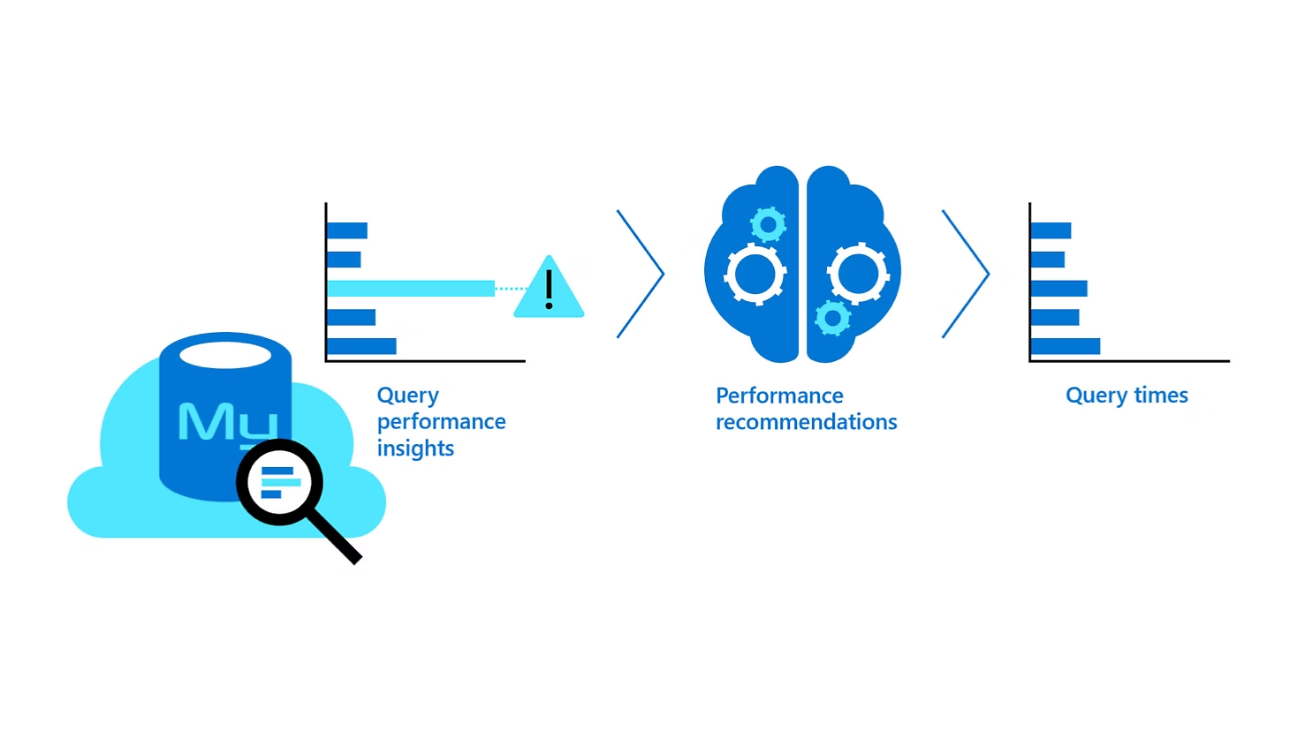

### **Provision and Scale Quickly and Easily with Azure Database for MySQL**

**Rapid Provisioning**:

* Azure Database for MySQL enables users to provision a MySQL database in less than two minutes, allowing for quick deployment of applications and services.

**AI-Powered Monitoring and Optimization**:

* The service includes AI-powered database monitoring and optimization tools. These tools help improve query speed by identifying slow-running queries through query performance insights and offering performance recommendations for further optimization.

**High Performance and Scalability**:

* Designed to support large-scale workloads, the service can handle up to 96 vCores, 672 gibibytes of memory, 16 TB of storage, and 48,000 input/output operations per second (IOPS). This robust infrastructure allows for a throughput of up to 150,000 queries per second, ensuring high performance for demanding applications.

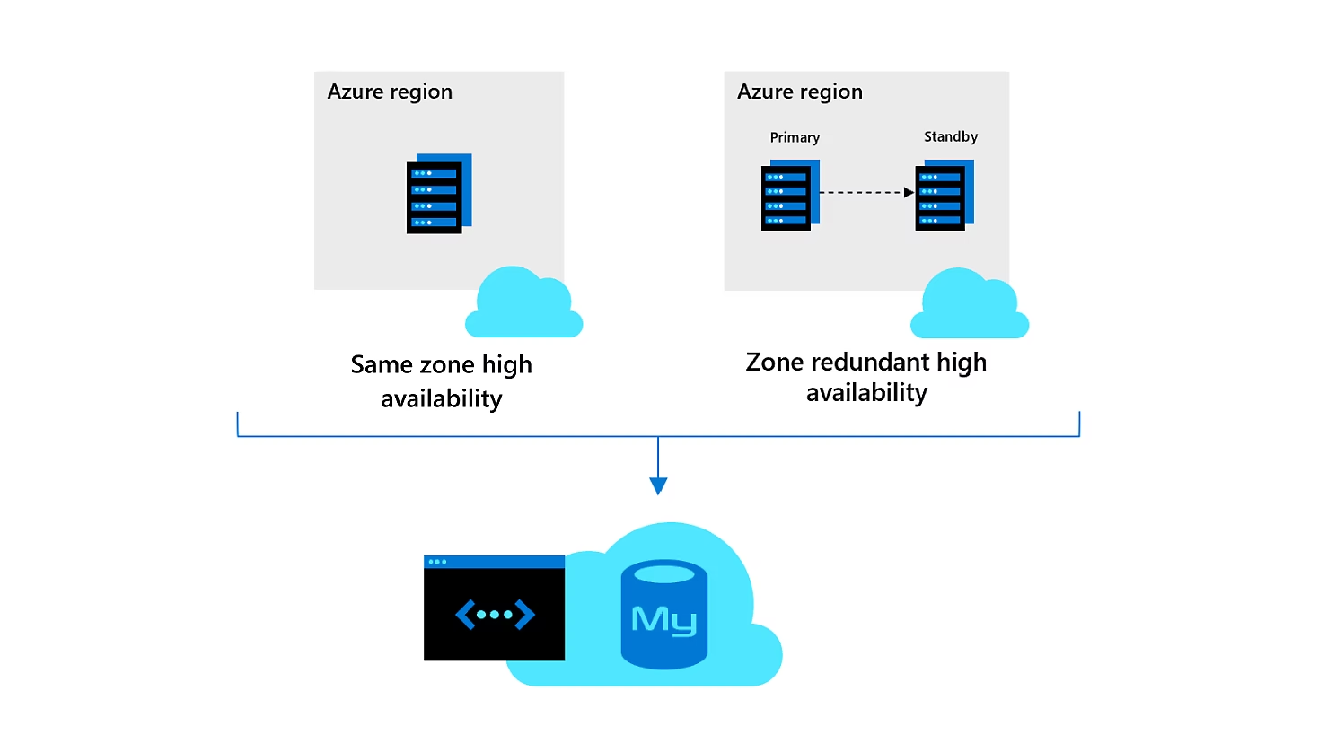

### **Build Resilient, Responsive Mission-Critical Apps with Azure Database for MySQL**

**Enhanced Business Continuity**:

* Azure Database for MySQL offers robust features to ensure business continuity for mission-critical applications. It supports enterprise-grade application services, making it suitable for demanding transactional and analytical workloads.

**Flexible Server Features**:

* The service provides flexible server features, including user-controlled maintenance windows, allowing you to schedule updates at convenient times. Additionally, it offers server parameter configuration and IOPS provisioning to optimise performance and reliability according to your application's needs.

**High Availability and SLA**:

* For applications requiring high availability, the Business Critical pricing tier provides advanced features, including up to a 99.99% service-level agreement (SLA) for same-zone or zone-redundant high availability. This ensures that your applications remain responsive and available even during failures.

**Performance for Mission-Critical Workloads**:

* The Business Critical tier is designed for high-performance transactional and analytical applications, offering enhanced resources and redundancy to support the most demanding use cases.

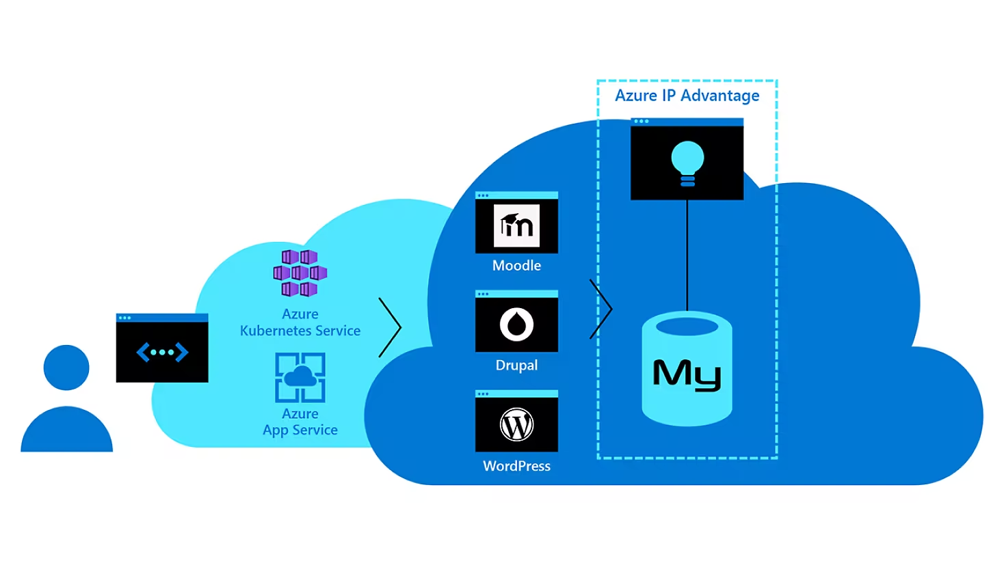

### **Deploy Apps Faster Using the Azure Ecosystem**

**Streamlined Deployment Experience**:

* Microsoft Azure Database for MySQL enhances productivity by simplifying the deployment process. This integration within the Azure ecosystem enables quick and efficient application deployment.

**CI/CD Integration**:

* Developers can leverage GitHub integration for continuous integration and continuous delivery (CI/CD) pipelines, streamlining the deployment workflow and accelerating the release cycle.

**Compatibility with Azure Services**:

* The service seamlessly integrates with various Azure services, such as Azure AI Services, Azure Kubernetes Service (AKS), and Azure App Service. This integration facilitates the deployment of sophisticated and scalable applications.

**Support for Popular Web Apps**:

* Azure Database for MySQL supports the deployment of a wide range of popular web applications, including:
  + **Magento**: An open-source e-commerce platform.
  + **Shopify**: A leading commerce platform for online stores.
  + **Moodle**: An open-source learning management system.
  + **Alfresco**: An open-source enterprise content management system.
  + **Drupal**: An open-source content management framework.
  + **WordPress**: The most widely used open-source content management system.

This ecosystem integration helps businesses and developers ship applications faster, leveraging Azure's comprehensive tools and services to streamline the development and deployment processes.

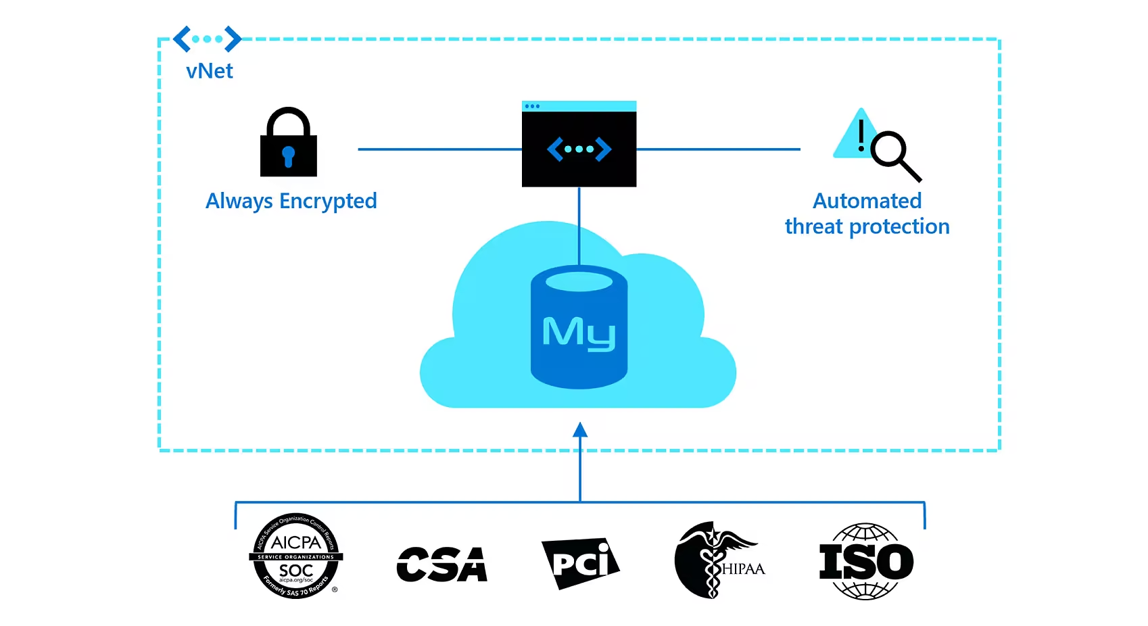

### **Build on a Trusted Platform with Azure Database for MySQL**

**Enterprise-Grade Security**:

* Azure Database for MySQL offers enterprise-grade security features, ensuring robust protection for your data. It includes built-in encryption and multiple security layers to safeguard sensitive information.

**Real-Time Threat Detection**:

* With Microsoft Defender for open-source relational databases, users can discover, track, and remediate potential threats in real-time. This proactive security measure helps protect databases from malicious activities and vulnerabilities.

**Data Isolation and Encryption**:

* The platform allows users to configure a virtual network, providing control over data isolation and access. This ensures that only authorised users and applications can interact with the database.
* It supports double encryption, including the use of custom encryption keys and enforcement of Transport Layer Security (TLS) 1.2. This dual-layer encryption enhances data security both at rest and in transit.

**Trusted Microsoft Cloud Platform**:

* Deploying on the Microsoft Cloud provides a trusted foundation, leveraging Azure's comprehensive security and compliance capabilities. This makes it an ideal choice for organizations requiring high standards of data protection and regulatory compliance.

This secure and trusted platform helps organizations build resilient and compliant applications, ensuring data integrity and privacy.

### **Built-In Security and Compliance with Azure Database for MySQL**

**Significant Investment in Cybersecurity**:

* Microsoft is heavily investing in cybersecurity, committing USD 20 billion over five years. This investment bolsters the security infrastructure and innovations across its cloud services, including Azure.

**Global Expertise**:

* The company employs over 8,500 security and threat intelligence experts across 77 countries, providing comprehensive protection and monitoring for its services.

**Strengthening Security Posture with Azure**:

* Azure offers a highly secure cloud foundation managed by Microsoft, which reduces the costs and complexity of security management. The platform provides multilayered, built-in security controls, along with unique threat intelligence, to help identify and protect against evolving threats.

**Secure Foundation**:

* Azure's infrastructure is built with customized hardware, featuring security controls integrated into hardware and firmware components. The platform includes protections against threats such as Distributed Denial of Service (DDoS) attacks. Microsoft’s global network of data centers provides state-of-the-art security, managed by a team of over 3,500 cybersecurity experts.

**Simplified Security with Built-In Controls**:

* Azure simplifies security with built-in controls and services across identity, data, networking, and applications. Microsoft Defender for Cloud offers continuous protection and deeper insights, extending security to hybrid environments and facilitating integration with partner solutions.

**Comprehensive Security Solutions**:

* **Identity Management**: Azure provides tools for managing identity and controlling access, ensuring only authorized users can access sensitive data.
* **Network Security**: Advanced network security features protect against unauthorized access and potential threats.
* **Data Protection**: Azure includes robust measures for safeguarding data, including encryption and access controls.
* **Key, Secrets, and Certificate Management**: Secure management of cryptographic keys, secrets, and certificates is facilitated within Azure.
* **Centralized Visibility and Threat Detection**: Azure offers centralized visibility into security posture, helping prevent attacks and detect threats early.

**Early Threat Detection with Unique Intelligence**:

* Azure uses real-time global cybersecurity intelligence derived from sources like Bing, Windows devices, and emails. This data is processed using machine learning, behavioral analytics, and application-based intelligence, generating actionable insights. These insights are used to inform Azure's security services, enabling faster threat detection and response.

This comprehensive security framework makes Azure Database for MySQL a reliable choice for businesses needing strong security and compliance features.

### **Key Features of Microsoft Azure Database for MySQL**

1. **Managed Service**:
   * Fully managed by Azure, reducing the administrative burden of database management, including hardware provisioning, software patching, and backups.
2. **Scalability**:
   * Easily scale compute and storage resources independently to meet the needs of growing applications. This flexibility helps manage costs and ensures the database can handle varying workloads.
3. **High Availability**:
   * Built-in high availability with automatic failover capabilities, ensuring minimal downtime and maintaining service continuity.
4. **Security**:
   * Comprehensive security features including data encryption at rest and in transit, firewall rules, and integration with Azure Active Directory for secure user authentication and access control.
5. **Backup and Restore**:
   * Automated backups with point-in-time restore capabilities, allowing users to recover their databases to a specific state within the backup retention period.
6. **Performance Monitoring and Tuning**:
   * Advanced monitoring tools and performance tuning features, including query performance insights, to optimise database operations and performance.
7. **Global Reach with Regional Support**:
   * Availability in multiple Azure regions worldwide, allowing users to deploy their databases closer to their end-users for better performance and compliance with data residency requirements.
8. **Flexible Pricing Options**:
   * Pay-as-you-go pricing and reserved capacity options, providing cost-effective solutions based on the user's needs and budget.
9. **Integration with Azure Services**:
   * Seamless integration with other Azure services such as Azure Data Factory, Azure Functions, and Power BI, enabling comprehensive data and analytics solutions.
10. **Support for Multiple MySQL Versions**:
    * Offers support for multiple MySQL versions, giving users the flexibility to choose the version that best suits their application's requirements.