**AZURE STORAGE ACCOUNT**

Azure Storage Account is a service provided by Microsoft Azure that offers a range of cloud storage solutions for different needs. It provides secure, scalable, and durable storage for various types of data. Here’s a brief overview:

**Types of Storage**

1. **Blob Storage**: For unstructured data such as text or binary data. Commonly used for backups, media files, and big data analytics.
2. **File Storage**: Provides fully managed file shares in the cloud accessible via the SMB protocol.
3. **Queue Storage**: A messaging store for reliable messaging between application components.
4. **Table Storage**: For storing large amounts of structured, non-relational data.
5. **Disk Storage**: For virtual machine disks and high-performance workloads.

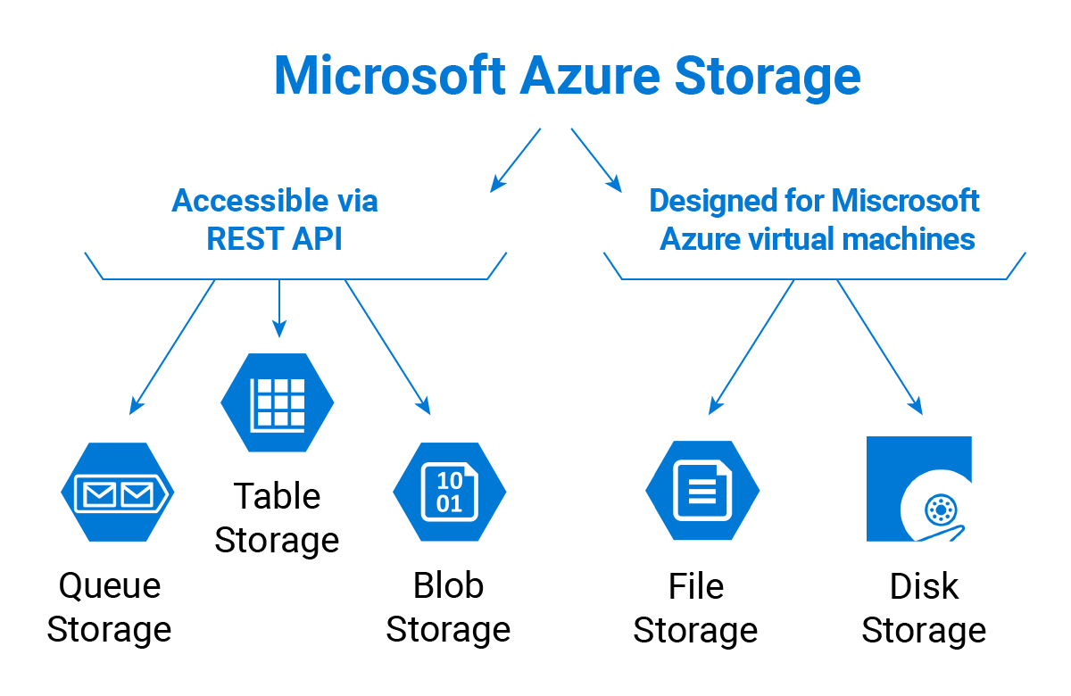

**Advantages**

1. **Scalability**: Azure Storage can handle large amounts of data and scale up or down based on demand.
2. **Durability**: Data is replicated across multiple data centers to ensure high availability and durability.
3. **Security**: Offers encryption at rest and in transit, along with role-based access control (RBAC) and network security options.
4. **Flexibility**: Supports various data types and access methods, such as REST APIs, SDKs, and Azure portal.
5. **Cost-Effective**: Pay-as-you-go pricing model with different tiers based on performance and access requirements.

**Disadvantages**

1. **Complexity**: Can be complex to set up and manage due to the range of storage options and configurations.
2. **Cost Management**: While cost-effective, costs can increase with high data usage and frequent access patterns.
3. **Latency**: Depending on the storage type and network conditions, latency might be a concern for certain applications.

**How It Works**

1. **Create a Storage Account**: Start by creating a storage account through the Azure portal, CLI, or Azure Resource Manager templates.
2. **Choose Storage Type**: Depending on your needs, choose the appropriate storage type (Blob, File, Queue, Table, or Disk).
3. **Access and Manage Data**: Use Azure SDKs, REST APIs, or Azure portal to manage and access your data.
4. **Scale and Optimize**: Based on your usage patterns, you can scale up or down and choose different performance tiers.

**Links for More Information**

* [Azure Storage Overview](https://learn.microsoft.com/en-us/azure/storage/common/storage-introduction)
* [Azure Storage Types](https://learn.microsoft.com/en-us/azure/storage/common/storage-account-overview)
* [Pricing Calculator](https://azure.microsoft.com/en-us/pricing/calculator/)
* [Azure Storage Documentation](https://learn.microsoft.com/en-us/azure/storage/)