EDABIP — API TEST CASE DOCUMENT
Enterprise Data Analytics & Business Intelligence Platform | Spring Boot REST API

1. TESTING PROCESS
Base URL: http://localhost:8080
Tool Used: Postman (importable collection provided: EDABIP.postman_collection.json)
Authentication Method: JWT (JSON Web Token). Obtained from POST /api/auth/login, then sent on every protected request.
Request Headers: Content-Type: application/json | Authorization: Bearer <token>
How to Authenticate: 1) POST /api/auth/login with valid credentials. 2) Copy data.token from the response. 3) For each protected request: Authorization tab > Bearer Token > paste token (or use the {{token}} variable).
Default Admin Credentials: usernameOrEmail: admin | password: admin123 (seeded automatically on first startup)
Body Format in Postman: Body > raw > JSON for all POST and PUT requests.

2. HOW TO READ THE RESULTS
Status Codes
200 OK = success | 201 Created = resource created | 400 = validation / bad request | 401 = wrong or expired credentials | 403 = role not allowed or no token | 404 = not found | 500 = server error
Error Format
All errors return a consistent JSON shape: { status, error, message, timestamp, validationErrors } produced by a global @RestControllerAdvice exception handler.
Status Column
Pass = actual result matched the expected result. Fail = mismatch.

3. DOCUMENT STRUCTURE
Testing Process: This overview sheet (process, headers, auth, status codes, error handling).
1. Authentication: Login, register, token validation — positive and negative. (8 test cases)
2. Employee: Create, read, update, delete, search/filter — positive and negative. (9 test cases)
3. Department: Create, read, update, delete, statistics — positive and negative. (7 test cases)
4. RBAC: EMPLOYEE-role user blocked from ADMIN/MANAGER actions; allowed reads. (9 test cases)
Sample Req & Resp: Full sample request + response JSON for success (200/201) and error (400/401/403) cases.

4. ERROR-HANDLING SCENARIOS TESTED
Validation Errors: A missing or malformed required field returns a clean 400 with the offending field named in validationErrors.
Wrong Credentials: Login with a wrong password returns 401 'Invalid username/email or password' — no token is issued.
Not Found: Fetching a non-existent id (e.g. /9999) returns 404 with a clear message.
Authorization: A missing token returns 403; a valid token with an insufficient role returns 403 (Access Denied).
Invalid Enum Value (known limitation): A lowercase enum (e.g. gender 'female' instead of 'FEMALE') currently returns 500 — always send enum values in UPPERCASE.
Foreign-key Constraint (known limitation): Deleting a record still referenced by others (e.g. an employee who has tasks) returns 500 — the database protects referential integrity.

1. AUTHENTICATION & USER MANAGEMENT — TEST CASES
Endpoints: POST /api/auth/login, POST /api/auth/register, GET /api/users (ADMIN) | Auth: /api/auth/** is public; user management requires an ADMIN token.

Test Case ID | Module / API Name | Test Scenario | Method | Endpoint URL | Request Payload / Input | Expected Result | Status
TC_AUTH_01 | Auth / Login | Login with valid admin credentials (positive) | POST | POST /api/auth/login | { "usernameOrEmail": "admin", "password": "admin123" } | 200 OK; JWT token, id, username and roles [ROLE_ADMIN] returned. | Pass
TC_AUTH_02 | Auth / Login | Login with a wrong password (negative) | POST | POST /api/auth/login | { "usernameOrEmail": "admin", "password": "wrongpass" } | 401; 'Invalid username/email or password'; no token. | Pass
TC_AUTH_03 | Auth / Login | Login with a non-existent user (negative) | POST | POST /api/auth/login | { "usernameOrEmail": "ghost", "password": "anything" } | 401 Authentication Failed; no token returned. | Pass
TC_AUTH_04 | Auth / Login | Login with a missing required field (negative) | POST | POST /api/auth/login | { "usernameOrEmail": "admin" } | 400; validationErrors: { password: 'Password is required' }. | Pass
TC_AUTH_05 | Auth / Register | Register a new EMPLOYEE-role user (positive) | POST | POST /api/auth/register | { "username": "swetha", "email": "swetha@edabip.com", "password": "swetha123", "roles": ["ROLE_EMPLOYEE"] } | 200 OK; 'User registered successfully'. | Pass
TC_AUTH_06 | Auth / Register | Register with an already-used username (negative) | POST | POST /api/auth/register | { "username": "admin", "email": "new@edabip.com", "password": "test123", "roles": ["ROLE_EMPLOYEE"] } | 400; username already taken. | Pass
TC_AUTH_07 | Auth / Register | Register with an invalid email format (negative) | POST | POST /api/auth/register | { "username": "newuser", "email": "not-an-email", "password": "test123" } | 400; validationErrors: { email: 'Email must be valid' }. | Pass
TC_AUTH_08 | Auth / Register | Register with a too-short password (negative) | POST | POST /api/auth/register | { "username": "newuser2", "email": "newuser2@edabip.com", "password": "123" } | 400; validationErrors: { password: 'Password must be at least 6 characters' }. | Pass

2. EMPLOYEE MANAGEMENT — TEST CASES
Endpoints: POST / GET / PUT / DELETE /api/employees, GET /api/employees/search | Auth: Bearer JWT required. Create/Update = ADMIN or MANAGER; Delete = ADMIN.

Test Case ID | Module / API Name | Test Scenario | Method | Endpoint URL | Request Payload / Input | Expected Result | Status
TC_EMP_01 | Employee / Create | Create an employee with valid data — ADMIN token (positive) | POST | POST /api/employees | { "firstName":"John","lastName":"Doe","email":"john.doe@edabip.com","phone":"9876543210","gender":"MALE","designation":"Software Engineer","departmentId":1,"salary":75000,"joiningDate":"2024-01-15","status":"ACTIVE" } | 201 Created; employee id=1; departmentName 'Engineering'. | Pass
TC_EMP_02 | Employee / Create | Create an employee with missing firstName (negative) | POST | POST /api/employees | { "lastName":"Doe","email":"jane.doe@edabip.com","gender":"FEMALE","status":"ACTIVE" } | 400; validationErrors: { firstName: 'First name is required' }. | Pass
TC_EMP_03 | Employee / Create | Create an employee with an invalid email (negative) | POST | POST /api/employees | { "firstName":"Jane","lastName":"Doe","email":"bademail","gender":"FEMALE","status":"ACTIVE" } | 400; validationErrors: { email: 'Email must be valid' }. | Pass
TC_EMP_04 | Employee / Read | Get all employees with a valid token (positive) | GET | GET /api/employees | — (no request body; Authorization: Bearer <token>) | 200 OK; data is an array of employees. | Pass
TC_EMP_05 | Employee / Read | Get a single employee by a valid id (positive) | GET | GET /api/employees/1 | — (no request body) | 200 OK; employee id=1 returned. | Pass
TC_EMP_06 | Employee / Read | Get a non-existent employee (negative) | GET | GET /api/employees/9999 | — (no request body) | 404; 'Employee not found ...' message. | Pass
TC_EMP_07 | Employee / Search | Search / filter employees by name and status (positive) | GET | GET /api/employees/search?name=John&status=ACTIVE | — (query params in URL) | 200 OK; matching employee(s) returned. | Pass
TC_EMP_08 | Employee / Update | Update an existing employee (positive) | PUT | PUT /api/employees/1 | { ... "designation":"Senior Software Engineer", "salary":95000 ... } | 200 OK; employee updated. | Pass
TC_EMP_09 | Employee / Delete | Delete an employee — ADMIN token (positive) | DELETE | DELETE /api/employees/1 | — (no request body) | 200 OK; 'Employee deleted'. | Pass

3. DEPARTMENT MANAGEMENT — TEST CASES
Endpoints: POST / GET / PUT / DELETE /api/departments | Auth: Bearer JWT required. Create/Update = ADMIN or MANAGER; Delete = ADMIN.

Test Case ID | Module / API Name | Test Scenario | Method | Endpoint URL | Request Payload / Input | Expected Result | Status
TC_DEPT_01 | Department / Create | Create a department with valid data (positive) | POST | POST /api/departments | { "name":"Engineering", "description":"Software development team" } | 201 Created; department id=1; employeeCount=0. | Pass
TC_DEPT_02 | Department / Create | Create a department with a missing name (negative) | POST | POST /api/departments | { "description":"No name provided" } | 400; validationErrors: { name: 'Department name is required' }. | Pass
TC_DEPT_03 | Department / Read | Get all departments (positive) | GET | GET /api/departments | — (no request body; Bearer token) | 200 OK; departments returned. | Pass
TC_DEPT_04 | Department / Read | Get a single department by id with statistics (positive) | GET | GET /api/departments/1 | — (no request body) | 200 OK; department returned; employeeCount=1 after adding an employee. | Pass
TC_DEPT_05 | Department / Read | Get a non-existent department (negative) | GET | GET /api/departments/9999 | — (no request body) | 404; department not found. | Pass
TC_DEPT_06 | Department / Update | Update an existing department (positive) | PUT | PUT /api/departments/1 | { "name":"Engineering & R&D", "description":"Updated" } | 200 OK; department updated. | Pass
TC_DEPT_07 | Department / Delete | Delete a department — ADMIN token (positive) | DELETE | DELETE /api/departments/1 | — (no request body) | 200 OK; 'Department deleted'. | Pass

4. ROLE-BASED ACCESS CONTROL (RBAC) — TEST CASES
Validates Spring Security rules (SecurityConfig + @PreAuthorize) across roles ADMIN / MANAGER / EMPLOYEE. | Auth: Bearer JWT.

Test Case ID | Module / API Name | Test Scenario | Method | Endpoint URL | Request Payload / Input | Expected Result | Status
TC_RBAC_01 | RBAC / No Auth | Access a protected endpoint with NO token (negative) | GET | GET /api/employees | Header: (none) | 403; access denied without a token. | Pass
TC_RBAC_02 | RBAC / Authenticated | Access a protected endpoint with a valid ADMIN token (positive) | GET | GET /api/employees | Header: Authorization: Bearer <ADMIN token> | 200 OK; data returned. | Pass
TC_RBAC_03 | RBAC / ADMIN | ADMIN creates an employee — allowed (positive) | POST | POST /api/employees | Header: Bearer <ADMIN token> + valid employee body | 201 Created; ADMIN is permitted. | Pass
TC_RBAC_04 | RBAC / EMPLOYEE | EMPLOYEE-role user tries to create an employee — denied (negative) | POST | POST /api/employees | Header: Bearer <EMPLOYEE token> + valid employee body | 403 Forbidden; employee correctly blocked. | Pass
TC_RBAC_05 | RBAC / EMPLOYEE | EMPLOYEE-role user tries to DELETE an employee — denied (negative) | DELETE | DELETE /api/employees/1 | Header: Bearer <EMPLOYEE token> | 403 Forbidden; blocked. | Pass
TC_RBAC_06 | RBAC / EMPLOYEE | EMPLOYEE-role user reads the employee list — allowed (positive) | GET | GET /api/employees | Header: Bearer <EMPLOYEE token> | 200 OK; employee allowed to read. | Pass
TC_RBAC_07 | RBAC / EMPLOYEE | EMPLOYEE-role user tries to open the dashboard — denied (negative) | GET | GET /api/dashboard/stats | Header: Bearer <EMPLOYEE token> | 403 Forbidden; blocked. | Pass
TC_RBAC_08 | RBAC / EMPLOYEE | EMPLOYEE-role user tries to view audit logs — denied (negative) | GET | GET /api/audit | Header: Bearer <EMPLOYEE token> | 403 Forbidden; blocked. | Pass
TC_RBAC_09 | RBAC / MANAGER | MANAGER creates a department — allowed (positive) | POST | POST /api/departments | Header: Bearer <MANAGER token> + valid department body | 201 Created; allowed for MANAGER. | Pass

SAMPLE REQUEST & RESPONSE
Real request/response shapes for the key success and error cases (data.token shortened).

Example 1 — Login (Success)
Request:
POST http://localhost:8080/api/auth/login
Content-Type: application/json
{ "usernameOrEmail": "admin", "password": "admin123" }
Response (200 OK):
{ "success": true, "message": "Login successful",
"data": { "token": "eyJhbGciOiJIUzUxMiJ9...", "type": "Bearer",
"id": 1, "username": "admin", "email": "admin@edabip.com",
"roles": ["ROLE_ADMIN"] } }

Example 2 — Create Employee (Success)
Request:
POST http://localhost:8080/api/employees
Content-Type: application/json | Authorization: Bearer <token>
{ "firstName": "John", "lastName": "Doe", "email": "john.doe@edabip.com",
"phone": "9876543210", "gender": "MALE", "designation": "Software Engineer",
"departmentId": 1, "salary": 75000, "joiningDate": "2024-01-15", "status": "ACTIVE" }
Response (201 Created):
{ "success": true, "message": "Employee created successfully",
"data": { "id": 1, "firstName": "John", "lastName": "Doe",
"fullName": "John Doe", "email": "john.doe@edabip.com",
"departmentName": "Engineering", "salary": 75000, "status": "ACTIVE" } }

Example 3 — Validation Error (Negative)
Request:
POST http://localhost:8080/api/employees | Authorization: Bearer <token>
{ "lastName": "Doe", "email": "jane@edabip.com", "gender": "FEMALE", "status": "ACTIVE" }
Response (400 Bad Request):
{ "status": 400, "error": "Validation Failed",
"message": "One or more fields are invalid",
"validationErrors": { "firstName": "First name is required" } }

Example 4 — Authentication Failure (Negative)
Request:
POST http://localhost:8080/api/auth/login
{ "usernameOrEmail": "admin", "password": "wrongpass" }
Response (401 Unauthorized):
{ "status": 401, "error": "Authentication Failed",
"message": "Invalid username/email or password", "validationErrors": null }

Example 5 — Role Blocked / Forbidden (Negative)
Request:
POST http://localhost:8080/api/employees | Authorization: Bearer <EMPLOYEE token>
{ ... valid employee body ... }
Response (403 Forbidden):
{ "status": 403, "error": "Access Denied",
"message": "You do not have permission to perform this action",
"validationErrors": null }

EDABIP
API Testing — Output Screenshots
Enterprise Data Analytics & Business Intelligence Platform

Screenshots of successful API execution captured from Postman.
Base URL: http://localhost:8080 | Auth: JWT Bearer Token

Index of Screenshots
1. POST Login (Authentication) — /api/auth/login
2. POST Create Department — /api/departments
3. POST Create Employee — /api/employees
4. POST Create Project — /api/projects
5. POST Register User (EMPLOYEE role) — /api/auth/register
6. POST Generate Report — /api/reports/generate
7. GET Get All Employees — /api/employees
8. GET Get Employee By ID — /api/employees/1
9. GET Search Employees (name + status) — /api/employees/search?name=John&status=ACTIVE
10. GET Get All Departments — /api/departments
11. GET Get Department By ID — /api/departments/1
12. GET Get All Projects — /api/projects
13. GET Get Project By ID — /api/projects/1
14. GET Get Tasks By Project — /api/tasks/project/1
15. GET Get Tasks By Employee — /api/tasks/employee/1
16. GET Dashboard Statistics — /api/dashboard/stats
17. GET Get All Reports — /api/reports
18. GET Filter Reports (date + department) — /api/reports/filter?departmentId=1&fromDate=2026-01-01&toDate=2026-12-31
19. GET Audit Logs (paginated) — /api/audit?page=0&size=20
20. GET Get All Users — /api/users
21. GET Get User By ID — /api/users/1
22. PUT Update Employee — /api/employees/1
23. PUT Update Task (mark completed) — /api/tasks/1
24. PUT Update Department — /api/departments/1
25. DELETE Delete Task — /api/tasks/1
26. DELETE Delete Employee — /api/employees/1
27. DELETE Delete Project — /api/projects/1
28. DELETE Delete Department — /api/departments/1

1. Login (Authentication)
Method: POST Module: Authentication
Endpoint: http://localhost:8080/api/auth/login
Result: 200 OK (Pass)
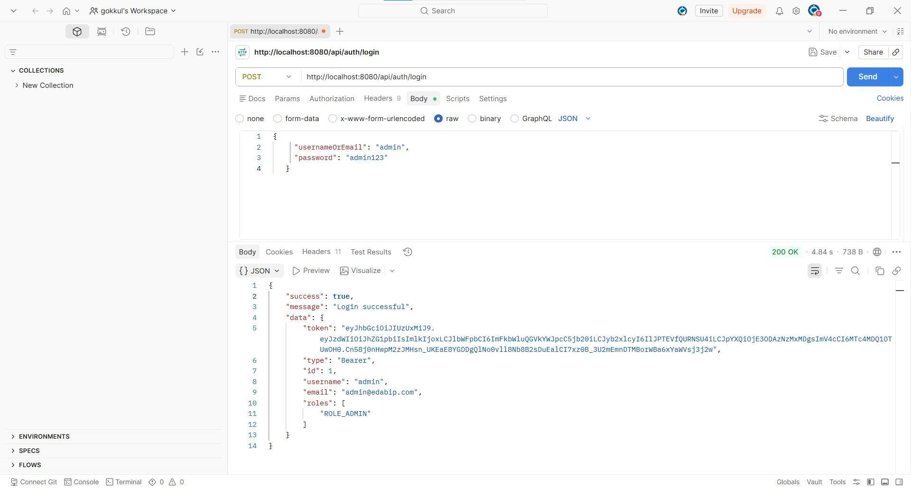

2. Create Department
Method: POST Module: Department
Endpoint: http://localhost:8080/api/departments
Result: 201 Created (Pass)
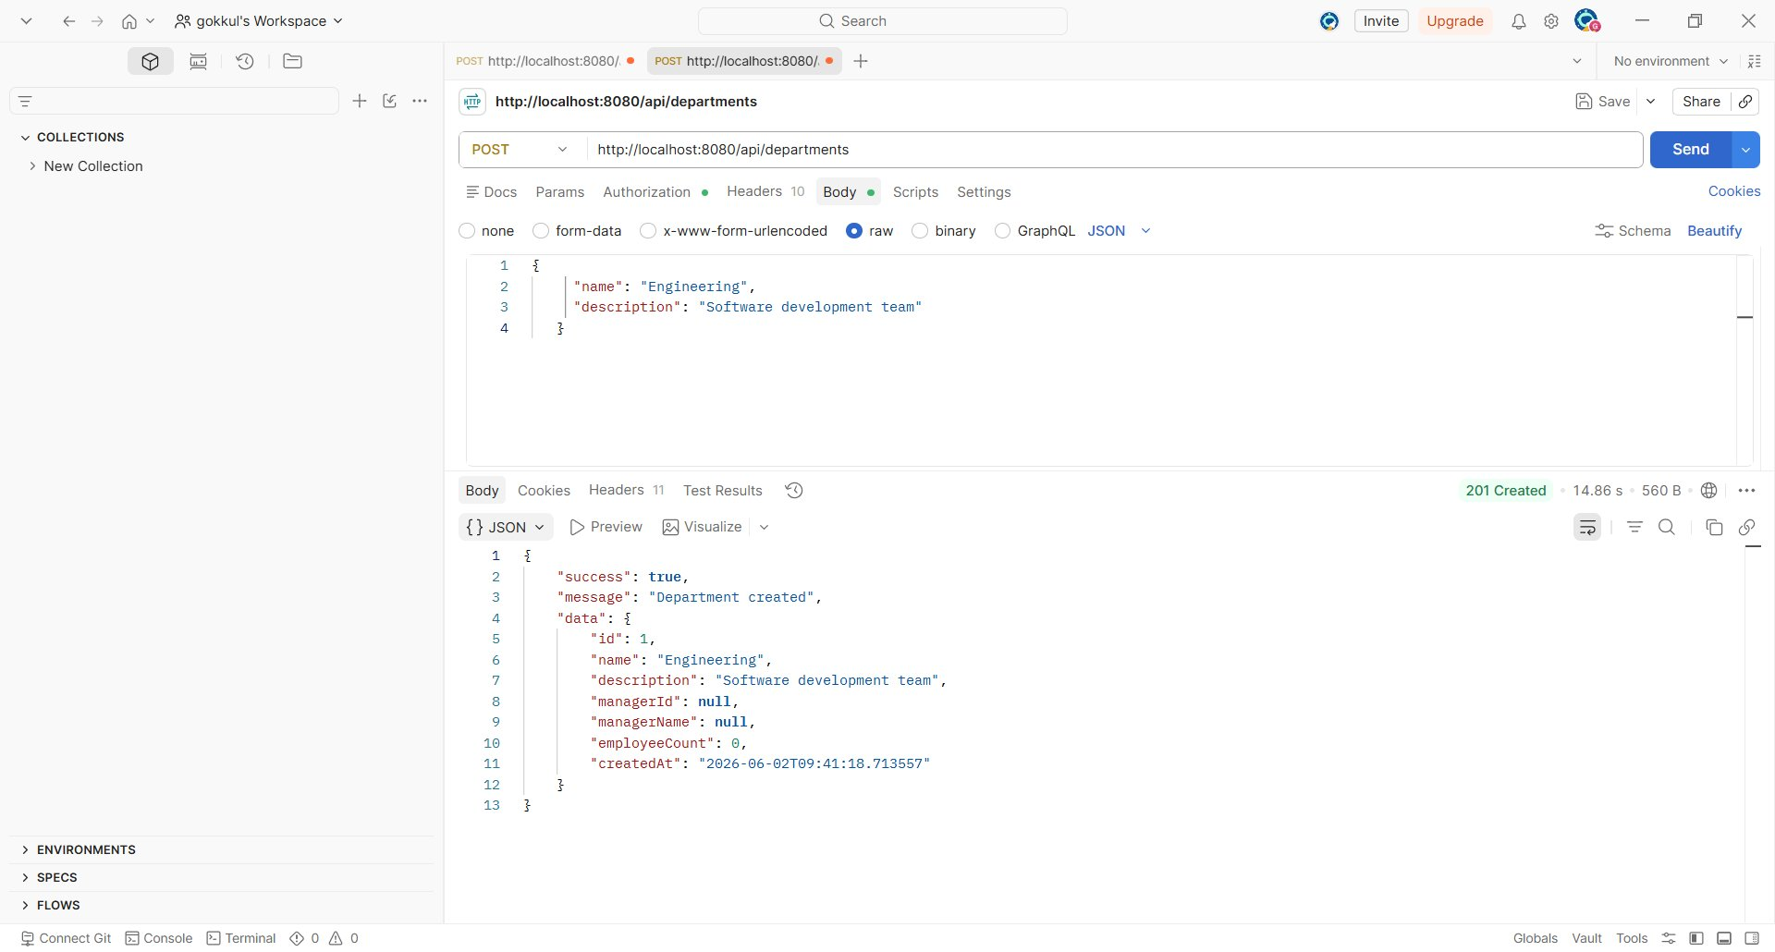

3. Create Employee
Method: POST Module: Employee
Endpoint: http://localhost:8080/api/employees
Result: 201 Created (Pass)
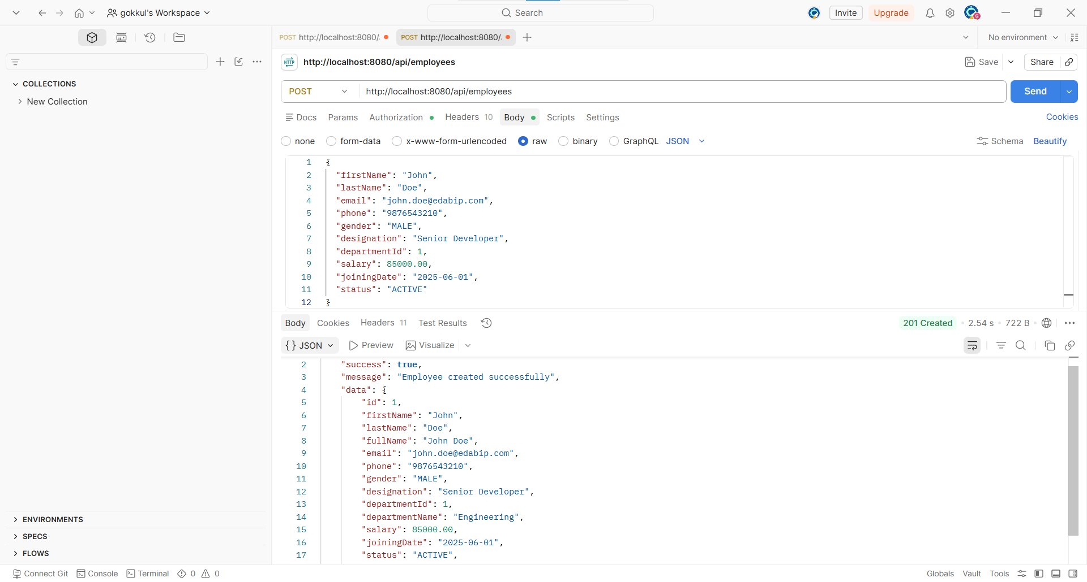

4. Create Project
Method: POST Module: Project/Task
Endpoint: http://localhost:8080/api/projects
Result: 201 Created (Pass)
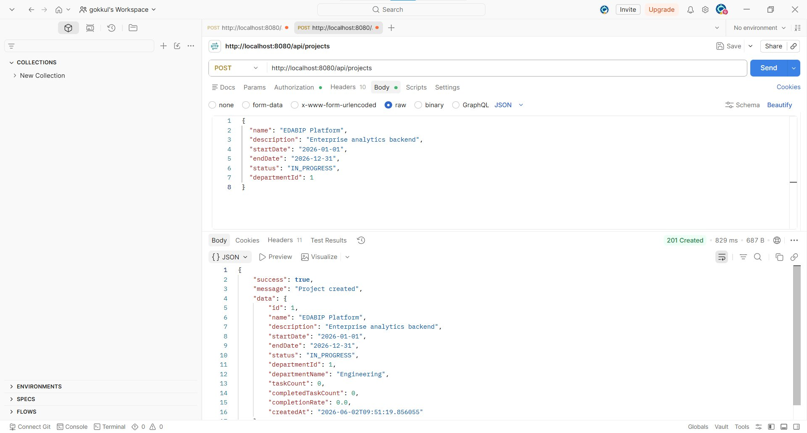

5. Register User (EMPLOYEE role)
Method: POST Module: Authentication
Endpoint: http://localhost:8080/api/auth/register
Result: 200 OK (Pass)
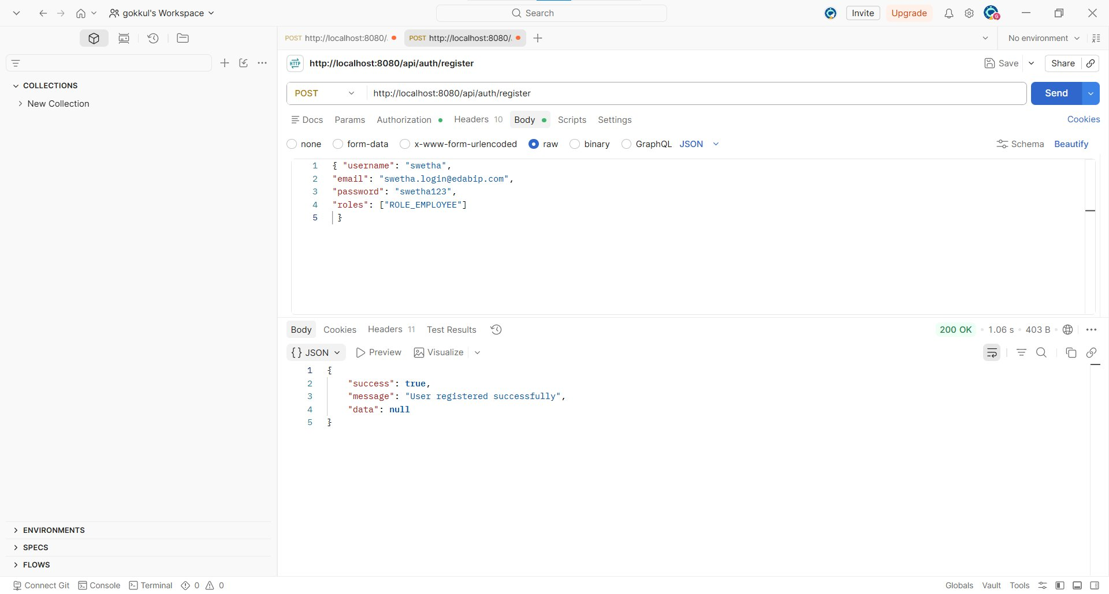

6. Generate Report
Method: POST Module: Reports
Endpoint: http://localhost:8080/api/reports/generate
Result: 201 Created (Pass)
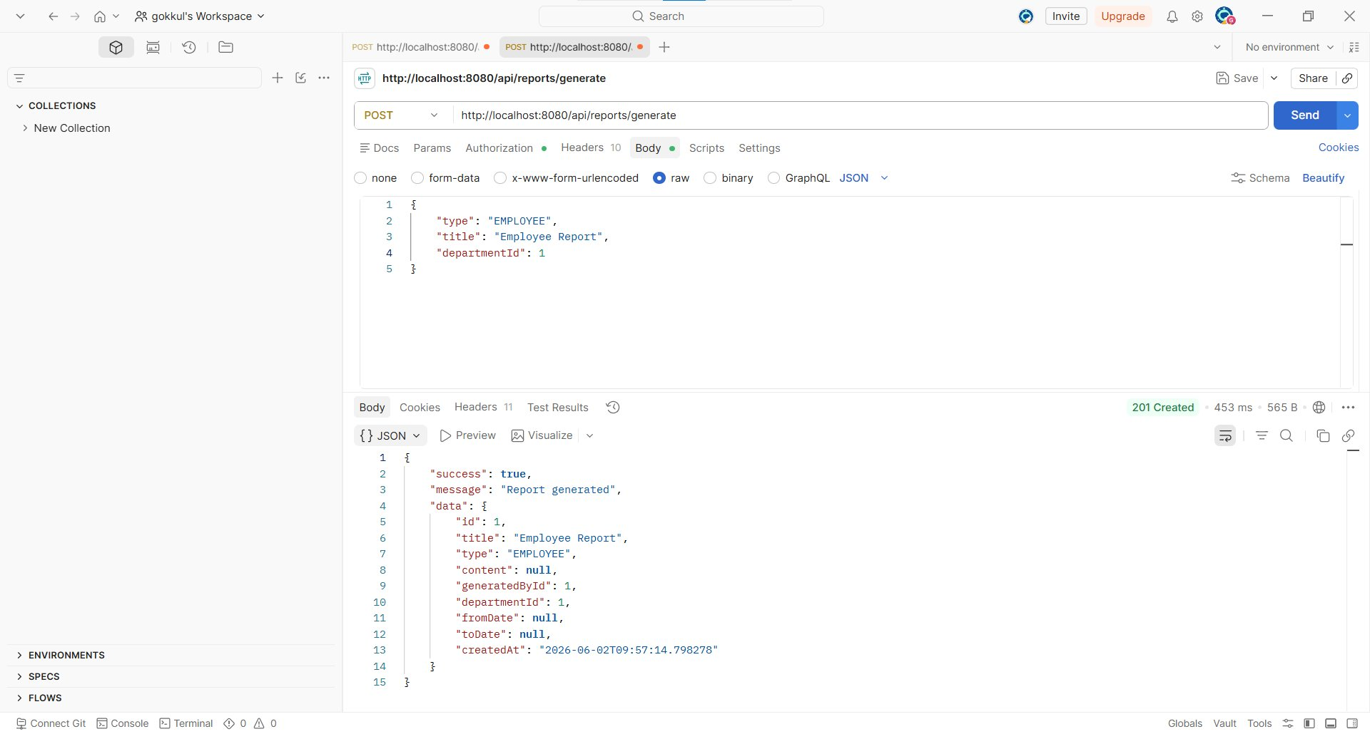

7. Get All Employees
Method: GET Module: Employee
Endpoint: http://localhost:8080/api/employees
Result: 200 OK (Pass)
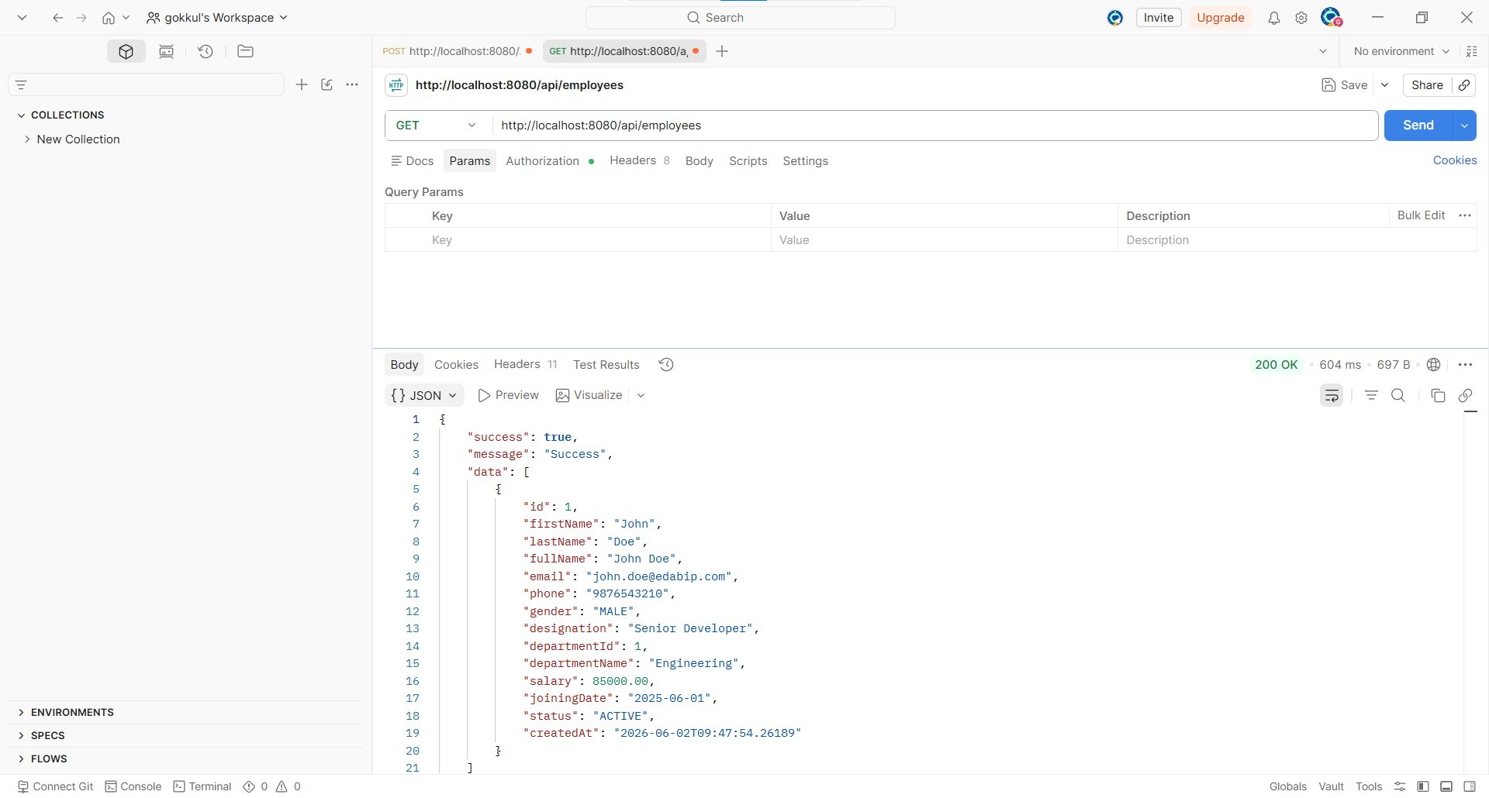

8. Get Employee By ID
Method: GET Module: Employee
Endpoint: http://localhost:8080/api/employees/1
Result: 200 OK (Pass)
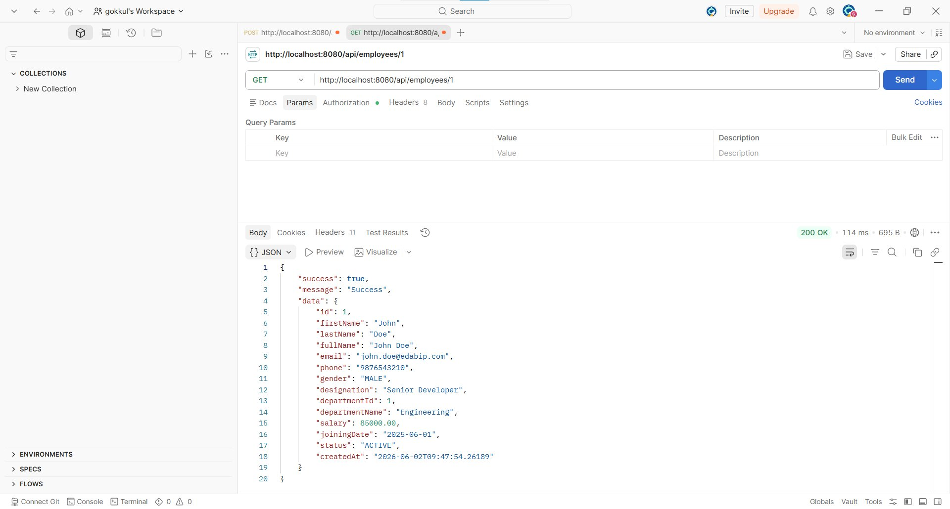

9. Search Employees (name + status)
Method: GET Module: Employee
Endpoint: http://localhost:8080/api/employees/search?name=John&status=ACTIVE
Result: 200 OK (Pass)
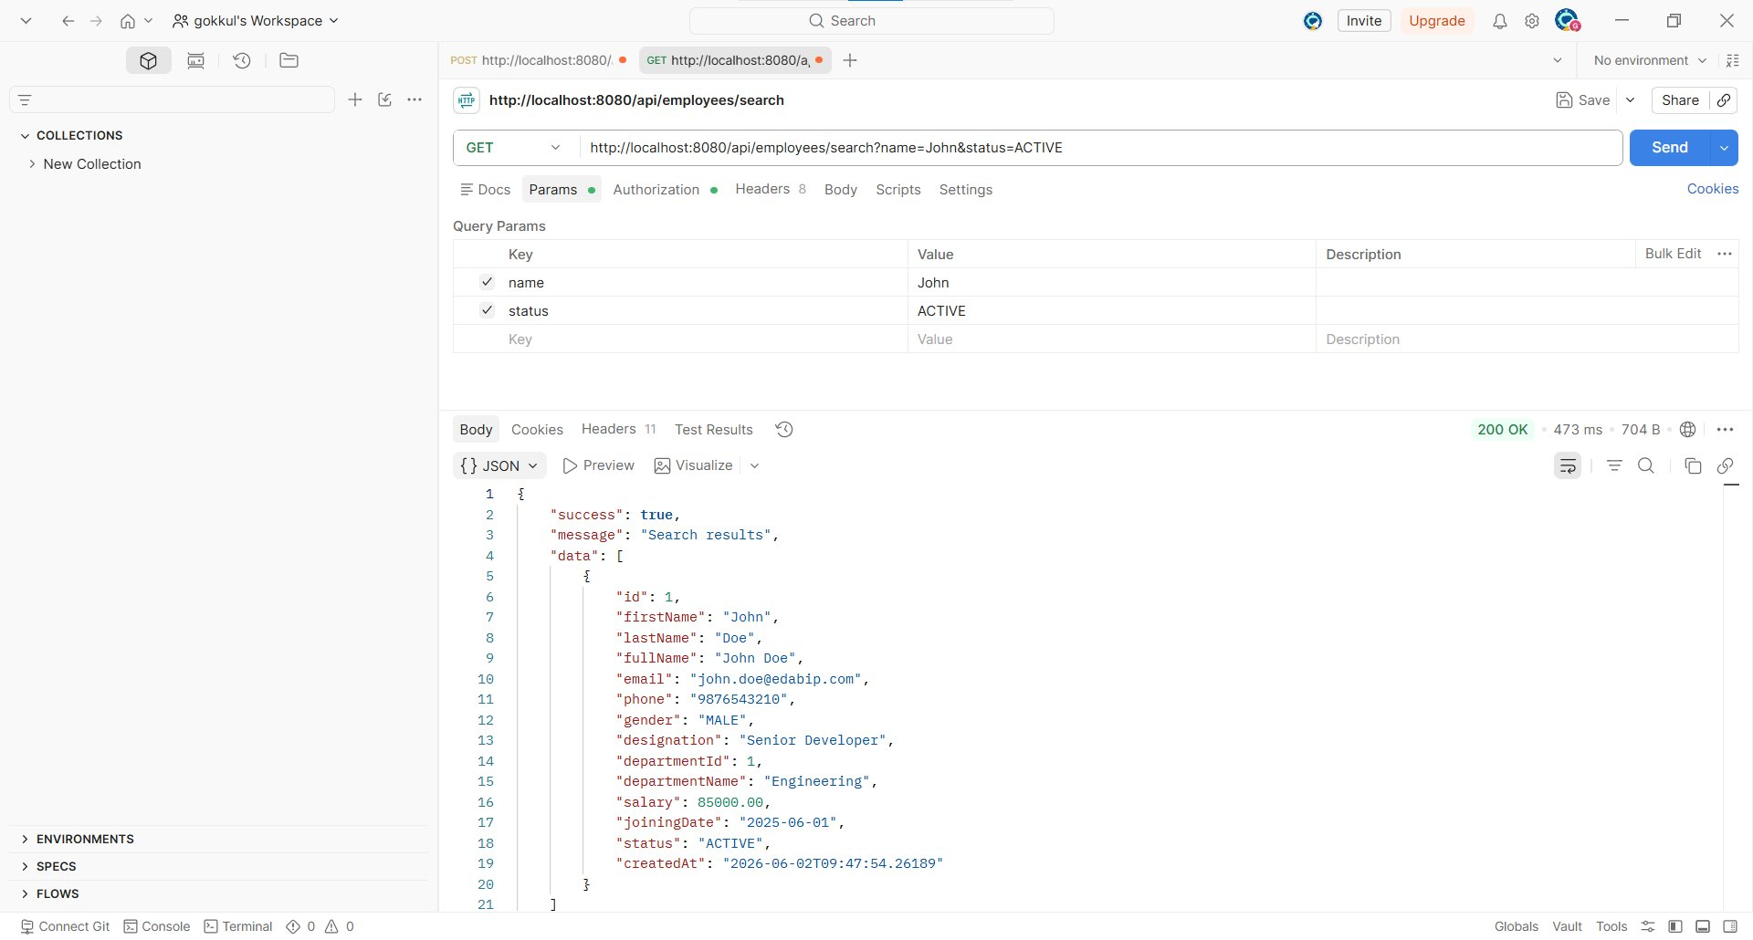

10. Get All Departments
Method: GET Module: Department
Endpoint: http://localhost:8080/api/departments
Result: 200 OK (Pass)
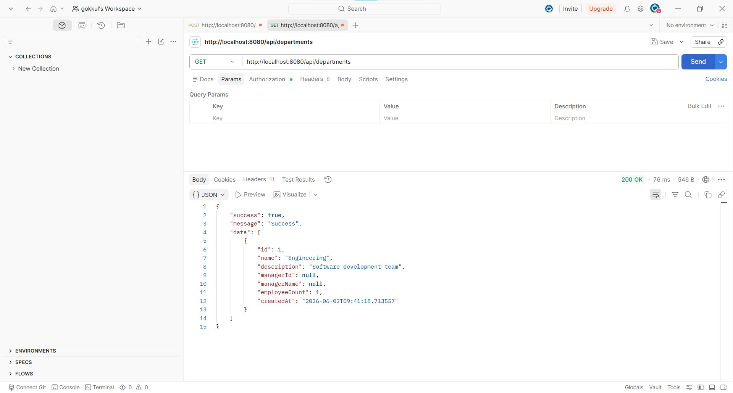

11. Get Department By ID
Method: GET Module: Department
Endpoint: http://localhost:8080/api/departments/1
Result: 200 OK (Pass)
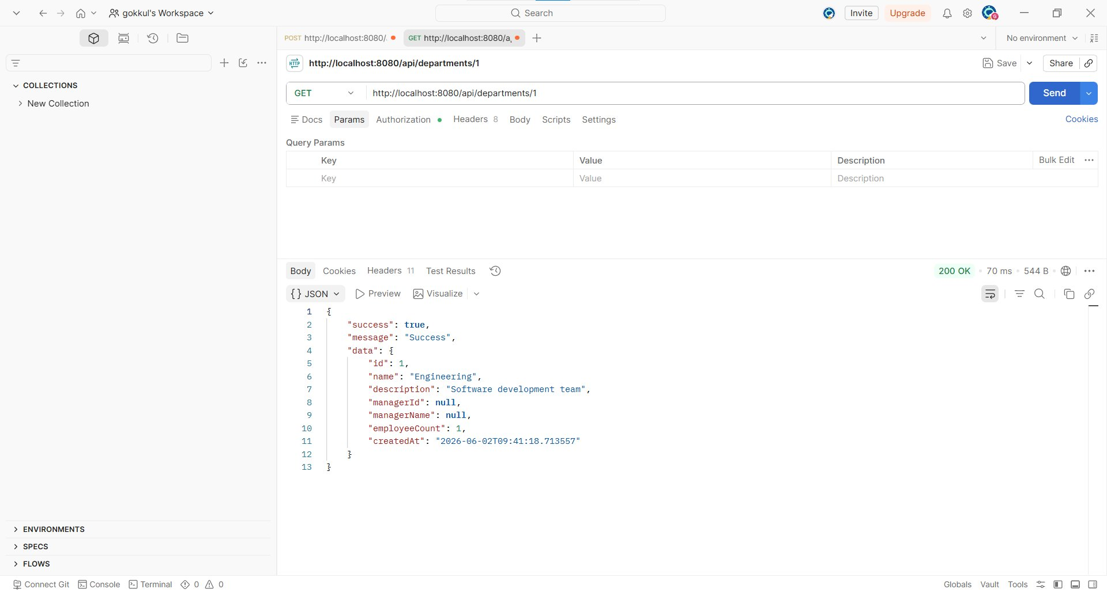

12. Get All Projects
Method: GET Module: Project/Task
Endpoint: http://localhost:8080/api/projects
Result: 200 OK (Pass)
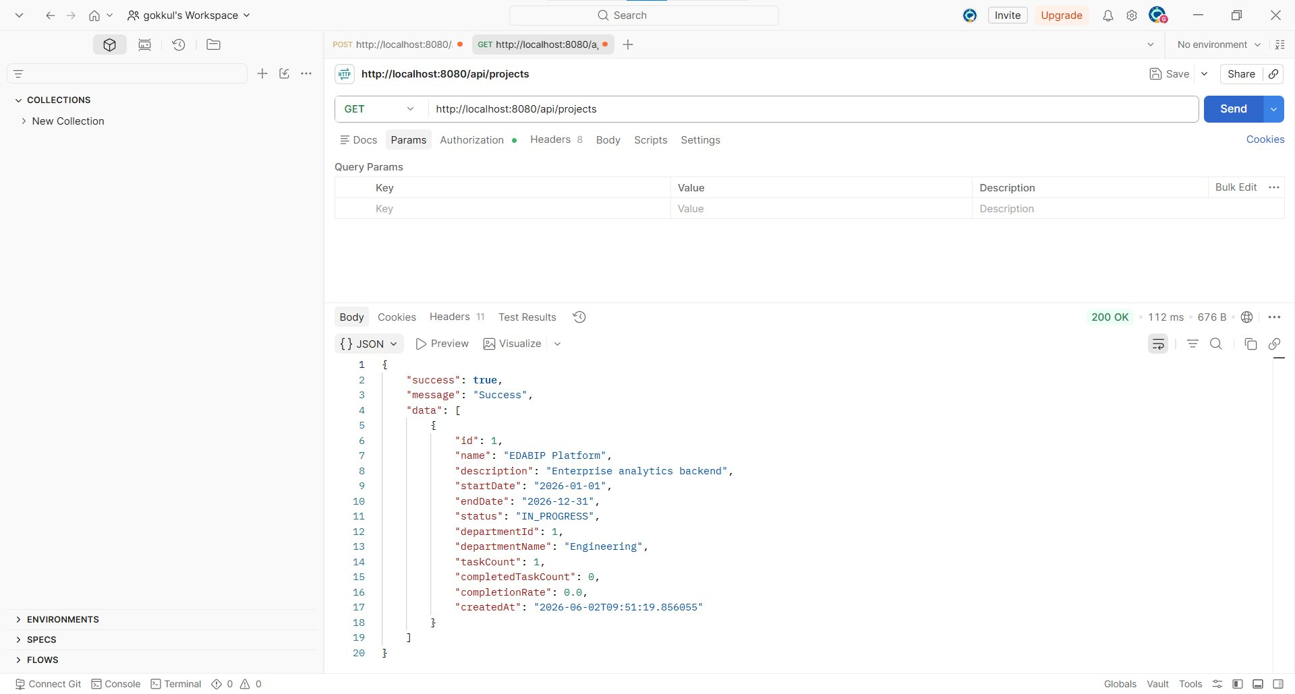

13. Get Project By ID
Method: GET Module: Project/Task
Endpoint: http://localhost:8080/api/projects/1
Result: 200 OK (Pass)
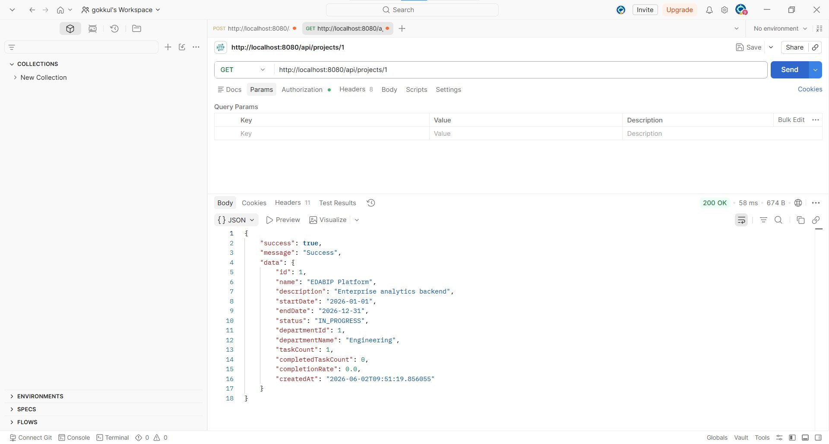

14. Get Tasks By Project
Method: GET Module: Project/Task
Endpoint: http://localhost:8080/api/tasks/project/1
Result: 200 OK (Pass)
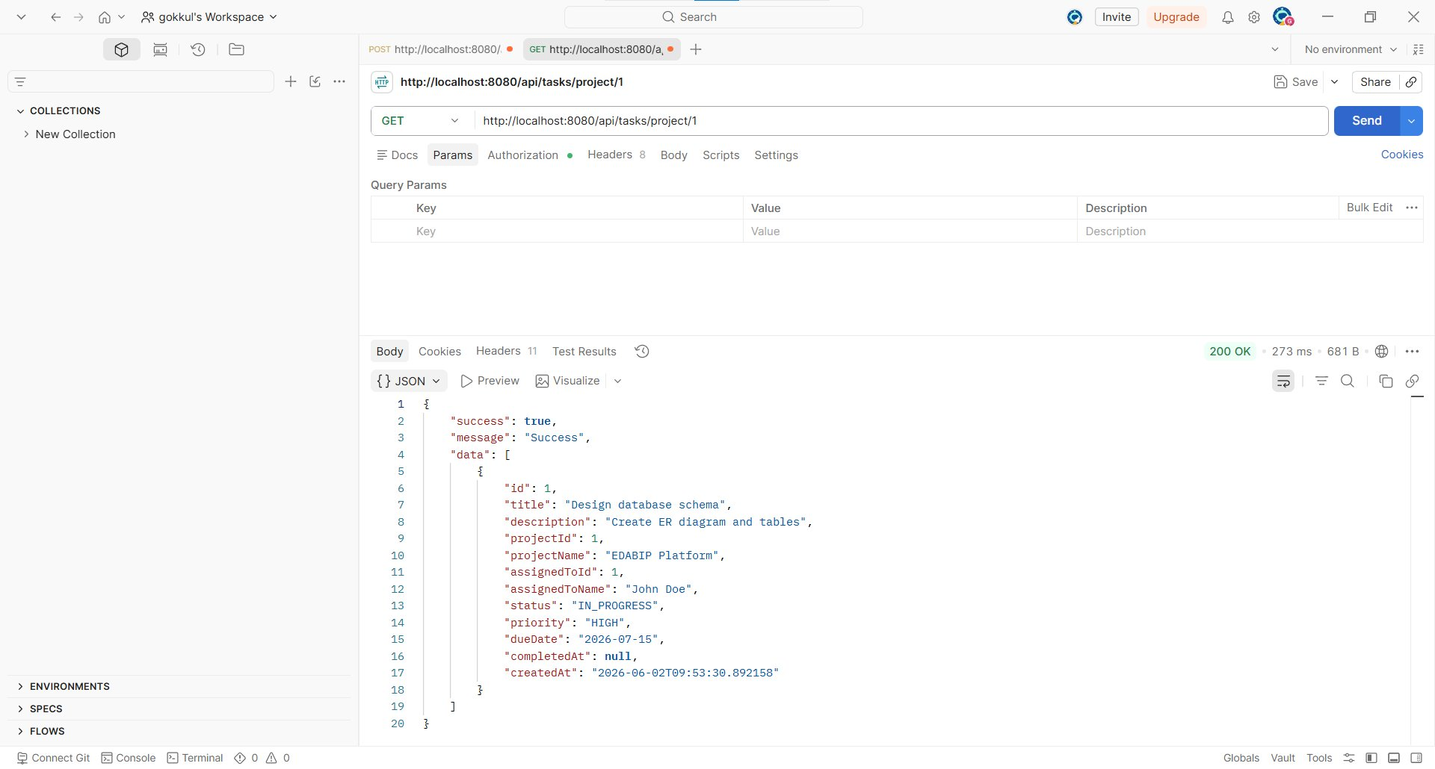

15. Get Tasks By Employee
Method: GET Module: Project/Task
Endpoint: http://localhost:8080/api/tasks/employee/1
Result: 200 OK (Pass)
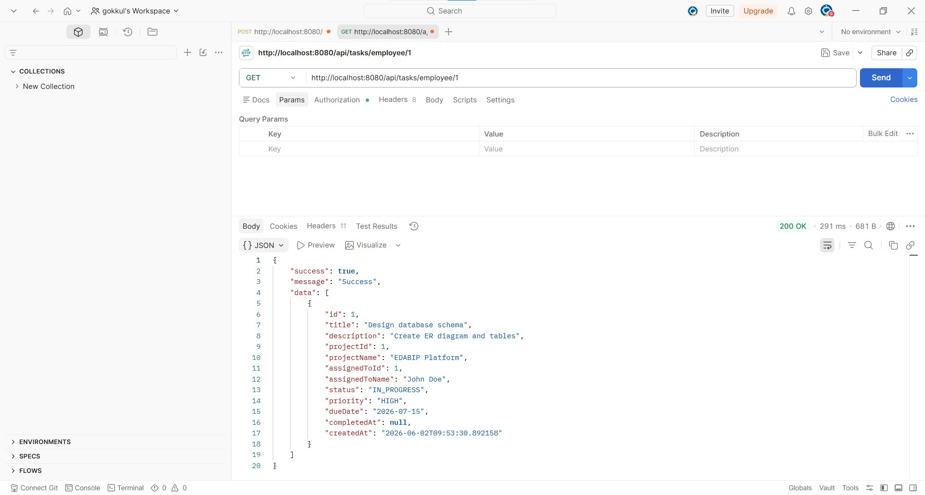

16. Dashboard Statistics
Method: GET Module: Dashboard
Endpoint: http://localhost:8080/api/dashboard/stats
Result: 200 OK (Pass)
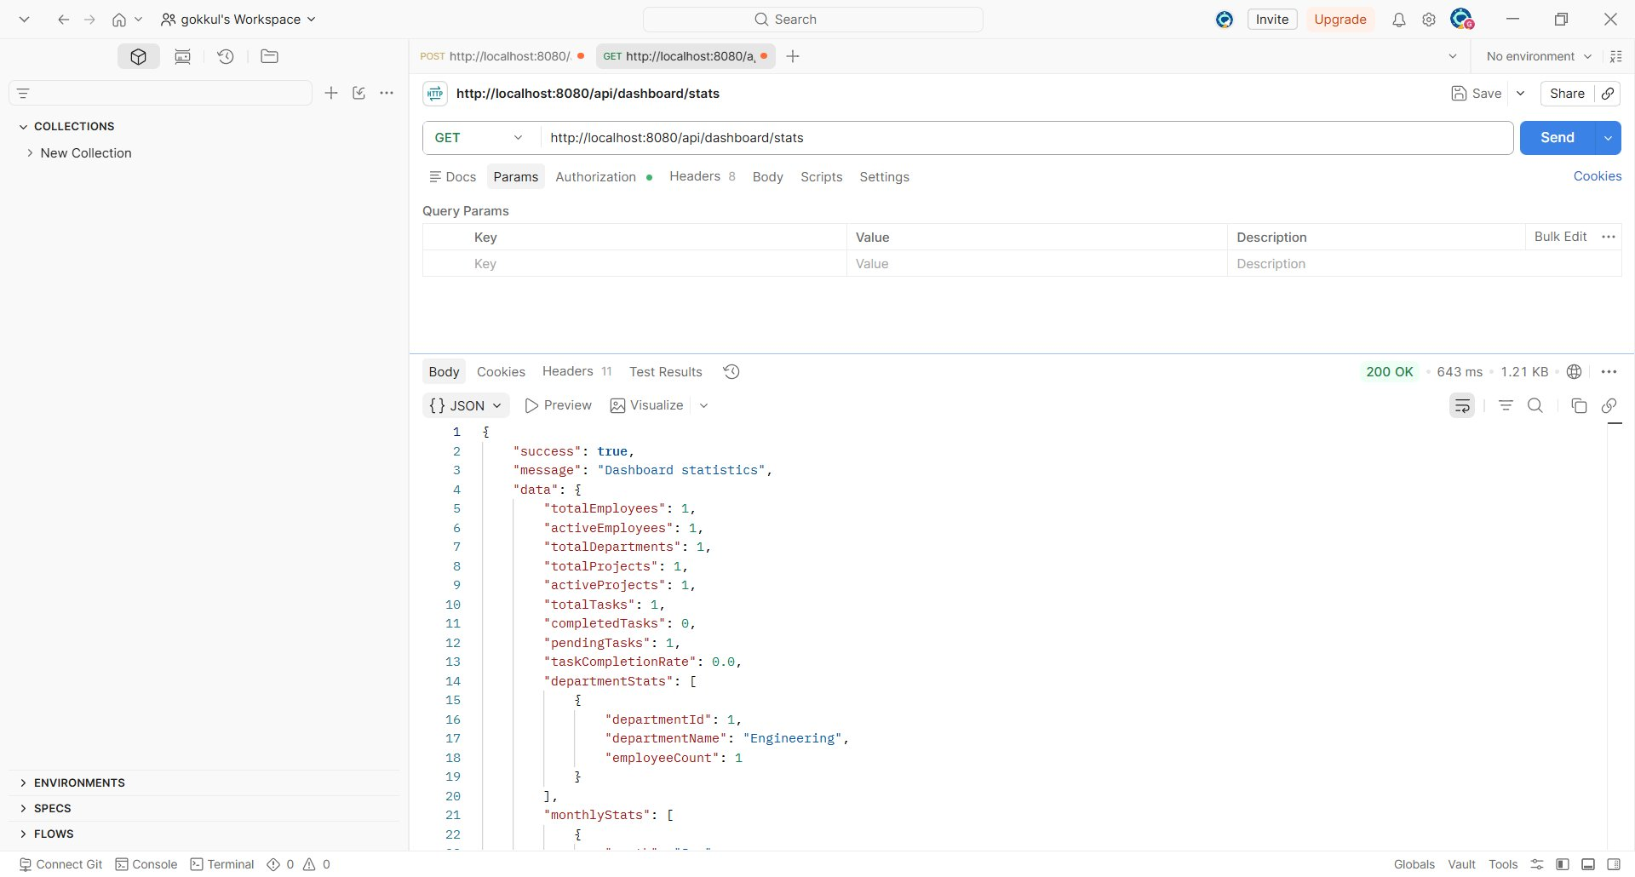

17. Get All Reports
Method: GET Module: Reports
Endpoint: http://localhost:8080/api/reports
Result: 200 OK (Pass)
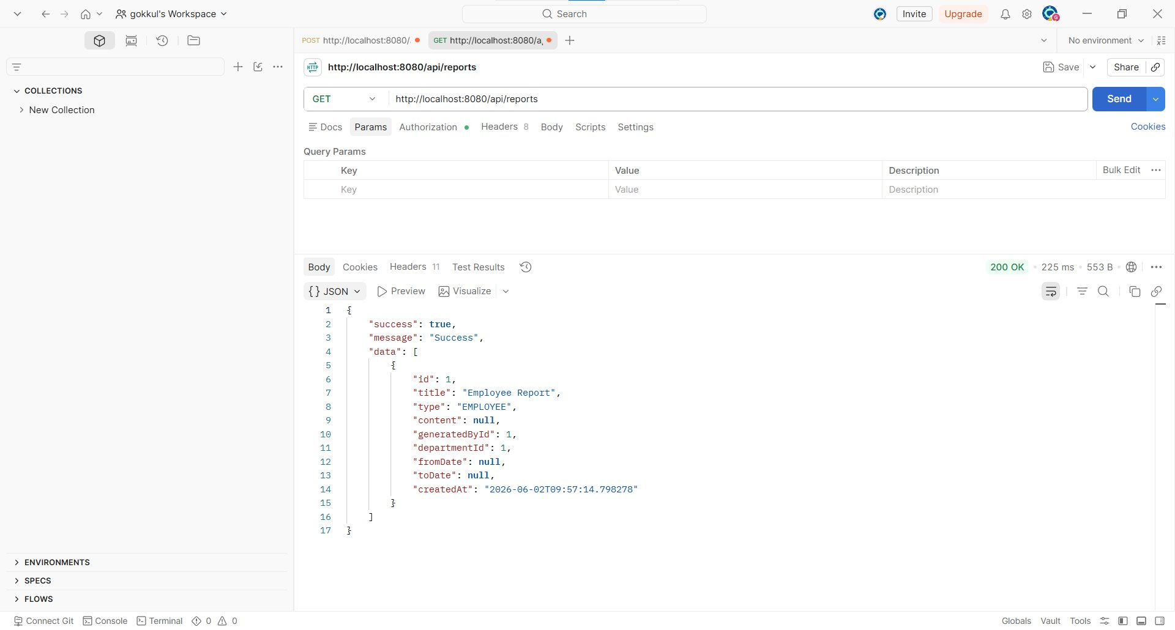

18. Filter Reports (date + department)
Method: GET Module: Reports
Endpoint: http://localhost:8080/api/reports/filter?departmentId=1&fromDate=2026-01-01&toDate=2026-12-31
Result: 200 OK (Pass)
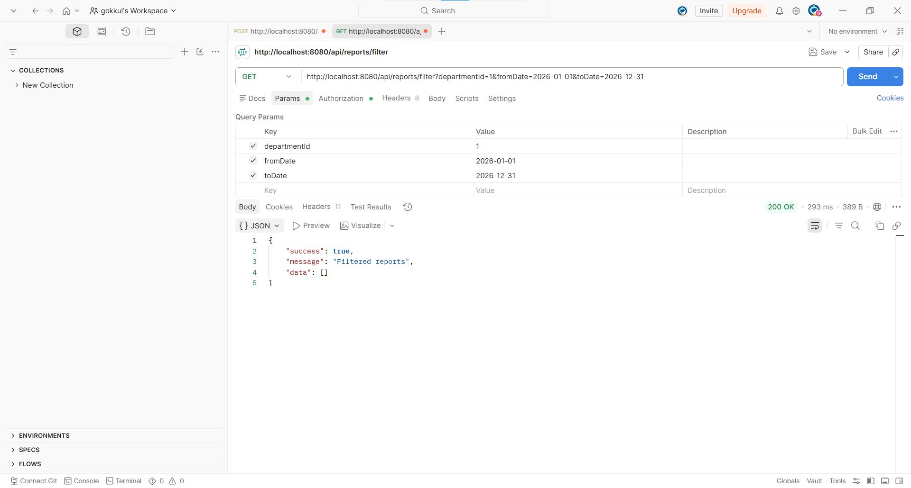

19. Audit Logs (paginated)
Method: GET Module: Audit
Endpoint: http://localhost:8080/api/audit?page=0&size=20
Result: 200 OK (Pass)
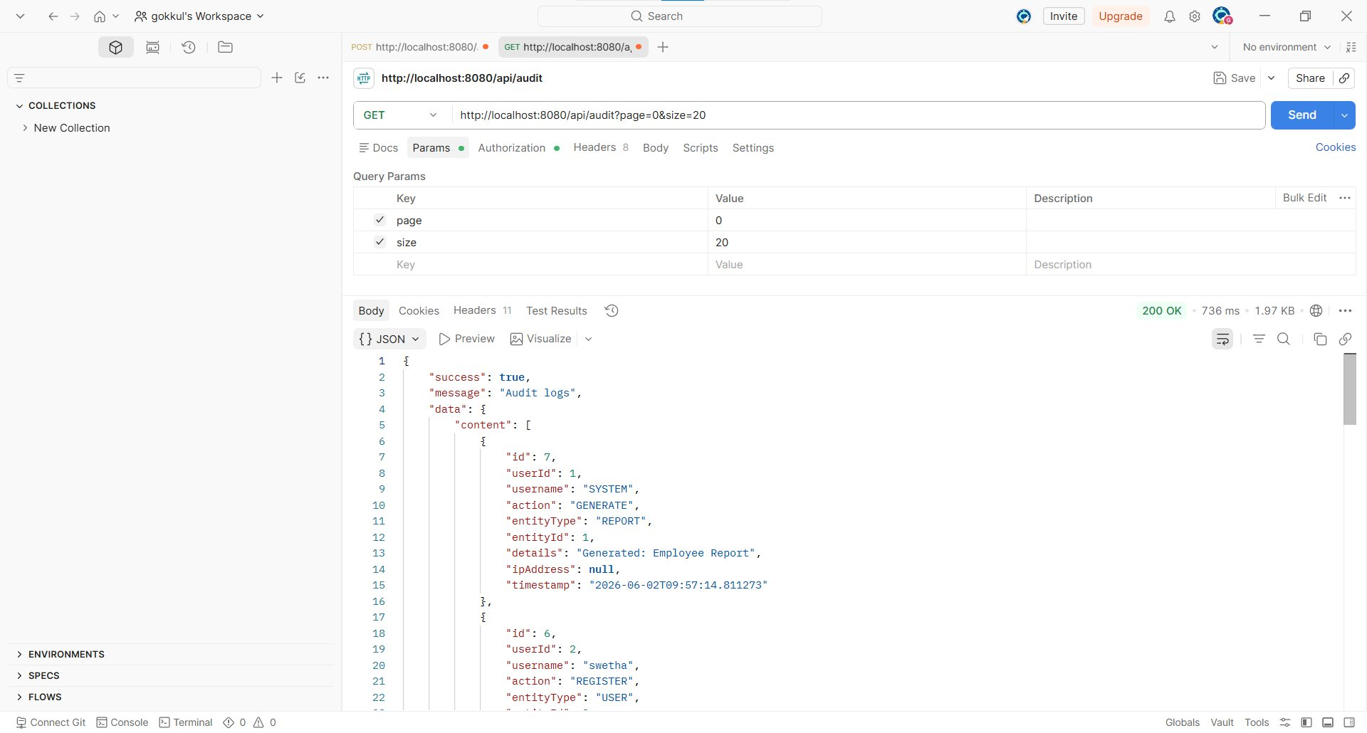

20. Get All Users
Method: GET Module: User Management
Endpoint: http://localhost:8080/api/users
Result: 200 OK (Pass)
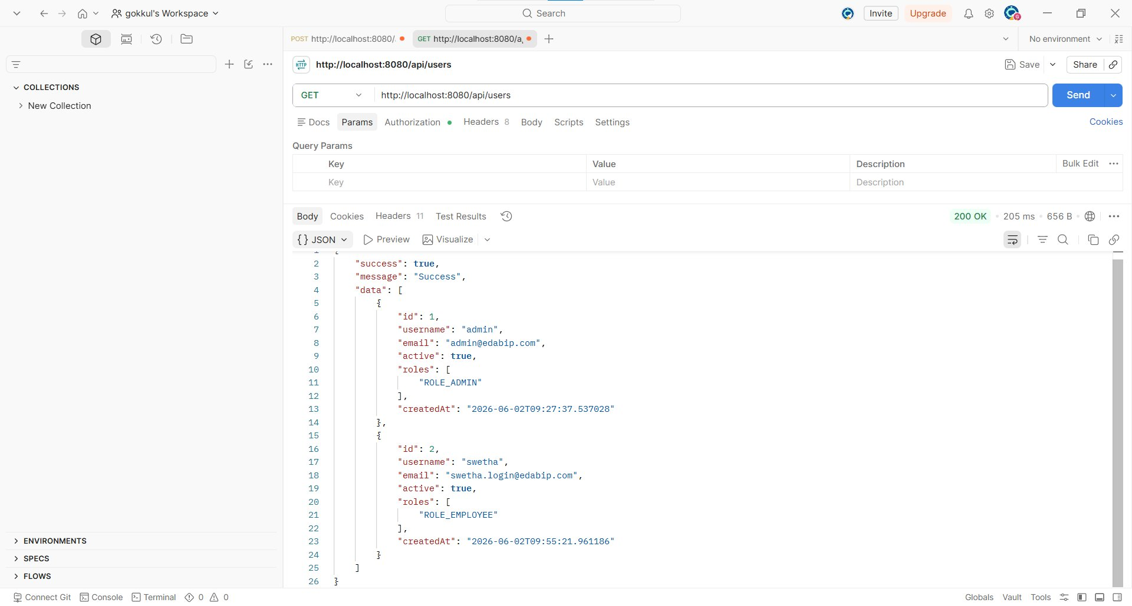

21. Get User By ID
Method: GET Module: User Management
Endpoint: http://localhost:8080/api/users/1
Result: 200 OK (Pass)
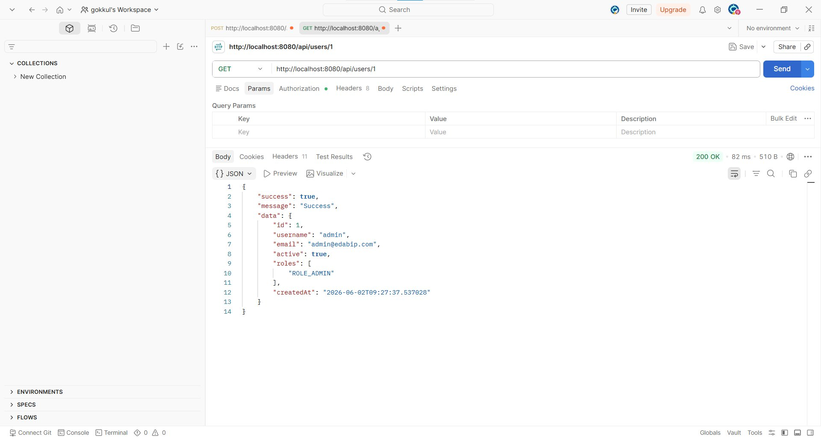

22. Update Employee
Method: PUT Module: Employee
Endpoint: http://localhost:8080/api/employees/1
Result: 200 OK (Pass)
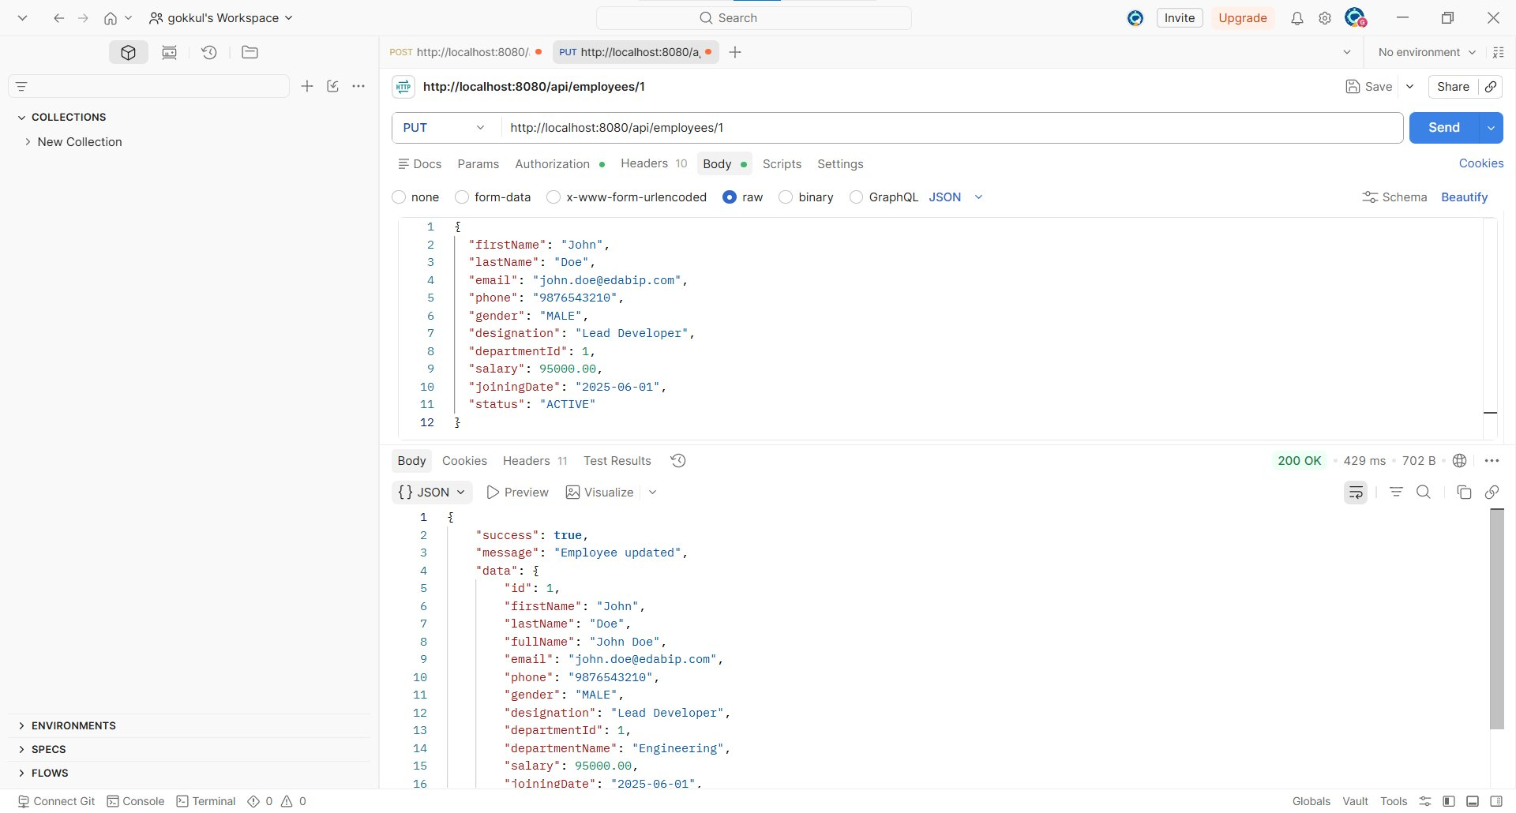

23. Update Task (mark completed)
Method: PUT Module: Project/Task
Endpoint: http://localhost:8080/api/tasks/1
Result: 200 OK (Pass)
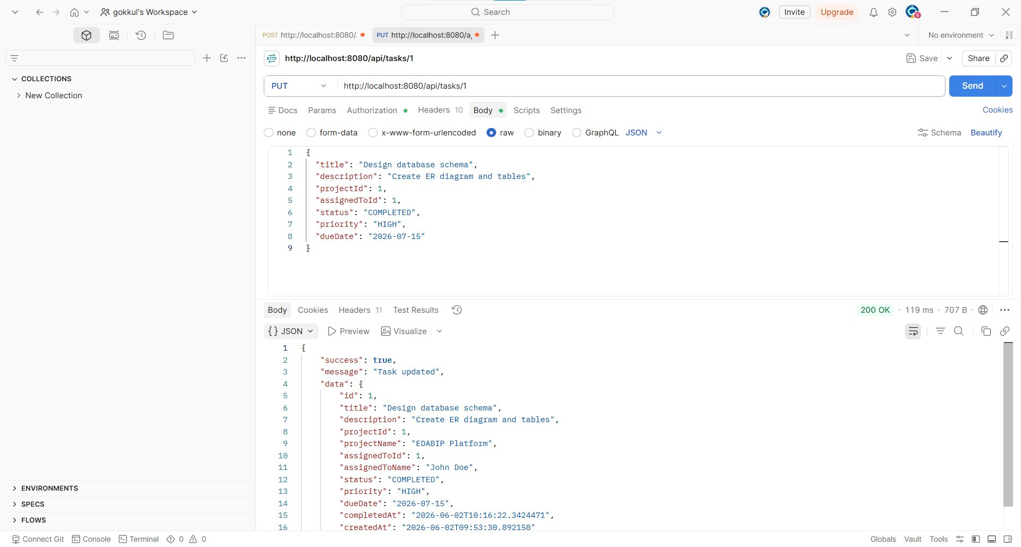

24. Update Department
Method: PUT Module: Department
Endpoint: http://localhost:8080/api/departments/1
Result: 200 OK (Pass)
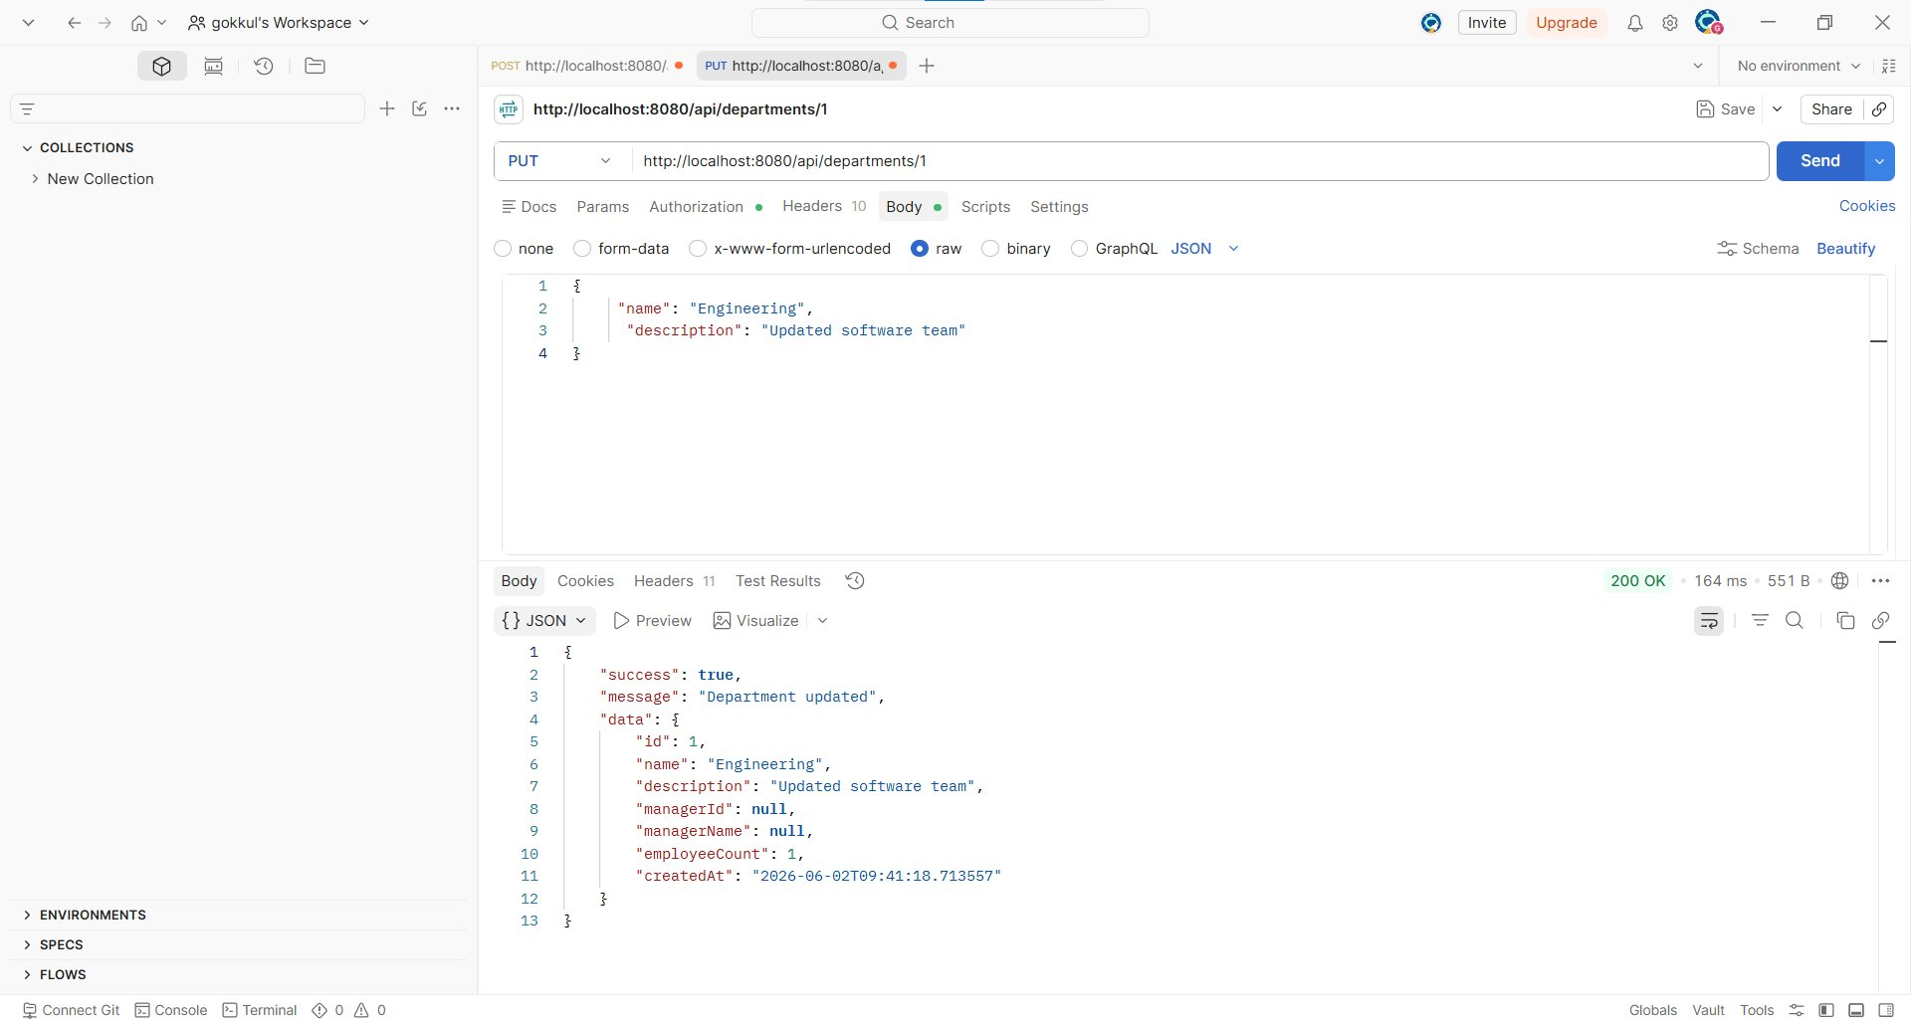

25. Delete Task
Method: DELETE Module: Project/Task
Endpoint: http://localhost:8080/api/tasks/1
Result: 200 OK (Pass)
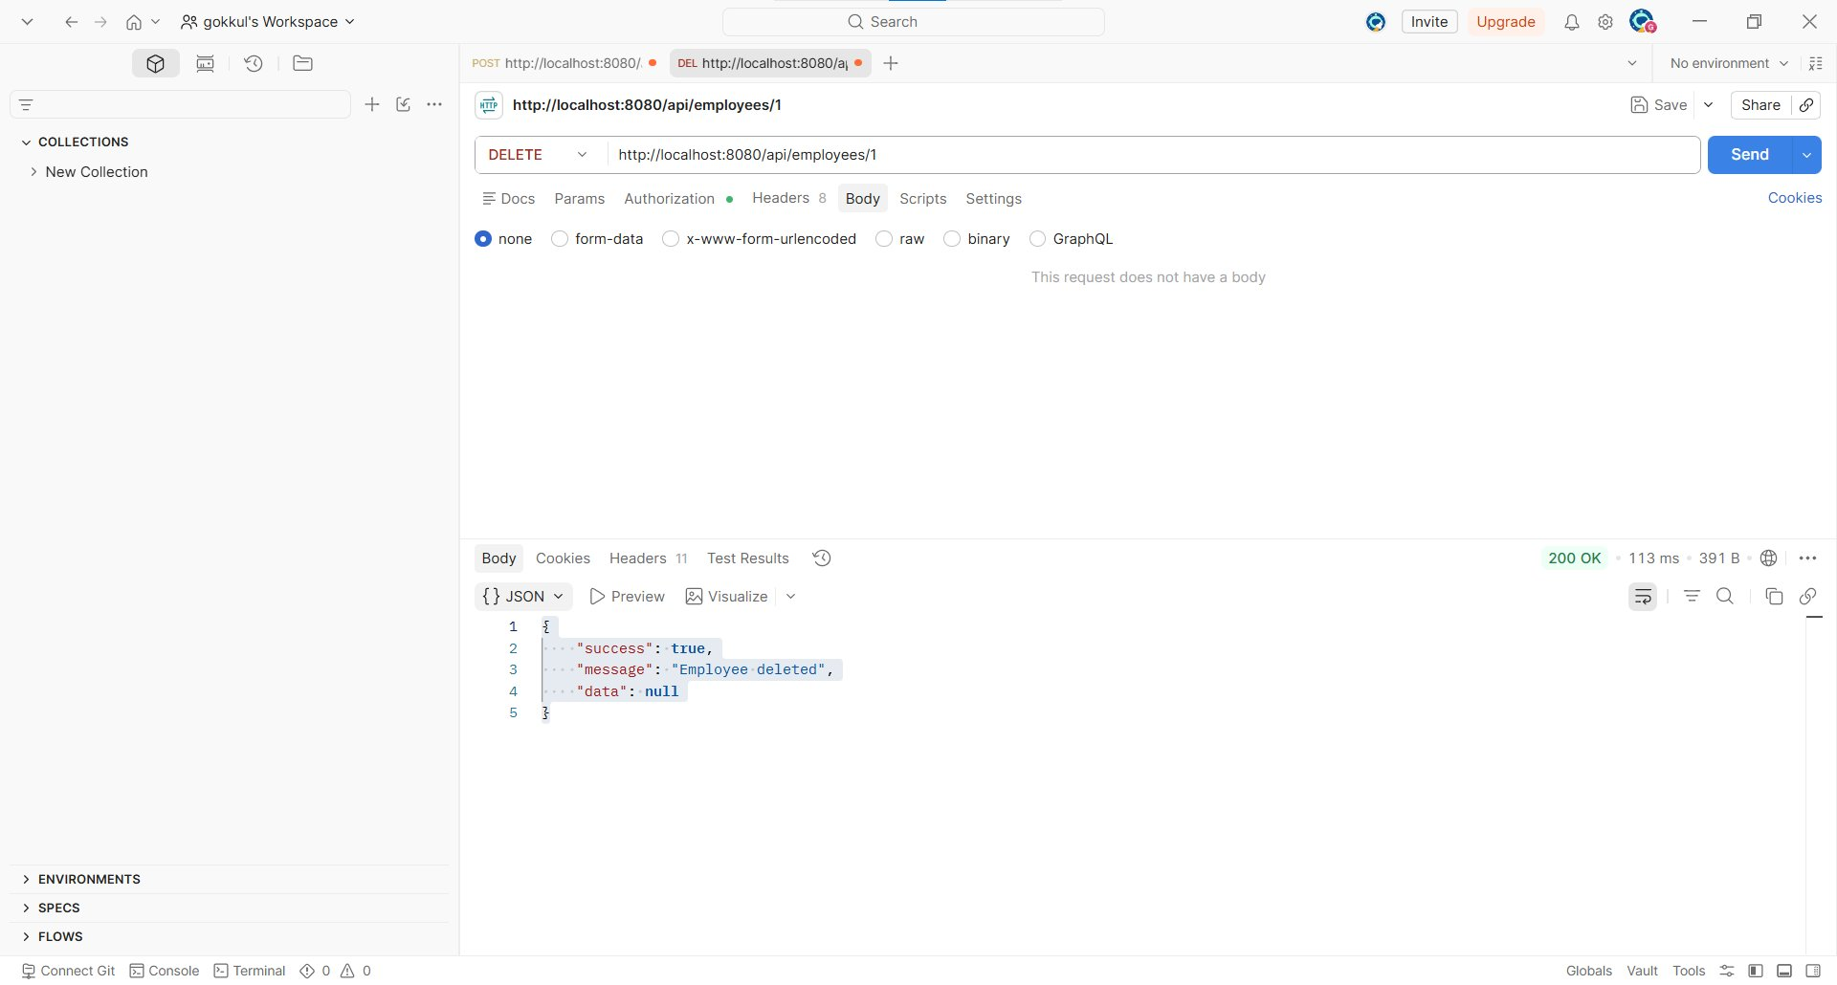

26. Delete Employee
Method: DELETE Module: Employee
Endpoint: http://localhost:8080/api/employees/1
Result: 200 OK (Pass)
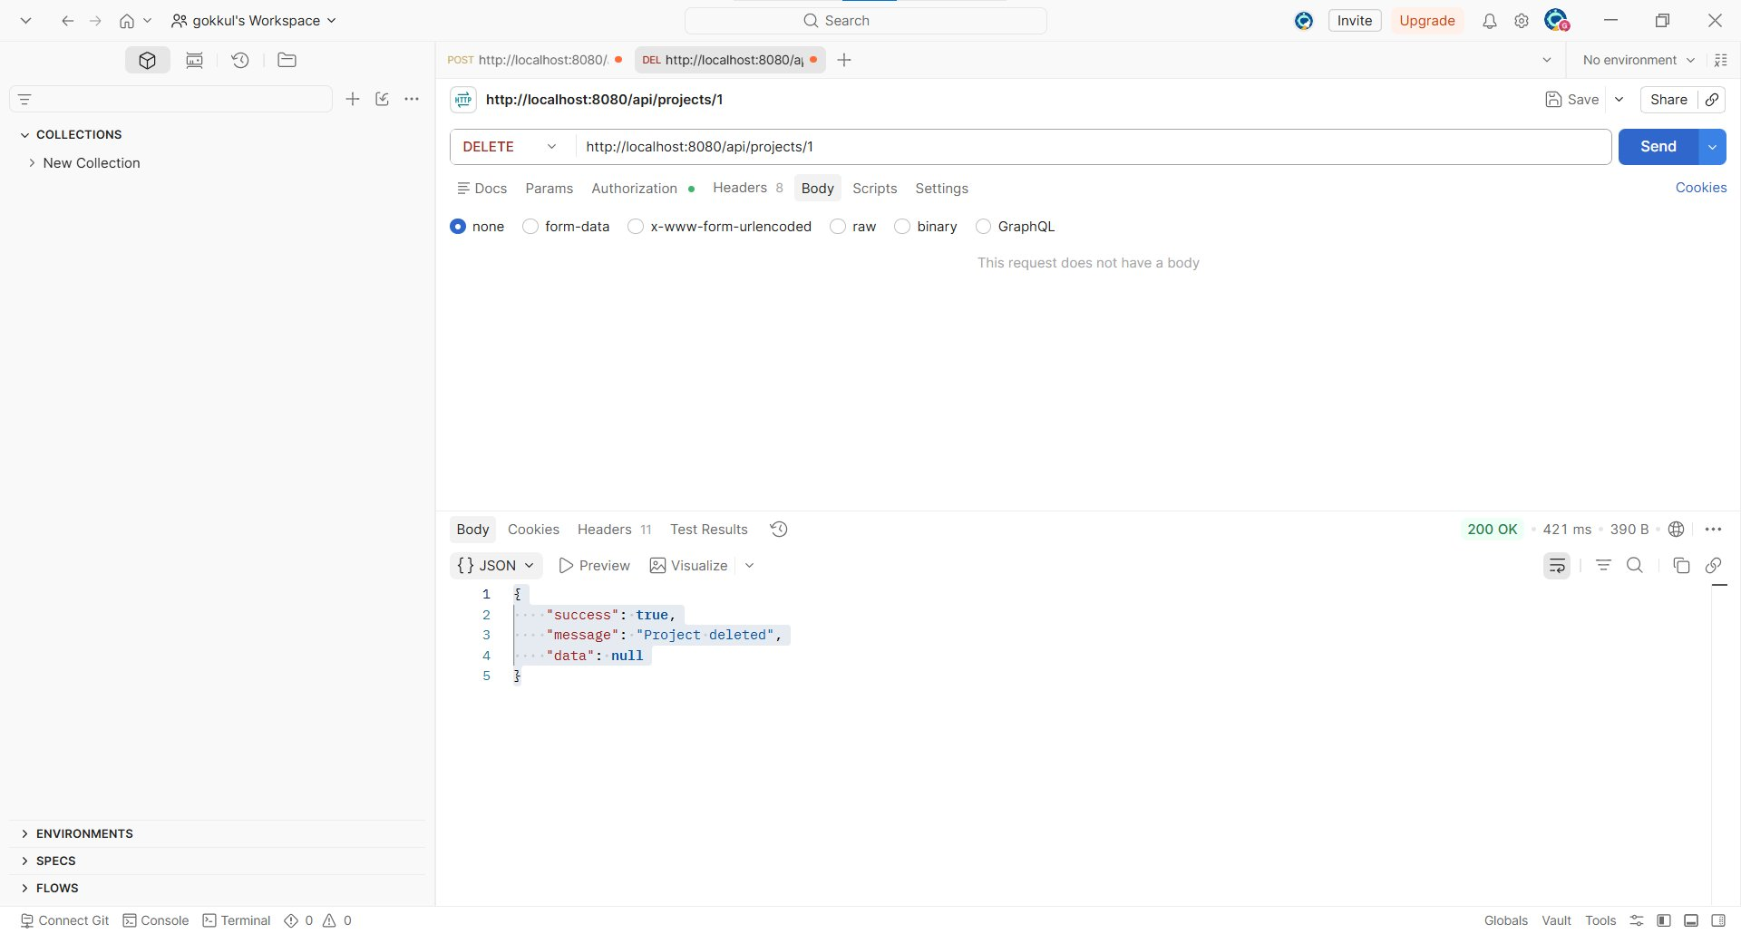

27. Delete Project
Method: DELETE Module: Project/Task
Endpoint: http://localhost:8080/api/projects/1
Result: 200 OK (Pass)
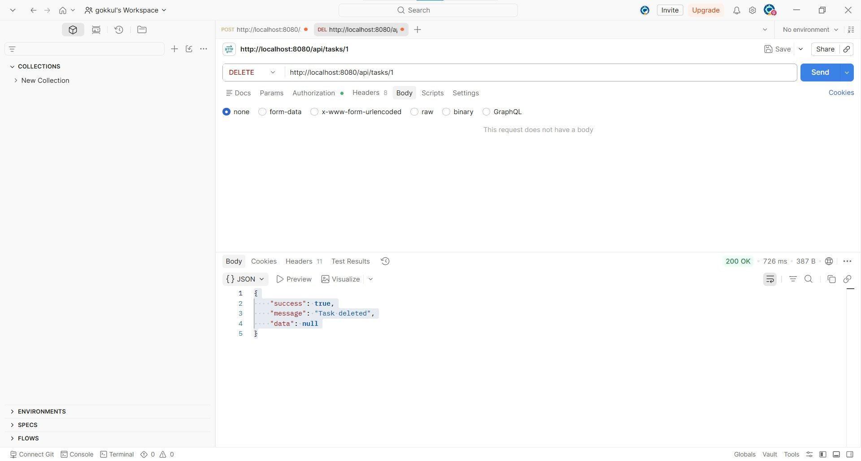

28. Delete Department
Method: DELETE Module: Department
Endpoint: http://localhost:8080/api/departments/1
Result: 200 OK (Pass)
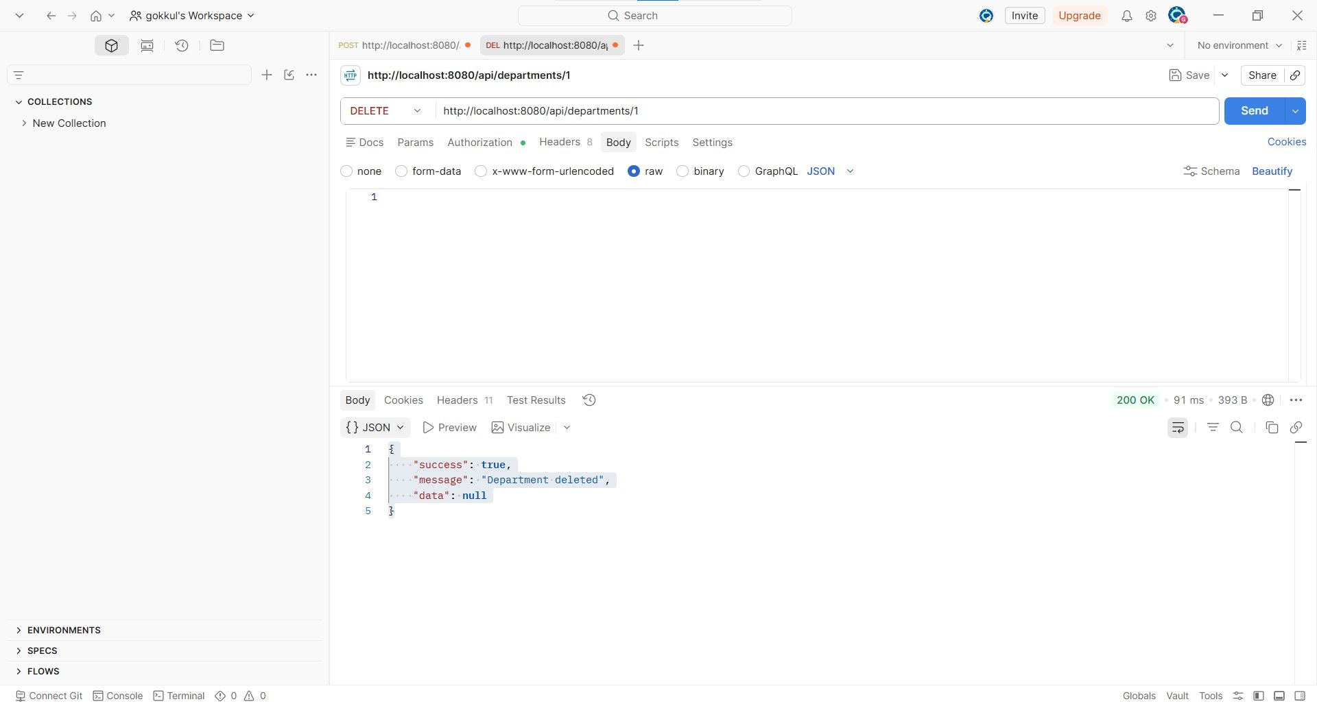

Error Handling Scenarios Tested
Negative test cases demonstrating validation and authentication error handling. All errors return a consistent JSON structure (status, error, message, timestamp, validationErrors).

N1. Login — Missing Password (validation)
Method: POST Module: Authentication
Endpoint: http://localhost:8080/api/auth/login
Result: 400 Bad Request (Pass — error correctly handled)
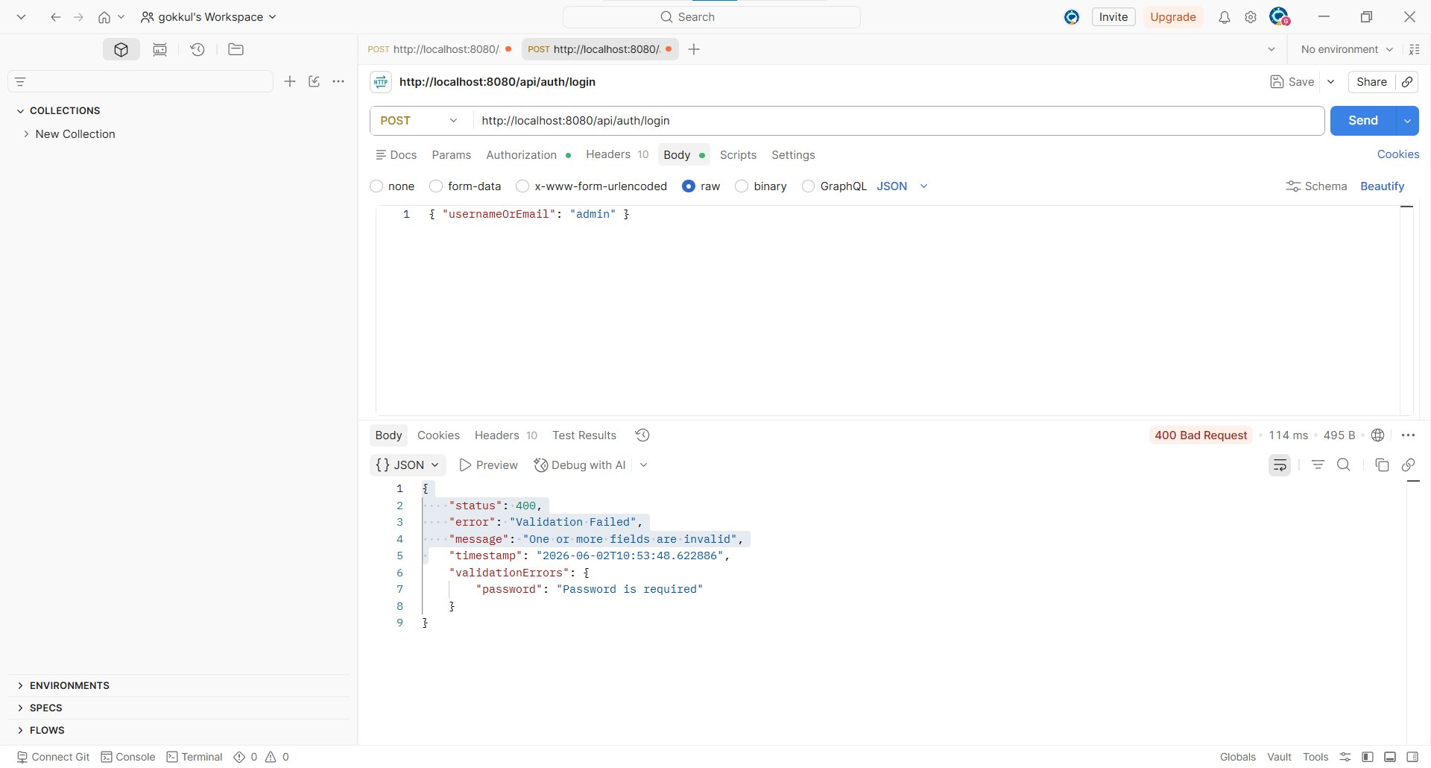

N2. Login — Wrong Password (auth failure)
Method: POST Module: Authentication
Endpoint: http://localhost:8080/api/auth/login
Result: 401 Unauthorized (Pass — error correctly handled)
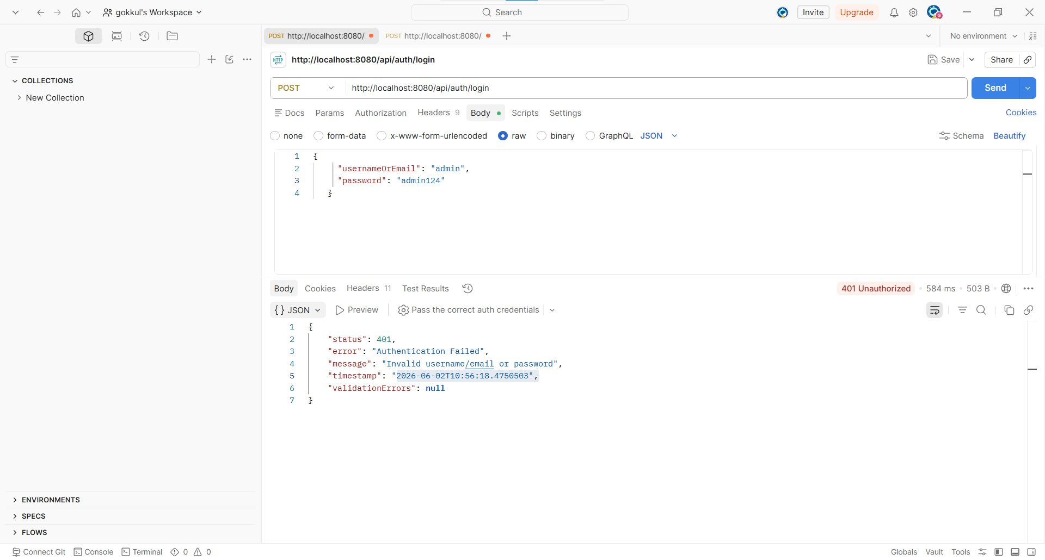

N3. Login as EMPLOYEE-role user (setup for RBAC)
Method: POST Module: RBAC
Endpoint: http://localhost:8080/api/auth/login
Result: 200 OK (Pass)
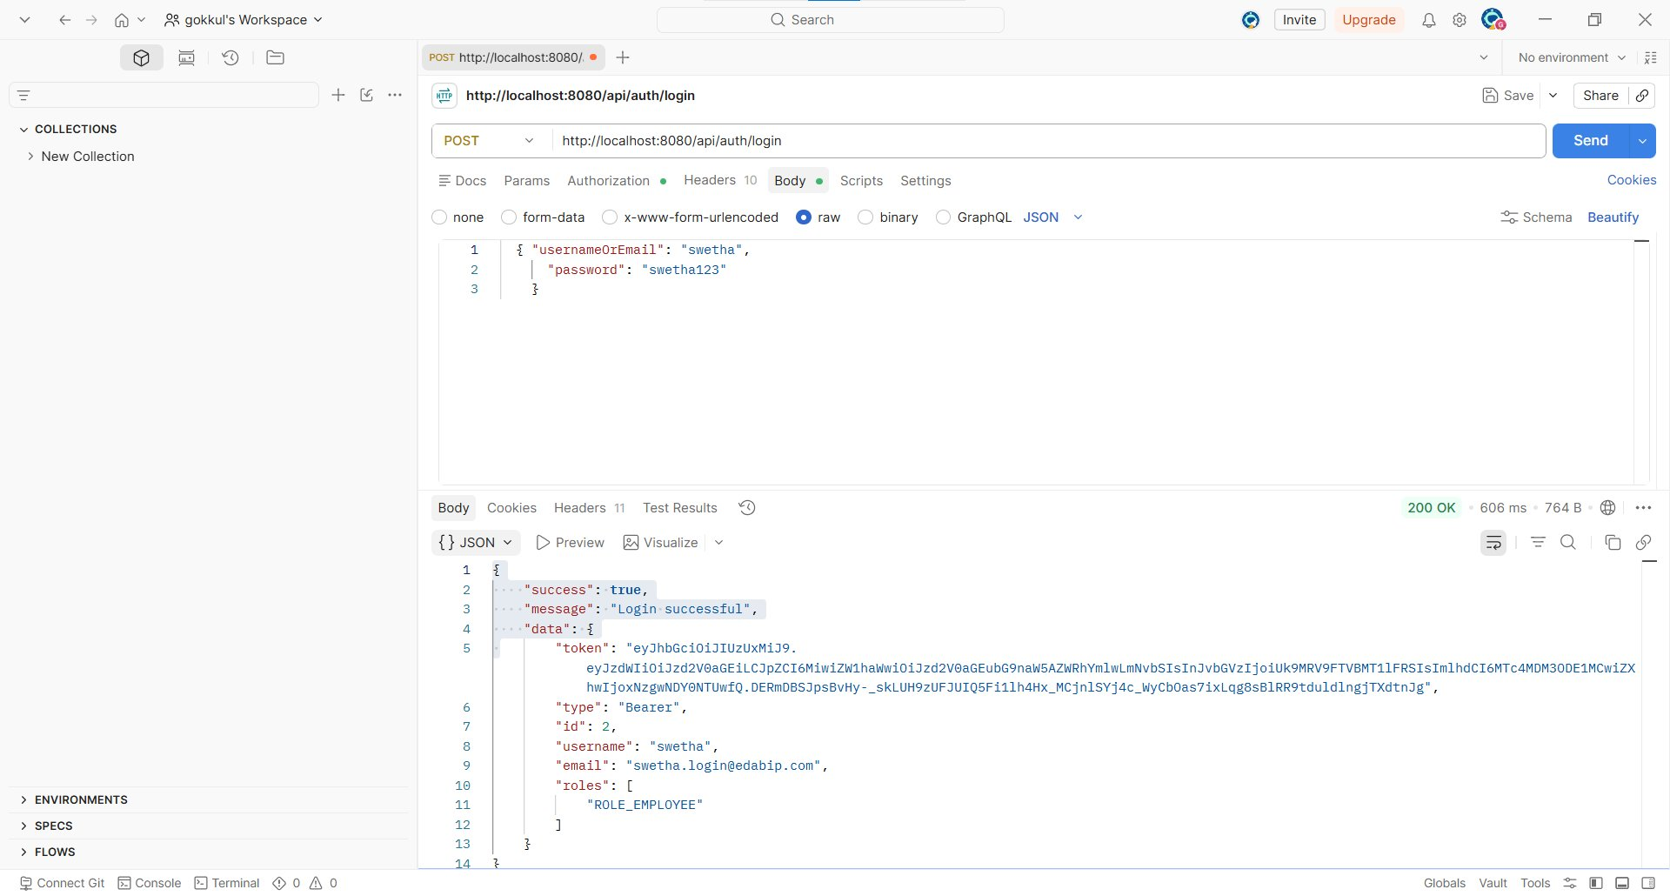

N4. EMPLOYEE blocked from creating a Department
Method: POST Module: RBAC
Endpoint: http://localhost:8080/api/departments
Result: 403 Forbidden (Pass — error correctly handled)
