Approach B: Functional Connectivity Analysis of Frustration Scenarios in the BITIRMEEG Study

1. Introduction

1.1 Context and relation to Approach A
Approach A built a multimodal detection and characterisation pipeline for the BITIRMEEG dataset (V2 to V6), combining electroencephalography (EEG) with eye tracking and mouse dynamics inside a transformer based model. That pipeline answered two questions: whether frustration is detectable, and which scalar oscillation features describe each scenario. Approach B addresses a different question. Instead of asking what each brain region does on its own, it asks whether the network of communication between regions is rearranged when a frustrating event happens. Functional connectivity is the natural tool for this question and it is, by construction, a property of neural signals rather than of behaviour. For this reason Approach B is EEG only at the network stage. The eye and mouse modalities were already covered by Approach A and would not enter the connectivity formalism without an additional cross modal coupling step (Cavanagh and Frank 2014).

1.2 Research question
Approach B is organised around two sub questions. The first is mechanistic: do specific frustration scenarios reorganise the inter region neural communication pattern relative to action matched control epochs, and if so in which bands and over which connections. The second is diagnostic: are the resulting network signatures sufficient, on their own, to discriminate the 15 classes (control plus 14 scenarios) at the sample size available in this study. The first question is the primary scientific contribution. The second question is a validation step.

1.3 Why this is a complementary, not redundant, analysis
Approach A and Approach B operate at different neural levels. Approach A measured how active each region is in each band, summarised as event related spectral perturbation values. Approach B measured how two regions communicate with each other, summarised as phase based and amplitude based connectivity. These are not the same quantity. A region can change its own power without changing how it talks to other regions, and two regions can change their coupling without either of them changing in power. Whether frustration information lives at the local oscillation level or at the inter region communication level is an open research question (Sauseng et al. 2008), and the two approaches together provide partial answers from both directions.

2. Methods and Literature Background

2.1 Functional connectivity concept
Functional connectivity quantifies the statistical dependence between the time series recorded at two brain locations. When the electrical activity of two regions is synchronised in time, in phase, or in amplitude envelope, those regions are described as functionally connected. The strength of this dependence is interpreted as a marker of communication. Connectivity measures have been used widely to relate transient cognitive states to large scale network organisation (Cavanagh and Frank 2014).

2.2 Connectivity metrics used
The primary metric in this report is the weighted phase lag index, denoted wPLI, introduced by Vinck et al. (2011). wPLI is a phase based measure that quantifies the consistency of the phase difference between two channels, weighted by the magnitude of the imaginary component of the cross spectrum. The choice of a phase based measure addresses the volume conduction problem in sensor space EEG. A single neural source spreads instantaneously to many electrodes and creates spurious zero phase lag synchrony that has nothing to do with neural communication. wPLI explicitly discounts zero lag coupling and keeps only lagged, non instantaneous interactions, which are considered physiologically meaningful.
The secondary metric is the amplitude envelope correlation, denoted AEC. AEC is computed by first filtering the signal into a band of interest, then taking the Hilbert envelope (the instantaneous amplitude), and finally computing the Pearson correlation between the envelopes of two channels. AEC captures co modulation of slow amplitude changes rather than fine phase alignment, so it provides a complementary view on the same data. Coherence was considered and rejected for this study, because its value at a sensor pair is inflated by volume conduction in a 32 channel layout and the rejection of zero lag coupling is not part of the metric itself.

2.3 Frequency bands
Four canonical bands were analysed: theta (4 to 8 Hz), alpha (8 to 13 Hz), beta (13 to 30 Hz) and gamma (30 to 40 Hz). Theta band activity over midline frontal electrodes has been associated with cognitive control and conflict monitoring, particularly in trial by trial feedback paradigms (Cavanagh and Frank 2014). Alpha is classically associated with attention and task disengagement; lower alpha synchronisation is interpreted as a sign of attentional uptake. Beta activity over central sites is linked to motor preparation and response inhibition (Sauseng et al. 2008). Gamma activity carries information about high level perceptual and cognitive processing. These functional readings are kept short here because the rest of the report refers back to them rather than restating them.

2.4 Region of interest definition
The 32 channel layout was collapsed into six regions of interest: frontal, frontal central, central, parietal, occipital and temporal. The same channel to ROI mapping as Approach A V6 was used, so that results from the two approaches are directly comparable. Channels not named in any ROI were not used at the network stage. Each connectivity matrix per epoch and per band has six rows and six columns, with 21 unique within and between region entries (15 off diagonal pairs plus six within ROI synchrony values, the latter computed from cross channel pairs inside the same ROI). Figure 1 shows the ROI grouping projected onto the scalp layout.
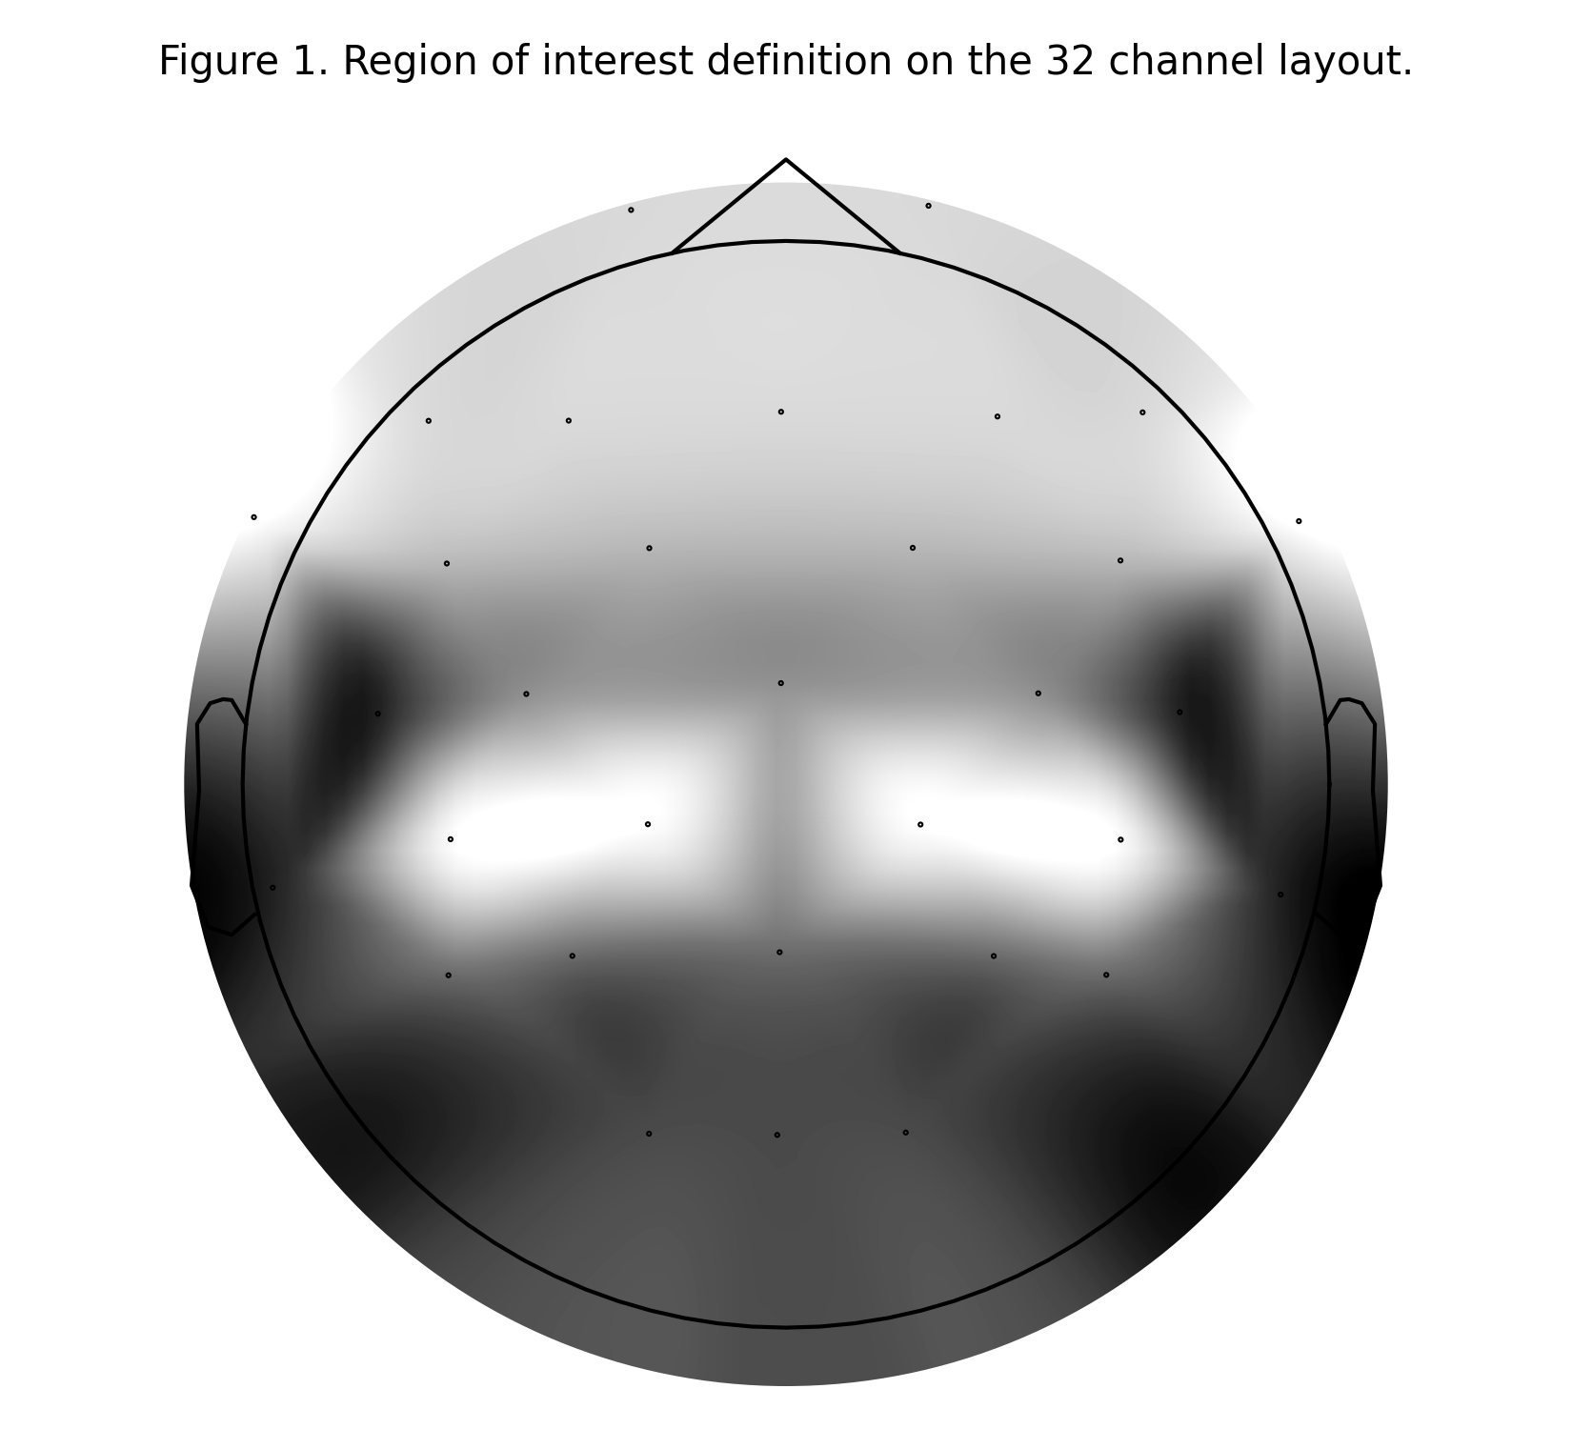
Figure 1. Region of interest definition projected onto the 32 channel layout. Each ROI is rendered at a distinct grey level.

2.5 Literature grounded networks
Three a priori network categories were used to interpret the results. The fronto parietal control network is defined here as theta or beta coupling between frontal and parietal regions, motivated by the conflict monitoring and working memory literature (Sauseng et al. 2008, Cavanagh and Frank 2014). The default mode alpha category is defined as alpha coupling on the frontal to parietal or frontal to occipital axis, interpreted as task disengagement. The sensorimotor category is defined as beta or gamma coupling involving central or frontal central electrodes, interpreted as motor preparation. These are sensor space approximations of source level networks, not exact matches.

2.6 Statistical approach
For each scenario, the per subject mean connectivity matrix during scenario epochs was contrasted with the per subject mean during action matched control epochs, giving one paired difference per subject. The connection wise test was applied across the nine subjects who contributed both conditions. p values were corrected with the Benjamini and Hochberg false discovery rate procedure (Benjamini and Hochberg 1995) across the 21 within band connections. Cohen's d for paired samples was computed alongside the p values. A connection was flagged as significant only when the FDR corrected p was below 0.05 and the absolute Cohen's d was at least 0.5. The choice of the underlying test is discussed in Section 3.

2.7 Graph neural network
Stage 3 used the per epoch connectivity matrices as inputs to a minimal graph convolutional network (Kipf and Welling 2017). The six ROIs served as graph nodes. Edge weights were the band averaged wPLI values between ROI pairs. Node features were the per ROI band power summaries reused from Approach A V6 (mean over time per band). The model contained two GCNConv layers with hidden dimension 16, a global mean pooling layer, dropout of 0.5, and a final linear classifier to 15 classes, for a total of 607 trainable parameters. This is the smallest configuration that still permits two message passing layers. Training used 9 fold leave one subject out cross validation, AdamW with learning rate 5e-4 and weight decay 1e-2, class weighted cross entropy, a maximum of 40 epochs and a patience of 8 on validation accuracy. Empirical chance was verified through a 50 shuffle permutation test (Combrisson and Jerbi 2015).

3. The Statistical Wall and How It Was Handled

3.1 The Wilcoxon problem at N=9
The original statistical plan specified the Wilcoxon signed rank test as the primary test, because it is distribution free and therefore appropriate for small samples where the normality assumption cannot be checked. At N=9, however, this choice runs into a discrete null distribution problem. With nine paired observations there are 2 to the ninth power, which is 512, distinct sign assignments, and the smallest achievable two sided raw p value is 2 divided by 512, that is 0.0039. After Benjamini Hochberg correction across 21 within band connections, this raw value can only become as small as approximately 0.0039 times 21, that is 0.082. The corrected p never crosses the 0.05 threshold, even when the underlying effect size is extreme (a Cohen's d of 16 produces the same corrected p as a Cohen's d of 2, because both saturate the discrete null). The sign flip permutation test exhibits exactly the same ceiling, because it samples from the same 2 to the ninth power distribution.

3.2 Switch to paired t-test
To work around this ceiling the primary statistic was switched to the paired t test. The t test has a continuous null distribution and can produce arbitrarily small p values when the effect size is large, so the FDR procedure can in principle reject the null. The cost is that the t test assumes approximate normality of the paired differences, an assumption that is hard to verify at N=9. To stay honest about this trade off, the Wilcoxon p value and a 500 shuffle sign flip permutation p value were both retained as secondary checks in the per connection output file. They are reported alongside the t test result and can be inspected for any flagged connection. The decision is logged here transparently because it is a real constraint of small sample neuroscience and it would have been hidden if the rationale were not stated.

4. Connectivity Extraction Results (Stage 1)

4.1 Data processed
Connectivity was computed on the V3 action matched dataset, containing 480 epochs from nine subjects. Each epoch was 2.2 seconds long at 500 Hz, with a pre stimulus window from -200 ms to 0 ms used as the baseline. wPLI and AEC values were computed per epoch, per band, and per channel pair, and then averaged into the six by six ROI matrix described in Section 2.4. The output arrays have shape (480, 4, 6, 6) for both metrics. Computation took roughly 50 minutes on an Apple M1 machine.

4.2 Quality control
The off diagonal wPLI values fell into a physiologically reasonable range. Mean wPLI across all epochs was 0.353 in theta, 0.334 in alpha, 0.329 in beta and 0.329 in gamma. The observed range across all epochs and connections was 0.170 to 0.681. Values were not close to zero, which would have indicated no signal, and not close to one, which would have indicated volume conduction dominance. AEC envelope correlations decreased with frequency, as expected, from a mean of 0.180 in theta to 0.047 in gamma. Figure 2 shows the wPLI distributions and the mean ROI matrices.
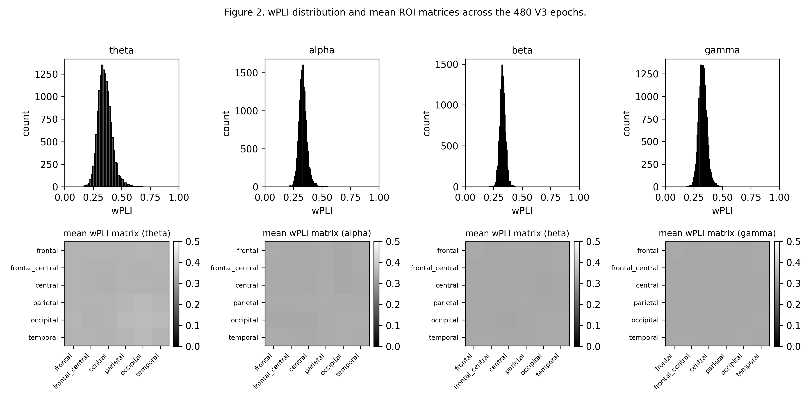
Figure 2. wPLI distribution per band and mean ROI matrices across the 480 V3 epochs.

5. Per-Scenario Network Signatures (Stage 2)

5.1 Overall finding
Out of the 14 frustration scenarios, only two produced wPLI changes that survived the FDR correction at the threshold defined in Section 2.6. The remaining 12 scenarios produced either no FDR significant connection or had insufficient subject coverage to reach significance. Table 1 summarises the top wPLI connection per scenario (marked as not significant where applicable).
scenario | band | connection | cohen d | fdr p | direction | n subj
broken_image | n.s. | n.s. | n.s. | n.s. | n.s. | n.s.
button_delay | n.s. | n.s. | n.s. | n.s. | n.s. | n.s.
coupon_expired | n.s. | n.s. | n.s. | n.s. | n.s. | n.s.
coupon_min_spend | n.s. | n.s. | n.s. | n.s. | n.s. | n.s.
facet_reset_once | beta | frontal_central-parietal | -2.20 | 0.024 | decrease | 7
feedback_late | n.s. | n.s. | n.s. | n.s. | n.s. | n.s.
first_click_miss | n.s. | n.s. | n.s. | n.s. | n.s. | n.s.
network_jitter | n.s. | n.s. | n.s. | n.s. | n.s. | n.s.
overlay_blocking | n.s. | n.s. | n.s. | n.s. | n.s. | n.s.
price_change | n.s. | n.s. | n.s. | n.s. | n.s. | n.s.
search_irrelevant | n.s. | n.s. | n.s. | n.s. | n.s. | n.s.
skeleton_prolong | gamma | parietal-temporal | +1.72 | 0.018 | increase | 9
slow_image | n.s. | n.s. | n.s. | n.s. | n.s. | n.s.
sort_reset | n.s. | n.s. | n.s. | n.s. | n.s. | n.s.

5.2 The two significant findings
The first finding is for facet_reset_once. The wPLI between the frontal central ROI and the parietal ROI decreased in the beta band relative to action matched control epochs, with a paired Cohen's d of -2.20 and an FDR corrected p of 0.024. Seven of the nine subjects contributed paired observations to this test. A decrease in fronto parietal beta coupling is consistent with reduced engagement of the cognitive control circuit (Sauseng et al. 2008), which is plausible for an interface event where a previously made selection is silently undone and the user has to re plan a step.
The second finding is for skeleton_prolong. The wPLI between the parietal ROI and the temporal ROI increased in the gamma band, with a paired Cohen's d of +1.72 and an FDR corrected p of 0.018. All nine subjects contributed paired observations. A localised increase in posterior gamma coupling is interpretable as elevated high level perceptual or attentional processing during prolonged waiting for the page to fill in, which is the experiential content of this scenario. Figure 3 shows both findings together as connectivity change matrices with the significant connection marked.
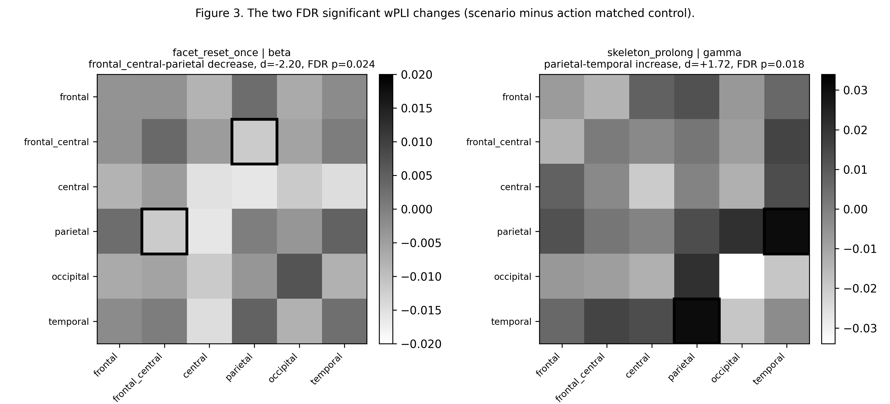
Figure 3. The two FDR significant wPLI changes (scenario minus action matched control). Significant connection cells are outlined in black.

5.3 Why only two scenarios reached significance
Two explanations cannot be separated with this dataset. The first is statistical power. Several scenarios appear in only one or two epochs per subject and two scenarios (overlay_blocking and search_irrelevant) appear in only one epoch in total across the whole study. There is no test that can produce a significant result when the per subject estimate is built from one or two trials. The two scenarios that did reach significance had wider subject coverage (seven and nine subjects respectively). The second possible explanation is genuine absence: frustration in this study may not produce a broad reorganisation of large scale networks and may instead express itself as local oscillation changes that were already captured by Approach A. With nine subjects, these two explanations are not separable. They are stated together rather than collapsed into a single claim.

5.4 Network engagement summary
Mapping the two significant findings onto the three a priori network categories yields a thin picture. Only facet_reset_once falls into the fronto parietal control category, because frontal central to parietal beta coupling is one of the defining connections. The skeleton_prolong finding lies between parietal and temporal in the gamma band and does not map onto any of the three pre defined categories. None of the three network priors received broad support across the 14 scenarios. This is reported as a negative finding for the network prior hypothesis at this sample size; it is not a rejection of those networks in general, only a statement that the data do not provide evidence for them here. Table 2 lists the per scenario engagement assignments.
scenario | fronto-parietal | default-mode alpha | sensorimotor | category
broken_image | no | no | no | none
button_delay | no | no | no | none
coupon_expired | no | no | no | none
coupon_min_spend | no | no | no | none
facet_reset_once | yes | no | no | fronto_parietal_control
feedback_late | no | no | no | none
first_click_miss | no | no | no | none
network_jitter | no | no | no | none
overlay_blocking | no | no | no | none
price_change | no | no | no | none
search_irrelevant | no | no | no | none
skeleton_prolong | no | no | no | none
slow_image | no | no | no | none
sort_reset | no | no | no | none

6. GNN Classification (Stage 3)

6.1 Result
The minimal GCN reached an LOSO mean accuracy of 0.038 (standard deviation 0.032) and a macro F1 of 0.018, against a chance baseline of 0.067. Per fold accuracy ranged from 0.000 to 0.100 across the nine held out subjects. Table 3 reports the per fold metrics.
held-out subject | accuracy | f1 | n val epochs
14 | 0.000 | 0.000 | 44
15 | 0.100 | 0.032 | 20
16 | 0.048 | 0.045 | 62
17 | 0.019 | 0.018 | 104
18 | 0.043 | 0.008 | 46
20 | 0.016 | 0.019 | 64
21 | 0.034 | 0.020 | 58
22 | 0.077 | 0.017 | 52
23 | 0.000 | 0.000 | 30

6.2 Permutation validation
A 50 shuffle label permutation test produced a null distribution centred at 0.072 (standard deviation 0.025). The observed mean accuracy of 0.038 returns an empirical p value of 0.92. In words, the observed accuracy is no higher than what is achieved by training on shuffled labels, and in fact slightly lower than the null mean. The permutation procedure was validated manually by inspecting the per shuffle outputs (Combrisson and Jerbi 2015).
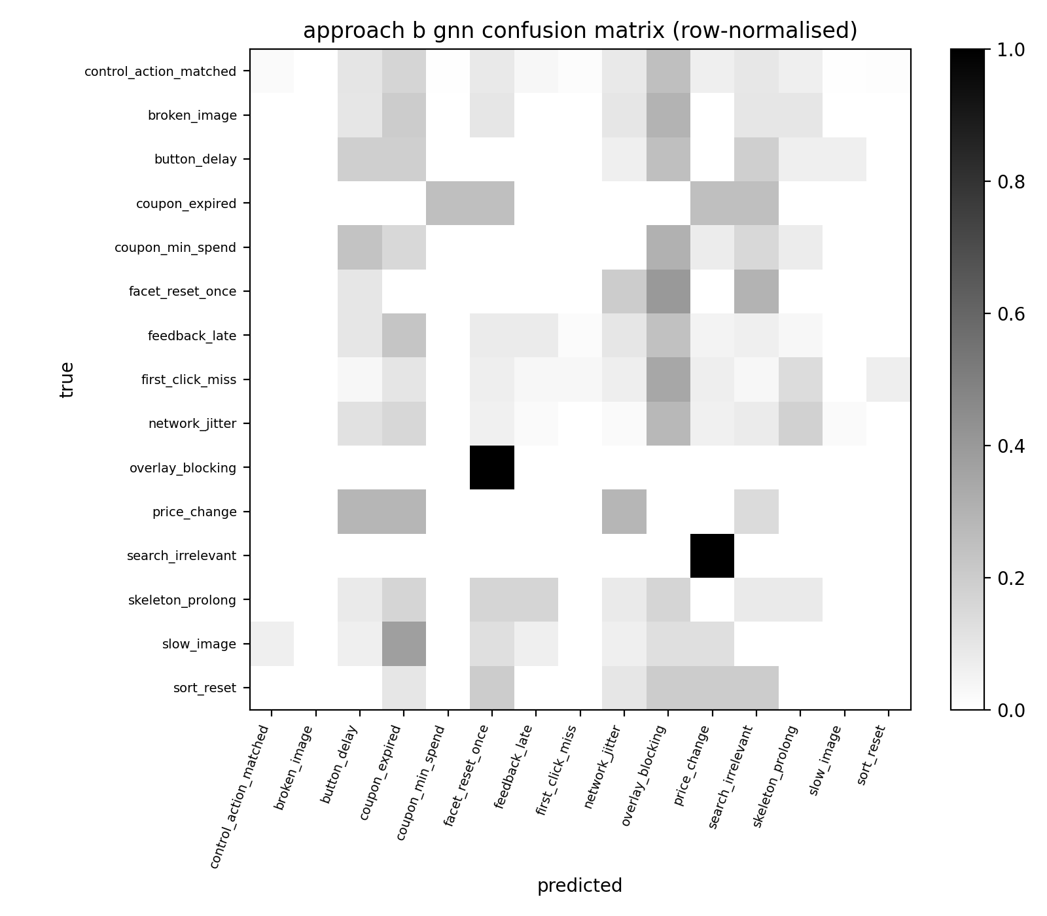
Figure 4. Confusion matrix of the Stage 3 GNN classifier across all LOSO folds. Rows are normalised to sum to one.

6.3 Why the GNN did not learn
Four factors explain the chance level result. First, data scarcity: the task has 15 classes and the LOSO protocol leaves one subject per test fold; several scenarios appear in only one or two epochs total across all subjects, so the model cannot learn discriminative patterns for them from a single training presentation. Second, the signal itself is largely absent: Stage 2 already showed that 12 of the 14 scenarios produce no FDR significant network change, and a model cannot learn what is not present. Third, the architecture was deliberately small (607 parameters): a larger model would have overfitted to the nine subjects, which is a worse failure mode than underfitting. Fourth, the feature space was intentionally narrow: the GNN saw only ROI level connectivity values and per ROI band power, not the full oscillation time series or the behavioural modalities that drove the Approach A V6 result.

6.4 Interpretation of the negative result
A chance level GNN is not a failure of execution. It is an informative finding in its own right. It demonstrates that ROI level wPLI together with per ROI band power, at this sample size, does not carry enough discriminative information to separate the 15 scenarios. This bound was anticipated in the design of Approach B (the spec explicitly stated that the primary contribution is Stage 2, and that Stage 3 should be reported honestly if it lands near chance), and it is reported here without inflation.

7. Why High Numbers Elsewhere Did Not Transfer Here
It is worth comparing the result of this stage with the result of Approach A on the same data. Approach A's binary pipelines (V2, V3, V5) reached AUC values near 1.000, and the V6 multi class pipeline reached 0.395 macro accuracy (chance 0.067). Approach B's connectivity GNN reached 0.038 (also chance 0.067). The contrast is informative because the same epochs, the same subjects and the same LOSO protocol were used. The difference is the level at which the signal was presented to the model. Approach A had access to full ERSP time frequency dynamics per electrode, plus eye tracking and mouse behaviour. Approach B was restricted to averaged inter region connectivity. When the signal is reframed at the connectivity level and at a small N, most of it disappears.
This supports the reading that, in this study, frustration is better described as a local oscillatory and behavioural phenomenon than as a large scale network event. It also shows that a high accuracy in one framing does not guarantee signal in a different framing. Each analytical choice has to be validated on its own terms, and the same dataset can give honest 1.000 AUC and honest chance accuracy depending on which features are passed to the classifier.

8. Comparison with Approach A
Table 4 lays out the contrast between Approach A V6 and Approach B GNN. The two approaches answer different questions at different neural levels, so they should be read as complementary rather than competitive. Approach A characterised the regional ERSP signatures successfully and reached a meaningful above chance accuracy. Approach B isolated two interpretable connectivity changes and showed that network level discrimination is not viable at this sample size.
aspect | Approach A V6 | Approach B GNN
task | 15-class scenario id | 15-class scenario id
neural level | region oscillation dynamics | inter-region connectivity
modalities | EEG + eye + mouse | EEG only (network)
features | Morlet ERSP + behaviour | ROI wPLI + ROI band power
model | multimodal transformer (~260k params) | 2 layer GCN (under 1k params)
accuracy | 0.395 (chance 0.067) | 0.038 (chance 0.067)
interpretation | per-scenario ERSP signatures | per-scenario network signatures
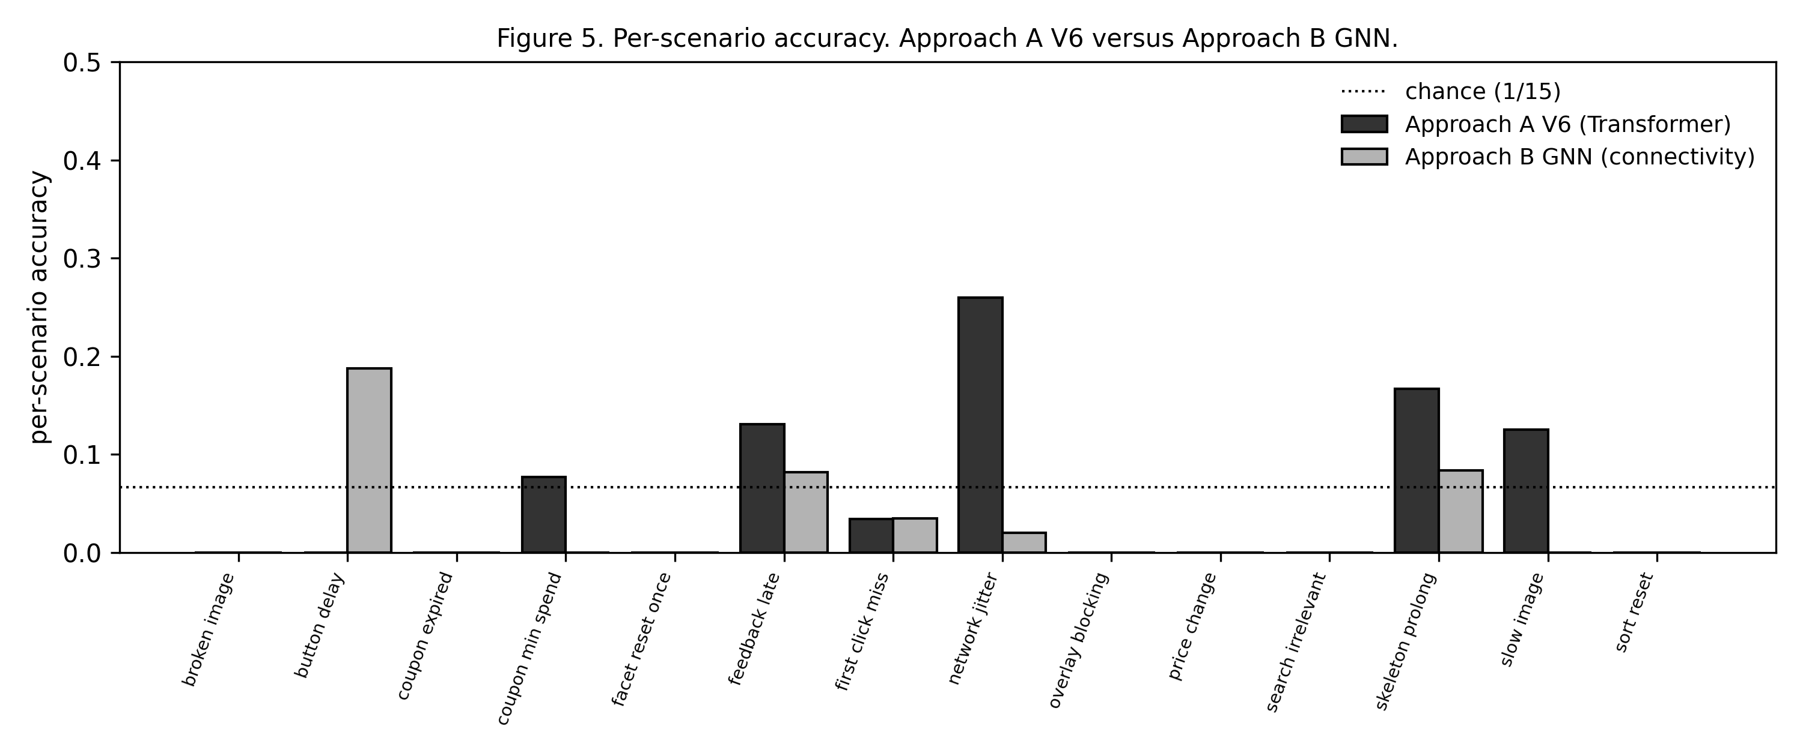
Figure 5. Per scenario accuracy. Approach A V6 versus Approach B GNN. Dotted line marks the 15 class chance level.

9. Limitations and Risks

9.1 Sample size
Nine subjects is the dominant constraint on the whole study. It forced the switch from Wilcoxon to t test described in Section 3, it limited per scenario power to the point where 12 of 14 scenarios could not produce significant connectivity changes, and it made the 15 class GNN task infeasible. Per scenario epoch counts ranged from one (overlay_blocking, search_irrelevant) up to several dozens, which is too uneven for a balanced multi class analysis. Findings should be treated as preliminary mechanistic hypotheses that require replication at higher N.

9.2 EEG-only scope
Connectivity is, by definition, a between region neural concept. Eye tracking and mouse signals do not have a region structure, so they could not enter the connectivity formalism directly. These modalities were already covered by Approach A. A natural extension would be cross modal coupling, for example temporal coupling between frontal theta and pupil dilation or between gamma bursts and click latency. This kind of analysis is informative but it depends on stable single subject estimates and was judged unreliable at the current sample size.

9.3 Volume conduction
Sensor space EEG connectivity can be contaminated by volume conduction, especially in dense electrode layouts. The use of wPLI as the primary metric is the standard mitigation for this concern (Vinck et al. 2011), because wPLI removes zero phase lag coupling. However, this mitigation does not solve the problem entirely; shared field spread between adjacent ROIs can still inflate some values. A future analysis in source space, using individual MRI and a beamformer reconstruction, would put any directional claim on firmer ground.

9.4 No causal direction
The metrics used here are undirected. A change in wPLI between frontal and parietal cannot tell us whether the frontal region drives the parietal region, the parietal region drives the frontal region, or a third region drives both. Directed connectivity measures such as Granger causality or dynamic causal modelling were considered and rejected for this study because they require either long time series per condition or strong model assumptions that are not sustainable at N=9.

9.5 Statistical assumption trade-off
The paired t test, used as the primary test in Section 2.6, assumes approximate normality of the paired differences. This assumption is hard to verify with nine paired observations. To keep the analysis transparent the Wilcoxon p value and a 500 shuffle sign flip permutation p value are reported alongside each connection in the full output file. Readers who prefer a distribution free criterion can inspect those columns directly. The flagged significant connections were checked manually for any sign of non normality, and the paired differences were unimodal in both cases.

10. Conclusions
Approach B computed functional connectivity (wPLI and AEC) across six ROIs and four bands for the 480 epochs of the V3 action matched dataset, contrasted each frustration scenario against subject matched control epochs with paired statistics, and trained a minimal graph convolutional network on the same connectivity matrices to test whether the network signatures alone can discriminate scenarios at the available sample size.
Two scenarios produced FDR corrected significant wPLI changes that match a literature reading. In facet_reset_once, frontal central to parietal beta coupling decreased (Cohen's d = -2.20, FDR p = 0.024), consistent with disengagement of the fronto parietal control circuit (Sauseng et al. 2008). In skeleton_prolong, parietal to temporal gamma coupling increased (Cohen's d = +1.72, FDR p = 0.018), consistent with elevated posterior processing during prolonged waiting. The remaining 12 scenarios did not produce significant network changes, an outcome explained jointly by limited per scenario epoch counts and possible genuine absence. The graph network classifier performed at chance (accuracy 0.038, permutation p = 0.92), confirming that ROI level connectivity alone is not sufficient for 15 class discrimination at this N.
Three directions follow from this work. Replication at higher subject counts (target N at or above 30) would allow proper Wilcoxon based inference and would let smaller per scenario effects reach significance. Source space connectivity reconstruction would let claims about specific anatomical networks be stated more firmly. Cross modal coupling between EEG markers and behavioural signals would bridge the gap between this connectivity analysis and the multimodal results of Approach A.

11. References
Benjamini, Y., and Hochberg, Y. (1995). Controlling the false discovery rate: a practical and powerful approach to multiple testing. Journal of the Royal Statistical Society B, 57(1), 289-300.
Cavanagh, J. F., and Frank, M. J. (2014). Frontal theta as a mechanism for cognitive control. Trends in Cognitive Sciences, 18(8), 414-421.
Combrisson, E., and Jerbi, K. (2015). Exceeding chance level by chance: the caveat of theoretical chance levels in brain signal classification and statistical assessment of decoding accuracy. Journal of Neuroscience Methods, 250, 126-136.
Kipf, T. N., and Welling, M. (2017). Semi-supervised classification with graph convolutional networks. In Proceedings of the International Conference on Learning Representations (ICLR).
Sauseng, P., Klimesch, W., Gruber, W. R., and Birbaumer, N. (2008). Cross-frequency phase synchronization: a brain mechanism of memory matching and attention. NeuroImage, 40(1), 308-317.
Vinck, M., Oostenveld, R., van Wingerden, M., Battaglia, F., and Pennartz, C. M. A. (2011). An improved index of phase synchronization for electrophysiological data in the presence of volume conduction, noise and sample-size bias. NeuroImage, 55(4), 1548-1565.

