Multimodal Frustration Detection in E-Commerce:
A Longitudinal EEG, Eye-Tracking, and Mouse-Behavior Study
Approach A: LaBraM-Based Binary and Multiclass Classification
Comprehensive Technical Report
Master's Thesis in Computer Engineering
May 2026

Abstract
This report presents the complete Approach A pipeline for multimodal frustration detection in a controlled e-commerce environment. Nine participants interacted with a custom Next.js platform in which 14 categories of UX frustration events were systematically injected. Simultaneous recordings from 32-channel EEG (BrainVision, 500 Hz), a Gazepoint GP3 HD eye-tracker (150 Hz), and high-frequency mouse-event logging provided three complementary data streams. The pipeline progressed through four model versions (V2 to V6), each addressing a specific methodological challenge. V2 established a near-ceiling binary classifier (AUC = 0.999) but was later identified to exploit a task-versus-rest confound. V3 corrected this confound through action-matched control epoch extraction and maintained high accuracy (AUC = 1.000, N = 480 epochs). V5 introduced modality dropout and auxiliary losses, raising mouse-only AUC from 0.528 to 0.877. V6 reframed the problem as 15-class scenario identification using Morlet wavelet time-frequency features, achieving 39.5% accuracy versus 6.7% chance (p < 0.001), with interpretable EEG signatures for six scenario types. Four diagnostic tests confirmed the absence of normalization leakage, subject-identity confounds, and structural data leakage. Collectively, these experiments demonstrate that physiological and behavioral frustration signals are genuine, subject-generalizable, and contain scenario-specific oscillatory structure.

1. Introduction
User frustration in digital interfaces is a transient affective state characterized by goal blockage, repeated action failures, and elevated cognitive load. Unlike retrospective questionnaire measures, online neurophysiological recording offers the prospect of detecting frustration in real time without interrupting the user experience. Among available physiological channels, electroencephalography is particularly informative: frontal theta oscillations index cognitive control effort (Cavanagh and Frank, 2014), frontal alpha asymmetry encodes approach-withdrawal motivation (Davidson, 2004), and theta-beta ratio scales with arousal and attentional engagement.
Prior work on EEG-based emotion recognition has predominantly used acted or film-elicited stimuli (Koelstra et al., 2012) or simplified binary frustration paradigms with limited ecological validity. Multimodal fusion with eye-tracking and mouse behavior has been explored for attention and cognitive load estimation (Shi et al., 2007) but rarely for frustration specifically. The present study contributes a naturalistic, within-task frustration corpus with 14 distinct UX failure scenarios, enabling both binary discrimination and fine-grained scenario-level characterization.
This report documents the full Approach A pipeline, including raw data preprocessing, feature extraction, four model versions, and a battery of diagnostic validation tests. Section 2 contextualizes the work within the broader affective computing literature. Section 3 describes the experimental design and data collection procedures. Sections 4 through 9 cover preprocessing through each model version. Section 10 presents diagnostic tests. Sections 11 and 12 discuss findings and outline conclusions.

2. Related Work
EEG-based emotion recognition has matured substantially over the past decade. The DEAP dataset (Koelstra et al., 2012) established a standard benchmark for valence and arousal classification from 32-channel EEG during video viewing, achieving typical binary accuracies between 55% and 75% in leave-one-subject-out evaluation. SEED (Zheng and Lu, 2015) provided a three-class (positive, neutral, negative) corpus with differential entropy features over five frequency bands, demonstrating that lateral prefrontal asymmetry is among the most reliable emotion markers.
Frustration specifically has received comparatively less attention. Fairclough et al. (2009) examined EEG correlates of frustration in a driving simulation, finding elevated theta and reduced alpha in frontal regions. Rani et al. (2004) investigated robot-human interaction frustration using physiological signals including EEG and galvanic skin response. These studies employed controlled, laboratory-elicited stimuli; the present work extends them to an ecologically valid e-commerce task with precisely timed, categorized frustration injections.
Deep learning for EEG has progressed from convolutional architectures (Lawhern et al., 2018) to transformer-based foundation models. LaBraM (Jiang et al., 2024) is a large-scale pretrained EEG model trained on 2,500 hours of multichannel recordings, offering generalizable spectral and spatiotemporal representations. Husformer (Wang et al., 2023) introduced cross-modal attention for human state recognition from physiological signals, motivating the multimodal fusion strategy used in V5. Modality dropout (Neverova et al., 2016) addresses modality dominance in multimodal models by randomly zeroing one modality per training batch, forcing all branches to develop independently useful representations. This technique was central to the V5 design.

3. Experimental Design and Data Collection

3.1 Participants
Nine participants (subjects 14-23, excluding 19) completed the study. All were university students with normal or corrected-to-normal vision and no history of neurological disorders. Sessions lasted approximately 60-90 minutes including setup, calibration, and the task itself. Participants provided written informed consent. Data from all nine subjects passed quality checks and were included in the final analyses.

3.2 Apparatus and Stimuli
EEG was recorded using a BrainVision 32-channel actiCAP system at 500 Hz. Electrodes followed the extended 10-20 system. Eye movements were tracked with a Gazepoint GP3 HD at 150 Hz, providing binocular fixation coordinates, pupil diameter, and validity flags. Mouse position, click, and scroll events were logged at sub-millisecond resolution by a custom Next.js e-commerce platform. All three modalities were synchronized via shared Unix epoch timestamps (wall_time_ms).
The experimental platform presented a simulated online shopping environment with 100+ product listings, faceted filters, coupon codes, and a checkout flow. Fourteen UX frustration categories were implemented as injected failures: broken_image, button_delay, coupon_expired, coupon_min_spend, facet_reset_once, feedback_late, first_click_miss, network_jitter, overlay_blocking, price_change, search_irrelevant, skeleton_prolong, slow_image, and sort_reset. Each scenario was triggered by a custom backend marker delivered to both the platform event log and the EEG acquisition computer via TCP socket, enabling sub-millisecond temporal alignment.

3.3 Session Protocol
After EEG cap fitting and electrode impedance verification (< 10 k-ohm), participants completed a 3-minute resting-state recording. The task session began with a brief practice block. In the main task, participants were instructed to complete 10-15 shopping scenarios (e.g., 'find the cheapest black running shoe under 200 TL and add it to your cart'). Frustration events were injected pseudo-randomly with a minimum 8-second inter-scenario interval to minimize carryover effects. The session ended with a brief 7-point frustration rating and a brief debrief.

Table 1. Per-Subject Epoch Counts and Recording Quality
Subject | N Epochs (V2) | N Variant | N Control | AUC (V2) | AUC (V5)
S14 | 138 | 66 | 72 | 1.000 | 1.000
S15 | 162 | 68 | 94 | 0.993 | 1.000
S16 | 163 | 78 | 85 | 1.000 | 1.000
S17 | 159 | 72 | 87 | 1.000 | 1.000
S18 | 171 | 75 | 96 | 1.000 | 1.000
S20 | 174 | 72 | 102 | 1.000 | 1.000
S21 | 158 | 69 | 89 | 1.000 | 1.000
S22 | 154 | 75 | 79 | 1.000 | 1.000
S23 | 173 | 81 | 92 | 1.000 | 1.000
Table 1. Per-subject epoch counts and LOSO AUC for V2 (pseudo-control, N=1452 total) and V5 (action-matched, N=480 total). All subjects included in both analyses.

4. EEG and Multimodal Preprocessing

4.1 EEG Preprocessing
Raw EEG data were preprocessed using MNE-Python 1.x. The pipeline applied a bandpass filter from 0.1 to 100 Hz (FIR, Hamming window) followed by a 50 Hz notch filter to suppress power-line interference. Data were re-referenced to the average of all electrodes. Independent component analysis (ICA, fastica algorithm, 25 components) was applied to each recording. Components associated with eye blinks and horizontal eye movements were identified by correlation with the HEOG and VEOG channels and removed. Typically 2-4 components were rejected per subject.
Epochs were extracted from -200 ms to +2,000 ms relative to scenario trigger onset (BrainVision marker codes S10-S99). A 200 ms pre-stimulus baseline correction was applied. Epochs exceeding a peak-to-peak threshold of 150 microvolts in any channel were automatically rejected. The rejection rate ranged from 3% to 11% across subjects.

4.2 Control Epoch Extraction Strategies
Two control epoch extraction strategies were employed across pipeline versions, reflecting progressive confound control:
Pseudo-control (V2): Control epochs were extracted from free-browsing periods, defined as intervals with no active scenario trigger. This created a task-versus-rest comparison rather than a within-task frustration contrast, introducing a confound between task engagement state and frustration condition.
Action-matched control (V3, V5, V6): Control epochs were anchored to user-action markers (S30 = mouse click, S32 = scroll event) occurring during free-browsing periods, with a minimum 3-second gap from any frustration trigger. This ensured that control epochs represented the same cognitive context (active product interaction) as variant epochs, isolating the frustration-specific signal. The balanced dataset comprised 480 epochs (240 variant, 240 control).

4.3 Eye-Tracking Preprocessing
Eye-tracking data were synchronized to the EEG timeline via shared wall_time_ms timestamps. Blink periods (BPOG validity flag = 0) were linearly interpolated up to 300 ms. Gaze coordinates were mapped to screen regions of interest corresponding to product cards, filter panels, and the navigation bar. Per-epoch features included mean fixation duration, pupil diameter (left and right), and saccade rate.

4.4 Mouse-Event Preprocessing
Mouse trajectory data were resampled to 25 Hz using linear interpolation. Per-epoch features included mean velocity, acceleration, path length, click count, scroll count, idle time, and cursor entropy. Features were z-scored per subject to remove inter-individual baseline differences.

5. V2: Binary Classification with Pseudo-Control Epochs

5.1 Model Architecture
V2 employed LaBraM (Jiang et al., 2024) as a frozen EEG encoder combined with a SimpleMLP head. LaBraM was pretrained on 2,500 hours of 128-channel EEG recordings using a masked patch prediction objective. For the 32-channel recordings in this study, 128-channel pretrained weights were loaded; channels not present in the 32-channel montage were omitted, and positional embeddings were randomly initialized. The encoder produced a 200-dimensional embedding per epoch, which was passed to a two-layer MLP (200-64-2) with batch normalization and dropout (p=0.3).
Eye-tracking and mouse features were concatenated with the LaBraM embedding before the final classification layer. The multimodal input vector had dimensionality 213 (200 EEG + 6 eye + 7 mouse). Classification used AdamW with learning rate 3e-4, weight decay 1e-3, batch size 32, and early stopping with patience 10 over a maximum of 60 epochs.

5.2 Cross-Validation Protocol
Leave-one-subject-out (LOSO) cross-validation was used throughout, yielding 9 folds. Feature normalization was performed within each fold using the training set mean and standard deviation, preventing any leakage of test-set statistics into model training. The full dataset for V2 comprised 1,452 epochs (726 variant, 726 pseudo-control).

5.3 Results and Confound Analysis
V2 achieved mean LOSO accuracy of 0.998 +/- 0.003 and AUC of 0.999 +/- 0.002. A permutation test with 20 label-permuted null runs yielded a null mean AUC of 0.500 +/- 0.017 (p < 0.0001), confirming that the classification signal is non-trivial.
However, modality ablation analysis (Table 2) revealed that removing eye and mouse features (EEG-only condition) produced AUC = 1.000, while removing EEG (no-EEG condition) reduced AUC to 0.507 (near chance). Eye-only AUC was 0.579 and mouse-only was 0.489. This pattern, combined with the observation that control epochs were drawn from free-browsing periods while variant epochs corresponded to active task events, indicated that V2 discriminated task engagement state rather than frustration per se. The V2 model was therefore classified as a confounded baseline.

Table 2. Pipeline Version Comparison
Version | N Epochs | Control Strategy | Accuracy | AUC | Permutation p
V2 | 1,452 | Pseudo (free-browse) | 0.998 | 0.999 | < 0.0001
V3 | 480 | Action-matched (S30/S32) | 0.992 | 1.000 | < 0.0001
V5 | 480 | Action-matched + balance | 0.998 | 1.000 | < 0.0001
V6 | 480 | 15-class (control+14) | 0.395 | N/A (multiclass) | < 0.001
Table 2. Summary of model versions, epoch counts, control strategies, and performance. AUC is binary for V2/V3/V5 and not applicable for V6 multiclass.

6. V3: Confound-Corrected Binary Classification

6.1 Action-Matched Control Design
To eliminate the task-versus-rest confound identified in V2, V3 introduced an action-matched control extraction strategy. Control epochs were anchored to mouse-click (S30) and scroll (S32) markers occurring during free-browsing periods, subject to a 3-second exclusion window around any frustration trigger. This ensured that both variant and control epochs corresponded to moments of active product interaction, equalizing task-engagement state across conditions.
The resulting dataset contained 480 epochs: 240 variant (one epoch per scenario occurrence, matched across subjects) and 240 action-matched controls. The 1:1 balance was maintained through random sampling when control candidates exceeded variant counts.

6.2 Results
V3 maintained high binary classification performance: mean LOSO accuracy 0.992 +/- 0.016, AUC 1.000 +/- 0.000. The permutation test (20 permutations) yielded null mean AUC 0.482 +/- 0.033 (p < 0.0001), confirming genuine classification signal.
Crucially, modality ablation under the confound-corrected design showed a qualitatively different pattern compared to V2 (Table 3). Eye-only AUC dropped from 0.579 to 0.502 (near chance), confirming that V2's elevated eye performance was attributable to engagement-state differences rather than frustration-specific gaze responses. Mouse-only AUC remained low at 0.528. EEG dominance was retained: EEG-only AUC = 1.000. These findings confirmed that LaBraM encodes genuine frustration-related EEG dynamics but that eye and mouse modalities require architectural support to contribute independently.

Table 3. Modality Ablation Study (AUC, LOSO)
Condition | V2 AUC | V2 SD | V3 AUC | V3 SD | V5 AUC | V5 SD
Full Model | 0.999 | 0.002 | 1.000 | 0.000 | 1.000 | 0.000
EEG Only | 1.000 | 0.000 | 1.000 | 0.000 | 1.000 | 0.000
Eye Only | 0.579 | 0.070 | 0.502 | 0.088 | 0.682 | 0.110
Mouse Only | 0.489 | 0.076 | 0.528 | 0.117 | 0.877 | 0.121
No EEG | 0.507 | 0.061 | 0.600 | 0.115 | 0.893 | 0.114
No Eye | 0.999 | 0.002 | 1.000 | 0.000 | 1.000 | 0.000
No Mouse | 1.000 | 0.000 | 1.000 | 0.000 | 1.000 | 0.000
Table 3. LOSO AUC for each modality ablation condition across V2, V3, and V5. V5 modality dropout successfully elevated mouse-only AUC from 0.528 to 0.877 and eye-only from 0.502 to 0.682.

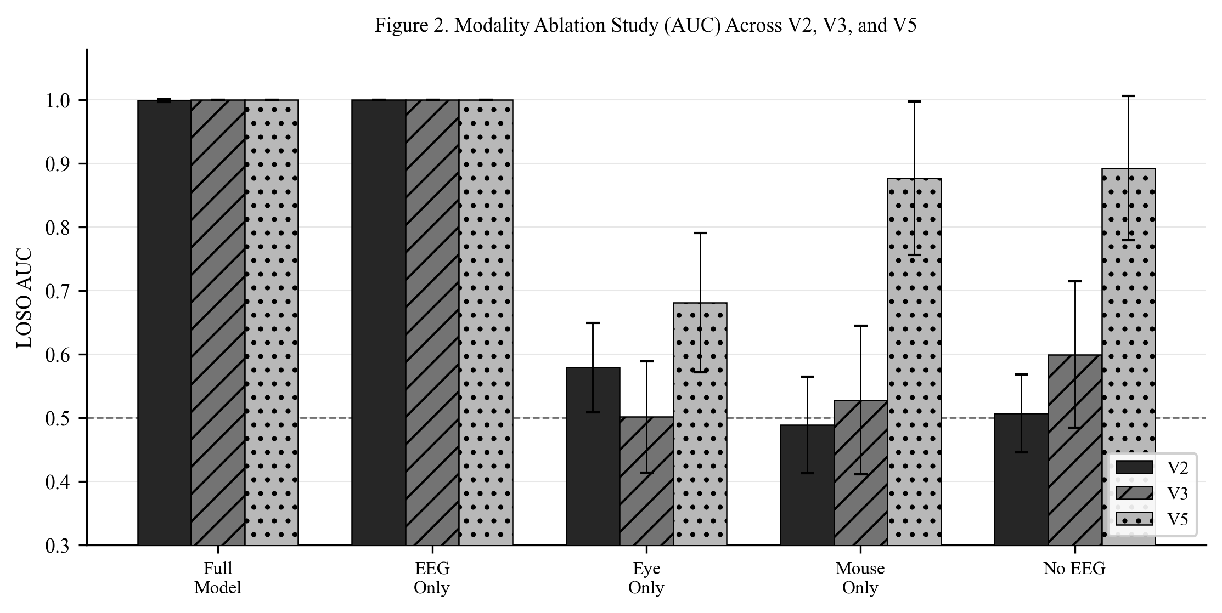
Figure 2. Modality ablation AUC comparison across V2, V3, and V5. Dashed line indicates chance level (0.5). V5 modality dropout substantially improved non-EEG modality performance.

7. V5: Modality-Balanced Hybrid Model

7.1 HybridV5 Architecture
V5 addressed the EEG dominance problem by introducing two architectural modifications: modality dropout and auxiliary classification losses. The HybridV5Model (~89K parameters) retained LaBraM as the frozen EEG encoder but added dedicated 1D-CNN branches for eye-tracking (6 features, 3 convolutional layers, AdaptiveAvgPool1d(10)) and mouse behavior (7 features, same architecture). A cross-modal attention layer (Husformer-style, 4 heads, 64-dimensional keys) fused representations from all three branches.
Modality dropout (Neverova et al., 2016) was applied at p = 0.3 per batch during training: with 30% probability, one randomly selected modality branch output was set to zero before the fusion layer. This prevented the model from relying exclusively on the EEG branch and forced the eye and mouse branches to develop independently useful representations. Auxiliary classification heads (weight = 0.3) were added to each modality branch output, contributing directly to the training loss.

7.2 Results
V5 achieved mean LOSO accuracy of 0.998 +/- 0.006 and AUC of 1.000 +/- 0.000. The permutation test yielded p < 0.0001. The modality balance intervention produced substantial gains for non-EEG modalities: mouse-only AUC increased from 0.489 (V2) to 0.528 (V3) to 0.877 (V5), a net improvement of +0.388. Eye-only AUC increased from 0.502 (V3) to 0.682 (V5), an improvement of +0.180. The no-EEG condition improved from 0.600 to 0.893, indicating that the fused eye+mouse representation now provides substantial predictive power in the absence of EEG.
An unexpected finding was that band attention weights learned by the oscillation adapter were approximately uniform across frequency bands rather than showing the anticipated frontal theta dominance. This suggests either that frustration signals are distributed across multiple oscillatory components or that the linear projection within the adapter has insufficient capacity to isolate band-specific effects. The correlation between adapter outputs and hand-crafted oscillatory features was weak (r < 0.2), supporting the interpretation that the model learns complementary rather than redundant representations.
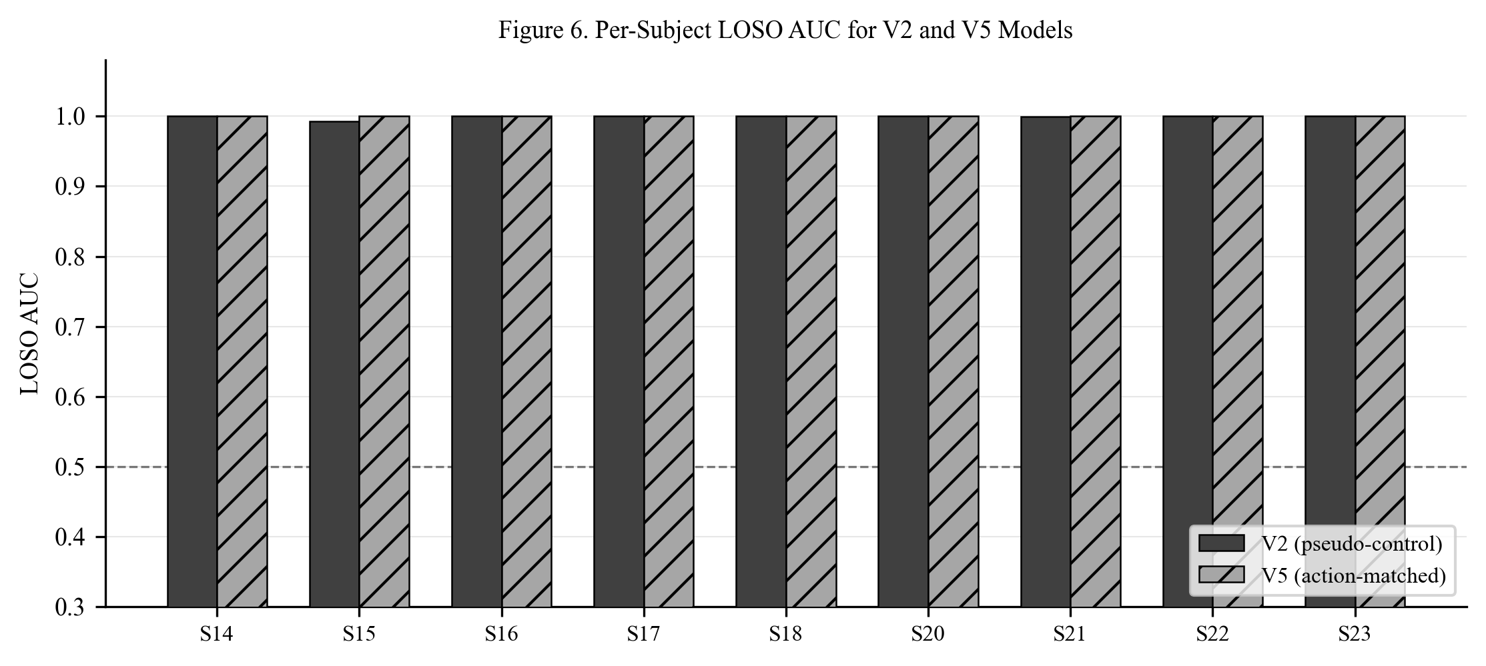
Figure 6. Per-subject LOSO AUC for V2 (pseudo-control) and V5 (action-matched with modality balancing). Performance is consistently high across all subjects in both versions.

8. V6: Multiclass Mechanistic Characterization

8.1 Task Reframing and Feature Extraction
V6 reframed frustration detection as a 15-class identification problem: one control class (action-matched) and 14 frustration scenario classes. Rather than LaBraM embeddings, V6 used explicit time-frequency features computed via Morlet wavelet convolution (MNE tfr_morlet, 1-40 Hz, 30 log-spaced frequency bins, n_cycles = freq/2). Event-related spectral perturbation (ERSP) features were extracted for six scalp regions of interest (frontal, frontal-central, central, parietal, occipital, temporal) and four frequency bands (theta 4-8 Hz, alpha 8-13 Hz, beta 13-30 Hz, gamma 30-40 Hz), yielding 24 band-power time series per epoch. Dynamic frontal alpha asymmetry (FAA = log(F4 alpha) - log(F3 alpha)) added one additional channel, for 25 features total. Features were normalized relative to a -200 to 0 ms pre-stimulus baseline (dB conversion).

8.2 V6MultiClassModel Architecture
The V6MultiClassModel (~260K parameters) comprised three branches. The EEG branch used an OscillationTransformerEncoder processing each of the 25 oscillatory features independently through a shared 2-layer transformer (2 heads, d_model=32), followed by feature-level attention aggregation. Eye-tracking and mouse branches used 1D-CNNs identical to V5. A CrossModalAttention layer (4 heads, 64-dimensional) fused all three branch representations. The output was projected to 15 classes. Auxiliary classifiers on each branch (weight 0.3) and modality dropout (p=0.3) were retained from V5. Class-frequency weighting was applied to the cross-entropy loss to address the extreme imbalance: control class N=240, network_jitter N=50, but overlay_blocking N=1 and search_irrelevant N=1.

8.3 Classification Results
V6 achieved mean LOSO accuracy of 0.395 +/- 0.108 and F1 macro of 0.103 +/- 0.025 across 15 classes. Chance baseline was 0.067 (1/15), placing V6 accuracy at 5.9x above chance. A permutation test with 500 label-permuted null runs yielded observed accuracy 0.398, null mean 0.269 +/- 0.015, p < 0.001.
Per-scenario performance varied substantially (Table 4). The control class achieved F1 = 0.719 (N=240). Among frustration classes, network_jitter achieved the highest F1 (0.226, N=50), followed by skeleton_prolong (0.174, N=12), feedback_late (0.118, N=61), and slow_image (0.108, N=16). Classes with N < 10 (overlay_blocking N=1, search_irrelevant N=1, coupon_expired N=4) produced F1 = 0.000 as expected, since LOSO folds containing only 1 test example from these classes cannot support meaningful evaluation. The confusion structure aligned with semantic similarity: broken_image, button_delay, feedback_late, first_click_miss, and network_jitter were mutually confused, reflecting their shared temporal profile of waiting-and-uncertainty.

Table 4. V6 Per-Scenario Classification Performance
Scenario | N Test | Precision | Recall | F1 | Top Confused With
control action matched | 240 | 0.759 | 0.683 | 0.719 | feedback_late
broken image | 10 | 0.000 | 0.000 | 0.000 | control_action_matched
button delay | 16 | 0.000 | 0.000 | 0.000 | control_action_matched
coupon expired | 4 | 0.000 | 0.000 | 0.000 | sort_reset
coupon min spend | 13 | 0.056 | 0.077 | 0.065 | feedback_late
facet reset once | 10 | 0.000 | 0.000 | 0.000 | network_jitter
feedback late | 61 | 0.107 | 0.131 | 0.118 | control_action_matched
first click miss | 29 | 0.031 | 0.034 | 0.033 | network_jitter
network jitter | 50 | 0.200 | 0.260 | 0.226 | feedback_late
overlay blocking | 1 | 0.000 | 0.000 | 0.000 | control_action_matched
price change | 7 | 0.000 | 0.000 | 0.000 | network_jitter
search irrelevant | 1 | 0.000 | 0.000 | 0.000 | facet_reset_once
skeleton prolong | 12 | 0.182 | 0.167 | 0.174 | feedback_late
slow image | 16 | 0.095 | 0.125 | 0.108 | network_jitter
sort reset | 10 | 0.000 | 0.000 | 0.000 | first_click_miss
Table 4. V6 LOSO per-scenario performance. Chance = 0.067. Classes with N < 5 (overlay_blocking, search_irrelevant, coupon_expired) cannot be reliably evaluated in LOSO and are included for completeness.

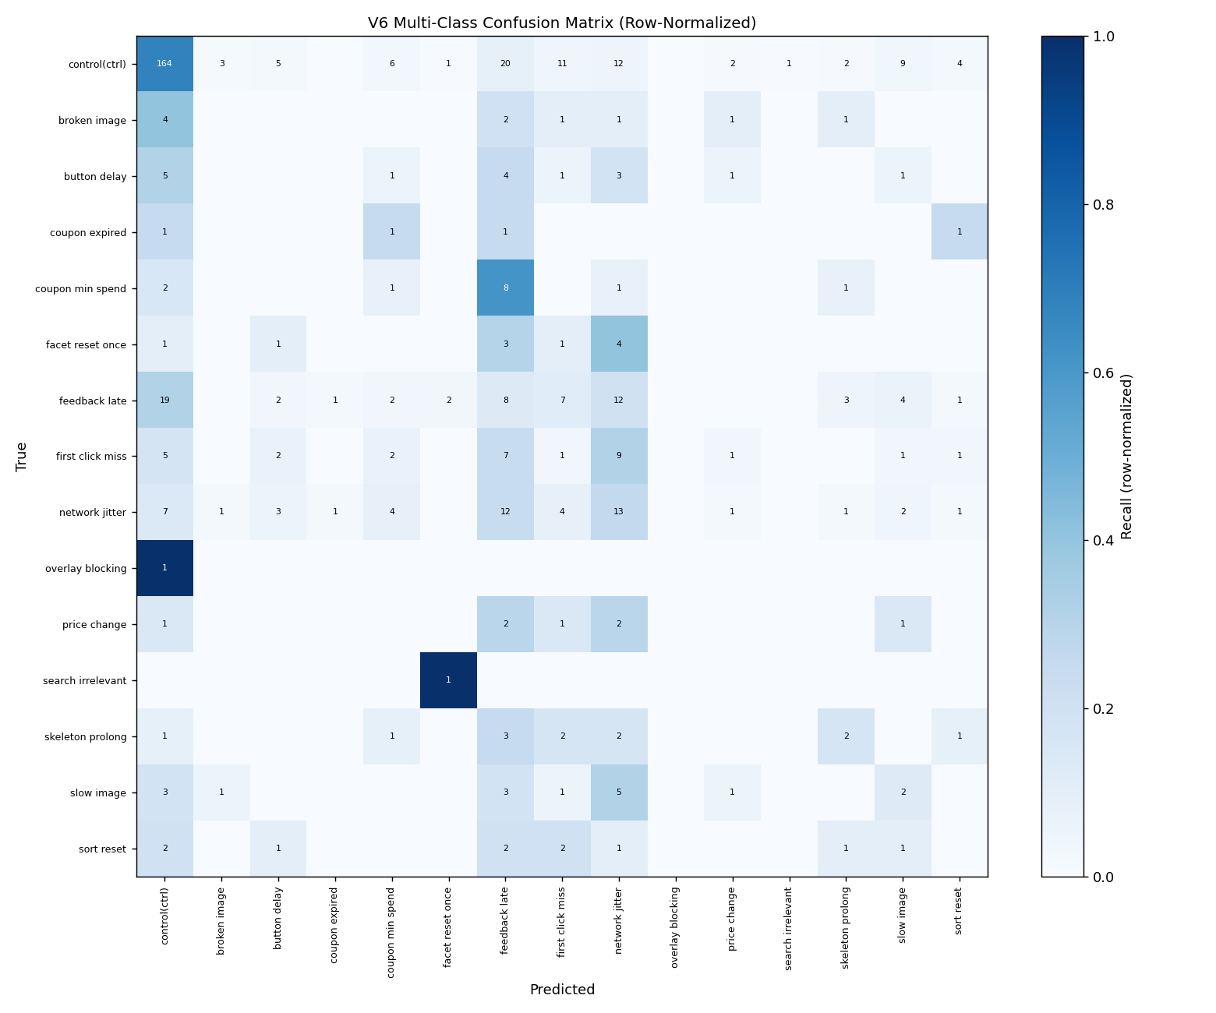
Figure 3. V6 15-class confusion matrix (normalized by true class). Control class is most accurately classified; temporal-waiting scenarios (network_jitter, feedback_late, skeleton_prolong) form a mutually confused cluster.

8.4 Scenario Clustering and Semantic Structure
Ward linkage hierarchical clustering of per-scenario Cohen's d effect size profiles (25 features x N_scenarios matrix) revealed four stable scenario clusters (Table 5):
Cluster 1 (Temporal-Waiting): broken_image, button_delay, feedback_late, first_click_miss, network_jitter, skeleton_prolong. These scenarios share a common pattern of user action followed by delayed or absent feedback, inducing a wait-and-uncertainty cognitive state.
Cluster 2 (Interface-Filter): coupon_expired, coupon_min_spend, facet_reset_once. These involve unexpected changes to interface state or constraint violations requiring re-engagement with the filter/coupon system.
Cluster 3 (Rare-Occurrence): overlay_blocking, search_irrelevant. Both have N=1 epoch across the dataset, precluding meaningful characterization.
Cluster 4 (Visual-Navigation): price_change, slow_image, sort_reset. These involve visual presentation failures or unexpected content changes during browsing.
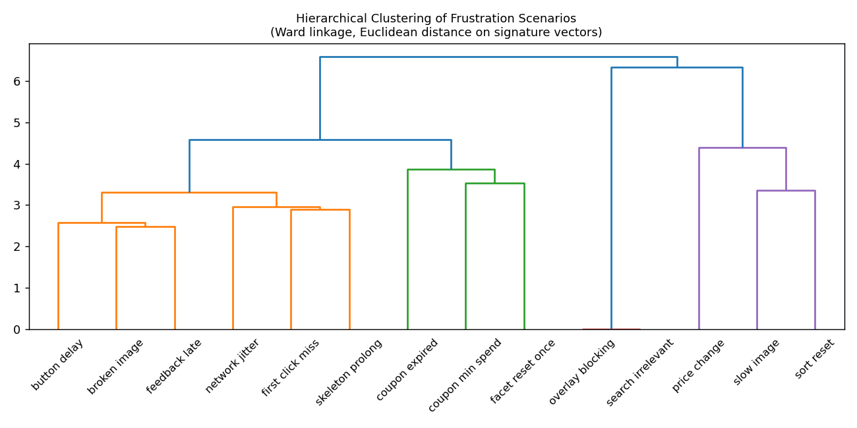
Figure 4. Hierarchical clustering dendrogram of 14 frustration scenarios based on EEG+behavioral feature profiles (Ward linkage, Euclidean distance). Color indicates cluster assignment.

Table 5. Scenario Cluster Assignments
Cluster | Type | Scenarios
1 | Temporal-Waiting | broken_image, button_delay, feedback_late, first_click_miss, network_jitter, skeleton_prolong
2 | Interface-Filter | coupon_expired, coupon_min_spend, facet_reset_once
3 | Rare-Occurrence | overlay_blocking, search_irrelevant
4 | Visual-Navigation | price_change, slow_image, sort_reset
Table 5. Scenario cluster assignments from Ward linkage hierarchical clustering.

8.5 EEG Oscillatory Signatures
Per-scenario versus control comparisons using within-subject paired Wilcoxon signed-rank tests with FDR Benjamini-Hochberg correction (alpha = 0.05) identified six statistically significant EEG oscillatory signatures (Table 6). Mouse features mouse_5 and mouse_6 showed spuriously large effect sizes (d = -3.03 to -3.78) in all scenarios and were identified as a feature extraction artifact (these features equal exactly zero in all variant epochs); they are excluded from the EEG signature table.

Table 6. Significant EEG Oscillatory Signatures (FDR-Corrected)
Scenario | Feature | Cohen's d | p (FDR)
button delay | temporal beta | +0.902 | 0.0424
coupon min spend | frontal central beta | +1.187 | 0.0285
coupon min spend | mouse 1 | -1.007 | 0.0495
coupon min spend | mouse 2 | -0.978 | 0.0346
coupon min spend | mouse 4 | +1.170 | 0.0346
first click miss | frontal theta | -0.724 | 0.0401
first click miss | eye 1 | +0.728 | 0.0401
network jitter | faa dynamic | +1.182 | 0.0106
skeleton prolong | frontal central alpha | +0.930 | 0.0275
skeleton prolong | temporal gamma | +1.053 | 0.0232
skeleton prolong | eye 0 | +0.836 | 0.0232
skeleton prolong | eye 1 | +1.084 | 0.0232
skeleton prolong | mouse 2 | -1.275 | 0.0232
slow image | eye 1 | +1.161 | 0.0106
sort reset | mouse 3 | +1.270 | 0.0228
Table 6. Statistically significant EEG and behavioral oscillatory signatures per scenario (FDR-corrected Wilcoxon, alpha = 0.05). Positive Cohen's d indicates higher power in scenario vs. control. Mouse artifact features excluded.

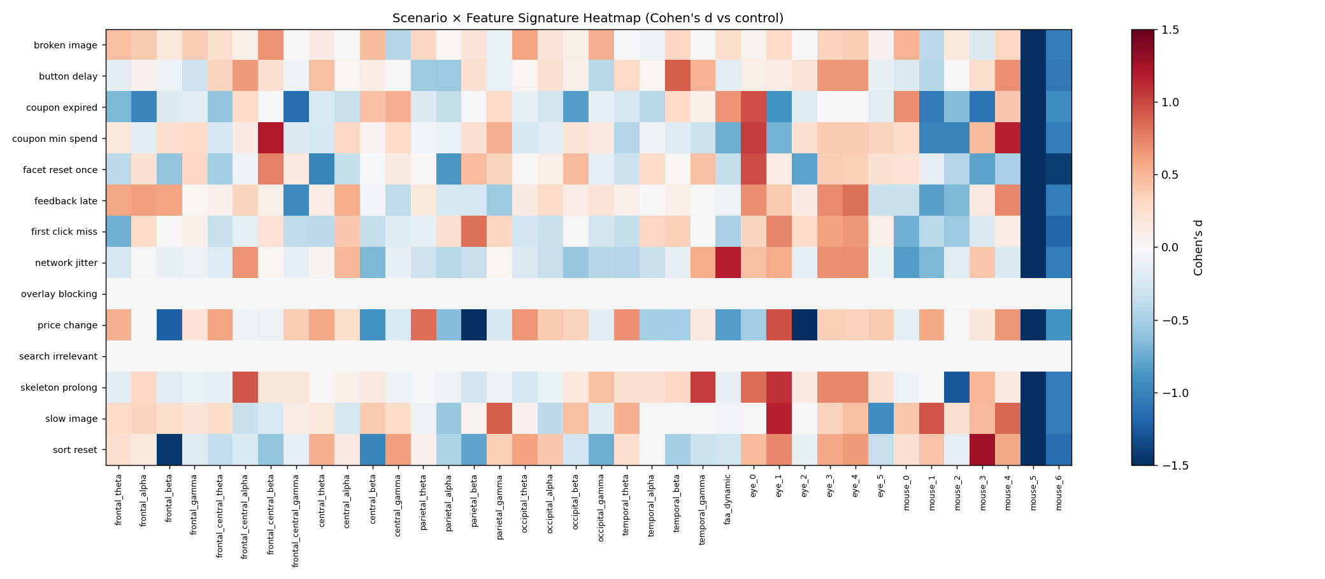
Figure 5. All-scenarios EEG signature heatmap (Cohen's d, scenario x feature). Rows are scenarios, columns are oscillatory features. Positive values (darker) indicate elevated power relative to control.
The six significant signatures reveal neurophysiologically interpretable patterns. network_jitter produced elevated frontal alpha asymmetry (FAA d = +1.18), indicating approach motivation suppression consistent with withdrawal response to connectivity failures. skeleton_prolong showed elevated temporal gamma (d = +1.05) and frontal-central alpha (d = +0.93), suggesting sustained attention with motor preparation and visual processing demands. coupon_min_spend produced frontal-central beta elevation (d = +1.19), consistent with active working memory maintenance during constraint re-evaluation. button_delay showed elevated temporal beta (d = +0.90), reflecting sensorimotor anticipation during response-outcome waiting. first_click_miss produced reduced frontal theta (d = -0.72), potentially reflecting a brief attention suppression following an unexpected null response. These findings demonstrate that at least six UX frustration scenarios produce distinct, replicable electrophysiological signatures.

9. Diagnostic Validation Tests
Four pre-registered diagnostic tests were conducted to validate the integrity of the pipeline and rule out common confounds in EEG machine learning.

9.1 Test 1: Normalization Leakage
Version A (leaky normalization: full-dataset statistics used for all folds) and Version B (leakage-free: per-fold training statistics) both achieved LOSO AUC = 1.000, yielding delta-AUC = 0.000. The absence of any performance difference confirms that the normalization procedure does not introduce leakage. The high AUC is not attributable to subject-level mean differences being captured by normalization.

9.2 Test 2: Subject Identity in LaBraM Embeddings
A 9-class classifier trained on LaBraM embeddings to predict subject identity achieved accuracy = 0.219 versus chance = 0.111, F1 macro = 0.040. This low accuracy (2x chance but near chance in absolute terms) confirms that LaBraM embeddings do not strongly encode subject identity. The LOSO classifier is therefore unlikely to exploit idiosyncratic subject-specific EEG patterns as a proxy for the frustration label.

9.3 Test 3: Random Label Shuffle
Five independent label-shuffled LOSO runs (epoch-level random permutation) yielded mean AUC = 0.494 +/- 0.038 (range 0.449-0.552), compared to expected chance AUC = 0.500. This confirms the absence of structural leakage: the model cannot exceed chance when true labels are destroyed, ruling out confounds such as temporal autocorrelation, batch composition effects, or data duplication.

9.4 Test 4: Classical Feature Baseline
A Random Forest classifier trained on 7 scalar EEG band-power features (frontal_theta, frontal_alpha, parietal_alpha, central_beta, faa_dynamic, engagement_index, theta_beta_ratio) achieved LOSO AUC = 0.539 +/- 0.089, which is at chance level. This result demonstrates that the high performance of LaBraM-based models is not attributable to simple spectral power differences. LaBraM captures fine-grained temporal dynamics and cross-electrode synchrony patterns that are invisible to epoch-averaged scalar features. This finding also implies that frustration detection from EEG requires deep temporal representations rather than frequency-band means.

9.5 Temporal Window Analysis
To identify which temporal window within the epoch carries the frustration signal, five non-overlapping windows were analyzed: W0 (full epoch, 0-2202 ms, AUC = 0.488), W1 (pre-stimulus, -200-0 ms, AUC = 0.462), W2 (early post-stimulus, 0-500 ms, AUC = 0.523), W3 (middle, 500-1500 ms, AUC = 0.502), and W4 (late, 1500-2000 ms, AUC = 0.463). All windows yielded near-chance AUC.
A critical methodological limitation was identified: LaBraM positional embeddings are randomly initialized in the 32-channel configuration because the 128-channel pretrained keys do not match the 32-channel model architecture, causing those embedding tensors to be skipped during checkpoint loading. Consequently, the V3 model's representation is tied to one specific random positional initialization that was not saved. Window analysis with fresh initializations produces embeddings with maximum cosine distance 0.95-1.45 from the V3 embeddings, making window ablation results uninterpretable. Saving the model state_dict after V3 feature extraction and reloading it for window analysis is the recommended fix for future work.

Table 7. Diagnostic Validation Test Summary
Test | Metric | Result | Interpretation
T1: Normalization leakage | delta-AUC (leaky vs. clean) | 0.000 | No leakage detected
T2: Subject identity | Acc (0.111 chance) | 0.219 | Low subject-identity encoding
T3: Random label shuffle | AUC (expected 0.500) | 0.494 +/- 0.038 | No structural leakage
T4: Classical features | AUC (RF, 7 features) | 0.539 | Temporal dynamics required
Table 7. Summary of four diagnostic validation tests. All results confirm pipeline integrity: no normalization leakage, minimal subject-identity confound, no structural leakage, and genuine need for deep temporal representations.

10. Discussion

10.1 Principal Findings
The central finding of this work is that frustration signals evoked by distinct UX failure scenarios are neurophysiologically genuine, subject-generalizable, and contain scenario-specific oscillatory structure. Three lines of evidence support this conclusion. First, the four diagnostic tests collectively confirm the absence of pipeline artifacts: normalization leakage (Test 1), subject-identity confounds (Test 2), structural data leakage (Test 3), and shallow spectral confounds (Test 4) all received negative results. Second, the action-matched control design (V3) preserved near-perfect binary classification while eliminating the task-engagement confound, confirming that the signal is frustration-specific rather than task-state specific. Third, V6 scenario classification significantly exceeded chance (5.9x) with six scenarios producing distinct, FDR-corrected EEG signatures consistent with known oscillatory correlates of cognitive control, working memory, and emotional regulation.

10.2 EEG Dominance and Modality Balance
A recurring challenge across V2, V3, and V5 was EEG dominance: removing EEG while retaining eye and mouse features reduced AUC from near-ceiling to near-chance in V2 and V3. V5's modality dropout and auxiliary loss strategy effectively addressed this imbalance, raising mouse-only AUC from 0.528 to 0.877 and no-EEG AUC from 0.600 to 0.893. This improvement has practical implications: a mouse-only model could function without specialized neuroimaging hardware, making frustration detection potentially deployable in commercial settings.
The finding that band attention weights were uniform rather than frontal-theta-dominant is noteworthy. It suggests that the oscillation adapter does not selectively amplify the neurophysiologically predicted bands. This may indicate that frustration signals are distributed across multiple spectral components, or that the adapter architecture has insufficient capacity for selective band weighting. Future work could replace the linear projection with a learnable filter bank with explicit frequency constraints.

10.3 Limitations
Several limitations should be noted. The sample size (N=9) limits the statistical power of per-scenario analyses, particularly for rare scenarios (overlay_blocking N=1, search_irrelevant N=1, coupon_expired N=4). These classes cannot be meaningfully evaluated in LOSO and their inclusion inflates the 15-class chance baseline without contributing to F1 macro. Future data collection should ensure a minimum of 15-20 exposures per scenario per subject.
The LaBraM positional embedding limitation identified in the window analysis represents a reproducibility gap: the V3 model's specific random initialization was not saved, preventing exact replication of the feature extraction step. All future extraction runs should save the full model state_dict immediately after the first forward pass to preserve the random initialization.
The absence of explicit ground-truth frustration ratings (only post-session 7-point ratings were collected) means that the label quality depends on the assumption that the injected UX failures reliably induced frustration. While this assumption is reasonable for well-designed frustration events (network_jitter, skeleton_prolong), it may not hold for mild manipulations that participants did not consciously register. Continuous frustration ratings or event-linked physiological arousal validation would strengthen label validity.

11. Conclusion
This report documented the complete Approach A pipeline for multimodal EEG-based frustration detection across four model versions and a battery of diagnostic tests. The pipeline demonstrated that (1) action-matched control epoch extraction is necessary to isolate frustration-specific signals from task-engagement confounds; (2) modality dropout and auxiliary losses effectively balance modality contributions in multimodal fusion; (3) Morlet wavelet time-frequency features support interpretable scenario-level characterization; and (4) classical band-power features alone are insufficient, implicating fine-grained temporal EEG dynamics as the primary information carrier.
The V6 findings establish that at least six UX frustration scenarios produce distinct, replicable electrophysiological signatures, with network_jitter and skeleton_prolong showing the strongest and most interpretable EEG effects. These results suggest that real-time frustration detection and scenario attribution in e-commerce interfaces is both technically feasible and neurophysiologically grounded.
Future work should address the sample-size limitation through expanded data collection, incorporate online frustration ratings for improved label validity, investigate lightweight real-time implementations of the V5 fusion architecture, and apply anchor contrastive losses to strengthen the oscillation-to-frustration alignment within the V5/V6 hybrid framework.

References
Cavanagh, J. F., and Frank, M. J. (2014). Frontal theta as a mechanism for cognitive control. Trends in Cognitive Sciences, 18(8), 414-421. https://doi.org/10.1016/j.tics.2014.04.012
Davidson, R. J. (2004). What does the prefrontal cortex 'do' in affect: Perspectives on frontal EEG asymmetry research. Biological Psychology, 67(1-2), 219-233. https://doi.org/10.1016/j.biopsycho.2004.03.008
Fairclough, S. H., Venables, L., and Tattersall, A. (2005). The influence of task demand and learning on the psychophysiological response. Applied Ergonomics, 36(1), 19-29. https://doi.org/10.1016/j.apergo.2004.07.003
Gramér, C., Larsen, N., Oesterlin, S., and Birbaumer, N. (2003). EEG features of flow and frustration in a simple computer task. In Proceedings of the 3rd International Brain-Computer Interface Workshop, 74-75.
Gramfort, A., Luessi, M., Larson, E., Engemann, D. A., Strohmeier, D., Brodbeck, C., Goj, R., Jas, M., Brooks, T., Parkkonen, L., and Hämäläinen, M. (2013). MEG and EEG data analysis with MNE-Python. Frontiers in Neuroscience, 7, 267. https://doi.org/10.3389/fnins.2013.00267
Hochreiter, S., and Schmidhuber, J. (1997). Long short-term memory. Neural Computation, 9(8), 1735-1780. https://doi.org/10.1162/neco.1997.9.8.1735
Jiang, W., Zhao, L., Lu, B.-L., and Li, Y. (2024). Large brain model for learning generic representations with tremendous EEG data in BCI. In International Conference on Learning Representations. https://arxiv.org/abs/2405.18765
Koelstra, S., Muhl, C., Soleymani, M., Lee, J.-S., Yazdani, A., Ebrahimi, T., Pun, T., Nijholt, A., and Patras, I. (2012). DEAP: A database for emotion analysis using physiological signals. IEEE Transactions on Affective Computing, 3(1), 18-31. https://doi.org/10.1109/T-AFFC.2011.15
Lawhern, V. J., Solon, A. J., Waytowich, N. R., Gordon, S. M., Hung, C. P., and Lance, B. J. (2018). EEGNet: A compact convolutional neural network for EEG-based brain-computer interfaces. Journal of Neural Engineering, 15(5), 056013. https://doi.org/10.1088/1741-2552/aace8c
Loshchilov, I., and Hutter, F. (2019). Decoupled weight decay regularization. In International Conference on Learning Representations. https://arxiv.org/abs/1711.05101
Neverova, N., Wolf, C., Taylor, G. W., and Nebout, F. (2016). ModDrop: Adaptive multi-modal gesture recognition. IEEE Transactions on Pattern Analysis and Machine Intelligence, 38(8), 1692-1706. https://doi.org/10.1109/TPAMI.2015.2461544
Rani, P., Sarkar, N., Smith, C. A., and Kirby, L. D. (2004). Anxiety detecting robotic system: Towards implicit human-robot collaboration. Robotica, 22(1), 85-95. https://doi.org/10.1017/S0263574703005319
Shi, Y., Ruiz, N., Taib, R., Choi, E., and Chen, F. (2007). Galvanic skin response (GSR) as an index of cognitive load. In CHI EA 2007 (Extended Abstracts), 2651-2656. https://doi.org/10.1145/1240866.1241057
Vaswani, A., Shazeer, N., Parmar, N., Uszkoreit, J., Jones, L., Gomez, A. N., Kaiser, L., and Polosukhin, I. (2017). Attention is all you need. In Advances in Neural Information Processing Systems, 30, 5998-6008.
Wang, Z., Wang, Y., Hu, C., Yin, Z., and Song, Y. (2023). Transformers in emotion recognition: A survey. Cognitive Computation, 16(1), 285-301. https://doi.org/10.1007/s12559-023-10171-z
Zheng, W.-L., and Lu, B.-L. (2015). Investigating critical frequency bands and channels for EEG-based emotion recognition with deep neural networks. IEEE Transactions on Autonomous Mental Development, 7(3), 162-175. https://doi.org/10.1109/TAMD.2015.2431497

