CSE 333 – Operating Systems

Programming Project #1

Göksel Tokur 150116049 – Buse Batman 150117011

Our program has a Menu including all our shell scripts and an exit option. After user selects an option, script takes an input and execute selected script as ./myprogram1 “args1”.

1. First shell script controls the given input is palindrome or not. Palindrome means a word, a phrase or sequence that reads the same backward as forwards.

Sample execution;

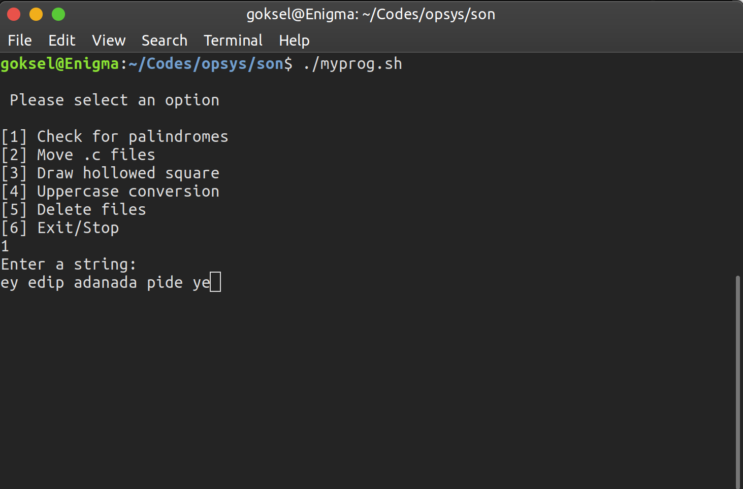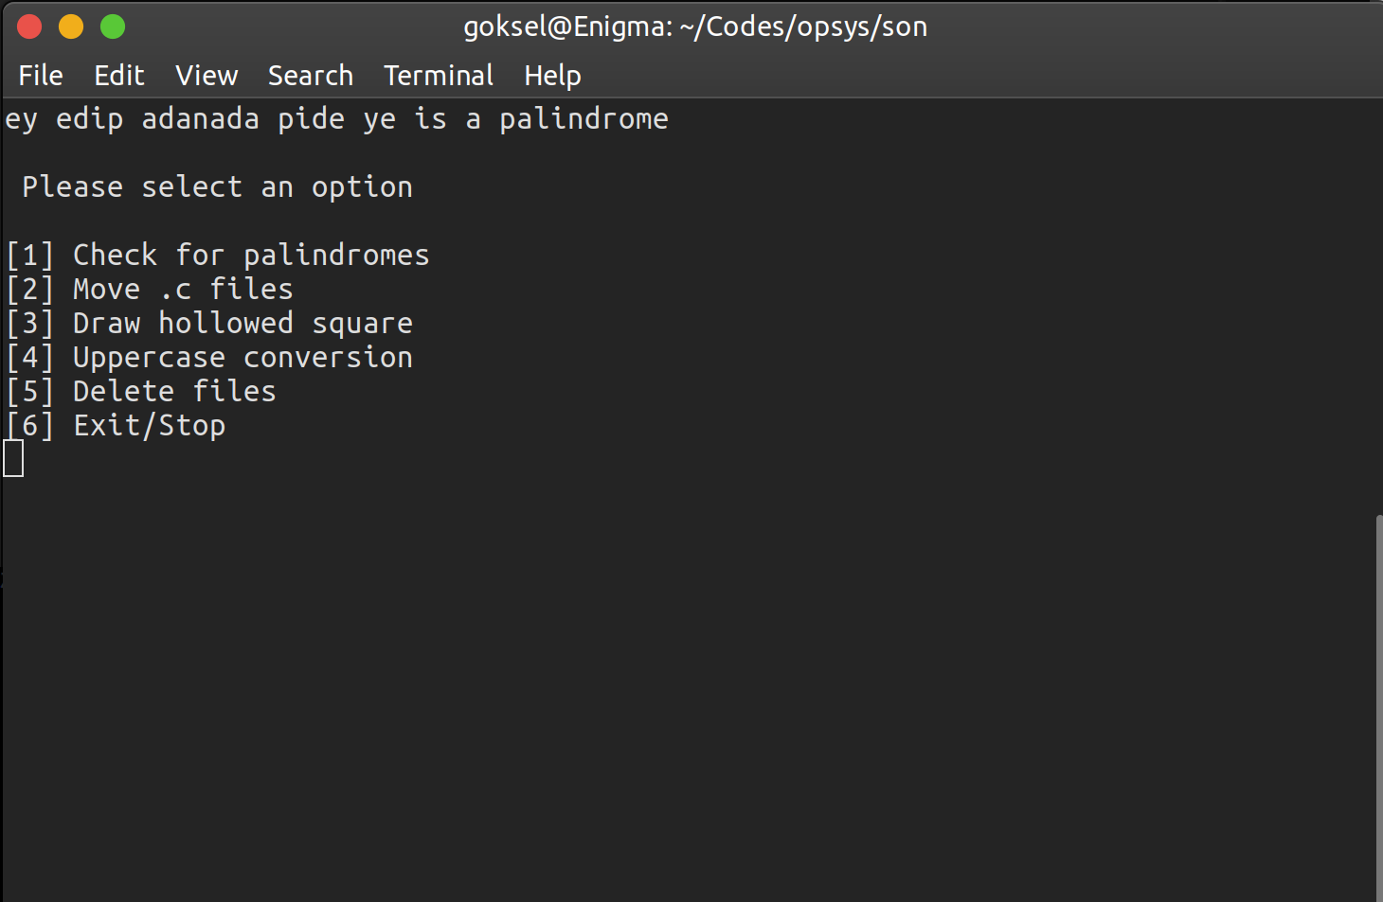

2. This script takes an optional pathname as parameter. If the script is run with no parameters, it creates a directory named ‘cprogs’ under current working directory and move all the files whose name ends with .c to created directory. If there is an argument, script creates a directory names ‘cprogs’ under given path (given argument is a pathname) and move all of the files whose name ends with .c under given path to this directory. If there is no files ends with .c, program says “There is no file ends with .c in current working directory.”.

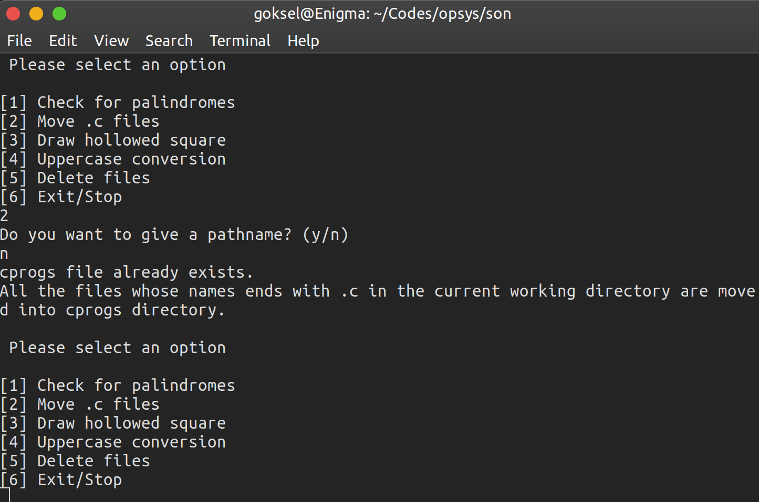

3. Third script draws a hollowed square with the given integer arguments. The first argument must be greater than the second one. Greater one being side of outer square and the other one being the side of the inner square.

Example;

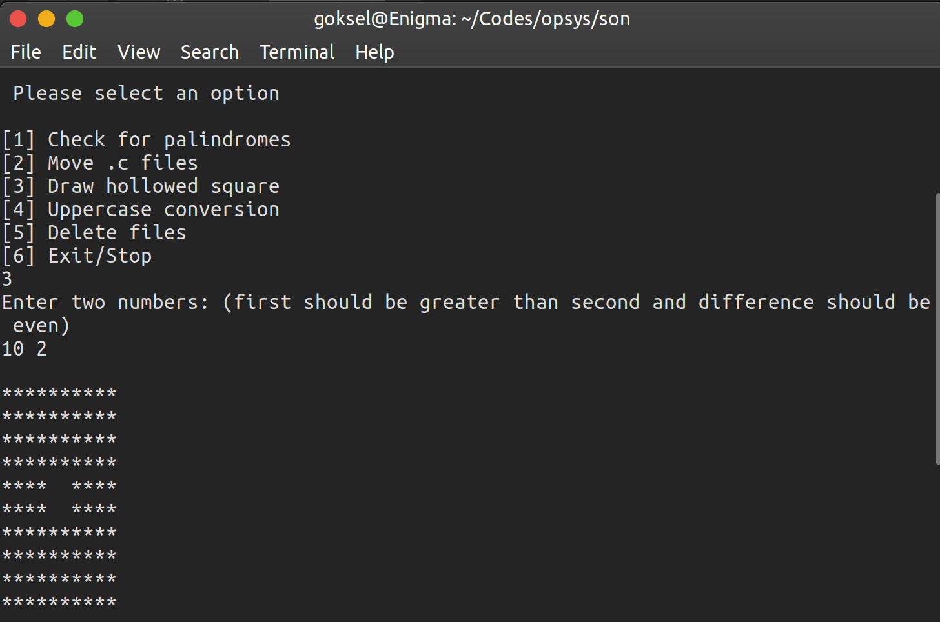

4. After selects the program in the menu, shell script takes a wildcard and an optional pathname as an argument. If given input is just a wildcard, program will search for the words that matches with this wildcard inside all the files whose name ends with .txt under current working directory and change them with their uppercase versions. If program is run with two arguments, program search same as above case but under the given pathname.

Before the execution;

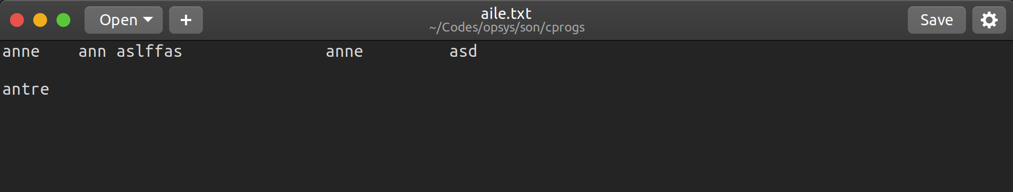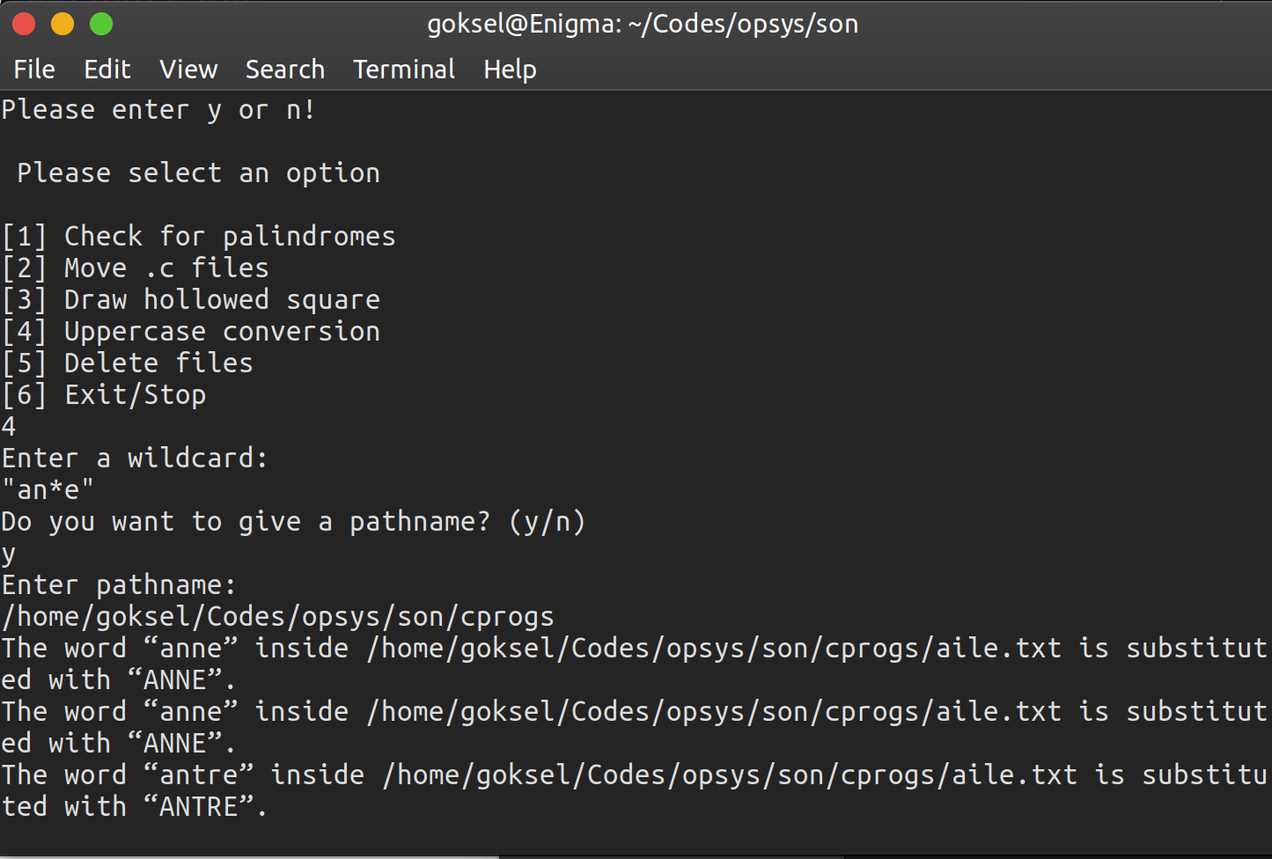

After the execution;

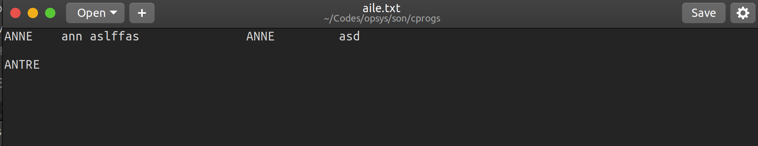

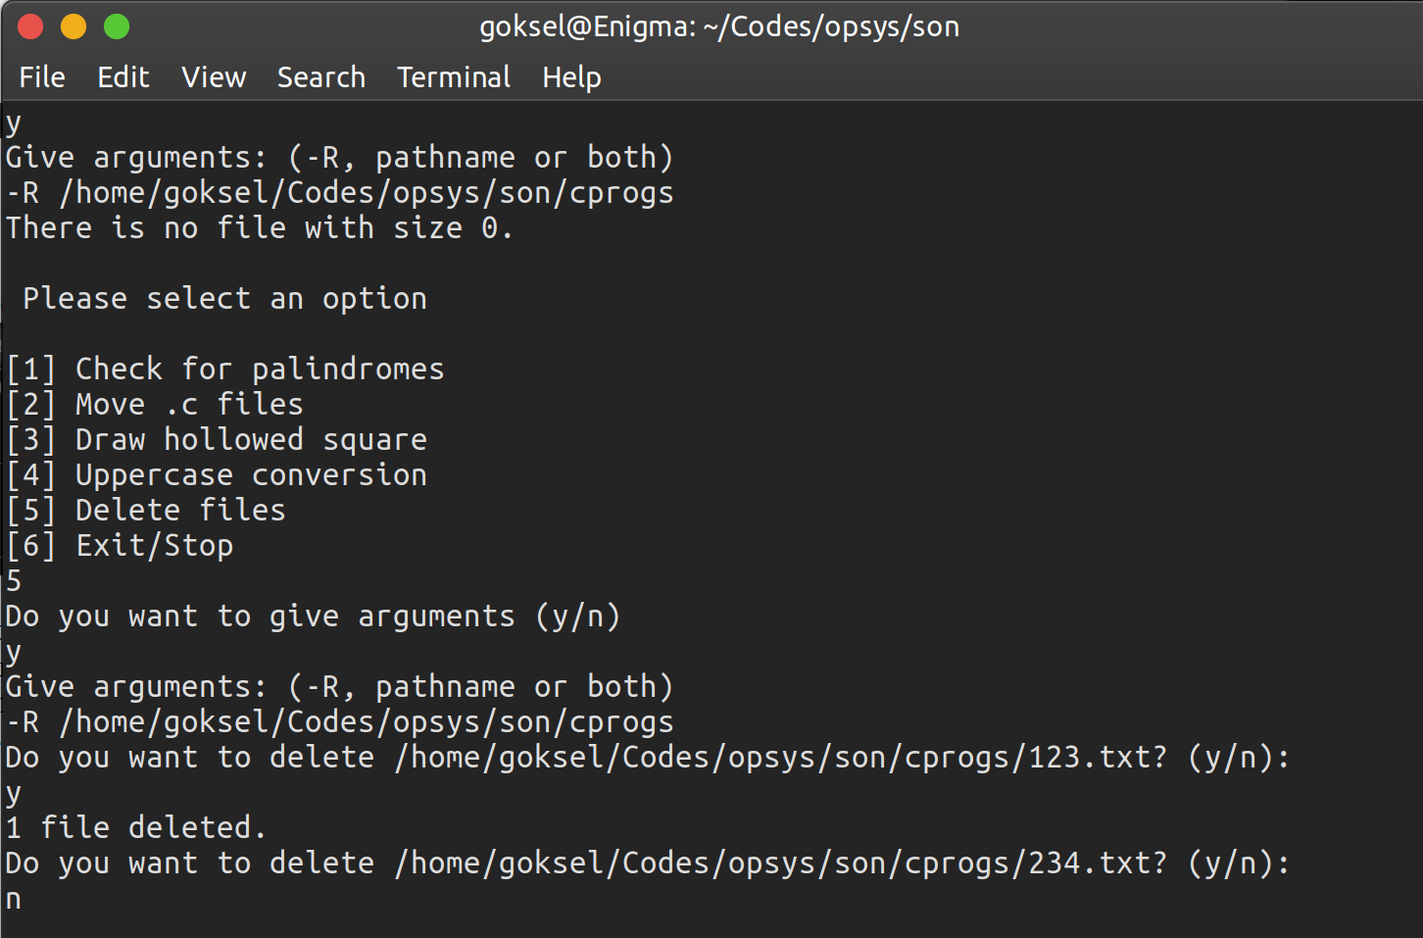5. This script takes an optional path as an argument and -R option that is given to work recursively. If program is run with no argument, it finds all the files whose size zero under current directory and ask to delete them if there is no file with size of zero program will end with no execution and says “There is no file with size of zero”. If user gives a pathname argument, program will find all the files whose size is zero under given path and ask to delete them.

Sample execution;