

CS 319 - Object-Oriented Software Engineering

Analysis Report – Draft Revised

Head Ball

Group 4

Osman Sefa İbiş | 21301693
Mehmet Eren Turanboy | 21302586
Göktuğ Özdoğan | 21301042
Shamil İbrahimov | 21300322

Deadline: 25/07/2017

Course Instructor: Bora Güngören

Table of Contents

- Introduction ....................................................................................................................................

- Current System ...............................................................................................................................

- Proposed System ............................................................................................................................

3.1 Game Overview…………………………………………………………………………

3.2 Functional Requirements…………………………………………………………

3.2.1 Single Player Game…………………………………………………………...

3.2.2 Multiplayer Game…………………………………………………………….

3.2.3 Pause………………………………………………………………………….

3.2.4 Instructions…………………………………………………………………...

3.2.5 Settings……………………………………………………………………….

3.2.6 Credits………………………………………………………………………..

3.2.7 Continue Game………………………………………………………………

3.3 Nonfunctional Requirements
3.4 Constraints
3.5 System Models
3.5.1 Scenarios
3.5.2 Use Case Models
3.5.3 Object Model
3.5.3.1 Class Diagrams
3.5.4 Dynamic Models
3.5.4.1 State Diagrams
3.5.4.2 Activity Diagrams
3.5.4.3 Sequence Diagrams
3.5.5 User İnterface
3.5.5.1 Navigational Path
3.5.5.2 Screen Mock-Ups
4.Glossary
5.Conclusion

1. Introduction

The “HeadBall” is a soccer game in which the player tries to score in the restricted time or score count against another player. The aim of the game is to successfully have score advantage against competitor. There will be in game power-ups to enhance the gameplay. Obstacles will prevent the ordinary ball rotation to create spontaneity in the game. The pitch will be small to enhance player and game interactions. In this game, user can select their soccer player which are visualized in funny appearances (big heads). The “HeadBall” has a potential to attract attention of soccer fans and players who likes competitive games. Our aim is to make a sport game to give users enjoyable time by competitive matches. Players will control characters by the dedicated keyboard buttons, players have the ability to jump, strike the ball with leg and go left or right directions.

2. Current System

In current game user can play in multiplayer mode and game physics are added (Gravity and Friction) The ball is now moving as it moves in real life. The user interface is updated and an menu panel is implemented. Power-ups and striking with leg actions will be implemented later.
3. Proposed System

“HeadBall” can be played by both two players or single player and user should select between options. In single player game user will choose a team that he/she want to play with and he/she can also select the opponent. User can choose the obstacle types that they want to play on. When game starts there will be ball on the top of the screen which falls because of the artificial gravity then user can approach and shoot the ball with heads or foot. If ball touches characters head, game would automatically interact and the ball will accelerate and change direction according to coming direction and the coming angle of the ball. If the character shoots the ball, ball will accelerate more than shoots by head. When ball touches the ground ball will bounce and lose its acceleration slightly due to friction.

If player chooses single player game his/her opponent will be a computer which has an artificial intelligent. During single player games, there will tournament that includes 16 matches that player will be play and during the tournaments opponents of the player will be chosen randomly and player can decide whether the matches will be time limited or score limited. In multiplayer mode player will play one match that will be decided by player whether it will be time limited or score limited. But if player will choose multiplayer mode his/her opponent will be another player who controls another character that can be controlled by direction arrows on the computer. If player has choose time limited mode players aim will score more than his/her opponent in that time but if the player chooses the score limited mode players aim will be reach the determined time before their opponent.

3.1 Overview

The Head Soccer Game is a sport game which is designed for linux and windows desktop machines. When game is started user will see a screen which has New Game, Continue, Instruction, Settings, Credits and Exit buttons. New Game button opens the new game screen in which user can select whether game will be played against the artificial intelligence or another player then user can choose stadium, ball and characters on the game, having done these player can start the current game. Continue button helps user to continue the game that user exited. Instruction button user will find a screen that includes tips and information for the game, this screen shows controls and information about power up symbols. Settings button take user a page that user can change sounds, controls and in game settings which are ball’s appearance and the stadium. If Credits button is

clicked user will see a screen that includes programmers of the game and date that programming part of the game has finished. Exit button closes the screen.
3.1.1 List Of Power Ups
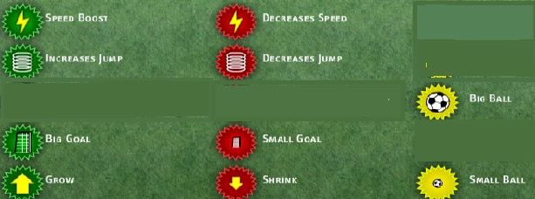

Power- Ups affect the player who touched the ball lastly.

- Speed Boost - Increases the speed of the Footballer
- Increases Jump - Make the Footballer jump higher
- Big Goal - Make your enemy's goal bigger
- Grow - Make your Footballer gigantic player
- Decreases Speed - Decreases speed of your Footballer
- Decreases Jump - Make your Footballer jump lower
- Small Goal - Make your enemy's goal smaller
- Shrink - Decreases size of your Footballer
- Big Ball - Makes the ball bigger
- Small Ball - Makes the ball smaller

3.1.2 List Of Obstacles

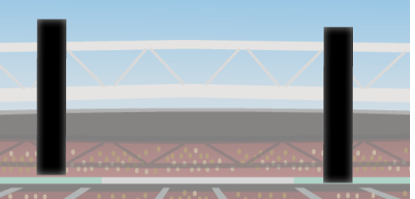


3.1.3 List Of Player Looks




3.2 Functional Requirements

3.2.1 Single Player Game

Before starting single a player game, player have to choose a team and a player from that team. Then player should choose whether the match will limit by time or a score limit. After specifying it player will choose difficulty then player can start the game. In single player mod, there will be 16 teams in the tournament. User has to win in each round in order to win the tournament. In single player game mode player’s opponent will be controlled by artificial intelligence.

3.2.2 Play Multiplayer Game

Before starting multiplayer a player game player should choose whether the match will limit by time or a score limit. After specifying settings, player will choose their characters that they will control. Then they start playing the game.

3.2.3 Pause

User will be able to stop the game during a match. The game will be paused if user pushes the button “ESC” from his keyboard, alternatively user can press the pause button from game screen. In pause menu user can look at Instructions, go back to Main Menu or exit the game instantly.

3.2.4 Instructions

User will see the controller buttons for both players and also an explanation of the power-ups can be seen from the Introductions. An example of the power-ups can be seen from the figure. It may change during implementation as we develop program.

3.2.5 Settings

Setting menu is reachable from the main menu. It contains three different options one of them is sound settings. In sound settings, user can mute or unmute the game music and sound effects. In key board settings user can change the kick button. In in-game settings user can select the stadium and ball images and game speed can be adjusted from here.

3.2.6 Continue

If the user has played a game before and returns the Main Menu he/she can reloads game by clicking Continue button. User will be able to continue the tournament where they left.

3.2.7 Credits

User can see the developer of the game, some information’s about the developing process and some funny stories.

3.3 Nonfunctional Requirements

-Performance Requirements

- In order to have a smooth game flow, the software will handle the amount of throughput within the size 1 MB in 1 second, that is necessary for continuity of the game.

- Response time will be low enough so that it will never surpass 1 second.

- Highscores will be saved (written) to the txt file. Reading this data and creating highscore table will be fast, it will not surpass 1 second.

-Reliability Requirements

- The game will be robust. Empty highscore list will not be a problem while displaying highscore list.

- Option preferences, listed highscores and saved games will be stored in files.

-Supportability Requirements

  - The game will be executable for every platform that Java works.

  - The software will not require any installation process.

- Usability Requirements

  - The game rules will not be hard to understand, user shall be able to learn game rules within 2 minutes by reading help instructions.

  - Game controls will be easy to understand such that user shallbe able to learn game controls within 1 minute by reading help instructions.

3.4 Constraints

  - HeadBall is going to be implemented using Java programming language.

  - Game graphics will be cropped from visuals found. (Example: Ronaldo’s Head)

  - Game language will be English.

3.5 System Models

3.5.1 Scenarios

Scenario 1:
Use Case Name: Pause and continue game
Actors: Player1
Entity Conditions: Player1 is playing the game
Exit Condition: Player1 is playing the game
Flow of event:
- Player1 presses pause button
- Player1 pauses the game
- Game pauses
- Pause screen will be shown
- Player1 presses continue button
- Game continues its previous position before it has been paused

Scenario 2:
Use Case Name: Learning Controls of the game
Actors: Player1
Entity Conditions: Player1 is on main menu
Exit Condition: Player1 chooses back button when he/she is on Instruction button
Flow of event:
- Player1 presses Extras button
- Player 1 presses Instruction button
- Player 1 sees the instructions
- Player1 presses back button
- Main menu appears

Scenario 3:
Use Case Name: Play league
Actors: Player1
Entity Conditions: Player1 is on main menu
Exit Condition: Player1 pauses the game
Flow of event:
- Player1 presses Play button
- Player1 presses Champions League button
- Player1 enters a league game
- Player1 presses “p”
- Pause Menu Appears

Scenario 4:
Use Case Name: Continue league
Actors: Player1
Entity Conditions: Player1 is on main menu
Exit Condition: Player1 pauses the game
Flow of event:
- Player1 presses Play button
- Player1 presses Continue Season button
- Player1 enters a previous league
- Player1 presses “p”
- Pause Menu Appears

Scenario 5:
Use Case Name: Entering a single player game
Actors: Player1
Entity Conditions: Player1 is on main menu
Exit Conditions: Player1 pauses the game
Flow of event:
- Player1 presses Play button
- Player1 presses Training button
- Player1 enters a game
- Player1 presses “p”
- Pause Menu Appears

Scenario 6:
Use Case Name: Entering a multilayer game
Actors: Player1 and Player2
Entity Conditions: Player1 and Player2 are on main menu
Exit Conditions: Player1 or Player2 pauses the game
Flow of event:
- Player1 or Player2 presses Play button
- Player1 or Player2 presses PvP button
- Player1 and Player2 enters a game
- Player1 or Player2 presses “p”
- Pause Menu Appears
Scenario 7:
Use Case Name: Changing sound settings
Actors: Player1
Entity Conditions: Player1 is on main menu
Exit conditions: Player1 clicks apply button
Flow of event:
- Player1 presses the customize button
- Player1 presses the Sound button
- Player1 Changes games volume
- Player1 chooses apply
- Settings Menu appears

Scenario 8:
Use Case Name: Changing Keyboard settings
Actors: Player1
Entity Conditions: Player1 is on main menu
Exit conditions: Player1 clicks apply button
Flow of event:
- Player1 presses the customize button
- Player1 presses the Keyboard button
- Player1 Changes games Keyboard buttons
- Player1 chooses apply
- Settings Menu appears

Scenario 9:
Use Case Name: Changing Stadium or Ball
Actors: Player1
Entity Conditions: Player1 is on main menu
Exit conditions: Player1 clicks apply button
Flow of event:
- Player1 presses the customize button
- Player1 presses the Stadium&Ball
- Player1 Changes games Keyboard buttons
- Player1 chooses apply
- Settings Menu appears

Scenario 10:
Use Case Name: Exiting game
Actors: Player1
Entity Conditions: Player1 is on pause menu
Exit conditions: Player1 clicks Exit button
Flow of event:
- Player1 presses the exit button
- Current game exited
- Main screen is shown
Scenario 11:
Use Case Name: Continue game
Actors: Player1
Entity Conditions: Player1 is on pause menu
Exit conditions: Player1 clicks Continue button
Flow of event:
- Player1 presses the continue button
- Game continues from previous position before exited
- Game continues

3.5.2 Use Case Model

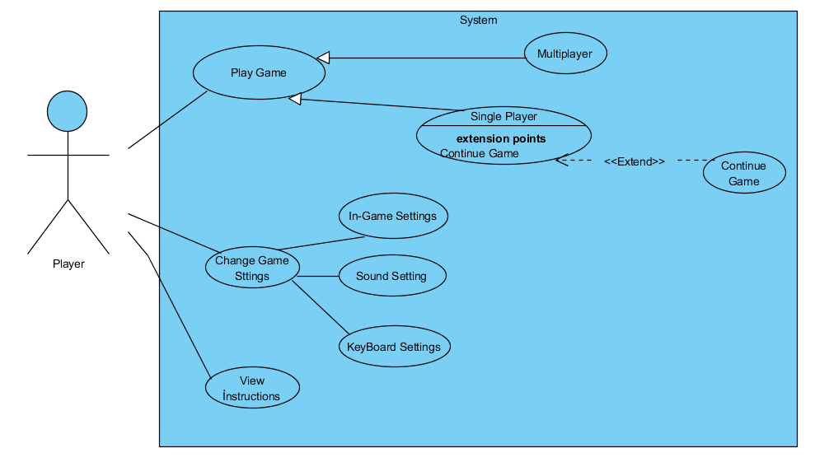

3.5.3 Object Model

3.5.3.1 Class Diagram

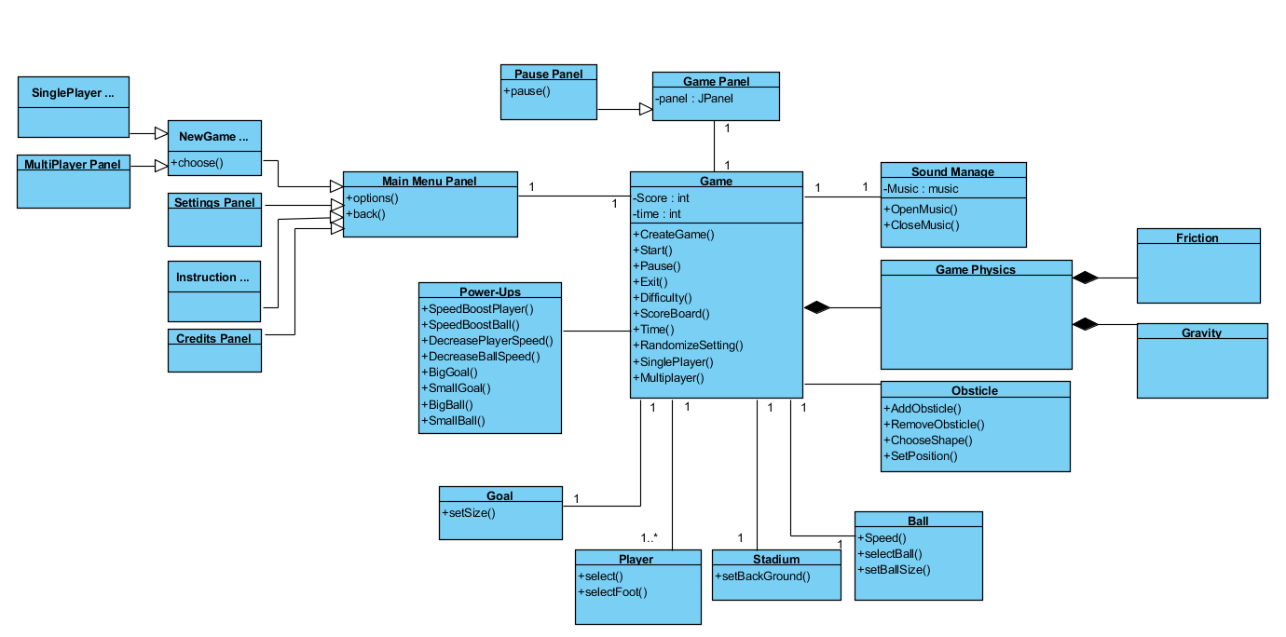

3.5.4 Dynamic Models

3.5.4.1 State Diagram
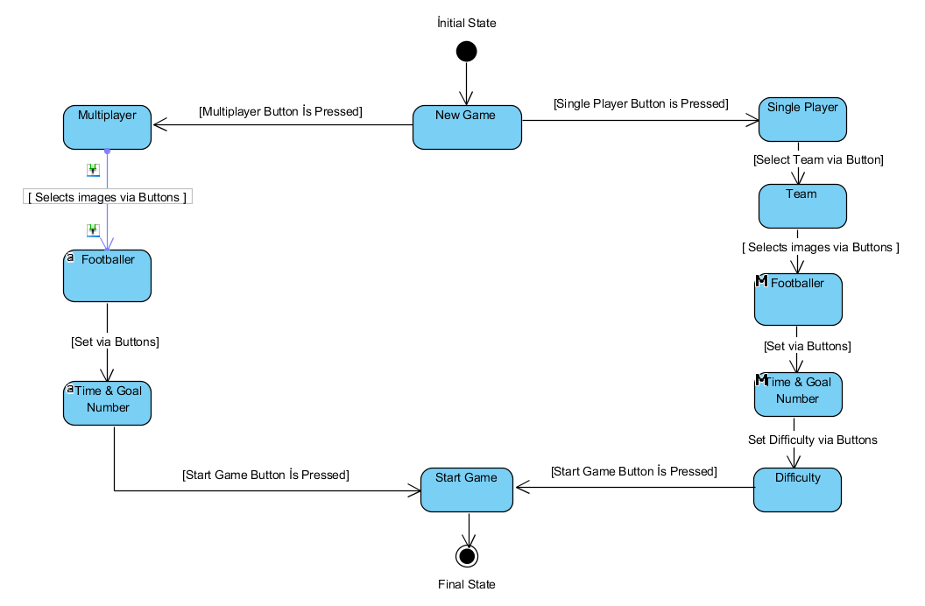

First user chooses to play as a Single Player, he or she chooses the Team, Footballer, Time and the
Number of the Goals and the difficulty, then he or she starts the game.

However, if the Multi Player option is chosen, then user chooses Footballer and Time&Goal Numbers. After he can play the game.

3.5.4.2Activity Diagram

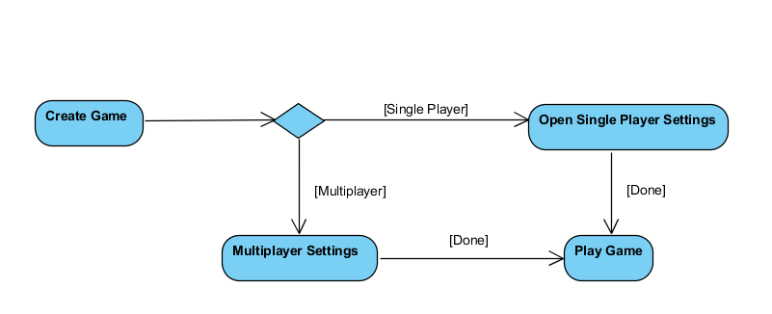

If the user chooses the Single Player option then he faces the Single Player Game Settings.
If the user chooses the Multi Player option then the user encounters the Multi Player Game Setting and after that he can start to play the game.

3.5.4.3 Sequence Diagrams

Other sequence diagrams will be added and updated.

Menu Panel sequence diagram:

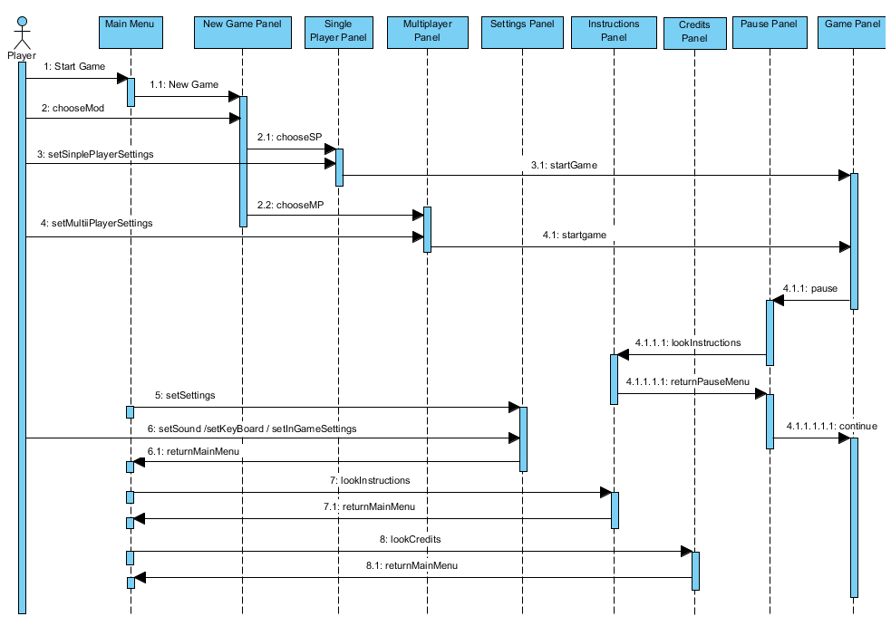

Pause Panel Sequence Diagram

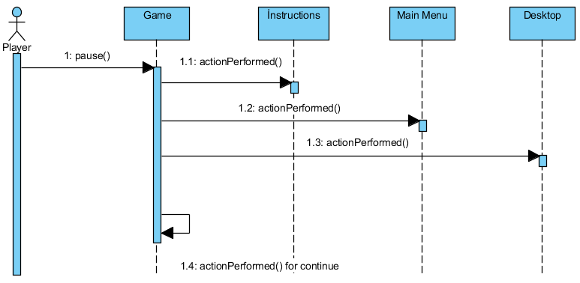

After the user pauses the game he will see the pause menu and he can choose to go to Instructions or to Main Menu or Exit the game. Also he can keep playing the game as well.

Goal Panel Sequence Diagram
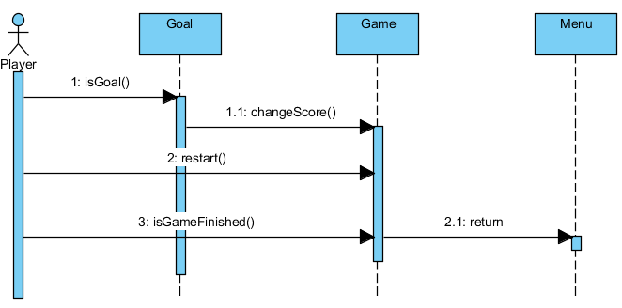

By coordinates of the goal and the ball we can understand whether there is a goal or not. If the goal is scored then score is updated and the game start again from the center. Also, if the game type is chosen based on the goal numbers it checked if the game is finished or not.

3.5.5 User Interface

3.5.5.1 Navigational Path

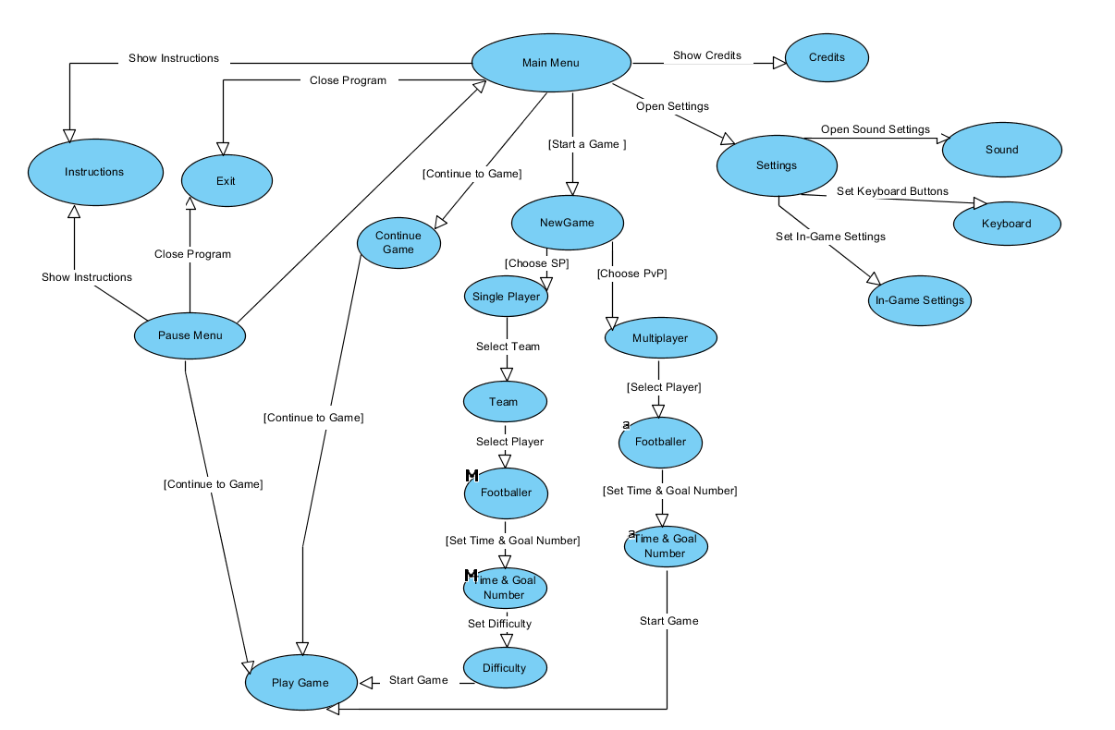

11

From the Main Menu user can go to Credits, Settings, Playing the New Game, Instructions or he

can Exit the game. In the Setting part user can arrange the Sound, Keyboard and some In-Game

Settings.

3.5.5.1 Screen Mock-Ups

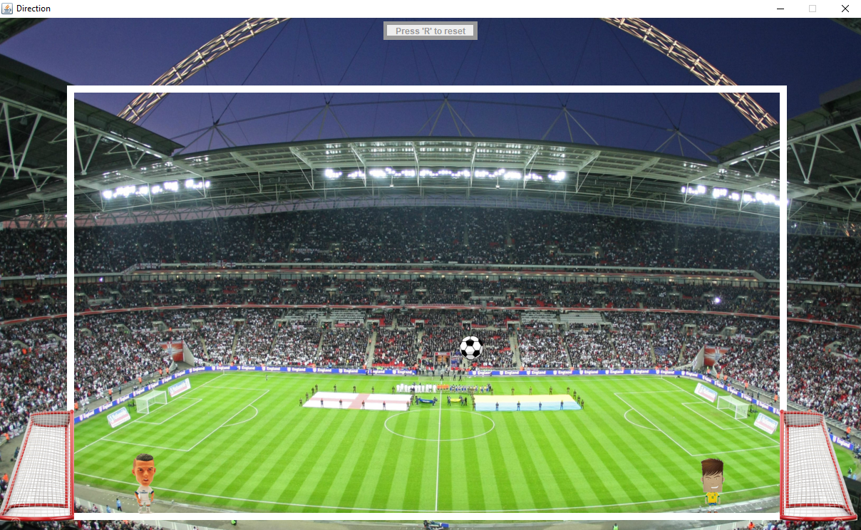

The gameplay screen where player interacts with the game.

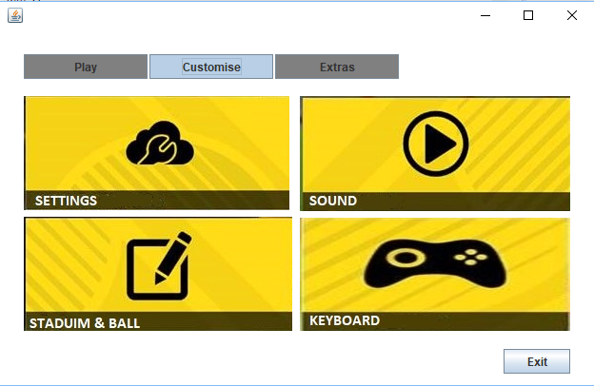

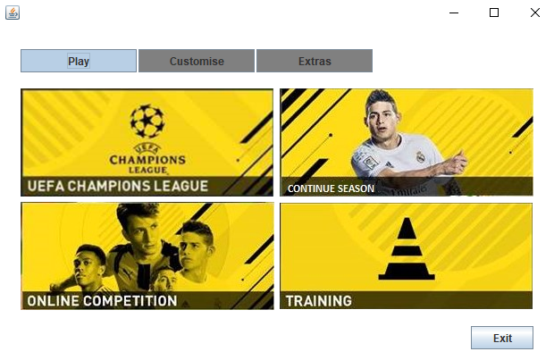

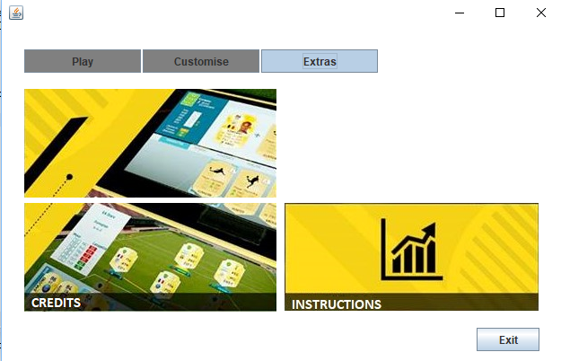

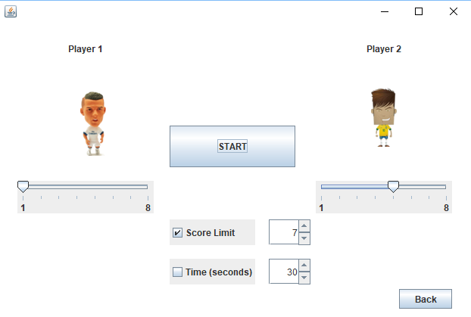

- Glossary

Champions League: An league that player should make match against 5 different players
PvP: A multilayer game mode that player can play with his friend using the same computers keyborad
Goal: The goals that each player has its own
Power-ups: Power-ups appears on the game in exact times of the game and it gave user some special skills and some advantages. Power-ups can be activating if a football player touches its icon
Big-Goal Power-up The goals people goals are gets bigger for 20 seconds

5. Conclusion

