

CS 319 - Object-Oriented Software Engineering

Analysis Report – Final

Head Ball

Group 4

Osman Sefa İbiş | 21301693
Mehmet Eren Turanboy | 21302586
Göktuğ Özdoğan | 21301042
Shamil İbrahimov | 21300322

Deadline: 25/07/2017

Course Instructor: Bora Güngören

Table Of Contents
1. Introduction 3
2. Proposed System 3
2.1 Overview 4
2.1.1 List Of Power Ups 5
2.1.2 List Of Obstacles 6
2.1.3 List Of Player Looks 6
3.2 Functional Requirements 7
3.2.1 Single Player Game 7
3.2.2 Play Multiplayer Game 7
3.2.3 Pause 7
3.2.4 Instructions 7
3.2.5 Settings 8
3.2.6 Continue 8
3.2.7 Credits 8
3.3 Nonfunctional Requirements 9
3.4 Constraints 10
3.5 System Models 10
3.5.1 Scenarios 10
3.5.2 Use Case Model 14
3.5.3 Object Model 15
3.5.3.1 Class Diagram 15
3.5.4 Dynamic Models 17
3.5.4.1 State Diagram 17
3.5.4.2 Activity Diagram 18
3.5.4.3 Sequence Diagrams 19
3.5.5 User Interface 22
3.5.5.1 Navigational Path 22
3.5.5.1 Screen Mock-Ups 23
4.Glossary 26
5.Reference 26

1. Introduction

The “HeadBall” is a soccer game in which the player tries to score in the restricted time or score count against another player. The aim of the game is to successfully have score advantage against competitor. The player will play one character only, therefore the player must both consider defending the goal as a goalkeeper and attacking as a striker when playing. There will be in game power-ups to enhance the gameplay. Obstacles will prevent the ordinary ball rotation to create spontaneity in the game. The pitch will be small to enhance player and game interactions. In this game, user can select their soccer player which are visualized in funny appearances (big heads). The “HeadBall” has a potential to attract attention of soccer fans and players who likes competitive games. Our aim is to make a sport game to give users enjoyable time by competitive matches. Players will control characters by the dedicated keyboard buttons, players have the ability to jump, strike the ball with leg and go left or right directions.

2. Proposed System

“HeadBall” can be played by both two players or single player and user should select between options. In single player game user will choose a team that he/she want to play with and he/she can also select the opponent. User can choose the obstacle types that they want to play on. When game starts there will be ball on the top of the screen which falls because of the artificial gravity then user can approach and shoot the ball with heads or foot. If ball touches characters head, game would automatically interact and the ball will accelerate and change direction according to coming direction and the coming angle of the ball. If the character shoots the ball, ball will accelerate more than shoots by head. When ball touches the ground ball will bounce and lose its acceleration slightly due to friction.

If player chooses single player game, their opponent will be a computer which has an artificial intelligence to play the game. During single player games, there will be a championship that includes 16 matches. There will be 16 teams which the player can see through scrollbar. During the championship opponents of the player will be chosen randomly and player can decide whether the matches will be time limited or score limited. In multiplayer mode player will play one match that will be decided by player whether it will be time limited or score limited. But if player chooses multiplayer mode his/her opponent will be another player who controls another character. The other player in the multiplayer mode will have dedicated keyboard buttons to play the game. If player has chosen time limited mode, players aim will be to score more than his/her opponent in that time but if the player chooses the score limited mode players aim will be to reach the determined score before their opponent.

2.1 Overview

The “HeadBall” is a soccer game which is designed for Linux and windows desktops. When game is started user will see a screen which has New Game, Continue, Instruction, Settings, Credits and Exit buttons. New Game button opens the new game screen in which user can select whether game will be played against the artificial intelligence or another player then user can choose characters on the game, after selections are done player can start the current game.

There will be a pause button to stop the game play also a menu will be shown. Pause menu will include continue, instructions, settings, credits and exit options. Continue button allows user to continue the game which had been paused. When Instruction button is clicked user will find a screen that includes tips and information for the game, this screen shows controls and information about power-ups. Settings button takes user to a page that user can change sounds, controls, the ball color and the stadium looks. When Credits button is selected user will see a screen that includes developers of the game. Exit button closes the screen.

2.1.1 List Of Power Ups
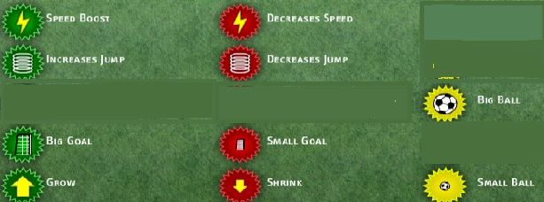

- Power- Ups affect the player who touched the ball lastly. The illustration will be shown in the instructions.

Speed Boost Increases the speed of the Footballer
Increases Jump Make the Footballer jump higher
Big Goal Make your enemy's goal bigger
Grow Make your Footballer gigantic player
Decreases Speed Decreases speed of your Footballer
Decreases Jump Make your Footballer jump lower
Small Goal Make your enemy's goal smaller
Shrink Decreases size of your Footballer
Big Ball Makes the ball bigger
Small Ball Makes the ball smaller

2.1.2 List Of Obstacles

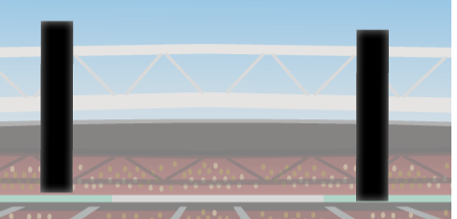
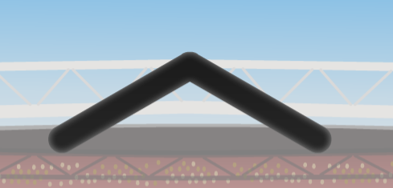

After the player chooses to play multiplayer the players can determine the obstacle
type. They can select different types of obstacles to make the game more challenging since the obstacles interact with the ball’s direction and acceleration.
The obstacles purpose is to change the direction and decrease the speed of the ball. In single player mode, the obstacle will not be chosen by the user since the selection of the obstacle will be determined by the computer. Changing the balls direction will enhance the gameplay.

2.1.3 List Of Player Looks




Both in single and multiplayer modes the desired character can be selected before the game starts. There will be 5 player looks. The player can view all the characters with the scroll bar. The character visuals will change as user manipulates the scroll bar. The final visual on the panel will be the user selected character and when player selects to start the game the character will be determined. Every character has different speed and jump height. This factor is important because it effects the gameplay immensely and the player must consider this fact while selecting to get early advantage.

3.2 Functional Requirements

3.2.1 Single Player Game

Before starting single a player game, player must choose a team and a player for that team. Then player should choose whether the match will limit by time or a score limit. After specifying it player will choose difficulty, then player can start the game. In single player mod, there will be 16 teams in the championship. User must win in each round in order to win the championship. In single player game mode player’s opponent will be controlled by artificial intelligence.

3.2.2 Play Multiplayer Game

Before starting multiplayer, game player should choose whether the match will limit by time or a score limit. After specifying settings, player will choose their characters that they will control. Then they start playing the game.

3.2.3 Pause

User will be able to stop the game during a match. The game will be paused if user pushes the button “ESC” from his keyboard, alternatively user can press the pause button from game screen. In Pause Menu, user can look at Instructions, go back to Main Menu or exit the game instantly.

3.2.4 Instructions

User will see the controller buttons for both players and also an explanation of the power-ups can be seen from the Introductions. An example of the power-ups can be seen from the figure. It may change during implementation as we develop the program.

3.2.5 Settings

Setting menu is reachable from the main menu. It contains three different options one of them is sound settings. In sound settings, user can mute or unmute the game music and sound effects. In key board settings user can change the keyboard keys to control the game. In in-game settings user can select the stadium & ball images and game speed can be adjusted from here.

3.2.6 Continue

If the user has played a game before and returns the Main Menu he/she can reload game by clicking Continue button. User will be able to continue the championship where they left. The championship information will be kept in a “.ser” file after each match is ended. endgame() method will store the score results at the end of the game.

3.2.7 Credits

User can see the developer of the game, some information’s about the developing process and some funny stories.

3.3 Nonfunctional Requirements

-Performance Requirements

- Response time will be low enough so that it will never surpass 1 second.

- High scores will be saved (written) to the txt file. Reading this data and creating high score table will be fast, it will not surpass 1 second.

-Reliability Requirements

- The game will be robust. Empty high score list will not be a problem while displaying high score list.

- Option preferences, listed high scores and saved games will be stored in files.

-Supportability Requirements

  - The game will be executable for every platform that Java works.

  - The software will not require any installation process.

- Usability Requirements

  - The game rules will not be hard to understand, user shall be able to learn game rules within 1 minutes by reading instructions.

  - Game controls will be easy to understand such that user shall be able to learn game controls within 1 minute by reading instructions.

3.4 Constraints

  - HeadBall is going to be implemented using Java programming language.

  - Game graphics will be cropped from visuals found. (Example: Ronaldo’s Head)

  - Game language will be English.

  - Game graphics will be done with JPanel.

3.5 System Models

3.5.1 Scenarios
- Scenario 1:
Use Case Name: Pause and continue game
Actors: Player1
Entity Conditions: Player1 is playing the game
Exit Condition: Player1 is playing the game
Flow of event:
- Player1 presses pause button
- Player1 pauses the game
- Game pauses
- Pause screen will be shown
- Player1 presses continue button
- Game continues its previous position before it has been paused
- Scenario 2:
Use Case Name: Learning Controls of the game
Actors: Player1
Entity Conditions: Player1 is on main menu
Exit Condition: Player1 chooses back button when he/she is on Instruction button
Flow of event:
- Player1 presses Extras button
- Player 1 presses Instruction button
- Player 1 sees the instructions
- Player1 presses back button
- Main menu appears
- Scenario 3:
Use Case Name: Play league
Actors: Player1
Entity Conditions: Player1 is on main menu
Exit Condition: Player1 pauses the game
Flow of event:
- Player1 presses Play button
- Player1 presses Champions League button
- Player1 enters a league game
- Player1 presses “p”
- Pause Menu Appears
- Scenario 4:
Use Case Name: Continue league
Actors: Player1
Entity Conditions: Player1 is on main menu
Exit Condition: Player1 pauses the game
Flow of event:
- Player1 presses Play button
- Player1 presses Continue Season button
- Player1 enters a previous league
- Player1 presses “p”
- Pause Menu Appears
- Scenario 5:
Use Case Name: Entering a single player game
Actors: Player1
Entity Conditions: Player1 is on main menu
Exit Conditions: Player1 pauses the game
Flow of event:
- Player1 presses Play button
- Player1 presses Training button
- Player1 enters a game
- Player1 presses “p”
- Pause Menu Appears
- Scenario 6:
Use Case Name: Entering a multiplayer game
Actors: Player1 and Player2
Entity Conditions: Player1 and Player2 are on main menu
Exit Conditions: Player1 or Player2 pauses the game
Flow of event:
- Player1 or Player2 presses Play button
- Player1 or Player2 presses PvP button
- Player1 and Player2 enters a game
- Player1 or Player2 presses “p”
- Pause Menu Appears
- Scenario 7:
Use Case Name: Changing sound settings
Actors: Player1
Entity Conditions: Player1 is on main menu
Exit conditions: Player1 clicks apply button
Flow of event:
- Player1 presses the customize button
- Player1 presses the Sound button
- Player1 Changes games volume
- 4.Player1 chooses apply
- Settings Menu appears
- Scenario 8:
Use Case Name: Changing Keyboard settings
Actors: Player1
Entity Conditions: Player1 is on main menu
Exit conditions: Player1 clicks apply button
Flow of event:
- Player1 presses the customize button
- Player1 presses the Keyboard button
- Player1 Changes games Keyboard buttons
- Player1 chooses apply
- Settings Menu appears
- Scenario 9:
Use Case Name: Changing Stadium or Ball
Actors: Player1
Entity Conditions: Player1 is on main menu
Exit conditions: Player1 clicks apply button
Flow of event:
- Player1 presses the customize button
- Player1 presses the Stadium & Ball
- Player1 Changes games Keyboard buttons
- Player1 chooses apply
- Settings Menu appears
- Scenario 10:
Use Case Name: Exiting game
Actors: Player1
Entity Conditions: Player1 is on pause menu
Exit conditions: Player1 clicks Exit button
Flow of event:
- Player1 presses the exit button
- Current game exited
- Main screen is shown
- Scenario 11:
Use Case Name: Continue game
Actors: Player1
Entity Conditions: Player1 is on pause menu
Exit conditions: Player1 clicks Continue button
Flow of event:
- Player1 presses the continue button
- Game continues from previous position before exited
- Game continues

3.5.2 Use Case Model

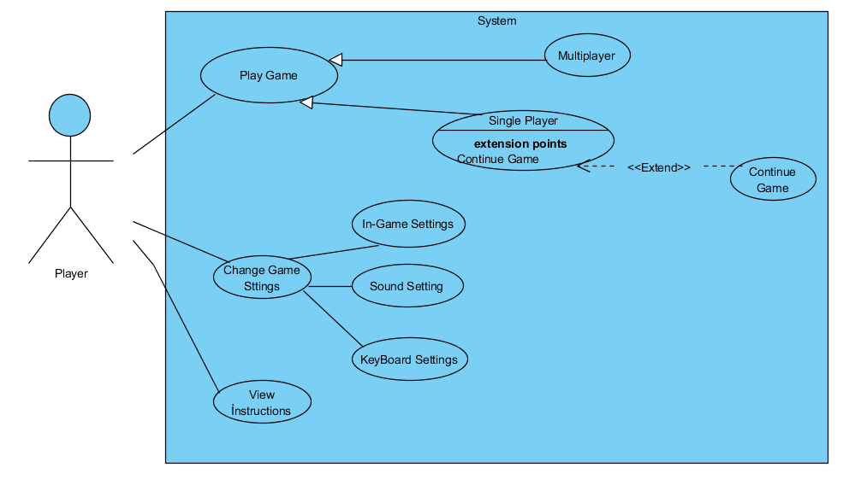
Figure 1- Illustrates the use case model for the user interface of “HeadBall”

- The user interface that the player can use is depicted in a use-case model. The user can play the game by doing the selection between whether desired game type is multiplayer or single player. If the player selects single player the results of the championship will be stored because of the user pauses the game and desire not to play(exit game) there will be an option to continue without losing the championship information. The player can play where he left from except if the matches are ended otherwise the exited match will not be stored. The player can change settings before the game start and also view instructions about gameplay and learn information about power-ups.

3.5.3 Object Model

3.5.3.1 Class Diagram

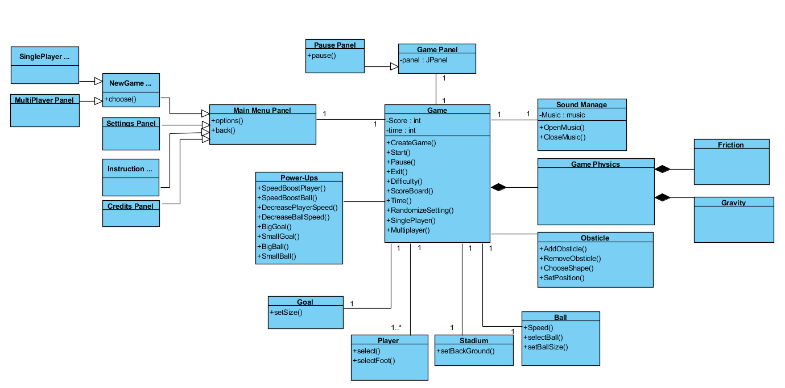
Figure 2 - Illustrates the class diagram of "HeadBall"

Game – This class is the main core class. Goal will be the main object which stores the main attributes.

Ball - This class is going to be ball object. It has speed and size which are settable.

Player - Since there will be one or more players, there is a Player class.

Goal - As a Player class, there are will be two goals in the game which will change its size by

Power-Ups.

Sound Manage - This class manage the sound of the music.

Power-Ups - This class is for changing the size of the goal, ball and also changes the speed of the

player and also ball.

Obstacles - This class is going to add obstacles to the game. It can be some kind of geometrical

shapes which makes it hard to play.

Game Physics - This class generates the Friction and the Gravity features of the game.

Pause Panel - This is what users see when they pause the game.

Setting Panel - This is the class which is responsible for the setting of the game. However, this is

not the place to choose for the single player or multiplayer.

3.5.4 Dynamic Models

3.5.4.1 State Diagram

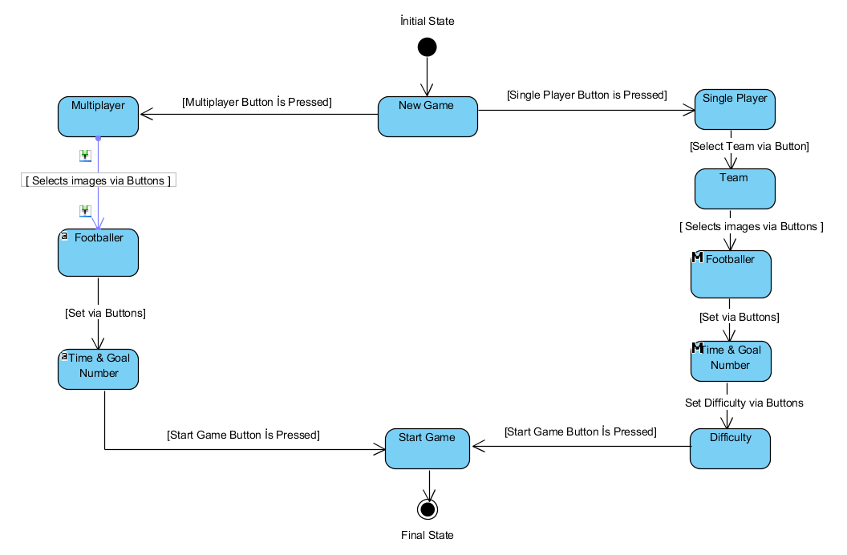
Figure 3 - State diagram of the Game Start

- When the player determines to start a new game, the player should also make a selection between game types. Single player selection option will show a panel which has different selection types to do. The player can select his team, the footballer character, whether the game will be time constraint or goal number constraint and the difficulty of the single player mode. After these selections the player can start the new game. Multiplayer selection option will show a panel where two players can select their footballer character. Also the players must mutually determine whether the game will be played with a time constraint or a goal number constraint. The player can determine the time or goal number boundaries.

3.5.4.2 Activity Diagram

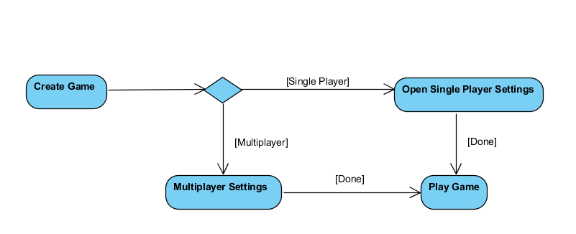
Figure 4 - Show the activity diagram of New Game

- If the user chooses the Single Player option then he faces the Single Player Game Settings.
If the user chooses the Multi Player option then the user encounters the Multi Player Game Setting and after that he can start to play the game.

3.5.4.3 Sequence Diagrams

Menu Panel Sequence Diagram:

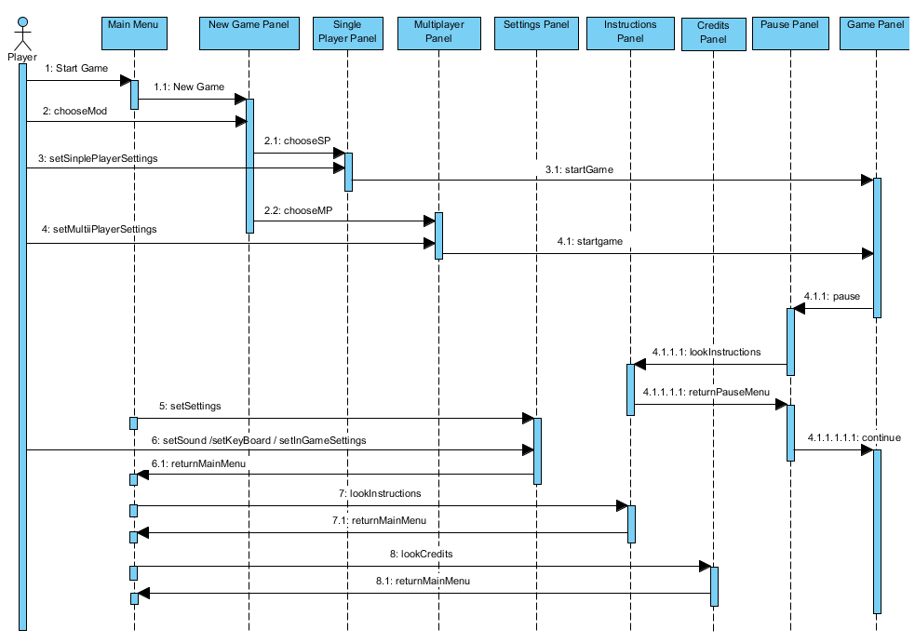
Figure 5 - İllustrates The Sequence Diagram For Menu Panel

- The menu panel sequence will be as depicted in the sequence diagram. There are multiple menu panels which are main menu, new Game panel, single player panel, multiplayer panel, settings panel, instructions panel, credits panel, pause panel and game panel. The sequence will be done with methods which are named in the diagram.

Pause Panel Sequence Diagram :

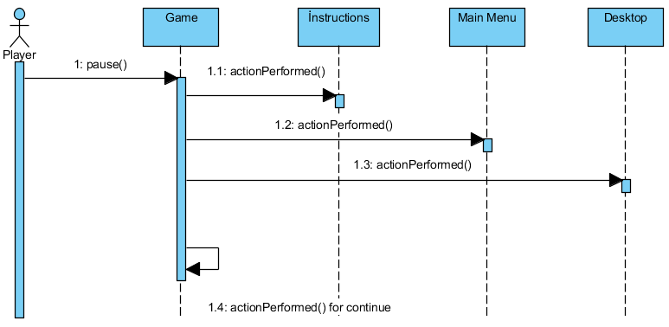
Figure 6 - Illustrates The Sequence Diagram For Pause Menu Panel

- After the user pauses the game he will see the pause menu and he can choose to go to Instructions or to Main Menu or Exit the game. Also he can keep playing the game as well.

Goal Panel Sequence Diagram
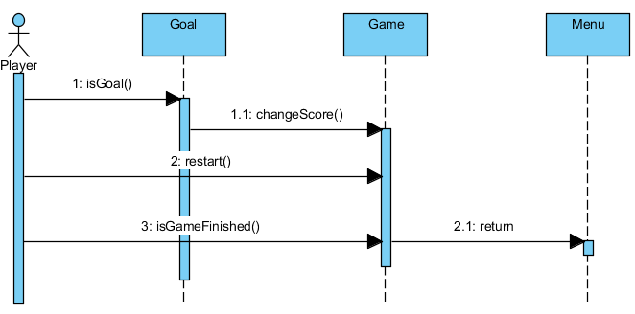
Figure 7 - Illustrate the Goal Sequence Diagram

- By coordinates of the goal and the ball we determine whether there is a goal or not. If the goal is scored then score is updated and the game starts again from the center. Also, if the game type is chosen based on the goal numbers, the game will compare the score and the desired ending score constraint to end the match or not.

3.5.5 User Interface

3.5.5.1 Navigational Path
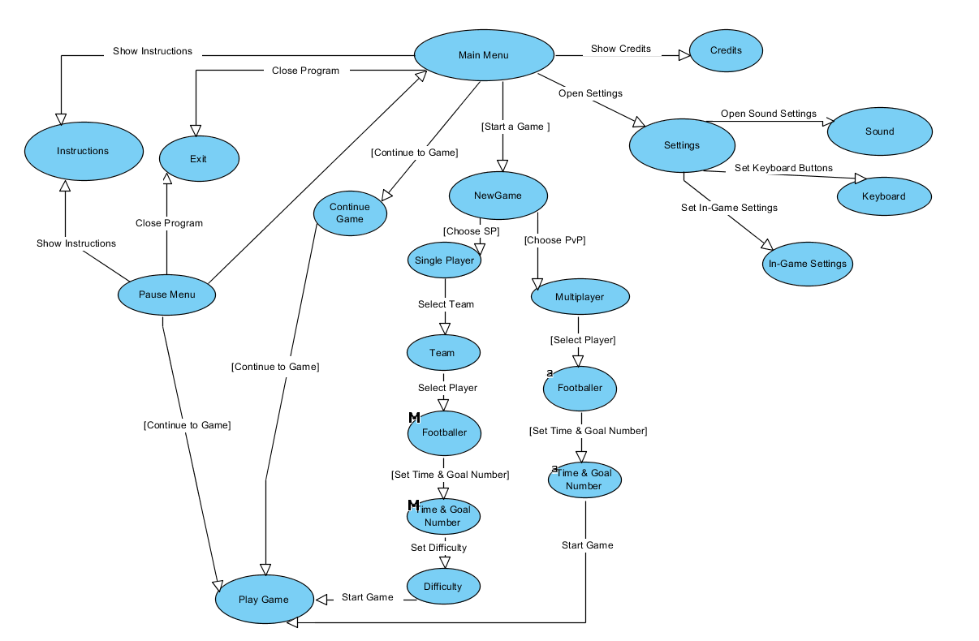
Figure 8 - Illustrates The Navigational Path

- The navigational path for the user to play a game is depicted in the figure. The player can see credits, change settings and view instructions before the game starts. If the player played in the single player mode before and left it before ending the championship, there will be and option to continue the game from where the player left it. When the player selects to start a new game, the navigational path will be as in the diagram. The new game selection path is important because it effects the game type. From pause menu and main menu the user can exit the game and view instructions.

3.5.5.1 Screen Mock-Ups

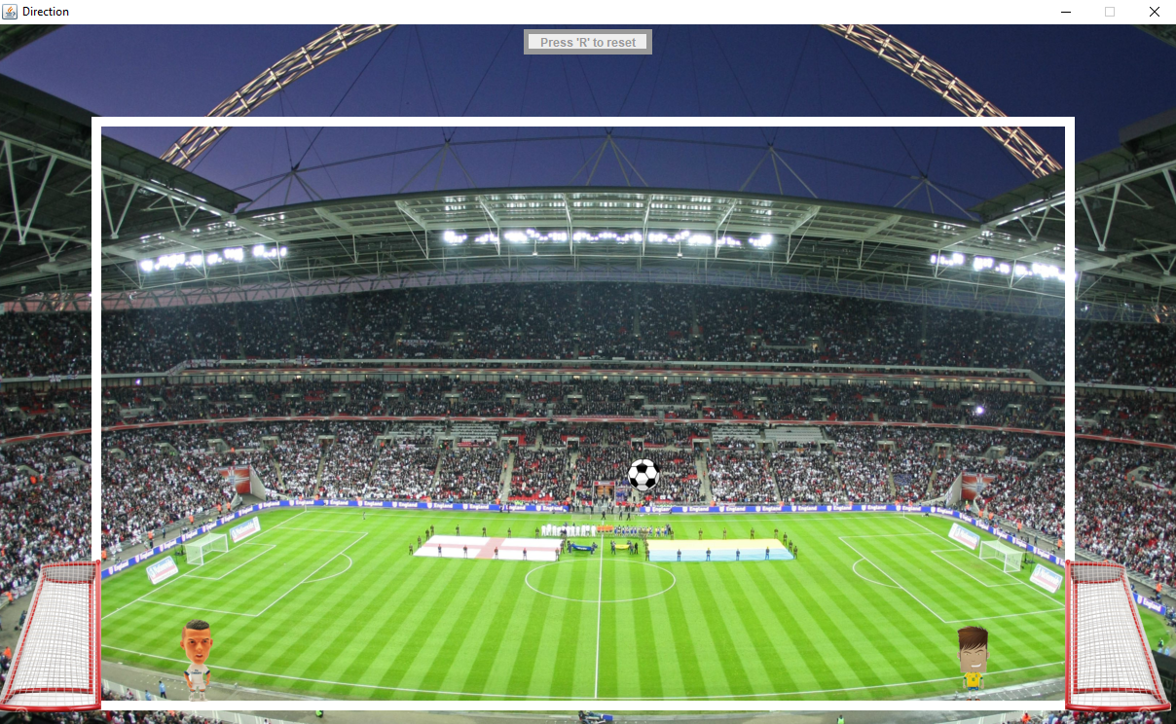
Figure 9 - The Game Panel : Gameplay Mock'up

- The gameplay is as the figure shows. The ball, two goals and two players.

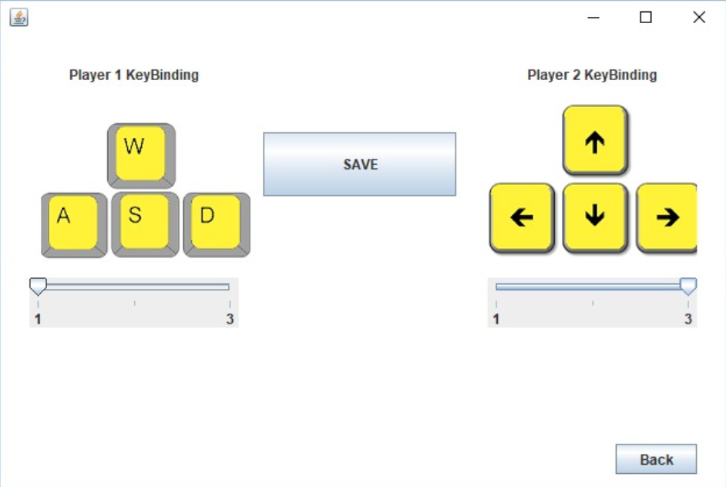
Figure 10 - Show the keyboard settings

- Only in multiplayer mode the keyboard setting will be as it is in the figure. Players can select 3 different keyboard option “WASD”, “Direction buttons” and “4862” from the scrollbar. Go left, right , jump and kick will be the operations that a player can perform. If both players select the same keyboard option a warning will show stating that one player must choose another keyboard option. When both players determine their choice save button should be pressed. Back button will take back to the settings menu.

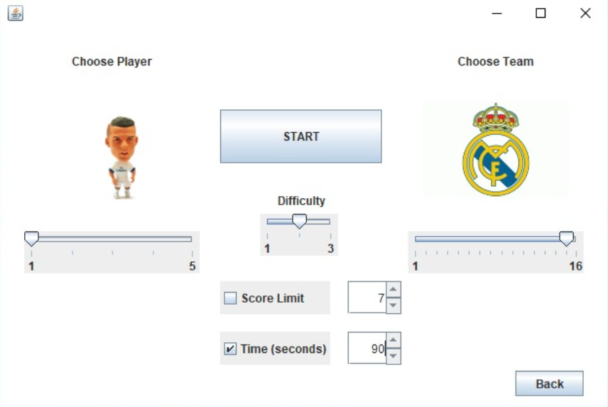
Figure 11 - Settings Before Game Starts (Single Player)

- New game panel for single player mode includes player preferences before the game starts. The player determines the footballer character. Five different characters will be shown to the player as the player scrolls. The player can choose desired football team and there will be sixteen different team logos as to choose from. Player can determine the difficulty level of the game. The user must determine whether to play with time constraint or score limit constraint by selecting check-box. Player can determine the seconds or score limit count. Back button will take player to main menu.

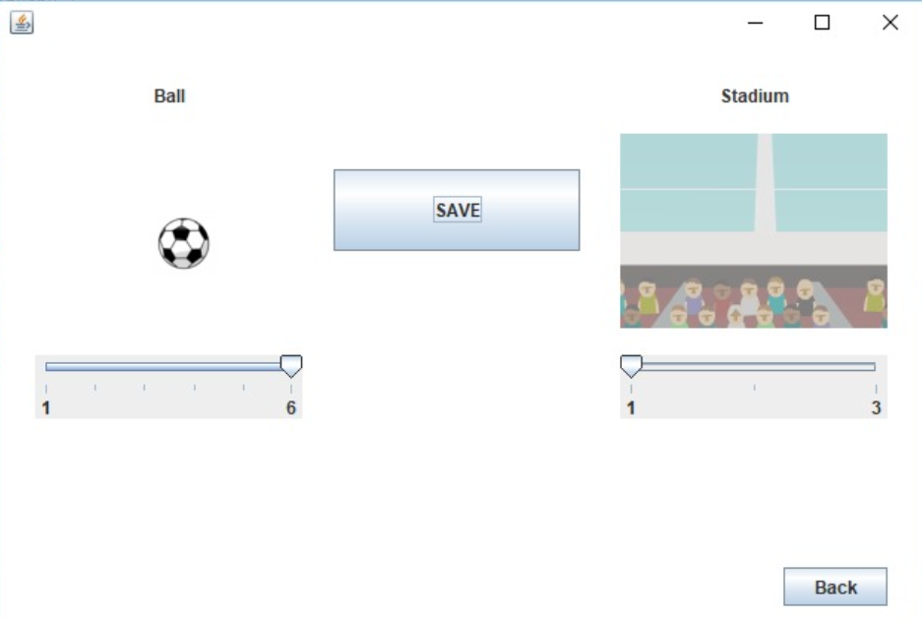
Figure 12 - Ball and Stadium changing panel

- Ball and stadium changing panel will allow the player to determine the ball color and stadium. Player should save to play with these settings. This panel will be accessible in settings menu. This panel will not be visible in pause menu. Player will not be able to change this setting after game starts.

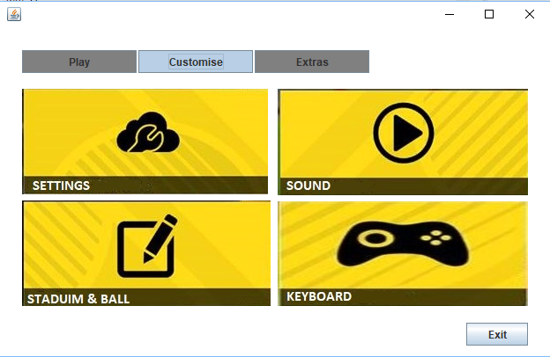
Figure 13- Settings Panel

The settings panel displays the keyboard, sound and stadium & ball settings. Also in the “settings” figure the player can change the speed of the game. Settings panel is accessed from the main menu by selecting the customize table.

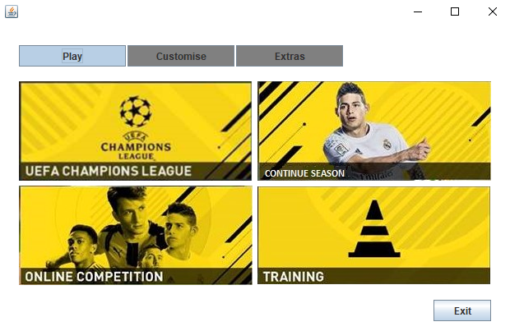

- Main menu panel displays championship single player mode, continuation for single player mode, multiplayer mode(“online competition”) and the single player one match mode. These options are visible under the “play” table. There is also settings(“customize”) and extras tables.

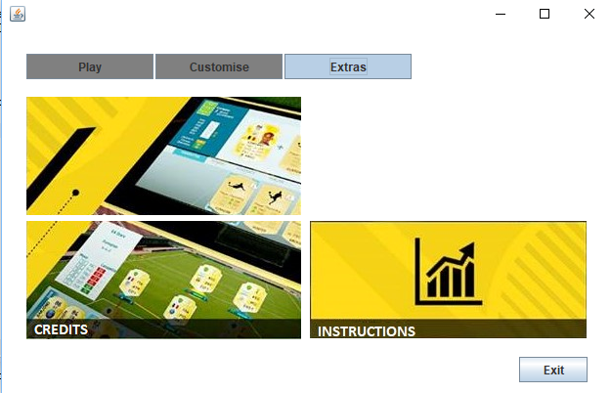

- The extras panel displays the credits and instructions options. If the player choses credits the developers of the game will be displayed. The instructions will show what are the power-ups and how they effect the game.

4.Glossary
- Championship: An one match only winning tournament which a player that player should win against seven team without any loss to attain winning. Total team count is 16.
- PvP: A multiplayer game mode that player can play with his friend using the same computers keyboard
- Goal: The goals that each player has its own
- Power-ups: Power-ups appears on the game in exact times of the game and it give user some special skills and some advantages. Power-ups can be activating if a football player touches its icon

5.Reference
The “HeadBall” game is inspired by the game called : Sports Head Football Championship which is developed by “mousebreaker.com”.

- http://www.mousebreaker.com/game/sports-heads-football-championship

