DBMS ASSIGNMENT 3

Submitted by : Gaurav J PES1UG19CS599
Gokul Karthik PES1UG19CS170
Gurukiran S PES1UG19CS173

1) Complete Working model of the Database application

Simple Queries

-- CUSTOMER VIEW

-- 1) list of all outlets - select * from outlet;s1

select outlet_name,outlet_location
from outlet;

-- 2) list of available vehicles - ASSUME checking in outlet_id=2
-- LATER can be passed parameter in function
select * from vehicle
where vehicleStatus='not-taken' and outlet_id=2;

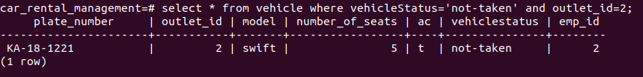
-- 3) list of reservations made by customer - ASSUME customer_id=1
-- LATER can be passed as a parameter
select * from reservation where customer_id=1;

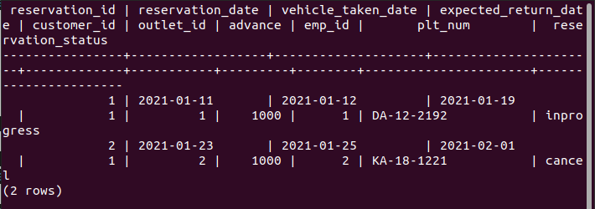
-- 4) when the customer selects the vehicle then the status of the vehicle is set to to selected

-- to show list of not-taken
select * from vehicle where vehicleStatus='not-taken';

update vehicle
set vehicleStatus='selected'
where plate_number='KA-18-1221' and vehicleStatus='not-taken';

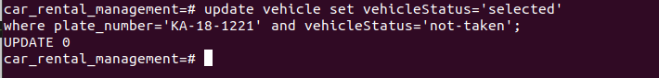

-- to show update
select * from vehicle where plate_number='KA-18-1221';

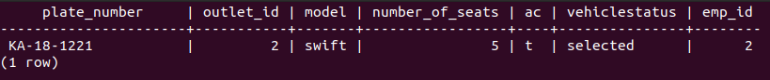
-- CAN DO concurrency control here

-- 5) getting outlet contact

select outlet_mail,outlet_phone from outlet_contact where outlet_id=1

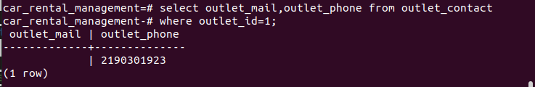

-- EMPLOYEE VIEW

-- 1) list of all vehicles in that outlet -
select * from vehicle where outlet_id=1;

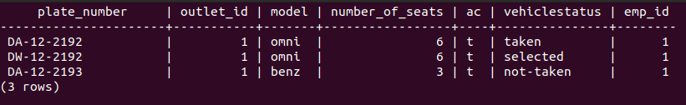

-- 2) list of all reservations made my all customers in that outlet,
-- to see if to approve a customer coming to outlet on pickup date
select * from reservation where outlet_id=1 and reservation_status='inprogress';

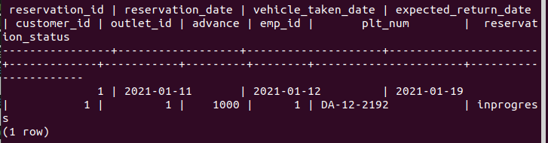

-- 3) update rent table, where reservations whose approves is inprogress
-- set the reservation status to returned, and update the rent

-- first set return_date(REAL) in rent, when customer comes back
update rent
set return_date='20-01-2021',number_of_days=return_date-taken_date,total_amount=1000*number_of_days+tax_amount
where reservation_id=1;

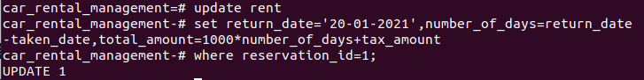
select * from rent where reservation_id=1;
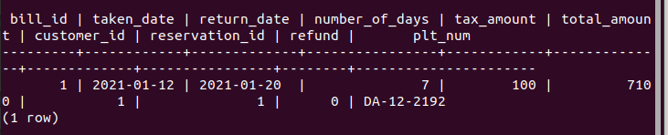

-- now in reservation go and set status to returned + vehicle status to 'not-taken'

update reservation
set reservation_status='completed'
where reservation_id=1;

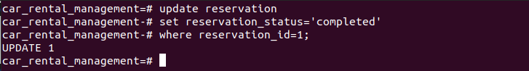
select * from reservation where reservation_id=1;

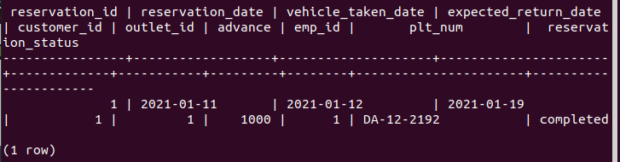

update Vehicle
set vehicleStatus='not-taken'
where plate_number = (SELECT plt_num from reservation where reservation_id=1);

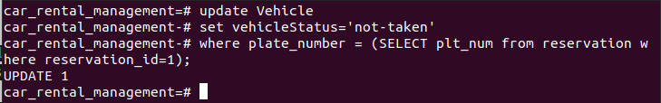

SELECT * from vehicle where plate_number = (SELECT plt_num from reservation where reservation_id=1);

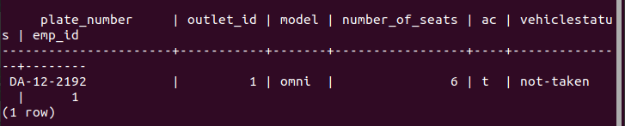

-- 4) IF customer shows usp on pickup date in reservation
-- insert into rent table

-- dummy to show
INSERT into reservation values(3, '21-04-2021', '28-04-2021','01-05-2021',2,1,1000,1,'DW-12-2192','inprogress');

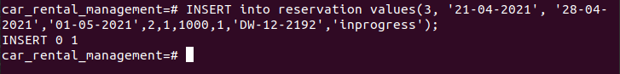

insert into rent(taken_date, return_date ,number_of_days ,total_amount, customer_id ,reservation_id ,refund ,plt_num )
select vehicle_taken_date,expected_return_date,expected_return_date-vehicle_taken_date,1000(expected_return_date-vehicle_taken_date), customer_id,reservation_id ,advance*0.1 , plt_num
from reservation
where reservation_id=3;
select * from rent where reservation_id=3;

-- as he showed up update vehicle status to taken

update Vehicle
set vehicleStatus='taken'
where plate_number = (SELECT plt_num from reservation where reservation_id=3);

SELECT * from vehicle where plate_number = (SELECT plt_num from reservation where reservation_id=3);

-- MANAGER/ADMIN VIEW

--1) view current savings of an outlet (after adding base + income of any rent(complex query)) -
select outlet_savings from outlet where outlet_id=1;

--2) list of all vehicles in that outlet -
select * from vehicle where outlet_id=1;

--3) orderby(number of seats, outlet) all vehicles in db

select number_of_seats, plate_number, model,outlet_id
from vehicle
order by number_of_seats;

--4) update outlet contact

update outlet_contact
set outlet_mail='ilikeWeed@cubahavana',outlet_phone='0212112123'
where outlet_id=1;

select * from outlet_contact where outlet_id=1

Complex and Nested Queries

Multiple users with different access privilege levels for different parts of the database should be created.

1. customer view

creating views for customer role

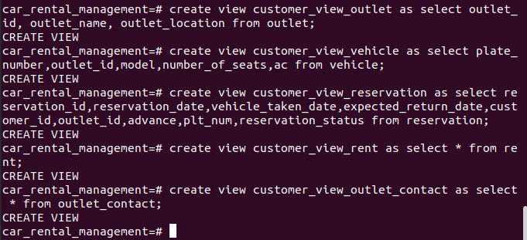
customer role creation and granting views to customer role

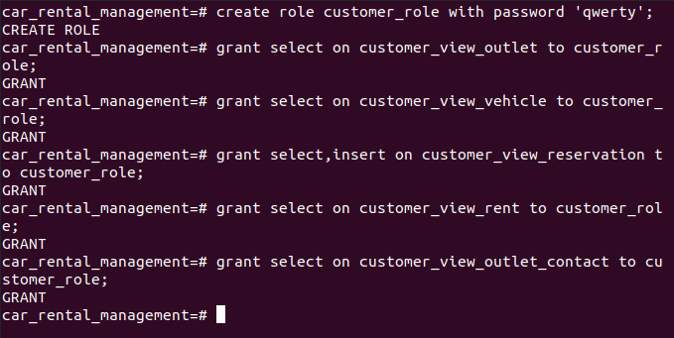

2. Employee view

Creating views of employee role

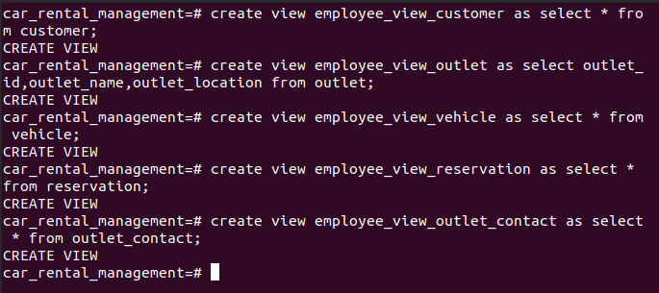
employee role creation and granting views to employee role

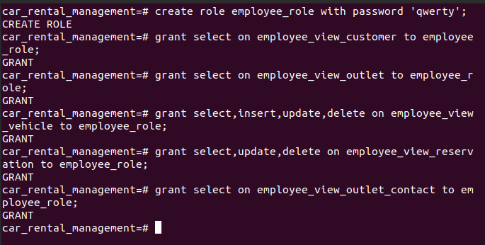

3. Admin view

Creating views of admin role

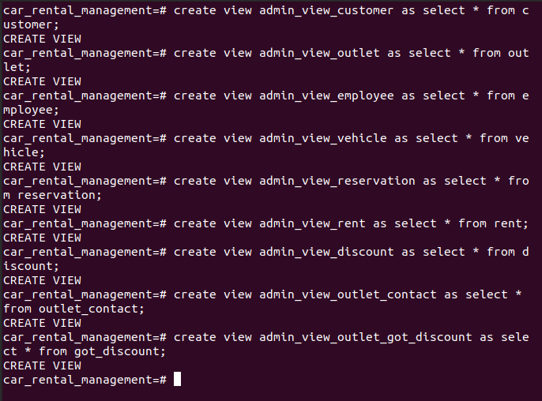
admin role creation and granting views to admin role

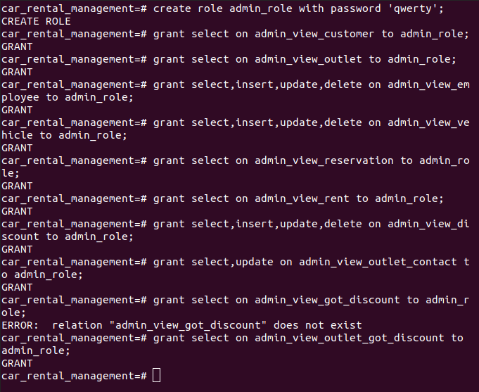

Creating users

Creating customer, employee, admin users
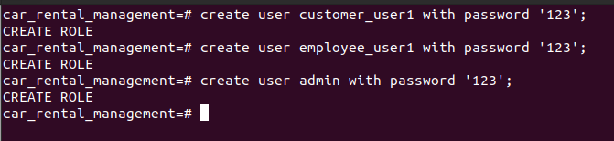
granting roles to each users.

