Multiple users with different privilege levels

1.Customer view

view created

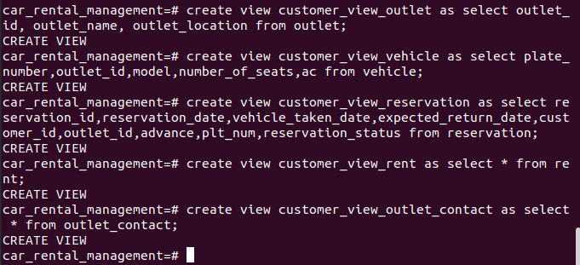
role creation and granting the views

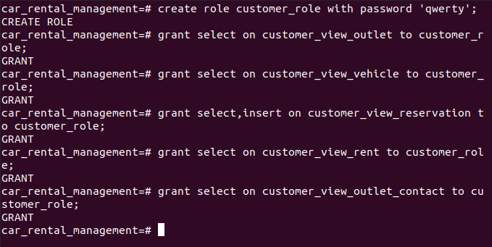

2.Employee view

views created

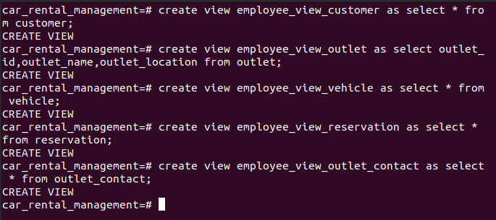
role creation and grant views

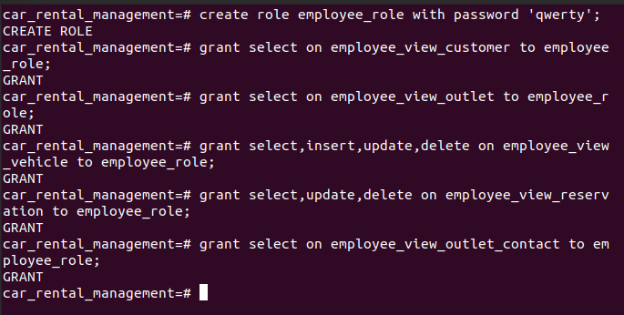

3.Admin view

creating views

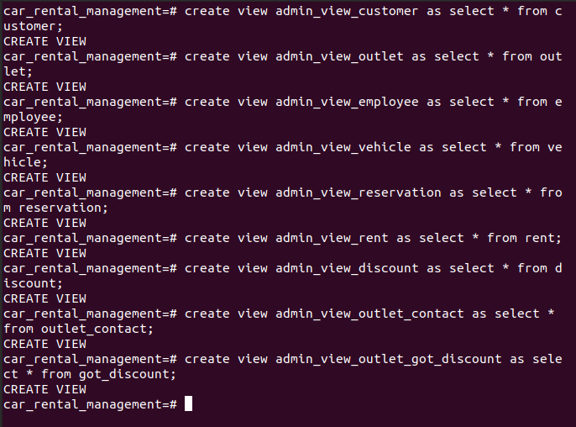

role creation and grant views

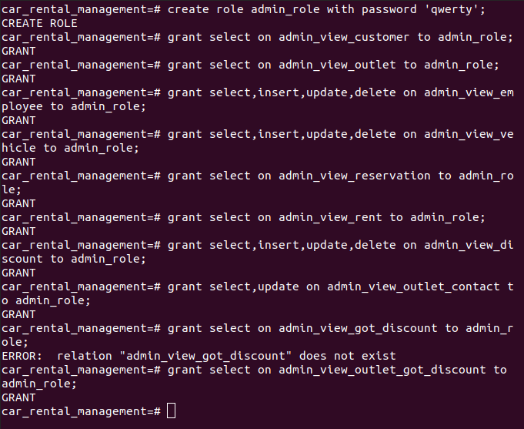

Creating users

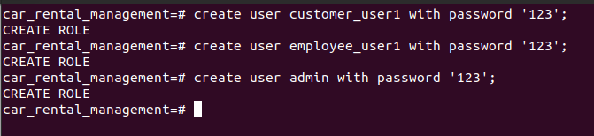
granting roles to users
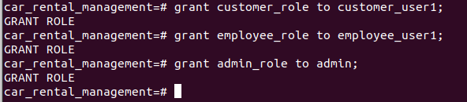

Concurrency control and concurrent transaction

update without committing in 2 terminals
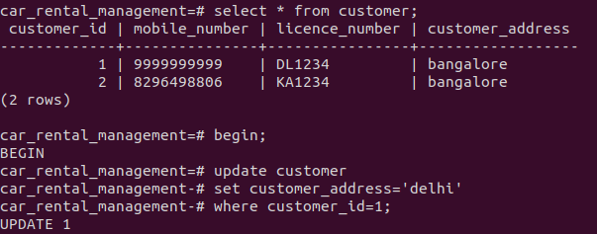
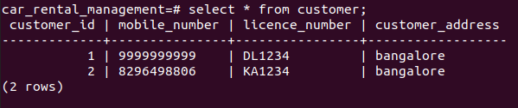

after committing changes results in 2 terminals
