Question 1: What is the output of \dt?

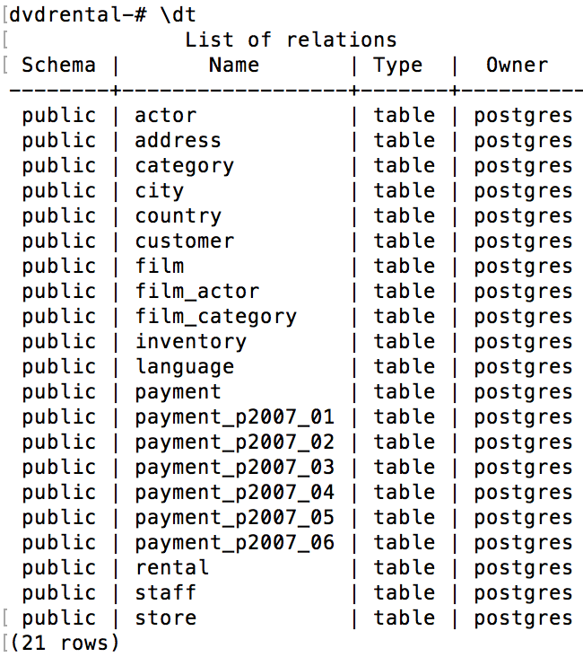

Question 2: What is the schema for the customer table?

Public

Question 3: What similarities do you see in the explain plains for these 3 queries?

Seq Scan cost is proportional to row numbers, because the cost is the entire execution time of the component, from when it begins reading in data to when it finishes writing its output.

1st query

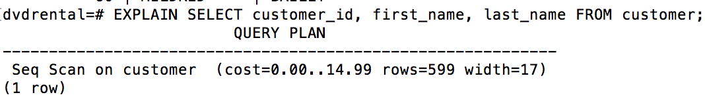

2nd query

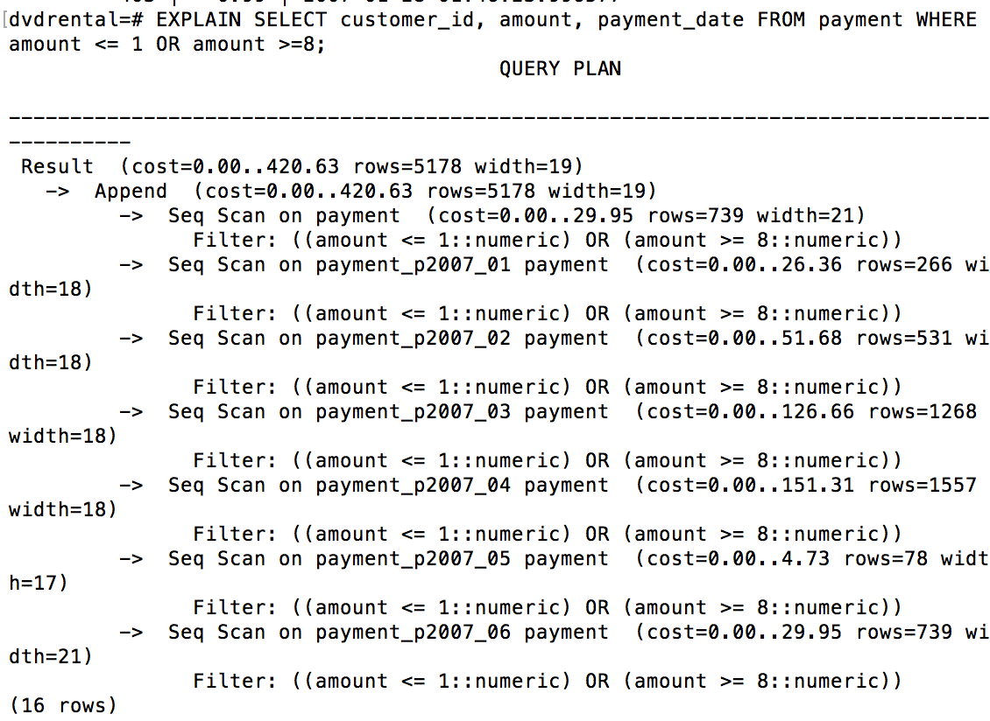

3rd query

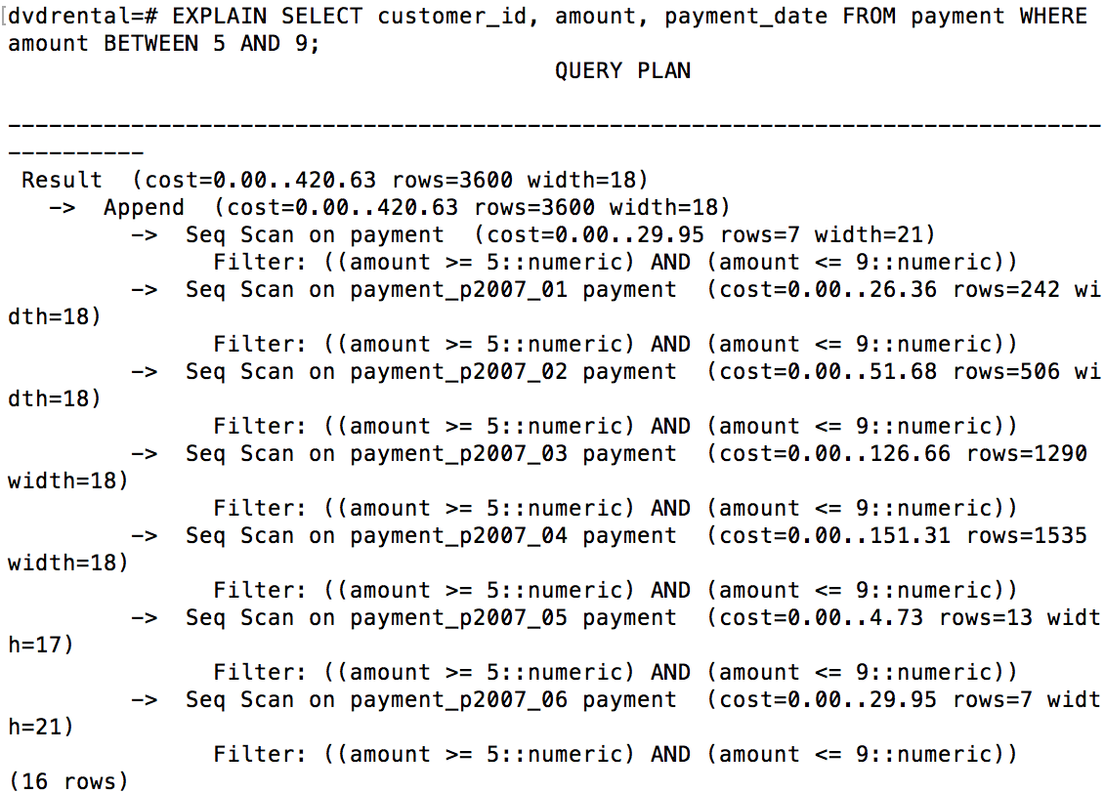s

Question 4: What is the difference between the plans for the Partitioned table and the union query? Why do you think this difference exists?

In the Partitioned table, there is an additional scan on “payment” table with “rows=443”.

In the union query, there is an extra “HashAggregate” step.

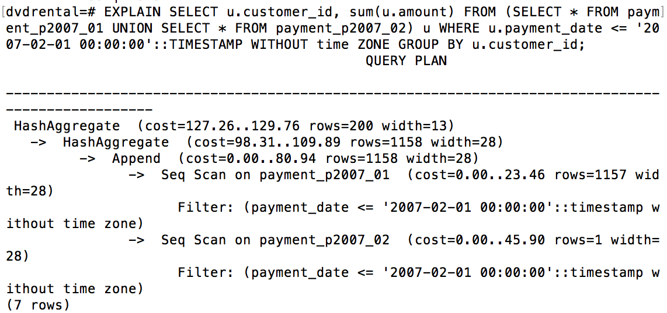

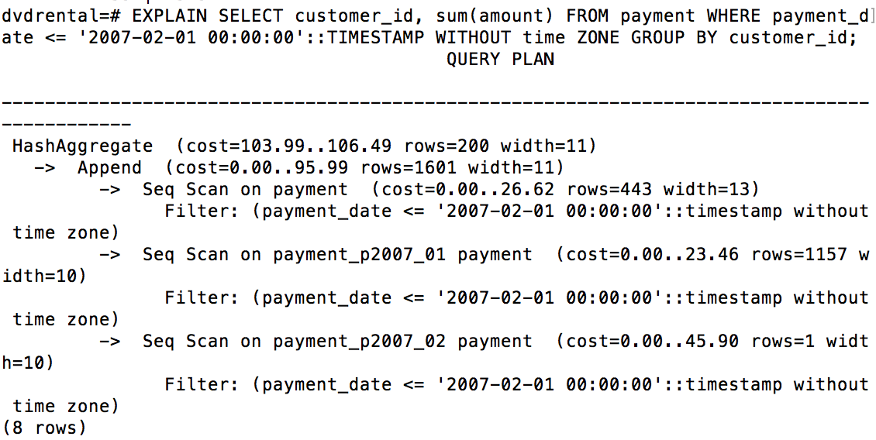

Question 5: What join algorithm is used for the inner join?

Hash join

