**OUTPUTS:**

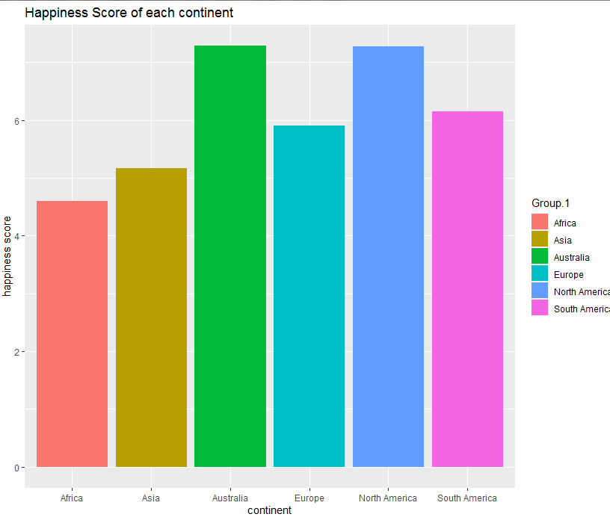

**CORRPLOT:**

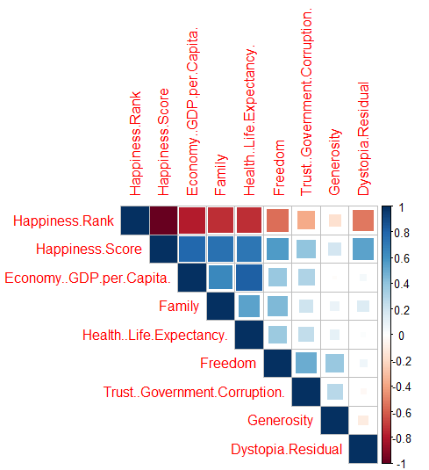

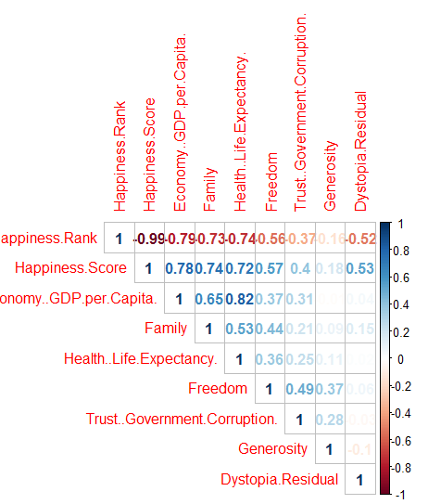

**BOXPLOT:**

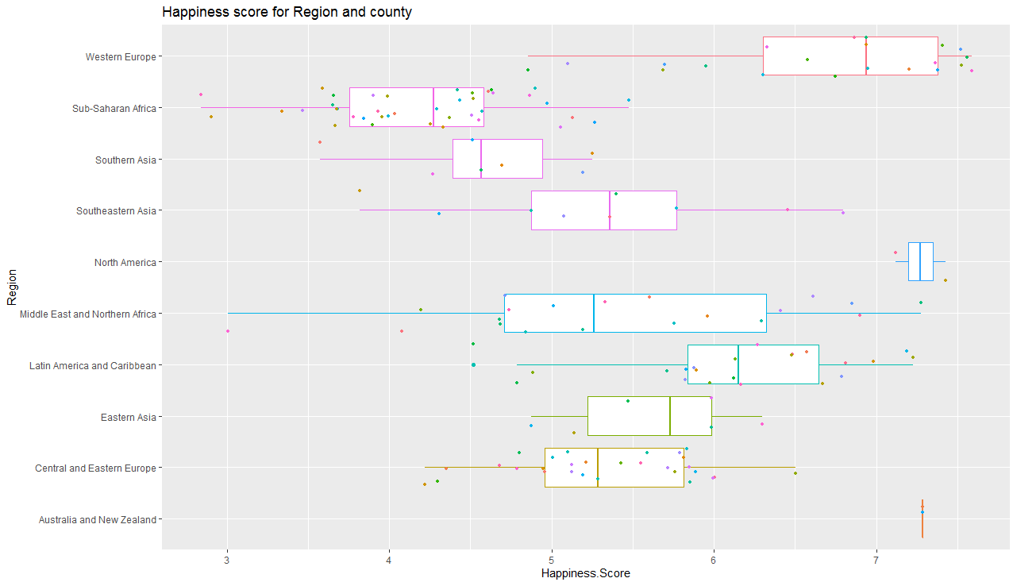

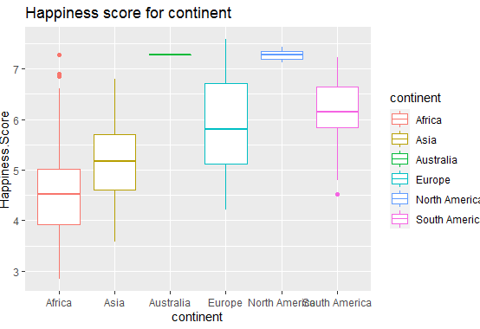

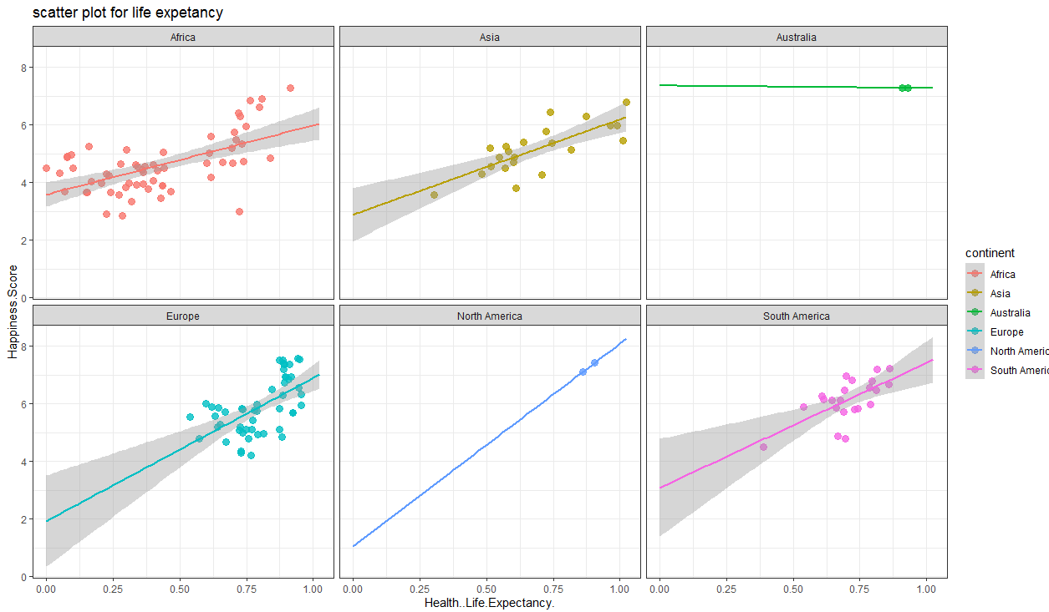

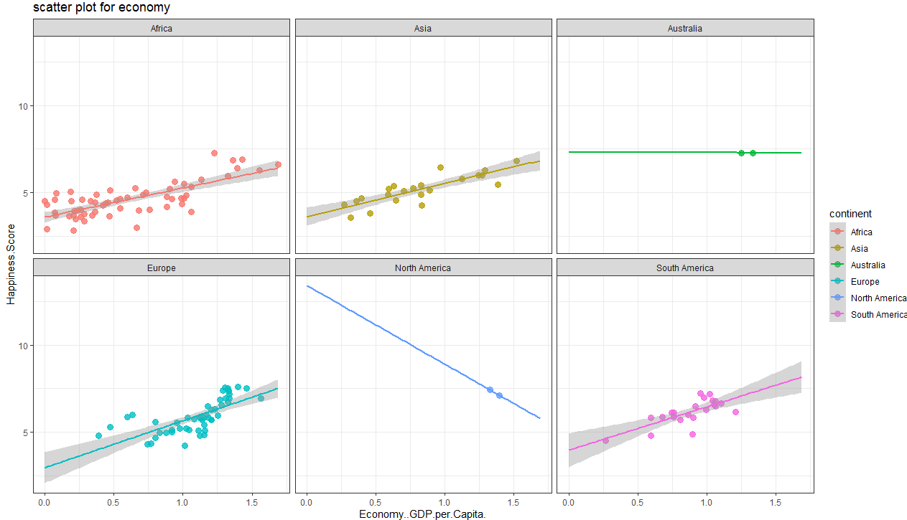

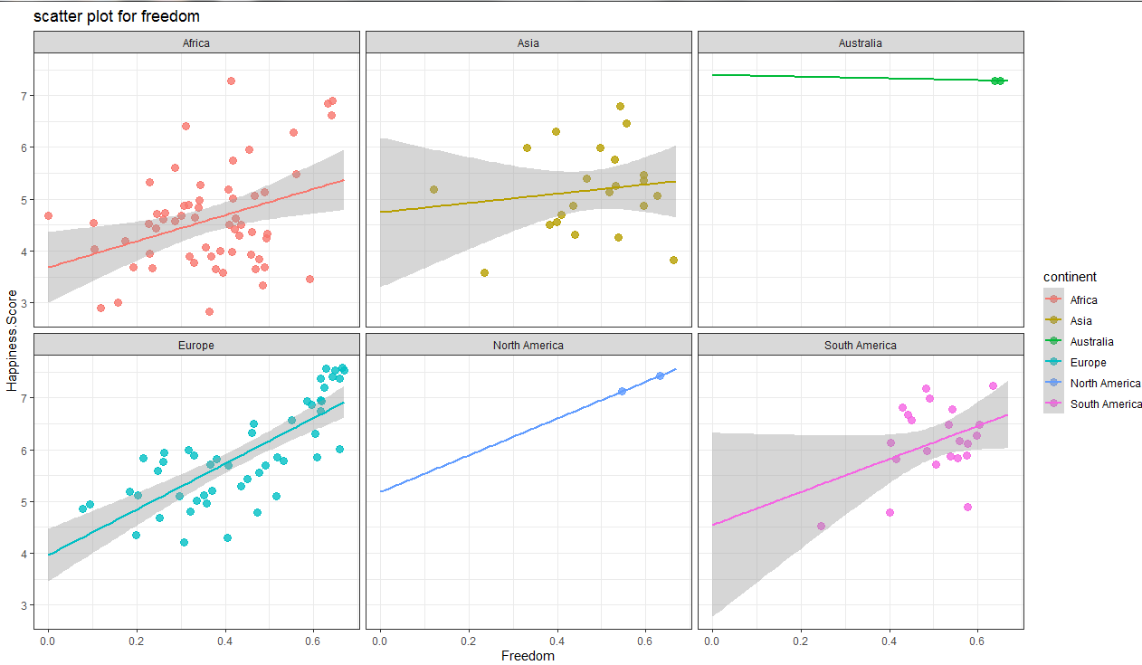

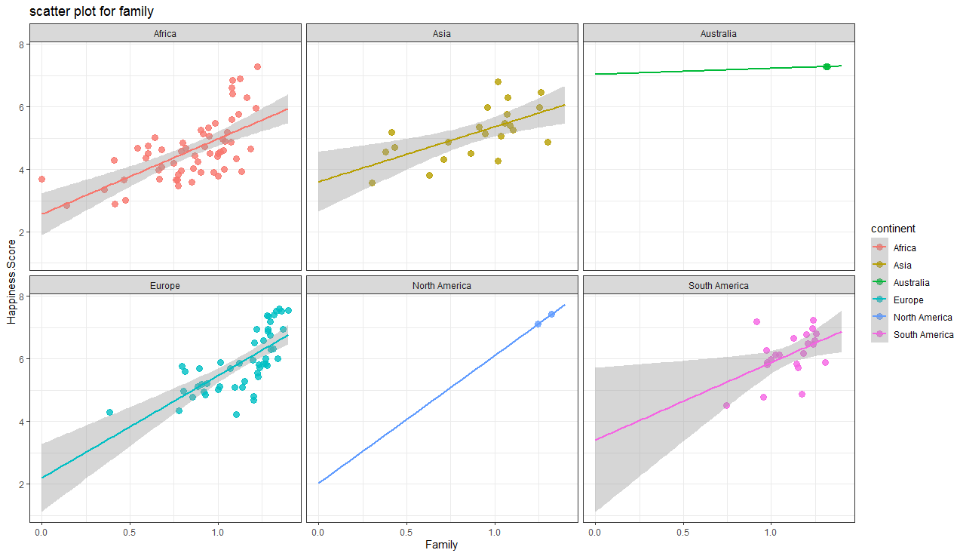

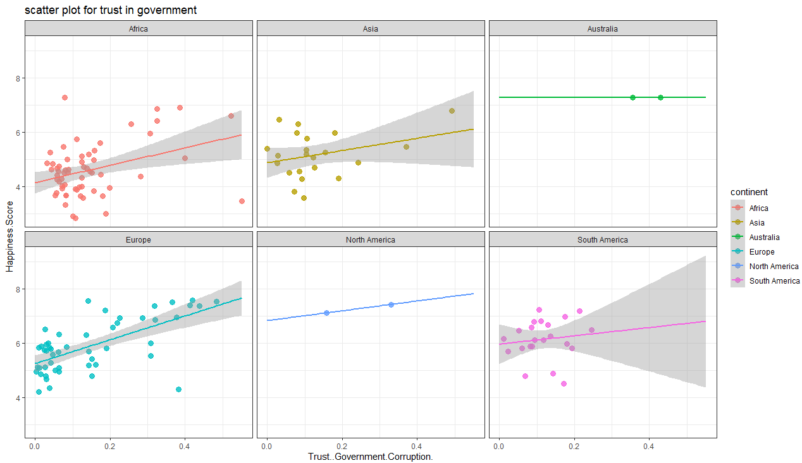

**SCATTER PLOT USING HAPPINESSMETER:**

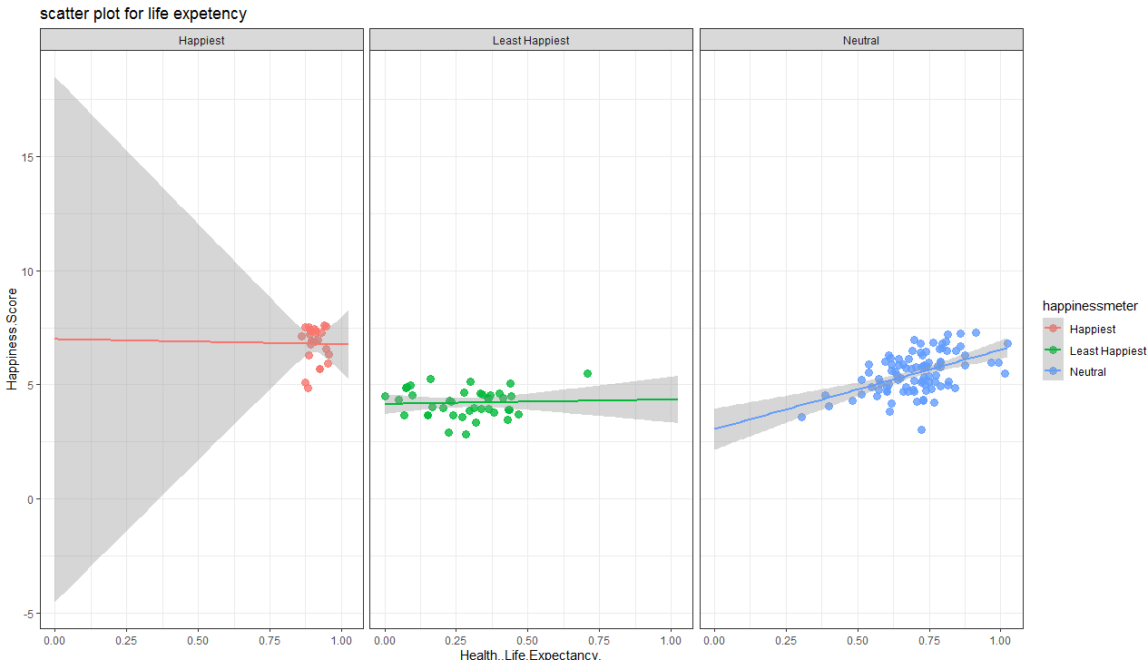

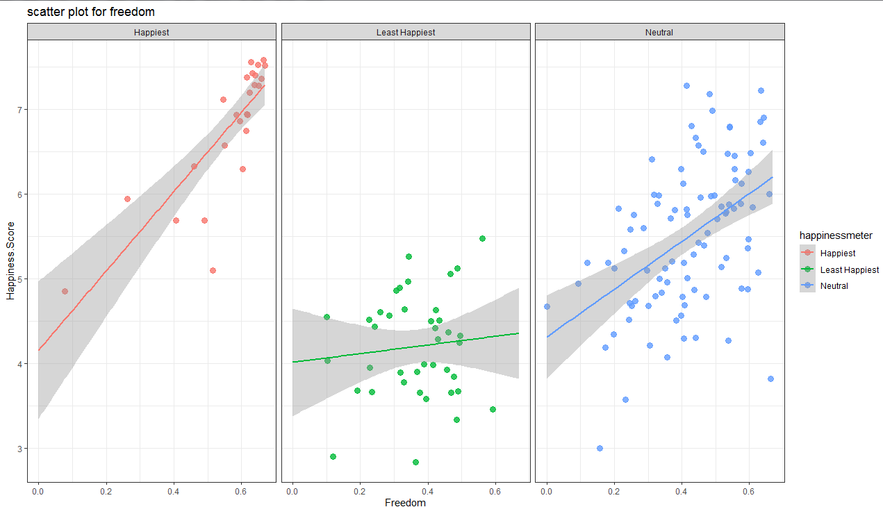

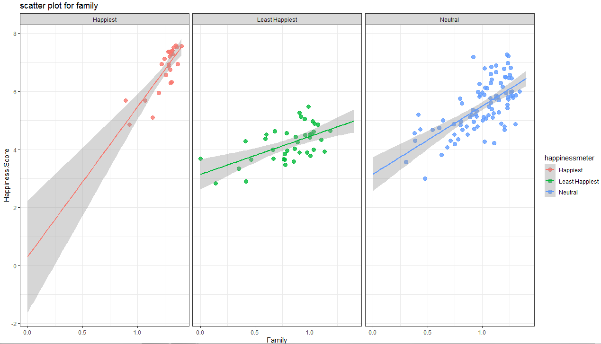



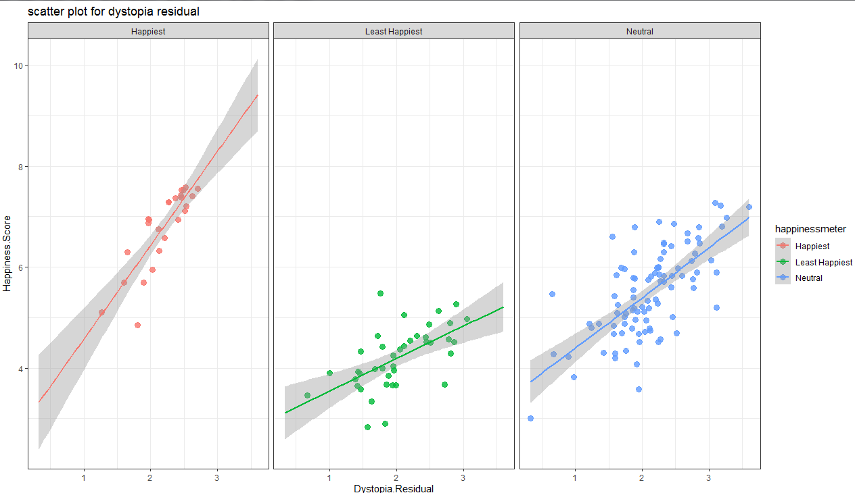

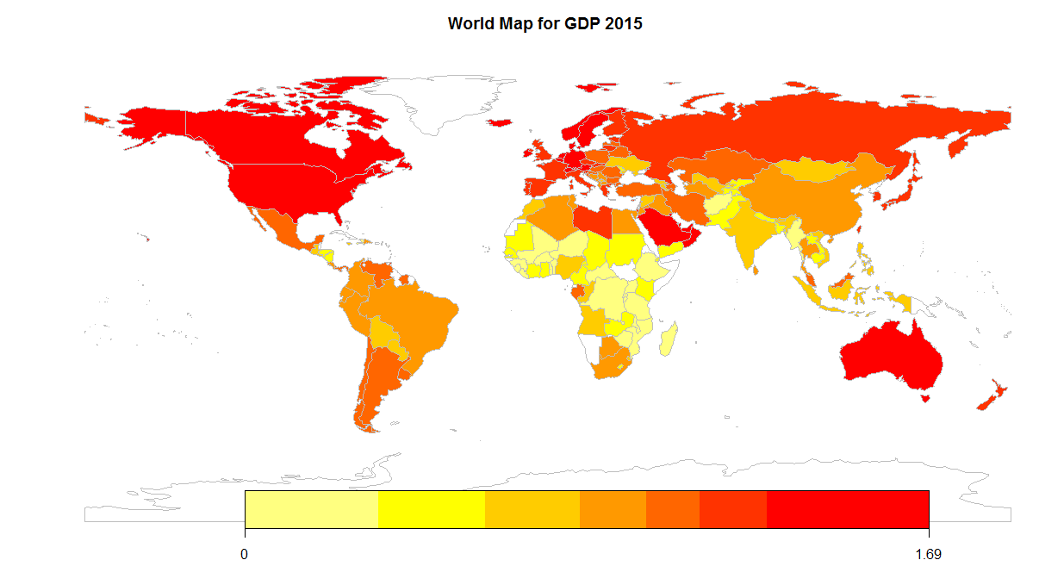

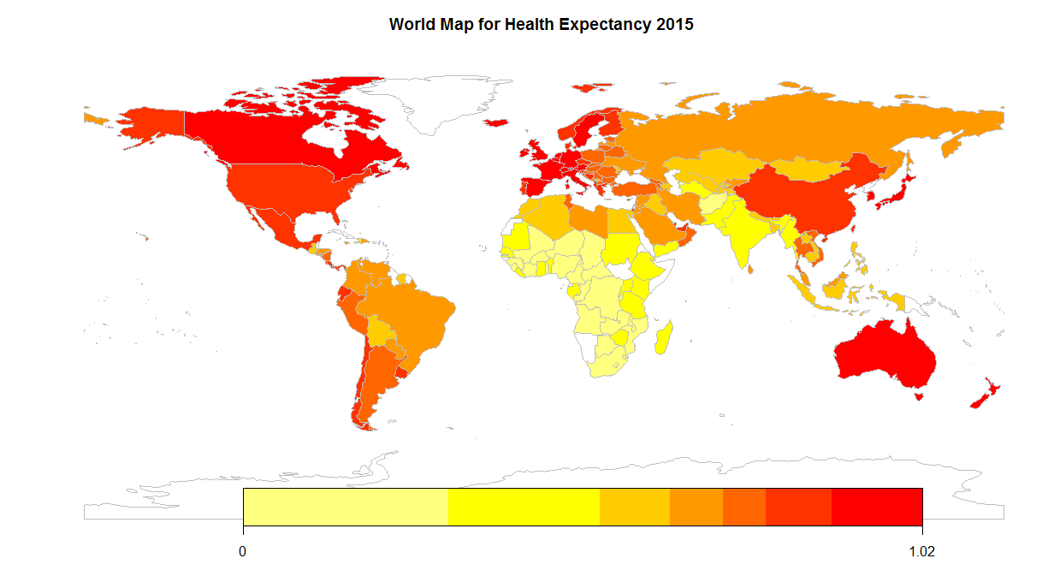

**CONCLUSION:**

Summary tells the gist of dataset:

Maximum and minimum happiness score:- 7.587 and 2.839 resp

Maximum GDP:-1.609

Health life Expectancy:-1.0252

Freedom:-.6697

Top 10 countries are from Western Europe (8) and Australia and New Zealand (2) Region

Last 10 countries majorly from Sub-Saharan Region (8)

* Happiness rank is inversely proportional to Score
* We will find correlation with Score
* Highest correlation variable:-GDP, Family, Health and Life Expectancy, Freedom, Dystopia Residual
* Happiness Region:- Western Europe(21), Australia Continent(2), North America(2)
* Unhappiest Region:- Sub-Saharan Africa(40)

**Health and Life Expectancy:**

Europe and South America have strong correlation

Africa has near neutral

**Economy GDP:**

South America has strong correlation

**Freedom:**

Europe and South America has positive correlation

Asia has poor correlation

**Happiness meter:**

Happiest: - Australia and New Zealand, Western Europe, North America

Unhappiest: - Sub-Saharan Africa

Neutral: - Southern Asia, South-eastern Asia, Middle East and Northern Africa

Latin America and Caribbean, Eastern Asia, Central and Eastern Europe

**Happiness Score for Continents:**

Europe is the happiest Continent

Africa is the unhappiest continent