━━━━━━
Plano de Ação Anual (PAA)
Deployment manual: putting the Annual Action Plan into production with Docker Compose or CapRover, and looking after it.
Implemented by G-Kakaroto

Contents
Right-click here and choose Update field to show the contents.

Putting the Plano de Ação Anual (PAA) into production with Docker Compose or CapRover: installing, e-mail, backups, updating and operating it.
This manual is for the people who install and look after the system: the institution's IT staff or its hosting partner. It does not describe how to use the application; for that, see the user manual.

1. Before you start

1.1 Choose how to deploy
 | Docker Compose | CapRover
Good for | A server you manage yourself, with Docker | A server that already runs CapRover, or where you want a web console
What runs | Six containers: web, app, queue, scheduler, MySQL, Redis (and Caddy for HTTPS, if you ask for it) | One container for the application, plus two one-click apps: MySQL and Redis
HTTPS | Caddy (included, optional) or your own proxy | CapRover does it
Configuration file | compose.prod.yml and .env.production | The app's environment variables in the CapRover console
Where to read | Part 2 | Part 3

Both run the same application image. Everything else in this manual (settings, e-mail, backups, updating, security) applies to both.
The compose file is not used by CapRover. CapRover reads only the captain-definition file at the root of the repository, which points to the Dockerfile.

1.2 What the application needs
Component | Why | Notes
MySQL 8 (5.7 also works) | The database | utf8mb4. Not MariaDB.
Redis 7 | Sessions, cache and the queue | Not published outside the server.
PHP-FPM and nginx | The application | Inside the image.
Queue worker | Sends e-mail notifications in the background | Inside the stack. Idle when e-mail is off.
Scheduler | Runs the nightly backup at 02:00 | Inside the stack.
SMTP account | Only if you want e-mail notifications | Any provider or your institution's mail server.

Sizing. For a ministry-sized user base (some hundreds of users): 2 CPU cores, 4 GB of memory and 20 GB of disk are comfortable. 1 core and 2 GB works for a trial or a small office. The application itself needs about 512 MB; MySQL needs most of the rest.

1.3 What to prepare
- A server (Linux for production) with Docker Engine and the Compose plugin, or a CapRover server.
- A name for the application, for example paa.example.gov.tl, with its DNS record pointing at the server, if you want HTTPS.
- Ports 80 and 443 reachable from the people who will use it. Do not open 3306 (MySQL) or 6379 (Redis).
- An SMTP account and a sender address your mail server accepts, for e-mail notifications.
- Secrets, each long and random: the application key, the database passwords, the Redis password and the administrator's password. Keep them in the institution's password manager, not in the repository.
- A place off the server for backups (another machine, a share, a bucket).

2. Deploy with Docker Compose

2.1 How it is put together
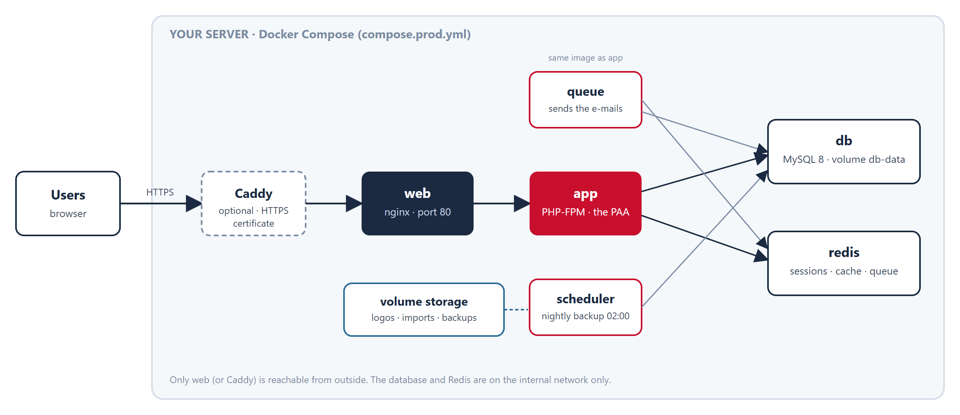
The Docker Compose stack
Only the web container (or Caddy, in front of it) is reachable from outside. The database and Redis stay on the internal network. The queue and the scheduler run the same image as the application, with a different command. Four volumes keep the data: the database, Redis, the application's storage folder (logos, imports, logs, backups) and Caddy's certificates.

2.2 Get the code and write the settings
git clone <repository> paa
cd paa
cp .env.production.example .env.production
Edit .env.production and fill in every value marked CHANGE. The most important:
Setting | What to put
APP_KEY | A new key, generated with the command below
APP_URL | The address people open, for example https://paa.example.gov.tl
DB_PASSWORD, DB_ROOT_PASSWORD, REDIS_PASSWORD | Long random passwords
ADMIN_EMAIL, ADMIN_PASSWORD | The first administrator (the password at least 12 characters)
APP_DOMAIN | The same name, if you use HTTPS through Caddy
MAIL_* | Your SMTP account, if you want e-mail (Part 5)

Generate the application key:
docker compose --env-file .env.production -f compose.prod.yml run --rm --no-deps -e WAIT_FOR_DB=false app php artisan key:generate --show
Copy the printed value (it starts with base64:) into APP_KEY.
Typing less. Set these once in your shell and drop --env-file and -f from the commands below: export COMPOSE_FILE=compose.prod.yml COMPOSE_ENV_FILES=.env.production.
Windows. Docker Desktop cannot build from a folder whose path contains characters outside plain ASCII (for example Orçamento): it fails with non-printable ASCII char. Use a plain path such as C:\paa. A Linux server does not have this problem.

2.3 Start it
docker compose --env-file .env.production -f compose.prod.yml up -d --build
The first build takes several minutes. When the app container starts, it waits for the database, builds it from the schema baseline and the migrations, and starts PHP-FPM. The queue, scheduler and web containers wait for it. Check:
docker compose --env-file .env.production -f compose.prod.yml ps
All services should be Up or healthy.

2.4 Create the roles and the first administrator
docker compose --env-file .env.production -f compose.prod.yml exec -u www-data app php artisan db:seed --force
This creates the roles, the economic categories, the default settings and the administrator from ADMIN_EMAIL and ADMIN_PASSWORD. Open http://<server>:8080 (the WEB_PORT), sign in, change the password at once, and continue with Part 4 of the user manual. The optional sample data is refused in production on purpose.

2.5 HTTPS
The simplest way is the Caddy service of the stack, which obtains and renews a free certificate by itself. It needs APP_DOMAIN in .env.production, the name pointing at the server, and ports 80 and 443 free and reachable:
docker compose --env-file .env.production -f compose.prod.yml --profile https up -d
Open https://<APP_DOMAIN>. Keep TRUSTED_PROXIES=* and SESSION_SECURE_COOKIE=true. If you already have your own proxy or load balancer, point it at the web container (WEB_PORT) and keep the same two settings.
For a trial on your own computer over plain http, set APP_URL=http://localhost:8080 and SESSION_SECURE_COOKIE=false. In production the application forces https links unless APP_URL starts with http://.

3. Deploy on CapRover
CapRover runs one container per app, so the repository has a single-container image for it: nginx, PHP-FPM, the queue worker and the scheduler run together in the app. The database and Redis are two separate CapRover apps.

3.1 How it is put together
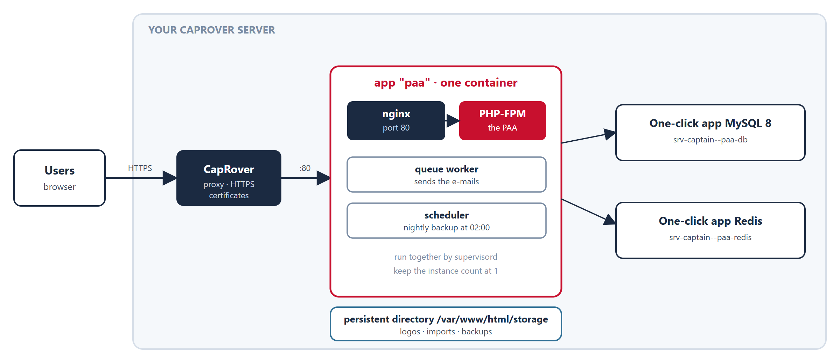
The CapRover deployment

3.2 The database and Redis
In Apps → One-Click Apps/Databases:
1. MySQL (version 8): name it paa-db and set a root password. Other apps reach it at srv-captain--paa-db.
2. Redis: name it paa-redis and set a password. Its address is srv-captain--paa-redis.

3.3 The application
1. Create an app named paa and tick Has Persistent Data. Enable HTTPS and Force HTTPS for its domain.
2. App Configs → Persistent Directories: add /var/www/html/storage with a label such as paa-storage. This keeps uploaded logos, logs and backups across deployments. Without it they are lost every time you deploy.
3. App Configs → Environmental Variables → Bulk Edit: paste the block below and fill it in.
APP_NAME=Plano de Ação Anual (PAA)
APP_ENV=production
APP_DEBUG=false
APP_KEY=base64:...
APP_URL=https://paa.your-domain
APP_LOCALE=tet
APP_FALLBACK_LOCALE=pt
LOG_CHANNEL=stderr
LOG_LEVEL=warning
TRUSTED_PROXIES=*
SESSION_SECURE_COOKIE=true
DB_CONNECTION=mysql
DB_HOST=srv-captain--paa-db
DB_PORT=3306
DB_DATABASE=paa
DB_USERNAME=root
DB_PASSWORD=<the MySQL root password>
REDIS_CLIENT=predis
REDIS_HOST=srv-captain--paa-redis
REDIS_PORT=6379
REDIS_PASSWORD=<the Redis password>
SESSION_DRIVER=redis
CACHE_STORE=redis
QUEUE_CONNECTION=redis
AUTO_CREATE_DB=true
RUN_MIGRATIONS=true
SEED_IF_EMPTY=true
ADMIN_NAME=Administrator
ADMIN_EMAIL=admin@your-domain
ADMIN_PASSWORD=<at least 12 characters>
MAIL_MAILER=smtp
MAIL_HOST=smtp.your-provider
MAIL_PORT=587
MAIL_USERNAME=...
MAIL_PASSWORD=...
MAIL_FROM_ADDRESS=paa@your-domain
To get a value for APP_KEY, run php artisan key:generate --show on any computer with the project, or use 32 random bytes encoded in base64 with the prefix base64:.
The three switches on the first start do this: AUTO_CREATE_DB creates the database if it does not exist (the user must be allowed to create databases, as root is), RUN_MIGRATIONS builds and updates its tables on every start, and SEED_IF_EMPTY creates the roles and the first administrator once, only while there is no user. They never touch existing data on later deployments.

3.4 Deploy
Deploy the repository by any CapRover method: a GitHub or GitLab webhook, caprover deploy, or an uploaded tar of the repository. The repository root must contain captain-definition. If CapRover says "Captain Definition file does not exist", the branch you are deploying does not have it. The first build takes several minutes.

3.5 After the deployment
- Open https://paa.your-domain, sign in with ADMIN_EMAIL and ADMIN_PASSWORD, and change the password at once.
- App Logs shows [paa] ... lines for each start-up step. GET /up answers 200 when the app is running.
- Keep the number of instances at 1. The scheduler runs inside the container, and a second instance would run the nightly backup twice.

4. Settings reference
These are environment variables: in .env.production for Docker Compose, in the app's environment for CapRover.
Setting | Default or example | Meaning
APP_KEY | none | Encryption key. Required. Never change it after people use the system: sessions and encrypted values stop working.
APP_ENV, APP_DEBUG | production, false | Leave as they are in production.
APP_URL | none | The public address. https:// in production.
APP_LOCALE, APP_FALLBACK_LOCALE | en, en | Default language (en, pt, tet) and the one used where a text is missing. People can switch language themselves.
LOG_CHANNEL, LOG_LEVEL | stderr, warning | Logs go to the container's output (docker compose logs, CapRover App Logs).
TRUSTED_PROXIES | empty | * behind Caddy or CapRover, so that links and cookies use https.
SESSION_SECURE_COOKIE | unset | true when the address is https; false for a trial over plain http.
DB_HOST, DB_PORT, DB_DATABASE, DB_USERNAME, DB_PASSWORD | db, 3306, … | The database.
DB_ROOT_PASSWORD | none | Docker Compose only: the MySQL root password.
REDIS_HOST, REDIS_PORT, REDIS_PASSWORD | redis, 6379 | Redis.
SESSION_DRIVER, CACHE_STORE, QUEUE_CONNECTION | redis | Keep redis in production.
RUN_MIGRATIONS | true (app container) | Build and update the database when the app starts.
SEED_IF_EMPTY | false | Run the base seeder once, while there is no user.
AUTO_CREATE_DB | false | Create the database if it does not exist.
ADMIN_NAME, ADMIN_EMAIL, ADMIN_PASSWORD | none | The first administrator, created by the seeder. The password is required in production.
MAIL_MAILER, MAIL_HOST, MAIL_PORT, MAIL_USERNAME, MAIL_PASSWORD, MAIL_SCHEME, MAIL_FROM_ADDRESS, MAIL_FROM_NAME | log | The SMTP account (Part 5). With log, mail is only written to the log.
BACKUP_ENABLED | true | The nightly backup.
BACKUP_KEEP_DAYS | 30 | Older backups are deleted after each run.
BACKUP_COPY_PATH | empty | A second folder each backup is copied to (for example /backups).
BACKUP_MAX_AGE_HOURS | 36 | /health reports "degraded" when the newest backup is older than this.
WEB_PORT | 8080 | Docker Compose only: the port of the web container on the server.
APP_DOMAIN | none | Docker Compose only: the name for the Caddy certificate.
BACKUP_HOST_DIR | ./backups | Docker Compose only: the server folder mapped to /backups.

5. E-mail and notifications
Inside the application nothing needs setting up. Notifications appear in the bell at the top. While a page is open the bell checks for new ones every 20 seconds and shows a short message when one arrives, so people do not have to reload.
By e-mail needs three things:
1. The MAIL_* settings of your SMTP account. Use MAIL_PORT=587 with MAIL_SCHEME=null (STARTTLS), or 465 with MAIL_SCHEME=smtps. MAIL_FROM_ADDRESS must be an address your mail server lets you send from.
2. The queue worker running. It is part of both deployments.
3. An administrator switching on System → Settings → Send notifications by e-mail. It is off by default. Each person can opt out under Profile → Also send me notifications by e-mail; the bell is never optional.
The mail is sent in the background, so a slow or broken mail server never holds up what a person is doing. A failed mail is retried three times and then recorded in the failed_jobs table.
To test it: switch it on, trigger a notification (for example, send an activity for approval), and follow the queue worker's output: docker compose logs -f queue with Docker Compose, or App Logs on CapRover. You should see SystemNotificationEmail ... DONE. If you only see it with MAIL_MAILER=log, the mail went to the log, not to a server.

6. Backups and restore
What is backed up. The scheduler makes a gzip-compressed mysqldump of the database every night at 02:00, keeps it in the storage volume under app/backups, deletes those older than BACKUP_KEEP_DAYS, and, if BACKUP_COPY_PATH is set, copies each to that folder as well. The storage volume also holds the uploaded logos and imports; they are small and rarely change.
A backup on the same disk is not a backup. Copy the folder off the server every day: another machine, a mounted share or a bucket. With Docker Compose, BACKUP_HOST_DIR (default ./backups) is a folder on the server you can copy from. On CapRover, use a second persistent directory, for example /backups, with BACKUP_COPY_PATH=/backups.
Run one now (Docker Compose):
docker compose --env-file .env.production -f compose.prod.yml exec -u www-data scheduler php artisan paa:backup
Restore into the database (Docker Compose). Stop the application first, so that nobody writes while you restore:
docker compose --env-file .env.production -f compose.prod.yml stop app queue scheduler web
gunzip -c backups/paa_YYYYMMDD_HHMMSS.sql.gz | docker compose --env-file .env.production -f compose.prod.yml exec -T db sh -c 'mysql -uroot -p"$MYSQL_ROOT_PASSWORD" "$MYSQL_DATABASE"'
docker compose --env-file .env.production -f compose.prod.yml start app queue scheduler web
Restore on CapRover. Find the backup file in the persistent volume (docker volume ls, then docker volume inspect <volume> shows its folder on the server), then on the server:
gunzip -c paa_YYYYMMDD_HHMMSS.sql.gz | docker exec -i $(docker ps -q -f name=srv-captain--paa-db) mysql -uroot -p<root password> paa
Stop the paa app in the CapRover console while you restore, and start it again afterwards.
Practise a restore once on a spare server before you need it. GET /health reports the age of the newest backup.

7. Updating and rolling back

7.1 Update
1. Take a backup (Part 6) and copy it off the server.
2. Get the new version and start it.
Docker Compose:
git pull
docker compose --env-file .env.production -f compose.prod.yml up -d --build
CapRover: deploy the new version by the same method as the first time.
3. The database is migrated when the application starts (RUN_MIGRATIONS=true). The queue worker restarts with the new code in the same step.
4. Open the application, sign in and check the pages you use most.

7.2 Roll back
Migrations are not undone. To go back to the previous version:
1. Stop the application.
2. Restore the backup taken before the update (Part 6).
3. Start the previous version of the code: git checkout <previous tag or commit> and up -d --build with Docker Compose, or deploy the previous commit on CapRover.

7.3 Updating the other services
With Docker Compose, MySQL, Redis and Caddy have their own images: docker compose ... pull then up -d brings them up to date. Do it at a quiet time and after a backup. Do not move MySQL to a new major version without reading its upgrade notes.

8. Operating the system
What | Docker Compose (after COMPOSE_FILE and COMPOSE_ENV_FILES are set) | CapRover
State of the services | docker compose ps | The app's page in the console
Application logs | docker compose logs -f app | App Logs
Queue worker logs (e-mail) | docker compose logs -f queue | App Logs (same container)
An artisan command | docker compose exec -u www-data app php artisan <command> | docker exec -it <app container> su-exec www-data php artisan <command> on the server
Stop everything (data is kept) | docker compose down | Stop the apps in the console

Never run `docker compose down -v` on a server in use: -v deletes the volumes, and the database with them.
Health. GET /up is the plain liveness check (HTTP 200 when the application runs). GET /health returns JSON with the state of the database, cache, storage, queue, disk and the latest backup, and no secrets. "status": "ok" is HTTP 200; "degraded" is also HTTP 200 and means something needs attention (failed or stuck queue jobs, under 10% free disk, no recent backup); "down" is HTTP 503 and means the database or the storage is unavailable. Point an uptime monitor at /health and read the status field, not only the HTTP code.
What is kept where.
Data | Docker Compose | CapRover
Database | volume db-data | the MySQL app's own data
Sessions, cache, queued jobs | volume redis-data | the Redis app's own data
Logos, imports, logs, backups | volume storage | the persistent directory
HTTPS certificates | volume caddy-data | CapRover

Housekeeping. The scheduler also clears failed jobs older than a week and expired password-reset tokens every day. Look at the free disk space from time to time: backups and Docker images grow. docker image prune removes old images.

9. Security checklist
- [ ] .env.production (or the CapRover variables) holds secrets: never commit them, and limit who can read them on the server.
- [ ] APP_DEBUG=false and APP_ENV=production.
- [ ] All passwords are long and random, and kept in a password manager.
- [ ] Ports 3306 and 6379 are not published. The compose file does not publish them.
- [ ] HTTPS is on, with SESSION_SECURE_COOKIE=true and TRUSTED_PROXIES=* behind the proxy.
- [ ] The first administrator's password was changed at the first sign-in, and the administrator uses two-factor sign-in (Profile).
- [ ] Self-registration stays off (the default): accounts are created by an administrator.
- [ ] The server's operating system and Docker are kept up to date; the application is rebuilt for each new version.
- [ ] Backups are copied off the server, and a restore has been practised.
- [ ] Only the people who administer the server have shell access to it; the application's administrators do not need it.

10. Troubleshooting
What you see | What it means and what to do
CapRover: Captain Definition file does not exist | The branch deployed has no captain-definition at its root. Deploy a version that has it.
APP_KEY is not set in the logs | Add APP_KEY to the settings. The container stops on purpose without it.
the database did not answer in time | Check DB_HOST (db with Docker Compose, srv-captain--paa-db on CapRover), the password, and that the database is running and healthy.
Access denied or Unknown database | The database or its user does not exist or the password differs. On CapRover set AUTO_CREATE_DB=true with the root user; with Docker Compose the db service creates it on its first start from DB_DATABASE, DB_USERNAME and DB_PASSWORD: if you changed them afterwards, the old volume still has the old ones.
The page shows no styling, or links start with http:// | APP_URL must be the https:// address, with TRUSTED_PROXIES=* and HTTPS forced at the proxy.
Docker build fails with non-printable ASCII char | The project folder has a non-ASCII character in its path (Windows). Use a plain path.
Docker build stops while downloading images | A network interruption. Run the build again: layers already downloaded are kept.
The app container restarts again and again | docker compose logs app shows why: usually a missing setting or a database that does not answer.
No e-mail arrives | Check, in this order: the switch in Settings is on; the person has not opted out; MAIL_MAILER is smtp and not log; the queue worker's log shows DONE or an error; the address in MAIL_FROM_ADDRESS is accepted by your mail server; the failed_jobs table.
The bell does not update | The page must be open and visible: the check pauses in a hidden tab. Reload once; check the browser's network tab for failing requests.
Uploaded logos disappear after an update | The storage volume or persistent directory is missing: add it (Part 3.3) and upload them again.
/health says degraded | Read which part: usually the newest backup is older than BACKUP_MAX_AGE_HOURS, the disk is nearly full, or queue jobs failed (look at the queue worker's log and the failed_jobs table). down means the database or storage cannot be reached.

11. Go-live checklist
Before
- [ ] The server is ready, with the name pointing at it and ports 80 and 443 open.
- [ ] Every secret is generated and stored.
- [ ] .env.production or the CapRover variables are filled in, with APP_URL as the https:// address.
- [ ] A trial deployment has been tried once, including an update and a restore.
Go-live
- [ ] The stack is up and every service is healthy; /up and /health answer 200.
- [ ] You can sign in as the administrator, and the password has been changed.
- [ ] The institution's name, logo, language and rules are set in System → Settings (user manual, Part 4).
- [ ] E-mail has been tested with one real notification.
- [ ] A first backup exists, and it is copied off the server.
After
- [ ] An uptime monitor watches /health.
- [ ] Someone is named to apply updates and to watch disk space and backups.
- [ ] The institution's own people have the user manual and the administrator account is held by more than one person.

