The input files are represented in a tabular form as shown below and used to analyse further.

|  |  |  |  |  |  |  |  |
| --- | --- | --- | --- | --- | --- | --- | --- |
| Database | workloads | Total record | total read operation | total  update operations | Overall throughput | Avg read latency | Avg update latency |
| **Hbase** | W1 | 12500 | 6160 | 6340 | 946.468 | 571.244 | 1228.166 |
| W2 | 25000 | 12439 | 12561 | 1353.4 | 451.68 | 874.121 |
| W3 | 50000 | 24890 | 25110 | 1580.528 | 434.64 | 738.083 |
| W4 | 100000 | 49677 | 50323 | 2016.048 | 357.338 | 587.703 |
| **MongoDB** | W1 | 12500 | 6316 | 6184 | 2150.353 | 369.466 | 446.807 |
| W2 | 25000 | 12489 | 12511 | 2739.726 | 280.697 | 380.547 |
| W3 | 50000 | 25022 | 24978 | 3007.157 | 273.558 | 344.674 |
| W4 | 100000 | 49979 | 50021 | 3844.971 | 206.934 | 288.421 |

1. **A graphical representation of the recorded Average Latency against the number of record read operations for HBase and MongoDB over all 4 workloads**

Below graph represents the average read latency versus the read record operations of both the databases.

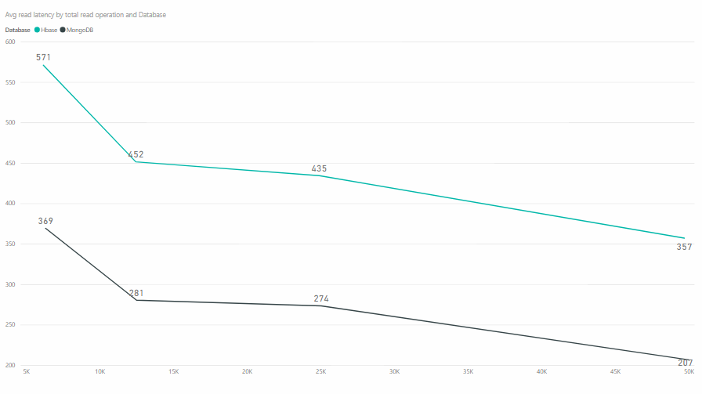

The above clearly states that the average latency for read operations is better in case of MongoDB than HBase. The databases shows that the average latency reduces with increase in number of read record operations.

1. **A graphical representation of the recorded Average Latency against the number of record update operations for HBase and MongoDB over all 4 workloads**

Below graph represents the average update latency versus the update record operations of both databases.

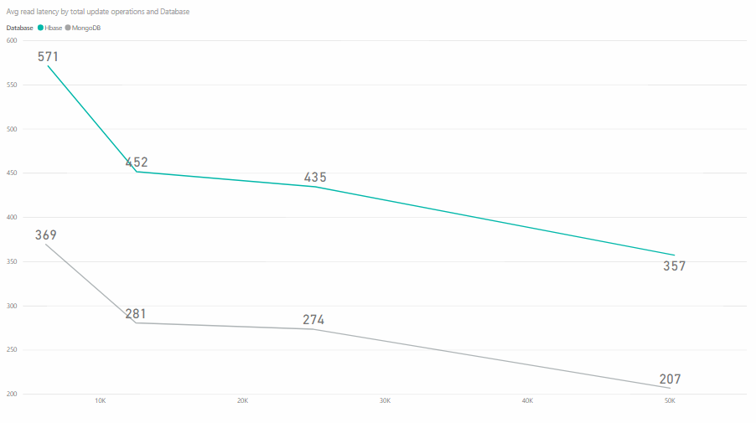

MongoDB performs better than HBase in terms of average update latency. The average update latency of MongoDB is lesser than that of HBase. The average latency for update operations in Hbase reduces as the workload increases.

1. **A graphical representation of the recorded Overall Throughput against the total number of record operations for HBase and MongoDB over all 4 workloads**

Below graph represents the Overall throughput versus the total record operations.

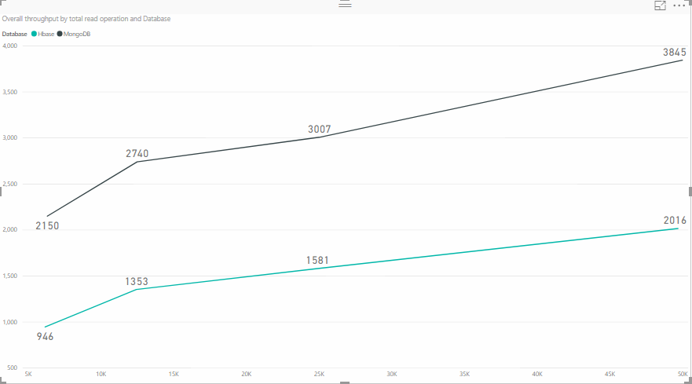

Overall throughput is better in case of MongoDB than HBase.

**Part B**

1. **Did any of the attempted database operations across any of the workloads fail? Justify your answer by indicating how this can be determined from the output files.**

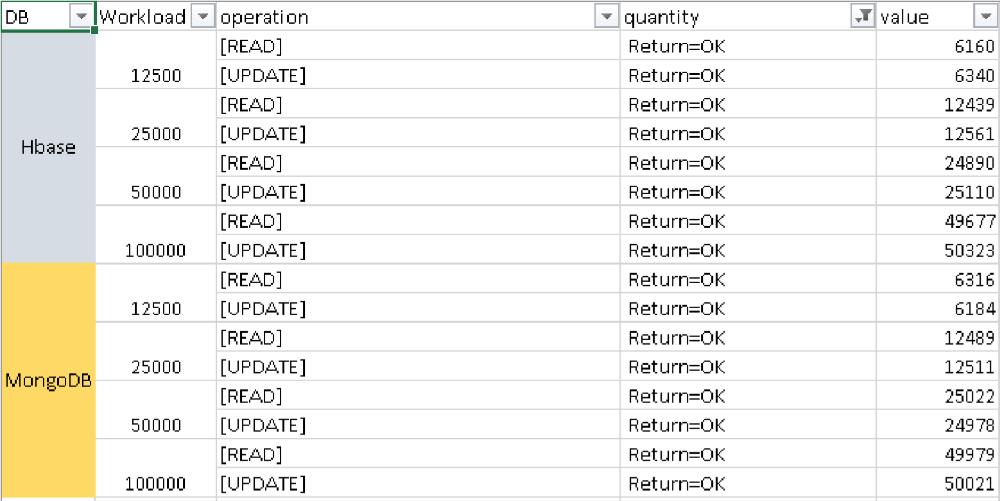

The data provided in the above table have all operations returned as “OK”. No “failure” or “not found” have been returned.