Ellipse Drawing: Polar and Non Polar

Code:
from OpenGL.GL import *
from OpenGL.GLU import *
from OpenGL.GLUT import *
import sys
import math

WINDOW_SIZE = 500
SCALE = 100
xc = yc = 0
rx = ry = 1
def polar_ellipse():
glClear(GL_COLOR_BUFFER_BIT)
glColor3f(1, 0, 0)
glPointSize(5)
glBegin(GL_POINTS)
global xc, yc, rx, ry
theta = 0.0
while theta <= 1.57:
x = float(rx) * math.cos(theta)
y = float(ry) * math.sin(theta)
plot_symmetric_points(x, y)
theta += 0.001
glEnd()
glFlush()

def non_polar_ellipse():
glClear(GL_COLOR_BUFFER_BIT)
glColor3f(1, 0, 0)
glPointSize(5)
glBegin(GL_POINTS)
global xc, yc, rx, ry
x = 0

while x <= rx:
y = ry * math.sqrt(1 - ((x * x) / (rx * rx)))
plot_symmetric_points(x, y)
x += 0.01
glEnd()
glFlush()

def plot_symmetric_points(x, y):
global xc, yc
glVertex2f((xc + x) / SCALE, (yc + y) / SCALE)
glVertex2f((xc + x) / SCALE, (yc - y) / SCALE)
glVertex2f((xc - x) / SCALE, (yc + y) / SCALE)
glVertex2f((xc - x) / SCALE, (yc - y) / SCALE)
def no_plot():
pass

def main():
glutInit(sys.argv)
glutInitDisplayMode(GLUT_SINGLE | GLUT_RGB)
glutInitWindowSize(WINDOW_SIZE, WINDOW_SIZE)
glutInitWindowPosition(50, 50)
global xc, yc, rx, ry
xc = int(input("Enter x coordinate of the centre "))
yc = int(input("Enter y coordinate of the centre "))
rx = int(input("Enter length of semimajor axis "))
ry = int(input("Enter length of semiminor axis "))
choice = int(input("1. Polar ellipse algorithm\n 2. Non polar ellipse algorithm\nEnter choice: "))
if choice == 1:
glutCreateWindow("Polar ellipse drawing algorithm")
glutDisplayFunc(polar_ellipse)
elif choice == 2:
glutCreateWindow("Nonpolar ellipse drawing algorithm")
glutDisplayFunc(non_polar_ellipse)
else:
print("Invalid option!")
glutCreateWindow("Invalid option")
glutDisplayFunc(no_plot)
glutMainLoop()
main()

Output:
1.
Enter x coordinate of the centre 10
Enter y coordinate of the centre 20
Enter length of semimajor axis 70
Enter length of semiminor axis 30
1. Polar ellipse algorithm
2. Non polar ellipse algorithm
Enter choice: 1
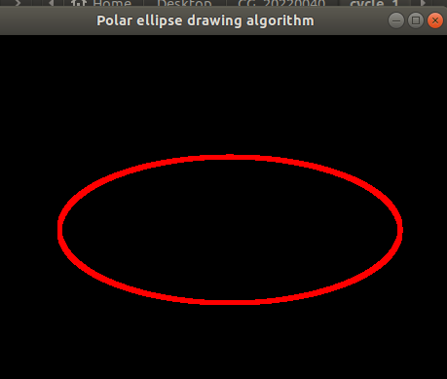

2.
Enter x coordinate of the centre 10
Enter y coordinate of the centre 20
Enter length of semimajor axis 40
Enter length of semiminor axis 70
1. Polar ellipse algorithm
2. Non polar ellipse algorithm
Enter choice: 2
