Circle Drawing: Polar, Non Polar, Midpoint

Code:
ffrom OpenGL.GL import *
from OpenGL.GLU import *
from OpenGL.GLUT import *
import sys
import math

WINDOW_SIZE = 500
SCALE = 100
xc = yc = 0
r = 1

def init_display():
glClear(GL_COLOR_BUFFER_BIT)
glColor3f(1, 0, 0)
glPointSize(5)
def midpoint_circle():
glBegin(GL_POINTS)
global xc, yc, r
x, y = 0, r
p = 1 - r
plot_symmetric_points(x, y)
while x < y:
x += 1
if p < 0:
p += 2 * x + 1
else:
y -= 1
p += 2 * (x - y) + 1
plot_symmetric_points(x, y)
glEnd()
glFlush()

def polar_circle():
glBegin(GL_POINTS)
theta = 0.0
while theta <= 6.28:
x = float(r) * math.cos(theta)
y = float(r) * math.sin(theta)
glVertex2f(x / SCALE, y / SCALE)
theta += 0.001
glEnd()
glFlush()

def nonpolar_circle():
global xc, yc, r
glBegin(GL_POINTS)
x, y = xc, r
plot_symmetric_points(x - xc, y)
while x < (xc + r):
x += 1
y = math.sqrt(float((r * r) - ((x - xc) * (x - xc))))
plot_symmetric_points(x - xc, y)
glEnd()
glFlush()

def plot_symmetric_points(x, y):
global xc, yc
glVertex2f((xc + x) / SCALE, (yc + y) / SCALE)
glVertex2f((xc + x) / SCALE, (yc - y) / SCALE)
glVertex2f((xc - x) / SCALE, (yc + y) / SCALE)
glVertex2f((xc - x) / SCALE, (yc - y) / SCALE)
glVertex2f((xc + y) / SCALE, (yc + x) / SCALE)
glVertex2f((xc + y) / SCALE, (yc - x) / SCALE)
glVertex2f((xc - y) / SCALE, (yc + x) / SCALE)
glVertex2f((xc - y) / SCALE, (yc - x) / SCALE)
def no_circle():
pass

def main():
glutInit(sys.argv)
glutInitDisplayMode(GLUT_SINGLE | GLUT_RGB)
glutInitWindowSize(WINDOW_SIZE, WINDOW_SIZE)
glutInitWindowPosition(50, 50)
global xc, yc, r
xc = int(input("Enter x coordinate of the centre "))
yc = int(input("Enter y coordinate of the centre "))
r = int(input("Enter length of radius "))
choice = int(input("Enter the required choice:\n 1. Midpoint circle algorithm\n 2. Polar circle generation algorithm\n 3. Non-Polar circle generation algorithm\nEnter Choice:"))

if choice == 1:
glutCreateWindow("Circle: Midpoint")
init_display()
glutDisplayFunc(midpoint_circle)
elif choice == 2:
glutCreateWindow("Circle: Polar")
init_display()
glutDisplayFunc(polar_circle)

elif choice == 3:
glutCreateWindow("Circle: Non Polar")
init_display()
glutDisplayFunc(nonpolar_circle)
else:
glutCreateWindow("Error")
init_display()
glutDisplayFunc(no_circle)
print("Invalid option chosen!")
glutMainLoop()
main()

Output:
1.
Enter x coordinate of the centre 10
Enter y coordinate of the centre 20

Enter length of radius 70
1. Midpoint circle algorithm
2. Polar circle generation algorithm
3. Non-Polar circle generation algorithm
Enter Choice:1

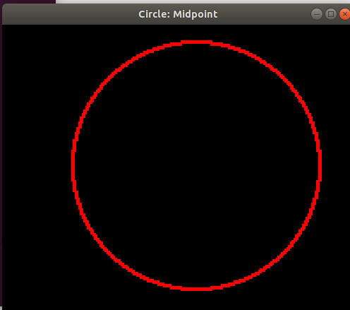

2.
Enter x coordinate of the centre 10
Enter y coordinate of the centre 20
Enter length of radius 80
Enter the required choice:
1. Midpoint circle algorithm
2. Polar circle generation algorithm
3. Non-Polar circle generation algorithm
Enter Choice:2
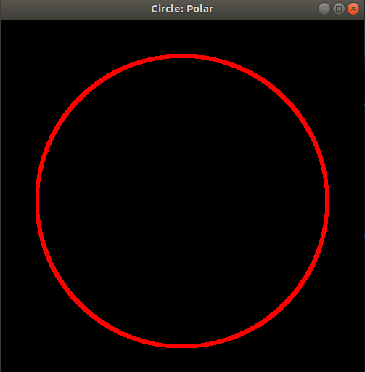

3.
Enter x coordinate of the centre 10
Enter y coordinate of the centre 20

Enter length of radius 60
Enter the required choice:
1. Midpoint circle algorithm
2. Polar circle generation algorithm
3. Non-Polar circle generation algorithm
Enter Choice:3

