

Sardar Patel Institute of Technology, Mumbai

Department of Electronics and Telecommunication Engineering

T.E. Sem-V (2020-2021)

ETL53-Fundamentals of Antenna Lab

**Lab - 1: Fundamental Parameters of Antenna**

**Name: Kaustubh Venkatesh Name : Gokul Nair**

**UID : 2018120033 Batch : C Roll No. : 36 UID : 2018120039 Batch : C Roll No. : 43**

# Aim

To compute and infer various fundamental parameters of antenna like Radiation pattern, Radiation power density, Radiation Intensity, Gain, Directivity, HPBW and FNBW.

# Introduction

The *IEEE Standard Definitions of Terms for Antennas* (IEEE Std 145–1983) defines the antenna or aerial as “a means for radiating or receiving radio waves.” In other words the antenna is the transitional structure between free-space and a guiding device. the antenna must also serve as a directional device in addition to a probing device.

# Antenna parameters

To describe the performance of an antenna, definitions of various parameters are necessary. Some of the parameters are interrelated and not all of them need be specified for

complete description of the antenna performance.

## Radiation Pattern

Defined as the mathematical function or a graphical representation of the radiation properties of the antenna as a function of space coordinates

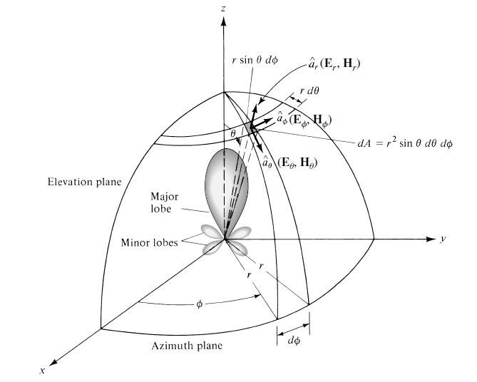

Figure 1 : Co-ordinate system for Antenna Analysis

## Radiation Intensity

Radiation intensityin a given direction is defined as “the power radiated from an antenna per unit solid angle.

## Directivity

Therefore directivity of an antenna defined as “the ratio of the radiation intensity in a given direction from the antenna to the radiation intensity averaged over all directions.

## D. BeamWidth

The beam-width of a pattern is defined as the angular separation between two identical points on opposite side of the pattern maximum. One of the most widely used beam-widths is the *Half-Power Beam-width* (*HPBW* ), which is defined as: “In a plane containing the direction of the maximum of a beam, the angle between the two directions in which the radiationintensity is one-half value of the beam.”

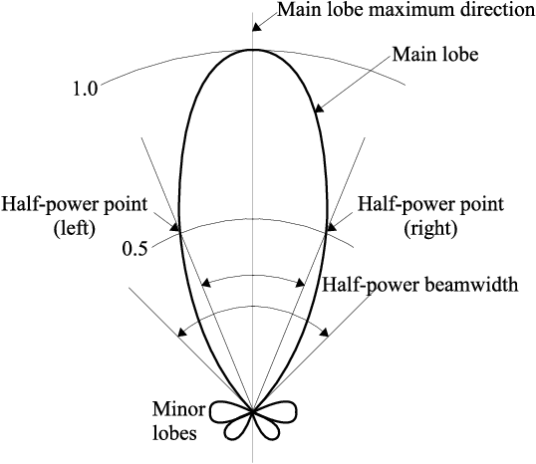

Figure 2 : 2 - Dimensional Power Pattern of an Antenna

## Radiation Power Density

The power density associated with the electromagnetic fields of an antenna in its far-field region is predominately real and is referred to as radiation power density.

## Gain

Gainof an antenna (in a given direction) is defined as “the ratio of the intensity, in a given direction, to the radiation intensity that would be obtained if the power accepted by the antenna were radiated isotropically.

# Code and Observations

%Fundamentals of Antenna LAB 1

%Calculation of Antenna Parameters

%Date : 18-08-2020

%MATLAB version R2020a

% Given : U(θ,φ) = cos²(2θ)*cos²(3θ)

clear all;

clc;

close all;

theta = [-pi/2:0.01:pi/2];

N = length(theta);

rad_pat = [];

for i = 1:N

rad_pat(i)=(cos(2*theta(i))*cos(3*theta(i)))^2;

end

%Polar plot of radiation intensity

polarplot(theta,rad_pat,'g','LineWidth',2);

title('Polar Plot of Radiation Pattern');

set(gca,'FontSize',15);

thetaticks(0:30:360);

%Calculating the value of B0

Prad = 10;

r = 1000;

fun = @(x,y)(cos(2*x).*cos(3*x)).^2.*sin(x);

ymax = 2*pi;

q = integral2(fun,0,pi/2,0,ymax);

B0 = Prad/q;

fprintf("Value of B0 ie. Max value of U : %.5f W/sr", B0);

%Value of Maximum Power density

W = B0/(r^2);

fprintf("\nValue of Maximum Power density : %d W/m2", W);

%Calculating directivity

D = 4*pi*B0/Prad;

fprintf("\nValue of Directivity : %.5f ", D);

D = 10*log10(D);

fprintf("\in dB : %.5f ", D);

%Calculating gain

ecd = 1;

Gain = D*ecd;

fprintf("\nSince the antenna is lossless, gain is the same as D.");

fprintf("\nValue of Gain : %.5f ", Gain);

%Calculating half power beamwidth

[val,idx]= min(abs(rad_pat-0.5));

minVal= abs(theta(idx));

hpbw = 2*180*minVal/pi;

fprintf("\nValue of Half Power Beam Width : %.5f Degrees", hpbw);

syms x

fnbw= solve(((cos(2*x).*cos(3*x)).^2)==0,x);

fnbw = min(fnbw)*2*180/pi;

fprintf("\nValue of First Null Beamwidth : %.5f Degrees\n", fnbw);

clear all;

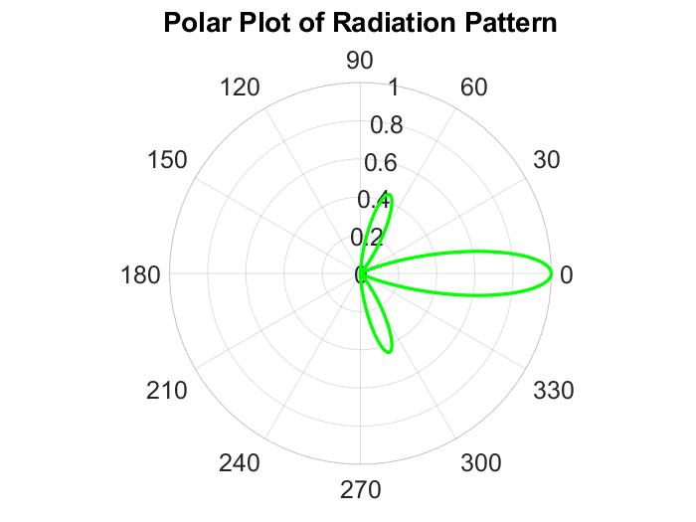

Figure 3 : Output Polar Plot of Radiation Pattern

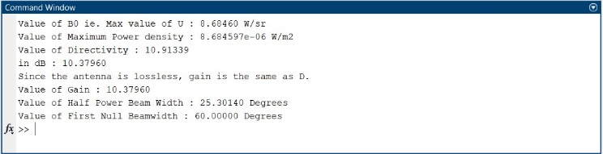

Figure 4 : Console Output in MATLAB

* As the power of the radiation intensity function increases, the bulge in the lobes decreases and directivity increases

# Conclusion

* From the experiment conducted, it can be concluded that an antenna is a device used to radiate or receive radio waves.
* Their performance can be described using various mathematically defined parameters such as radiation pattern, intensity, beamwidth, directivity etc.
* As the degree of the function of radiation intensity increases, the directivity and gain also increase.