

Sardar Patel Institute of Technology, Mumbai

Department of Electronics and Telecommunication Engineering

T.E. Sem-V (2020-2021)

ETL53-Fundamentals of Antenna Lab

**Lab - 2: Friis Transmission Equation**

**Name: Kaustubh Venkatesh Name : Gokul Nair**

**UID : 2018120033 Batch : C Roll No. : 36 UID : 2018120039 Batch : C Roll No. : 43**

# Aim

To compute and infer Friis Transmission equation under condition polarization matched and unmatched.

# Introduction

The Friis transmission formula is used in telecommunications engineering, equating the power at the terminals of a receive antenna as the product of power density of the incident wave and the effective aperture of the receiving antenna under idealized conditions given another antenna some distance away transmitting a known amount of power.

# Friis Transmission equation

The Friis Transmission Equation relates the power received to the power transmitted between two antennas separated by a distance R > 2D2/λ, where D is the largest dimension of either antenna.

## The Equation

According to the Friis Transmission equation for a general case, the ratio of the received to the input power of is represented by :

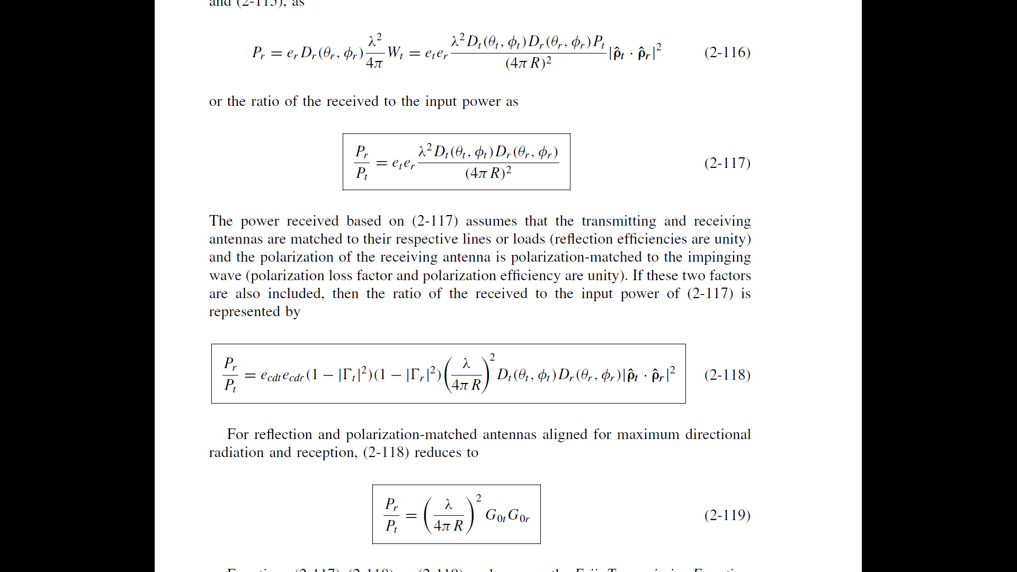

Where

* ecdt and ecdr are the efficiencies of the antennas
* Pt is the Power transmitted
* Pr is the Power received
* λ is the wavelength of the signal
* Dt and Dr are the Directivities of the antennas
* R is the distance between the two antennas
* ρt and ρr are the polarization vectors of the antennas
* Γt and Γr are the Reflection Coefficients of the antennas

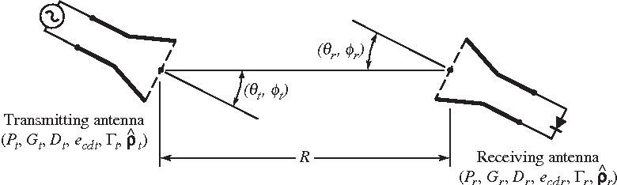

Figure 1 : Geometrical orientation of transmitting and receiving antennas for Friis transmission equation

## Polarization

Polarization of an antenna in a given direction is defined as “the polarization of the wave transmitted (radiated) by the antenna in the direction of maximum gain.” In practice, polarization of the radiated energy varies with the direction from the centre of the antenna, so that different parts of the pattern may have different polarizations. The types of polarization possible are :

* Linear Polarization
* Circular Polarization
* Elliptical Polarization

## Directivity

The directivity of an antenna defined as “the ratio of the radiation intensity in a given direction from the antenna to the radiation intensity averaged over all directions.

## Polarization Loss Factor

It is defined, based on the polarization of the antenna in its transmitting mode, as : PLF = |ˆρt · ˆρr |2

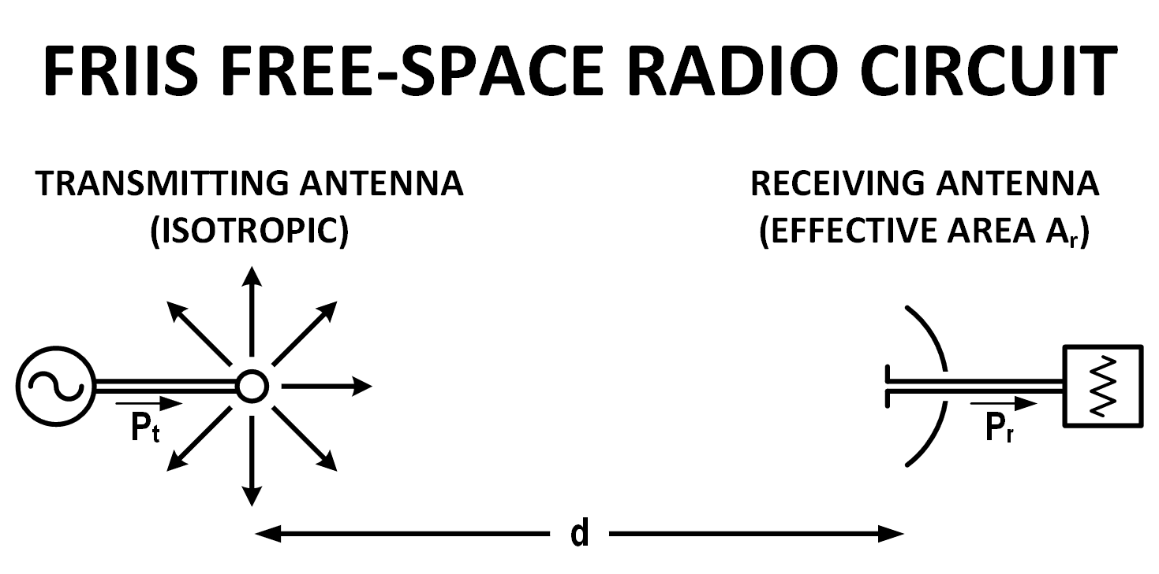

Figure 2 : Friis free-space radio circuit

# Code and Observations

%Fundamentals of Antenna LAB 2

%Calculating power received by antenna using Friis Transmission Equation

%MATLAB version R2020a

%Date : 25-08-2020

clc;

clear all;

close all;

freq = input("Enter the Frequency of transmission (in GHZ) : ");

inp = input("Do you want to enter Gain or Directivity?\n1)Press 1 for Gain\n2)Press 2 for Directivity : ");

wave_length = 3e8/(freq*1e9);

Gtx = 1;

Grx = 1;

switch inp

case 1

Gtx = input("Enter the gain of the Transmitting antenna (in dB) : ");

Grx = input("Enter the gain of the Receiving antenna (in dB) : ");

Gtx = 10^(Gtx/10);

Grx = 10^(Grx/10);

case 2

Dtx = input("Enter the Directivity of the Transmitting antenna (in dB) : ");

Drx = input("Enter the Directivity of the Receiving antenna (in dB) : ");

Dtx = 10^(Dtx/10);

Drx = 10^(Drx/10);

ecd_tx = input("Enter the efficiency of the Transmitting antenna : ");

ecd_rx = input("Enter the efficiency of the Receiving antenna : ");

Gtx = ecd_tx*Dtx;

Grx = ecd_rx*Drx;

otherwise

Gtx = 10;

Grx = 100;

end

r = input("Enter the distance between the antennas (in m) : ");

prad = input("Enter the Power radiated in Watts : ");

flag = input("Enter 1 if Antenna's Polarization is matched and 0 for Unmatched : ");

plf = 1;

rho_rx = 0;

rho_ry = 0;

rho_tx = 0;

rho_ty = 0;

if (flag == 1)

plf = 1;

else

disp("Please represent the complex number as 'i'");

rho_rx = input("Enter the X-component of Polarizing vector for the Receiving antenna : ");

rho_ry = input("Enter the Y-component of Polarizing vector for the Receiving antenna : ");

rho_tx = input("Enter the x-component of Polarizing vector for the Transmitting antenna : ");

rho_ty = input("Enter the Y-component of Polarizing vector for the Transmitting antenna : ");

plf = (abs(rho_rx*rho_tx + rho_ry*rho_ty))^2;

end

p1 = rho_rx + rho_ry;

p2 = rho_tx + rho_ty;

p1 = p1/norm(p1);

p2 = p1/norm(p2);

Ex1 = rho_tx;

Ey1 = rho_ty;

phi=angle(Ey1)-angle(Ex1);

if abs(Ex1)==abs(Ey1) && phi==pi/2

ptype1="CCW Circular Polarization";

elseif abs(Ex1)==abs(Ey1) && phi==-pi/2

ptype1="CW Circular Polarization";

elseif abs(Ex1)~=abs(Ey1) && phi==pi/2

ptype1="CCW Elliptical Polarization";

elseif abs(Ex1)~=abs(Ey1) && phi==-pi/2

ptype1="CW Elliptical Polarization";

elseif Ex1~=0 && Ey1~=0 && phi==pi || phi==0

ptype1="Linear Polarization";

else

ptype1="Invalid";

end

Ex2 = rho_rx;

Ey2 = rho_ry;

phi2 = angle(Ey2)-angle(Ex2);

if abs(Ex2)==abs(Ey2) && phi2==pi/2

ptype2="CW Circular Polarization";

elseif abs(Ex2)==abs(Ey2) && phi2==-pi/2

ptype2="CCW Circular Polarization";

elseif abs(Ex2)~=abs(Ey2) && phi2==pi/2

ptype2="CW Elliptical Polarization";

elseif abs(Ex2)~=abs(Ey2) && phi2==-pi/2

ptype2="CCW Elliptical Polarization";

elseif phi2==pi || phi2==0

ptype2="Linear Polarization";

else

ptype2="Invalid";

end

disp("Polarization of Transmitting antenna : " + ptype1);

disp("Polarization of Receiving Antenna : " + ptype2);

%Friis Transmission equation

prec = prad*plf*Gtx*Grx*(wave_length/(4*pi*r))^2;

fprintf("The Power received by the antenna is : %d W\n",prec);

if flag == 0

VarNames = {'Power Received in Watts', 'Power Transmitted in Watts','Tx Polarization','Rx polarization', 'Tx Gain', 'Rx Gain', 'PLF'};

T = table(prec ,prad, ptype1, ptype2, Gtx, Grx,plf, 'VariableNames',VarNames);

else

VarNames = {'Power Received in Watts', 'Power Transmitted in Watts', 'Tx Gain', 'Rx Gain'};

T = table(prec, prad, Gtx, Grx, 'VariableNames', VarNames);

End

disp(T);

clear all;

* Inference :

Using the Friis Transmission equation, we can calculate the power received by the antenna based on the gain, reflection coefficients, relative polarization as well as the frequency of transmission.

* Console Output :

Enter the Frequency of transmission (in GHZ) : 3

Do you want to enter Gain or Directivity?

1)Press 1 for Gain

2)Press 2 for Directivity : 1

Enter the gain of the Transmitting antenna (in dB) : 10

Enter the gain of the Receiving antenna (in dB) : 20

Enter the distance between the antennas (in m) : 3000

Enter the Power radiated in Watts : 50

Enter 1 if Antenna's Polarization is matched and 0 for Unmatched : 0

Please represent the complex number as 'i'

Enter the X-component of Polarizing vector for the Receiving antenna : 1

Enter the Y-component of Polarizing vector for the Receiving antenna : 0

Enter the x-component of Polarizing vector for the Transmitting antenna : 0.707

Enter the Y-component of Polarizing vector for the Transmitting antenna : 0.707i

Polarization of Transmitting antenna : CCW Circular Polarization

Polarization of Receiving Antenna : Linear Polarization

The Power received by the antenna is : 1.758517e-07 W

* Command Window :

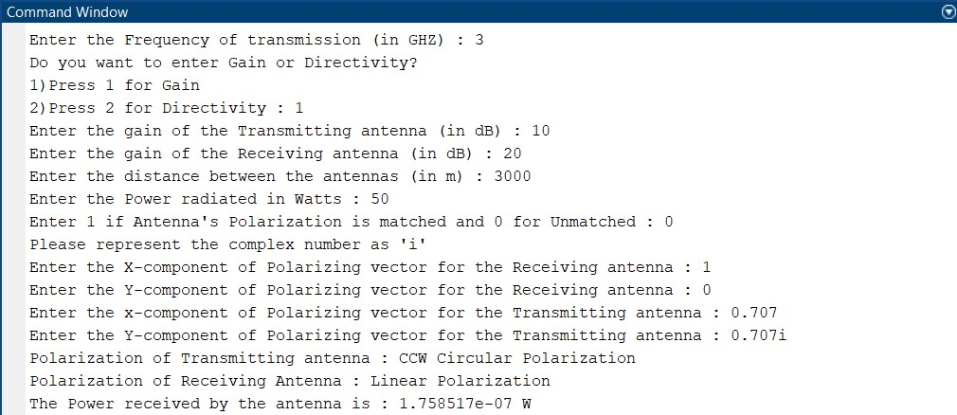

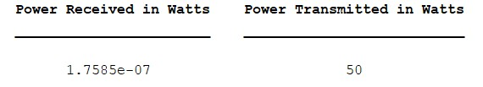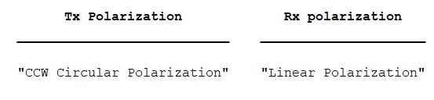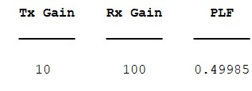

# Conclusion

* From the experiment conducted, it can be concluded that the analysis and design of radar and communications systems often require the use of the Friis Transmission Equation.
* The power received is maximum when the two antennas have a matched polarization.