

Sardar Patel Institute of Technology, Mumbai

Department of Electronics and Telecommunication Engineering

T.E. Sem-V (2020-2021)

ETL53-Fundamentals of Antenna Lab

**Lab - 3: Pyramidal Horn Antenna**

**Name: Kaustubh Venkatesh Name : Gokul Nair**

**UID : 2018120033 Batch : C Roll No. : 36 UID : 2018120039 Batch : C Roll No. : 43**

# Aim

To design a Pyramidal Horn antenna in E and H plane. Consider the E plane aperture (Ae = 10) is fed with a rectangular wave guide with TE-10 mode. The dimensions of the three rectangular wave guide area = 0.2 in E plane and b = 0.375 in the H plane. Compute the following :

1) length of the horn antenna

2) H plane aperture

3) flare angle for E and H plane

4) HPBW and FNBW in E and H plane.

5) Directivity

Input Parameters :

Operating Frequency = 4.4 GHz

# Introduction

A horn antenna is an antenna that consists of a flaring metal waveguide shaped like a horn to direct radio waves in a beam. Horns are widely used as antennas at UHF and microwave frequencies, above 300 MHz. Their advantages are moderate directivity, low standing wave ratio (SWR), broad bandwidth, and simple construction and adjustment.

# Pyramidal horn antenna

## Construction

A horn antenna with the horn in the shape of a four-sided pyramid, with a rectangular cross section. They are a common type, used with rectangular waveguides, and radiate linearly polarized radio waves.

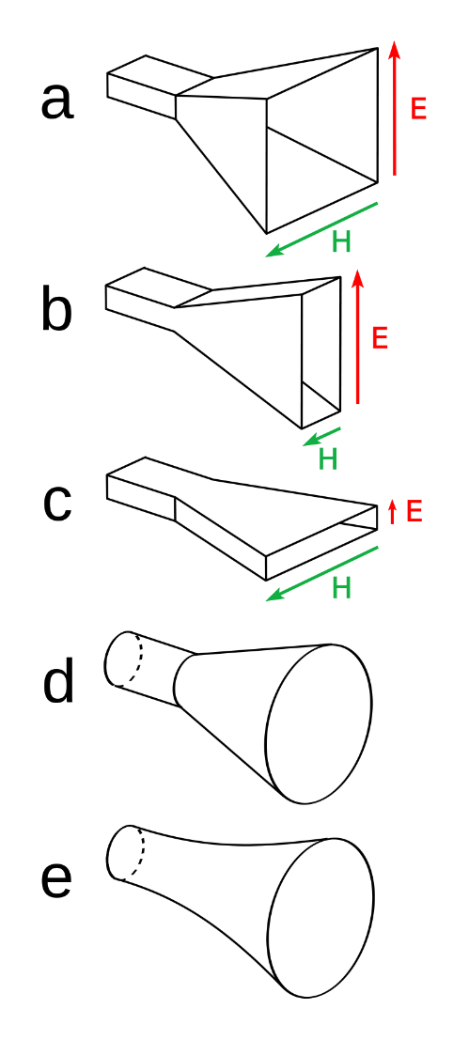

Figure 1 : Basic Construction

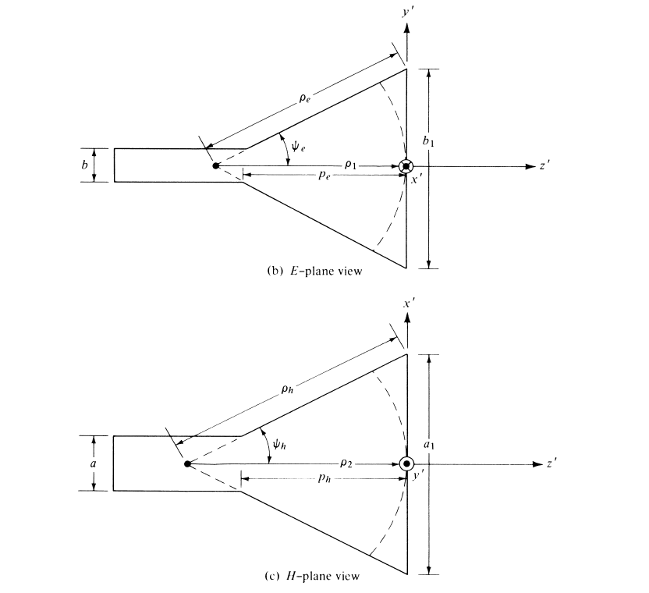

Figure 2 : E and H Plane View

## E and H field Equations

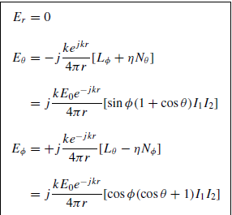

## Angle of Flare

One of the key properties of a horn antenna is the angle at which the horn flares out. This affects many areas of performance such as gain and directivity. The angle of flare can be different for E and H planes.

# Code and Observations

%Fundamentals of Antenna LAB 3

%Pyramidal Horn Antenna

%MATLAB version R2020a

%Date : 08-09-2020

%Op Freq = 4.4 GHz

clear all;

clc;

close all;

f = input("Enter Operating Frequency in GHz : ");

aE1 = input("Enter E-plane aperture : ");

a = input("Dimension of rectangular waveguide in E-plane (a) : ");

b = input("Dimension of rectangular waveguide in H-plane (b) : ");

wave_length = (3e8)/(f*1e9);

aE = aE1 * wave_length;

deltaE = a * wave_length;

deltaH = b * wave_length;

l = (aE*aE)/(8*deltaE);

disp("Length of horn antenna : " + num2str(l) + " m");

aH = sqrt(l*8*deltaH);

disp("H-Plane Aperture : " + num2str(aH));

b1 = aE/(2*l);

c = aH/(2*l);

thetaE = 2*(atan(b1))*(180/pi);

disp("Flare angle in E-plane : " + num2str(thetaE) + " Degrees");

thetaH = 2*(atan(c))*(180/pi);

disp("Flare angle in H-plane : " + num2str(thetaH) + " Degrees");

HPBWE = 56/aE;

disp("HPBW in E-plane : " + num2str(HPBWE) + " Degrees");

HPBWH = 67/aH;

disp("HPBW in H-plane : " + num2str(HPBWH) + " Degrees");

FNBWE = 115/aE;

disp("FNBW in E-plane : " + num2str(FNBWE) + " Degrees");

FNBWH = 172/aH;

disp("FNBW in E-plane : " + num2str(FNBWH) + " Degrees");

Ap = aE*aH;

D = 10*(log10(7.5*Ap));

disp("Directivity : " + num2str(D) + " dB");

clear all;

* Inference :

Using the Operational Frequency, aperture and dimensions of the waveguides, we can calculate the various parameters of a pyramidal horn antenna such as its length, HPBW, FNBW, Directivity, Flare angle etc.

* Console Output :

Enter Operating Frequency in GHz : 4.4

Enter E-plane aperture : 10

Dimension of rectangular waveguide in E-plane (a) : 0.2

Dimension of rectangular waveguide in H-plane (b) : 0.375

Length of horn antenna : 4.2614 m

H-Plane Aperture : 0.93362

Flare angle in E-plane : 9.1478 Degrees

Flare angle in H-plane : 12.503 Degrees

HPBW in E-plane : 82.1333 Degrees

HPBW in H-plane : 71.76­38 Degrees

FNBW in E-plane : 168.6667 Degrees

FNBW in E-plane : 184.2295 Degrees

Directivity : 6.789 dB

* Command Window :

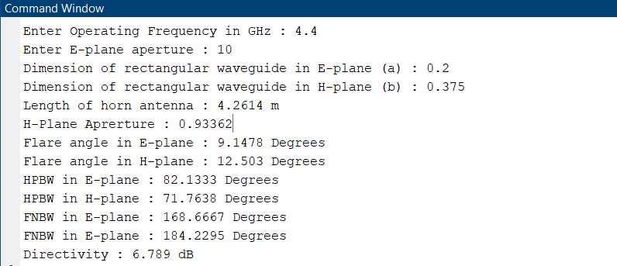

# Conclusion

* From the experiment conducted, it can be concluded that using the frequency, aperture and waveguide dimensions, we can design a pyramidal horn antenna to fit the given specifications.
* As the aperture of the antenna in E and H plane increase, the directivity also increases.