

Sardar Patel Institute of Technology, Mumbai

Department of Electronics and Telecommunication Engineering

T.E. Sem-V (2020-2021)

ETL53-Fundamentals of Antenna Lab

**Lab - 4: Pattern Multiplication Phenomenon**

**Name: Kaustubh Venkatesh Name : Gokul Nair**

**UID : 2018120033 Batch : C Roll No. : 36 UID : 2018120039 Batch : C Roll No. : 43**

# Aim

To show Pattern Multiplication phenomena in an Antenna using two infinitesimal dipoles. Given an array of two infinitesimal dipoles positioned along the z-axis, the normalized total field radiated by the two elements assuming no coupling between the elements is :

Etn = cos(theta)*cos(k*d*cos(theta)+ beta)/2).

Compute the following :

### 1) Compute all the nulls.

### 2) Plot the Radiation pattern of single Antenna element.

### 3) Plot the Radiation pattern of an Array Antenna

### 4) Plot the Pattern Multiplication phenomena

Operational Parameters :

Distance between the Antennas (d) = lambda

Phase Difference (beta) = + pi/ 2

# Introduction

An antenna array (or array antenna) is a set of multiple connected antennas which work together as a single antenna, to transmit or receive radio waves. The individual antennas (called elements) are usually connected to a single receiver or transmitter by feedlines that feed the power to the elements in a specific phase relationship.

# Two element array

## Basic Equations

Let us assume that the antenna under investigation is an array of two infinitesimal horizontal dipoles positioned along the z-axis, as shown in the figure The total field radiated by the two elements, assuming no coupling between the elements, is equal to the sum of the two and in the y-z plane it is given by :

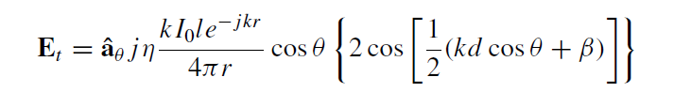

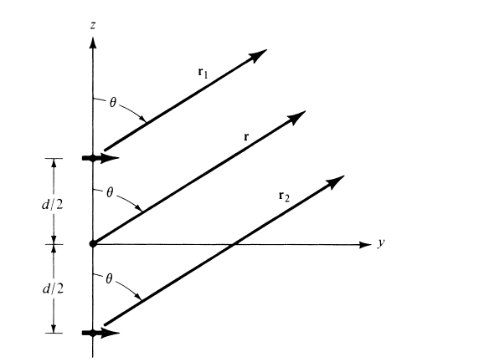

Figure 1 : Geometry of a 2-element array for far field approximations (along z-axis)

## Patter Multiplication

It has been illustrated that the far-zone field of a uniform two-element array of identical elements is equal to the product of the field of a single element, at a selected reference point (usually the origin), and the array factor of that array. That is :

E(total) = [E(single element at reference point)] × [array factor]

This is referred to as pattern multiplication for arrays of identical elements.

## Array Factor

The array factor, in general, is a function of the number of elements, their geometrical arrangement, their relative magnitudes, their relative phases, and their spacings.

For a two element array made up of infinitesimal dipoles, the normalized array factor is given by :

(AF)n = cos[ 0.5 * (kd cos θ + β)]

Where :

* θ : Angle between the axis and line joining the point and the array
* β : Phase difference
* d : Distance between the antennas
* k : Angular Wave Number

# Code and Observations

%Fundamentals of Antenna LAB 4

%Pattern Multiplication Phenomenon

%MATLAB version R2020a

%Date : 15-09-2020

% Operational Parameters :

% d = lambda

% beta = +pi/2

clear all;

clc;

close all;

%Declaring Variables

lambda = 1;

theta = linspace(0,2*pi,1000);

c = input("Enter the distance between the antenna in terms of wavelength (d) : ");

d = lambda*c;

beta = input("Enter the phase difference in radians (?): ");

k = 2*pi/lambda;

N = length(theta);

%The antenna array equation

Et_1 = abs(cos(theta));

Et_2 = [];

for i=1:N

Et_2(i)= abs(cos(0.5*(k*d*cos(theta(i))+beta)));

end

%Total Pattern multiplication

Et = Et_1.*Et_2;

%Calculating the nulls of the plot

syms x

nulls = solve(cos(0.5*(k*d*cos(x)+beta)) == 0,x);

disp("The nulls are : ");

for i=1:length(nulls)

temp = 180*nulls(i)/pi;

fprintf("%d) %.3f Degrees\n",i,temp);

end

%Plotting the graphs

subplot(131);

polarplot(theta, Et_1, 'r','LineWidth',2);

title('Polar Plot(Radiation Pattern)','FontSize',15);

set(gca,'FontSize',15);

subplot(132);

polarplot(theta, Et_2, 'g', 'LineWidth', 2);

title('Polar Plot(Array Factor)','FontSize',15);

set(gca,'FontSize',15);

subplot(133);

polarplot(theta, Et, 'b', 'LineWidth', 2);

title('Polar Plot(Combined Plot)','FontSize',15);

set(gca,'FontSize',15);

thetaticks(0:30:360);

clear all;

* Inference :

Using the distance between the antennas and the phase difference, we can plot the polar graphs of the radiation patterns of the two infinitesimal dipole antenna array and also calculate the null angles associated with it.

* Console Output :

Enter the distance between the antenna in terms of wavelength (d) : 1

Enter the phase difference in radians (β): pi/2

The nulls are :

1) -75.522 Degrees

2) 75.522 Degrees

* Output Polar Plots :

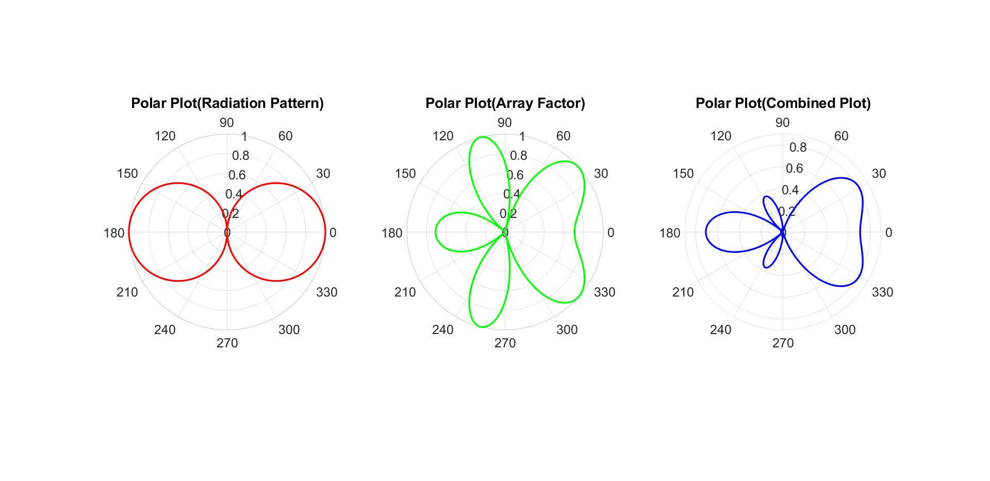 



# Conclusion

* From the experiment conducted, it can be concluded that the total electric and magnetic fields of an antenna array is given by the array factor multiplied by the field due to a single element.
* The array factor depends upon the geometrical arrangement, spacing, magnitude and phase difference of the individual antennas.