

Sardar Patel Institute of Technology, Mumbai

Department of Electronics and Telecommunication Engineering

T.E. Sem-V (2020-2021)

ETL53-Fundamentals of Antenna Lab

**Lab - 5: N-element Uniform Amplitude Broadside Array**

**Name: Kaustubh Venkatesh Name : Gokul Nair**

**UID : 2018120033 Batch : C Roll No. : 36 UID : 2018120039 Batch : C Roll No. : 43**

# Aim

To design a uniform array of N elements so that its maximum is directed towards the broad side. The spacing between the elements is lambda/10. For the array factor of the antenna, compute the :

1) Progressive phase excitation,

2) All the angles in degrees where the nulls will occur.

3) All the angles in degrees where the maximas will occur

4) Half Power beam width

5) Directivity in dimensionless and dB

6) Plot the radiation pattern of the array factor

The elements are oriented along the z-axis symmetrically

Operational Parameters : N = 6

# Introduction

An antenna array (or array antenna) is a set of multiple connected antennas which work together as a single antenna, to transmit or receive radio waves. The individual antennas (called elements) are usually connected to a single receiver or transmitter by feedlines that feed the power to the elements in a specific phase relationship.

# N Element broadside array

## Basic Equations

In many applications it is desirable to have the maximum radiation of an array directed normal to the axis of the array [broadside; θ0 = 90].

To avoid any grating lobe, the largest spacing between the elements should be less than one wavelength (d_max < λ).

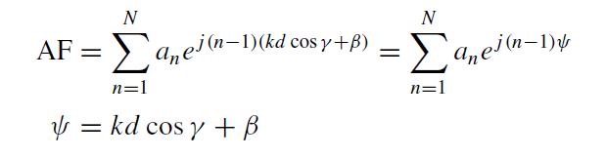

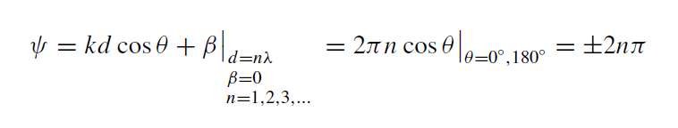

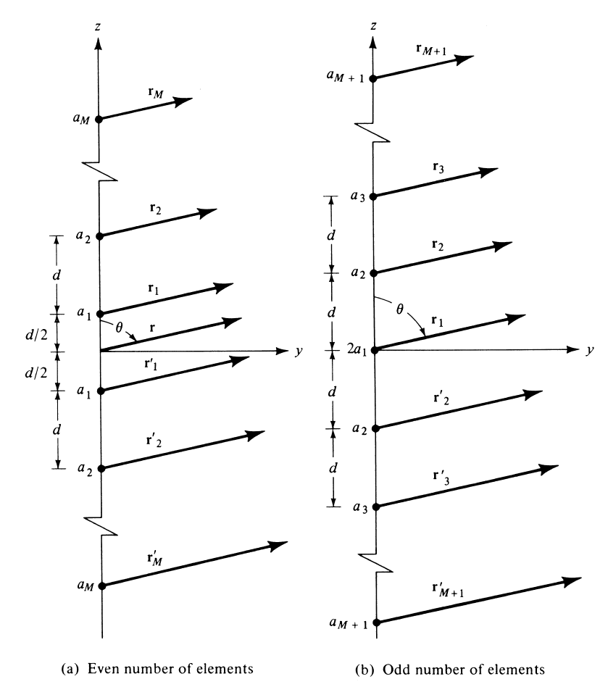

Figure 1 : Geometry of N Element arrays

## Nulls and Maximas of Broadside Array

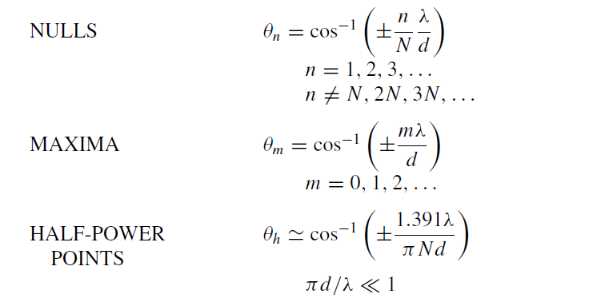

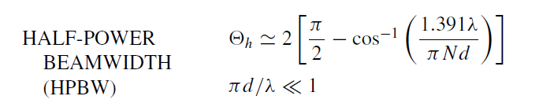

## Directivity

For an N element Broadside array, the maximum directivity is given by :

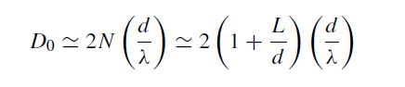

Where :

* θ : Angle between the axis and line joining the point and the array
* d : Distance between the antennas
* k : Angular Wave Number
* N : Number of antenna elements

# Code and Observations

%Fundamentals of Antenna LAB 5

%N-element Uniform Amplitude Broadside Array

%MATLAB version R2020a

%Date : 22-09-2020

%Operational Parameters : N = 6

clc;

clear all;

close all;

%Variables

lambda = 1;

N = 6;

theta = linspace(0,2*pi,1000);

d = input("Enter the spacing between the antennas in terms of wavelength (d) : ");

beta = input("Enter the phase difference between the elements (?) : ");

k = 2*pi/lambda;

theta_broadside = 90;

%For broadside direction, theta is 90 degrees

%Progressive phase excitation

ppc = k*d*cosd(theta_broadside) + beta;

%calculating the normalized array factor

%af = sin(3*(k*d*cos(theta) + beta))./sin(0.5*(k*d*cos(theta) + beta));

af = cos(1.5*(k*d*cos(theta) + beta)).*(2*cos(k*d*cos(theta)+beta) + 1);

af = af/3;

%Calculating the nulls

syms x

nulls = solve(cos(1.5*(k*d*cos(x) + beta)).*(2*cos(k*d*cos(x)+beta) + 1)== 0,x);

disp("The nulls are : ");

%Checking if nulls exist

flag = 0;

if isreal(nulls)

flag = 1;

end

if flag==0

disp("Nulls do not exist");

else

for i=1:length(nulls)

temp = 180*nulls(i)/pi;

fprintf("%d) %.3f Degrees\n",i,temp);

end

end

%Caclulating the maximas

maximas = find(af == max(af));

disp("The maximas are : ");

for i=1:length(maximas)

temp = theta(maximas(i))*180/pi;

fprintf("%d) %.3f Degrees\n",i,temp);

end

%Calculating Half Power Beam Width

hpbw = 180*2*(pi/2 - acos((1.391*lambda)/(pi*N*d)))/pi;

fprintf("Half Power Beam Width : %.3f Degrees\n", hpbw);

% h = find(abs(af-0.707)<0.002);

% idx = min(h);

% minVal= abs(theta(idx));

% minVal = abs(pi/2 - minVal);

% hpbw = 2*180*minVal/pi;

%Calculating directivity

D = 2*N*d/lambda;

fprintf("Directivity : %.3f \n", D);

D = 10*log10(D);

fprintf("in dB : %.3f dB \n", D);

%Plotting the graph

polarplot(theta, af, 'r','LineWidth',2);

title('Polar Plot(Array Factor : Normalized)','FontSize',15);

set(gca,'FontSize',15);

* Inference : We can thus see that based on the number of elements in a Uniform Broadside Array, the array factor expression changes. The HPBW, directivity, nulls and maximas can be calculated based on the formulae and the points on the radiation pattern.
* Console Output :

Enter the spacing between the antennas in terms of wavelength (d) : 0.1

Enter the phase difference between the elements (β) : 0

The nulls are :

Nulls do not exist

The maximas are :

1) 90.090 Degrees

2) 269.910 Degrees

Half Power Beam Width : 95.114 Degrees

Directivity : 1.200

in dB : 0.792 dB

* Output Polar Plot :

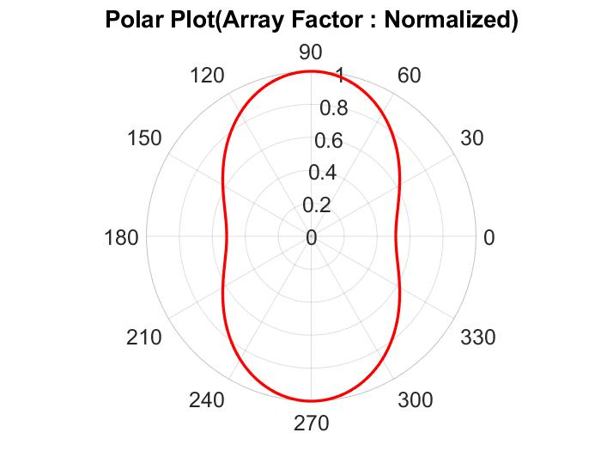

# Conclusion

* From the experiment conducted, it can be concluded that for an N-element Uniform Broadside Array antenna, the array factor can be calculated based on the symmetrical geometry of the array, which is different for odd and even number of elements.
* As the spacing between the elements becomes more than 1, more and more grating and side lobes are introduced in the radiation pattern.