

Sardar Patel Institute of Technology, Mumbai

Department of Electronics and Telecommunication Engineering

T.E. Sem-V (2020-2021)

ETL53-Fundamentals of Antenna Lab

**Lab - 6: N-element Uniform Amplitude End-Fire Array**

**Name: Kaustubh Venkatesh Name : Gokul Nair**

**UID : 2018120033 Batch : C Roll No. : 36 UID : 2018120039 Batch : C Roll No. : 43**

# Aim

Design an N-element Ordinary End-fire array with the elements placed symmetrically along the z-axis at distance d = 3*lambda/4 apart.

For the array factor calculate the :

1) Progressive phase excitation between the elements

2) Angles where nulls of the array factor occurs in degrees

3) Angles where maximas occur in degrees

4) Half Power beamwidth and directivity

5) Plot the radiation pattern of the array factor

Operational parameters : N = 6

# Introduction

An antenna array (or array antenna) is a set of multiple connected antennas which work together as a single antenna, to transmit or receive radio waves. The individual antennas (called elements) are usually connected to a single receiver or transmitter by feedlines that feed the power to the elements in a specific phase relationship.

# N Element ordinary End-fire array

## Basic Equations

In some applications, it may be necessary that the antenna radiates toward only one direction (either θ0 = 0◦ or 180◦) To direct the first maximum toward θ0 = 0◦.

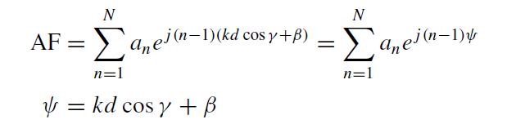

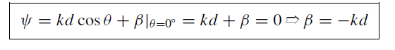

Where :

* θ : Angle between the axis and line joining the point and the array
* d : Distance between the antennas
* k : Angular Wave Number
* N : Number of antenna elements

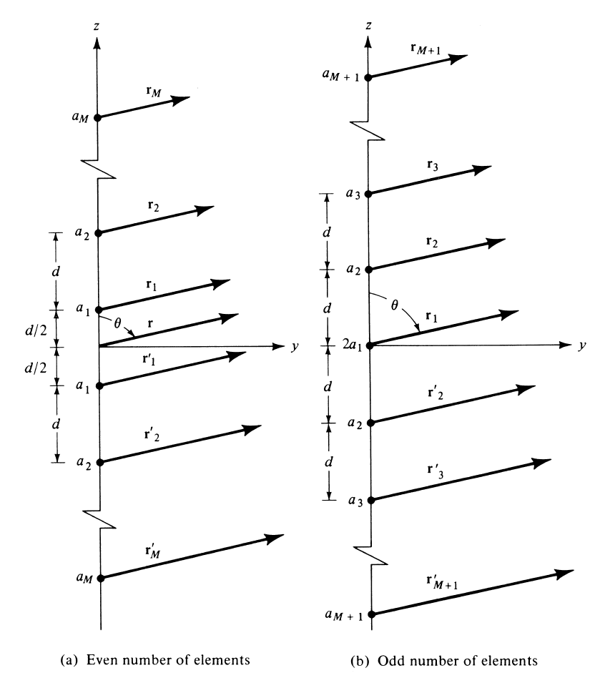

Figure 1 : Geometry of N Element arrays

## Nulls and Maximas of Ordinary End-Fire Array

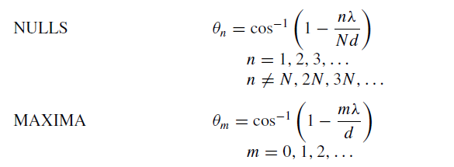

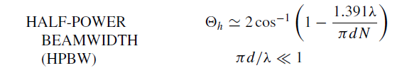

## Directivity

For an N element Ordinary End-Fire array, the maximum directivity is given by :

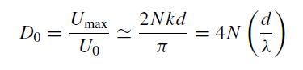

This is twice the directivity for a uniform broadside array antenna.

# Code and Observations

%Fundamentals of Antenna LAB 6

%N-element Uniform Amplitude Ordinary End-fire Array

%MATLAB version R2020a

%Date : 29-09-2020

% Operational parameters : N = 6

clc;

clear all;

close all;

%Variables

lambda = 1;

N = 6;

theta = linspace(0,2*pi,1000);

d = input("Enter the spacing between the antennas in terms of wavelength (d) : ");

k = 2*pi/lambda;

beta = -k*d; %End-fire directed towards theta = 0 degrees

%Progressive phase excitation

ppe = beta;

disp("Progressive phase excitation : " + ppe + " radians");

%calculating the normalized array factor

af = cos(1.5*(k*d*cos(theta) + beta)).*(2*cos(k*d*cos(theta)+beta) + 1);

af = af/3;

%af = sin(5*(k*d*cos(theta) + beta))./sin(0.5*(k*d*cos(theta) + beta));

%Calculating the nulls

syms x

nulls = solve(cos(1.5*(k*d*cos(x) + beta)).*(2*cos(k*d*cos(x)+beta) + 1)== 0,x);

disp("The nulls are : ");

%Checking if nulls exist

flag = 0;

for i=1:length(nulls)

if isreal(nulls(i))

temp = 180*nulls(i)/pi;

fprintf("%d) %.3f Degrees\n",i,temp);

flag = 1;

end

end

if flag==0

disp("Nulls do not exist");

end

%Caclulating the maximas

maximas = find(af == max(af));

disp("The maximas are : ");

for i=1:length(maximas)

temp = theta(maximas(i))*180/pi;

fprintf("%d) %.3f Degrees\n",i,temp);

end

%Calculating Half Power Beam Width

hpbw = acos(1 - ((1.391*lambda)/(pi*N*d)));

hpbw = 2*180*hpbw/pi;

fprintf("Half Power Beam Width : %.3f Degrees\n", hpbw);

%Calculating directivity

D = 4*N*d/lambda;

fprintf("Directivity : %.3f \n", D);

D = 10*log10(D);

fprintf("in dB : %.3f dB \n", D);

%Plotting the graph

polarplot(theta, af, 'r','LineWidth',2);

title('Polar Plot(Array Factor : Normalized)','FontSize',15);

set(gca,'FontSize',15);

* Inference :

1. We can thus see that based on the number of elements in a Uniform End-Fire array, the array factor expression changes.
2. The HPBW, directivity, nulls and maximas can be calculated based on the formulae and the points on the radiation pattern.
3. The pattern is directed towards a particular angle which is given by k*d.

* Console Output :

Enter the spacing between the antennas in terms of wavelength (d) : 0.75

Progressive phase excitation : -4.7124 radians

The nulls are :

1) 56.251 Degrees

2) -56.251 Degrees

3) 263.621 Degrees

5) 96.379 Degrees

The maximas are :

1) 0.000 Degrees

2) 360.000 Degrees

Half Power Beam Width : 51.260 Degrees

Directivity : 18.000

in dB : 12.553 dB

* Output Polar Plot :

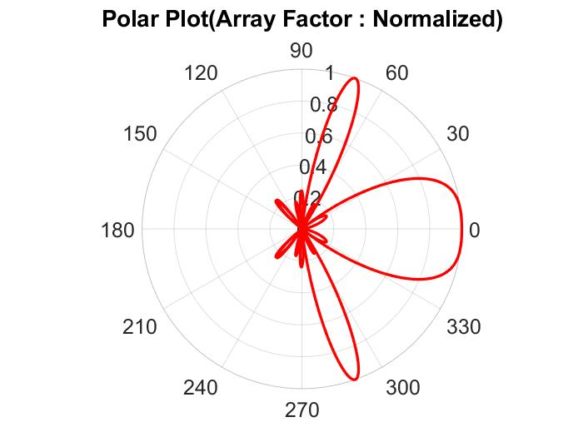

# Conclusion

* From the experiment conducted, it can be concluded that for an N-element Uniform End-Fire Array antenna, the array factor can be calculated based on the symmetrical geometry of the array.
* The pattern can be directed towards 0° or 180° based on the value of phase difference beta.
* As the spacing between the elements becomes more than lambda, the number of grating and side lobes increase.