

Sardar Patel Institute of Technology, Mumbai

Department of Electronics and Telecommunication Engineering

T.E. Sem-V (2020-2021)

ETL53-Fundamentals of Antenna Lab

**Lab - 7: N-element Binomial Amplitude End-Fire Array**

**Name: Kaustubh Venkatesh Name : Gokul Nair**

**UID : 2018120033 Batch : C Roll No. : 36 UID : 2018120039 Batch : C Roll No. : 43**

# Aim

To design a Endfire non uniform N- element binomial array of isotropic elements positioned

symmetrically along the z-axis with a distance d= λ/2 apart. Compute for array factor :

1. Amplitude excitation coefficient

2. Progressive phase excitation

3. Array factor

4. Angles in degrees where all the null occurs

5. Angles in degrees where all the maxima occurs

6. HPBW and Directivity

7. Plot the radiation pattern of the array factor

Operational Parameters : N = 6

# Introduction

An antenna array (or array antenna) is a set of multiple connected antennas which work together as a single antenna, to transmit or receive radio waves. The individual antennas (called elements) are usually connected to a single receiver or transmitter by feedlines that feed the power to the elements in a specific phase relationship.

# N Element Binomial End-fire array

## Basic Equations

The array factor for the binomial array is represented by the following where An is the excitation coefficient. The excitation coefficients are determined using the binomial distribution and the Pascal’s triangle.

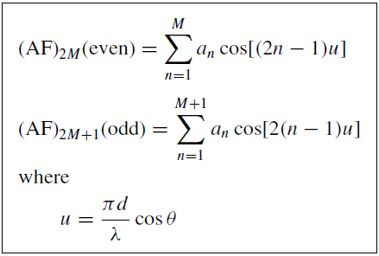

Where :

* θ : Angle between the axis and line joining the point and the array
* d : Distance between the antennas
* N : Number of antenna elements

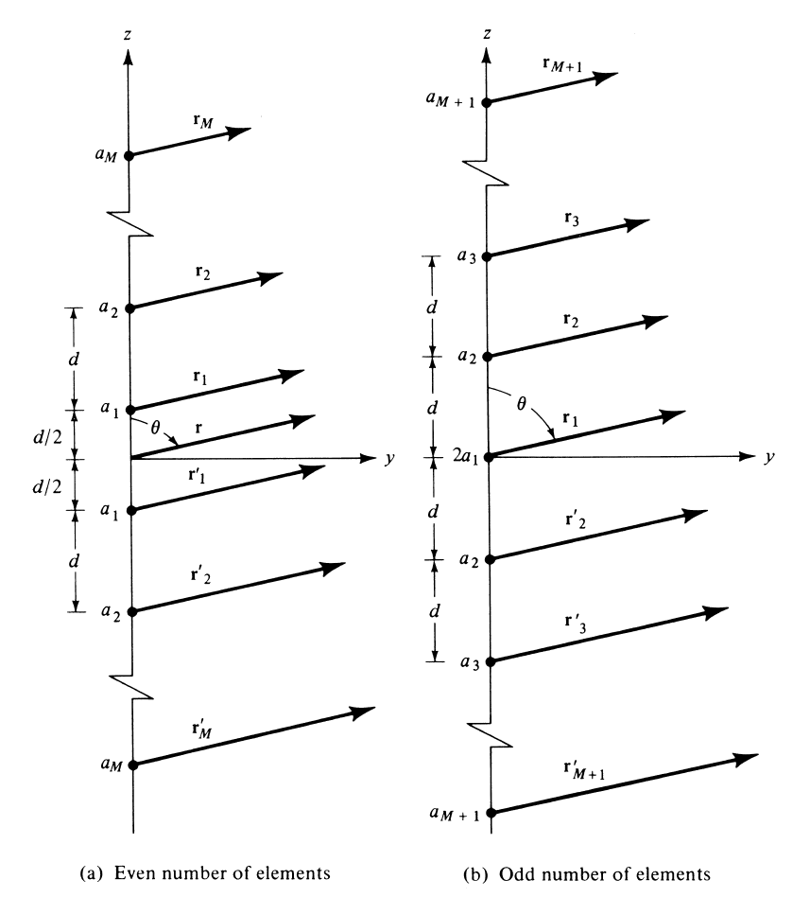

Figure 1 : Geometry of N Element arrays

## Half Power Beamwidth of Binomial End-Fire Array

For an N element Binomial End-Fire array, the Half Power BeamWidth is given by :

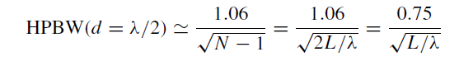

## Directivity

For an N element Binomial End-Fire array, the maximum directivity is given by :

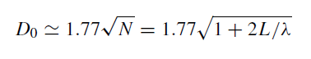

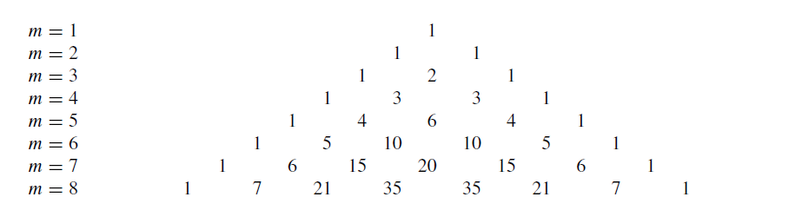

Figure 2 : Pascal’s triangle for m = 6

# Code and Observations

%Fundamentals of Antenna LAB 6

%N-element Binomial Ordinary End-fire Array

%MATLAB version R2020a

%Date : 06-10-2020

% Operational Parameters : N = 6

clc;

clear all;

close all;

%Variables

lambda = 1;

N = 6;

theta = linspace(0,2*pi,1000);

d = input("Enter the spacing between the antennas in terms of wavelength (d) : ");

k = 2*pi/lambda;

beta = -k*d; %End-fire directed towards theta = 0 degrees

%Amplitude Excitation Coefficients

aem = [1 5 10];

fprintf("The Amplitude Excitation Coefficients are : ");

disp(aem);

%Progressive phase excitation

ppe = beta;

disp("Progressive phase excitation : " + ppe + " radians");

%Calculating the normalized array factor for N = 6

u = (k*d*cos(theta) + beta)/2;

af = abs(2*(cos(u) + 5*cos(3*u) + 10*cos(5*u)));

%Always take absolute value

af = af/max(af);

%Calculating the nulls

syms x

nulls = solve((cos(0.5*(k*d*cos(x)+beta)) + 5*cos(1.5*(k*d*cos(x)+beta)) + 10*cos(2.5*(k*d*cos(x)+beta)))== 0,x);

disp("The nulls are : ");

%Checking if nulls exist

flag = 0;

for i=1:length(nulls)

if isreal(nulls(i))

temp = 180*nulls(i)/pi;

fprintf("%d) %.3f Degrees\n",i,temp);

flag = 1;

end

end

if flag==0

disp("Nulls do not exist");

end

%Caclulating the maximas

maximas = find(af == max(af));

disp("The maximas are : ");

for i=1:length(maximas)

temp = theta(maximas(i))*180/pi;

fprintf("%d) %.3f Degrees\n",i,temp);

end

%Calculating Half Power Beam Width

hpbw = 1.06/sqrt(N-1);

hpbw = 2*180*hpbw/pi;

fprintf("Half Power Beam Width : %.3f Degrees\n", hpbw);

%Calculating directivity

D = 1.77*sqrt(N);

fprintf("Directivity : %.3f \n", D);

D = 10*log10(D);

fprintf("in dB : %.3f dB \n", D);

%Plotting the graph

polarplot(theta, af, 'r','LineWidth',2);

title('Polar Plot(Array Factor : Normalized)','FontSize',15);

set(gca,'FontSize',15);

* Console Output :

Enter the spacing between the antennas in terms of wavelength (d) : 0.5

The Amplitude Excitation Coefficients are : 1 5 10

Progressive phase excitation : -3.1416 radians

The nulls are :

1) -90.000 Degrees

2) 40.507 Degrees

3) 70.077 Degrees

4) 90.000 Degrees

5) -40.507 Degrees

6) -70.077 Degrees

7) 139.493 Degrees

8) 109.923 Degrees

9) 220.507 Degrees

10) 250.077 Degrees

The maximas are :

1) 0.000 Degrees

2) 360.000 Degrees

Half Power Beam Width : 54.322 Degrees

Directivity : 4.336

in dB : 6.370 dB

* Inference :

1. We can thus see that based on the number of elements in a Binomial End-Fire array, the array factor expression changes.
2. The pattern is directed towards a particular angle which is given by k*d.
3. The excitation coefficients can be calculated using the Pascal’s triangle. Due to non-uniformity of the amplitude of elements, the number of side lobes is reduced to 0 for d = 0.5 * lambda.
4. For d = 0. 5 * lambda, the end fire exists in both directions.

* Output Polar Plot :

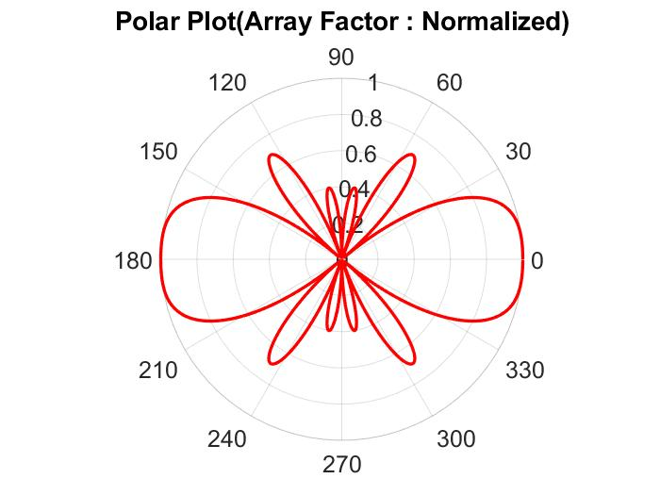

# Conclusion

* From the experiment conducted, it can be concluded that for an N-element Binomial Endfire antenna, the array factor is calculated using the geometry and the excitation factors can be calculated using the Pascal’s triangle.
* The introduction of non-uniform amplitude in a binomial array antenna helps in reducing the number of side lobes. The half power beamwidth of the pattern is also increased.