

Sardar Patel Institute of Technology, Mumbai

Department of Electronics and Telecommunication Engineering

T.E. Sem-V (2020-2021)

ETL53-Fundamentals of Antenna Lab

**Lab - 8: N-element Dolph-Tschebycheff Broadside Array**

**Name: Kaustubh Venkatesh Name : Gokul Nair**

**UID : 2018120033 Batch : C Roll No. : 36 UID : 2018120039 Batch : C Roll No. : 43**

# Aim

To design a non-uniform N- element -50 dB side lobe levels Dolph-Tschebyscheff array of isotropic elements placed symmetrically along the z-axis with a distance d= λ/2 apart.

Compute for the antenna :

1. Amplitude excitation coefficient

2. Array factor

3. Angles in degrees where all the null occurs

4. Angles in degrees where all the maxima occurs

5. Plot the radiation pattern of the array factor

Operational Parameters : N = 6

# Introduction

An antenna array (or array antenna) is a set of multiple connected antennas which work together as a single antenna, to transmit or receive radio waves. The individual antennas (called elements) are usually connected to a single receiver or transmitter by feedlines that feed the power to the elements in a specific phase relationship.

# N Element Dolph-tschebycheff array

This method was originally introduced by Dolph and investigated afterward by others. It is primarily a compromise between uniform and binomial arrays. Its excitation coefficients are related to Tschebyscheff polynomials of first order. The side lobe level of the pattern determines the amplitude excitation coefficients.

## Basic Equations

The array factor is calculated using Tschebycheff polynomials given by the recursive formula:

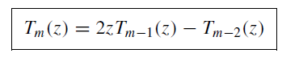

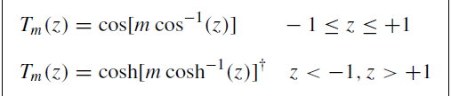

Where :

* θ : Angle between the axis and line joining the point and the array
* d : Distance between the antennas
* z = cos(u) = cos(0.5*k*d*cos(θ))

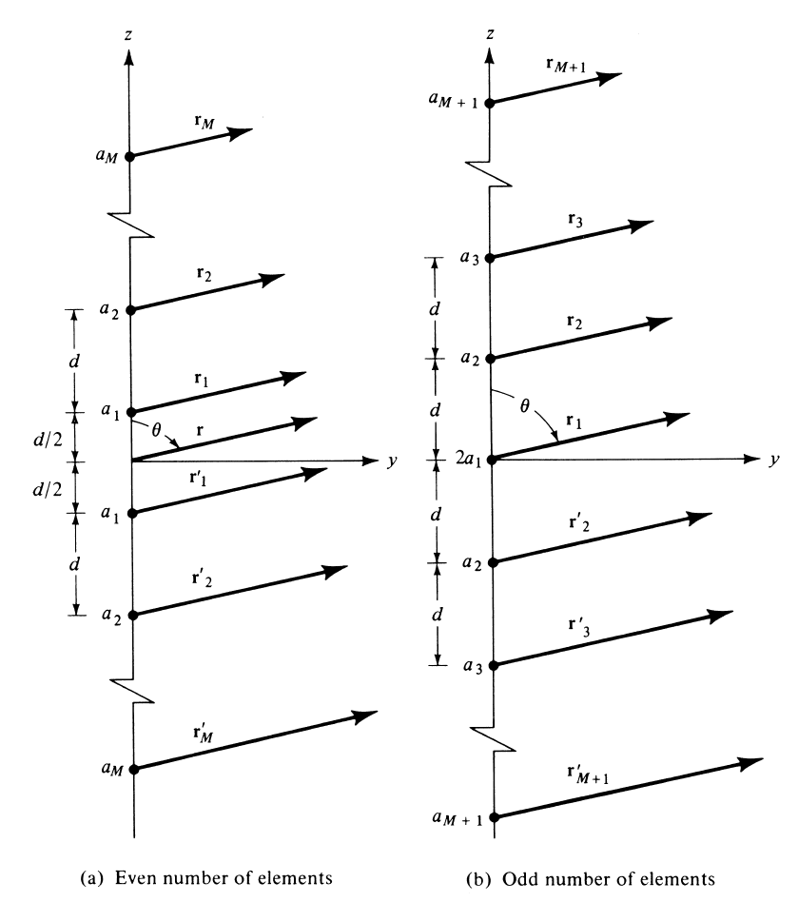

Figure 1 : Geometry of N Element arrays

## Half Power Beamwidth of Dolph-Tschebycheff array

The half-power beamwidth and directivity can

be found by introducing a beam broadening factor given approximately by:

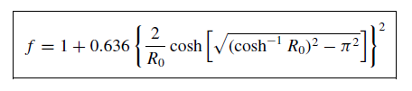

## Directivity

For an N-element Dolph-Tschebycheff, the maximum directivity is given by :

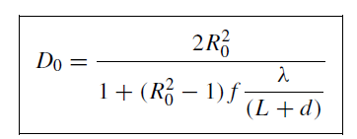

For a broadside antenna, the directivity and half power beamwidth can be equated as :

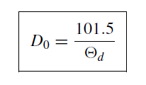

# Code and Observations

%Fundamentals of Antenna LAB 8

%N-element Dolph-Tschebyscheff array

%MATLAB version R2020a

%Date : 13-10-2020

% Operational Parameters : N = 6

clc;

clear;

close all;

%Variables

lambda = 1;

N = 6;

theta = 0:0.01:2*pi;

d = input("Enter the spacing between the antennas in terms of wavelength (d) : ");

beta = input("Enter the phase difference between the elements (?) : ");

k = 2*pi/lambda;

%Calculating the amplitude excitation coefficients

R0 = 10^(50/20);

z0 = cosh(0.2*acosh(R0));

a3 = z0^5;

a2 = (20*a3 - 20*(z0^3))/4;

a1 = z0 + 3*a2 - 5*a3;

a1 = a1/a3;

a2 = a2/a3;

a3 = a3/a3;

disp("The amplitude excitation coefficients are :");

disp(a1 + " " + a2 + " " + a3);

%Calculating the normalized array factor

u = (k*d*cos(theta) + beta)./2;

af = abs(a1*cos(u) + a2*cos(3.*u) + a3*cos(5.*u));

af = af/max(af);

%Calculating the nulls

syms x

nulls = solve(a1*cos(0.5*(k*d*cos(x)+beta))+a2*(cos(1.5*(k*d*cos(x)+beta)))+a3*cos(2.5*(k*d*cos(x)+beta))== 0,x);

disp("The nulls are : ");

%Checking if nulls exist

flag = 0;

for i=1:length(nulls)

if isreal(nulls(i))

temp = 180*nulls(i)/pi;

fprintf("%d) %.3f Degrees\n",i,temp);

flag = 1;

end

end

if flag==0

disp("Nulls do not exist");

end

%Caclulating the maximas

maximas = find(af == max(af));

disp("The maximas are : ");

for i=1:length(maximas)

temp = theta(maximas(i))*180/pi;

fprintf("%d) %.3f Degrees\n",i,temp);

end

%Calculating the half power beamwidth and directivity

f = 1+0.636*(2/R0*cosh(sqrt((acosh(R0))^2-pi^2)))^2; %beam broadening factor

D0 = 2*R0^2/(1+(R0^2-1)*f/(d*N));

fprintf("Directivity : %.3f \n", D0);

D = 10*log10(D0);

fprintf("in dB : %.3f dB \n", D);

hpbw = 101.5/D0;

fprintf("Half Power Beam Width : %.3f Degrees\n", hpbw);

%Plotting the polar graph

figure();

polarplot(theta, af, 'r','LineWidth',2);

title('Polar Plot(Array Factor : Normalized)','FontSize',15);

set(gca,'FontSize',15);

%plotting the linear graph

x = theta*180/pi;

x = x(1:316);

y = af(1:316);

figure();

semilogy(x,y,'b','LineWidth',2);

title('Linear Plot of Normalized Array Factor','FontSize',15);

xlabel('Theta in Degrees');

ylabel('Amplitude of array factor in dB');

xlim([0 180]);

grid on;

set(gca,'FontSize',12);

* Console Output :

Enter the spacing between the antennas in terms of wavelength (d) : 0.5

Enter the phase difference between the elements (β) : 0

The amplitude excitation coefficients are :

6.1396 3.6903 1

The nulls are :

1) 0.000 Degrees

2) 51.574 Degrees

3) 22.271 Degrees

4) -51.574 Degrees

5) -22.271 Degrees

6) 157.729 Degrees

7) 231.574 Degrees

8) 202.271 Degrees

9) 128.426 Degrees

The maximas are :

1) 89.954 Degrees

Directivity : 4.009

in dB : 6.030 dB

Half Power Beam Width : 25.318 Degrees

* Inference :

1. We can thus see that based on the number of elements and side lobe level in a Dolph-Tschebycheff array, the array factor expression changes.
2. The excitation coefficients can be calculated using Tschebycheff’s polynomials of first order based on the side lobe levels specified.
3. The side lobes are considerably decreased when compared to uniform and binomial antennas.

* Output Plots :

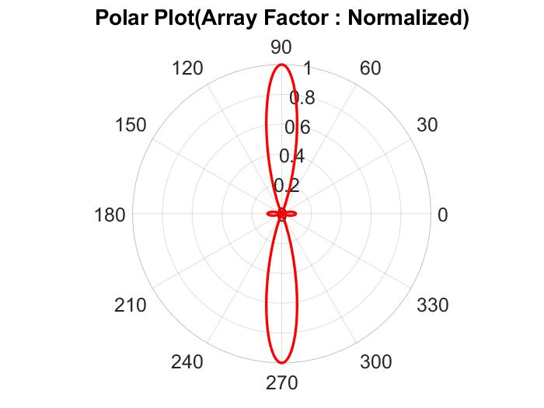

### Polar plot of normalized array factor

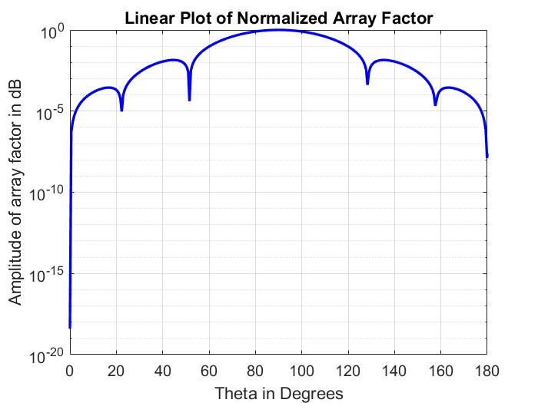

1. Linear plot of normalized array factor

# Conclusion

* From the experiment conducted, it can be concluded that for an N-element Dolph-Tschebycheff antenna, the array factor is calculated using the geometry and the excitation factors can be calculated using the given side lobe levels and Tschebycheff’s polynomials of first order.
* The side lobes are reduced considerably when compared to uniform arrays. The half power beam width however increases for this antenna.