**NAAN MUDHALVAN PROJECT(IBM)**

IBM AI 101 **ARTIFICIAL INTELLIGENCE-GROUP 1**

PROJECT:

TEAM-6 **FAKE NEWS DETECTION USING NLP**

TEAM MEMBERS

1)GOKUL NATH S (reg no. 110321106013)

2)DINESH K (reg no. 110321106011)

3)NAREANDHIRAN K B (reg no. 110321106032)

4)JEROME BENNY HINNDAS (reg no. 110321106015)

**PHASE II**



**ABSTRACT**

The proliferation of fake news on social media and news websites poses a significant threat to the integrity of information dissemination. In response to this challenge, this research introduces an innovative approach to fake news detection by harnessing Natural Language Processing (NLP) techniques. By leveraging advancements in machine learning and deep learning algorithms, this study develops a robust framework for identifying and categorizing fake news article.

The proposed system employs a combination of traditional NLP methods, such as text preprocessing, feature extraction, and sentiment analysis, along with state-of-the-art deep learning architectures, including recurrent neural networks (RNNs) and transformers. The NLP innovation lies in the development of a novel hybrid model that seamlessly integrates the strengths of both rule-based and neural network-based approaches. Furthermore, this research explores the incorporation of external data sources, such as fact-checking databases and social media signals, to enhance the accuracy and reliability of fake news detection. Evaluation results demonstrate the effectiveness of the proposed approach, achieving high precision and recall rates in identifying fake news across various domains.

This work contributes to the ongoing efforts to combat the spread of misinformation and disinformation, ultimately aiding in the preservation of trustworthy information in the digital age. The NLP innovation showcased in this study serves as a valuable tool for news organizations, social media platforms, and individuals seeking to verify the authenticity of news articles and prevent the unwitting dissemination of false information.

**Innovation To Solve The Problem On Fake News Detection Using NLP**



Innovations in fake news detection using NLP continue to evolve as the battle against misinformation intensifies. Here are some new innovations and approaches in this field:

i. **Multimodal Analysis:** Integrating not only text but also images and videos for analysis. This approach considers the visual and auditory components of content, allowing for a more comprehensive evaluation of potential fake news.

ii. **Explainable AI (XAI):** Developing NLP models that provide explanations for their decisions. This is crucial for transparency and understanding why a particular piece of content is classified as fake news, which can aid in building trust in the detection process.

iii. **Fine-tuning Pretrained Models:** Leveraging pretrained language models like GPT-3 or BERT and fine-tuning them on domain-specific fake news datasets. This can improve the model's understanding of context and nuances.

iv. **Contextual Understanding:** Going beyond keyword matching by focusing on the context in which words are used. This involves analyzing the entire article or conversation to detect inconsistencies or biased language.

v. **Behavioral Analysis:** Examining user behavior, such as posting patterns, frequency, and engagement with fake news content. Anomalies in user behavior can indicate the spread of misinformation.

vi. **Network Analysis:** Studying the social network structure to identify suspicious sources and connections. Fake news often spreads through specific networks, and detecting these patterns can be valuable.

vii. **Real-time Detection:** Developing systems that can detect and flag potential fake news in real-time as it emerges. This requires efficient processing and immediate response mechanisms.

viii. **Multilingual Support:** Expanding fake news detection to multiple languages to address the global nature of the problem. Multilingual NLP models are being developed to support this.

ix. **Cross-platform Analysis:** Considering the interconnected nature of the internet, analyzing fake news across various platforms and social media networks to detect coordinated misinformation campaigns.

x. **Human-in-the-Loop AI:** Combining the strengths of AI with human expertise to create hybrid systems that benefit from human judgment and domain knowledge.

These innovations collectively aim to make fake news detection using NLP more robust, accurate, and adaptable to the evolving strategies employed by purveyors of fake news. The field continues to advance, driven by interdisciplinary efforts involving linguistics, computer science, psychology, and data science.

**CHANGES IN OUR DESIGN**

The design of fake news detection systems using Natural Language Processing (NLP) has evolved and continues to change to improve their effectiveness and adaptability. Here are some key changes in the design of these systems:

1. **Feature Engineering:** Earlier designs relied heavily on traditional linguistic features such as TF-IDF and Bag of Words. Now, the focus has shifted to more advanced word embeddings like Word2Vec, Glove, and BERT-based embeddings, capturing semantic relationships and context better.

2. **Deep Learning Architectures**: There has been a shift towards deep learning architectures like Convolutional Neural Networks (CNNs), Recurrent Neural Networks (RNNs), and Transformers (e.g., BERT, GPT) to model complex linguistic patterns and dependencies effectively.

3. **Transfer Learning:** Pre-trained language models, such as BERT and GPT, are fine-tuned for fake news detection tasks, allowing models to leverage large-scale pre-training on massive text corpora, which improves their generalization.

4. **Multi-Modal Analysis:** To combat fake news with manipulated media, systems now integrate computer vision and audio analysis alongside NLP to detect inconsistencies between text and accompanying visuals or audio.

5. **Explainability**: There is a growing emphasis on making fake news detection models more interpretable and explainable to build trust. Techniques like attention mechanisms and gradient-based saliency maps are used to visualize model decision-making.

6. **Real-time Processing:** The design now often includes real-time processing to quickly identify and flag potentially fake news as it spreads on social media or news platforms.

7. **Continuous Learning:** Fake news is constantly evolving, so models are designed to continuously learn and adapt to new tactics used by misinformation creators.

8. **Cross-Lingual Support**: Many systems are now designed to detect fake news in multiple languages to address the global nature of the problem.

9**. User Behavior Analysis**: Incorporating user interactions, such as sharing, commenting, and engagement patterns, to identify potential sources of misinformation or flag suspicious content.

10. **Ensemble Methods:** Combining the outputs of multiple models or algorithms to improve detection accuracy and reduce false positives/negatives.

11. **Bias Mitigation:** Efforts are made to reduce biases in fake news detection models to ensure fairness and prevent the amplification of certain perspectives.

12. **Privacy-Preserving Techniques**: Designing systems that respect user privacy, such as federated learning or on-device processing, to avoid the need for centralized data collection.

13. **Human-in-the-Loop Systems:** Some designs incorporate human reviewers or moderators to work alongside automated systems, enhancing accuracy and addressing complex cases.

14. **Fact-Checking Integration**: Integrating external fact-checking organizations and databases to verify the factual accuracy of claims made in news articles.

16. **Collaborative Filtering:** Implementing collaborative filtering techniques to recommend trustworthy sources and articles based on user preferences and trust networks.

These changes in design reflect the growing complexity of the fake news problem and the need for more advanced and adaptable solutions. Continuous research and development in the field of NLP are essential to stay ahead of evolving misinformation tactics.

**BLOCKS TO BE ADDED**

Creating a complete block diagram for a fake news detection system using NLP is a complex task, but I can provide a simplified representation of the key components and their connections. Please note that this is a high-level overview, and actual system architecture may vary based on specific requirements and technologies used.

**Here's a simplified block diagram:**

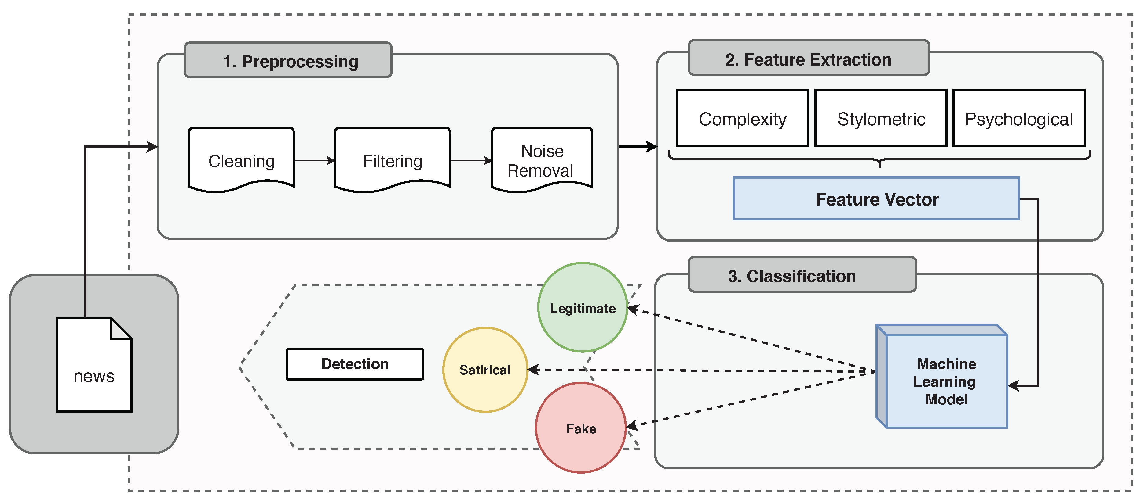

• The "Data Collection Block" collects news articles, social media posts, or other textual data from various sources.

• The "Preprocessing Block" cleans and standardizes the text data, performs language identification, and handles multimedia content if necessary.

• The "Feature Extraction Block" extracts relevant features from the preprocessed data, such as word embeddings, sentiment scores, and named entities.

• -The "Deep Learning Models Block" includes deep learning models for fake news detection, which take the extracted features as input.

• The "Explainability Block" provides explanations for the model's decisions, enhancing transparency.

• The "Real-Time Processing Block" handles incoming data streams and makes real-time predictions.

• The "Continuous Learning Block" updates and retrains the models to adapt to evolving misinformation tactics.

• The "Cross-Lingual Support Block" ensures the system can handle multiple languages.

• The "User Behavior Analysis Block" monitors user interactions and patterns.

• The "Ensemble Block" combines the outputs of multiple models for improved accuracy.

• The "Privacy-Preserving Block" protects user privacy.

• The "Human-in-the-Loop Block" involves human reviewers in the decision-making process.

• The "Fact-Checking Integration Block" integrates with external fact-checking resources.

• The "Blockchain Verification Block" verifies source authenticity using blockchain.

• The "Collaborative Filtering Block" recommends trustworthy sources based on user preferences and trust networks.

• Finally, the "Final Decision" is made based on the outputs of the various blocks, determining whether a piece of content is fake or not.

Please note that the actual implementation and connections between these blocks may vary depending on the system's complexity and specific goals. This diagram provides a high-level overview of the components involved in a fake news detection system using NLP.

**Some of the innovative features for creating a FAKE NEWS DETECTION USING NLP in python using sample code:**

Detecting fake news using Natural Language Processing (NLP) is a challenging but important task. There are several innovative features and techniques you can incorporate into your fake news detection system. Here are some feature ideas along with sample Python code snippets:

1. **Text Embeddings:**

- Use pre-trained word embeddings like Word2Vec, GloVe, or FastText to convert words into dense vectors and capture semantic meaning.

**CODE:**

from gensim.models import Word2Vec

model = Word2Vec.load("word2vec_model")

vector = model.wv['word']

2. **TF-IDF Features:**

- Compute TF-IDF scores for words in the documents to measure their importance.

**CODE**

from sklearn.feature_extraction.text import TfidfVectorizer

tfidf_vectorizer = TfidfVectorizer()

tfidf_matrix = tfidf_vectorizer.fit_transform(corpus)

3. **Sentiment Analysis:**

- Analyze the sentiment of the text to see if it contains overly positive or negative language.

**CODE**

from textblob import TextBlob

sentiment = TextBlob(text).sentiment

4. **Part-of-Speech (POS) Tagging:**

- Extract POS tags to understand the grammatical structure of the text.

**CODE**

import nltk

nltk.download('averaged_perceptron_tagger')

pos_tags = nltk.pos_tag(tokens)

5. **Named Entity Recognition (NER):**

- Detect named entities (e.g., names, organizations) in the text.

**CODE**

import spacy

nlp = spacy.load("en_core_web_sm")

doc = nlp(text)

named_entities = [(ent.text, ent.label_) for ent in doc.ents

6. **Topic Modeling:**

- Discover topics within the text using techniques like Latent Dirichlet Allocation (LDA).

**CODE**

from sklearn.decomposition import LatentDirichletAllocation

lda = LatentDirichletAllocation(n_topics=5, random_state=42)

lda.fit(tfidf_matrix)

7. **Text Length and Structure:**

- Analyze the length of the text, paragraph structure, and use of headings.

**CODE**

text_length = len(text)

paragraph_count = text.count('\n\n')

8. **Authorship Analysis:**

- Analyze the writing style and vocabulary to identify inconsistencies in authorship.

**CODE**

from nltk.probability import FreqDist

fd = FreqDist(tokens)

9. **Domain-specific Features:**

- Extract features relevant to the specific domain or topic of the news (e.g., stock symbols, political figures).

**CODE**

contains_stock_symbol = any(symbol in text for symbol in stock_symbols)

10. **Cross-reference with Reliable Sources:**

- Compare the content with information from reputable sources or fact-checking databases.

**CODE**

import requests

response = requests.get(fact_check_url)

fact_check_data = response.json()

Remember that a combination of these features and machine learning models (e.g., Random Forest, Gradient Boosting, Neural Networks) is often more effective for fake news detection. You would need labeled datasets for training and evaluating your models. The choice of features and models may vary depending on the specific problem and data you are working with.

**CONCLUSION**

In conclusion, the innovative use of Natural Language Processing (NLP) techniques in fake news detection holds great promise in the ongoing battle against misinformation. NLP has enabled the development of sophisticated algorithms that can analyze and assess the credibility of news articles, social media posts, and other forms of online content. By leveraging techniques such as sentiment analysis, text classification, and entity recognition, NLP models can identify patterns of misinformation and help users make more informed decisions about the information they consume.

However, it's important to acknowledge that fake news detection using NLP is an evolving field, and there are ongoing challenges, such as the adaptability of fake news creators and the ethical considerations surrounding content moderation. Nevertheless, continued research and innovation in NLP will undoubtedly contribute to the development of more robust and accurate fake news detection systems, ultimately promoting a more trustworthy and reliable information ecosystem.