Stock Analysis Report: Report Capstone Sample
Ticker: RPTC | Status: complete
Generated at: 2026-09-14T23:15:09

Executive Summary
- Report Capstone Sample (RPTC) — sector: reporting.
- Latest revenue: 1331.00.
- Latest net profit: 133.10.
- Valuation intrinsic value/share: 19.30 with signal 'overvalued'.
- Forensic fraud probability: 25.0%.
- Scenario base target price: 160.11.
- Technical trend: uptrend.
- Investment decision: BUY.

Company & Business
Report Capstone Sample (RPTC) sector: reporting, industry: N/A.
- Financial statement rows: 48
- Price rows: 60
- Shareholding rows: 0

Financial Statements
Normalized financial statement line items extracted from the ingested source.

Balance Sheet
Line Item | 2023 | 2022
Cash and Equivalents | 66.0 | 60.0
Current Assets | 399.0 | 363.0
Current Liabilities | 266.0 | 242.0
Shares Outstanding | 100.0 | 100.0
Total Assets | 1331.0 | 1210.0
Total Debt | 200.0 | 200.0
Total Equity | 665.5 | 605.0

Profit & Loss
Line Item | 2023 | 2022
EBITDA | 266.2 | 242.0
Net Profit | 133.1 | 121.0
Revenue | 1331.0 | 1210.0

Cash Flow
Line Item | 2023 | 2022
Capital Expenditure | 40.0 | 36.0
Operating Cash Flow | 160.0 | 145.0

Financial Ratio Analysis
Calculated 26 ratios for fiscal year 2023.

Ratio Results
Category | Ratio | Value | Status
liquidity | current_ratio | 1.5000 | ok
liquidity | quick_ratio | N/A | missing_inputs
liquidity | cash_ratio | 0.2481 | ok
liquidity | operating_cash_flow_ratio | 0.6015 | ok
liquidity | working_capital_ratio | 0.0999 | ok
liquidity | defensive_interval_ratio | N/A | missing_inputs
solvency | debt_to_equity | 0.3005 | ok
solvency | debt_to_assets | 0.1503 | ok
solvency | interest_coverage | N/A | missing_inputs
solvency | equity_multiplier | 2.0000 | ok
solvency | long_term_debt_to_equity | N/A | missing_inputs
profitability | gross_margin | N/A | missing_inputs
profitability | operating_margin | N/A | missing_inputs
profitability | ebitda_margin | 0.2000 | ok
profitability | net_profit_margin | 0.1000 | ok
profitability | roa | 0.1000 | ok
profitability | roe | 0.2000 | ok
profitability | roce | N/A | missing_inputs
efficiency | asset_turnover | 1.0000 | ok
efficiency | fixed_asset_turnover | N/A | missing_inputs
efficiency | inventory_turnover | N/A | missing_inputs
efficiency | receivables_turnover | N/A | missing_inputs
efficiency | payables_turnover | N/A | missing_inputs
market | eps | 1.3310 | ok
market | pe_ratio | 90.2554 | ok
market | pb_ratio | 18.0511 | ok

Forensic Analysis
Fraud-risk and accounting-quality diagnostics.
- Fraud probability: 25.0%
- Altman Z: N/A (not_available)
- Beneish M: N/A
- Piotroski F: 5/9
- Benford chi-square: 5.6858

Red Flags
Severity | Code | Message
warning | PIOTROVSKI_MODERATE | Piotroski F-Score is moderate at 5/9.

Industry & Peer Analysis
Selected 0 peers. Position classification: strong.

Porter's Five Forces
Force | Score
Threat of New Entrants | 3
Supplier Power | 3
Buyer Power | 3
Threat of Substitutes | 3
Competitive Rivalry | 3

Technical Analysis
Price trend, indicator, support/resistance, and pattern analysis.
- Latest close: 120.13
- Trend: uptrend
- RSI: 73.0
- Support levels: [115.39, 102.84]
- Resistance levels: [122.0]
- Patterns detected: 0
- Charts exported: 5

Valuation
Relative valuation, DCF scenarios, comparables, and sensitivity.
- Final intrinsic value/share: 19.30
- Margin of safety: -83.9%
- Valuation signal: overvalued

Multiples
Metric | Value
P/E | 90.26
P/B | 18.05
P/S | 9.03
EV/EBITDA | 45.63

Valuation Scenarios
Scenario | DCF | Comparable | Final
bull | 22.94 | N/A | 22.94
base | 19.30 | N/A | 19.30
bear | 15.41 | N/A | 15.41

DCF Sensitivity
WACC | 1.00% | 1.50% | 2.00% | 2.50% | 3.00%
8.00% | 21.97 | 23.40 | 25.06 | 27.02 | 29.38
9.00% | 18.96 | 20.01 | 21.20 | 22.57 | 24.17
10.00% | 16.63 | 17.41 | 18.30 | 19.30 | 20.45
11.00% | 14.76 | 15.37 | 16.05 | 16.81 | 17.66
12.00% | 13.23 | 13.72 | 14.25 | 14.84 | 15.50

Scenario & Forecast Analysis
Three-year bull/base/bear forecasts and target-price derivation.
- Base target price: 160.11
- Target range: 132.52 to 191.06
- Macro overlay adjustment: -0.00%

Scenario Forecasts
Scenario | Revenue Growth | Final Revenue | Final EBITDA | Final EPS | Target Price | Upside %
bull | 13.00% | 1920.50 | 384.10 | 1.920 | 191.06 | 59.0
base | 10.00% | 1771.56 | 354.31 | 1.772 | 160.11 | 33.3
bear | 7.00% | 1630.53 | 326.11 | 1.631 | 132.52 | 10.3

Dividend Analysis
No dividend data was found in the ingested dataset.

Shareholding Analysis
No shareholding-pattern data was found in the ingested dataset.

Corporate Governance
No structured governance dataset was provided by the current ingestion source. Source tracking, uploaded-file audit fields, and data-validation status are captured in the database.
- Governance checklist items are marked partial unless governance data is ingested.

Risk Analysis
Forensic risk and market-risk metrics.
- Composite fraud probability: 25.0%
- Price observations: 60
- Annualized volatility: 0.10
- Maximum drawdown: 0.04
- Historical 95% VaR: 0.01
- Beta: N/A

Investment Decision
Recommendation: BUY
- Composite decision score is 70.0/100.
- Valuation signal is overvalued.
- Forensic fraud probability is moderate.
- Scenario upside is strong at 33.3%.
- Technical trend is upward.
- Piotroski F-Score is moderate at 5/9.

Technical Charts

Candlestick
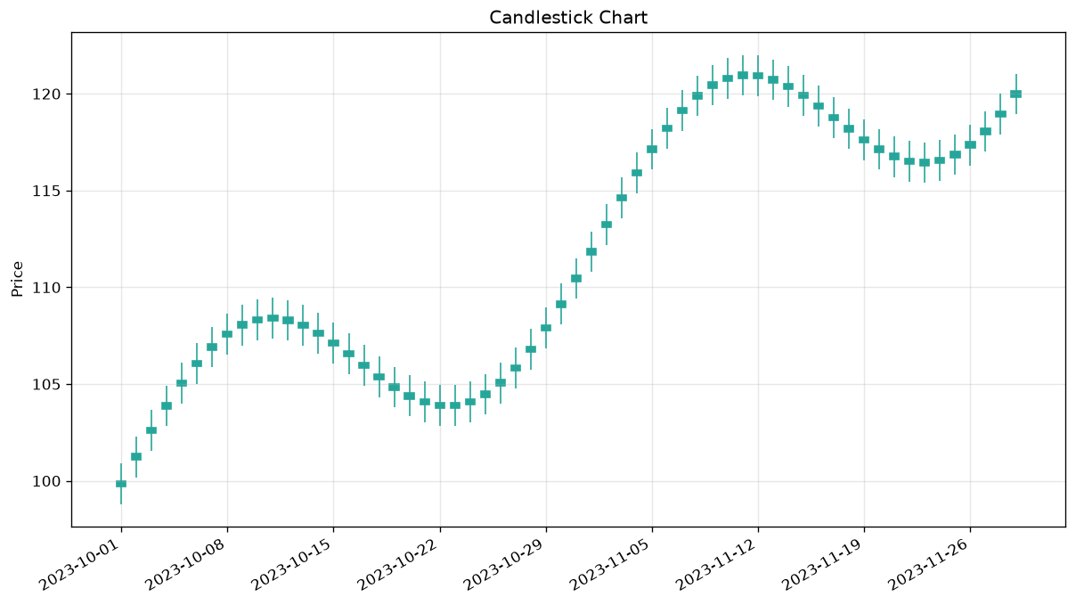

Line
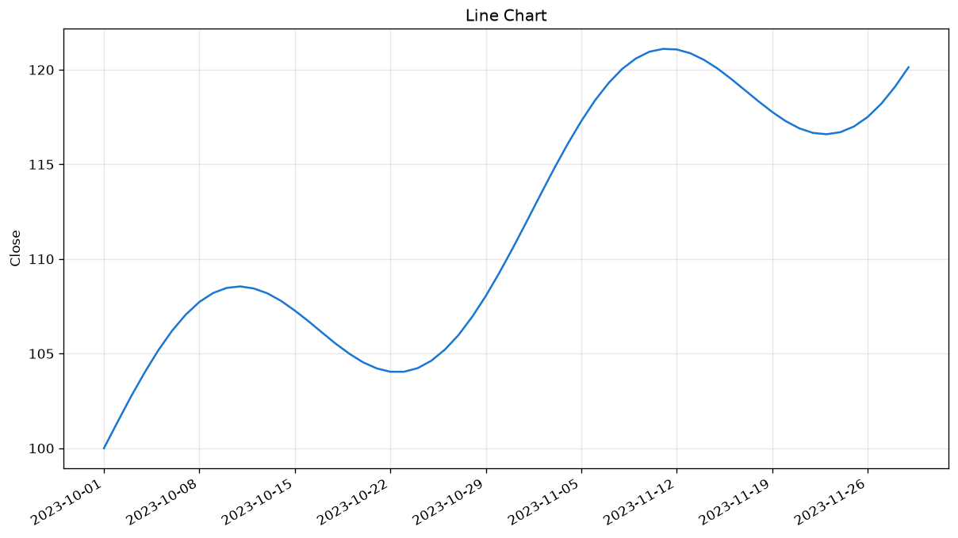

Volume
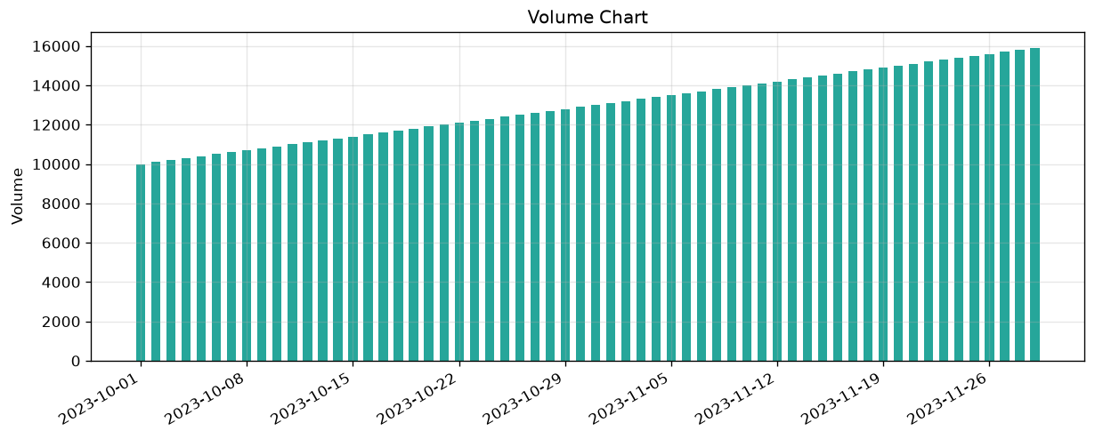

Indicators
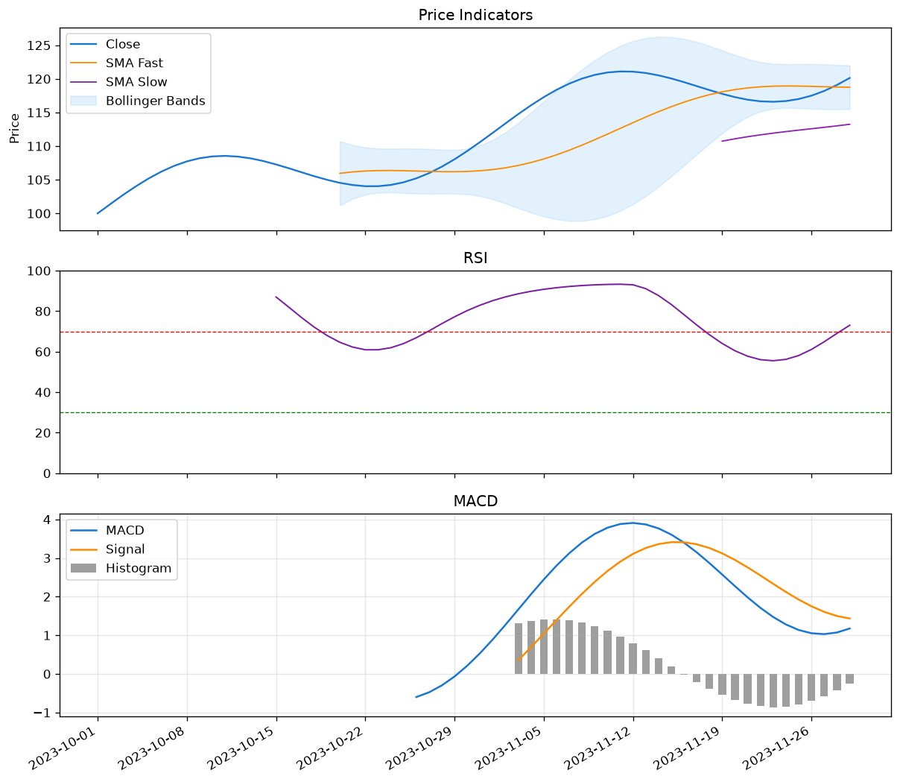

Patterns
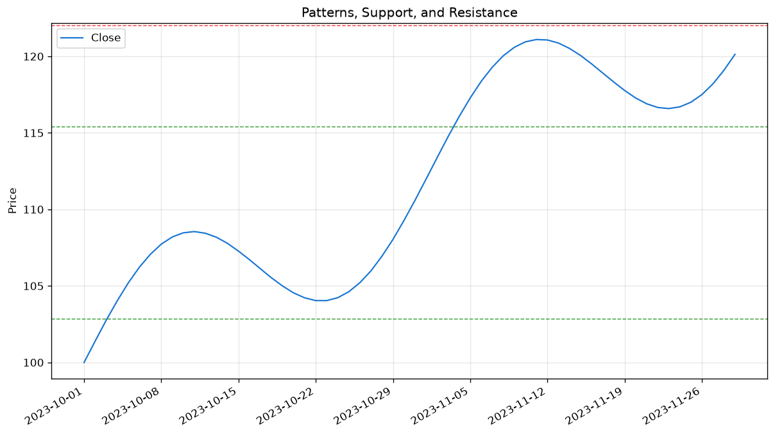

227-Point Checklist Appendix
Item | Section | Description | Module | Status
A01 | Company & Business | Company & Business checkpoint 1 | M1 + M8 | covered
A02 | Company & Business | Company & Business checkpoint 2 | M1 + M8 | covered
A03 | Company & Business | Company & Business checkpoint 3 | M1 + M8 | covered
A04 | Company & Business | Company & Business checkpoint 4 | M1 + M8 | covered
A05 | Company & Business | Company & Business checkpoint 5 | M1 + M8 | covered
A06 | Company & Business | Company & Business checkpoint 6 | M1 + M8 | covered
A07 | Company & Business | Company & Business checkpoint 7 | M1 + M8 | covered
A08 | Company & Business | Company & Business checkpoint 8 | M1 + M8 | covered
A09 | Company & Business | Company & Business checkpoint 9 | M1 + M8 | covered
A10 | Company & Business | Company & Business checkpoint 10 | M1 + M8 | covered
A11 | Company & Business | Company & Business checkpoint 11 | M1 + M8 | covered
A12 | Company & Business | Company & Business checkpoint 12 | M1 + M8 | covered
A13 | Company & Business | Company & Business checkpoint 13 | M1 + M8 | covered
A14 | Company & Business | Company & Business checkpoint 14 | M1 + M8 | covered
A15 | Company & Business | Company & Business checkpoint 15 | M1 + M8 | covered
B01 | Industry Analysis | Industry Analysis checkpoint 1 | M4 | partial
B02 | Industry Analysis | Industry Analysis checkpoint 2 | M4 | partial
B03 | Industry Analysis | Industry Analysis checkpoint 3 | M4 | partial
B04 | Industry Analysis | Industry Analysis checkpoint 4 | M4 | partial
B05 | Industry Analysis | Industry Analysis checkpoint 5 | M4 | partial
B06 | Industry Analysis | Industry Analysis checkpoint 6 | M4 | partial
B07 | Industry Analysis | Industry Analysis checkpoint 7 | M4 | partial
B08 | Industry Analysis | Industry Analysis checkpoint 8 | M4 | partial
B09 | Industry Analysis | Industry Analysis checkpoint 9 | M4 | partial
B10 | Industry Analysis | Industry Analysis checkpoint 10 | M4 | partial
B11 | Industry Analysis | Industry Analysis checkpoint 11 | M4 | partial
B12 | Industry Analysis | Industry Analysis checkpoint 12 | M4 | partial
C01 | Macro Analysis | Macro Analysis checkpoint 1 | M1 + M7 | partial
C02 | Macro Analysis | Macro Analysis checkpoint 2 | M1 + M7 | partial
C03 | Macro Analysis | Macro Analysis checkpoint 3 | M1 + M7 | partial
C04 | Macro Analysis | Macro Analysis checkpoint 4 | M1 + M7 | partial
C05 | Macro Analysis | Macro Analysis checkpoint 5 | M1 + M7 | partial
C06 | Macro Analysis | Macro Analysis checkpoint 6 | M1 + M7 | partial
C07 | Macro Analysis | Macro Analysis checkpoint 7 | M1 + M7 | partial
C08 | Macro Analysis | Macro Analysis checkpoint 8 | M1 + M7 | partial
C09 | Macro Analysis | Macro Analysis checkpoint 9 | M1 + M7 | partial
C10 | Macro Analysis | Macro Analysis checkpoint 10 | M1 + M7 | partial
C11 | Macro Analysis | Macro Analysis checkpoint 11 | M1 + M7 | partial
D01 | Balance Sheet | Balance Sheet checkpoint 1 | M1 + M2 | covered
D02 | Balance Sheet | Balance Sheet checkpoint 2 | M1 + M2 | covered
D03 | Balance Sheet | Balance Sheet checkpoint 3 | M1 + M2 | covered
D04 | Balance Sheet | Balance Sheet checkpoint 4 | M1 + M2 | covered
D05 | Balance Sheet | Balance Sheet checkpoint 5 | M1 + M2 | covered
D06 | Balance Sheet | Balance Sheet checkpoint 6 | M1 + M2 | covered
D07 | Balance Sheet | Balance Sheet checkpoint 7 | M1 + M2 | covered
D08 | Balance Sheet | Balance Sheet checkpoint 8 | M1 + M2 | covered
D09 | Balance Sheet | Balance Sheet checkpoint 9 | M1 + M2 | covered
D10 | Balance Sheet | Balance Sheet checkpoint 10 | M1 + M2 | covered
D11 | Balance Sheet | Balance Sheet checkpoint 11 | M1 + M2 | covered
D12 | Balance Sheet | Balance Sheet checkpoint 12 | M1 + M2 | covered
E01 | P&L Statement | P&L Statement checkpoint 1 | M1 + M2 | covered
E02 | P&L Statement | P&L Statement checkpoint 2 | M1 + M2 | covered
E03 | P&L Statement | P&L Statement checkpoint 3 | M1 + M2 | covered
E04 | P&L Statement | P&L Statement checkpoint 4 | M1 + M2 | covered
E05 | P&L Statement | P&L Statement checkpoint 5 | M1 + M2 | covered
E06 | P&L Statement | P&L Statement checkpoint 6 | M1 + M2 | covered
E07 | P&L Statement | P&L Statement checkpoint 7 | M1 + M2 | covered
E08 | P&L Statement | P&L Statement checkpoint 8 | M1 + M2 | covered
E09 | P&L Statement | P&L Statement checkpoint 9 | M1 + M2 | covered
F01 | Cash Flow | Cash Flow checkpoint 1 | M1 + M2 | covered
F02 | Cash Flow | Cash Flow checkpoint 2 | M1 + M2 | covered
F03 | Cash Flow | Cash Flow checkpoint 3 | M1 + M2 | covered
F04 | Cash Flow | Cash Flow checkpoint 4 | M1 + M2 | covered
F05 | Cash Flow | Cash Flow checkpoint 5 | M1 + M2 | covered
F06 | Cash Flow | Cash Flow checkpoint 6 | M1 + M2 | covered
G01 | Financial Ratios | Financial Ratios checkpoint 1 | M2 | covered
G02 | Financial Ratios | Financial Ratios checkpoint 2 | M2 | covered
G03 | Financial Ratios | Financial Ratios checkpoint 3 | M2 | covered
G04 | Financial Ratios | Financial Ratios checkpoint 4 | M2 | covered
G05 | Financial Ratios | Financial Ratios checkpoint 5 | M2 | covered
G06 | Financial Ratios | Financial Ratios checkpoint 6 | M2 | covered
G07 | Financial Ratios | Financial Ratios checkpoint 7 | M2 | covered
G08 | Financial Ratios | Financial Ratios checkpoint 8 | M2 | covered
G09 | Financial Ratios | Financial Ratios checkpoint 9 | M2 | covered
G10 | Financial Ratios | Financial Ratios checkpoint 10 | M2 | covered
G11 | Financial Ratios | Financial Ratios checkpoint 11 | M2 | covered
G12 | Financial Ratios | Financial Ratios checkpoint 12 | M2 | covered
G13 | Financial Ratios | Financial Ratios checkpoint 13 | M2 | covered
G14 | Financial Ratios | Financial Ratios checkpoint 14 | M2 | covered
G15 | Financial Ratios | Financial Ratios checkpoint 15 | M2 | covered
G16 | Financial Ratios | Financial Ratios checkpoint 16 | M2 | covered
G17 | Financial Ratios | Financial Ratios checkpoint 17 | M2 | covered
G18 | Financial Ratios | Financial Ratios checkpoint 18 | M2 | covered
G19 | Financial Ratios | Financial Ratios checkpoint 19 | M2 | covered
G20 | Financial Ratios | Financial Ratios checkpoint 20 | M2 | covered
G21 | Financial Ratios | Financial Ratios checkpoint 21 | M2 | covered
G22 | Financial Ratios | Financial Ratios checkpoint 22 | M2 | covered
G23 | Financial Ratios | Financial Ratios checkpoint 23 | M2 | covered
G24 | Financial Ratios | Financial Ratios checkpoint 24 | M2 | covered
G25 | Financial Ratios | Financial Ratios checkpoint 25 | M2 | covered
G26 | Financial Ratios | Financial Ratios checkpoint 26 | M2 | covered
H01 | Growth Analysis | Growth Analysis checkpoint 1 | M2 + M7 | covered
H02 | Growth Analysis | Growth Analysis checkpoint 2 | M2 + M7 | covered
H03 | Growth Analysis | Growth Analysis checkpoint 3 | M2 + M7 | covered
H04 | Growth Analysis | Growth Analysis checkpoint 4 | M2 + M7 | covered
H05 | Growth Analysis | Growth Analysis checkpoint 5 | M2 + M7 | covered
H06 | Growth Analysis | Growth Analysis checkpoint 6 | M2 + M7 | covered
H07 | Growth Analysis | Growth Analysis checkpoint 7 | M2 + M7 | covered
H08 | Growth Analysis | Growth Analysis checkpoint 8 | M2 + M7 | covered
H09 | Growth Analysis | Growth Analysis checkpoint 9 | M2 + M7 | covered
H10 | Growth Analysis | Growth Analysis checkpoint 10 | M2 + M7 | covered
H11 | Growth Analysis | Growth Analysis checkpoint 11 | M2 + M7 | covered
I01 | Technical Analysis | Technical Analysis checkpoint 1 | M5 | covered
I02 | Technical Analysis | Technical Analysis checkpoint 2 | M5 | covered
I03 | Technical Analysis | Technical Analysis checkpoint 3 | M5 | covered
I04 | Technical Analysis | Technical Analysis checkpoint 4 | M5 | covered
I05 | Technical Analysis | Technical Analysis checkpoint 5 | M5 | covered
I06 | Technical Analysis | Technical Analysis checkpoint 6 | M5 | covered
I07 | Technical Analysis | Technical Analysis checkpoint 7 | M5 | covered
I08 | Technical Analysis | Technical Analysis checkpoint 8 | M5 | covered
I09 | Technical Analysis | Technical Analysis checkpoint 9 | M5 | covered
I10 | Technical Analysis | Technical Analysis checkpoint 10 | M5 | covered
I11 | Technical Analysis | Technical Analysis checkpoint 11 | M5 | covered
I12 | Technical Analysis | Technical Analysis checkpoint 12 | M5 | covered
I13 | Technical Analysis | Technical Analysis checkpoint 13 | M5 | covered
I14 | Technical Analysis | Technical Analysis checkpoint 14 | M5 | covered
I15 | Technical Analysis | Technical Analysis checkpoint 15 | M5 | covered
I16 | Technical Analysis | Technical Analysis checkpoint 16 | M5 | covered
I17 | Technical Analysis | Technical Analysis checkpoint 17 | M5 | covered
I18 | Technical Analysis | Technical Analysis checkpoint 18 | M5 | covered
I19 | Technical Analysis | Technical Analysis checkpoint 19 | M5 | covered
I20 | Technical Analysis | Technical Analysis checkpoint 20 | M5 | covered
I21 | Technical Analysis | Technical Analysis checkpoint 21 | M5 | covered
I22 | Technical Analysis | Technical Analysis checkpoint 22 | M5 | covered
I23 | Technical Analysis | Technical Analysis checkpoint 23 | M5 | covered
I24 | Technical Analysis | Technical Analysis checkpoint 24 | M5 | covered
I25 | Technical Analysis | Technical Analysis checkpoint 25 | M5 | covered
I26 | Technical Analysis | Technical Analysis checkpoint 26 | M5 | covered
I27 | Technical Analysis | Technical Analysis checkpoint 27 | M5 | covered
I28 | Technical Analysis | Technical Analysis checkpoint 28 | M5 | covered
I29 | Technical Analysis | Technical Analysis checkpoint 29 | M5 | covered
I30 | Technical Analysis | Technical Analysis checkpoint 30 | M5 | covered
J01 | Valuation | Valuation checkpoint 1 | M6 | covered
J02 | Valuation | Valuation checkpoint 2 | M6 | covered
J03 | Valuation | Valuation checkpoint 3 | M6 | covered
J04 | Valuation | Valuation checkpoint 4 | M6 | covered
J05 | Valuation | Valuation checkpoint 5 | M6 | covered
J06 | Valuation | Valuation checkpoint 6 | M6 | covered
J07 | Valuation | Valuation checkpoint 7 | M6 | covered
J08 | Valuation | Valuation checkpoint 8 | M6 | covered
J09 | Valuation | Valuation checkpoint 9 | M6 | covered
J10 | Valuation | Valuation checkpoint 10 | M6 | covered
J11 | Valuation | Valuation checkpoint 11 | M6 | covered
J12 | Valuation | Valuation checkpoint 12 | M6 | covered
J13 | Valuation | Valuation checkpoint 13 | M6 | covered
J14 | Valuation | Valuation checkpoint 14 | M6 | covered
J15 | Valuation | Valuation checkpoint 15 | M6 | covered
J16 | Valuation | Valuation checkpoint 16 | M6 | covered
K01 | Dividend | Dividend checkpoint 1 | M2 | not_covered
K02 | Dividend | Dividend checkpoint 2 | M2 | not_covered
K03 | Dividend | Dividend checkpoint 3 | M2 | not_covered
K04 | Dividend | Dividend checkpoint 4 | M2 | not_covered
K05 | Dividend | Dividend checkpoint 5 | M2 | not_covered
K06 | Dividend | Dividend checkpoint 6 | M2 | not_covered
K07 | Dividend | Dividend checkpoint 7 | M2 | not_covered
L01 | Shareholding | Shareholding checkpoint 1 | M1 | not_covered
L02 | Shareholding | Shareholding checkpoint 2 | M1 | not_covered
L03 | Shareholding | Shareholding checkpoint 3 | M1 | not_covered
L04 | Shareholding | Shareholding checkpoint 4 | M1 | not_covered
L05 | Shareholding | Shareholding checkpoint 5 | M1 | not_covered
L06 | Shareholding | Shareholding checkpoint 6 | M1 | not_covered
L07 | Shareholding | Shareholding checkpoint 7 | M1 | not_covered
L08 | Shareholding | Shareholding checkpoint 8 | M1 | not_covered
L09 | Shareholding | Shareholding checkpoint 9 | M1 | not_covered
M01 | Governance | Governance checkpoint 1 | M1 + M5 | partial
M02 | Governance | Governance checkpoint 2 | M1 + M5 | partial
M03 | Governance | Governance checkpoint 3 | M1 + M5 | partial
M04 | Governance | Governance checkpoint 4 | M1 + M5 | partial
M05 | Governance | Governance checkpoint 5 | M1 + M5 | partial
M06 | Governance | Governance checkpoint 6 | M1 + M5 | partial
M07 | Governance | Governance checkpoint 7 | M1 + M5 | partial
M08 | Governance | Governance checkpoint 8 | M1 + M5 | partial
M09 | Governance | Governance checkpoint 9 | M1 + M5 | partial
N01 | Risk Analysis | Risk Analysis checkpoint 1 | M3 + M5 | covered
N02 | Risk Analysis | Risk Analysis checkpoint 2 | M3 + M5 | covered
N03 | Risk Analysis | Risk Analysis checkpoint 3 | M3 + M5 | covered
N04 | Risk Analysis | Risk Analysis checkpoint 4 | M3 + M5 | covered
N05 | Risk Analysis | Risk Analysis checkpoint 5 | M3 + M5 | covered
N06 | Risk Analysis | Risk Analysis checkpoint 6 | M3 + M5 | covered
N07 | Risk Analysis | Risk Analysis checkpoint 7 | M3 + M5 | covered
N08 | Risk Analysis | Risk Analysis checkpoint 8 | M3 + M5 | covered
N09 | Risk Analysis | Risk Analysis checkpoint 9 | M3 + M5 | covered
N10 | Risk Analysis | Risk Analysis checkpoint 10 | M3 + M5 | covered
N11 | Risk Analysis | Risk Analysis checkpoint 11 | M3 + M5 | covered
N12 | Risk Analysis | Risk Analysis checkpoint 12 | M3 + M5 | covered
O01 | Beta & Risk-Return | Beta & Risk-Return checkpoint 1 | M6 | partial
O02 | Beta & Risk-Return | Beta & Risk-Return checkpoint 2 | M6 | partial
O03 | Beta & Risk-Return | Beta & Risk-Return checkpoint 3 | M6 | partial
O04 | Beta & Risk-Return | Beta & Risk-Return checkpoint 4 | M6 | partial
O05 | Beta & Risk-Return | Beta & Risk-Return checkpoint 5 | M6 | partial
O06 | Beta & Risk-Return | Beta & Risk-Return checkpoint 6 | M6 | partial
O07 | Beta & Risk-Return | Beta & Risk-Return checkpoint 7 | M6 | partial
O08 | Beta & Risk-Return | Beta & Risk-Return checkpoint 8 | M6 | partial
O09 | Beta & Risk-Return | Beta & Risk-Return checkpoint 9 | M6 | partial
O10 | Beta & Risk-Return | Beta & Risk-Return checkpoint 10 | M6 | partial
O11 | Beta & Risk-Return | Beta & Risk-Return checkpoint 11 | M6 | partial
P01 | Market Analysis | Market Analysis checkpoint 1 | M4 + M7 | covered
P02 | Market Analysis | Market Analysis checkpoint 2 | M4 + M7 | covered
P03 | Market Analysis | Market Analysis checkpoint 3 | M4 + M7 | covered
P04 | Market Analysis | Market Analysis checkpoint 4 | M4 + M7 | covered
P05 | Market Analysis | Market Analysis checkpoint 5 | M4 + M7 | covered
P06 | Market Analysis | Market Analysis checkpoint 6 | M4 + M7 | covered
P07 | Market Analysis | Market Analysis checkpoint 7 | M4 + M7 | covered
P08 | Market Analysis | Market Analysis checkpoint 8 | M4 + M7 | covered
P09 | Market Analysis | Market Analysis checkpoint 9 | M4 + M7 | covered
Q01 | Scenario & Forecast | Scenario & Forecast checkpoint 1 | M7 | covered
Q02 | Scenario & Forecast | Scenario & Forecast checkpoint 2 | M7 | covered
Q03 | Scenario & Forecast | Scenario & Forecast checkpoint 3 | M7 | covered
Q04 | Scenario & Forecast | Scenario & Forecast checkpoint 4 | M7 | covered
Q05 | Scenario & Forecast | Scenario & Forecast checkpoint 5 | M7 | covered
Q06 | Scenario & Forecast | Scenario & Forecast checkpoint 6 | M7 | covered
Q07 | Scenario & Forecast | Scenario & Forecast checkpoint 7 | M7 | covered
Q08 | Scenario & Forecast | Scenario & Forecast checkpoint 8 | M7 | covered
Q09 | Scenario & Forecast | Scenario & Forecast checkpoint 9 | M7 | covered
Q10 | Scenario & Forecast | Scenario & Forecast checkpoint 10 | M7 | covered
Q11 | Scenario & Forecast | Scenario & Forecast checkpoint 11 | M7 | covered
R01 | Investment Decision | Investment Decision checkpoint 1 | M8 | covered
R02 | Investment Decision | Investment Decision checkpoint 2 | M8 | covered
R03 | Investment Decision | Investment Decision checkpoint 3 | M8 | covered
R04 | Investment Decision | Investment Decision checkpoint 4 | M8 | covered
R05 | Investment Decision | Investment Decision checkpoint 5 | M8 | covered
R06 | Investment Decision | Investment Decision checkpoint 6 | M8 | covered
R07 | Investment Decision | Investment Decision checkpoint 7 | M8 | covered
R08 | Investment Decision | Investment Decision checkpoint 8 | M8 | covered
R09 | Investment Decision | Investment Decision checkpoint 9 | M8 | covered
R10 | Investment Decision | Investment Decision checkpoint 10 | M8 | covered
R11 | Investment Decision | Investment Decision checkpoint 11 | M8 | covered

