TECHNICAL SPECIFICATION
DCU – MDAS MQTT Message Formats
Message interaction between the Data Concentrator Unit (DCU)
and the third-party Meter Data Acquisition System (MDAS)

Status | Draft v0.10
Transport | MQTT (QoS 1 / 2), JSON payloads
Topic root | cms/mqtt/dcu/{leaf}/{serial}
Derived from | DCU MQTT message PDF, INSTANTANEOUS CDF, Modbus sample
Audience | DCU firmware & MDAS integration teams

Contents
Contents 1
1. Overview 1
1.1 Message Families 1
1.2 Conventions 1
2. Common Envelope (Cyclic Messages) 1
2.1 Envelope skeleton 1
2.2 Envelope fields 1
2.3 NP (Nameplate) fields 1
2.4 DATATYPE values (cyclic messages) 1
2.5 Topic namespace 1
3. Section A — Cyclic Data (Published by DCU) 1
3.1 DCU Health 1
3.2 Instantaneous Data 1
3.3 Meter Data (all profiles except Instantaneous) 1
3.4 Modbus Data 1
4. Section B — On-Demand Data (Request / Reply) 1
4.1 Command fields 1
4.2 DATA_TYPE values 1
4.3 Meter Data Command (GetDay / FetchDay) 1
4.3.1 Command Request (MDAS → DCU) 1
4.3.2 Command Reply (DCU → MDAS) 1
4.3.3 Data Response (DCU → Server) 1
4.4 DCU Reset 1
4.5 Configuration (set_cfg / get_cfg) 1
4.5.1 set_cfg request — examples 1
4.5.2 get_cfg request / reply 1
4.6 Modbus On-Demand Register Read (ReadModbus) 1
5. Section C — Delivery Acknowledgement (ACK) 1
5.1 ACK vs. command_reply vs. MQTT QoS 1
5.2 Message flows 1
5.3 ACK shape 1
6. Reference 1
6.1 Command Status Codes (observed in PDF) 1
6.2 Topic Summary 1

1. Overview
Purpose: This specification defines the application-level messages exchanged between CMS Data Concentrator Unit (DCU) and a third-party Meter Data Acquisition System (MDAS / Server). It covers scheduled health and metering data published by the DCU, on-demand commands issued by the MDAS, the data responses those commands trigger, and a lightweight delivery acknowledgement that confirms receipt in both directions.
Transport: All messages are JSON over MQTT. Every message travels on the “cms/mqtt/dcu/{leaf}/{serial}” topic tree, where {serial} is the DCU serial number. The broker (QoS 1/2) guarantees packet delivery; an application-level ACK confirms the payload was actually received and parsed.
Design at a glance: Cyclic (published) messages share a common envelope — everything up to and including DCU_DETAILS — and differ only in their DATA payload. Commands use a lighter request/reply structure with no NP / DCU_DETAILS. Data-bearing columns are sent columns-once: the field names appear a single time and each record is a positional value array, which keeps GPRS/MQTT payloads compact.
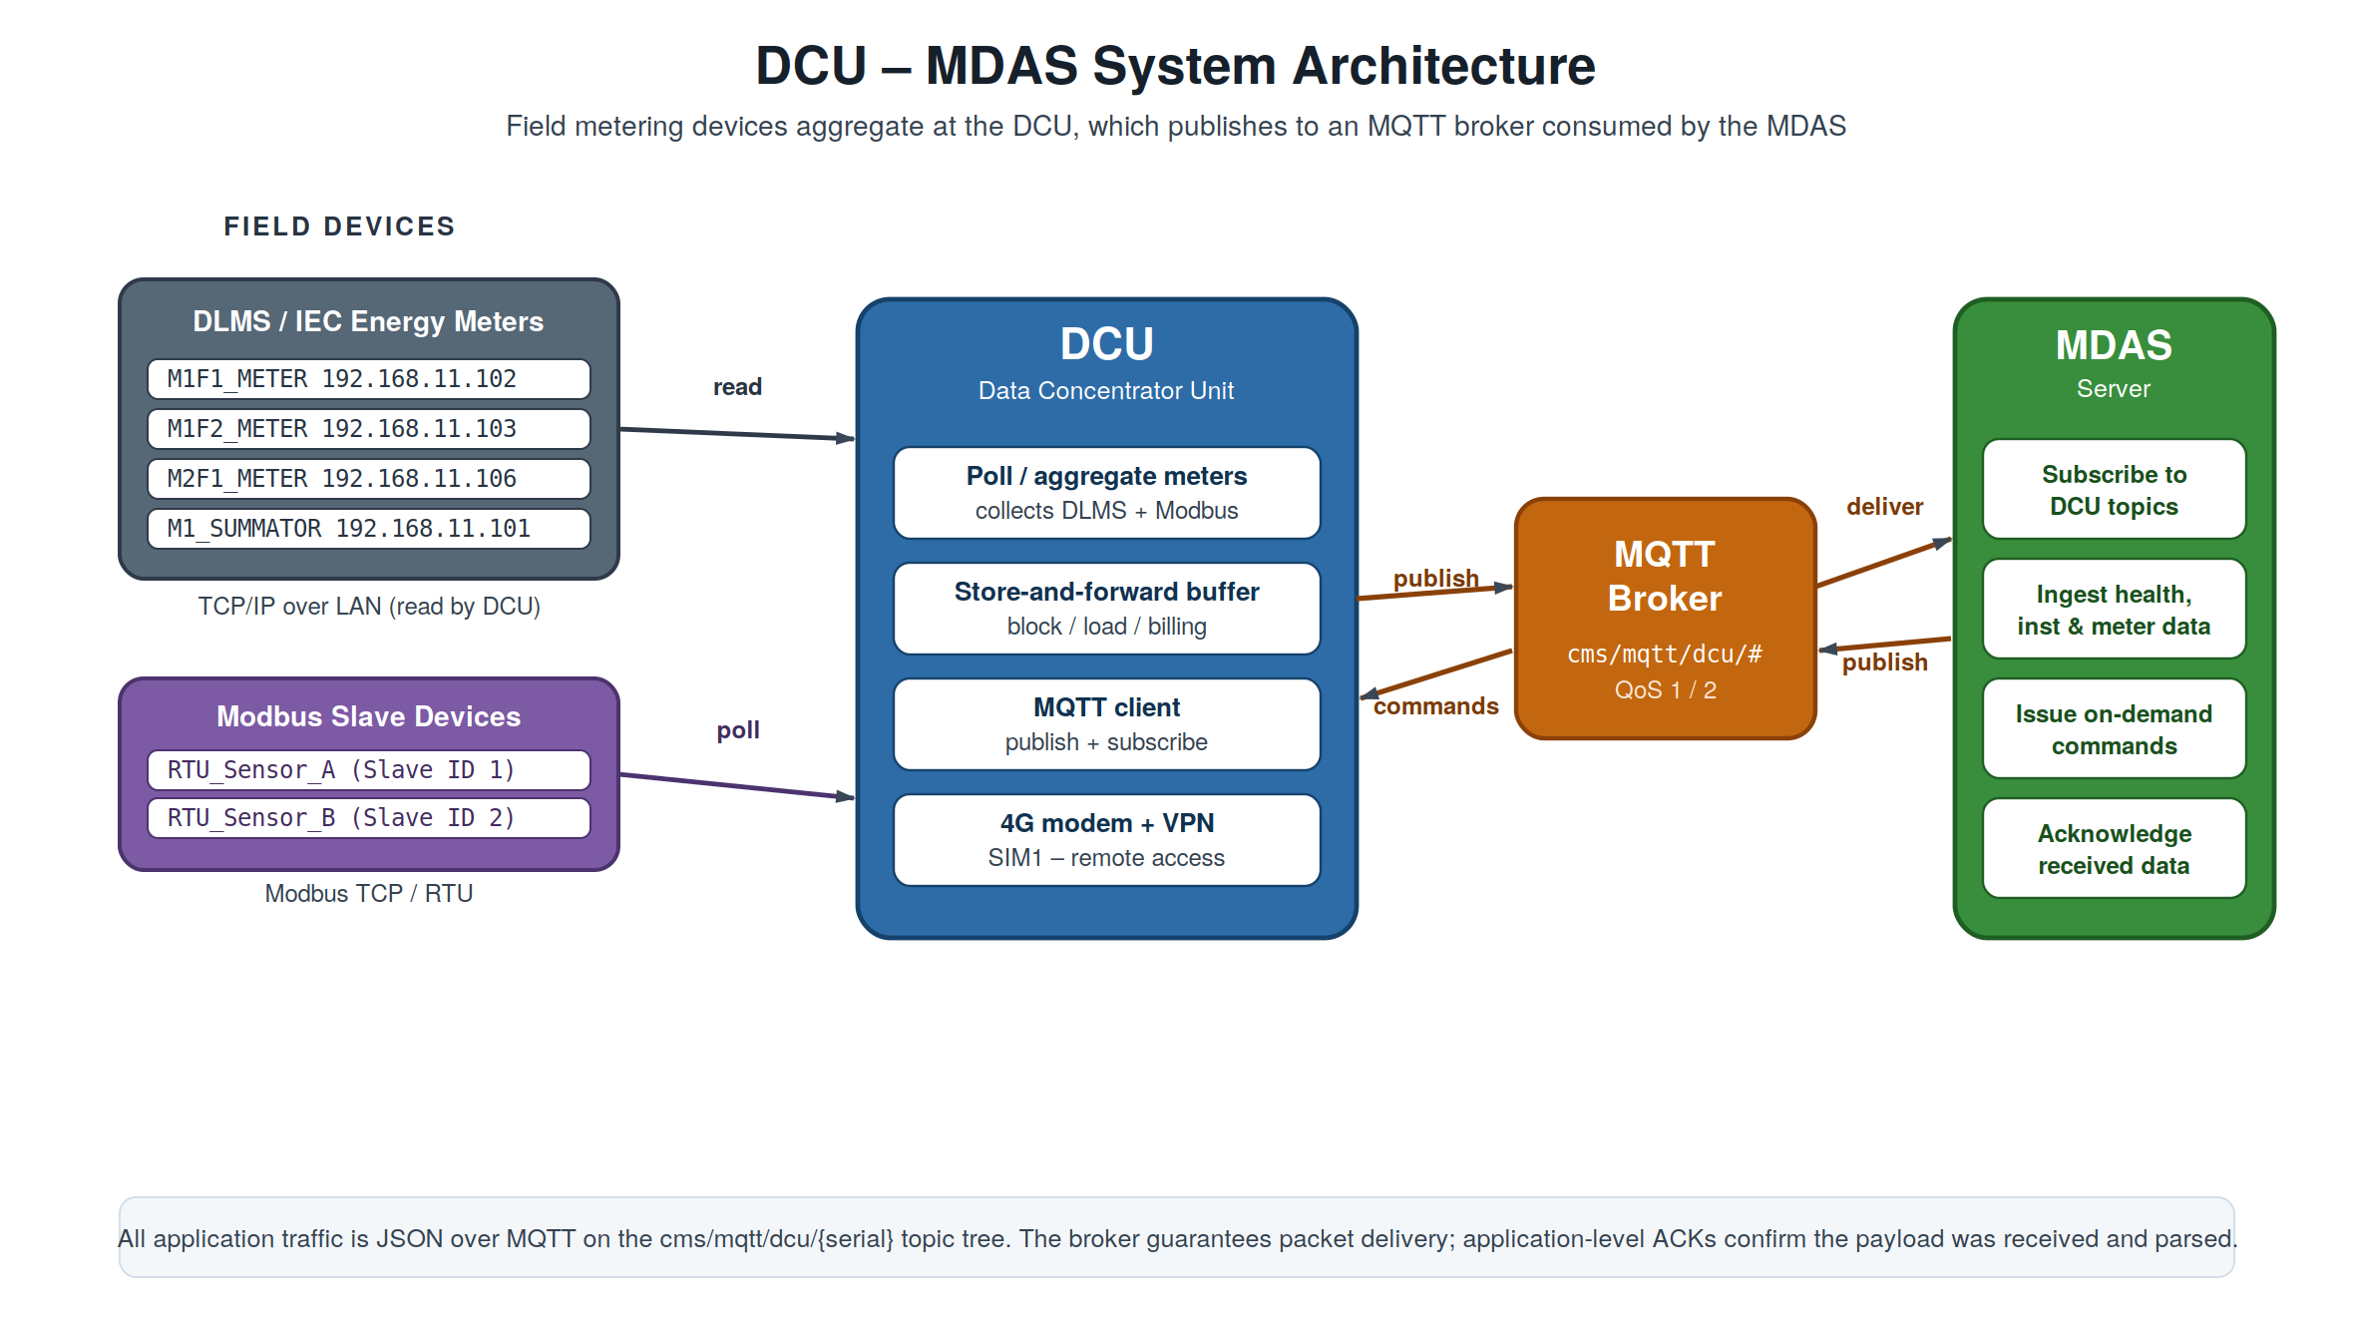
Figure 1. System architecture — field meters and Modbus slaves aggregate at the DCU, which exchanges JSON with the MDAS through an MQTT broker.

1.1 Message Families
The protocol has three message families. Section A – ‘Cyclic Data’ is published by the DCU on a schedule; Section B – ‘On-Demand Commands’ is requested on demand by the MDAS; Section C – ‘ Acknowledgement is the receipt that flows in either direction.
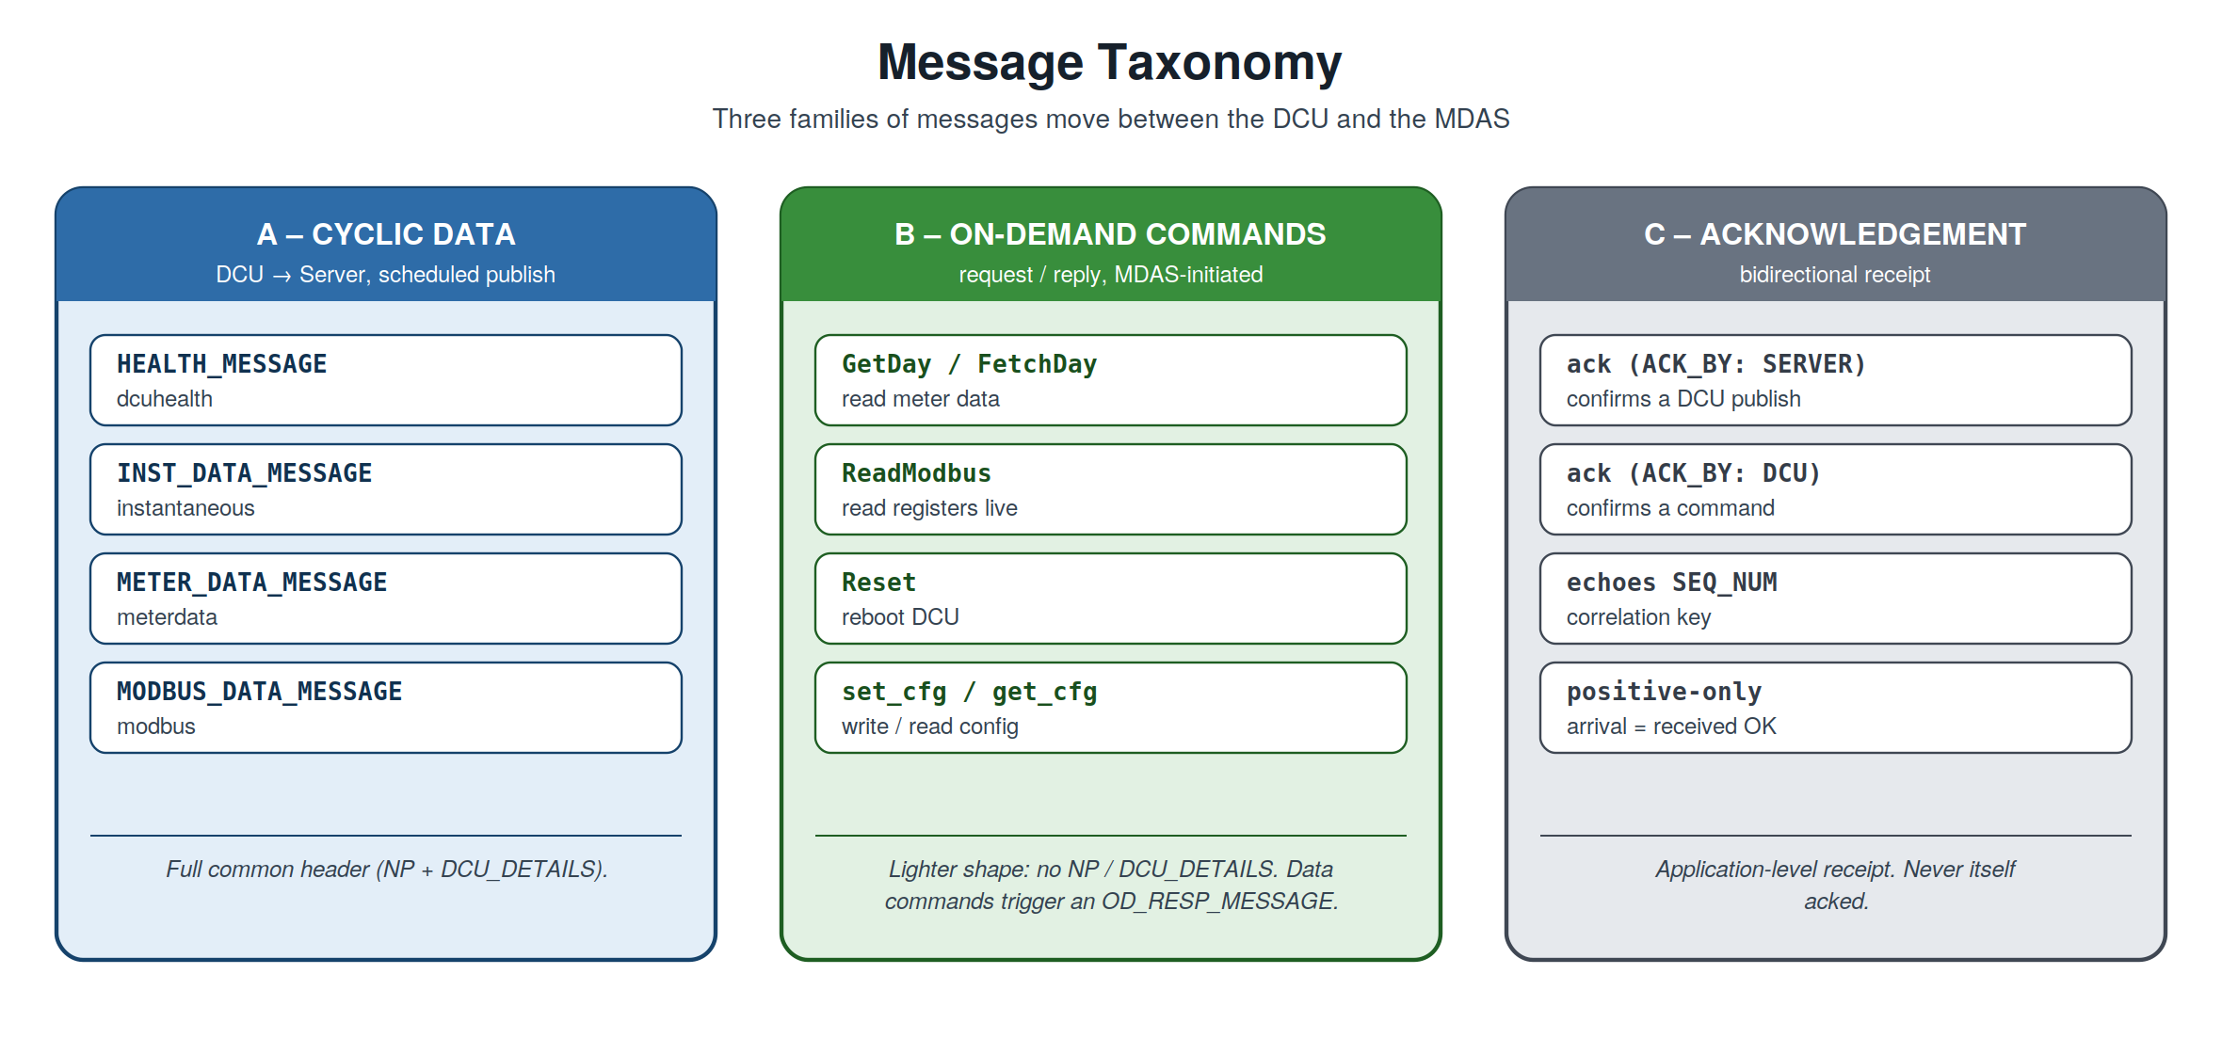
Figure 2. The three message families and the members of each.

1.2 Conventions
- Booleans are carried as the strings "YES" / "NO", faithful to the source meters. (Open question: convert to real true/false?)
- Dates use ISO YYYY-MM-DD; timestamps use YYYY-MM-DD HH:MM:SS
- Inner field names keep the original XML/CDF attribute names in UPPER_SNAKE_CASE for 1:1 traceability to the source.
- Correlation. SEQ_NUM ties a reply, a data response, and an ACK back to the message that triggered them.
Draft status
This is draft v0.10. Several values (notably the A.3 Meter Data profiles) are illustrative placeholders pending the real source CDF, and a number of fields are marked as open questions throughout. Items flagged “TODO/confirm” in the source are reproduced here as call-outs so they are not lost.

2. Common Envelope (Cyclic Messages)
The published messages in Section A and the on-demand data response (OD_RESP_MESSAGE, B.1.3 / B.4.3) share one top-level structure. Only the DATA object changes between them; the header identifying the device is identical.
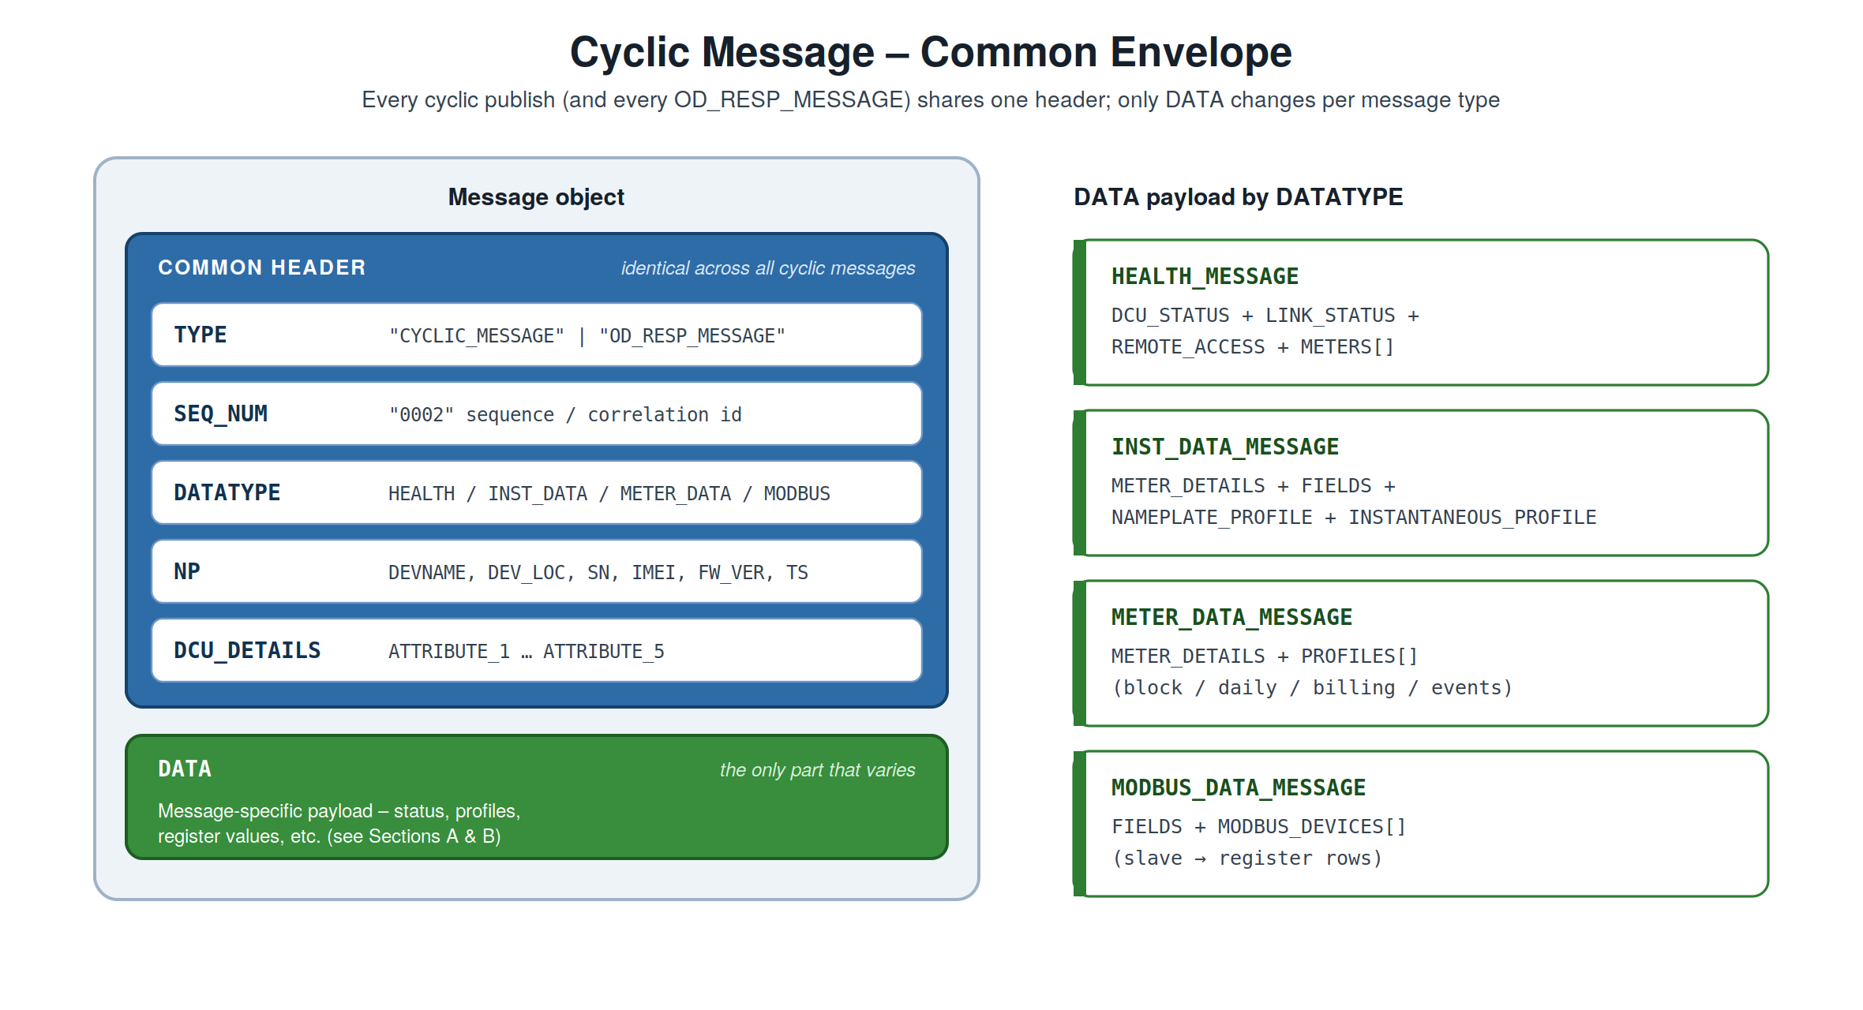
Figure 3. Anatomy of the common envelope. The header is constant per device; DATA carries the message-specific payload.

2.1 Envelope skeleton
JSON
{
"TYPE": "CYCLIC_MESSAGE",
"SEQ_NUM": "0001",
"DATATYPE": "INST_DATA_MESSAGE",
"NP": {
"DEVNAME": "DCU-E70-DVC",
"DEV_LOC": "Bengaluru",
"SN": "10131F25",
"IMEI": "8345345345",
"FW_VER": "VER5.7 Jan 16 2025-11:53:40(R)",
"TS": "2025-09-22 15:25:52"
},
"DCU_DETAILS": {
"ATTRIBUTE_1": "490007",
"ATTRIBUTE_2": "CLW_CHITHARANJAN",
"ATTRIBUTE_3": "M1F1F2F3_M2F1F2F3_3F",
"ATTRIBUTE_4": "9010013700017",
"ATTRIBUTE_5": "33 kV_ FEEDER"
},
"DATA": { }
}

2.2 Envelope fields
Field | Meaning
TYPE | CYCLIC_MESSAGE (scheduled publish) or OD_RESP_MESSAGE (data response to a command). Commands themselves use "command" / "command_reply" — see Section 4.
SEQ_NUM | Sequence number of the message (per device / per session); also the correlation key.
DATATYPE | Specific message kind — see the DATATYPE table below.
NP | Nameplate — device identity block, common to all cyclic messages.
DCU_DETAILS | DCU descriptor attributes (ATTRIBUTE_1..5), common to all cyclic messages.
DATA | Message-specific payload.

2.3 NP (Nameplate) fields
Field |  | Meaning | Source in PDF
DEVNAME |  | Device name / model | HEALTH_STATUS@DCU (e.g. DCU-E70-DVC)
DEV_LOC |  | Device location | new — assign per device
SN |  | Serial number | SERIALNUM (e.g. 10131F25)
IMEI |  | Modem IMEI | new — not in PDF
FW_VER |  | Firmware version | FIRMWARE
TS |  | Message timestamp | DCU_STATUS@TIME / generation time
Note:
- DEVNAME is the DCU device name - DCU-E70-DVC
- DEV_LOC and IMEI are to be filled in (DCU configuration items)
- DCU_DETAILS (ATTRIBUTE_1..5) is per-device and constant across that device's messages; these are present in the Health message, and the same values are reused elsewhere.

2.4 DATATYPE values (cyclic messages)
TYPE | DATATYPE | Message | Topic suffix
CYCLIC_MESSAGE | HEALTH_MESSAGE | DCU Health | dcuhealth
CYCLIC_MESSAGE | INST_DATA_MESSAGE | Instantaneous data | instantaneous
CYCLIC_MESSAGE | METER_DATA_MESSAGE | Meter data (all profiles) | meterdata
CYCLIC_MESSAGE | MODBUS_DATA_MESSAGE | Modbus register data | modbus
Commands (cmdrequest / cmdreply) do not use DATATYPE; they use COMMAND_TYPE + DATA_TYPE — see Section 4.

2.5 Topic namespace
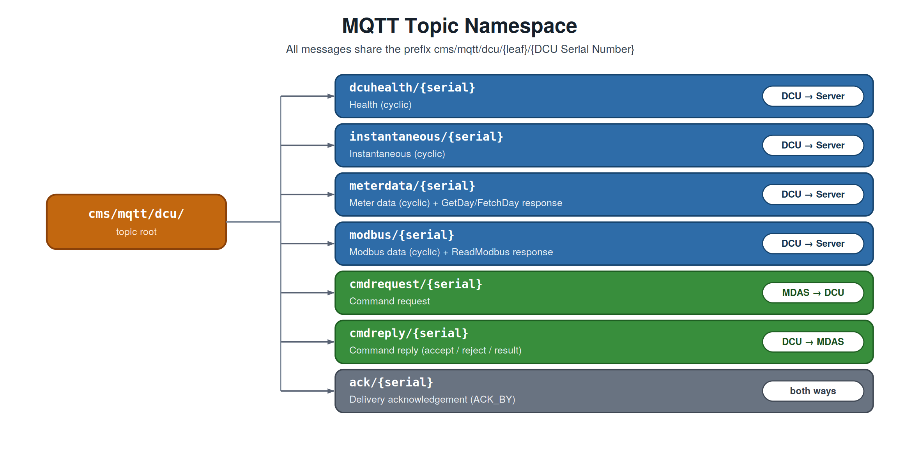
Figure 4. The MQTT topic tree. Every leaf is suffixed with the DCU serial number.

3. Section A — Cyclic Data (Published by DCU)
These messages are published by the DCU on a configurable schedule. All four use the common envelope from Section 2.

3.1 DCU Health
Direction: DCU → Server | Topic: cms/mqtt/dcu/dcuhealth/{serial} | Interval: Configurable, minimum 1 min
Reports DCU power/link status, remote-access state, and the communication status of every meter behind the DCU. The DATA object carries a DCU_STATUS block plus a METERS[] array.

Original (XML)
XML
<HEALTH_STATUS DCU="DCU-E70-DVC" SERIALNUM="10131F25"
FIRMWARE="VER5.7 Jan 16 2025-11:53:40(R)">
<DCU_DETAILS ATTRIBUTE_1="490007" ATTRIBUTE_2="CLW_CHITHARANJAN" .../>
<DCU_STATUS POWER="ON" TIME="2025-09-22 15:25:52"
ACTIVE_SINCE="2025-09-20 16:35:29" TIME_SYNCHED="YES">
<LINK_STATUS CONNECTED_ON="MODEM" ACTIVE_SIM="SIM1" ISP="IND airtel"/>
<REMOTE_ACCESS VPN_IP="172.24.18.65" REMOTE_ACCESS_ENABLED="YES"/>
</DCU_STATUS>
<METERS>
<METER ID="21" BAY="M1F1_METER" IP_ADDRESS="192.168.11.102"
COMMUNICATION_STATUS="CONNECTED" .../>
...
</METERS>
</HEALTH_STATUS>

JSON
JSON
{
"TYPE": "CYCLIC_MESSAGE",
"SEQ_NUM": "0001",
"DATATYPE": "HEALTH_MESSAGE",
"NP": { "DEVNAME": "DCU-E70-DVC", "DEV_LOC": "", "SN": "10131F25",
"IMEI": "", "FW_VER": "VER5.7 Jan 16 2025-11:53:40(R)",
"TS": "2025-09-22 15:25:52" },
"DCU_DETAILS": { "ATTRIBUTE_1": "490007", "ATTRIBUTE_2": "CLW_CHITHARANJAN",
"ATTRIBUTE_3": "M1F1F2F3_M2F1F2F3_3F", "ATTRIBUTE_4": "9010013700017",
"ATTRIBUTE_5": "33 kV_ FEEDER" },
"DATA": {
"DCU_STATUS": {
"POWER": "ON",
"TIME": "2025-09-22 15:25:52",
"ACTIVE_SINCE": "2025-09-20 16:35:29",
"TIME_SYNCHED": "YES",
"LINK_STATUS": { "CONNECTED_ON": "MODEM", "ACTIVE_SIM": "SIM1", "ISP": "IND airtel" },
"REMOTE_ACCESS": { "VPN_IP": "172.24.18.65", "REMOTE_ACCESS_ENABLED": "YES" }
},
"METERS": [
{ "ID": 21, "BAY": "M1F1_METER", "IP_ADDRESS": "192.168.11.102",
"COMM_STATUS": "CONNECTED", "COMM_INHIBIT": "NO", "TIME_SYNCHED": "NO",
"VPN_IP": "172.24.18.66", "REMOTE_ACCESS_ENABLED": "NO" },
{ "ID": 22, "BAY": "M1F2_METER", "IP_ADDRESS": "192.168.11.103",
"COMM_STATUS": "CONNECTED", "COMM_INHIBIT": "NO", "TIME_SYNCHED": "NO",
"VPN_IP": "172.24.18.67", "REMOTE_ACCESS_ENABLED": "NO" }
// ... remaining meters (IDs 23, 25, 26, 27, 29, 30) follow the same shape
]
}
}

3.2 Instantaneous Data
Direction: DCU → Server | Topic: cms/mqtt/dcu/instantaneous/{serial} | Interval: Configurable, minimum 1 min
Source: INSTANTANEOUS CDF (XML), which holds two profiles per meter — D1 = Nameplate and D2 = Instantaneous (snapshot).

CDF → JSON mapping
CDF element |  | JSON location
GENERAL/DCU_DETAILS@Name |  | NP.DEVNAME (header)
GENERAL/DCU_DETAILS@SERIALNUM |  | NP.SN (header)
GENERAL/DCU_DETAILS@TIME |  | NP.TS (header)
GENERAL/DCU_DETAILS@ATTRIBUTE_1..5 |  | DCU_DETAILS (header)
GENERAL/METER_DETAILS |  | DATA.METER_DETAILS
D1/NAMEPARAM[] |  | DATA.NAMEPLATE_PROFILE[]
D2/SNAPSHOT@DATE + INSTAPARAM[] |  | DATA.INSTANTANEOUS_PROFILE.DATE + .VALUES[]
Columnar (columns-once) layout
Every param keeps all five fields (CODE, OBIS_CODE, NAME, VALUE, UNIT), but the names are declared once in DATA.FIELDS; each param is then a positional row array in that order. This removes the repeated keys from every row.
Size impact: array-of-objects ≈ 7,313 B minified → columnar rows ≈ 4,488 B (~39% smaller), all fields retained. Send minified on the wire; optionally gzip for a further large reduction.

JSON
JSON
{
"TYPE": "CYCLIC_MESSAGE",
"SEQ_NUM": "0002",
"DATATYPE": "INST_DATA_MESSAGE",
"NP": { "DEVNAME": "DCU-E70-HVPNL", "DEV_LOC": "", "SN": "10132124",
"IMEI": "", "FW_VER": "", "TS": "2025-06-13 16:03:35" },
"DCU_DETAILS": { "ATTRIBUTE_1": "CHG_TEST", "ATTRIBUTE_2": "TEST",
"ATTRIBUTE_3": "M1M2_1F", "ATTRIBUTE_4": "TEST", "ATTRIBUTE_5": "33KV_FEEDER" },
"DATA": {
"METER_DETAILS": { "BAY": "MAIN_METER_IC1", "IP_ADDRESS": "192.168.11.101" },
"FIELDS": ["CODE", "OBIS_CODE", "NAME", "VALUE", "UNIT"],
"NAMEPLATE_PROFILE": [
["G1", "00_00_60_01_00_ff", "Meter_Serial_Number", " HVPN5016", ""],
["G22", "00_00_60_01_01_ff", "Manufacturer_Name", "GENUS POWER INFRASTRUCTURES LTD", ""],
["G17", "01_00_00_02_00_ff", "Firmware_Version", "HB003.57345", ""]
// ... remaining nameplate rows
],
"INSTANTANEOUS_PROFILE": {
"DATE": "2025-06-13 16:03:27.000",
"VALUES": [
["P2-1-1-1-0", "01_00_1f_07_00_ff", "Current_IR", "0.00000", "A"],
["P1-1-4-1-0", "01_00_20_07_00_ff", "Voltage_VRY", "58.23000", "V"],
["P9-1-0-0-0", "01_00_0e_07_00_ff", "Frequency", "50.07000", "Hz"],
["P7-1-5-0-0", "01_00_01_08_00_ff", "Energy_kWh_Import", "418.26791", "Wh"]
// ... remaining instantaneous rows
]
}
}
}

3.3 Meter Data (all profiles except Instantaneous)
Direction: DCU → Server | Topic: cms/mqtt/dcu/meterdata/{serial} | Interval: Configurable, minimum 5 min
Carries multiple profiles — block/load survey, daily, billing, and events — in one message. Sent as actual JSON (not zipped). Every profile uses the columns-once layout: its FIELDS + PARAMS heading is sent once, then each record carries only a key plus the value array.
- Block load: BLOCK_INTERVAL (minutes) sits outside; each block is identified by its interval index 0…95 (96 blocks/day at 15 min). Entries are [index, [values…]] — no per-block timestamp.
- Daily / Billing / Events: entries are [timestamp, [values…]] (date for daily/billing, full timestamp for events).

JSON
JSON
{
"TYPE": "CYCLIC_MESSAGE",
"SEQ_NUM": "0003",
"DATATYPE": "METER_DATA_MESSAGE",
"NP": { "DEVNAME": "DCU-E70-HVPNL", "SN": "10132124", "TS": "2025-04-02 06:00:00", ... },
"DCU_DETAILS": { "ATTRIBUTE_1": "CHG_TEST", ... },
"DATA": {
"METER_DETAILS": { "BAY": "MAIN_METER_IC1", "IP_ADDRESS": "192.168.11.101" },
"PROFILES": [
{
"PROFILE": "BLOCK_LOAD_PROFILE",
"DATE": "2025-04-02",
"BLOCK_INTERVAL": 15,
"FIELDS": ["CODE", "OBIS_CODE", "NAME", "UNIT"],
"PARAMS": [
["P2-1-1-1-0", "01_00_1f_07_00_ff", "Current_IR", "A"],
["P1-1-4-1-0", "01_00_20_07_00_ff", "Voltage_VRY", "V"]
// ... up to 26 params
],
"BLOCKS": [
[0, ["0.95914", "0.03752", "...", "1.00978"]],
[1, ["0.13912", "0.14507", "...", "0.62852"]],
["...", "94 more blocks (interval index 2 ... 94)"],
[95, ["0.88189", "0.52595", "...", "0.38066"]]
]
},
{
"PROFILE": "DAILY_LOAD_PROFILE",
"FIELDS": ["CODE", "OBIS_CODE", "NAME", "UNIT"],
"PARAMS": [ ["P7-1-5-0-0", "01_00_01_08_00_ff", "Energy_kWh_Import", "Wh"], ... ],
"RECORDS": [
["2025-04-01", ["12450.00000", "410.50000", "16780.00000", ...]],
["2025-04-02", ["12612.30000", "421.80000", "17005.40000", ...]]
]
}
// ... BILLING_PROFILE and EVENT_LOG follow the same record shape
]
}
}

3.4 Modbus Data
Direction: DCU → Server | Topic: cms/mqtt/dcu/modbus/{serial} | Interval: Cyclic
Carries the latest register values polled from one or more Modbus slave devices behind the DCU. The source file's dcu_nameplate maps onto the common header; registers use the same columns-once layout.

Source → JSON mapping
Original field |  | JSON location
dcu_nameplate.dcu_name |  | NP.DEVNAME
dcu_nameplate.dcu_sernum |  | NP.SN
dcu_nameplate.date_time |  | NP.TS
dcu_nameplate.attr1..5 |  | DCU_DETAILS.ATTRIBUTE_1..5
modbus_devices[] |  | DATA.MODBUS_DEVICES[]
registers[] (address,name,type,value) |  | rows under common DATA.FIELDS
Notes
• VALUE is a scalar for register TYPE 5 and an array of bits for TYPE 1 (coil block) — kept as-is in the row's value column.
• NUM_VALS equals the REGISTERS length (redundant; kept from the source).
• TYPE is the Modbus register/data-type code from the source.

JSON
JSON
{
"TYPE": "CYCLIC_MESSAGE",
"SEQ_NUM": "0004",
"DATATYPE": "MODBUS_DATA_MESSAGE",
"NP": { "DEVNAME": "", "SN": "", "TS": "2026-02-18 12:57:43", ... },
"DCU_DETAILS": { "ATTRIBUTE_1": "", ... },
"DATA": {
"FIELDS": ["ADDRESS", "NAME", "TYPE", "VALUE"],
"MODBUS_DEVICES": [
{
"SLAVE_ID": 1, "IP_ADDRESS": "", "NAME": "RTU_Sensor_A",
"STATUS": "Connected", "LAST_UPDATE_TIME": "2026-02-18 12:57:43",
"NUM_VALS": 4,
"REGISTERS": [
[10, "reg-1", 1, [1, 1, 1, 1, 1, 1, 1, 0]],
[10000, "reg-2", 1, [0, 0, 0, 0, 0, 1, 1, 1]],
[20000, "reg-3", 5, -2],
[30000, "reg-4", 5, 0]
]
},
{ "SLAVE_ID": 2, "NAME": "RTU_Sensor_B", "NUM_VALS": 2, "REGISTERS": [ ... ] }
]
}
}

4. Section B — On-Demand Data (Request / Reply)
Commands do not use the cyclic common header. There is no NP and no DCU_DETAILS — the target DCU is identified inside DATA.

4.1 Command fields
Field | Meaning
TYPE | "command" (request) / "command_reply" (reply).
SEQ_NUM | Correlation id — the reply echoes the request's SEQ_NUM (replaces the PDF's TRANSACTION).
COMMAND_TYPE | GetDay / FetchDay (read meter data), ReadModbus, Reset, set_cfg, get_cfg.
DATA_TYPE | What the command targets — a data kind for GetDay/FetchDay, or a config group for set_cfg/get_cfg.
DATA | Always includes DCU. Data commands add METER + DATE (single) or START_DATE/END_DATE (range); config commands add the parameter fields; replies add CMD_STATUS + CMD_MSG.
Flow. command (MDAS→DCU) → command_reply (DCU→MDAS, accept/reject). For data commands the actual data then follows on success as one or more OD_RESP_MESSAGEs on the matching data topic. Reset, set_cfg, get_cfg end at the command_reply.

4.2 DATA_TYPE values

For data commands (GetDay / FetchDay) — which profile to return
DATA_TYPE | Data targeted
INST | Instantaneous
BLOCK | Block load profile
DAILY | Daily load profile
BILLING | Billing profile
EVENT | Event log
MODBUS | Modbus slave registers

For config commands (set_cfg / get_cfg) — which configuration group
DATA_TYPE | Configuration group | DATA fields (besides DCU)
METER_IP | A meter's IP address | METER, IP_ADDRESS
SERIAL_PORT | Serial port settings | PORT, BAUD_RATE, DATA_BITS, PARITY, STOP_BITS
MQTT_BROKER | MQTT broker connection | BROKER_URL, PORT, USERNAME, PASSWORD, CLIENT_ID, USE_TLS
PUBLISH_INTERVAL | Cyclic publish intervals (min) | HEALTH_, INST_, METER_DATA_, MODBUS_INTERVAL

4.3 Meter Data Command (GetDay / FetchDay)

4.3.1 Command Request (MDAS → DCU)
Direction: MDAS → DCU | Topic: cms/mqtt/dcu/cmdrequest/{serial} | Interval: On demand

GetDay reads stored data from the DCU; FetchDay forces the LS data to be polled from the meter. Use a single DATE or a START_DATE/END_DATE range — the two forms are mutually exclusive.

GetDay (single date)
JSON
{
"TYPE": "command",
"SEQ_NUM": "1001",
"COMMAND_TYPE": "GetDay",
"DATA_TYPE": "BLOCK",
"DATA": {
"DCU": "10132ED5",
"METER": "M1_METER",
"DATE": "2025-09-21"
}
}

FetchDay (date range)
JSON
{
"TYPE": "command",
"SEQ_NUM": "1002",
"COMMAND_TYPE": "FetchDay",
"DATA_TYPE": "DAILY",
"DATA": {
"DCU": "10132ED5",
"METER": "M1_METER",
"START_DATE": "2024-10-30",
"END_DATE": "2024-11-05"
}
}

4.3.2 Command Reply (DCU → MDAS)
Direction: DCU → MDAS | Topic: cms/mqtt/dcu/cmdreply/{serial} | Interval: On demand

The reply echoes SEQ_NUM, COMMAND_TYPE, DATA_TYPE, and the request's DATA keys, and adds CMD_STATUS + CMD_MSG.

Case 1 — success
JSON
{
"TYPE": "command_reply",
"SEQ_NUM": "1001",
"COMMAND_TYPE": "GetDay",
"DATA_TYPE": "BLOCK",
"DATA": {
"DCU": "10132ED5",
"METER": "M1_METER",
"DATE": "2025-09-21",
"CMD_STATUS": 0,
"CMD_MSG": "SUCCESS"
}
}

Case 2 — meter does not match DCU
JSON
{
"TYPE": "command_reply",
"SEQ_NUM": "1001",
"COMMAND_TYPE": "GetDay",
"DATA_TYPE": "BLOCK",
"DATA": {
"DCU": "10132ED5",
"METER": "M3_METER",
"DATE": "2025-09-21",
"CMD_STATUS": 3,
"CMD_MSG": "Invalid meter name"
}
}
Case 3 (unknown command type) is identical in shape with CMD_STATUS: 7, CMD_MSG: "Unknown request". See the status-code table in Section 6.

4.3.3 Data Response (DCU → Server)
Direction: DCU → Server | Topic: cms/mqtt/dcu/meterdata/{serial} | Interval: After command (echoes SEQ_NUM)
On success, the requested data follows as one or more OD_RESP_MESSAGEs — the same structure as the cyclic message (NP + DCU_DETAILS + DATA), with two differences: TYPE is "OD_RESP_MESSAGE", and SEQ_NUM echoes the command's so the MDAS can match data to request.
JSON
{
"TYPE": "OD_RESP_MESSAGE",
"SEQ_NUM": "1001",
"DATATYPE": "METER_DATA_MESSAGE",
"NP": { "DEVNAME": "DCU-E70-HVPNL", "SN": "10132124", "TS": "2025-09-22 15:40:08", ... },
"DCU_DETAILS": { "ATTRIBUTE_1": "CHG_TEST", ... },
"DATA": { "...": "PROFILES exactly as in the A.3 Meter Data message" }
}

4.4 DCU Reset
Direction: MDAS → DCU / DCU → MDAS | Topic: cms/mqtt/dcu/cmdrequest · cmdreply /{serial} | Interval: On demand

Reset carries no DATA_TYPE/METER/DATE — only the target DCU. It ends at the command_reply (no data response follows).

Request
JSON
{
"TYPE": "command",
"SEQ_NUM": "1003",
"COMMAND_TYPE": "Reset",
"DATA": {
"DCU": "10132ED5"
}
}

Reply
JSON
{
"TYPE": "command_reply",
"SEQ_NUM": "1003",
"COMMAND_TYPE": "Reset",
"DATA": {
"DCU": "10132ED5",
"CMD_STATUS": 0,
"CMD_MSG": "SUCCESS"
}
}

4.5 Configuration (set_cfg / get_cfg)
Server-initiated configuration. set_cfg writes a group's fields; get_cfg reads them back. The DCU acknowledges with a command_reply (no data response); for get_cfg the reply itself carries the current values.

4.5.1 set_cfg request — examples

4.5.1.1 set_cfg request — Primary MQTT Broker

DCU is mandatory. All other fields are optional and can be sent as needed.
JSON
{
"TYPE": "command",
"SEQ_NUM": "2004",
"COMMAND_TYPE": "set_cfg",
"DATA_TYPE": "MQTT_BROKER_PRIMARY",
"DATA": {
"DCU": "12345678",
"BROKER_IP": "192.168.10.115",
"BROKER_PORT": "8883",
"CLIENT_ID": "cms_primary",
"USERNAME": "gokul",
"PASSWORD" : "hello@321"
"HEALTH_INTERVAL": 1,
"INST_INTERVAL": 1,
"METER_DATA_INTERVAL": 5,
"MODBUS_INTERVAL": 5
}
}

4.5.1.2 set_cfg request —Secondary MQTT Broker

DCU is mandatory. All other fields are optional and can be sent as needed.
JSON
{
"TYPE": "command",
"SEQ_NUM": "2004",
"COMMAND_TYPE": "set_cfg",
"DATA_TYPE": "MQTT_BROKER_SECONDARY",
"DATA": {
"DCU": "12345678",
"BROKER_IP": "192.168.10.115",
"BROKER_PORT": "8883",
"CLIENT_ID": "cms_primary",
"USERNAME": "gokul",
"PASSWORD" : "hello@321"
"HEALTH_INTERVAL": 1,
"INST_INTERVAL": 1,
"METER_DATA_INTERVAL": 5,
"MODBUS_INTERVAL": 5
}
}
Values are in minutes. Send only the intervals to change (any subset is valid). Spec minimums: HEALTH/INST ≥ 1, METER_DATA ≥ 5.

4.5.1.3 set_cfg request — MODEM

DCU and SIM_SLOT are mandatory. SIM_SLOT must be either 1 (SIM 1) or 2 (SIM 2). All other fields are optional and can be sent as needed.
JSON
{
"TYPE": "command",
"SEQ_NUM": "2004",
"COMMAND_TYPE": "set_cfg",
"DATA_TYPE": "MODEM",
"DATA": {
"DCU" : "123456789",
"SIM_SLOT" : 1 or 2, [ 1-SIM1, 2-SIM2]
"USERNAME" : "airtel",
"PASSWORD" : "hello@321",
"APN" : "airtelgprs.com"
"DIAL_NUM" : "*99#"
}
}

4.5.1.4 set_cfg request — IPSEC

DCU and IPSEC_TUNNEL are mandatory. IPSEC_TUNNEL must be either 1 (Tunnel 1) or 2 (Tunnel 2). All other fields are optional and can be sent as needed.
JSON
{
"TYPE": "command",
"SEQ_NUM": "2004",
"COMMAND_TYPE": "set_cfg",
"DATA_TYPE": "IPSEC",
"DATA": {
"DCU" : "123456789",
"IPSEC_TUNNEL" : 1 or 2, [1-IPSEC TUNNEL 1, 2-IPSEC TUNNEL 2]
"ENABLE_TUNNEL" : 1, [1-ENABLE , 0-DISBALE]
"RIGHT_IP" : "122.166.196.34",
"LEFT_ID" : "welcome@123",
"LEFT_SUBNET" : "192.168.11.0",
"RIGHT_ID" : "hello@123",
"RIGHT_SUBNET" : "192.168.10.0"
"TUNNEL_NAME" : "tunnel_01"
}
}

4.5.1.5 set_cfg request — NTP

DCU and NTP_SERVER are mandatory. NTP_SERVER must be either 1 (NTP Server 1) or 2 (NTP Server 2). All other fields are optional and can be sent as needed.
JSON
{
"TYPE": "command",
"SEQ_NUM": "2004",
"COMMAND_TYPE": "set_cfg",
"DATA_TYPE": "NTP",
"DATA": {
"DCU" : "123456789",
"NTP_SERVER" : 1 or 2, [1-NTP SERVER 1, 2- NTP SERVER 2]
“ENABLE_NTP” : 1 or 0, [1-ENABLE , 0-DISBALE]
"NTP_IP" : "192.168.10.68",
"NTP_PORT" : 123,
}
}

4.5.1.6 set_cfg request — FTP

DCU and FTP_SERVER are mandatory. FTP_SERVER must be either 1 (FTP Server 1) or 2 (FTP Server 2). All other fields are optional and can be sent as needed.
JSON
{
"TYPE": "command",
"SEQ_NUM": "2004",
"COMMAND_TYPE": "set_cfg",
"DATA_TYPE": "FTP",
"DATA": {
"DCU" : "123456789",
"FTP_SERVER" : 1 or 2, [1-FTP SERVER 1, 2-FTP SERVER 2]
"ENABLE_SERVER" : 1 or 0, [1-ENABLE , 0-DISBALE]
"IP_ADDRESS" : "192.168.10.69",
"PORT" : 123,
"USERNAME" : "GOKUL",
"PASSWORD" : "GOK@123,
"REMOTE_DIRECTORY" : "D:\CMS_FTP_DATA”,
"TIME_INTERVAL": 15
}
}

4.5.1.7 set_cfg request — IEC104

DCU is mandatory. All other fields are optional and can be sent as needed.
JSON
{
"TYPE": "command",
"SEQ_NUM": "2004",
"COMMAND_TYPE": "set_cfg",
"DATA_TYPE": "IEC104",
"DATA": {
"DCU" : "123456789",
"ENABLE_104" : 1 or 0, [1-ENABLE 101, 0-DISABLE 101]
"ASDU_ADDRESS" : 2,
"CYCLIC_INT" : 60,
"DLMS_IOA_OFFSET" : 5000,
"MODBUS_IOA_OFFSET": 6000,
"COMMANDS_IOA_OFFSET" : 7000,
}
}

4.5.1.8 set_cfg request — IEC101

DCU is mandatory. All other fields are optional and can be sent as needed.
JSON
{
"TYPE": "command",
"SEQ_NUM": "2004",
"COMMAND_TYPE": "set_cfg",
"DATA_TYPE": "IEC101",
"DATA": {
"DCU" : "123456789",
"ENABLE_101" : 1 or 0, [1-ENABLE 101, 0-DISABLE 101]
"ASDU_ADDRESS" : 2,
"CYCLIC_INT" : 60,
"DLMS_IOA_OFFSET" : 5000,
"MODBUS_IOA_OFFSET": 6000,
"COMMANDS_IOA_OFFSET" : 7000
}
}

4.5.1.9 set_cfg request — SERPORT

DCU and SERIAL_PORT are mandatory. SERIAL_PORT must be either 1 (Serial Port 1) or 2 (Serial Port 2). All other fields are optional and can be sent as needed.
JSON
{
"TYPE": "command",
"SEQ_NUM": "2004",
"COMMAND_TYPE": "set_cfg",
"DATA_TYPE": "SERPORT",
"DATA": {
"DCU" : "123456789",
"SERIAL_PORT" : 1 or 2, [1-SERIAL PORT 1, 2-SERIAL PORT 2]
"BAUD_RATE" : 9600,
"PARITY" : "even" or "odd" or "none"
"DATA_BITS": 8,
"STOP_BITS" : 1
}
}

4.5.1.9 set_cfg request — MODBUS_TCP

DCU and METER_NAME are mandatory. METER_NAME specifies the Modbus TCP meter to be configured. All other fields are optional and can be sent as needed.
JSON
{
"TYPE": "command",
"SEQ_NUM": "2004",
"COMMAND_TYPE": "set_cfg",
"DATA_TYPE": "MODBUS_TCP",
"DATA": {
"DCU" : "123456789"
"METER_NAME" : "MODTCP_Meter_1",
"IP_ADDRESS" : "192.168.10.118",
"PORT" : "506"
"SLAVE_ID": 8,
"RETRIES" : 1,
"POLL_SKIP_COUNT":3,
"RESP_TIMEOUT" : 11
}
}

4.5.1.9 set_cfg request — MODBUS_RTU

DCU, SERIAL_PORT, and METER_NAME are mandatory. SERIAL_PORT must be either 1 (Serial Port 1) or 2 (Serial Port 2), and METER_NAME specifies the Modbus RTU meter to be configured. All other fields are optional and can be sent as needed.
JSON
{
"TYPE": "command",
"SEQ_NUM": "2004",
"COMMAND_TYPE": "set_cfg",
"DATA_TYPE": "MODBUS_RTU",
"DATA": {
"DCU" : "123456789",
"SERIAL_PORT" : 1 or 2, [1-SERIAL PORT 1, 2-SERIAL PORT 2]
"METER_NAME" : "MODRTU_Meter_1",
"SLAVE_ID": 8,
"RETRIES" : 1,
"POLL_SKIP_COUNT":3,
"RESP_TIMEOUT" : 11
}
}

4.5.2 get_cfg request / reply
The request carries DCU plus only the identifying key for the group; the reply returns the current values plus CMD_STATUS + CMD_MSG.

4.5.2.1 Request -> MQTT BROKER
JSON
{
"COMMAND_TYPE": "get_cfg",
"SEQ_NUM": "2102",
"DATA_TYPE": "MQTT_BROKER",
"DATA": {
"DCU": "REConnect_12345678"
}
}

4.5.2.2 Response -> MQTT BROKER
JSON
{
"TYPE": "OD_RESP_MESSAGE",
"SEQ_NUM": "2102",
"DATATYPE": "MQTT_BROKER",
"NP": {
"DEVNAME": "DCU",
"DEV_LOC": "BANGALORE",
"SN": "123456789",
"IMEI": "",
"FW_VER": "CS-REConnect_DCU_T_V0.1_11Jun2026",
"TS": "2026-07-27 15:41:19"
},
"DCU_DETAILS": {
"ATTRIBUTE_1": "",
"ATTRIBUTE_2": "",
"ATTRIBUTE_3": "",
"ATTRIBUTE_4": "",
"ATTRIBUTE_5": ""
},
"DATA": {
"MQTT_BROKERS": [
{
"INSTANCE": 0,
"PRIMARY": 1,
"ENABLE_MQTT": 1,
"BROKER_IP_URL": "192.168.10.115",
"BROKER_PORT": 8883,
"CLIENT_ID": "cms_primary_gokul",
"USERNAME": "gokul",
"PASSWORD": "hello@321",
"ENABLE_SSL": 1,
"ENCRYPTED_KEY": 0,
"INSECURE": 1,
"CA_CERTIFICATE": "/usr/cms/config/tls_mqtt/inst1/ca.crt",
"CLIENT_CERTIFICATE": "/usr/cms/config/tls_mqtt/inst1/client.crt",
"CLIENT_KEY": "/usr/cms/config/tls_mqtt/inst1/client.key",
"KEY_PASSWORD": "",
"QOS": 2,
"CLEAN_SESSION": 1,
"KEEP_ALIVE_INTERVAL": 120,
"CMD_REQ_TOPIC": "cms/mqtt/dcu/cmd/req",
"CMD_RESP_TOPIC": "cms/mqtt/dcu/cmd/resp",
"DLMS_DATA_PUB_TOPIC": "cms/mqtt/dcu/dlms/data",
"DLMS_DATA_PUB_INTERVAL": 15,
"DLMS_INST_PUB_TOPIC": "cms/mqtt/dcu/dlms/inst",
"DLMS_INST_PUB_INTERVAL": 15,
"MODBUS_DATA_PUB_TOPIC": "cms/mqtt/dcu/modbus/data",
"MODBUS_DATA_PUB_INTERVAL": 15,
"HC_PUB_TOPIC": "cms/mqtt/dcu/healthcheck",
"HC_PUB_INTERVAL": 5
},
{
"INSTANCE": 1,
"PRIMARY": 0,
"ENABLE_MQTT": 1,
"BROKER_IP_URL": "192.168.10.110",
"BROKER_PORT": 1883,
"CLIENT_ID": "cms_secondary",
"USERNAME": "cms_mqtt2",
"PASSWORD": "cms@1234",
"ENABLE_SSL": 0,
"ENCRYPTED_KEY": 0,
"INSECURE": 1,
"CA_CERTIFICATE": "",
"CLIENT_CERTIFICATE": "",
"CLIENT_KEY": "",
"KEY_PASSWORD": "",
"QOS": 2,
"CLEAN_SESSION": 1,
"KEEP_ALIVE_INTERVAL": 120,
"CMD_REQ_TOPIC": "cms/mqtt/dcu/cmd/req",
"CMD_RESP_TOPIC": "cms/mqtt/dcu/cmd/resp",
"DLMS_DATA_PUB_TOPIC": "cms/mqtt/dcu/dlms/data",
"DLMS_DATA_PUB_INTERVAL": 15,
"DLMS_INST_PUB_TOPIC": "cms/mqtt/dcu/dlms/inst",
"DLMS_INST_PUB_INTERVAL": 15,
"MODBUS_DATA_PUB_TOPIC": "cms/mqtt/dcu/modbus/data",
"MODBUS_DATA_PUB_INTERVAL": 15,
"HC_PUB_TOPIC": "cms/mqtt/dcu/healthcheck",
"HC_PUB_INTERVAL": 5
}
]
}
}

4.5.2.3 Request -> MODEM
JSON
{
"COMMAND_TYPE": "get_cfg",
"SEQ_NUM": "2102",
"DATA_TYPE": "MODEM",
"DATA": {
"DCU": "REConnect_12345678"
}
}

4.5.2.4 Response -> MODEM
JSON
{
"TYPE": "OD_RESP_MESSAGE",
"SEQ_NUM": "2102",
"DATATYPE": "MODEM",
"NP": {
"DEVNAME": "DCU",
"DEV_LOC": "BANGALORE",
"SN": "123456789",
"IMEI": "",
"FW_VER": "CS-REConnect_DCU_T_V0.1_11Jun2026",
"TS": "2026-07-27 15:43:24"
},
"DCU_DETAILS": {
"ATTRIBUTE_1": "",
"ATTRIBUTE_2": "",
"ATTRIBUTE_3": "",
"ATTRIBUTE_4": "",
"ATTRIBUTE_5": ""
},
"DATA": {
"MODEM": {
"ENABLE_GPRS": 1,
"NUM_SIMS": 2,
"SIM_SELECTION": "auto",
"SIM1": {
"APN": "airtelgprs.com",
"USERNAME": "internet",
"PASSWORD": "internet@123",
"PHONE_NUMBER": "*99#"
},
"SIM2": {
"APN": "airtelgprs.com",
"USERNAME": "internet",
"PASSWORD": "internet@123",
"PHONE_NUMBER": "*99#"
}
}
}
}

4.5.2.5 Request -> IPSEC
JSON
{
"COMMAND_TYPE": "get_cfg",
"SEQ_NUM": "2102",
"DATA_TYPE": "IPSEC",
"DATA": {
"DCU": "REConnect_12345678"
}
}

4.5.2.6 Response -> IPSEC
JSON
{
"TYPE": "OD_RESP_MESSAGE",
"SEQ_NUM": "2102",
"DATATYPE": "IPSEC",
"NP": {
"DEVNAME": "DCU",
"DEV_LOC": "BANGALORE",
"SN": "123456789",
"IMEI": "",
"FW_VER": "CS-REConnect_DCU_T_V0.1_11Jun2026",
"TS": "2026-07-27 15:46:00"
},
"DCU_DETAILS": {
"ATTRIBUTE_1": "",
"ATTRIBUTE_2": "",
"ATTRIBUTE_3": "",
"ATTRIBUTE_4": "",
"ATTRIBUTE_5": ""
},
"DATA": {
"IPSEC_TUNNELS": [
{
"INSTANCE": 0,
"ENABLE_TUNNEL": 1,
"TUNNEL_NAME": "Tunnel_1",
"LEFT": "",
"LEFT_ID": "left@cmsgp.com",
"LEFT_SRC_IP": "",
"LEFT_SUBNET": "192.168.101.0",
"RIGHT_IP": "122.166.196.34",
"RIGHT_ID": "right@cmsgp.com",
"RIGHT_SUBNET": "192.168.10.0",
"CONN_TYPE": "tunnel",
"KEYING_MODE": "ikev2",
"PRE_SHARED_KEY": "dtnu@123",
"PHASE1_ENCRYPT": "aes256",
"PHASE1_AUTH": "sha1",
"PHASE1_DH_GROUP": "modp1024",
"PHASE2_ENCRYPT": "aes256",
"PHASE2_AUTH": "sha256",
"PHASE2_DH_GROUP": "modp2048",
"IKE_LIFETIME": 86400,
"KEY_LIFETIME": 3600,
"PFS": 1,
"NAT_TRAV": 1,
"FRAGMENTATION": 1,
"MOBIKE": 1,
"AGGRESSIVE_MODE": 1,
"AUTO_MODE": "add",
"CLOSE_ACTION": "restart",
"DPD_DELAY": 60,
"DPD_TIMEOUT": 180,
"DPD_ACTION": "clear",
"REKEY_MARGIN": 300
},
{
"INSTANCE": 1,
"ENABLE_TUNNEL": 0,
"TUNNEL_NAME": "Tunnel_2",
"LEFT": "",
"LEFT_ID": "local@cmsgp.com",
"LEFT_SRC_IP": "",
"LEFT_SUBNET": "192.168.7.0",
"RIGHT_IP": "122.166.189.229",
"RIGHT_ID": "remote@cmsgp.com",
"RIGHT_SUBNET": "192.168.32.0",
"CONN_TYPE": "tunnel",
"KEYING_MODE": "ikev1",
"PRE_SHARED_KEY": "reconnect@1234",
"PHASE1_ENCRYPT": "aes256",
"PHASE1_AUTH": "sha1",
"PHASE1_DH_GROUP": "modp1024",
"PHASE2_ENCRYPT": "aes256",
"PHASE2_AUTH": "sha1",
"PHASE2_DH_GROUP": "modp1024",
"IKE_LIFETIME": 86400,
"KEY_LIFETIME": 3600,
"PFS": 1,
"NAT_TRAV": 1,
"FRAGMENTATION": 1,
"MOBIKE": 0,
"AGGRESSIVE_MODE": 1,
"AUTO_MODE": "start",
"CLOSE_ACTION": "restart",
"DPD_DELAY": 60,
"DPD_TIMEOUT": 180,
"DPD_ACTION": "clear",
"REKEY_MARGIN": 540
}
]
}
}

4.5.2.7 Request -> IEC104
JSON
{
"COMMAND_TYPE": "get_cfg",
"SEQ_NUM": "2102",
"DATA_TYPE": "IEC104",
"DATA": {
"DCU": "REConnect_12345678"
}
}

4.5.2.8 Response -> IEC104
JSON
{
"TYPE": "OD_RESP_MESSAGE",
"SEQ_NUM": "2102",
"DATATYPE": "IEC104",
"NP": {
"DEVNAME": "DCU",
"DEV_LOC": "BANGALORE",
"SN": "123456789",
"IMEI": "",
"FW_VER": "CS-REConnect_DCU_T_V0.1_11Jun2026",
"TS": "2026-07-27 15:47:01"
},
"DCU_DETAILS": {
"ATTRIBUTE_1": "",
"ATTRIBUTE_2": "",
"ATTRIBUTE_3": "",
"ATTRIBUTE_4": "",
"ATTRIBUTE_5": ""
},
"DATA": {
"IEC104": {
"ENABLE_104": 0,
"PORT": 2404,
"MAX_CONNECTIONS": 2,
"ALLOWED_MASTER_CHECK": 0,
"MASTER_0_IP": "192.168.10.100",
"MASTER_0_ENABLED": 0,
"MASTER_1_IP": "192.168.10.101",
"MASTER_1_ENABLED": 0,
"ENABLE_TLS": 0,
"CA_CERTIFICATE": "",
"SERVER_CERTIFICATE": "",
"SERVER_KEY": "",
"KEY_PASSWORD": "",
"ENCRYPTED_KEY": 0,
"ASDU_ADDR": 1,
"ASDU_ADDR_SIZE": 2,
"COT_ADDR_SIZE": 2,
"IOA_ADDR_SIZE": 3,
"IOA_OFFSET": 10000,
"IOA_OFFSET_MODBUS": 20000,
"IOA_OFFSET_COMMAND": 30000,
"K": 12,
"W": 8,
"T0": 30,
"T1": 15,
"T2": 10,
"T3": 20,
"CYCLIC_INTERVAL": 60
}
}
}

4.5.2.9 Request -> IEC101
JSON
{
"COMMAND_TYPE": "get_cfg",
"SEQ_NUM": "2102",
"DATA_TYPE": "IEC101",
"DATA": {
"DCU": "REConnect_12345678"
}
}

4.5.2.10 Response -> IEC101
JSON
{
"TYPE": "OD_RESP_MESSAGE",
"SEQ_NUM": "2102",
"DATATYPE": "IEC101",
"NP": {
"DEVNAME": "DCU",
"DEV_LOC": "BANGALORE",
"SN": "123456789",
"IMEI": "",
"FW_VER": "CS-REConnect_DCU_T_V0.1_11Jun2026",
"TS": "2026-07-27 15:48:05"
},
"DCU_DETAILS": {
"ATTRIBUTE_1": "",
"ATTRIBUTE_2": "",
"ATTRIBUTE_3": "",
"ATTRIBUTE_4": "",
"ATTRIBUTE_5": ""
},
"DATA": {
"IEC101": {
"ENABLE_101": 0,
"PORT": 2405,
"MAX_CONNECTIONS": 2,
"ALLOWED_MASTER_CHECK": 0,
"MASTER_0_IP": "192.168.10.100",
"MASTER_0_ENABLED": 0,
"MASTER_1_IP": "192.168.10.101",
"MASTER_1_ENABLED": 0,
"ENABLE_TLS": 0,
"CA_CERTIFICATE": "",
"SERVER_CERTIFICATE": "",
"SERVER_KEY": "",
"KEY_PASSWORD": "",
"ENCRYPTED_KEY": 0,
"ASDU_ADDR": 1,
"ASDU_ADDR_SIZE": 2,
"COT_ADDR_SIZE": 2,
"IOA_ADDR_SIZE": 3,
"IOA_OFFSET": 10000,
"IOA_OFFSET_MODBUS": 20000,
"IOA_OFFSET_COMMAND": 30000,
"LINK_ADDR": 1,
"LINK_ADDR_SIZE": 2,
"BALANCED_MODE": 0,
"SINGLE_CHAR_ACK": 0,
"LINK_LAYER_TIMEOUT_MS": 5000,
"LINK_LAYER_RETRIES": 3,
"CYCLIC_INTERVAL": 60
}
}
}

4.5.2.11 Request -> NTP
JSON
{
"COMMAND_TYPE": "get_cfg",
"SEQ_NUM": "2102",
"DATA_TYPE": "NTP",
"DATA": {
"DCU": "REConnect_12345678"
}
}

4.5.2.12 Response -> NTP
JSON
{
"TYPE": "OD_RESP_MESSAGE",
"SEQ_NUM": "2102",
"DATATYPE": "NTP",
"NP": {
"DEVNAME": "DCU",
"DEV_LOC": "BANGALORE",
"SN": "123456789",
"IMEI": "",
"FW_VER": "CS-REConnect_DCU_T_V0.1_11Jun2026",
"TS": "2026-07-27 15:48:59"
},
"DCU_DETAILS": {
"ATTRIBUTE_1": "",
"ATTRIBUTE_2": "",
"ATTRIBUTE_3": "",
"ATTRIBUTE_4": "",
"ATTRIBUTE_5": ""
},
"DATA": {
"NTP": {
"ENABLE_NTP1": 0,
"ENABLE_NTP2": 0,
"NTP1_SERVER_IP": "192.168.10.60",
"NTP1_PORT": 123,
"NTP2_SERVER_IP": "192.168.10.85",
"NTP2_PORT": 123,
"SYNC_INTERVAL_HOURS": 24,
"SYNC_STATUS": "-",
"LAST_SYNC_TIME": "-",
"NEXT_SYNC_TIME": "-",
"SYNCED_SERVER": "-"
}
}
}

4.5.2.13 Request -> FTP
JSON
{
"COMMAND_TYPE": "get_cfg",
"SEQ_NUM": "2102",
"DATA_TYPE": "FTP",
"DATA": {
"DCU": "REConnect_12345678"
}
}

4.5.2.14 Response -> FTP
JSON
{
"TYPE": "OD_RESP_MESSAGE",
"SEQ_NUM": "2102",
"DATATYPE": "FTP",
"NP": {
"DEVNAME": "DCU",
"DEV_LOC": "BANGALORE",
"SN": "123456789",
"IMEI": "",
"FW_VER": "CS-REConnect_DCU_T_V0.1_11Jun2026",
"TS": "2026-07-27 15:49:56"
},
"DCU_DETAILS": {
"ATTRIBUTE_1": "",
"ATTRIBUTE_2": "",
"ATTRIBUTE_3": "",
"ATTRIBUTE_4": "",
"ATTRIBUTE_5": ""
},
"DATA": {
"FTP": {
"FTP_ENABLE": 1,
"SERVERS": [
{
"INSTANCE": 1,
"SERVER_ENABLE": 0,
"IP_ADDRESS": "192.168.10.60",
"PORT": 21,
"USERNAME": "user_1",
"PASSWORD": "password_1",
"REMOTE_DIRECTORY": "dcuFtpDataDir1",
"TIME_INTERVAL": 15
},
{
"INSTANCE": 2,
"SERVER_ENABLE": 0,
"IP_ADDRESS": "192.168.10.70",
"PORT": 21,
"USERNAME": "user_2",
"PASSWORD": "password_2",
"REMOTE_DIRECTORY": "dcuFtpDataDir2",
"TIME_INTERVAL": 15
}
]
}
}
}

4.5.2.15 Request -> MODBUS_TCP
JSON
{
"COMMAND_TYPE": "get_cfg",
"SEQ_NUM": "2102",
"DATA_TYPE": "MODBUS_TCP",
"DATA": {
"DCU": "REConnect_12345678"
}
}

4.5.2.16 Response -> MODBUS_TCP
JSON
{
"TYPE": "OD_RESP_MESSAGE",
"SEQ_NUM": "2102",
"DATATYPE": "MODBUS_TCP",
"NP": {
"DEVNAME": "DCU",
"DEV_LOC": "BANGALORE",
"SN": "123456789",
"IMEI": "",
"FW_VER": "CS-REConnect_DCU_T_V0.1_11Jun2026",
"TS": "2026-07-27 15:50:48"
},
"DCU_DETAILS": {
"ATTRIBUTE_1": "",
"ATTRIBUTE_2": "",
"ATTRIBUTE_3": "",
"ATTRIBUTE_4": "",
"ATTRIBUTE_5": ""
},
"DATA": {
"MODBUS_TCP": [
{
"DEVICE_ID": 0,
"ENABLE_DEVICE": 1,
"DEVICE_NAME": "MODTCP_Meter_1",
"LOCATION": "Site_1",
"IP_ADDRESS": "192.168.11.100",
"PORT": 502,
"SLAVE_ID": 1,
"NUM_POINTS": 10,
"RESPONSE_TIMEOUT": 1000,
"RETRIES": 3,
"POLL_FAULTY_COUNT": 5,
"INTER_FRAME_DELAY": 100,
"METER_TYPE": "MODTCP",
"REGISTER_FIELDS": [
"REGISTER_NO",
"NAME",
"ADDRESS",
"FUNCTION",
"DATA_TYPE",
"NUM_REGS",
"BYTE_ORDER",
"SCALE_FACTOR",
"ZERO_VALUE",
"MAP_PROTO",
"MAP_PROTO_101",
"REPORT_MODE",
"TOL_MIN",
"TOL_MAX",
"TOL_PER",
"SEND_SMS"
],
"REGISTERS": [
[
0,
"R1",
0,
3,
4,
2,
0,
1,
0,
0,
0,
0,
0,
0,
0,
0
]
]
}
]
}
}

4.5.2.17 Request -> MODBUS_RTU
JSON
{
"COMMAND_TYPE": "get_cfg",
"SEQ_NUM": "2102",
"DATA_TYPE": "MODBUS_RTU",
"DATA": {
"DCU": "REConnect_12345678"
}
}

4.5.2.18 Response -> MODBUS_RTU
JSON
{
"TYPE": "OD_RESP_MESSAGE",
"SEQ_NUM": "2102",
"DATATYPE": "MODBUS_RTU",
"NP": {
"DEVNAME": "DCU",
"DEV_LOC": "BANGALORE",
"SN": "123456789",
"IMEI": "",
"FW_VER": "CS-REConnect_DCU_T_V0.1_11Jun2026",
"TS": "2026-07-27 15:57:07"
},
"DCU_DETAILS": {
"ATTRIBUTE_1": "",
"ATTRIBUTE_2": "",
"ATTRIBUTE_3": "",
"ATTRIBUTE_4": "",
"ATTRIBUTE_5": ""
},
"DATA": {
"MODBUS_RTU": [
{
"DEVICE_ID": 0,
"ENABLE_DEVICE": 1,
"DEVICE_NAME": "MODRTU_Meter_1",
"LOCATION": "Site_1",
"SLAVE_ID": 1,
"NUM_POINTS": 10,
"RESPONSE_TIMEOUT": 1000,
"RETRIES": 3,
"POLL_FAULTY_COUNT": 5,
"INTER_FRAME_DELAY": 10,
"REGISTER_FIELDS": [
"REGISTER_NO",
"NAME",
"ADDRESS",
"FUNCTION",
"DATA_TYPE",
"NUM_REGS",
"BYTE_ORDER",
"SCALE_FACTOR",
"MAP_PROTO",
"MAP_PROTO_101",
"REPORT_MODE",
"TOL_MIN",
"TOL_MAX",
"TOL_PER"
],
"REGISTERS": [
[
0,
"R1",
0,
3,
4,
2,
0,
1,
0,
0,
0,
0,
0,
0
]
]
}
]
}
}

4.6 Modbus On-Demand Register Read (ReadModbus)
Direction MDAS → DCU / DCU → Server | Topic cmdrequest → cmdreply → modbus /{serial} | Interval On demand
Reads registers live from a Modbus slave behind the DCU. Same flow as the meter-data read: command → command_reply (ack) → OD_RESP_MESSAGE carrying the values on the modbus topic. In the request, ADDRESS is the start address, TYPE the Modbus data-type code, COUNT the quantity to read.

Command Request
JSON
{
"TYPE": "command",
"SEQ_NUM": "3001",
"COMMAND_TYPE": "ReadModbus",
"DATA_TYPE": "MODBUS",
"DATA": {
"DCU": "10132ED5",
"SLAVE_ID": 1,
"FIELDS": ["ADDRESS", "TYPE", "COUNT"],
"REGISTERS": [
[10, 1, 8],
[20000, 5, 1]
]
}
}

Data Response (after the command_reply ack)
JSON
{
"TYPE": "OD_RESP_MESSAGE",
"SEQ_NUM": "3001",
"DATATYPE": "MODBUS_DATA_MESSAGE",
"NP": { "DEVNAME": "", "SN": "", "TS": "2026-02-18 13:05:10", ... },
"DCU_DETAILS": { "ATTRIBUTE_1": "", ... },
"DATA": {
"FIELDS": ["ADDRESS", "NAME", "TYPE", "VALUE"],
"MODBUS_DEVICES": [
{
"SLAVE_ID": 1, "NAME": "RTU_Sensor_A", "STATUS": "Connected",
"LAST_UPDATE_TIME": "2026-02-18 13:05:10", "NUM_VALS": 2,
"REGISTERS": [
[10, "reg-1", 1, [1, 1, 1, 1, 1, 1, 1, 0]],
[20000, "reg-3", 5, -2]
]
}
]
}
}

5. Section C — Delivery Acknowledgement (ACK)
A lightweight receipt so each side can be sure that its message has reached the other end. It is bidirectional and applies to every message: the server ACKs each cyclic publish and each data response from the DCU; the DCU ACKs each command it receives.

5.1 ACK vs. command_reply vs. MQTT QoS
Mechanism | What it guarantees
MQTT QoS 1/2 | The broker delivered the packet — not that the application read or understood it.
ACK | Application-level receipt: “I received SEQ_NUM and it parsed.” Sent immediately on receipt, before processing.
command_reply | The processing result (accept/reject, success/failure) — comes after the DCU acts on the command.
For commands the command_reply already implies receipt, so the ACK there is optional. For the cyclic DCU→Server messages — which today have no acknowledgement at all — the ACK is the only delivery confirmation.

5.2 Message flows
The receiver acks first (immediately on receipt); then, if warranted, the reply and the actual data follow. Three cases:
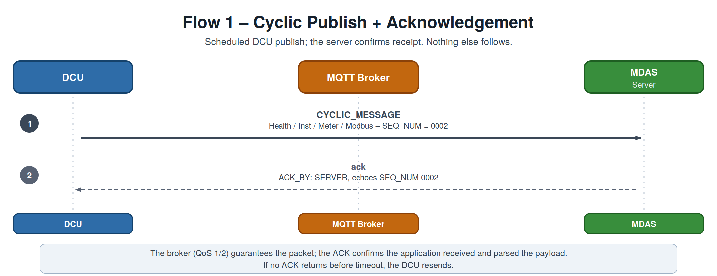
Figure 5. Flow 1 — a cyclic publish is acknowledged by the server; nothing else follows.
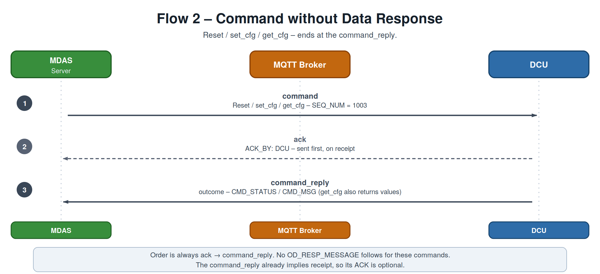
Figure 6. Flow 2 — Reset / set_cfg / get_cfg: ack first, then command_reply. No data response.
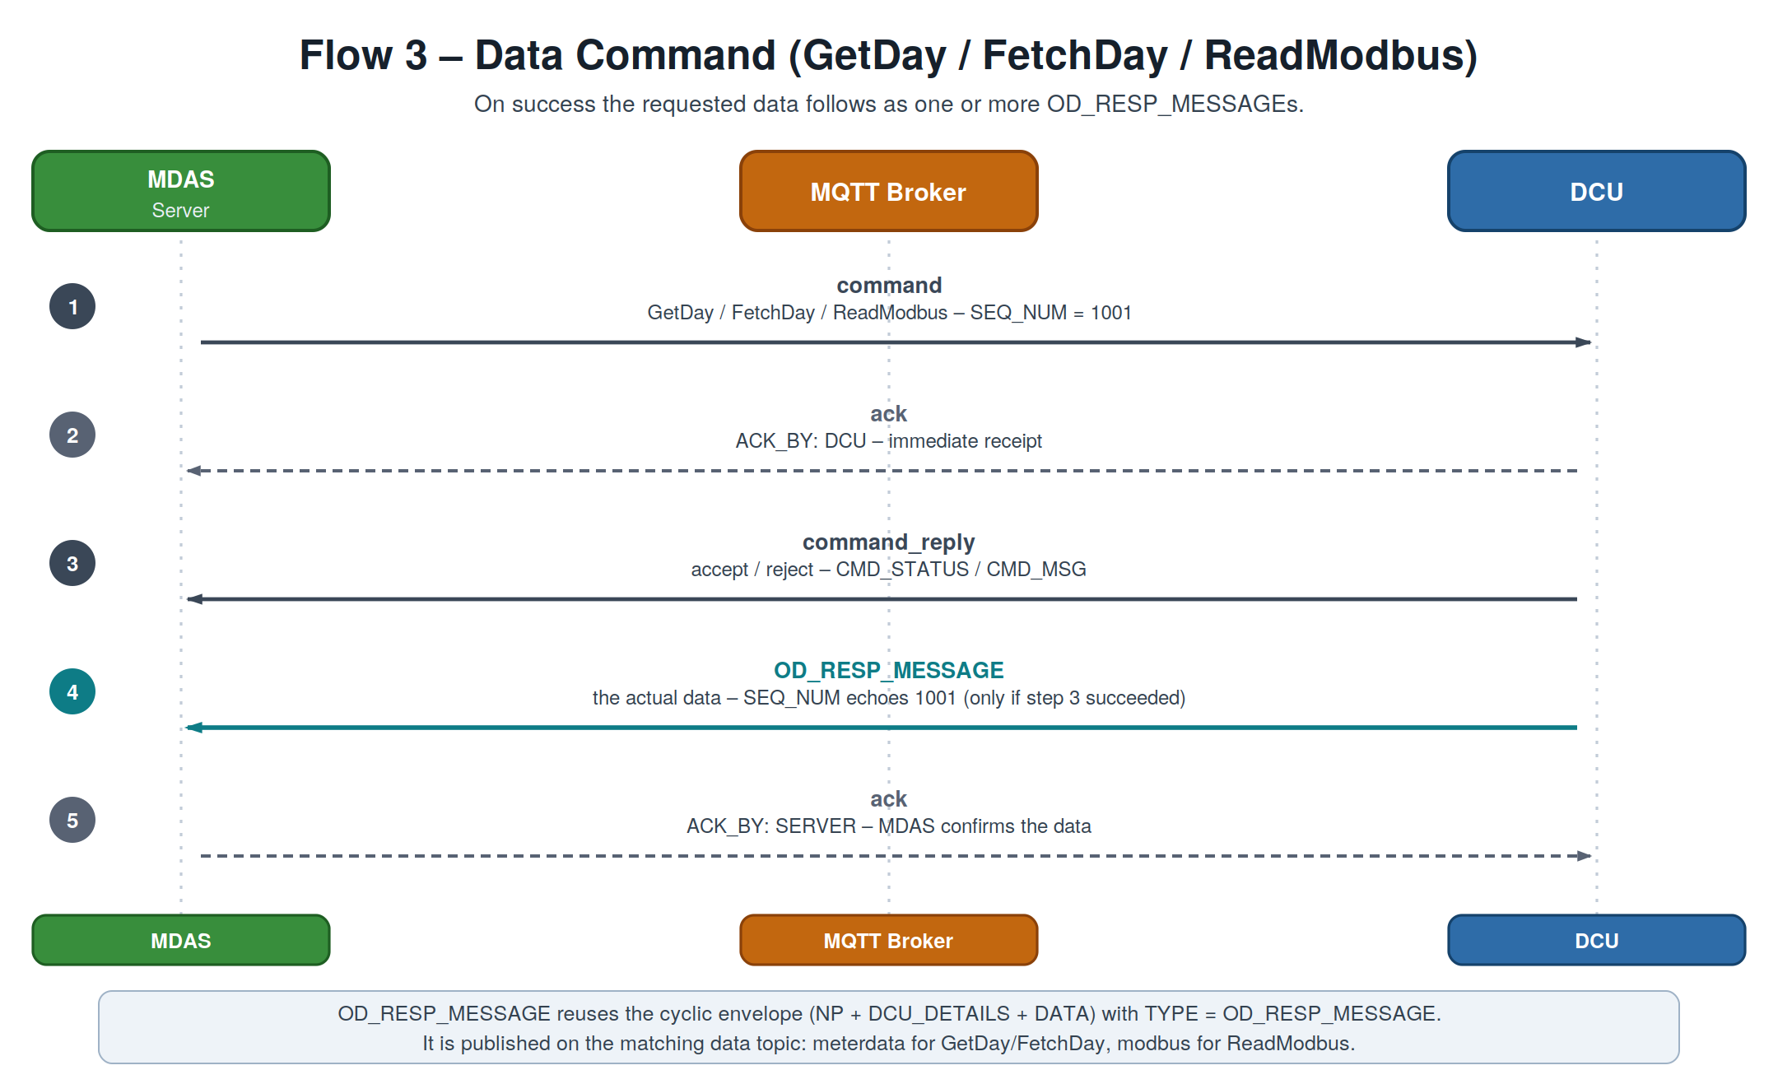
Figure 7. Flow 3 — a data command: ack, command_reply, then the OD_RESP_MESSAGE carrying the data, which the MDAS in turn acks.
Ordering rule
ack → command_reply (processing result) → OD_RESP_MESSAGE (data). The ACK is always step 1 of the response. A command_reply is the reply to an already-acked command, so it is not separately acked — this keeps ACKs from cascading. (Confirm.)

5.3 ACK shape
Like commands, an ACK carries no NP / DCU_DETAILS; the device is identified by DCU inside the message. Both directions use a single topic, cms/mqtt/dcu/ack/{serial}; ACK_BY disambiguates the sender.
Field | Meaning
TYPE | Always "ack".
SEQ_NUM | Echoes the SEQ_NUM of the acknowledged message — the correlation key.
ACK_BY | "SERVER" (acking a DCU→Server message) or "DCU" (acking a command).
DCU | DCU serial number the message belongs to.
TS | Timestamp the ACK was generated.

Server ACKs a DCU message (echoes the A.2 publish, SEQ_NUM 0002)
JSON
{
"TYPE": "ack",
"SEQ_NUM": "0002",
"ACK_BY": "SERVER",
"DCU": "10132124",
"TS": "2025-06-13 16:03:37"
}

DCU ACKs a command (receipt of GetDay 1001, sent before the reply)
JSON
{
"TYPE": "ack",
"SEQ_NUM": "1001",
"ACK_BY": "DCU",
"DCU": "10132ED5",
"TS": "2025-09-21 09:15:02"
}

6. Reference

6.1 Command Status Codes (observed in PDF)
CMD_STATUS | CMD_MSG | Meaning
0 | SUCCESS | Command executed successfully
3 | Invalid meter name | Meter not matched with DCU
7 | Unknown request | Unrecognised command type

6.2 Topic Summary
# | Message | TYPE | Direction | Topic | Trigger
1 | DCU Health | CYCLIC_MESSAGE | DCU → Server | …/dcuhealth/{serial} | Cyclic, min 1 min
2 | Instantaneous | CYCLIC_MESSAGE | DCU → Server | …/instantaneous/{serial} | Cyclic, min 1 min
3 | Meter Data | CYCLIC_MESSAGE | DCU → Server | …/meterdata/{serial} | Cyclic, min 5 min
3b | Modbus Data | CYCLIC_MESSAGE | DCU → Server | …/modbus/{serial} | Cyclic
4 | Command Request | command | MDAS → DCU | …/cmdrequest/{serial} | On demand
5 | Command Reply | command_reply | DCU → MDAS | …/cmdreply/{serial} | On demand
6 | Data Response | OD_RESP_MESSAGE | DCU → Server | …/meterdata · …/modbus | After command
7 | Acknowledgement | ack | both ways | …/ack/{serial} | On receipt

End of specification — DCU – MDAS MQTT Message Formats, Draft v0.10.

