TECHNICAL SPECIFICATION
DCU – MDAS MQTT Message Formats
Message interaction between the Data Concentrator Unit (DCU)
and the third-party Meter Data Acquisition System (MDAS)

Status | Draft v0.20
Transport | MQTT (QoS 1 / 2), JSON payloads
Topic root | cms/mqtt/dcu/{leaf}/{serial}
Derived from | DCU MQTT message PDF, INSTANTANEOUS CDF, Modbus sample
Audience | DCU firmware & MDAS integration teams

Contents
Contents 2
1. Overview 5
1.1 Message Families 6
1.2 Conventions 6
2. Common Envelope (Cyclic Messages) 7
2.1 Envelope skeleton 7
2.2 Envelope fields 8
2.3 NP (Nameplate) fields 8
2.4 DATA_TYPE values (cyclic messages) 8
2.5 Topic namespace 9
3. Section A — Cyclic Data (Published by DCU) 10
3.1 DCU Health 10
3.2 Instantaneous Data 11
3.3 Meter Data (all profiles except Instantaneous) 12
3.4 Modbus Data 13
4. Section B — On-Demand Data (Request / Reply) 14
4.1 Command fields 14
4.2 DATA_TYPE values 14
4.3 Meter Data Command (GetDay / FetchDay) 15
4.3.1 Command Request (MDAS → DCU) 15
4.3.2 Command Reply (DCU → MDAS) 18
4.3.3 Data Response (DCU → Server) 18
4.4 General Commands 19
4.4.1 DCU Reset 19
4.4.2 DCU Transparent Mode 19
4.5 Configuration (set_cfg / get_cfg) 21
4.5.1 set_cfg request — examples 22
4.5.1.1 set_cfg request — Primary MQTT Broker 22
4.5.1.2 set_cfg request —Secondary MQTT Broker 22
4.5.1.3 set_cfg request — MODEM 22
4.5.1.4 set_cfg request — IPSEC 23
4.5.1.5 set_cfg request — NTP 23
4.5.1.6 set_cfg request — FTP 24
4.5.1.7 set_cfg request — IEC104 24
4.5.1.8 set_cfg request — IEC101 24
4.5.1.9 set_cfg request — SERPORT 25
4.5.1.9 set_cfg request — MODBUS_TCP 25
4.5.1.9 set_cfg request — MODBUS_RTU 26
4.5.1.10 set_cfg request — DLMS_SERIAL 26
4.5.1.10 set_cfg request — DLMS_ETHERNET 26
4.5.2 get_cfg request / reply 27
4.5.2.1 Request -> MQTT BROKER 27
4.5.2.2 Response -> MQTT BROKER 27
4.5.2.3 Request -> MODEM 29
4.5.2.4 Response -> MODEM 29
4.5.2.5 Request -> IPSEC 29
4.5.2.6 Response -> IPSEC 30
4.5.2.7 Request -> IEC104 31
4.5.2.8 Response -> IEC104 31
4.5.2.9 Request -> IEC101 32
4.5.2.10 Response -> IEC101 32
4.5.2.11 Request -> NTP 33
4.5.2.12 Response -> NTP 33
4.5.2.13 Request -> FTP 34
4.5.2.14 Response -> FTP 34
4.5.2.15 Request -> MODBUS_TCP 35
4.5.2.16 Response -> MODBUS_TCP 35
4.5.2.17 Request -> MODBUS_RTU 36
4.5.2.18 Response -> MODBUS_RTU 36
4.5.2.19 Request -> DLMS_SERIAL 37
4.5.2.20 Response -> DLMS_SERIAL 37
4.5.2.21 Request -> DLMS_ETHERNET 39
4.5.2.22 Response -> DLMS_ETHERNET 39
4.6 Meter Configuration Commands 40
4.6.1. Meter Time Sync Message 40
4.6.2. Set Profile Capture Period Message 41
4.6.3. Set Demand Period Message 41
4.7 Modbus On-Demand Register Read (ReadModbus) 42
5. Section C — Delivery Acknowledgement (ACK) 44
5.1 ACK vs. command_reply vs. MQTT QoS 44
5.2 Message flows 44
5.3 ACK shape 46
6. Reference 48
6.1 Command Status Codes 48
6.2 Topic Summary 48

Overview
Purpose: This specification defines the application-level messages exchanged between CMS Data Concentrator Unit (DCU) and a third-party Meter Data Acquisition System (MDAS / Server). It covers scheduled health and metering data published by the DCU, on-demand commands issued by the MDAS, the data responses those commands trigger, and a lightweight delivery acknowledgement that confirms receipt in both directions.
Transport: All messages are JSON over MQTT. Every message travels on the "cms/mqtt/dcu/{leaf}/{serial}" topic tree, where {serial} is the DCU serial number. The broker (QoS 1/2) guarantees packet delivery; an application-level ACK confirms the payload was actually received and parsed.
Design at a glance: Cyclic (published) messages share a common envelope — everything up to and including DCU_DETAILS — and differ only in their DATA payload. Commands use a lighter request/reply structure with no NP / DCU_DETAILS. Data-bearing columns are sent columns-once: the field names appear a single time and each record is a positional value array, which keeps GPRS/MQTT payloads compact.
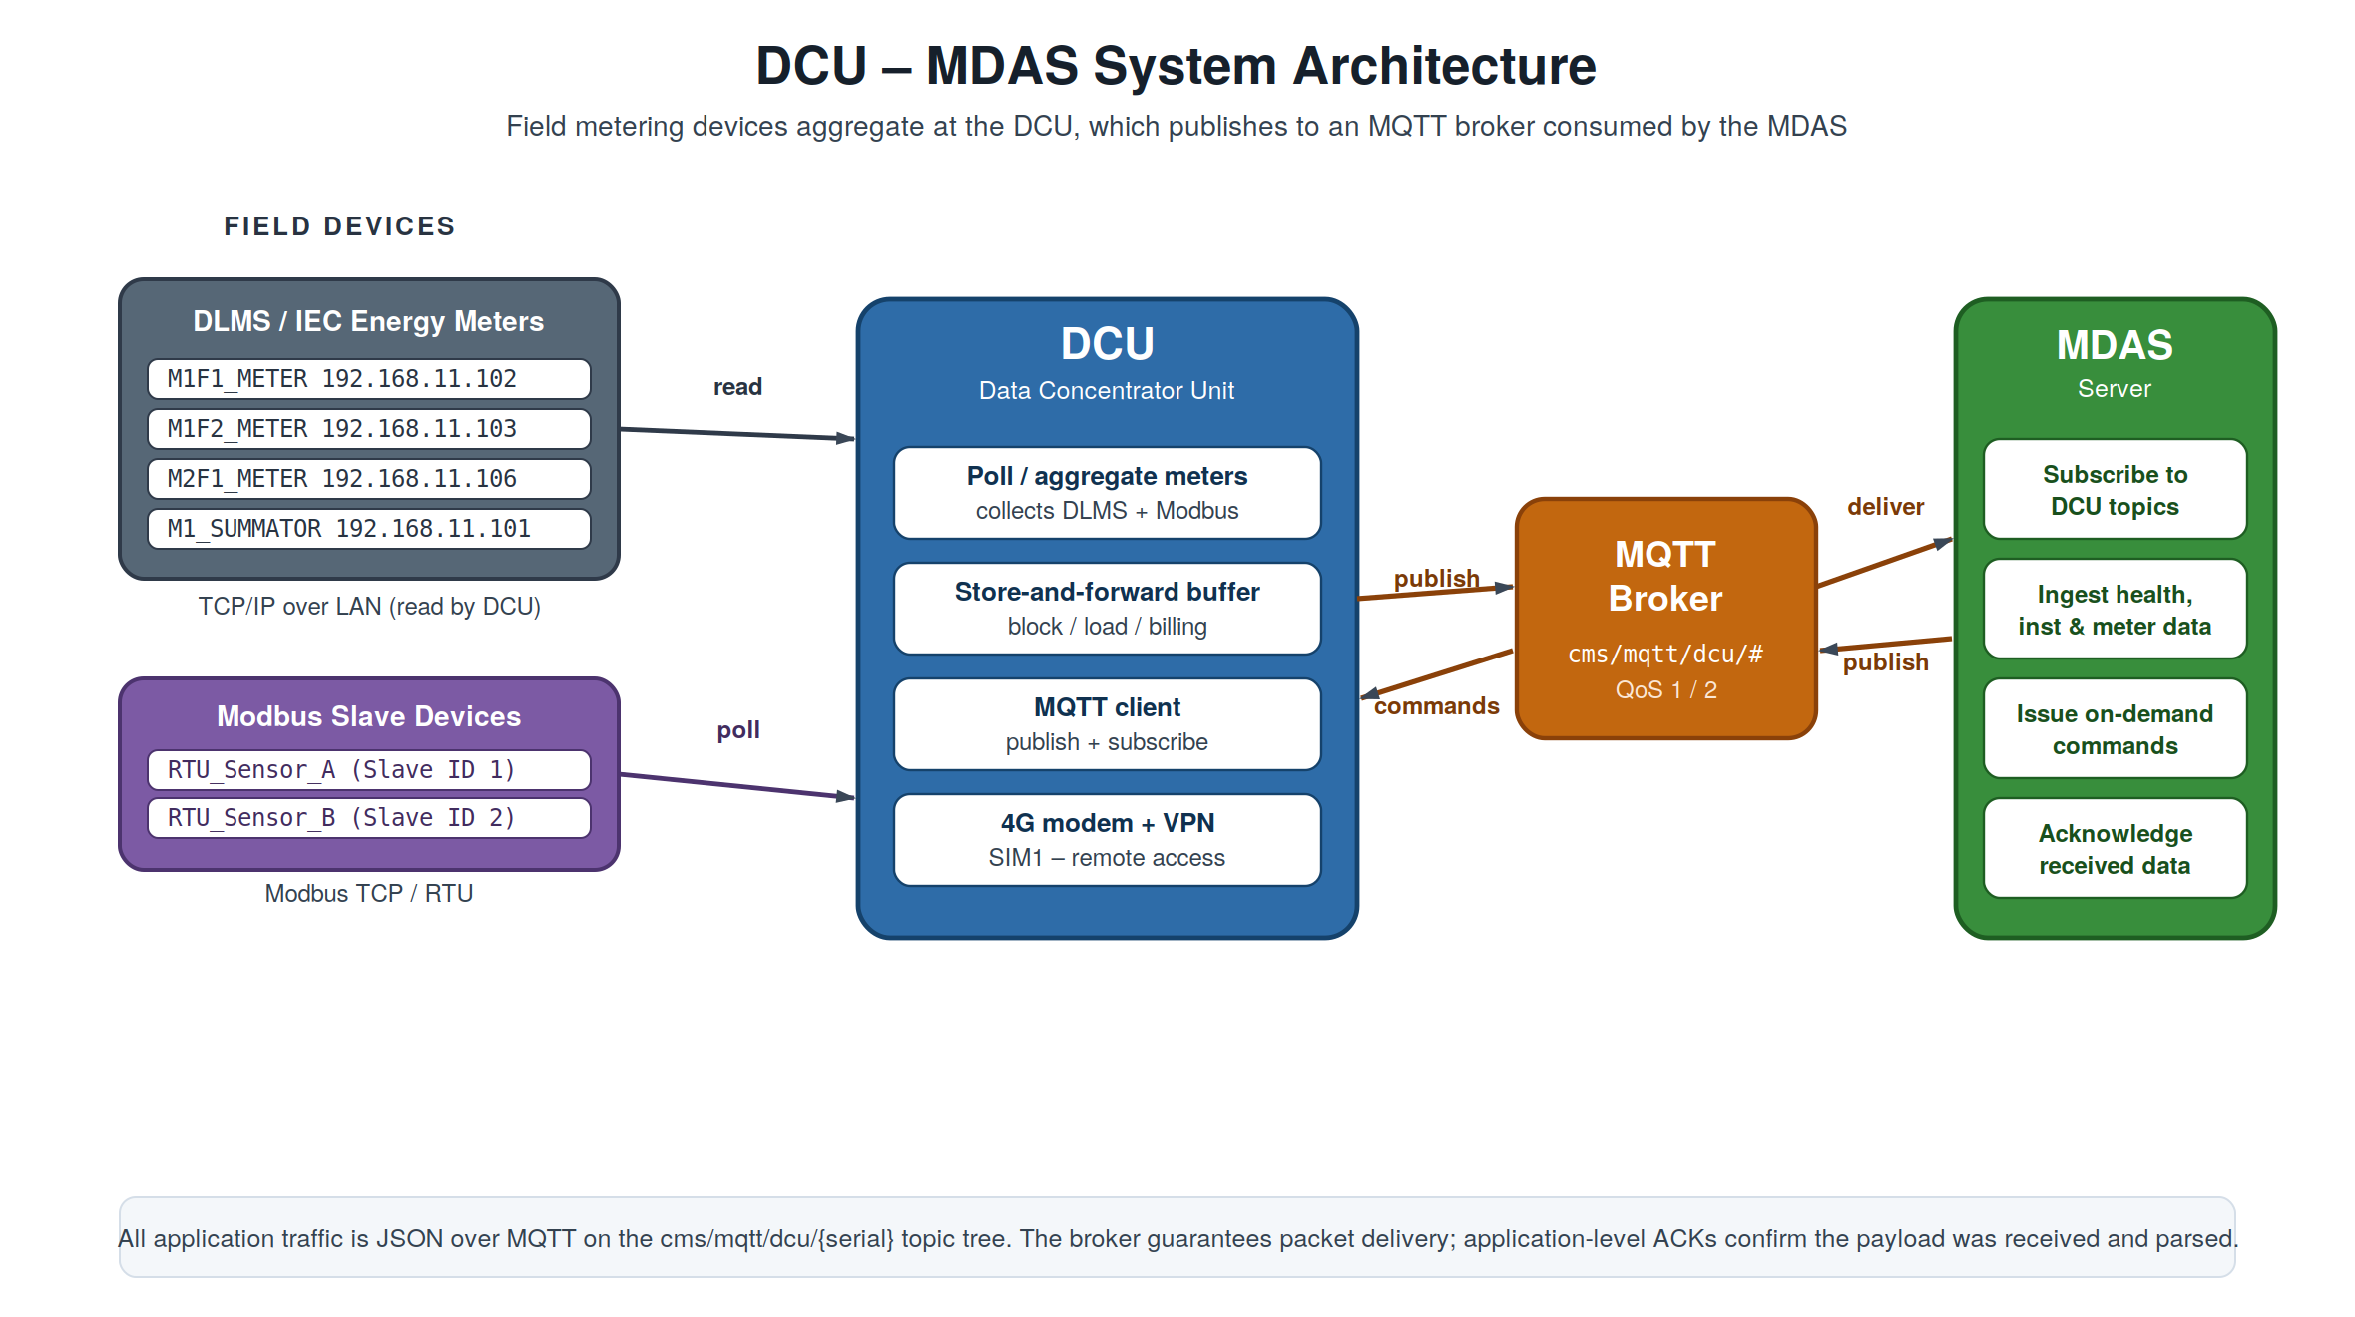
Figure 1. System architecture — field meters and Modbus slaves aggregate at the DCU, which exchanges JSON with the MDAS through an MQTT broker.

1.1 Message Families
The protocol has three message families. Section A – ‘Cyclic Data’ is published by the DCU on a schedule; Section B – ‘On-Demand Commands’ is requested on demand by the MDAS; Section C – ‘ Acknowledgement is the receipt that flows in either direction.
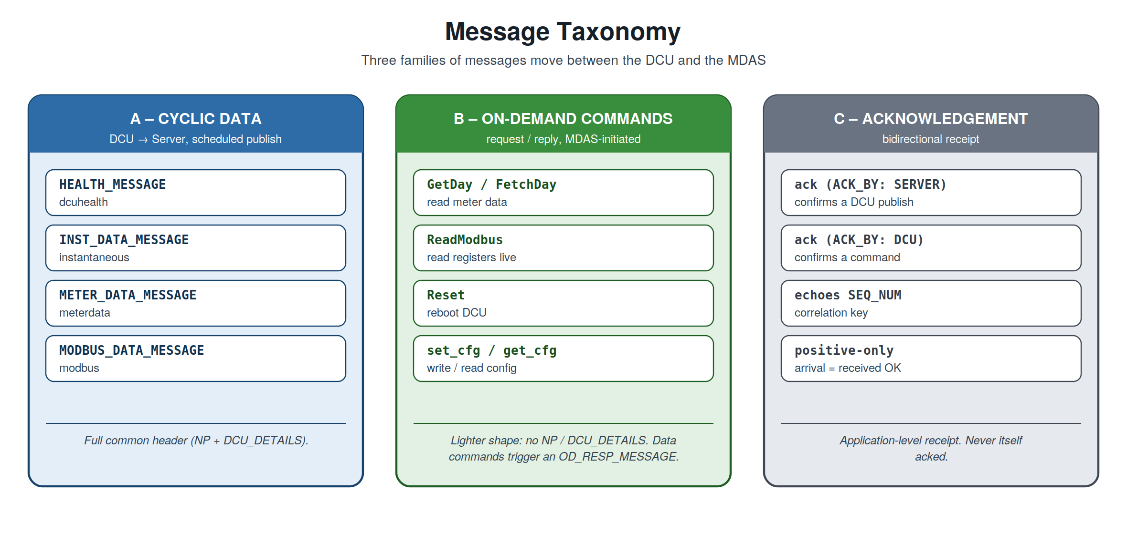
Figure 2. The three message families and the members of each.

1.2 Conventions
- Booleans are carried as the strings "YES" / "NO", faithful to the source meters. (Open question: convert to real true/false?)
- Dates use ISO YYYY-MM-DD; timestamps use YYYY-MM-DD HH:MM:SS
- Inner field names keep the original XML/CDF attribute names in UPPER_SNAKE_CASE for 1:1 traceability to the source.
- Correlation. SEQ_NUM ties a reply, a data response, and an ACK back to the message that triggered them.
Draft status
This is draft v0.10. Several values (notably the A.3 Meter Data profiles) are illustrative placeholders pending the real source CDF, and a number of fields are marked as open questions throughout. Items flagged "TODO/confirm" in the source are reproduced here as call-outs so they are not lost.

2. Common Envelope (Cyclic Messages)
The published messages in Section A and the on-demand data response (OD_RESP_MESSAGE, B.1.3 / B.4.3) share one top-level structure. Only the DATA object changes between them; the header identifying the device is identical.
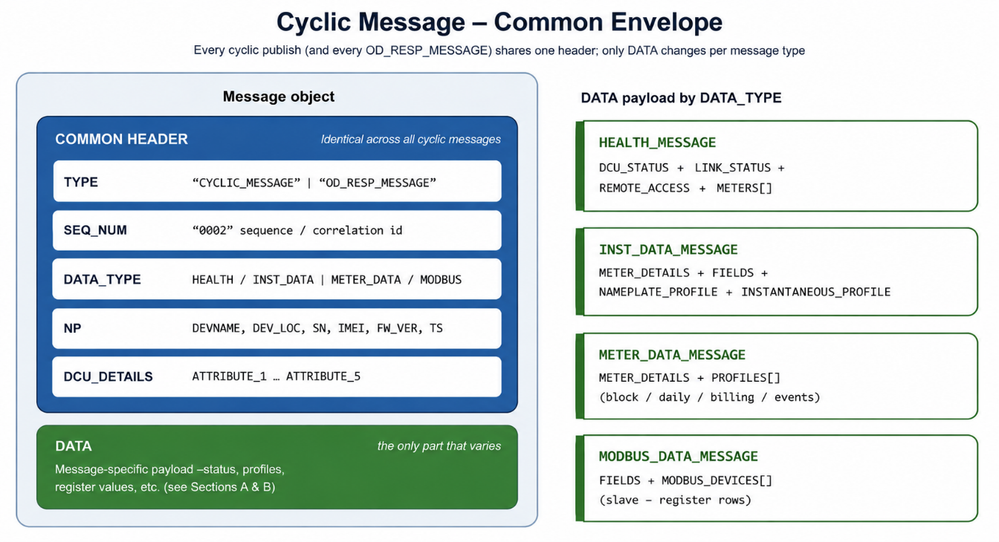
Figure 3. Anatomy of the common envelope. The header is constant per device; DATA carries the message-specific payload.

2.1 Envelope skeleton
JSON
{
"TYPE": "CYCLIC_MESSAGE",
"SEQ_NUM": "0001",
"DATA_TYPE": "INST_DATA_MESSAGE",
"NP": {
"DEVNAME": "DCU-E70-DVC",
"DEV_LOC": "Bengaluru",
"SN": "10131F25",
"IMEI": "8345345345",
"FW_VER": "VER5.7 Jan 16 2025-11:53:40(R)",
"TS": "2025-09-22 15:25:52"
},
"DCU_DETAILS": {
"ATTRIBUTE_1": "490007",
"ATTRIBUTE_2": "CLW_CHITHARANJAN",
"ATTRIBUTE_3": "M1F1F2F3_M2F1F2F3_3F",
"ATTRIBUTE_4": "9010013700017",
"ATTRIBUTE_5": "33 kV_ FEEDER"
},
"DATA": { }
}

2.2 Envelope fields
Field | Meaning
TYPE | CYCLIC_MESSAGE (scheduled publish) or OD_RESP_MESSAGE (data response to a command). Commands themselves use "command" / "command_reply" — see Section 4.
SEQ_NUM | Sequence number of the message (per device / per session); also the correlation key. It will assign a 16 bit unsigned running integer value.
DATA_TYPE | Specific message kind — see the DATA_TYPE table below.
NP | Nameplate — device identity block, common to all cyclic messages.
DCU_DETAILS | DCU descriptor attributes (ATTRIBUTE_1..5), common to all cyclic messages.
DATA | Message-specific payload.

2.3 NP (Nameplate) fields
Field |  | Meaning | Source in PDF
DEVNAME |  | Device name / model | HEALTH_STATUS@DCU (e.g. DCU-E70-DVC)
DEV_LOC |  | Device location | new — assign per device
SN |  | Serial number | SERIALNUM (e.g. 10131F25)
IMEI |  | Modem IMEI | new — not in PDF
FW_VER |  | Firmware version | FIRMWARE
TS |  | Message timestamp | DCU_STATUS@TIME / generation time
Note:
- DEVNAME is the DCU device name - DCU-E70-DVC
- DEV_LOC and IMEI are to be filled in (DCU configuration items)
- DCU_DETAILS (ATTRIBUTE_1..5) is per-device and constant across that device's messages; these are present in the Health message, and the same values are reused elsewhere.

2.4 DATA_TYPE values (cyclic messages)
TYPE | DATA_TYPE | Message | Topic suffix
CYCLIC_MESSAGE | HEALTH_MESSAGE | DCU Health | dcuhealth
CYCLIC_MESSAGE | INST_DATA_MESSAGE | Instantaneous data | instantaneous
CYCLIC_MESSAGE | METER_DATA_MESSAGE | Meter data (all profiles) | meterdata
CYCLIC_MESSAGE | MODBUS_DATA_MESSAGE | Modbus register data | modbus
Commands (cmdrequest / cmdreply) do not use DATA_TYPE; they use COMMAND_TYPE + DATA_TYPE — see Section 4.

2.5 Topic namespace
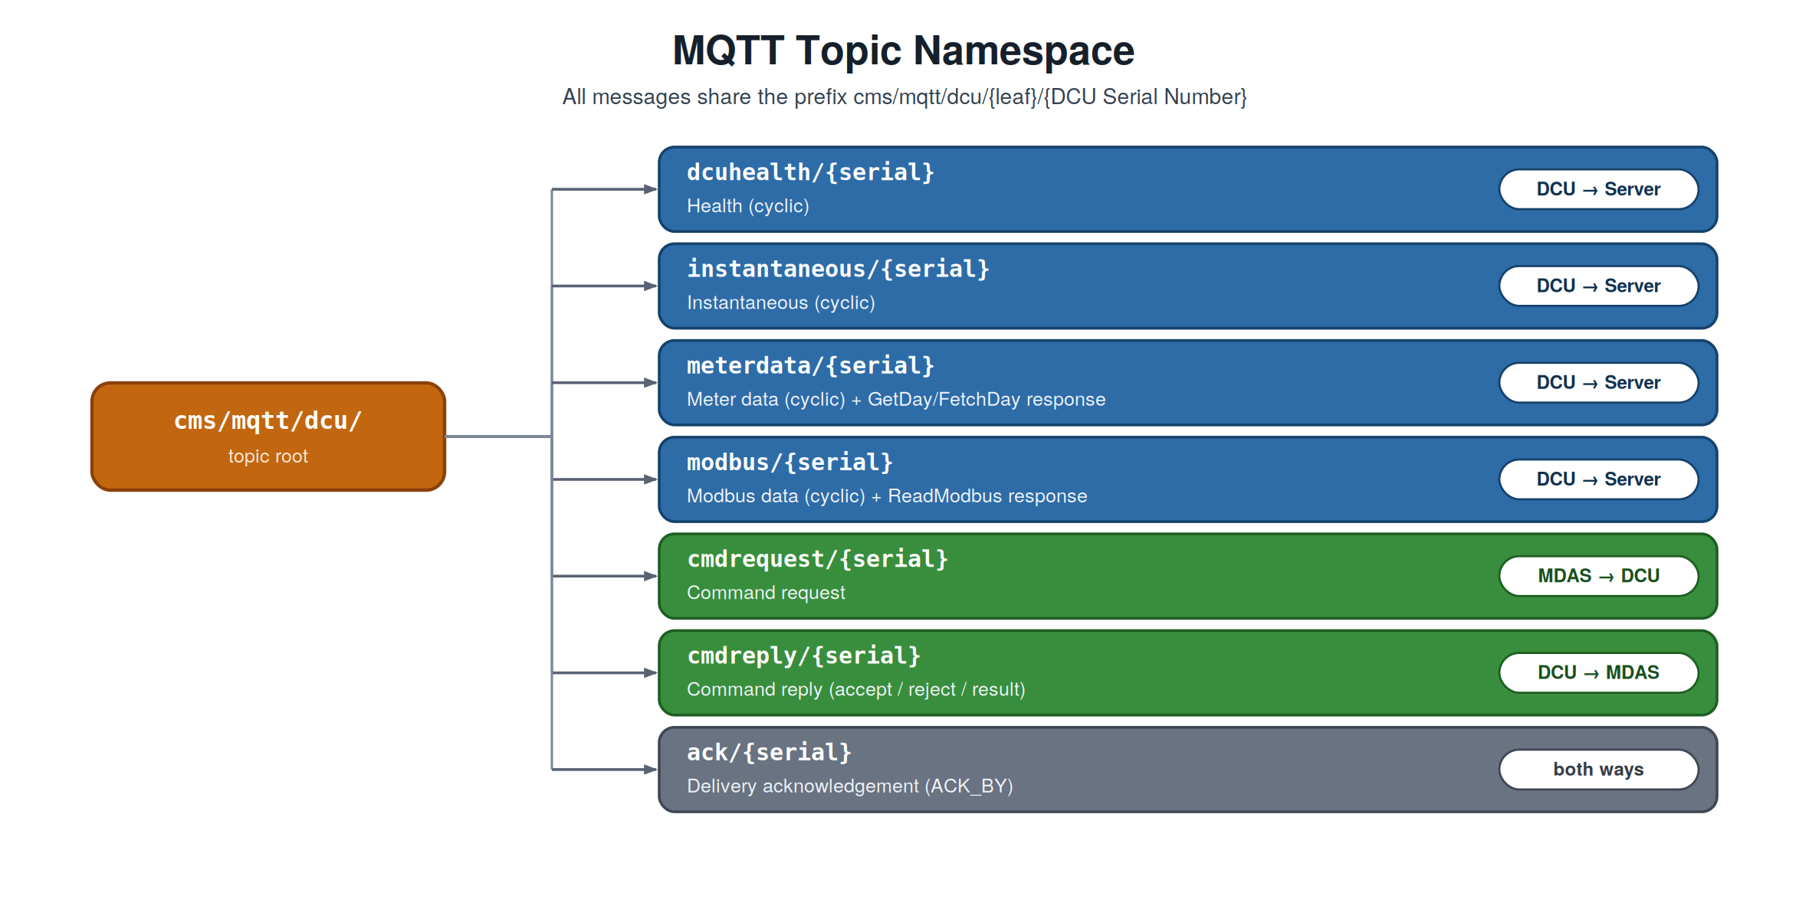
Figure 4. The MQTT topic tree. Every leaf is suffixed with the DCU serial number.

3. Section A — Cyclic Data (Published by DCU)
These messages are published by the DCU on a configurable schedule. All four use the common envelope from Section 2.

3.1 DCU Health
Direction: DCU → Server | Topic: cms/mqtt/dcu/dcuhealth/{serial} | Interval: Configurable, minimum 1 min
Reports DCU power/link status, remote-access state, and the communication status of every meter behind the DCU. The DATA object carries a DCU_STATUS block plus a METERS[] array. The parameters which are not applicable for Modbus meters will have the values “NA”.

Original (XML)
XML
<HEALTH_STATUS DCU="DCU-E70-DVC" SERIALNUM="10131F25"
FIRMWARE="VER5.7 Jan 16 2025-11:53:40(R)">
<DCU_DETAILS ATTRIBUTE_1="490007" ATTRIBUTE_2="CLW_CHITHARANJAN" .../>
<DCU_STATUS POWER="ON" TIME="2025-09-22 15:25:52"
ACTIVE_SINCE="2025-09-20 16:35:29" TIME_SYNCHED="YES">
<LINK_STATUS CONNECTED_ON="MODEM" ACTIVE_SIM="SIM1" ISP="IND airtel"/>
<REMOTE_ACCESS VPN_IP="172.24.18.65" REMOTE_ACCESS_ENABLED="YES"/>
</DCU_STATUS>
<METERS>
<METER ID="21" BAY="M1F1_METER" IP_ADDRESS="192.168.11.102"
COMMUNICATION_STATUS="CONNECTED" .../>
...
</METERS>
</HEALTH_STATUS>

JSON
JSON
{
"TYPE": "CYCLIC_MESSAGE",
"SEQ_NUM": "0001",
"DATA_TYPE": "HEALTH_MESSAGE",
"NP": { "DEVNAME": "DCU-E70-DVC", "DEV_LOC": "", "SN": "10131F25",
"IMEI": "", "FW_VER": "VER5.7 Jan 16 2025-11:53:40(R)",
"TS": "2025-09-22 15:25:52" },
"DCU_DETAILS": { "ATTRIBUTE_1": "490007", "ATTRIBUTE_2": "CLW_CHITHARANJAN",
"ATTRIBUTE_3": "M1F1F2F3_M2F1F2F3_3F", "ATTRIBUTE_4": "9010013700017",
"ATTRIBUTE_5": "33 kV_ FEEDER" },
"DATA": {
"DCU_STATUS": {
"POWER": "ON",
"TIME": "2025-09-22 15:25:52",
"ACTIVE_SINCE": "2025-09-20 16:35:29",
"TIME_SYNCHED": "YES",
"LINK_STATUS": { "CONNECTED_ON": "MODEM", "ACTIVE_SIM": "SIM1", "ISP": "IND airtel" },
"REMOTE_ACCESS": { "VPN_IP": "172.24.18.65", "REMOTE_ACCESS_ENABLED": "YES" }
},
"METERS": [
{ "ID": 21, "BAY": "M1F1_METER", "IP_ADDRESS": "192.168.11.102",
"COMM_STATUS": "CONNECTED", "COMM_INHIBIT": "NO", "TIME_SYNCHED": "NO",”DRIFT”:”00:00:50”, "DEMAND_PERIOD" : "15", "PROFILE_CAP_PERIOD" : "15",
"VPN_IP": "172.24.18.66", "REMOTE_ACCESS_ENABLED": "NO" },
{ "ID": 22, "BAY": "M1F2_METER", "IP_ADDRESS": "192.168.11.103",
"COMM_STATUS": "CONNECTED", "COMM_INHIBIT": "NO", "TIME_SYNCHED": “NO",”DRIFT”:”00:01:50”, "DEMAND_PERIOD" : "15", "PROFILE_CAP_PERIOD" : "15",
"VPN_IP": "172.24.18.67", "REMOTE_ACCESS_ENABLED": "NO" }
// ... remaining meters (IDs 23, 25, 26, 27, 29, 30) follow the same shape
]
}
}

3.2 Instantaneous Data
Direction: DCU → Server | Topic: cms/mqtt/dcu/instantaneous/{serial} | Interval: Configurable, minimum 1 min
Source: INSTANTANEOUS CDF (XML), which holds two profiles per meter — D1 = Nameplate and D2 = Instantaneous (snapshot).

CDF → JSON mapping
CDF element |  | JSON location
GENERAL/DCU_DETAILS@Name |  | NP.DEVNAME (header)
GENERAL/DCU_DETAILS@SERIALNUM |  | NP.SN (header)
GENERAL/DCU_DETAILS@TIME |  | NP.TS (header)
GENERAL/DCU_DETAILS@ATTRIBUTE_1..5 |  | DCU_DETAILS (header)
GENERAL/METER_DETAILS |  | DATA.METER_DETAILS
D1/NAMEPARAM[] |  | DATA.NAMEPLATE_PROFILE[]
D2/SNAPSHOT@DATE + INSTAPARAM[] |  | DATA.INSTANTANEOUS_PROFILE.DATE + .VALUES[]
Columnar (columns-once) layout
Every param keeps all five fields (CODE, OBIS_CODE, NAME, VALUE, UNIT), but the names are declared once in DATA.FIELDS; each param is then a positional row array in that order. This removes the repeated keys from every row.
Size impact: array-of-objects ≈ 7,313 B minified → columnar rows ≈ 4,488 B (~39% smaller), all fields retained. Send minified on the wire; optionally gzip for a further large reduction.

JSON
JSON
{
"TYPE": "CYCLIC_MESSAGE",
"SEQ_NUM": "0002",
"DATA_TYPE": "INST_DATA_MESSAGE",
"NP": { "DEVNAME": "DCU-E70-HVPNL", "DEV_LOC": "", "SN": "10132124",
"IMEI": "", "FW_VER": "", "TS": "2025-06-13 16:03:35" },
"DCU_DETAILS": { "ATTRIBUTE_1": "CHG_TEST", "ATTRIBUTE_2": "TEST",
"ATTRIBUTE_3": "M1M2_1F", "ATTRIBUTE_4": "TEST", "ATTRIBUTE_5": "33KV_FEEDER" },
"DATA": {
"METER_DETAILS": { "BAY": "MAIN_METER_IC1", "IP_ADDRESS": "192.168.11.101" },
"FIELDS": ["OBIS_CODE","VALUE"],
"NAMEPLATE_PROFILE": [
["00_00_60_01_00_ff","HVPN5016"],
["00_00_60_01_01_ff","GENUS POWER INFRASTRUCTURES LTD"],
["01_00_00_02_00_ff","HB003.57345"]
// ... remaining nameplate rows
],
"INSTANTANEOUS_PROFILE": {
"DATE": "2025-06-13 16:03:27.000",
"VALUES": [
["01_00_1f_07_00_ff","0.00000"],
["01_00_20_07_00_ff","58.23000"],
["01_00_0e_07_00_ff","50.07000"],
["01_00_01_08_00_ff","418.26791"]
// ... remaining instantaneous rows
]
}
}
}

3.3 Meter Data (all profiles except Instantaneous)
Direction: DCU → Server | Topic: cms/mqtt/dcu/meterdata/{serial} | Interval: Configurable, minimum 5 min
Carries multiple profiles — block/load survey, daily, billing, and events — in one message. Sent as actual JSON (not zipped). Every profile uses the columns-once layout: its FIELDS + PARAMS heading is sent once, then each record carries only a key plus the value array.
- Block load: BLOCK_INTERVAL (minutes) sits outside; each block is identified by its interval index 0…95 (96 blocks/day at 15 min). Entries are [index, [values…]] — no per-block timestamp.
- Daily / Billing / Events: entries are [timestamp, [values…]] (date for daily/billing, full timestamp for events).

JSON
JSON
{
"TYPE": "CYCLIC_MESSAGE",
"SEQ_NUM": "0003",
"DATA_TYPE": "METER_DATA_MESSAGE",
"NP": { "DEVNAME": "DCU-E70-HVPNL", "SN": "10132124", "TS": "2025-04-02 06:00:00", ... },
"DCU_DETAILS": { "ATTRIBUTE_1": "CHG_TEST", ... },
"DATA": {
"METER_DETAILS": { "BAY": "MAIN_METER_IC1", "IP_ADDRESS": "192.168.11.101" },
"PROFILES": [
{
"PROFILE": "BLOCK_LOAD_PROFILE",
"DATE": "2025-04-02",
"BLOCK_INTERVAL": 15,
"FIELDS": ["OBIS_CODE"],
"PARAMS": [
["01_00_1f_07_00_ff"],
["01_00_20_07_00_ff"]
// ... up to 26 params
],
"BLOCKS": [
[0, ["0.95914", "0.03752", "...", "1.00978"]],
[1, ["0.13912", "0.14507", "...", "0.62852"]],
["...", "94 more blocks (interval index 2 ... 94)"],
[95, ["0.88189", "0.52595", "...", "0.38066"]]
]
},
{
"PROFILE": "DAILY_LOAD_PROFILE",
"FIELDS": ["OBIS_CODE"],
"PARAMS": [ ["01_00_01_08_00_ff],... ],
"RECORDS": [
["2025-04-01", ["12450.00000", "410.50000", "16780.00000", ...]],
["2025-04-02", ["12612.30000", "421.80000", "17005.40000", ...]]
]
}
// ... BILLING_PROFILE and EVENT_LOG follow the same record shape
]
}
}

3.4 Modbus Data
Direction: DCU → Server | Topic: cms/mqtt/dcu/modbus/{serial} | Interval: Cyclic
Carries the latest register values polled from one or more Modbus slave devices behind the DCU. The source file's dcu_nameplate maps onto the common header; registers use the same columns-once layout.

Source → JSON mapping
Original field |  | JSON location
dcu_nameplate.dcu_name |  | NP.DEVNAME
dcu_nameplate.dcu_sernum |  | NP.SN
dcu_nameplate.date_time |  | NP.TS
dcu_nameplate.attr1..5 |  | DCU_DETAILS.ATTRIBUTE_1..5
modbus_devices[] |  | DATA.MODBUS_DEVICES[]
registers[] (address,name,type,value) |  | rows under common DATA.FIELDS
Notes
• VALUE is a scalar for register TYPE 5 and an array of bits for TYPE 1 (coil block) — kept as-is in the row's value column.
• NUM_VALS equals the REGISTERS length (redundant; kept from the source).
• TYPE is the Modbus register/data-type code from the source.

JSON
JSON
{
"TYPE": "CYCLIC_MESSAGE",
"SEQ_NUM": "0004",
"DATA_TYPE": "MODBUS_DATA_MESSAGE",
"NP": { "DEVNAME": "", "SN": "", "TS": "2026-02-18 12:57:43", ... },
"DCU_DETAILS": { "ATTRIBUTE_1": "", ... },
"DATA": {
"FIELDS": ["ADDRESS", "NAME", "TYPE", "VALUE"],
"MODBUS_DEVICES": [
{
"SLAVE_ID": 1, "IP_ADDRESS": "", "NAME": "RTU_Sensor_A",
"STATUS": "Connected", "LAST_UPDATE_TIME": "2026-02-18 12:57:43",
"NUM_VALS": 4,
"REGISTERS": [
[10, "reg-1", 1, [1, 1, 1, 1, 1, 1, 1, 0]],
[10000, "reg-2", 1, [0, 0, 0, 0, 0, 1, 1, 1]],
[20000, "reg-3", 5, -2],
[30000, "reg-4", 5, 0]
]
},
{ "SLAVE_ID": 2, "NAME": "RTU_Sensor_B", "NUM_VALS": 2, "REGISTERS": [ ... ] }
]
}
}

4. Section B — On-Demand Data (Request / Reply)
Commands do not use the cyclic common header. There is no NP and no DCU_DETAILS — the target DCU is identified inside DATA.

4.1 Command fields
Field | Meaning
TYPE | "command" (request) / "command_reply" (reply).
SEQ_NUM | Correlation id — the reply echoes the request's SEQ_NUM (replaces the PDF's TRANSACTION).
COMMAND_TYPE | GetDay / FetchDay (read meter data), ReadModbus, Reset, set_cfg, get_cfg., START_TRANS_MODE,STOP_TRANS_MODE, SET_METER_CFG
DATA_TYPE | What the command targets — a data kind for GetDay/FetchDay, or a config group for set_cfg/get_cfg. Type of meters for START_TRANS_MODE, type of SET_METER_CFG command like TIME_SYNC,PROFILE_PERIOD,DEMAND_INT_PERIOD.
DATA | Always includes DCU. Data commands add METER + DATE (single); config commands add the parameter fields; replies add CMD_STATUS + CMD_MSG.
Flow. command (MDAS→DCU) → ACK ( DCU->MDAS), command_reply (DCU→MDAS, accept/reject). For data commands the actual data then follows on success as one or more OD_RESP_MESSAGEs on the matching data topic. For Reset, set_cfg, get_cfg command_reply message is sent directly without data.

4.2 DATA_TYPE values

For data commands (GetDay / FetchDay) — which profile to return
DATA_TYPE | Data targeted
INST | Instantaneous
BLOCK | Block load profile
DAILY | Daily load profile
BILLING | Billing profile
EVENT | Event log
MODBUS | Modbus slave registers

For config commands (set_cfg / get_cfg) — which configuration group
DATA_TYPE | Configuration group | DATA fields (besides DCU)
MQTT_BROKER | MQTT Broker Connection | BROKER_IP, BROKER_PORT, CLIENT_ID, USERNAME, PASSWORD, HEALTH_INTERVAL, INST_INTERVAL, METER_DATA_INTERVAL, MODBUS_INTERVAL
MODEM | GPRS Modem Configuration | SIM_SLOT, USERNAME, PASSWORD, APN, DIAL_NUM
IPSEC | IPsec VPN Configuration | IPSEC_TUNNEL, ENABLE_TUNNEL, RIGHT_IP, LEFT_ID, LEFT_SUBNET, RIGHT_ID, RIGHT_SUBNET, TUNNEL_NAME
NTP | Network Time Synchronization | NTP_SERVER, ENABLE_NTP, NTP_IP, NTP_PORT
FTP | FTP Server Configuration | FTP_SERVER, ENABLE_SERVER, IP_ADDRESS, PORT, USERNAME, PASSWORD, REMOTE_DIRECTORY, TIME_INTERVAL
IEC104 | IEC104 Protocol Settings | ENABLE_104, ASDU_ADDRESS, CYCLIC_INT, DLMS_IOA_OFFSET, MODBUS_IOA_OFFSET, COMMANDS_IOA_OFFSET
IEC101 | IEC101 Protocol Settings | ENABLE_101, ASDU_ADDRESS, CYCLIC_INT, DLMS_IOA_OFFSET, MODBUS_IOA_OFFSET, COMMANDS_IOA_OFFSET
SERIAL PORT | Serial Port Settings | SERIAL_PORT, BAUD_RATE, PARITY, DATA_BITS, STOP_BITS
MODBUS_TCP | Modbus RTU Communication Settings | METER_NAME, IP_ADDRESS, PORT, SLAVE_ID, RETRIES, POLL_SKIP_COUNT, RESP_TIMEOUT
MODBUS_RTU | Modbus TCP Communication Settings | SERIAL_PORT, METER_NAME, SLAVE_ID, RETRIES, POLL_SKIP_COUNT, RESP_TIMEOUT
DLMS_SERIAL | DLMS Serial Meter Communication Settings | SERIAL_PORT, METER_NAME, METER_ADDRESS
DLMS_ETHERNET | DLMS Ethernet Meter Communication Settings | METER_NAME, METER_ADDRESS

4.3 Meter Data Command (GetDay / FetchDay)

4.3.1 Command Request (MDAS → DCU)
Direction: MDAS → DCU | Topic: cms/mqtt/dcu/cmdrequest/{serial} | Interval: On demand

GetDay reads stored data of the given type from the DCU for the current day. ; FetchDay forces the type of data to be polled from the meter for the given DATE.

GetDay
JSON
// Data Type = INST
{
"TYPE": "command",
"SEQ_NUM": "1001",
"COMMAND_TYPE": "GetDay",
"DATA_TYPE": "INST",
"DATA": {
"DCU": "10132ED5",
"METER": "AEM1179",

}
}
// Data Type = LS
{
"TYPE": "command",
"SEQ_NUM": "1001",
"COMMAND_TYPE": "GetDay",
"DATA_TYPE": "LS",
"DATA": {
"DCU": "10132ED5",
"METER": "AEM1179",
"START_DATE": "20-09-2026",
"END_DATE": "24-09-2026",

}
// Data Type = Midnight
{
"TYPE": "command",
"SEQ_NUM": "1001",
"COMMAND_TYPE": "GetDay",
"DATA_TYPE": "MIDNIGHT",
"DATA": {
"DCU": "10132ED5",
"METER": "AEM1179",
"START_DATE": "20-09-2026",
"END_DATE": "24-09-2026",
}
// Data Type = Billing
{
"TYPE": "command",
"SEQ_NUM": "1001",
"COMMAND_TYPE": "GetDay",
"DATA_TYPE": "BILLING",
"DATA": {
"DCU": "10132ED5",
"METER": "AEM1179",
"START_DATE": "20-09-2026",
"END_DATE": "24-09-2026",
}
// Data Type = Event
{
"TYPE": "command",
"SEQ_NUM": "1001",
"COMMAND_TYPE": "GetDay",
"DATA_TYPE": "EVENT",
"DATA": {
"DCU": "10132ED5",
"METER": "AEM1179",
"START_DATE": "20-09-2026",
"END_DATE": "24-09-2026",
"EVENT_CATEGORY": "2" [ "1" to "6" for particular category or "all" ]
}
}
The Event code denots
1 -> voltage
2 -> current
3 -> power
4 -> transaction
5 -> other tamper
6 -> non roll over

FetchDay (date)
JSON
// Data Type = LS
{
"TYPE": "command",
"SEQ_NUM": "1001",
"COMMAND_TYPE": " FetchDay ",
"DATA_TYPE": "LS",
"DATA": {
"DCU": "10132ED5",
"METER": "AEM1179",
"START_DATE": "20-09-2026",
"END_DATE": "24-09-2026",
}
// Data Type = Midnight
{
"TYPE": "command",
"SEQ_NUM": "1001",
"COMMAND_TYPE": " FetchDay ",
"DATA_TYPE": "MIDNIGHT",
"DATA": {
"DCU": "10132ED5",
"METER": "AEM1179",
"START_DATE": "20-09-2026",
"END_DATE": "24-09-2026",
}
// Data Type = Billing
{
"TYPE": "command",
"SEQ_NUM": "1001",
"COMMAND_TYPE": " FetchDay ",
"DATA_TYPE": "BILLING",
"DATA": {
"DCU": "10132ED5",
"METER": "AEM1179",
"START_DATE": "20-09-2026",
"END_DATE": "24-09-2026",
}
// Data Type = Event
{
"TYPE": "command",
"SEQ_NUM": "1001",
"COMMAND_TYPE": " FetchDay ",
"DATA_TYPE": "EVENT",
"DATA": {
"DCU": "10132ED5",
"METER": "AEM1179",
"START_DATE": "20-09-2026",
"END_DATE": "24-09-2026",
"EVENT_CATEGORY": "2" [ "1" to "6" for particular category or "all" ]
}
}

The Event code denots
1 -> voltage
2 -> current
3 -> power
4 -> transaction
5 -> other tamper
6 -> non roll over

4.3.2 Command Reply (DCU → MDAS)
Direction: DCU → MDAS | Topic: cms/mqtt/dcu/cmdreply/{serial} | Interval: On demand

The reply echoes SEQ_NUM, COMMAND_TYPE, DATA_TYPE, and the request's DATA keys, and adds CMD_STATUS + CMD_MSG.

Case 1 — success
JSON
{
"TYPE": "command_reply",
"SEQ_NUM": "1001",
"COMMAND_TYPE": "GetDay",
"DATA_TYPE": "BLOCK",
"DATA": {
"DCU": "10132ED5",
"METER": "AEM1179",
"DATE": "2025-09-21",
"CMD_STATUS": 0,
"CMD_MSG": "SUCCESS"
}
}

Case 2 — meter does not match DCU
JSON
{
"TYPE": "command_reply",
"SEQ_NUM": "1001",
"COMMAND_TYPE": "GetDay",
"DATA_TYPE": "BLOCK",
"DATA": {
"DCU": "10132ED5",
"METER": "AEM1179",
"DATE": "2025-09-21",
"CMD_STATUS": 3,
"CMD_MSG": "Invalid meter name"
}
}
Case 3 (unknown command type) is identical in shape with CMD_STATUS: 7, CMD_MSG: "Unknown request". See the status-code table in Section 6.

4.3.3 Data Response (DCU → Server)
Direction: DCU → Server | Topic: cms/mqtt/dcu/cmdreply/{serial} | Interval: After command (echoes SEQ_NUM)
On success, the requested data follows as one or more OD_RESP_MESSAGEs — the same structure as the cyclic message (NP + DCU_DETAILS + DATA), with two differences: TYPE is "OD_RESP_MESSAGE", and SEQ_NUM echoes the command's so the MDAS can match data to request.

JSON
{
"TYPE": "OD_RESP_MESSAGE",
"SEQ_NUM": "1001",
"DATA_TYPE": "METER_DATA_MESSAGE",
"NP": { "DEVNAME": "DCU-E70-HVPNL", "SN": "10132124", "TS": "2025-09-22 15:40:08", ... },
"DCU_DETAILS": { "ATTRIBUTE_1": "CHG_TEST", ... },
"DATA": { "...": "PROFILES exactly as in the A.3 Meter Data message" }
}

4.4 General Commands

4.4.1 DCU Reset
Direction: MDAS → DCU / DCU → MDAS | Topic: cms/mqtt/dcu/cmdrequest · cmdreply /{serial} | Interval: On demand

Reset carries no DATA_TYPE/METER/DATE — only the target DCU. It ends at the command_reply (no data response).

Request
JSON
{
"TYPE": "command",
"SEQ_NUM": "1003",
"COMMAND_TYPE": "Reset",
"DATA": {
"DCU": "10132ED5"
}
}

Reply
JSON
{
"TYPE": "command_reply",
"SEQ_NUM": "1003",
"COMMAND_TYPE": "Reset",
"DATA": {
"DCU": "10132ED5",
"CMD_STATUS": 0,
"CMD_MSG": "SUCCESS"
}
}

4.4.2 DCU Transparent Mode
Direction: MDAS → DCU / DCU → MDAS | Topic: cms/mqtt/dcu/cmdrequest · cmdreply /{serial} | Interval: On demand

Request
JSON
{
"TYPE": "command",
"SEQ_NUM": "1009",
"COMMAND_TYPE": "START_TRANS_MODE" ,
"DATA_TYPE": "SERIAL",
"DATA": {
"DCU": "10132ED5",
"PORT": "1 or 2", [1-Serial Port 1, 2-Serial Port 2]
“DUR”:”30” //duration of transperant mode in minutes
}
}

Request
JSON
{
"TYPE": "command",
"SEQ_NUM": "1009",
"COMMAND_TYPE": "START_TRANS_MODE",
"DATA_TYPE": "ETHERNET",
"DATA": {
"DCU": "10132ED5",
"METER": "AEM1179", [ETHERNET METERS]
“DUR”:”30” //duration of transperant mode in minutes
}
}

Request
JSON
{
"TYPE": "command",
"SEQ_NUM": "1009",
"COMMAND_TYPE": "START_TRANS_MODE",
"DATA_TYPE": "FULL",
"DATA": {
"DCU": "10132ED5",
“DUR”:”30” //duration of transperant mode in minutes
}
}

Request
JSON
{
"TYPE": "command",
"SEQ_NUM": "1009",
"COMMAND_TYPE": "STOP_TRANS_MODE" ,
"DATA_TYPE": "SERIAL",
"DATA": {
"DCU": "10132ED5",
"PORT": "1 or 2", [1-Serial Port 1, 2-Serial Port 2]
}
}

Request
JSON
{
"TYPE": "command",
"SEQ_NUM": "1009",
"COMMAND_TYPE": "STOP_TRANS_MODE",
"DATA_TYPE": "ETHERNET",
"DATA": {
"DCU": "10132ED5",
"METER": "AEM1179", [ETHERNET METERS]
}
}

Request
JSON
{
"TYPE": "command",
"SEQ_NUM": "1009",
"COMMAND_TYPE": "STOP_TRANS_MODE",
"DATA_TYPE": "FULL",
"DATA": {
"DCU": "10132ED5",
}
}

Reply
JSON
{
"TYPE": "command_reply",
"SEQ_NUM": "1003",
"COMMAND_TYPE": "Reset",
"DATA": {
"DCU": "10132ED5",
"CMD_STATUS": 0,
"CMD_MSG": "SUCCESS"
}

Reply
JSON
{
"TYPE": "command_reply",
"SEQ_NUM": "1003",
"COMMAND_TYPE": "START_TRANS_MODE",
"DATA": {
"DCU": "10132ED5",
"CMD_STATUS": 0,
"CMD_MSG": "SUCCESS"
}

Reply
JSON
{
"TYPE": "command_reply",
"SEQ_NUM": "1003",
"COMMAND_TYPE": "STOP_TRANS_MODE",
"DATA": {
"DCU": "10132ED5",
"CMD_STATUS": 0,
"CMD_MSG": "SUCCESS"
}

4.5 Configuration (set_cfg / get_cfg)
Server-initiated configuration. set_cfg writes a group's fields; get_cfg reads them back. The DCU acknowledges with a command_reply (no data response); for get_cfg the reply itself carries the current values.

4.5.1 set_cfg request — examples

4.5.1.1 set_cfg request — Primary MQTT Broker
DCU is mandatory. At least one of the remaining fields must be provided for the configuration update.
JSON
{
"TYPE": "command",
"SEQ_NUM": "2004",
"COMMAND_TYPE": "set_cfg",
"DATA_TYPE": "MQTT_BROKER_PRIMARY",
"DATA": {
"DCU": "12345678",
"BROKER_IP": "192.168.10.115",
"BROKER_PORT": "8883",
"CLIENT_ID": "cms_primary",
"USERNAME": "gokul",
"PASSWORD" : "hello@321",
"HEALTH_INTERVAL": "5",
"INST_INTERVAL": "5",
"METER_DATA_INTERVAL": "5",
"MODBUS_INTERVAL": "5"
}
}

4.5.1.2 set_cfg request —Secondary MQTT Broker
DCU is mandatory. At least one of the remaining fields must be provided for the configuration update.
JSON
{
"TYPE": "command",
"SEQ_NUM": "2004",
"COMMAND_TYPE": "set_cfg",
"DATA_TYPE": "MQTT_BROKER_SECONDARY",
"DATA": {
"DCU": "12345678",
"BROKER_IP": "192.168.10.115",
"BROKER_PORT": "8883",
"CLIENT_ID": "cms_primary",
"USERNAME": "gokul",
"PASSWORD" : "hello@321",
"HEALTH_INTERVAL": "5",
"INST_INTERVAL": "5",
"METER_DATA_INTERVAL": "5",
"MODBUS_INTERVAL": "5"
}
}
Values are in minutes. Send only the intervals to change (any subset is valid). Spec minimums: HEALTH/INST ≥ 1, METER_DATA ≥ 5.

4.5.1.3 set_cfg request — MODEM
DCU and SIM_SLOT are mandatory. SIM_SLOT must be either 1 (SIM 1) or 2 (SIM 2). All other fields are optional and can be sent as needed.
JSON
{
"TYPE": "command",
"SEQ_NUM": "2004",
"COMMAND_TYPE": "set_cfg",
"DATA_TYPE": "MODEM",
"DATA": {
"DCU" : "123456789",
"SIM_SLOT" : "1" or "2", [ 1-SIM1, 2-SIM2]
"USERNAME" : "airtel",
"PASSWORD" : "hello@321",
"APN" : "airtelgprs.com",
"DIAL_NUM" : "*99#"
}
}

4.5.1.4 set_cfg request — IPSEC
DCU and IPSEC_TUNNEL are mandatory. IPSEC_TUNNEL must be either 1 (Tunnel 1) or 2 (Tunnel 2). At least one of the remaining fields must be provided for the configuration update.
JSON
{
"TYPE": "command",
"SEQ_NUM": "2004",
"COMMAND_TYPE": "set_cfg",
"DATA_TYPE": "IPSEC",
"DATA": {
"DCU" : "123456789",
"IPSEC_TUNNEL" : "1" or "2", [1-IPSEC TUNNEL 1, 2-IPSEC TUNNEL 2]
"ENABLE_TUNNEL" : "YES" or "NO",
"RIGHT_IP" : "122.166.196.34",
"LEFT_ID" : "welcome@123",
"LEFT_SUBNET" : "192.168.11.0",
"RIGHT_ID" : "hello@123",
"RIGHT_SUBNET" : "192.168.10.0",
"TUNNEL_NAME" : "tunnel_01"
}
}

4.5.1.5 set_cfg request — NTP
DCU and NTP_SERVER are mandatory. NTP_SERVER must be either 1 (NTP Server 1) or 2 (NTP Server 2). At least one of the remaining fields must be provided for the configuration update.
JSON
{
"TYPE": "command",
"SEQ_NUM": "2004",
"COMMAND_TYPE": "set_cfg",
"DATA_TYPE": "NTP",
"DATA": {
"DCU" : "123456789",
"NTP_SERVER" : "1" or "2", [1-NTP SERVER 1, 2- NTP SERVER 2]
"ENABLE_NTP" : "YES" or "NO",
"NTP_IP" : "192.168.10.68",
"NTP_PORT" : "123",
"NTP_INTERVAL" : "1 or 7 or NOW" [1- 1 day, 7 – 1 week, NOW – sync now]

}
}

4.5.1.6 set_cfg request — FTP
DCU and FTP_SERVER are mandatory. FTP_SERVER must be either 1 (FTP Server 1) or 2 (FTP Server 2). At least one of the remaining fields must be provided for the configuration update.
JSON
{
"TYPE": "command",
"SEQ_NUM": "2004",
"COMMAND_TYPE": "set_cfg",
"DATA_TYPE": "FTP",
"DATA": {
"DCU" : "123456789",
"FTP_SERVER" : "1" or "2", [1-FTP SERVER 1, 2-FTP SERVER 2]
"ENABLE_SERVER" : "YES" or "NO",
"IP_ADDRESS" : "192.168.10.69",
"PORT" : "22",
"USERNAME" : "GOKUL",
"PASSWORD" : "GOK@123",
"REMOTE_DIRECTORY" : "D:\\CMS_FTP_DATA",
"TIME_INTERVAL": "15"
}
}

4.5.1.7 set_cfg request — IEC104
DCU is mandatory. At least one of the remaining fields must be provided for the configuration update.
JSON
{
"TYPE": "command",
"SEQ_NUM": "2004",
"COMMAND_TYPE": "set_cfg",
"DATA_TYPE": "IEC104",
"DATA": {
"DCU" : "123456789",
"ENABLE_104" : "YES" or "NO",
"ASDU_ADDRESS" : "2",
"CYCLIC_INT" : "60",
"DLMS_IOA_OFFSET" : "5000",
"MODBUS_IOA_OFFSET": "6000",
"COMMANDS_IOA_OFFSET" : "7000"
}
}

4.5.1.8 set_cfg request — IEC101
DCU is mandatory. At least one of the remaining fields must be provided for the configuration update.
JSON
{
"TYPE": "command",
"SEQ_NUM": "2004",
"COMMAND_TYPE": "set_cfg",
"DATA_TYPE": "IEC101",
"DATA": {
"DCU" : "123456789",
"ENABLE_101" : "YES" or "NO",
"ASDU_ADDRESS" : "2",
"CYCLIC_INT" : "60",
"DLMS_IOA_OFFSET" : "5000",
"MODBUS_IOA_OFFSET": "6000",
"COMMANDS_IOA_OFFSET" : "7000"
}
}

4.5.1.9 set_cfg request — SERPORT
DCU and SERIAL_PORT are mandatory. SERIAL_PORT must be either 1 (Serial Port 1) or 2 (Serial Port 2). At least one of the remaining fields must be provided for the configuration update.
JSON
{
"TYPE": "command",
"SEQ_NUM": "2004",
"COMMAND_TYPE": "set_cfg",
"DATA_TYPE": "SERPORT",
"DATA": {
"DCU" : "123456789",
"SERIAL_PORT" : "1" or "2", [1-SERIAL PORT 1, 2-SERIAL PORT 2]
"BAUD_RATE" : "9600",
"PARITY" : "even" or "odd" or "none",
"DATA_BITS": "8",
"STOP_BITS" : "1"
}
}

4.5.1.9 set_cfg request — MODBUS_TCP
DCU and METER_NAME are mandatory. METER_NAME specifies the Modbus TCP meter to be configured. At least one of the remaining fields must be provided for the configuration update.
JSON
{
"TYPE": "command",
"SEQ_NUM": "2004",
"COMMAND_TYPE": "set_cfg",
"DATA_TYPE": "MODBUS_TCP",
"DATA":
{
"DCU" : "123456789",
"METER_NAME" : "MODTCP_Meter_1",
"IP_ADDRESS" : "192.168.10.118",
"PORT" : "506",
"SLAVE_ID": "8",
"RETRIES" : "1",
"POLL_SKIP_COUNT": "3",
"RESP_TIMEOUT" : "11"
}
}

4.5.1.9 set_cfg request — MODBUS_RTU
DCU, SERIAL_PORT, and METER_NAME are mandatory. SERIAL_PORT must be either 1 (Serial Port 1) or 2 (Serial Port 2), and METER_NAME specifies the Modbus RTU meter to be configured. All other fields are optional and can be sent as needed.
JSON
{
"TYPE": "command",
"SEQ_NUM": "2004",
"COMMAND_TYPE": "set_cfg",
"DATA_TYPE": "MODBUS_RTU",
"DATA": {
"DCU" : "123456789",
"SERIAL_PORT" : "1" or "2", [1-Serial Port 1, 2-Serial Port 2]
"METER_NAME" : "MODRTU_Meter_1",
"SLAVE_ID": "8",
"RETRIES" : "1",
"POLL_SKIP_COUNT": "3",
"RESP_TIMEOUT" : "11"
}
}

4.5.1.10 set_cfg request — DLMS_SERIAL
DCU, SERIAL_PORT, METER_NAME and METER_ADDRESS are mandatory. SERIAL_PORT must be either 1 (Serial Port 1) or 2 (Serial Port 2), and METER_NAME specifies the DLMS Serial meter to be configured. METER_ADDRESS specifies the meter address.
JSON
{
"TYPE": "command",
"SEQ_NUM": "2004",
"COMMAND_TYPE": "set_cfg",
"DATA_TYPE": "DLMS_SERIAL",
"DATA": {
"DCU" : "123456789",
"SERIAL_PORT" : "1" or "2", [1-SERIAL PORT 1, 2-SERIAL PORT 2]
"METER_NAME" : "Meter_1",
"METER_ADDRESS": "256",
"LLS_PASSWORD":"lnt1",
"HLS_PASSWORD":"1234"
}
}

4.5.1.10 set_cfg request — DLMS_ETHERNET
DCU , METER_NAME and METER_ADDRESS are mandatory. METER_NAME specifies the DLMS Ethernet meter to be configured. METER_ADDRESS specifies the meter address.
JSON
{
"TYPE": "command",
"SEQ_NUM": "2004",
"COMMAND_TYPE": "set_cfg",
"DATA_TYPE": "DLMS_ETHERNET",
"DATA": {
"DCU" : "123456789",
"METER_NAME" : "Meter_1",
"IP_ADDR": "192.168.11.56",
"LLS_PASSWORD":"lnt1",
"HLS_PASSWORD":"1234"
}
}

A command_reply message is returned for all set_cfg requests. The reply indicates whether the configuration update was SUCCESS or FAILED..
SUCCESS REPLY:
JSON
{
"TYPE": "command_reply",
"SEQ_NUM": "2004",
"COMMAND_TYPE": "set_cfg",
"DATA_TYPE": "MODBUS_RTU", [From the above data types]
"DATA": {
"DCU": "123456789",
"CMD_STATUS": 0,
"CMD_MSG": "SUCCESS"
}
}

FAILURE REPLY:
JSON
{
"TYPE": "command_reply",
"SEQ_NUM": "2004",
"COMMAND_TYPE": "set_cfg",
"DATA_TYPE": "MODBUS_RTU", [From the above data types]
"DATA": {
"DCU": "123456789",
"CMD_STATUS": 10,
"CMD_MSG": "FAILED"
}
}

4.5.2 get_cfg request / reply
The request carries DCU plus only the identifying key for the group; the reply returns the current values plus CMD_STATUS + CMD_MSG.

4.5.2.1 Request -> MQTT BROKER
JSON
{
"TYPE": "command",
"SEQ_NUM": "2102",
"COMMAND_TYPE": "get_cfg",
"DATA_TYPE": "MQTT_BROKER",
"DATA": {
"DCU": "123456789"
}
}

4.5.2.2 Response -> MQTT BROKER
JSON
{
"TYPE": "command_reply",
"SEQ_NUM": "2102",
"COMMAND_TYPE": "get_cfg",
"DATA_TYPE": "MQTT_BROKER",
"DATA": {
"DCU": "123456789",
"CMD_STATUS": 0,
"CMD_MSG": "SUCCESS",
"MQTT_BROKERS": [
{
"INSTANCE": 0,
"PRIMARY": "YES",
"ENABLE_MQTT": "YES",
"BROKER_IP_URL": "192.168.10.115",
"BROKER_PORT": 8883,
"CLIENT_ID": "cms_primary_gokul",
"USERNAME": "gokul",
"PASSWORD": "hello@321",
"ENABLE_SSL": "YES",
"ENCRYPTED_KEY": "NO",
"INSECURE": "YES",
"CA_CERTIFICATE": "/usr/cms/config/tls_mqtt/inst1/ca.crt",
"CLIENT_CERTIFICATE": "/usr/cms/config/tls_mqtt/inst1/client.crt",
"CLIENT_KEY": "/usr/cms/config/tls_mqtt/inst1/client.key",
"KEY_PASSWORD": "",
"QOS": 2,
"CLEAN_SESSION": "YES",
"KEEP_ALIVE_INTERVAL": 120,
"CMD_REQ_TOPIC": "cms/mqtt/dcu/cmd/req",
"CMD_RESP_TOPIC": "cms/mqtt/dcu/cmd/resp",
"DLMS_DATA_PUB_TOPIC": "cms/mqtt/dcu/dlms/data",
"DLMS_DATA_PUB_INTERVAL": 15,
"DLMS_INST_PUB_TOPIC": "cms/mqtt/dcu/dlms/inst",
"DLMS_INST_PUB_INTERVAL": 15,
"MODBUS_DATA_PUB_TOPIC": "cms/mqtt/dcu/modbus/data",
"MODBUS_DATA_PUB_INTERVAL": 15,
"HC_PUB_TOPIC": "cms/mqtt/dcu/healthcheck",
"HC_PUB_INTERVAL": 5
},
{
"INSTANCE": 1,
"PRIMARY": "NO",
"ENABLE_MQTT": "YES",
"BROKER_IP_URL": "192.168.10.110",
"BROKER_PORT": 1883,
"CLIENT_ID": "cms_secondary",
"USERNAME": "cms_mqtt2",
"PASSWORD": "cms@1234",
"ENABLE_SSL": "NO",
"ENCRYPTED_KEY": "NO,
"INSECURE": "YES",
"CA_CERTIFICATE": "",
"CLIENT_CERTIFICATE": "",
"CLIENT_KEY": "",
"KEY_PASSWORD": "",
"QOS": 2,
"CLEAN_SESSION": "YES",
"KEEP_ALIVE_INTERVAL": 120,
"CMD_REQ_TOPIC": "cms/mqtt/dcu/cmd/req",
"CMD_RESP_TOPIC": "cms/mqtt/dcu/cmd/resp",
"DLMS_DATA_PUB_TOPIC": "cms/mqtt/dcu/dlms/data",
"DLMS_DATA_PUB_INTERVAL": 15,
"DLMS_INST_PUB_TOPIC": "cms/mqtt/dcu/dlms/inst",
"DLMS_INST_PUB_INTERVAL": 15,
"MODBUS_DATA_PUB_TOPIC": "cms/mqtt/dcu/modbus/data",
"MODBUS_DATA_PUB_INTERVAL": 15,
"HC_PUB_TOPIC": "cms/mqtt/dcu/healthcheck",
"HC_PUB_INTERVAL": 5
}
]
}
}

4.5.2.3 Request -> MODEM
JSON
{
"TYPE": "command",
"SEQ_NUM": "2102",
"COMMAND_TYPE": "get_cfg",
"DATA_TYPE": "MODEM",
"DATA": {
"DCU": "123456789"
}
}

4.5.2.4 Response -> MODEM
JSON
{
"TYPE": "command_reply",
"SEQ_NUM": "2102",
"COMMAND_TYPE": "get_cfg",
"DATA_TYPE": "MODEM",
"DATA": {
"DCU": "123456789",
"CMD_STATUS": 0,
"CMD_MSG": "SUCCESS"
"MODEM": {
"ENABLE_GPRS": "YES",
"NUM_SIMS": 2,
"SIM_SELECTION": "auto",
"SIM1": {
"APN": "airtelgprs.com",
"USERNAME": "internet",
"PASSWORD": "internet@123",
"PHONE_NUMBER": "*99#"
},
"SIM2": {
"APN": "airtelgprs.com",
"USERNAME": "internet",
"PASSWORD": "internet@123",
"PHONE_NUMBER": "*99#"
}
}
}
}

4.5.2.5 Request -> IPSEC
JSON
{
"TYPE": "command",
"SEQ_NUM": "2102",
"COMMAND_TYPE": "get_cfg",
"DATA_TYPE": "IPSEC",
"DATA": {
"DCU": "123456789"
}
}

4.5.2.6 Response -> IPSEC
JSON
{
"TYPE": "command_reply",
"SEQ_NUM": "2102",
"COMMAND_TYPE": "get_cfg",
"DATA_TYPE": "IPSEC",
"DATA": {
"DCU": "123456789",
"CMD_STATUS": 0,
"CMD_MSG": "SUCCESS"
"IPSEC_TUNNELS": [
{
"INSTANCE": 0,
"ENABLE_TUNNEL": 1,
"TUNNEL_NAME": "Tunnel_1",
"LEFT": "",
"LEFT_ID": "left@cmsgp.com",
"LEFT_SRC_IP": "",
"LEFT_SUBNET": "192.168.101.0",
"LEFT_SUBNET_MASK": "255.255.255.0",

"RIGHT_IP": "122.166.196.34",
"RIGHT_ID": "right@cmsgp.com",
"RIGHT_SUBNET": "192.168.10.0",
"RIGHT_SUBNET_MASK": "255.255.255.0",

"CONN_TYPE": "tunnel",
"KEYING_MODE": "ikev2",
"PRE_SHARED_KEY": "dtnu@123",
"PHASE1_ENCRYPT": "aes256",
"PHASE1_AUTH": "sha1",
"PHASE1_DH_GROUP": "modp1024",
"PHASE2_ENCRYPT": "aes256",
"PHASE2_AUTH": "sha256",
"PHASE2_DH_GROUP": "modp2048",
"IKE_LIFETIME": 86400,
"KEY_LIFETIME": 3600,
"PFS": 1,
"NAT_TRAV": 1,
"FRAGMENTATION": 1,
"MOBIKE": 1,
"AGGRESSIVE_MODE": 1,
"AUTO_MODE": "add",
"CLOSE_ACTION": "restart",
"DPD_DELAY": 60,
"DPD_TIMEOUT": 180,
"DPD_ACTION": "clear",
"REKEY_MARGIN": 300
},
{
"INSTANCE": 1,
"ENABLE_TUNNEL": 0,
"TUNNEL_NAME": "Tunnel_2",
"LEFT": "",
"LEFT_ID": "local@cmsgp.com",
"LEFT_SRC_IP": "",
"LEFT_SUBNET": "192.168.7.0",
"LEFT_SUBNET_MASK": "255.255.255.0",

"RIGHT_IP": "122.166.189.229",
"RIGHT_ID": "remote@cmsgp.com",
"RIGHT_SUBNET": "192.168.32.0",
"RIGHT_SUBNET_MASK": "255.255.255.0",

"CONN_TYPE": "tunnel",
"KEYING_MODE": "ikev1",
"PRE_SHARED_KEY": "reconnect@1234",
"PHASE1_ENCRYPT": "aes256",
"PHASE1_AUTH": "sha1",
"PHASE1_DH_GROUP": "modp1024",
"PHASE2_ENCRYPT": "aes256",
"PHASE2_AUTH": "sha1",
"PHASE2_DH_GROUP": "modp1024",
"IKE_LIFETIME": 86400,
"KEY_LIFETIME": 3600,
"PFS": 1,
"NAT_TRAV": 1,
"FRAGMENTATION": 1,
"MOBIKE": 0,
"AGGRESSIVE_MODE": 1,
"AUTO_MODE": "start",
"CLOSE_ACTION": "restart",
"DPD_DELAY": 60,
"DPD_TIMEOUT": 180,
"DPD_ACTION": "clear",
"REKEY_MARGIN": 540
}
]
}
}

4.5.2.7 Request -> IEC104
JSON
{
"TYPE": "command",
"SEQ_NUM": "2102",
"COMMAND_TYPE": "get_cfg",
"DATA_TYPE": "IEC104",
"DATA": {
"DCU": "123456789"
}
}

4.5.2.8 Response -> IEC104
JSON
{
"TYPE": "command_reply",
"SEQ_NUM": "2102",
"COMMAND_TYPE": "get_cfg",
"DATA_TYPE": "IEC104",
"DATA": {
"DCU": "123456789",
"CMD_STATUS": 0,
"CMD_MSG": "SUCCESS"
"IEC104": {
"ENABLE_104": 0,
"PORT": 2404,
"MAX_CONNECTIONS": 2,
"ALLOWED_MASTER_CHECK": 0,
"MASTER_0_IP": "192.168.10.100",
"MASTER_0_ENABLED": 0,
"MASTER_1_IP": "192.168.10.101",
"MASTER_1_ENABLED": 0,
"ENABLE_TLS": 0,
"CA_CERTIFICATE": "",
"SERVER_CERTIFICATE": "",
"SERVER_KEY": "",
"KEY_PASSWORD": "",
"ENCRYPTED_KEY": 0,
"ASDU_ADDR": 1,
"ASDU_ADDR_SIZE": 2,
"COT_ADDR_SIZE": 2,
"IOA_ADDR_SIZE": 3,
"IOA_OFFSET": 10000,
"IOA_OFFSET_MODBUS": 20000,
"IOA_OFFSET_COMMAND": 30000,
"K": 12,
"W": 8,
"T0": 30,
"T1": 15,
"T2": 10,
"T3": 20,
"CYCLIC_INTERVAL": 60
}
}
}

4.5.2.9 Request -> IEC101
JSON
{
"TYPE": "command",
"SEQ_NUM": "2102",
"COMMAND_TYPE": "get_cfg",
"DATA_TYPE": "IEC101",
"DATA": {
"DCU": "123456789"
}
}

4.5.2.10 Response -> IEC101
JSON
{
"TYPE": "command_reply",
"SEQ_NUM": "2102",
"COMMAND_TYPE": "get_cfg",
"DATA_TYPE": "IEC101",
"DATA": {
"DCU": "123456789",
"CMD_STATUS": 0,
"CMD_MSG": "SUCCESS"
"IEC101": {
"ENABLE_101": 0,
"PORT": 2405,
"MAX_CONNECTIONS": 2,
"ALLOWED_MASTER_CHECK": 0,
"MASTER_0_IP": "192.168.10.100",
"MASTER_0_ENABLED": 0,
"MASTER_1_IP": "192.168.10.101",
"MASTER_1_ENABLED": 0,
"ENABLE_TLS": 0,
"CA_CERTIFICATE": "",
"SERVER_CERTIFICATE": "",
"SERVER_KEY": "",
"KEY_PASSWORD": "",
"ENCRYPTED_KEY": 0,
"ASDU_ADDR": 1,
"ASDU_ADDR_SIZE": 2,
"COT_ADDR_SIZE": 2,
"IOA_ADDR_SIZE": 3,
"IOA_OFFSET": 10000,
"IOA_OFFSET_MODBUS": 20000,
"IOA_OFFSET_COMMAND": 30000,
"LINK_ADDR": 1,
"LINK_ADDR_SIZE": 2,
"BALANCED_MODE": 0,
"SINGLE_CHAR_ACK": 0,
"LINK_LAYER_TIMEOUT_MS": 5000,
"LINK_LAYER_RETRIES": 3,
"CYCLIC_INTERVAL": 60
}
}
}

4.5.2.11 Request -> NTP
JSON
{
"TYPE": "command",
"SEQ_NUM": "2102",
"COMMAND_TYPE": "get_cfg",
"DATA_TYPE": "NTP",
"DATA": {
"DCU": "123456789"
}
}

4.5.2.12 Response -> NTP
JSON
{
"TYPE": "command_reply",
"SEQ_NUM": "2102",
"COMMAND_TYPE": "get_cfg",
"DATA_TYPE": "NTP",
"DATA": {
"DCU": "123456789",
"CMD_STATUS": 0,
"CMD_MSG": "SUCCESS"
"NTP": {
"ENABLE_NTP1": 0,
"ENABLE_NTP2": 0,
"NTP1_SERVER_IP": "192.168.10.60",
"NTP1_PORT": 123,
"NTP2_SERVER_IP": "192.168.10.85",
"NTP2_PORT": 123,
"SYNC_INTERVAL_HOURS": 24,
"SYNC_STATUS": "-",
"LAST_SYNC_TIME": "-",
"NEXT_SYNC_TIME": "-",
"SYNCED_SERVER": "-"
}
}
}

4.5.2.13 Request -> FTP
JSON
{
"TYPE": "command",
"SEQ_NUM": "2102",
"COMMAND_TYPE": "get_cfg",
"DATA_TYPE": "FTP",
"DATA": {
"DCU": "123456789"
}
}

4.5.2.14 Response -> FTP
JSON
{
"TYPE": "command_reply",
"SEQ_NUM": "2102",
"COMMAND_TYPE": "get_cfg",
"DATA_TYPE": "FTP",
"DATA": {
"DCU": "123456789",
"CMD_STATUS": 0,
"CMD_MSG": "SUCCESS"
"FTP": {
"FTP_ENABLE": 1,
"SERVERS": [
{
"INSTANCE": 1,
"SERVER_ENABLE": 0,
"IP_ADDRESS": "192.168.10.60",
"PORT": 21,
"USERNAME": "user_1",
"PASSWORD": "password_1",
"REMOTE_DIRECTORY": "dcuFtpDataDir1",
"TIME_INTERVAL": 15
},
{
"INSTANCE": 2,
"SERVER_ENABLE": 0,
"IP_ADDRESS": "192.168.10.70",
"PORT": 21,
"USERNAME": "user_2",
"PASSWORD": "password_2",
"REMOTE_DIRECTORY": "dcuFtpDataDir2",
"TIME_INTERVAL": 15
}
]
}
}
}

4.5.2.15 Request -> MODBUS_TCP
JSON
{
"TYPE": "command",
"SEQ_NUM": "2102",
"COMMAND_TYPE": "get_cfg",
"DATA_TYPE": "MODBUS_TCP",
"DATA": {
"DCU": "123456789"
}
}

4.5.2.16 Response -> MODBUS_TCP
JSON
{
"TYPE": "command_reply",
"SEQ_NUM": "2102",
"COMMAND_TYPE": "get_cfg",
"DATA_TYPE": "MODBUS_TCP",
"DATA": {
"DCU": "123456789",
"CMD_STATUS": 0,
"CMD_MSG": "SUCCESS"
"MODBUS_TCP": [
{
"DEVICE_ID": 0,
"ENABLE_DEVICE": 1,
"DEVICE_NAME": "MODTCP_Meter_1",
"LOCATION": "Site_1",
"IP_ADDRESS": "192.168.11.100",
"PORT": 502,
"SLAVE_ID": 1,
"NUM_POINTS": 10,
"RESPONSE_TIMEOUT": 1000,
"RETRIES": 3,
"POLL_FAULTY_COUNT": 5,
"INTER_FRAME_DELAY": 100,
"METER_TYPE": "MODTCP",
“COMMON_ADDR”: “1”,
"REGISTER_FIELDS": [
"REGISTER_NO",
"NAME",
"ADDRESS",
"FUNCTION",
"DATA_TYPE",
"NUM_REGS",
"BYTE_ORDER",
"SCALE_FACTOR",
"ZERO_VALUE",
"MAP_PROTO",
"MAP_PROTO_101",
"REPORT_MODE",
"TOL_MIN",
"TOL_MAX",
"TOL_PER",
"SEND_SMS"
],
"REGISTERS": [
[
0,
"R1",
0,
3,
4,
2,
0,
1,
0,
0,
0,
0,
0,
0,
0,
0
]
]
}
]
}
}

4.5.2.17 Request -> MODBUS_RTU
JSON
{
"TYPE": "command",
"SEQ_NUM": "2102",
"COMMAND_TYPE": "get_cfg",
"DATA_TYPE": "MODBUS_RTU",
"DATA": {
"DCU": "123456789"
}
}

4.5.2.18 Response -> MODBUS_RTU
JSON
{
"TYPE": "command_reply",
"SEQ_NUM": "2102",
"COMMAND_TYPE": "get_cfg",
"DATA_TYPE": "MODBUS_RTU",
"DATA": {
"DCU": "123456789",
"CMD_STATUS": 0,
"CMD_MSG": "SUCCESS"
"MODBUS_RTU": [
{
"DEVICE_ID": 0,
"ENABLE_DEVICE": 1,
"DEVICE_NAME": "MODRTU_Meter_1",
"LOCATION": "Site_1",
"SLAVE_ID": 1,
"NUM_POINTS": 10,
"RESPONSE_TIMEOUT": 1000,
"RETRIES": 3,
"POLL_FAULTY_COUNT": 5,
"INTER_FRAME_DELAY": 10,
“COMMON_ADDR”: “1”,

"REGISTER_FIELDS": [
"REGISTER_NO",
"NAME",
"ADDRESS",
"FUNCTION",
"DATA_TYPE",
"NUM_REGS",
"BYTE_ORDER",
"SCALE_FACTOR",
"MAP_PROTO",
"MAP_PROTO_101",
"REPORT_MODE",
"TOL_MIN",
"TOL_MAX",
"TOL_PER"
],
"REGISTERS": [
[
0,
"R1",
0,
3,
4,
2,
0,
1,
0,
0,
0,
0,
0,
0
]
]
}
]
}
}

4.5.2.19 Request -> DLMS_SERIAL
JSON
{
"TYPE": "command",
"SEQ_NUM": "2102",
"COMMAND_TYPE": "get_cfg",
"DATA_TYPE": "DLMS_SERIAL",
"DATA": {
"DCU": "123456789"
}
}

4.5.2.20 Response -> DLMS_SERIAL
JSON
{
"TYPE":"command_reply",
"SEQ_NUM":"2102",
"COMMAND_TYPE": "get_cfg",
"DATA_TYPE":"DLMS_SERIAL",
"CMD_STATUS": 0,
"CMD_MSG": "SUCCESS"
"DATA":{
"DCU": "123456789",
"DLMS_SERIAL":{
"SERIAL_PORT_1":{
"NUM_METERS":"3",
"METER_DATA":[
{
"ENABLE_METER":"0",
"METER_NAME":"METER_1_1",
"METER_ADDRESS":"256",
"LLS_PASSWORD":"lnt1",
"HLS_PASSWORD":"1234",
“COMMON_ADDR”: “1”,
},
{
"ENABLE_METER":"1",
"METER_NAME":"METER_2_1",
"METER_ADDRESS":"2534",
"LLS_PASSWORD":"lnt1",
"HLS_PASSWORD":"1234",
“COMMON_ADDR”: “1”,
},
{
"ENABLE_METER":"0",
"METER_NAME":"METER_3_1",
"METER_ADDRESS":"12256",
"LLS_PASSWORD":"lnt1",
"HLS_PASSWORD":"1234",
“COMMON_ADDR”: “1”,
}
]
},
"SERIAL_PORT_2":{
"NUM_METERS":"3",
"METER_DATA":[
{
"ENABLE_METER":"1",
"METER_NAME":"METER_1_1",
"METER_ADDRESS":"256",
"LLS_PASSWORD":"lnt1",
"HLS_PASSWORD":"1234",
“COMMON_ADDR”: “1”,
},
{
"ENABLE_METER":"0",
"METER_NAME":"METER_2_1",
"METER_ADDRESS":"2534",
"LLS_PASSWORD":"lnt1",
"HLS_PASSWORD":"1234",
“COMMON_ADDR”: “1”,
},
{
"ENABLE_METER":"1",
"METER_NAME":"METER_3_1",
"METER_ADDRESS":"12256",
"LLS_PASSWORD":"lnt1",
"HLS_PASSWORD":"1234",
“COMMON_ADDR”: “1”,
}
]
}
}
}
}

4.5.2.21 Request -> DLMS_ETHERNET
JSON
{
"TYPE": "command",
"SEQ_NUM": "2102",
"COMMAND_TYPE": "get_cfg",
"DATA_TYPE": "DLMS_ETHERNET",
"DATA": {
"DCU": "123456789"
}
}

4.5.2.22 Response -> DLMS_ETHERNET
JSON
{
"TYPE":"command_reply",
"SEQ_NUM":"2102",
"COMMAND_TYPE": "get_cfg",
"DATA_TYPE":"DLMS_ETHERNET",
"DATA":{
"DCU": "123456789",
"CMD_STATUS": 0,
"CMD_MSG": "SUCCESS"
"DLMS_ETHERNET":{
"NUM_METERS":"3",
"METER_DATA":[
{
"ENABLE_METER":"0",
"MTER_IP_ADDRESS":"192.168.11.14",
"PORT":"4059",
"METER_NAME":"METER_1_1",
"METER_ADDRESS":"256",
"LLS_PASSWORD":"lnt1",
"HLS_PASSWORD":"1234",
“COMMON_ADDR”: “1”,
},
{
"ENABLE_METER":"1",
"MTER_IP_ADDRESS":"192.168.11.14",
"PORT":"4059",
"METER_NAME":"METER_2_1",
"METER_ADDRESS":"2534",
"LLS_PASSWORD":"lnt1",
"HLS_PASSWORD":"1234",
“COMMON_ADDR”: “1”,
},
{
"ENABLE_METER":"1",
"MTER_IP_ADDRESS":"192.168.11.14",
"PORT":"4059",
"METER_NAME":"METER_3_1",
"METER_ADDRESS":"12256",
"LLS_PASSWORD":"lnt1",
"HLS_PASSWORD":"1234",
“COMMON_ADDR”: “1”,
}
]
}
}
}

A command_reply message is returned for all get_cfg requests. The reply indicates whether the configuration is received success or not
SUCCESS REPLY:
JSON
{
"TYPE": "command_reply",
"SEQ_NUM": "2102",
"COMMAND_TYPE": "get_cfg",
"DATA_TYPE": "MODBUS_RTU", [From the above data types]
"DATA": {
"DCU": "123456789",
"CMD_STATUS": 0,
"CMD_MSG": "SUCCESS"
}
//actual data get data follows
}

FAILURE REPLY:
JSON
{
"TYPE": "command_reply",
"SEQ_NUM": "2102",
"COMMAND_TYPE": "get_cfg",
"DATA_TYPE": "MODBUS_RTU", [From the above data types]
"DATA": {
"DCU": "123456789",
"CMD_STATUS": 10,
"CMD_MSG": "FAILED"
}
}

4.6 Meter Configuration Commands

4.6.1. Meter Time Sync Message
JSON
{
"TYPE": "command",
"SEQ_NUM": "2102",
"COMMAND_TYPE": "OD_TIMESYNC_MESSAGE",
"DATA_TYPE": "SET_METER_CFG",
"DATA": {
"DCU": "123456789",
"METER": "AEM1179",
"port" : "0",
"set_time": "dd-mm-yyyy hh:mm:ss" [24-09-2026 12:10:00] or "adjust_sec" : "100"

}
}

4.6.2. Set Profile Capture Period Message
JSON
{
"TYPE": "command",
"SEQ_NUM": "2102",
"COMMAND_TYPE": "OD_PROF_CAP_PERIOD_MESSAGE",
"DATA_TYPE": "SET_METER_CFG",
"DATA": {
"DCU": "123456789",
"METER": "AEM1179",
"port" : "0",
"period": "5" //valid values - 5,15,30,60 minutes
}
}

4.6.3. Set Demand Period Message
JSON
{
"TYPE": "command",
"SEQ_NUM": "2102",
"COMMAND_TYPE": "SET_METER_CFG",
"DATA_TYPE": "DEMAND_PERIOD_MESSAGE",
"DATA": {
"DCU": "123456789",
"METER": "AEM1179",
"port" : "0",
"period": "30" //valid values - 5,15,30,60
}
}

A command_reply message is returned for alL meter configuration command requests. The reply indicates whether the configuration is set success or not
SUCCESS REPLY:
JSON
{
"TYPE": "command_reply",
"SEQ_NUM": "2102",
"COMMAND_TYPE": "SET_METER_CFG ",
"DATA_TYPE": " DEMAND_PERIOD_MESSAGE ", [From the above data types]
"DATA": {
"DCU": "123456789",
"CMD_STATUS": 0,
"CMD_MSG": "SUCCESS"
}
//actual data get data follows
}

FAILURE REPLY:
JSON
{
"TYPE": "command_reply",
"SEQ_NUM": "2102",
"COMMAND_TYPE": "SET_METER_CF",
"DATA_TYPE": "DEMAND_PERIOD_MESSAGE ", [From the above data types]
"DATA": {
"DCU": "123456789",
"CMD_STATUS": 10,
"CMD_MSG": "FAILED"
}
}

4.7 Modbus On-Demand Register Read (ReadModbus)
Direction MDAS → DCU / DCU → Server | Topic cmdrequest → cmdreply → modbus /{serial} | Interval On demand
Reads registers live from a Modbus slave behind the DCU. Same flow as the meter-data read: command → command_reply (ack) → OD_RESP_MESSAGE carrying the values on the modbus topic. In the request, ADDRESS is the start address, TYPE the Modbus data-type code, COUNT the quantity to read.

Command Request
JSON
{
"TYPE": "command",
"SEQ_NUM": "3001",
"COMMAND_TYPE": "ReadModbus",
"DATA_TYPE": "MODBUS",
"DATA": {
"DCU": "10132ED5",
"SLAVE_ID": 1,
"FIELDS": ["ADDRESS", "TYPE", "COUNT"],
"REGISTERS": [
[10, 1, 8],
[20000, 5, 1]
]
}
}

Data Response (after the command_reply ack)
JSON
{
"TYPE": "OD_RESP_MESSAGE",
"SEQ_NUM": "3001",
"DATA_TYPE": "MODBUS_DATA_MESSAGE",
"NP": { "DEVNAME": "", "SN": "", "TS": "2026-02-18 13:05:10", ... },
"DCU_DETAILS": { "ATTRIBUTE_1": "", ... },
"DATA": {
"FIELDS": ["ADDRESS", "NAME", "TYPE", "VALUE"],
"MODBUS_DEVICES": [
{
"SLAVE_ID": 1, "NAME": "RTU_Sensor_A", "STATUS": "Connected",
"LAST_UPDATE_TIME": "2026-02-18 13:05:10", "NUM_VALS": 2,
"REGISTERS": [
[10, "reg-1", 1, [1, 1, 1, 1, 1, 1, 1, 0]],
[20000, "reg-3", 5, -2]
]
}
]
}
}

5. Section C — Delivery Acknowledgement (ACK)
A lightweight receipt so each side can be sure that its message has reached the other end. It is bidirectional and applies to every message: the server ACKs each cyclic publish and each data response from the DCU; the DCU ACKs each command it receives.

5.1 ACK vs. command_reply vs. MQTT QoS
Mechanism | What it guarantees
MQTT QoS 1/2 | The broker delivered the packet — not that the application read or understood it.
ACK | Application-level receipt: "I received SEQ_NUM and it parsed." Sent immediately on receipt, before processing.
command_reply | The processing result (accept/reject, success/failure) — comes after the DCU acts on the command.
For all the messages / commands ACK is mandatory which is the delivery confirmation.

5.2 Message flows
The receiver acks first (immediately on receipt); then, if warranted, the reply and the actual data follow. Three cases:
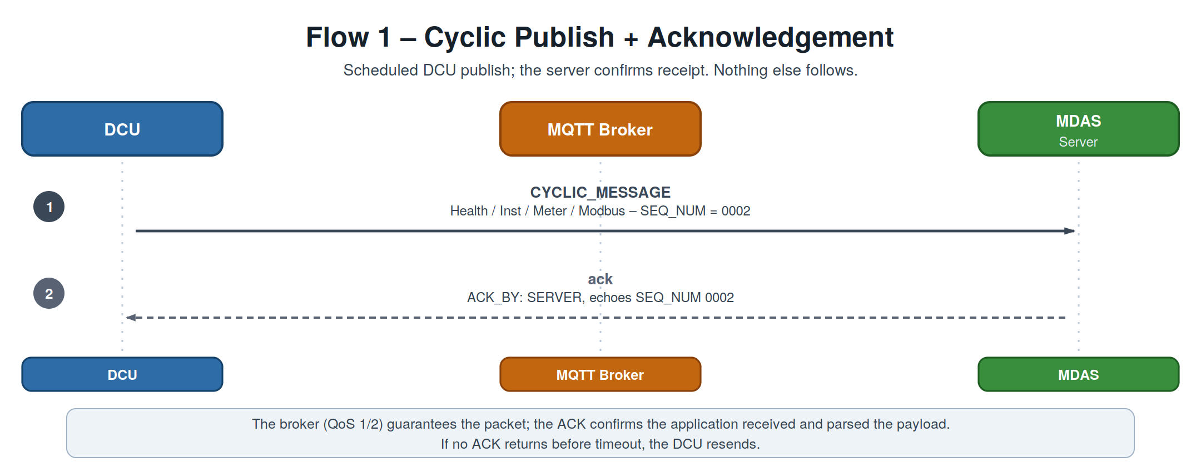
Figure 5. Flow 1 — a cyclic publish is acknowledged by the server; nothing else follows.
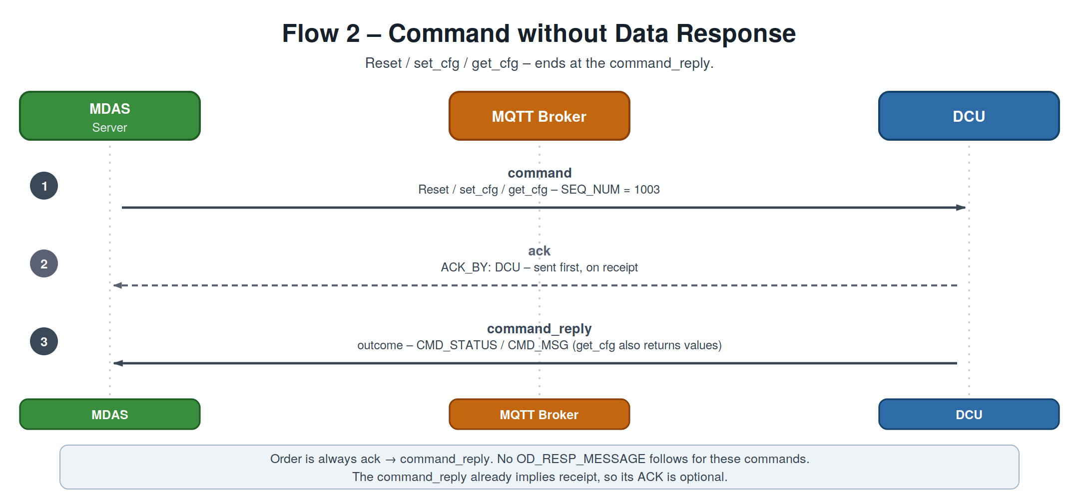
Figure 6. Flow 2 — Reset / set_cfg / get_cfg: ack first, then command_reply. No data response.
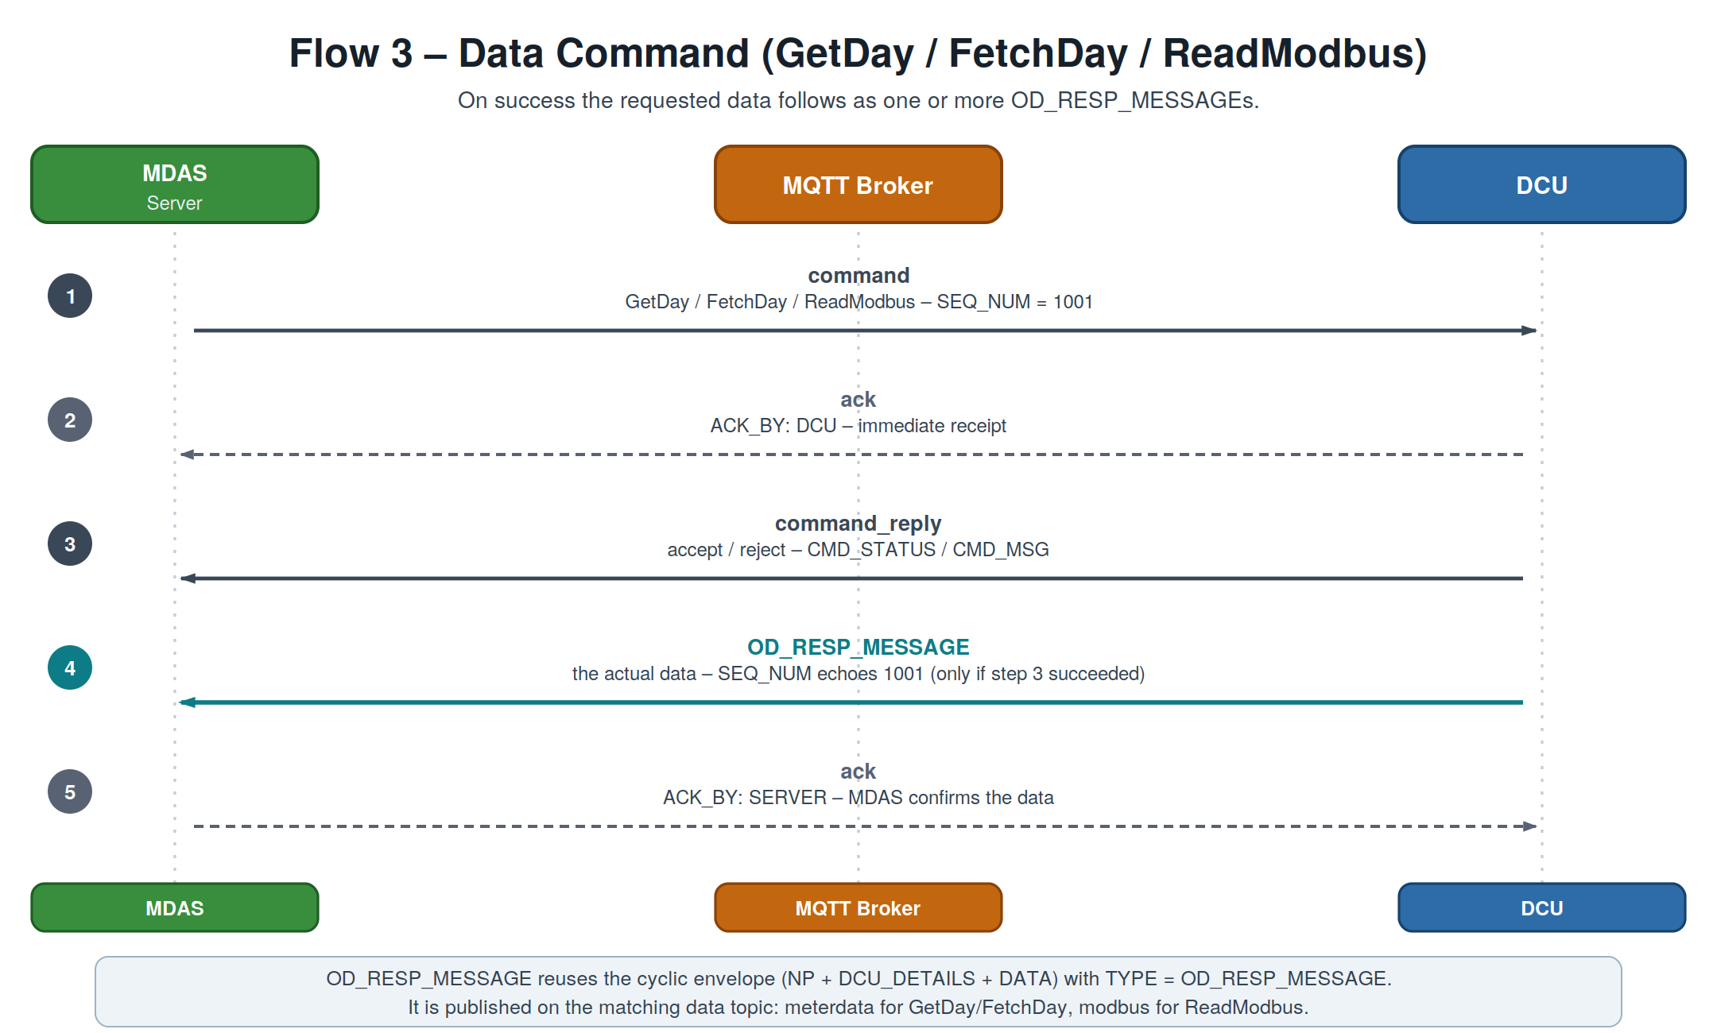
Figure 7. Flow 3 — a data command: ack, command_reply, then the OD_RESP_MESSAGE carrying the data, which the MDAS in turn acks.
Ordering rule
ack → command_reply (processing result) → OD_RESP_MESSAGE (data). The ACK is always step 1 of the response. A command_reply is the reply to an already-acked command, so it is not separately acked — this keeps ACKs from cascading. (Confirm.)

5.3 ACK shape
Like commands, an ACK carries no NP / DCU_DETAILS; the device is identified by DCU inside the message. Both directions use a single topic, cms/mqtt/dcu/ack/{serial}; ACK_BY disambiguates the sender.
Field | Meaning
TYPE | Always "ack".
SEQ_NUM | Echoes the SEQ_NUM of the acknowledged message — the correlation key.
ACK_BY | "SERVER" (acking a DCU→Server message) or "DCU" (acking a command).
DCU | DCU serial number the message belongs to.
TS | Timestamp the ACK was generated.

Server ACKs a DCU message (echoes the A.2 publish, SEQ_NUM 0002)
JSON
{
"TYPE": "ack",
"SEQ_NUM": "0002",
"ACK_BY": "SERVER",
"DCU": "10132124",
"TS": "2025-06-13 16:03:37"
}

DCU ACKs a command (receipt of GetDay 1001, sent before the reply)
JSON
{
"TYPE": "ack",
"SEQ_NUM": "1001",
"ACK_BY": "DCU",
"DCU": "10132ED5",
"TS": "2026-07-21 09:15:02"
}

DCU ACKs a command (receipt of FetchDay 1002, sent before the reply)
JSON
{
"TYPE": "ack",
"SEQ_NUM": "1002",
"ACK_BY": "DCU",
"DCU": "10132ED5",
"TS": "2026-07-21 09:15:02"
}

DCU ACKs a command (receipt of ReadModbus 3001, sent before the reply)
JSON
{
"TYPE": "ack",
"SEQ_NUM": "3001",
"ACK_BY": "DCU",
"DCU": "10132ED5",
"TS": "2026-07-21 09:15:02"
}

DCU ACKs a command (receipt of set_cfg 2004, sent before the reply)
JSON
{
"TYPE": "ack",
"SEQ_NUM": "2004",
"ACK_BY": "DCU",
"DCU": "10132ED5",
"TS": "2026-07-21 09:15:02"
}

DCU ACKs a command (receipt of get_cfg 2102, sent before the reply)
JSON
{
"TYPE": "ack",
"SEQ_NUM": "2102",
"ACK_BY": "DCU",
"DCU": "10132ED5",
"TS": "2026-07-21 09:15:02"
}

DCU ACKs a command (receipt of reset 1003, sent before the reply)
JSON
{
"TYPE": "ack",
"SEQ_NUM": "1003",
"ACK_BY": "DCU",
"DCU": "10132ED5",
"TS": "2026-07-21 09:15:02"
}

6. Reference

6.1 Command Status Codes
CMD_STATUS | CMD_MSG | Meaning
0 | SUCCESS | Command executed successfully
3 | Invalid meter name | Meter not matched with DCU
7 | Unknown request | Unrecognised command type
8 | Invalid parameter | Parameter is invalid
9 | Invalid parameter value | Parameter value is beyond the allowed range
10 | FAILED | Command failed
More codes may be added in Future.

6.2 Topic Summary
# | Message | TYPE | Direction | Topic | Trigger
1 | DCU Health | CYCLIC_MESSAGE | DCU → Server | …/dcuhealth/{serial} | Cyclic, min 1 min
2 | Instantaneous | CYCLIC_MESSAGE | DCU → Server | …/instantaneous/{serial} | Cyclic, min 1 min
3 | Meter Data | CYCLIC_MESSAGE | DCU → Server | …/meterdata/{serial} | Cyclic, min 5 min
3b | Modbus Data | CYCLIC_MESSAGE | DCU → Server | …/modbus/{serial} | Cyclic
4 | Command Request | command | MDAS → DCU | …/cmdrequest/{serial} | On demand
5 | Command Reply | command_reply | DCU → MDAS | …/cmdreply/{serial} | On demand
6 | Data Response | OD_RESP_MESSAGE | DCU → Server | …/meterdata · …/modbus | After command
7 | Acknowledgement | ack | both ways | …/ack/{serial} | On receipt

End of specification — DCU – MDAS MQTT Message Formats, Draft v0.10.

