**1.Introduction to Computer Hardware**

Identify major components of a computer such as Mother board, Daughter cards, Bus slots, SMPS, Internal storage devices, Interfacing Ports.

Physical identification of major components of a computer system such as motherboard, RAM modules, daughter cards, bus slots, SMPS, internal storage devices, interfacing ports. Specifications of desktop and server class computers. Installation of common operating systems for desktop and server use. (Students may be asked to formulate specifications for a computer to be used as a Desktop, Web server.)

**MOTHERBOARD**

A motherboard (also called mainboard, main circuit board, or mobo) is the main printed circuit board (PCB) in general-purpose computers and other expandable systems. It holds and allows communication between many of the crucial electronic components of a system, such as the central processing unit (CPU) and memory, and provides connectors for other peripherals.

Unlike a backplane, a motherboard usually contains significant sub-systems, such as the central processor, the chipset’s input/output and memory controllers, interface connectors, and other components integrated for general use.

Motherboard means specifically a PCB with expansion capabilities. As the name suggests, this board is often referred to as the "mother" of all components attached to it, which often include peripherals, interface cards, and daughterboards: sound cards, video cards, network cards, host bus adapters, TV tuner cards, IEEE 1394 cards, and a variety of other custom components.

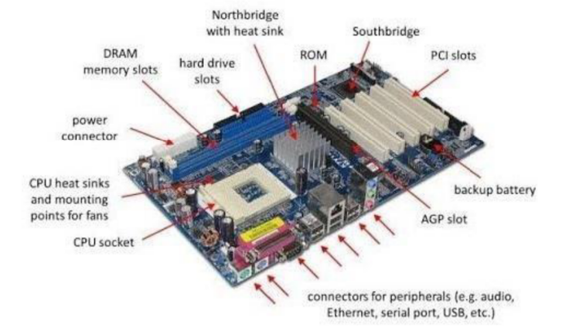

**RAM MODULES**

In computing, a memory module or RAM (random-access memory) stick is a printed circuit board on which memory integrated circuits are mounted. Memory modules permit easy installation and replacement in electronic systems, especially computers such as personal computers, workstations, and servers. The first memory modules were proprietary designs that were specific to a model of computer from a specific manufacturer. Later, memory modules were standardized by organizations such as JEDEC and could be used in any system designed to use them.

Types of memory modules include:

* TransFlash Memory Module
* SIMM, a single in-line memory module
* DIMM, dual in-line memory module
* Rambus memory modules (subset of DIMMs, normally referred to as RIMMs)
* SO-DIMM, small outline DIMM, a smaller version of the DIMM, used in laptops

Distinguishing characteristics of computer memory modules include voltage, capacity, speed (bit rate), and form factor. For economic reasons, the large (main) memories found in personal computers, workstations, and non-handheld game consoles (such as PlayStation and Xbox) normally consist of dynamic RAM (DRAM). Other parts of the computer, such as cache memories, normally use static RAM (SRAM). Small amounts of SRAM are sometimes used in the same package as DRAM. However, since SRAM has high leakage power and low density, die-stacked DRAM has recently been used for designing multi-megabyte-sized processor caches.

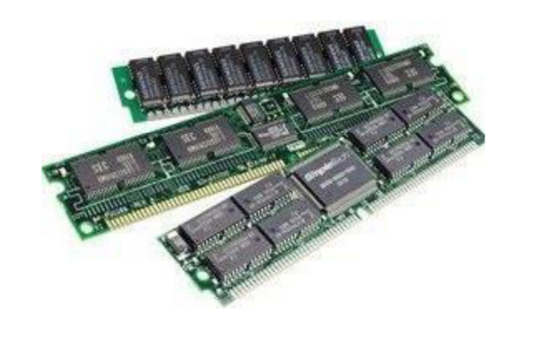

**DAUGHTER BOARD**

The daughter board is a computer hardware component. It is also known as the piggyback board, riser card, daughter board, daughter card, or daughter card. A daughter board is a printed circuit board that is connected to the motherboard or expansion card. As compared to the motherboard, it is smaller in size.

A daughter board does not act as an expansion card. An expansion card adds extra new functions to the computer, but a daughter board that is connected to the motherboard adds or supports the main functions of the motherboard.

Daughter boards are directly connected to the motherboard. Expansion cards are connected to the motherboard using the bus and other serial interfaces, but daughter boards are directly connected to the board by soldering. As an update of the motherboard or expansion card, daughter boards are released to extend the features and services of the motherboard or expansion cards.

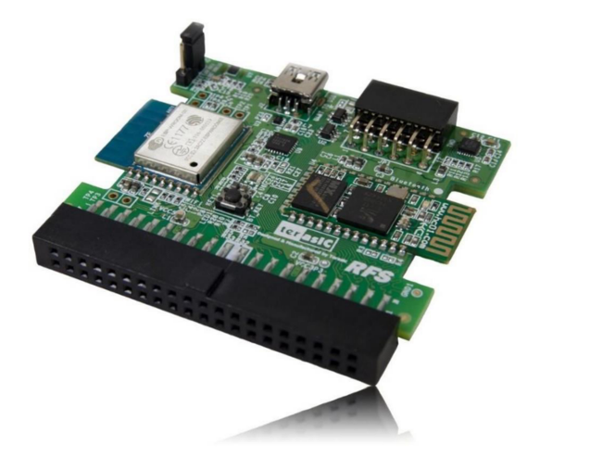

**BUS SLOTS**

Alternatively known as a bus slot or expansion port, an expansion slot is a connection or port inside a computer on the motherboard or riser card. It provides an installation point for a hardware expansion card to be connected, which provides additional features to a computer such as video, sound, advanced graphics, Ethernet, or memory.

The expansion card has an edge connector that fits precisely into the expansion slot as well as a row of contacts that is designed to establish an electrical connection between the motherboard and the electronics on the card, which are mostly integrated circuits. Depending on the form factor of the case and motherboard, a computer system generally can have anywhere from one to seven expansion slots. With a backplane system, up to 19 expansion cards can be installed.

Expansion cards can provide various functions including:

* Sound
* Modems
* Solid-state drive
* Network
* Power-on self-test
* Interface adapters
* Advanced multirate codec
* TV and radio tuning
* Basic input/output system (BIOS)
* Video processing
* Host adapting such as redundant array of independent disks or small computer system interface
* Expansion read-only memory (ROM)
* Security devices
* RAM memory

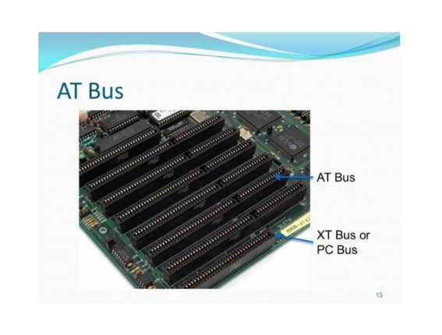

**SMPS**

A switched-mode power supply (SMPS) is an electronic circuit that converts power using switching devices that are turned on and off at high frequencies, and storage components such as inductors or capacitors to supply power when the switching device is in its non-conduction state.

Switching power supplies have high efficiency and are widely used in a variety of electronic equipment, including computers and other sensitive equipment requiring a stable and efficient power supply.

A switched-mode power supply is also known as a switch-mode power supply or switching-mode power supply.

Switched-mode power supplies are classified according to the type of input and output voltages. The four major categories are:

* AC to DC
* DC to DC
* DC to AC
* AC to AC

A basic isolated AC to DC switched-mode power supply consists of:

* Input rectifier and filter
* Inverter consisting of switching devices such as MOSFETs
* Transformer
* Output rectifier and filter
* Feedback and control circuit

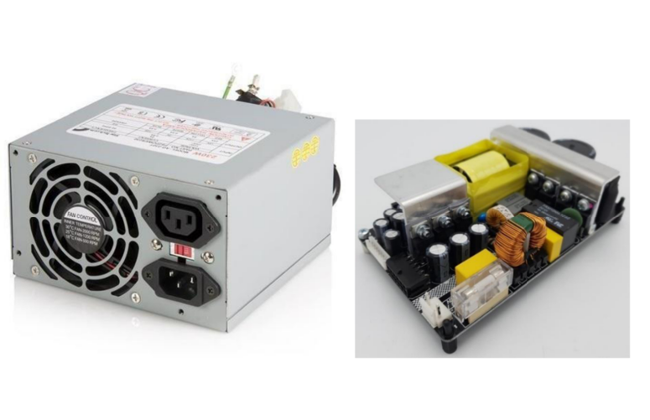

**INTERNAL STORAGE DEVICES**

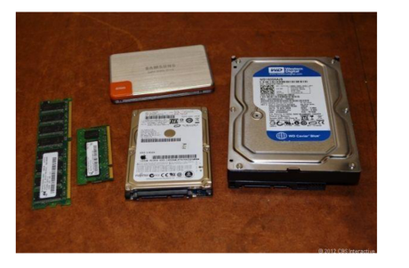

A storage unit is a part of the computer system that is employed to store the information and instructions to be processed. A storage device is an integral part of the computer hardware that stores information/data to process the result of any computational work.

Without a storage device, a computer would not be able to run or even boot up. Or in other words, we can say that a storage device is hardware that is used for storing, porting, or extracting data files. It can also store information/data both temporarily and permanently. Computer storage is of two types:

* **Primary Storage Devices:** Also known as internal memory and main memory. This is a section of the CPU that holds program instructions, input data, and intermediate results. It is generally smaller in size. RAM (Random Access Memory) and ROM (Read Only Memory) are examples of primary storage.
* **Secondary Storage Devices:** Secondary storage is a memory that is stored externally to the computer. It is mainly used for permanent and long-term storage of programs and data. Examples include Hard Disk, CD, DVD, Pen/Flash drive, SSD, etc.

**INTERFACING PORTS**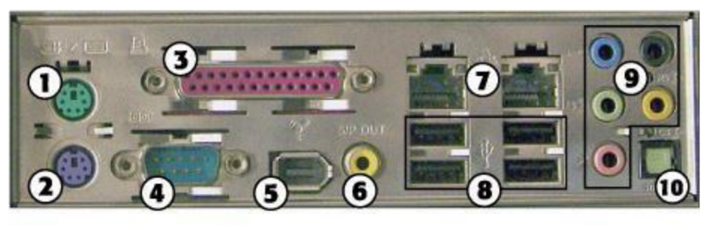

1. PS/2 mouse port
2. PS/2 keyboard port
3. Parallel port
4. Serial port
5. IEEE 1394a port
6. SPDIF coaxial digital audio port
7. Ethernet ports
8. USB ports
9. 1/8-inch mini-jack audio ports
10. SPDIF optical digital audio port

A **port** is a physical docking point used to connect external devices to the computer. It acts as an interface between the computer and external devices like hard drives and printers.

**Characteristics of Ports:**

* External devices are connected to a computer using cables and ports.
* Ports are slots on the motherboard into which a cable of an external device is plugged.
* Examples of external devices attached via ports: mouse, keyboard, monitor, microphone, speakers, etc.

**2.Basic Linux Commands**

Study of a terminal based text editor such as Vim or Emacs. (By the end of the course, students are expected to acquire following skills in using the editor: cursor operations, manipulate text, search for patterns, global search and replace)

Basic Linux commands, familiarity with following commands/operations expected

1. man

2. ls, echo, read

3. more, less, cat,

4. cd, mkdir, pwd, find

5. mv, cp, rm ,tar

6. wc, cut, paste

7. head, tail, grep, expr

8. chmod, chown

9. Redirections & Piping

10. useradd, usermod, userdel, passwd

11. df,top, ps

12. ssh, scp, ssh-keygen, ssh-copy-id

**1. pwd (Print Working Directory):** Use the pwd command to find out the path of the current working directory (folder) you’re in. The command will return an absolute (full) path, which is basically a path of all the directories that starts with a forward slash (/). An example of an absolute path is /home/username.

mits@mits-H610M-H-V2-DDR4:~$ pwd

/home/mits

**2. history :** When you have been using Linux for a certain period oftime, you will quickly notice that you can run hundreds of commands every day. As such, running history command is particularly useful if you want to review the commands you have entered before.

mits@mits-H610M-H-V2-DDR4:~$ history

 2033  clear

 2034  cat -n india

 2035  cat -n india | head -6 | tail -2

 2036  echo "god is love"

 2037  man echo

 2038  echo -n "god is love"

 2039  man echo

 2040  echo -e "god\nis\nlove"

 2041  history

 2042  pwd

 2043  man ls

 2044  ls

2045 clear

2046 History

**3. man :**by using this command you can easily learn how to use

mits@mits-H610M-H-V2-DDR4:~$ man ls

NAME

       ls - list directory contents

SYNOPSIS

       ls [OPTION]... [FILE]...

DESCRIPTION

       List  information  about the FILEs (the current directory by default).  Sort entries alphabetically if none of -cftuvSUX nor --sort

       is specified.

       Mandatory arguments to long options are mandatory for short options too.

       -a, --all

              do not ignore entries starting with .

       -A, --almost-all

              do not list implied . and ..

       --author

              with -l, print the author of each file

       -b, --escape

              print C-style escapes for nongraphic characters

       --block-size=SIZE

              with -l, scale sizes by SIZE when printing them; e.g., '--block-size=M'; see SIZE format below

       -B, --ignore-backups

              do not list implied entries ending with ~

       -c     with -lt: sort by, and show, ctime (time of last modification of file status information); with -l: show ctime and  sort  by

              name; otherwise: sort by ctime, newest first

       -C     list entries by columns

**4. cd** :To navigate through the Linux files and directories, use the cd .It requires either the full path or the name of the directory, depending on the current working directory that you’re in.

mits@ mits-H610M-H-V2-DDR4:~$ cd s1mca

mits@mits-H610M-H-V2-DDR4:~/s1mca$ cd s2mca

mits@mits-H610M-H-V2-DDR4:~/s1mca/s2mca$ cd ..

mits@mits-H610M-H-V2-DDR4:~/s1mca$ cd ..

mits@ mits-H610M-H-V2-DDR4:~$

**5. ls**:The ls command is used to view the contents of a directory. By default, this command will display the contents of your current working directory.If you want to see the content of other directories, type ls and then the directory’s path.

mits@mits-H610M-H-V2-DDR4:~$ ls

document.docx  document.pdf  india  snap

There are variations you can use with the ls command:

* ls -R will list all the files in the sub-directories aswell

mits@mits-H610M-H-V2-DDR4:~$ ls -R.:document.docx document.pdf india snap

* ls –l – long listing

mits@mits-H610M-H-V2-DDR4:~$ ls -ltotal 252-rw-rw-r-- 1 mits mits 26431 Feb 5 11:36 document.docx-rw-rw-r-- 1 mits mits 218271 Feb 5 10:16 document.pdf-rw-rw-r-- 1 mits mits 454 Feb 5 10:48 india drwx------ 4 mits mits 4096 Feb 5 10:08 snap

* ls -a will show the hidden files

mits@mits-H610M-H-V2-DDR4:~$ ls -a. .bash_logout .config .fontconfig .lesshst .mca.swp .profile .sudo_as_admin_successful.. .bashrc document.docx .gnupg .local .mca.txt.swp snap .thunderbird.bash_history .cache document.pdf india .~lock.document.docx# .mozilla .ssh

* ls -al will list the files and directories with detailed information like the perimission, size, owner, etc.

mits@mits-H610M-H-V2-DDR4:~$ ls -altotal 364 -rw-rw-r-- 1 mits mits 84 Feb 5 11:36 .~lock.document.docx#-rw------- 1 mits mits 12288 Apr 15 2024 .mca.swp-rw------- 1 mits mits 12288 Apr 15 2024 .mca.txt.swpdrwx------ 3 mits mits 4096 Oct 10 15:30 .mozilla-rw-r--r-- 1 mits mits 807 Jan 24 2024 .profiledrwx------ 4 mits mits 4096 Feb 5 10:08 snapdrwx------ 2 mits mits 4096 Mar 4 2024 .ssh-rw-r--r-- 1 mits mits 0 Jan 24 2024 .sudo_as_admin_successfuldrwx------ 6 mits mits 4096 Oct 10 15:30 .thunderbird

* ls -t lists files sorted in the order of “lastmodified”

mits@mits-H610M-H-V2-DDR4:~$ ls -tdocument.docx india document.pdf snap

* ls -r option will reverse the natural sorting order. Usually used incombination with other switches such as ls -tr. This will reverse thetime-wise listing.

mits@mits-H610M-H-V2-DDR4:~$ ls -rsnap india document.pdf document.docx

**6. mkdir :** Use mkdir command to make a new directory — if you type mkdir Music it will create a directory called Music.To generate a new directory inside another directory, use this Linux basic command

mits@mits-H610M-H-V2-DDR4:~$ lsdocument.docx f1 india kerala linuxtext snapmits@mits-H610M-H-V2-DDR4:~/$ mkdir s1mcamits@mits-H610M-H-V2-DDR4:~/$ mkdir s2mca

mits@mits-H610M-H-V2-DDR4:~$ lsdocument.docx f1 india kerala linuxtext snap s1mca s2mca

**7. rmdir:**If you need to delete a directory, use the rmdir command.However, rmdir only allows you to delete empty directories.

mits@mits-H610M-H-V2-DDR4:~$ lsdocument.docx f1 india kerala linuxtext snap s1mca s2mca

mits@mits-H610M-H-V2-DDR4:~/$ rmdir s2mcamits@mits-H610M-H-V2-DDR4:~$ lsdocument.docx f1 india kerala linuxtext snap s1mca

**8. touch:**The touch command allows you to create a blank new filethrough the Linux command line.

mits@mits-H610M-H-V2-DDR4:~/s2mca$ lsf1 linux new

mits@mits-H610M-H-V2-DDR4:~/s2mca$ touch apple orangemits@mits-H610M-H-V2-DDR4:~/s2mca$ lsapple f1 linux new orange

**9. rm :** The rm command is used to delete directories and the contents within them. If you only want to delete the directory —as an alternative to rmdir — use rm -r. Be very careful with this command and double-check which directory you are in. This will delete everything and there is no undo. To remove a file use rm filename.

mits@mits-H610M-H-V2-DDR4:~$ lsdocument.docx grapes india kerala linuxtext mca mint s2mca snap yellowmits@mits-H610M-H-V2-DDR4:~$ rm mcarm: cannot remove 'mca': Is a directorymits@mits-H610M-H-V2-DDR4:~$ rm -r mcamits@mits-H610M-H-V2-DDR4:~$ lsdocument.docx grapes india kerala linuxtext mint s2mca snap yellow

**10.** **Cat:**cat (short for concatenate) is one of the most frequently used commands in Linux. It is used to list the contents of a file on the standard output stdout . To run this command, type cat followed by the file’s name and its extension.

mits@mits-H610M-H-V2-DDR4:~$ cat > india

india is my country

i love my country

all indians are my brothers and sisters

india, officially the Republic of India,[j][20] is a country in South Asia.

^C

mits@mits-H610M-H-V2-DDR4:~$ cat india

india is my country

i love my country

all indians are my brothers and sisters

india, officially the Republic of India,[j][20] is a country in South Asia

mits@mits-H610M-H-V2-DDR4:~$ cat -n  india

     1 india is my country

     2 i love my country

     3 all indians are my brothers and sisters

india, officially the Republic of India,[j][20] is a country in South Asia.

**11. echo:** echo command is used to move some data into a file. If you want to add the text, “Hello, my name is John” into a file called name.txt, you would type echo Hello, my name is John

>> name.txt 2. head.

mits@mits-H610M-H-V2-DDR4:~$ echo "god is love"

god is love

mits@mits-H610M-H-V2-DDR4:~$ echo -e "god\nis\nlove"

god

is

love

**12. head:** The head command is used to view the first lines of any text file. By default, it will show the first ten lines, but you can change this number to your liking. If you only want to show the first five lines, type head -n 5 filename.txt.

mits@mits-H610M-H-V2-DDR4:~$ head india

india is my country

i love my country

all indians are my brothers and sisters

india, officially the Republic of India,[j][20] is a country in South Asia.

 It is the seventh-largest country by area

since its independence in 1947, the world's most populous democracy

Bounded by the Indian Ocean on the south

he Arabian Sea on the southwest

Bay of Bengal on the southeast

shares land borders with Pakistan to the west

mits@mits-H610M-H-V2-DDR4:~$ head -5 india

india is my country

i love my country

all indians are my brothers and sisters

india, officially the Republic of India,[j][20] is a country in South Asia.

 It is the seventh-largest country by area

**13. tail:** This one has a similar function to the head command, but instead of showing the first lines, the tail command will display the last ten lines of a text file. tail -n filename.txt.

mits@mits-H610M-H-V2-DDR4:~$ tail india

i love my country

all indians are my brothers and sisters

india, officially the Republic of India,[j][20] is a country in South Asia.

 It is the seventh-largest country by area

since its independence in 1947, the world's most populous democracy

Bounded by the Indian Ocean on the south

he Arabian Sea on the southwest

Bay of Bengal on the southeast

shares land borders with Pakistan to the west

China, Nepal, and Bhutan to the north

mits@mits-H610M-H-V2-DDR4:~$ tail -5 india

Bounded by the Indian Ocean on the south

he Arabian Sea on the southwest

Bay of Bengal on the southeast

shares land borders with Pakistan to the west

China, Nepal, and Bhutan to the north

**14.read:** read the contents of a line into a variable. The read command can be used with and without arguments. read command is used to read [options] [name...] . $read $read var1 var2 var3. $echo &quot;[$var1] [$var2] [$var3].

mits@mits-H610M-H-V2-DDR4:~$ echo "Enter your name:"; read;

Enter your name:

Gokul

mits@mits-H610M-H-V2-DDR4:~$ echo "Enter your name:"; read name;

echo "hello" $name;

Enter your name:

gokul

hello Gokul

**15.more:** Like cat command, more command displays the content of a file. Only difference is that, in case of larger files, &#39; cat&#39; command output will scroll off your screen while &#39; more&#39; command displays output one screenful at a time. Enter key

mits@mits-H610M-H-V2-DDR4:~$ more -p india

india is my country

i love my country

all indians are my brothers and sisters

india, officially the Republic of India,[j][20] is a country in South Asia.

 It is the seventh-largest country by area

since its independence in 1947, the world's most populous democracy

Bounded by the Indian Ocean on the south

he Arabian Sea on the southwest

Bay of Bengal on the southeast

shares land borders with Pakistan to the west

China, Nepal, and Bhutan to the north

**16.less:** The 'less' command is same as 'more' command but include some more features. It automatically adjusts with the width and height of the terminal window, while 'more' command cuts the content as the width of the terminal window get shorter

mits@mits-H610M-H-V2-DDR4:~$ less india

india is my country

i love my country

all indians are my brothers and sisters

india, officially the Republic of India,[j][20] is a country in South Asia.

 It is the seventh-largest country by area

since its independence in 1947, the world's most populous democracy

Bounded by the Indian Ocean on the south

he Arabian Sea on the southwest

Bay of Bengal on the southeast

shares land borders with Pakistan to the west

China, Nepal, and Bhutan to the north

india (END)

**17.cut :** The cut command is used for cutting out the sections from each line offiles and writing the result to standard output. It can be used to cut parts of aline by byte position, character and file.

mits@mits-H610M-H-V2-DDR4:~$ cat > state

andhra pradesh

arunachal pradesh

assam

bihar

Chhattisgarh

india

^C

mits@mits-H610M-H-V2-DDR4:~$ cut -b 1,2,3,4 state

andh

arun

assa

biha

Chha

indi

mits@mits-H610M-H-V2-DDR4:~$ cut -b 1-3,6-7 state

anda

aruch

ass

bih

Chhti

ind

mits@mits-H610M-H-V2-DDR4:~$ cut -b 3- state

dhra pradesh

unachal pradesh

sam

har

hattisgarh

dia

**18.paste :** It is used to join files horizontally (parallel merging) by outputting lines consisting of lines from each file specified, separated by tab as delimiter, to the standard output. paste [OPTION]... [FILES]...$ paste state.txt capital.txt.

mits@mits-H610M-H-V2-DDR4:~$ cat number

1

2

3

4

5

mits@mits-H610M-H-V2-DDR4:~$ cat state

arunachal pradesh

assam

andhra pradesh

bihar

chattisgrah

mits@mits-H610M-H-V2-DDR4:~$ cat capital

itanagar

dispur

hyderabad

patna

raipur

mits@mits-H610M-H-V2-DDR4:~$ paste number state capital

1   arunachal pradesh   itanagar

2   assam   dispur

3   andhra pradesh  hyderabad

4   bihar   patna

5   chattisgrah raipur

mits@mits-H610M-H-V2-DDR4:~$ paste -d "|" number state capital

1|arunachal pradesh|itanagar

2|assam|dispur

3|andhra pradesh|hyderabad

4|bihar|patna

5|chattisgrah|Raipur

mits@mits-H610M-H-V2-DDR4:~$ paste -d "," number state capital

1,arunachal pradesh,itanagar

2,assam,dispur

3,andhra pradesh,hyderabad

4,bihar,patna

5,chattisgrah,raipur

mits@mits-H610M-H-V2-DDR4:~$ paste -d "|," number state capital

1|arunachal pradesh,itanagar

2|assam,dispur

3|andhra pradesh,hyderabad

4|bihar,patna

5|chattisgrah,raipur

mits@mits-H610M-H-V2-DDR4:~$ paste -s number state capital

1   2   3   4   5

arunachal pradesh   assam   andhra pradesh  bihar   chattisgrah

itanagar    dispur  hyderabad   patna   raipur

mits@mits-H610M-H-V2-DDR4:~$ paste -s -d ":" number state capital

1:2:3:4:5

arunachal pradesh:assam:andhra pradesh:bihar:chattisgrah

itanagar:dispur:hyderabad:patna:raipu

**19.uname :** The uname command, short for Unix Name, will print detailed information about your Linux system like the machine name, operating system, kernel, and so on $uname, $uname-r

mits@mits-H610M-H-V2-DDR4:~$ uname

Linux

mits@mits-H610M-H-V2-DDR4:~$ uname -r

6.8.0-52-generic

**20.cp :** cp command issued to copy files from the currentdirectorytoa different directory. For instance, the command cp scenery.jpg

/home/username/Pictures would create a copy of scenery.jpg (from your current directory) into the Pictures directory. cp -i will ask for user’s consent in case of a potential file overwrite. cp -p will preserve source files’mode, ownership and timestamp. cp -r will copy directories recursively. cp -u copies files only if the destination fileisnotexistingor thesource file is newer than the destination file.

mits@mits-H610M-H-V2-DDR4:~/gokul$ ls

file1

mits@mits-H610M-H-V2-DDR4:~/gokul$ cp file1 file2

mits@mits-H610M-H-V2-DDR4:~/gokul$ ls

file1  file2

**21.mv :** The primary use of the mv command is to move files, it can also be used to rename files.The arguments in mv are similar to the cp command. You need to type mv, the file’s name, and the destination’s directory. mv file.txt

/home/username/Documents .To rename files, the Linux is mv oldname.ext newname.ext.

mits@mits-H610M-H-V2-DDR4:~/s2mca$ ls

apple  f1  linux  new  orange

mits@mits-H610M-H-V2-DDR4:~/s2mca$ mv f1 f2

mits@mits-H610M-H-V2-DDR4:~/s2mca$ ls

apple  f2  linux  new  orange

**22.locate :**To locate a file, just like the search command in Windows. What’s more, using the -i argument along with this command will make it case insensitive, so you can search for a file even if you don’t remember its exact name. To search for a file that contains two or more words, use an asterisk (*). For example, locate -i school*note command will search for any file that contains the word “school” and “note”, whether it is uppercase or lowercase.

**23.Find**:Similar to the locate command ,using find also searches for files and directories. The difference is, you use the find command to locate files within a given directory. As an example, find /home/ -name notes.txt command will search for a file called notes.txt within the home directory and its subdirectories. Other variations when using the find are: To find files in the current directory use, find . -name notes.txt .To look for directories use, / -type d -name notes. Txt

mits@mits-H610M-H-V2-DDR4:~$ find ./ -name *.txt

./sample.txt

./mca/sample.txt

mits@mits-H610M-H-V2-DDR4:~$ find ./mca -name sample.txt -exec rm -i {} \;

rm: remove regular empty file './mca/sample.txt'? y

mits@mits-H610M-H-V2-DDR4:~$ find ./ -name sample.txt

./sample.txt

mits@mits-H610M-H-V2-DDR4:~$ find ./ -empty

./s2mca/orange

./s2mca/new

./s2mca/apple

**24.grep :** Another basic Linux command that is undoubtedly helpful for everyday use is grep. It lets you search through all the text in a given file. To illustrate, grep blue notepad.txt will search for the word blue in the notepad file. Lines that contain the searched word will be displayed fully. Usually output of a previous command is piped into the grep command. For example, ls -l |grep “kernel”.

mits@mits-H610M-H-V2-DDR4:~$ cat exmple

unix is great os. unix was developed in Bell labs.

learn operating system.

Unix linux which one you choose.

uNix is easy to learn.unix is a multiuser os.Learn unix .unix is a powerful.

mits@mits-H610M-H-V2-DDR4:~$ grep -c "unix" exmple

2

mits@mits-H610M-H-V2-DDR4:~$ grep -h "unix" exmple

unix is great os. unix was developed in Bell labs.

uNix is easy to learn.unix is a multiuser os.Learn unix .unix is a powerful.

mits@mits-H610M-H-V2-DDR4:~$ grep -i "unix" exmple

unix is great os. unix was developed in Bell labs.

Unix linux which one you choose.

uNix is easy to learn.unix is a multiuser os.Learn unix .unix is a powerful.

mits@mits-H610M-H-V2-DDR4:~$ grep -l "unix" exmple

exmple

mits@mits-H610M-H-V2-DDR4:~$ grep -n "unix" exmple

1:unix is great os. unix was developed in Bell labs.

4:uNix is easy to learn.unix is a multiuser os.Learn unix .unix is a powerful.

**25.df :** Use df command to get a report on the system’s disk space usage, shown in percentage and KBs. If you want to see the report in megabytes, type df - m.

mits@mits-H610M-H-V2-DDR4:~$ df

Filesystem     1K-blocks     Used Available Use% Mounted on

tmpfs             789976     2284    787692   1% /run

/dev/sda5      216888480 16665692 189132664   9% /

tmpfs            3949860        0   3949860   0% /dev/shm

tmpfs               5120        4      5116   1% /run/lock

efivarfs             256      125       127  50% /sys/firmware/efi/efivars

/dev/sda1          98304    31816     66488  33% /boot/efi

tmpfs             789972      108    789864   1% /run/user/1000

**26.du :** If you want to check how much space a file or a directory takes, the du (Disk Usage) command is the answer. However, the disk usage summary will show disk block numbers instead of the usual size format. If you want to see it in bytes, kilobytes, and megabytes, add the -h argument to the command line.

mits@mits-H610M-H-V2-DDR4:~$ du

4 ./snap/firefox/5783/.config/gtk-3.0

4 ./snap/firefox/5783/.config/ibus

4 ./snap/firefox/5783/.config/dconf

4 ./snap/firefox/5783/.config/gtk-2.0

8 ./snap/firefox/5783/.config/pulse

8 ./snap/firefox/5783/.config/fontconfig

52 ./snap/firefox/5783/.config

4 ./snap/firefox/5783/.local/share/icons

4 ./snap/firefox/5783/.local/share/glib-2.0/schemas

8 ./snap/firefox/5783/.local/share/glib-2.0

24 ./snap/firefox/5783/.local/share

28 ./snap/firefox/5783/.local

88 ./snap/firefox/5783

4 ./snap/firefox/5751/.config/gtk-3.0

4 ./snap/firefox/5751/.config/ibus

4 ./snap/firefox/5751/.config/dconf

4 ./snap/firefox/5751/.config/gtk-2.0

**27.useradd :** This is available only to system admins .Since Linux is a multi- user system, this means more than one person can interact with the same system at the same time. useradd is used to create a new user, while passwd is adding a password to that user’s account. To add a new person named John type, useradd John and then to add his password type, passwd 123456789

mits@mits-H610M-H-V2-DDR4:~$ sudo useradd gokul

[sudo] password for mits:

mits@mits-H610M-H-V2-DDR4:~$ cat /etc/passwd | grep gokul

gokul:x:1003:1003::/home/gokul:/bin/sh

mits@mits-H610M-H-V2-DDR4:~$ cat /etc/passwd | grep "gokul"

gokul:x:1003:1003::/home/gokul:/bin/sh

**28.userdel :**Remove a user is very similar to adding a new user. To delete theusers account type, userdel UserName

mits@mits-H610M-H-V2-DDR4:~$ sudo userdel gokul

mits@mits-H610M-H-V2-DDR4:~$ cat /etc/passwd | tail -3

mca:x:1001:1001::/home/mca:/bin/sh

mysql:x:128:136:MySQL Server,,,:/nonexistent:/bin/false

exam:x:1002:1002:Exam,,,:/home/exam:/bin/bash

**29.sudo :** Short for “SuperUser Do”, this command enables you to perform tasks that require administrative or root permissions. You must have sufficient permissions to use this command.

mits@mits-H610M-H-V2-DDR4:~$ chown gokul myfile1.txt

chown: changing ownership of 'myfile1.txt': Operation not permitted

mits@mits-H610M-H-V2-DDR4:~$ sudo chown gokul myfile1.txt

**30.passwd :** Changes passwords for user accounts. A normal user may only change the password for their own account, while the superuser may change the password for any account.

**31.usermod :** usermod command is used to change the properties of a user in Linux through the command line command-line utility that allows you to modify a user’s login information.

mits@mits-H610M-H-V2-DDR4:~$ sudo usermod -l gookul gokul

mits@mits-H610M-H-V2-DDR4:~$ cat /etc/passwd | grep "gookul"

gookul:x:1003:1004::/home/gokul:/bin/sh

**32.Groupadd :** groupadd command creates a new group account using the values specified on the command line and the default values from the system.

Syntax:

groupadd [option] group_name

mits@mits-H610M-H-V2-DDR4:~$ sudo groupadd s2mca

mits@mits-H610M-H-V2-DDR4:~$ cat /etc/group | grep "s2mca"

s2mca:x:1004:

**33.groups :** print the groups a user is in#groups alice.

Syntax:

groups [username]...

mits@mits-H610M-H-V2-DDR4:~$ groups mits

mits : mits adm cdrom sudo dip plugdev lpadmin lxd sambashare

**34.groupdel :** groupdel command modifies the system account files, deleting all entries that refer to group. The named group must exist #groupdel marketin.

Syntax:

groupdel [options] GROUP

mits@mits-H610M-H-V2-DDR4:~$ sudo groupdel s1mca

mits@mits-H610M-H-V2-DDR4:~$ cat /etc/group | tail -3

mysql:x:136:

exam:x:1002:

gokul:x:1003:

**35.groupmod :** The groupmod command modifies the definition of thespecified group by modifying the appropriate entry in the group database. # groupmod -n group1 group2.

Syntax:

groupmod [option] GROUP

mits@mits-H610M-H-V2-DDR4:~$ sudo groupmod -n s1mca s2mca

[sudo] password for mits:

mits@mits-H610M-H-V2-DDR4:~$ cat /etc/group | tail -3

exam:x:1002:

gokul:x:1003:

s1mca:x:1004:

**36.chmod :** To change directory permissions of file/ Directory in Linux. #chmod who what which file/directory chmod +rwx filename to add permissions. chmod -rwx directory name to remove permissions. chmod +x filename to allow executable permissions. chmod -wx filename to take out write and executable permissions. #chmod u+x test #chmod g- rwx test #chmod o-r test 4

mits@mits-H610M-H-V2-DDR4:~$ ls -l

drwxrwxr-x 2 mits mits    4096 Feb 20 11:47  mca

-rw-rw-r-- 1 mits mits      18 Feb  6 14:16  mint

-rw-rw-r-- 1 mits mits     148 Mar  5 11:22  myfile1.txt

-rw-rw-r-- 1 mits mits     148 Mar  5 11:22  myfile2.txt

mits@mits-H610M-H-V2-DDR4:~$ chmod 777 myfile1.txt

mits@mits-H610M-H-V2-DDR4:~$ ls -l

drwxrwxr-x 2 mits mits    4096 Feb 20 11:47  mca

-rw-rw-r-- 1 mits mits      18 Feb  6 14:16  mint

-rwxrwxrwx 1 mits mits     148 Mar  5 11:22  myfile1.txt

-rw-rw-r-- 1 mits mits     148 Mar  5 11:22  myfile2.txt

**37.chown :** The chown command allows you to change the user and/or group ownership of a given file, directory. #chownTom Test

mits@mits-H610M-H-V2-DDR4:~$ ls -l

-rw-rw-r-- 1 mits mits     148 Mar  5 11:22  myfile1.txt

-rw-rw-r-- 1 mits mits     148 Mar  5 11:22  myfile2.txt

mits@mits-H610M-H-V2-DDR4:~$ sudo chown gokul myfile1.txt

mits@mits-H610M-H-V2-DDR4:~$ ls -l

-rwxrwxrwx 1 gokul mits     148 Mar  5 11:22  myfile1.txt

-rw-rw-r-- 1 mits  mits     148 Mar  5 11:22  myfile2.txt

**38.id :** id command in Linux is used to find out user and group names and numeric ID's (UID or group ID) of the current user.

mits@mits-H610M-H-V2-DDR4:~$ id

uid=1000(mits) gid=1000(mits) groups=1000(mits),4(adm),24(cdrom),27(sudo),30(dip),46(plugdev),122(lpadmin),134(lxd),135(sambashare)

mits@mits-H610M-H-V2-DDR4:~$ ps

    PID TTY          TIME CMD

   9099 pts/0    00:00:00 bash

  11662 pts/0    00:00:00 ps

**39.ps :** The ps command, short for Process Status, is a command line utility that is used to display or view information related to the processes running in a Linux system. PID – This is the unique process ID TTY– This is the type of terminal that the user is logged in to . TIME – This is the time in minutes and seconds that the process has been running .CMD – The command that launched the process

Syntax:

ps [options]

mits@mits-H610M-H-V2-DDR4:~/gokul$ ps

    PID TTY          TIME CMD

   4182 pts/0    00:00:00 bash

   9697 pts/0    00:00:00 ps

**40.top:** top command is used to show the Linux processes. It provides a dynamic real- time view of the running system

Syntax:

top [options]

mits@mits-H610M-H-V2-DDR4:~$ top

top - 14:35:28 up  1:28,  1 user,  load average: 0.52, 0.44, 0.39

Tasks: 337 total,   1 running, 336 sleeping,   0 stopped,   0 zombie

%Cpu(s):  1.0 us,  0.7 sy,  0.0 ni, 98.2 id,  0.0 wa,  0.0 hi,  0.1 si,  0.0 st

MiB Mem :   7714.6 total,    447.0 free,   3179.0 used,   4088.6 buff/cache

MiB Swap:   2048.0 total,   2048.0 free,      0.0 used.   3508.2 avail Mem

**41.wc :** wc stands for word count. Used for counting purpose. It is used to find out number of lines, word count, byte and characters count in the files specified in the file arguments. #wc state.txt 6 8 54 state.tx . #wc state.txt capital.txt wc -l state.txt wc

-w state.txt capital.txt wc -c state.txt .wc -m state.txt

mits@mits-H610M-H-V2-DDR4:~$ cat state

Kerala

Tamil nadu

Goa

mits@mits-H610M-H-V2-DDR4:~$ wc state

3 4 22 state

mits@mits-H610M-H-V2-DDR4:~$ wc -l state

3 state

mits@mits-H610M-H-V2-DDR4:~$ wc -c state

22 state

mits@mits-H610M-H-V2-DDR4:~$ wc -w state

4

**42.tar :** The Linux ‘tar’stands for tape archive, is used to create Archive and extract the Archive files Linux tar command to create compressed or uncompressed Archive files

**43.expr :** The expr command evaluates a given expression and displays its corresponding output. It is used for: . Basic operations like addition, subtraction, multiplication, division, and modulus on integers. Evaluating regular expressions,string operations like substring, length of strings etc. Performing operations on variables inside a shell script.

mits@mits-H610M-H-V2-DDR4:~$ a="20"

mits@mits-H610M-H-V2-DDR4:~$ b="4"

mits@mits-H610M-H-V2-DDR4:~$ expr $a + $b

24

mits@mits-H610M-H-V2-DDR4:~$ expr $a - $b

16

mits@mits-H610M-H-V2-DDR4:~$ expr $a \* $b

80

mits@mits-H610M-H-V2-DDR4:~$ expr $a / $b

5

**44.Redirections & Piping :** A pipe is a form of redirection to send the output of one command/program/process to another command/program/process for further processing. Pipe is used to combine two or more commands, the output of one command acts as input to another command, and this command’s output may act as input to the next command and so on.

mits@mits-H610M-H-V2-DDR4:~$echo "Hello" > output.txt

mits@mits-H610M-H-V2-DDR4:~$echo "Linux" >> output.txt

mits@mits-H610M-H-V2-DDR4:~$ls -l | grep ".txt"

**45.ssh :** ssh stands for “Secure Shell”. It is a protocol used to securely connect to a remote server/system. ssh is secure in the sense that it transfers the data in encrypted form between the host and the client. It transfers inputs from the client to the host and relays back the output. ssh runs at TCP/IP port 22

mits@mits-H610M-H-V2-DDR4:~/gokul$ ssh

usage: ssh [-46AaCfGgKkMNnqsTtVvXxYy] [-B bind_interface]

           [-b bind_address] [-c cipher_spec] [-D [bind_address:]port]

           [-E log_file] [-e escape_char] [-F configfile] [-I pkcs11]

           [-i identity_file] [-J [user@]host[:port]] [-L address]

           [-l login_name] [-m mac_spec] [-O ctl_cmd] [-o option] [-p port]

           [-Q query_option] [-R address] [-S ctl_path] [-W host:port]

           [-w local_tun[:remote_tun]] destination [command [argument ...]]

**46.scp :** SCP (secure copy) is a command-line utility that allows you to securely copy files and directories between two locations. With scp, you can copy a file or directory: From your local system to a remote system. From a remote system to your local system. Between two remote systems from your local system. Remote file system locations are specified in format [user@]host:/path Syntax: scp [OPTION] [user@]SRC_HOST:]file1 [user@]DEST_HOST:]file2 $scp

/etc/yum.config /etc/hosts

ServerX:/home/student $scp ServerX:/etc/hostname/home/student

mits@mits-H610M-H-V2-DDR4:~/gokul$ scp

usage: scp [-346ABCOpqRrsTv] [-c cipher] [-D sftp_server_path] [-F ssh_config]

           [-i identity_file] [-J destination] [-l limit]

           [-o ssh_option] [-P port] [-S program] source ... target

**47.ssh-keygen :** ssh-keygen command to generate a public/private authentication key pair. Authentication keys allow a user to connect to a remote system without supplying a password. Keys must be generated for each user separately. If you generate key pairs as the root user, only the root can use the keys. $ssh-keygen -t rsa

3.Execute the following scenario using basic Linux commands

a) Login to your home directory

b) List contents of your current working directory

c) List all contents of your current working directory, including hidden files

d) Make a directory called April2024 inside your current working directory. Change to the directory April2024

e) Create an empty file name file1

f) Make a copy of file1 to file2

g) Copy file1 from the current working directory and save it as the name file2 in one Directory up from the current directory

h) Clear the terminal window

mits@mits-H610M-H-V2-DDR4:~$ pwd

/home/mits

mits@mits-H610M-H-V2-DDR4:~$ ls

document.docx  document.pdf  india  snap

mits@mits-H610M-H-V2-DDR4:~$ ls -a

.    .bash_logout  .config  .fontconfig  .lesshst   .mca.swp      .profile  .sudo_as_admin_successful

..  .bashrc       document.docx  .gnupg       .local       .mca.txt.swp  snap      .thunderbird

.bash_history  .cache        document.pdf   india  .~lock.document.docx#  .mozilla   .ssh

mits@mits-H610M-H-V2-DDR4:~$ mkdir April2024

mits@mits-H610M-H-V2-DDR4:~$ cd April2024

mits@mits-H610M-H-V2-DDR4:~/April2024$ touch file1

mits@mits-H610M-H-V2-DDR4:~/April2024$ ls

file1

mits@mits-H610M-H-V2-DDR4:~/April2024$ cp file1 file2

mits@mits-H610M-H-V2-DDR4:~/April2024$ ls

file1 file2

mits@mits-H610M-H-V2-DDR4:~/April2024$ cp file1 ../file2

mits@mits-H610M-H-V2-DDR4:~/April2024$ clear

4.Execute the following scenario using basic Linux commands

a) Login to your home directory

b) Write the contents of syslog (located in the /var/log/ directory) onto thescreen a page at a time.

c) Read documentation on a command: less

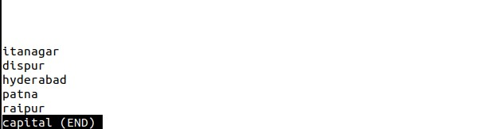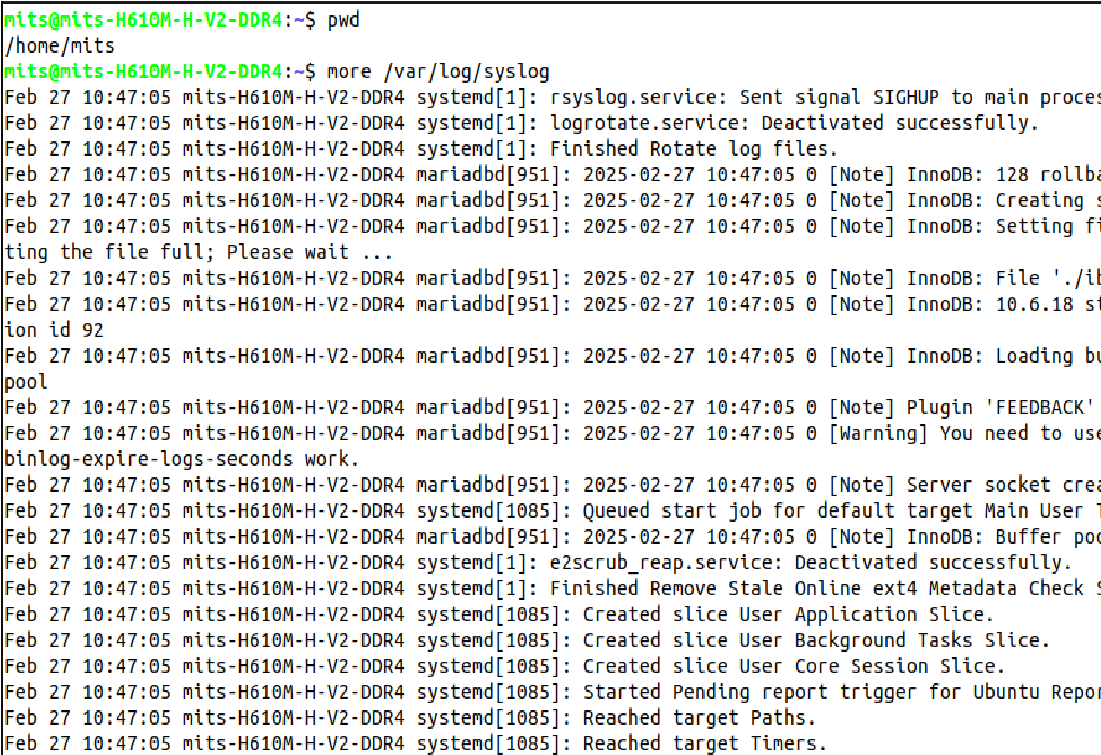

5.Execute the following scenario using basic Linux Commands

a) Create an untitled document myfile.txt using anyone editor

b) Place the following text in myfile.txt and save it

Neo: What are you trying to tell me?

That I can dodge bullets?

Morpheus: No, Neo. I'm trying to tell

you that when you're ready, you won't have to.

c) Count the number of characters, words, and lines in the file

d) Find the occurrence of the word “tell” in the file e.

e) Make two copies of myfile.txt with names myfile1.txt and myfile2.txt

f) List all the filenames with the word file in the present working directory

mits@nits-H610M-H-V2-DDR4:~$ touch myfile.txt

mits@mits-H610M-H-V2-DDR4:~$ gedit myfile.txt

mits@mits-H610M-H-V2-DDR4:~$ cat myfile.txt

Neo: What are you trying to tell me?

That I can dodge bullets?

Morpheus: No, Neo. I'm trying to tell

you that when you're ready, you won't have to.

mits@mits-H610M-H-V2-DDR4:~$ wc myfile.txt

4 29 148 myfile.txt

mits@mits-H610M-H-V2-DDR4:~$ wc -c myfile.txt

148 myfile.txt

mits@mits-H610M-H-V2-DDR4:~$ wc -w myfile.txt

29 nyfile.txt

mits@mits-H610M-H-V2-DDR4:~$ wc -l myfile.txt

4 myfile.txt

mits@mits-H610M-H-V2-DDR4:~$ grep -c "tell" myfile.txt

2

mits@mits -H610M-H-V2-DDR4:~$ grep "tell" myfile.txt

Neo: What are you trying to tell me?

Morpheus: No, Neo. I'm trying to tell

mits@mits-H610M-H-V2-DDR4:~$ cp myfile.txt myfile1.txt

mits@nits-H610M-H-V2-DDR4:~$ cp myfile.txt myfile2.txt

mits@mits-H610M-H-V2-DDR4:-$ ls *file*

file2 myfile1.txt myfile2.txt myfile.txt