**Introduction to Command Line**

**Date:02-04-2025**

**1.Ping**

A ping is a basic Internet command that allows a user to test and verify whether a given destination IP address exists and can accept requests in computer network administration. Ping is also used for diagnosis to confirm that the computer the user tries to reach is operational. Ping can be used with any operating system (OS) that supports networking, including the majority of embedded network administration software.

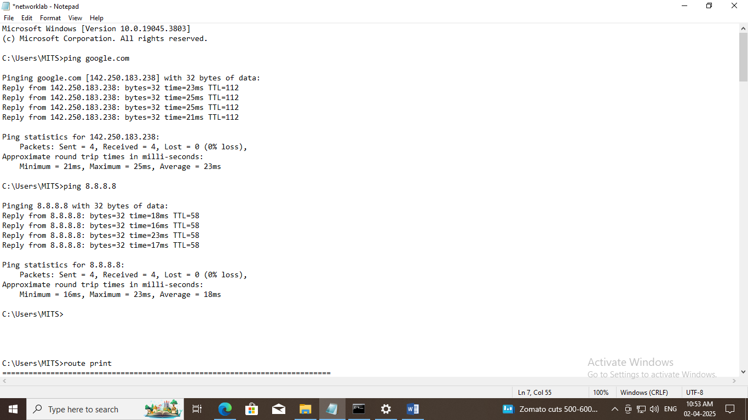

**2.Route**

The Route command is a powerful tool used to view and manipulate the IP routing table in various operating systems, including Unix-like systems and Microsoft Windows. This command is essential for network administrators to manage network routes and ensure efficient data transmission.

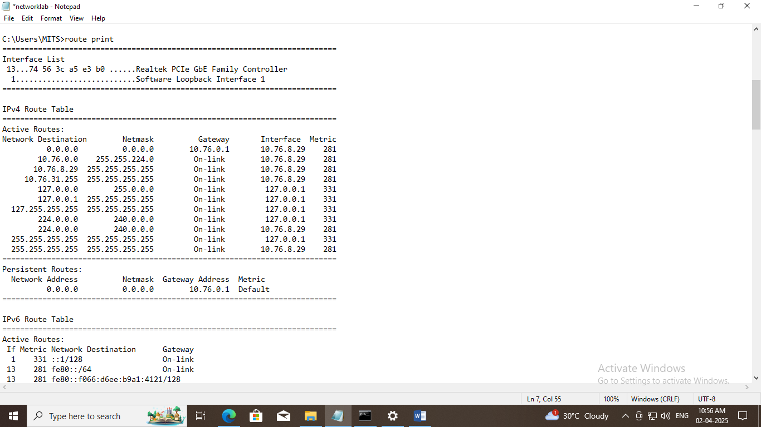

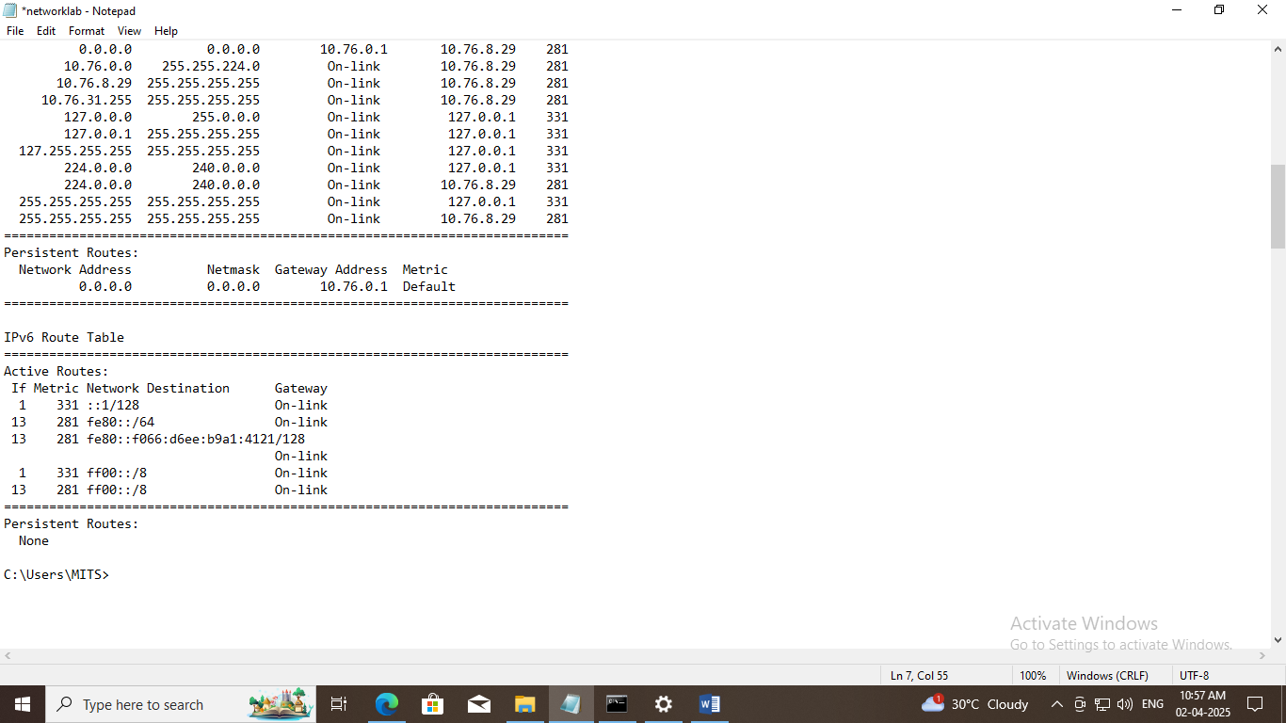

**3.Nslookup**

This command helps diagnose the Domain Name System (DNS) infrastructure and comes with a number of sub-commands. These are mainly for systems administrators. The primary interest for average PC users is its use to find the computer name corresponding to a numeric IP. For example, if you want to know who is &quot;216.109.112.135&quot; , enter &quot;nslookup 216.109.112.135&quot; and you will find that it is (or was anyway) a Yahoo computer. My firewall keeps a log of the IPs involved in the attempts to probe my computer and I sometimes look a few up to see who they are. (There are also Who is search sites available on the Web as mentioned in the Ipconfig section.)

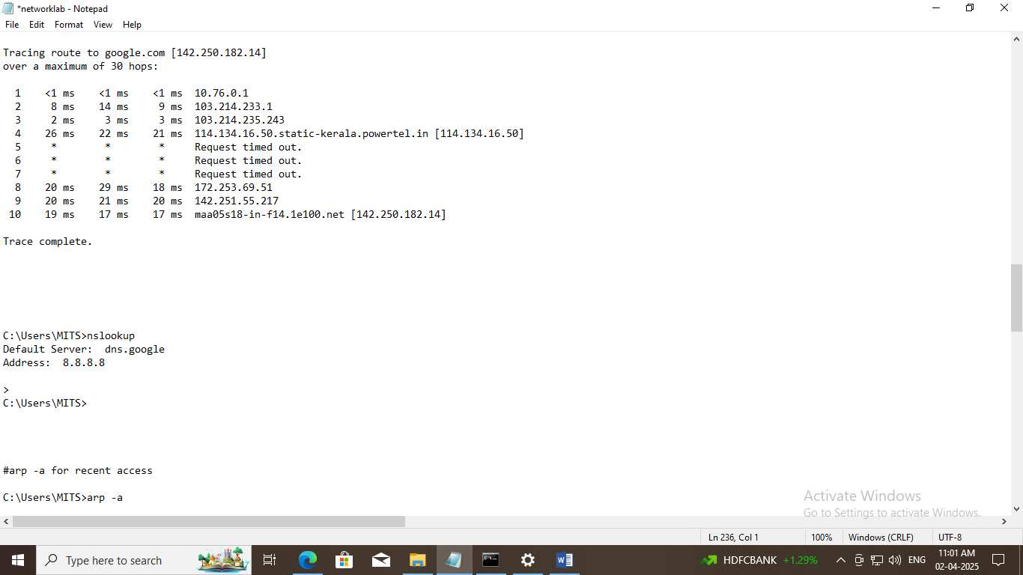

**4. Ipconfig**

The Windows IP Configuration tool (ipconfig) is the command-line equivalent of the accessory &quot;Winipcfg&quot; that was present in Windows 9X/Me. It is used to display the TCP/IP network configuration values. To open it, enter &quot;ipconfig&quot; in the command prompt. If you are connected directly to the Internet, you will obtain your IP address.

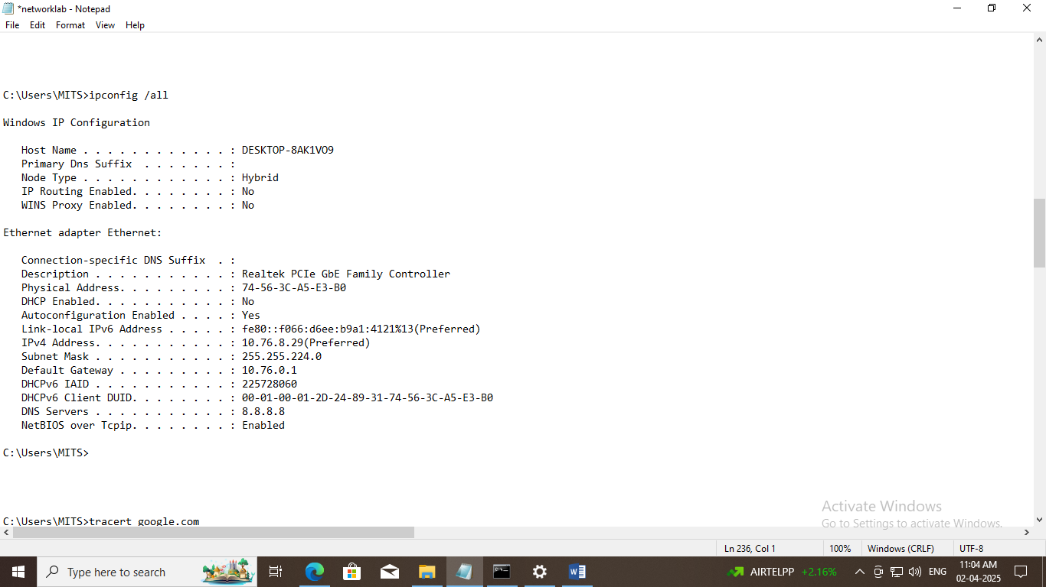

**5.Tracert**

Tracert (traceroute) is another old tool borrowed from Unix. The actual path between two computers on the Internet is not a straight line but consists of numerous segments or &quot;hops&quot; from one intermediate computer to another. Tracert shows each step of the path taken. It can be interesting to see just how convolute edit is. The times for each hop and the IP addresses for each intermediate computer are displayed. Tracert shows up to 30 hops. It is convenient for finding if there is one particular segment that is causing a slow or bad connection. A typical command might be &quot;tracert dell.com&quot;.

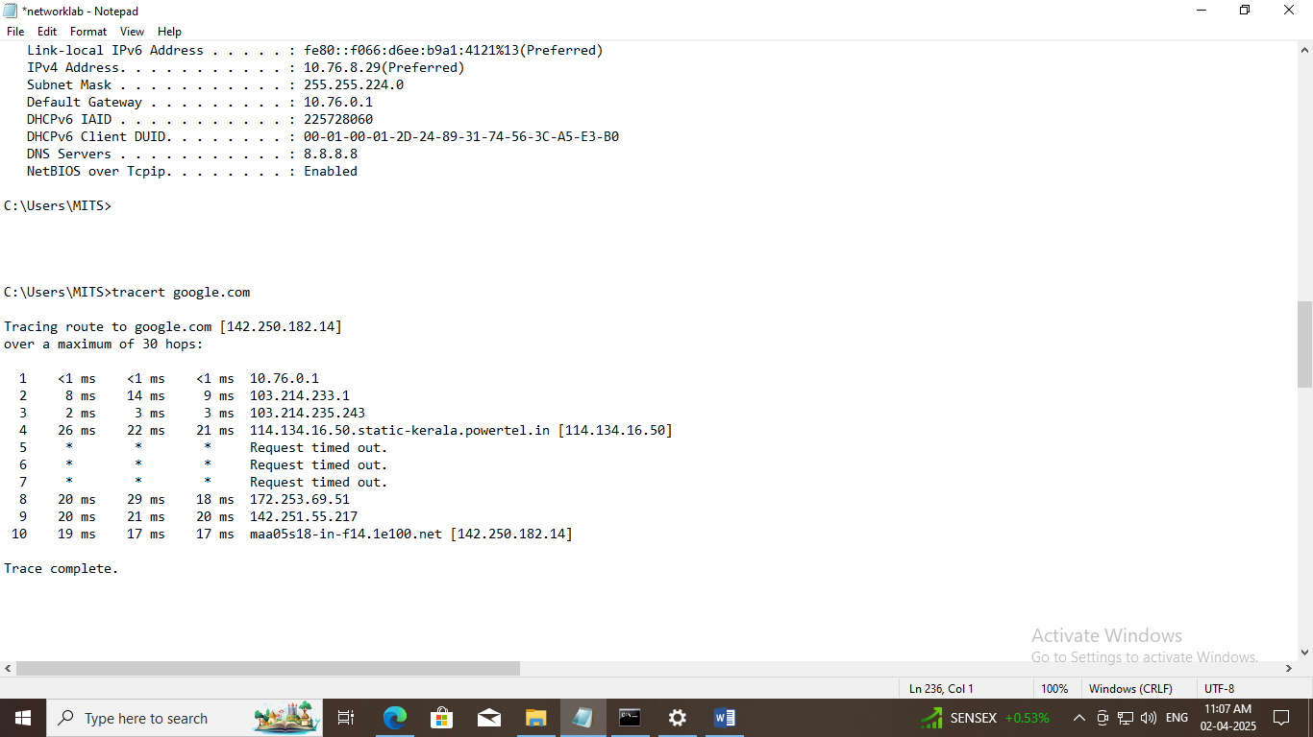

**6.arp**

The ARP command corresponds to the Address Resolution Protocol. Although it is easy to think of network communications in terms of IP addressing, packet delivery is ultimately dependent on the Media Access Control (MAC) address of the device’s network adapter. This is where the Address Resolution Protocol comes into play. Its job is to map IP addresses to MAC addresses. Windows devices maintain an ARP cache, which contains the results of recent ARP queries. You can see the contents of this cache by using the ARP -A command. If you are having problems communicating with one specific host, you can append the remote host’s IP address to the ARP -A command.

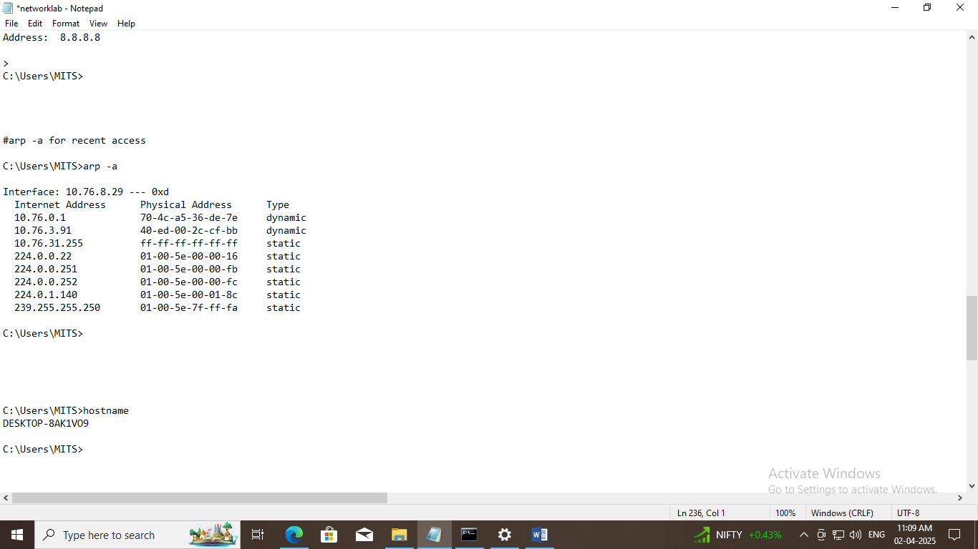

**7.nbtstat**

As I am sure you probably know, computers that are running a Windows operating system are assigned a computer name. Oftentimes, there is a domain name or a workgroup name that is also assigned to the computer. The computer name is sometimes referred to as the NetBIOS name. Windows uses several different methods to map NetBIOS names to IP addresses, such as broadcast, LMHost lookup, or even using the nearly extinct method of querying a WINS server. Of course, NetBIOS over TCP/IP can occasionally break down. The NbtStat command can help you to diagnose and correct such problems. The NbtStat -n command for example, shows the NetBIOS names that are in use by a device. The NbtStat -r command shows how many NetBIOS names the device has been able to resolve recently.

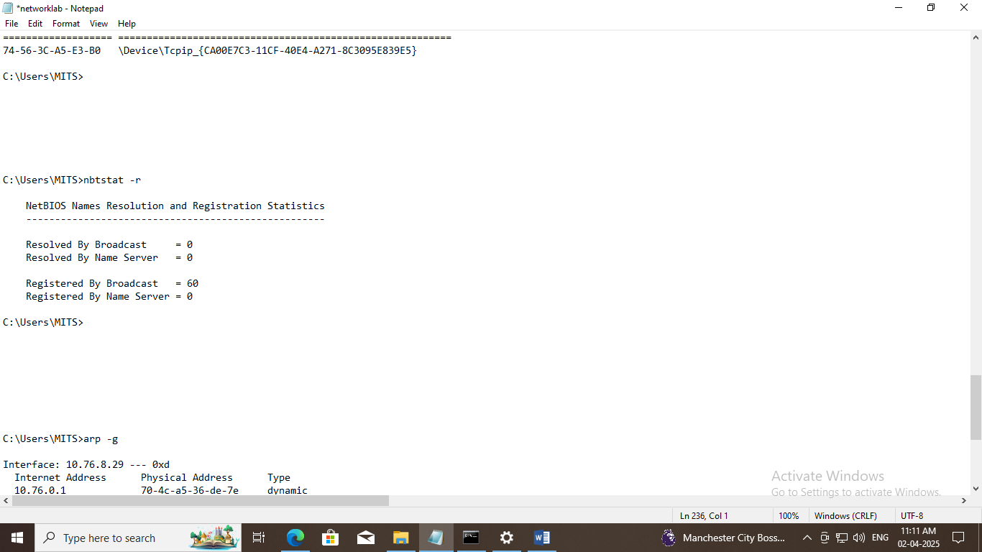

**8.hostname**

The previously discussed NbtStat command can provide you with the host name that has been assigned to a Windows device, if you know which switch to use with the command. However, if you’re just looking for a fast and easy way of verifying a computer’s name, then try using the Hostname command. Typing Hostname at the command prompt returns the local computer name.

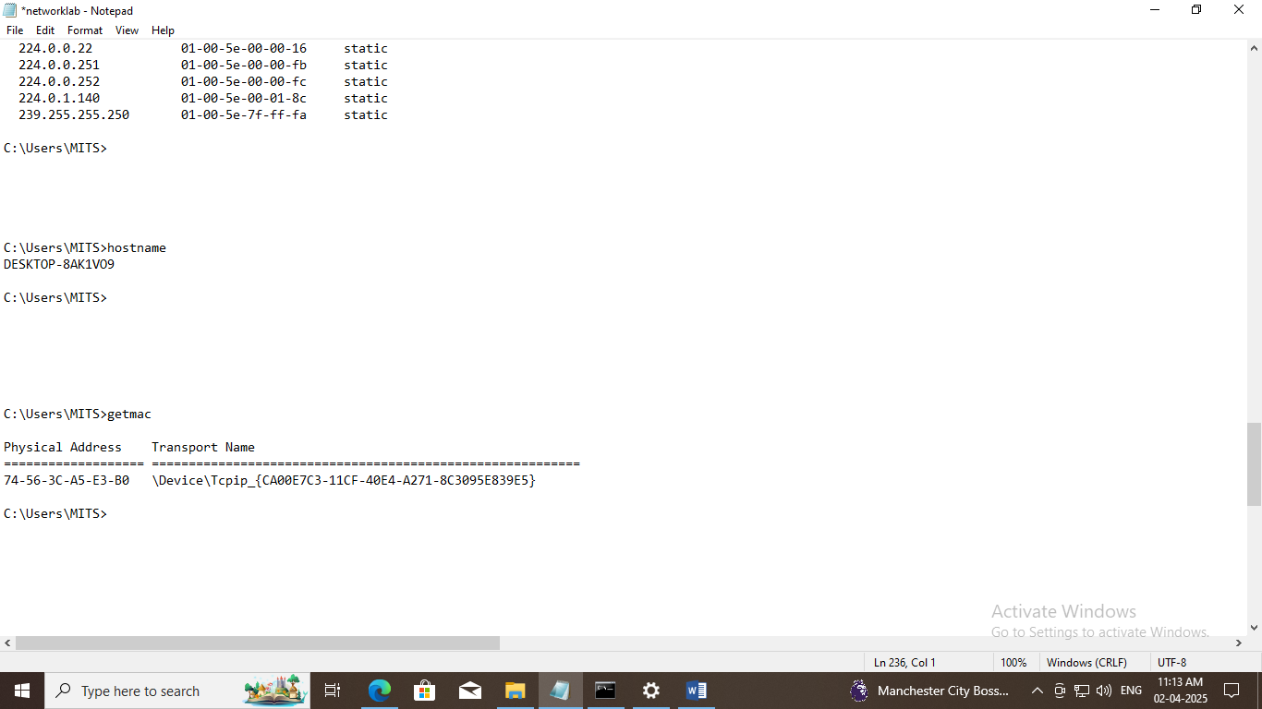

**9. pathping**

Earlier, I talked about the Ping utility and the Tracert utility, and the similarities between them. As you might have guessed, the PathPing tool is a utility that combines the best aspects of Tracert and Ping. Entering the PathPing command.

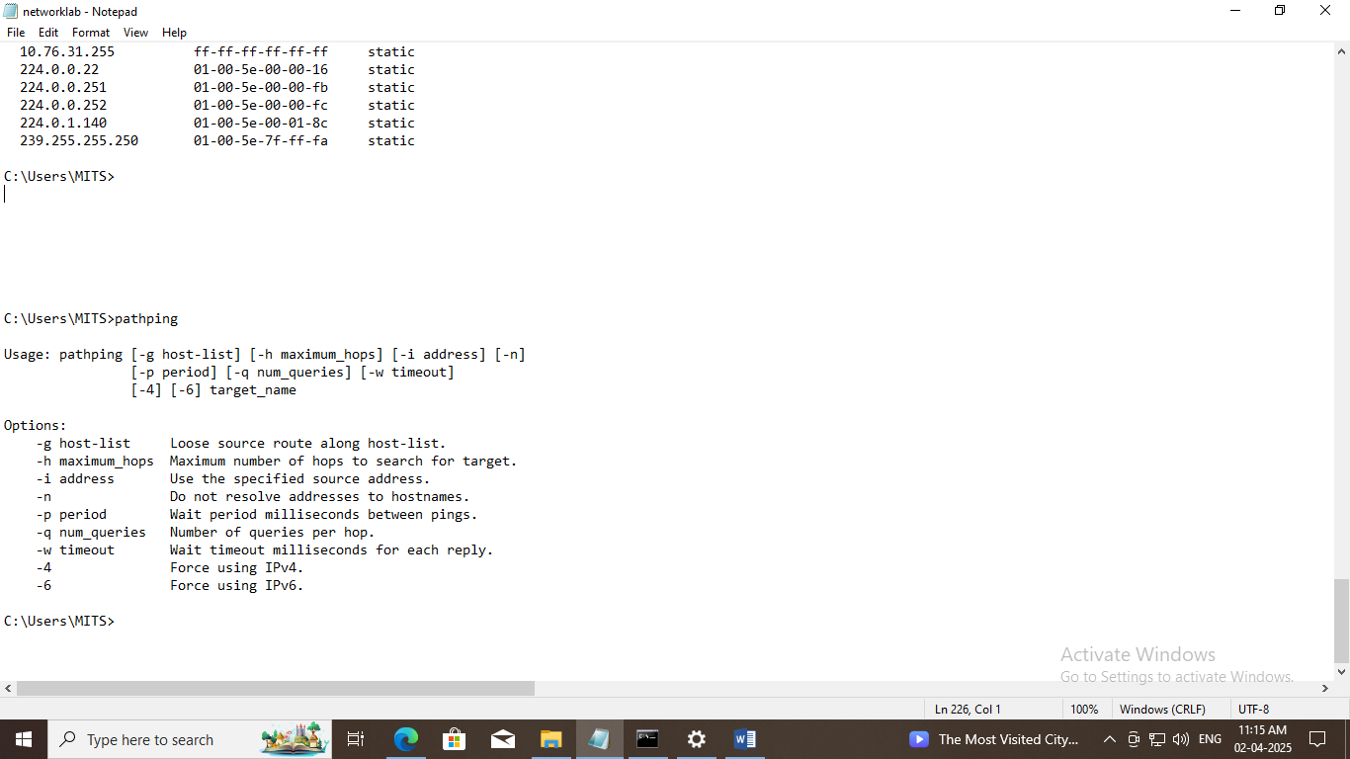

**10.getmac**

Another very simple command that shows the MAC address of your network interfaces.

