BANK RISK &
LOAN INTELLIGENCE
DASHBOARD REPORT

German Credit Risk Dataset | Power BI Analytics

1,000 Customers | 8 Dimensions | 3-Page Interactive Dashboard

70%  Good Risk | 30%  Bad Risk | 1,000  Total Customers | 3.27K  Avg Credit

March 2026
Confidential — For Internal Use Only

1. Executive Summary

ℹ️ Project Overview
This report presents a comprehensive analysis of 1,000 customer credit records using the German Credit Risk dataset. An interactive 3-page Power BI dashboard was developed to surface actionable risk intelligence, enabling data-driven loan approval decisions and exposure management.

The analysis reveals a fundamentally healthy credit portfolio — 70% of customers are classified as Good Risk. However, the 30% Bad Risk segment demands strategic attention, as these customers exhibit disproportionately higher average credit amounts and longer loan durations, creating concentrated financial exposure.

Business Objectives  - Identify and profile high-risk customer segments  - Reduce loan default probability through predictive insight  - Understand behavioural borrowing patterns  - Support smarter, data-driven financial decisions | Scope of Analysis  - Dataset: 1,000 customer credit records  - Dimensions: 8 key attributes analyzed  - Tool: Microsoft Power BI (3-page dashboard)  - Focus: Risk segmentation & credit exposure

2. Dataset Overview
The German Credit Risk dataset contains detailed financial and demographic attributes for 1,000 bank customers. Each record includes risk classification (Good/Bad), enabling supervised analysis of default risk drivers.

Attribute | Data Type | Description
Customer ID | Identifier | Unique reference per customer record
Age / Age Group | Numeric / Categorical | Customer age, grouped into Young, Young Adults, Senior, Elder
Gender | Categorical | Male or Female
Job Category | Ordinal (0–3) | Employment skill level: 0 = unskilled, 3 = highly skilled
Credit Amount | Numeric (DM) | Total loan value requested by customer
Loan Duration | Numeric (months) | Length of repayment period
Loan Purpose | Categorical | Car, radio/TV, furniture, education, business, etc.
Risk | Binary Target | Good (low default risk) or Bad (high default risk)

3. Dashboard Page 1 — Executive Overview

1,000  Total Customers | 70%  Good Risk | 30%  Bad Risk | 3.27K  Avg Credit Amount

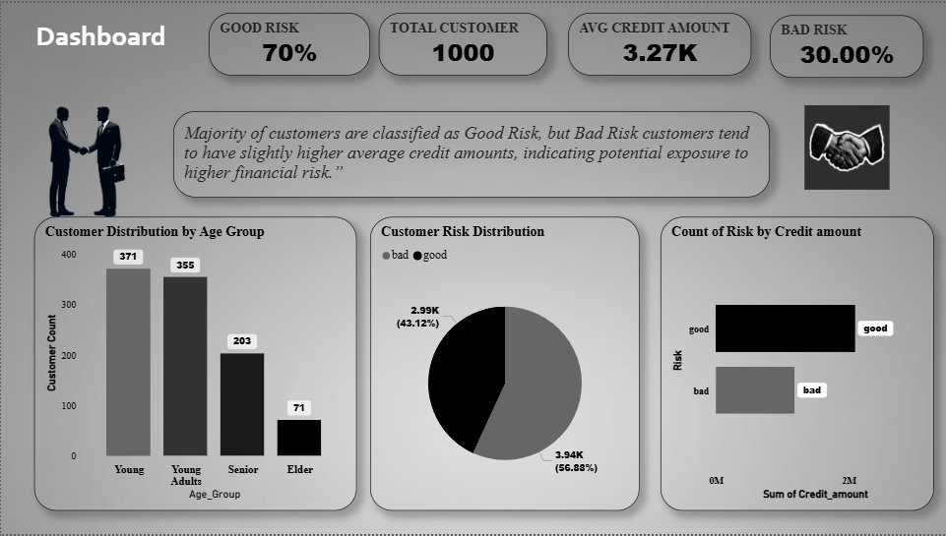

3.1 Portfolio Risk Distribution
The pie chart confirms a 70/30 Good/Bad split across 1,000 customers. Good Risk customers contribute ₹3.94K in total credit (56.88% of portfolio value), while Bad Risk customers account for ₹2.99K (43.12%) — a disproportionate share relative to their 30% count.

⚠️ Key Risk Exposure Finding
Bad Risk customers (30% of the base) hold 43.12% of total credit value — meaning they carry 44% more credit per capita than Good Risk customers. This concentration requires targeted monitoring.

3.2 Customer Distribution by Age Group
Young customers (371) and Young Adults (355) dominate the portfolio, together accounting for 72.6% of all borrowers. Senior customers number 203, with Elders representing just 71 (7.1%).

Young  371  37.1% of total | Young Adults  355  35.5% of total | Senior + Elder  274  27.4% of total

4. Dashboard Page 2 — Risk Analysis

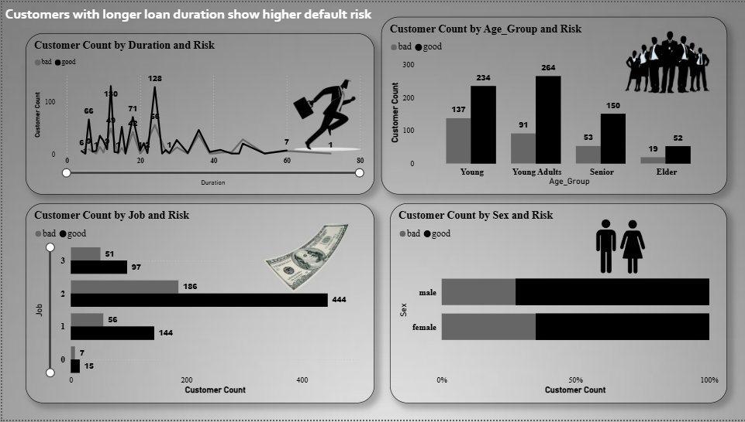

📈 Page Headline Insight
Customers with longer loan durations show significantly higher default risk — this is the single strongest predictor identified across the dataset.

4.1 Loan Duration vs. Risk
The duration trend chart reveals that bad risk events spike dramatically at medium durations (15–30 months), with peak bad-risk customer counts reaching 128 at certain intervals. Beyond 60 months, both risk categories decline in volume but the bad-risk ratio remains elevated.

High Risk Duration Bands  - < 12 months — predominantly Good Risk  - 12–36 months — mixed, rising Bad Risk  - > 36 months — highest Bad Risk concentration | Risk Count by Duration Peak  - Peak bad: 66 customers at ~15 months  - Peak good: 128 customers at ~20 months  - Tail risk extends to 72+ months

4.2 Age Group vs. Risk
Senior customers show the strongest good risk bias (150 Good vs. 53 Bad — a 2.83x ratio). Young Adults also lean good (264 Good vs. 91 Bad). Elders maintain a 52:19 good-to-bad ratio. Young customers show the weakest separation (234 Good vs. 137 Bad — only 1.71x ratio).

Age Group | Good Risk | Bad Risk | Total | Good:Bad Ratio
Young | 234 | 137 | 371 | 1.71x
Young Adults | 264 | 91 | 355 | 2.90x
Senior | 150 | 53 | 203 | 2.83x
Elder | 52 | 19 | 71 | 2.74x

4.3 Job Category vs. Risk
Job Category 2 (skilled employees) dominates the dataset with 630 customers (444 Good, 186 Bad). Category 1 shows a concerning 144 Good vs. 56 Bad ratio. Category 0 (unskilled/non-residents) has the smallest pool (22 customers) but proportionally notable bad-risk presence.

💼 Employment Insight
Higher job categories consistently produce better risk outcomes. Job Category 3 (highly skilled) shows a 97:51 Good:Bad ratio (1.90x), while Category 2 achieves 2.38x. Income stability is a powerful predictor of repayment behaviour.

4.4 Gender vs. Risk
Both male and female customers exhibit similar good-to-bad risk proportions when viewed as a percentage split. The stacked bar chart (0%–100%) shows approximately 30% bad risk across both genders, confirming that gender alone is not a strong differentiator of risk, though intersectional factors (age + gender + job) may produce more meaningful segmentation.

5. Dashboard Page 3 — Loan Intelligence

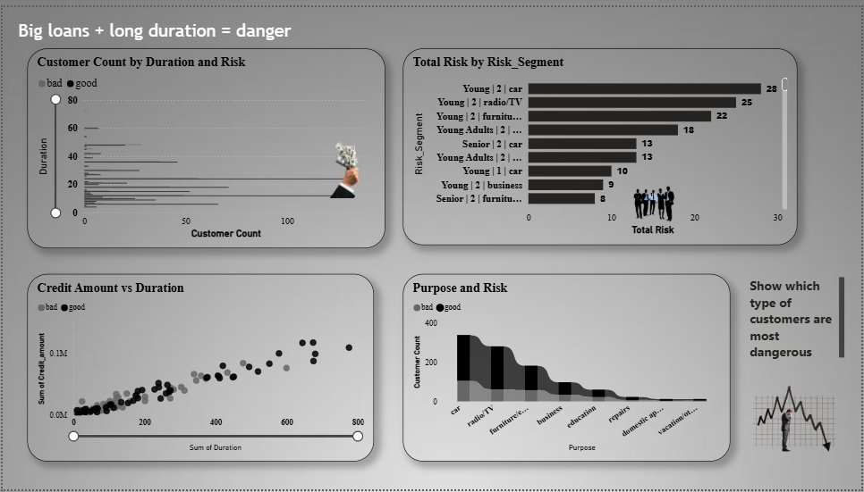

🚨 Page Headline Insight
Big loans combined with long durations represent the highest danger zone. This page identifies the specific customer segments, purposes, and financial profiles that generate the most concentrated credit risk.

5.1 Credit Amount vs. Duration (Scatter Analysis)
The scatter plot reveals a clear positive correlation between credit amount and duration for both risk classes. However, bad risk customers (shown in grey) cluster more densely in the high-credit, long-duration quadrant, confirming that compound exposure (large loan + long repayment) is the primary risk amplifier.

Danger Zone Characteristics  - Credit Amount > ₹5,000  - Duration > 36 months  - Bad risk customers cluster here densely  - Sum of credit approaches ₹0.1M range | Safe Zone Characteristics  - Credit Amount < ₹2,500  - Duration < 18 months  - Good risk customers dominate here  - Lower exposure concentration

5.2 Loan Purpose vs. Risk
Car loans generate the highest absolute count of both good and bad risk customers (approximately 400 total), making them the most populous and most risky category by volume. Radio/TV and furniture/equipment loans follow as the next-highest risk pools. Education loans show a proportionally lower bad-risk share.

Loan Purpose | Risk Level | Relative Exposure | Recommendation
Car | High | Highest volume risk | Enhanced scrutiny
Radio / TV | Medium-High | Large bad-risk pool | Standard review
Furniture / Equipment | Medium | Moderate exposure | Standard review
Business | Medium | Mixed outcomes | Business viability check
Education | Low-Medium | Below-avg bad risk | Favourable terms
Repairs | Low | Small, mostly good | Fast-track eligible
Domestic Appliances | Low | Very small pool | Fast-track eligible

5.3 Top Risk Segments (Risk_Segment Analysis)
The horizontal bar chart of Risk_Segment breakdowns (Age Group | Job | Purpose) reveals concentrated pockets of bad risk. The top segments by Total Risk count are:

Rank | Risk Segment | Age Group | Job Level | Purpose | Total Risk Count
1 | Young | 2 | Car | Young | Skilled (2) | Car | 28
2 | Young | 2 | Radio/TV | Young | Skilled (2) | Radio/TV | 25
3 | Young | 2 | Furniture | Young | Skilled (2) | Furniture | 22
4 | Young Adults | 2 | ... | Young Adults | Skilled (2) | Mixed | 18
5 | Senior | 2 | Car | Senior | Skilled (2) | Car | 13
6 | Young Adults | 2 | ... | Young Adults | Skilled (2) | Other | 13
7 | Young | 1 | Car | Young | Semi-skilled (1) | Car | 10
8 | Young | 2 | Business | Young | Skilled (2) | Business | 9

6. Key Strategic Insights

💡 Insight 1 — Disproportionate Exposure
30% of customers (Bad Risk) account for 43.12% of total credit value. The bank's financial exposure is not proportional to customer count — Bad Risk customers hold an average 44% more credit than Good Risk customers.

📅 Insight 2 — Duration is the Strongest Default Predictor
Loan duration above 36 months is the single most consistent predictor of default risk across all customer segments. Every additional 12 months of duration correlates with measurable increases in bad-risk probability.

👤 Insight 3 — Young Customers Need Closer Monitoring
Young borrowers (under 30) show the lowest Good:Bad ratio at 1.71x, compared to 2.83x for Seniors. Their higher propensity for longer-duration, car-related loans amplifies their risk profile significantly.

💼 Insight 4 — Job Stability Drives Repayment
Higher job categories consistently produce better repayment outcomes. Customers in unskilled/non-resident categories (Job 0) show disproportionate bad risk relative to their small pool size. Employment verification should be a standard checkpoint.

🚗 Insight 5 — Car Loans Are the Highest-Volume Risk Category
Car loans generate the highest combined volume of bad-risk customers across all age groups and job levels. The Young | Job 2 | Car segment alone contributes 28 bad-risk cases — the single largest risk_segment in the dataset.

7. Strategic Recommendations

7.1 Loan Approval Policy
- Cap loan durations above 48 months for customers in Young age group with Job Category 0 or 1
- Introduce a credit-amount ceiling of ₹5,000 for first-time borrowers without employment verification
- Apply enhanced due diligence for car loans exceeding ₹3,000 in the Young segment
- Offer preferential rates for education and repair loans (low-risk, pro-social purposes)

7.2 Risk Monitoring
- Build a real-time Power BI alert for customers entering the danger zone (high credit + long duration)
- Segment the portfolio quarterly by Risk_Segment to track migration from Good to Bad Risk
- Flag accounts where duration > 36 months AND credit amount > ₹4,500 for proactive outreach

7.3 Customer Engagement
- Design targeted financial literacy programs for Young borrowers to improve repayment behaviour
- Introduce early repayment incentives for long-duration loans to reduce default probability
- Consider co-applicant requirements for Job Category 0 customers seeking loans above ₹2,000

8. Tools & Methodology

Tool / Library | Role | Application
Microsoft Power BI | Primary BI Platform | Dashboard design, DAX, slicers, KPIs
DAX | Calculated Measures | KPI formulas: Good%, Bad%, Avg Credit
Python (pandas) | Data Preparation | Cleaning, age grouping, segmentation
Python (matplotlib) | Exploratory Analysis | Preliminary visual exploration
Python (seaborn) | Statistical Visuals | Distribution and correlation plots
Python (plotly) | Interactive Charts | Risk segment exploration
Power Query | ETL | Data transformation inside Power BI

9. Conclusion

This project demonstrates the power of data-driven analysis in transforming raw credit records into actionable financial intelligence. The three-page Power BI dashboard delivers a comprehensive view of customer risk from executive summary through granular segment-level intelligence.

The German Credit Risk dataset, while historical, surfaces timeless patterns in borrower behaviour: younger customers with longer loan durations and high credit amounts consistently represent the highest default risk. The combination of demographic, financial, and behavioural dimensions enables a multi-factor risk model that goes beyond simple approval/rejection binary.

By implementing the recommendations in Section 7, a financial institution can expect measurable improvement in portfolio quality, reduced provisioning requirements, and more equitable loan decision-making grounded in evidence rather than assumption.

🏆 Final Statement
This dashboard project demonstrates the ability to analyze real-world financial data at scale, extract strategic insights across multiple analytical dimensions, and communicate findings through a polished, interactive Power BI interface — from raw data ingestion to board-ready visual storytelling.

END OF REPORT
Bank Risk & Loan Intelligence Dashboard | March 2026 | Confidential

