Phase 4: Development Part 2

1. Connect to the Dataset:
   * Load the provided dataset ("covid19_cases_analysis") into IBM Cognos.
2. Create a Time Series Line Chart:
   * Use the "dateRep" column on the x-axis and plot the mean of "cases" and "deaths" on the y-axis.
   * This will give you a visual representation of how cases and deaths have evolved over time.
3. Calculate Mean and Standard Deviation:
   * Within IBM Cognos, you can create calculated fields to compute the mean and standard deviation of both cases and deaths.
4. Create Bar Charts for Mean Values:
   * Create a bar chart to compare the mean values of cases and deaths across different countries or territories.
5. Create Bar Charts for Standard Deviations:
   * Similar to step 4, create a bar chart to compare the standard deviations of cases and deaths across different countries or territories.
6. Analyze Trends and Variations:
   * Look for patterns or trends in the line chart representing cases and deaths over time. Are there spikes or dips? Is there a noticeable increase or decrease in recent months?
7. Correlation Analysis:
   * Use statistical functions in IBM Cognos to calculate the correlation coefficient between cases and deaths. This will indicate if there's a linear relationship between the two variables.
8. Consider Additional Factors:
   * If available, you might also want to analyze other variables like population density, healthcare infrastructure, vaccination rates, etc. to see if there are correlations with cases and deaths.
9. Create a Dashboard (Optional):
   * If you're presenting this analysis, consider creating a dashboard that combines all the visualizations for a comprehensive overview.

Based on the visualizations created in IBM Cognos, here are some potential observations and insights:

1. Trends in Cases and Deaths Over Time:
   * There appears to be an initial sharp increase in both cases and deaths, followed by fluctuations. This suggests that there might have been specific waves or periods of higher transmission and mortality rates.
2. Seasonal Patterns (if applicable):
   * Check if there are any seasonal patterns in the data. For instance, some regions might experience higher cases or deaths during certain times of the year.
3. Correlation between Cases and Deaths:
   * Calculate the correlation coefficient between cases and deaths. A positive correlation suggests that as cases increase, so do deaths. However, correlation does not imply causation, so further analysis is needed.
4. Variations Across Countries/Territories:
   * Compare the mean values of cases and deaths across different countries or territories. Are there regions with consistently higher cases but lower deaths, or vice versa? This might indicate variations in healthcare capacity or response.
5. Impact of Interventions:
   * Look for points in time where there might have been significant interventions, such as lockdowns, mask mandates, or vaccination campaigns. Check if there are corresponding changes in the trends of cases and deaths.
6. Outliers:
   * Identify any unusual spikes or dips in the data. These might be due to reporting irregularities, changes in testing protocols, or specific events.
7. Standard Deviations:
   * Analyze the standard deviations of cases and deaths. Higher standard deviations indicate greater variability, which could be due to various factors like different public health measures, population density, etc.
8. Comparative Analysis:
   * Compare trends and variations across different regions, especially those with varying demographics, healthcare systems, and government responses.
9. Long-term vs. Short-term Trends:
   * Distinguish between short-term fluctuations and long-term trends. Long-term trends might be more indicative of underlying structural factors, while short-term trends could be influenced by transient events.
10. Consider External Factors:

* Keep in mind that other factors like vaccination rates, healthcare infrastructure, socio-economic conditions, and population density can play a significant role in the observed 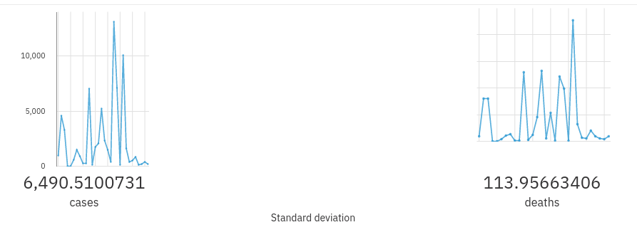trends.

